Atomic Operations Education Resource

Overview

This activity aims to teach students about the need for consistency and atomic blocks through the use of transactions. This is an introductory exercise. Consistency and atomic blocks are the idea that threads should only be able to access data at the right times and in the correct order in order to complete their task effectively.

Suitable For

Higher/Advanced Higher Computer Science

Key Concepts

The use of transactions, multi-threading, parallelism, basic understanding of arrays, consistency and atomic sections.

Learning Outcomes

* Understand how bank transactions work.
* Understand why some important data can’t be accessed at the same time.
* Understand the importance of serialisability (but not really mention it).
* Understand why it is important to read and write data in a specific order.

Success Criteria

* I will be able to put a set of instructions from two different transactions in order.
* I will understand why operations in a transaction need to be atomic, and understand the meaning of being atomic.
* I will be able to describe a series of transactions in order that makes them atomic.

Time Required

1 period - 1 hour

Preparation

1. Print out the blocks on the last 6 pages on separate pieces of different coloured paper to show the separation of the transactions. Cut out the blocks, each block can be placed on top of one another.

Prior Learning Assumed

None - this is a new topic.

Outline of Activity

1. Outline to the class that in order for banks to keep track of their bank accounts correctly they have to make sure that actions are done in the right order otherwise mistakes are made.
2. Outline that more than one transaction (a series of actions) can happen at one time, for example someone might be withdrawing £100 out for their gas bill, and at the same time £200 is coming out for their electric bill. If things are done in the wrong order then mistakes can be made and the bank account could be shown to hold a value of money that isn’t correct. Show the class the set of green blocks (pin them up on the board). Outline that these blocks are the transaction outlined for John’s bank account to have his £200 electricity bill being taken out. These are called read-modify-write operations, where you read an initial value, then change it in some way, then write back the new result.
3. Using all the blocks on the board, interleaved them one pink after one green. (1,4,2,5,3,6). Outline that if the two transactions are interleaved, they can hold different values at the end of the transactions running. Explain that this is wrong and not atomic.
4. Ask the students to suggest an order that will make the instructions work. By putting the transactions in order, this is atomic and it means that there is only ever going to be one correct value for the bank balance at the end of both of them. If you don’t read or write the transactions correctly, then the two transactions are going to cause problems within the bank account.

The correct order is the three green/three pink and then the other three next.

1. Finalise by explaining that this is the way atomic operations are set up, so that you don’t have overlapping values for example mistakes being made in the bank balances.

The blocks can be used in other ways to demonstrate that the transactions should be linked correctly, asking students to arrange the blocks in different ways, and recording the transactions output to show the different results that can happen – however it always needs to go back that the read-modify-write routine is the correct way to use these instructions.

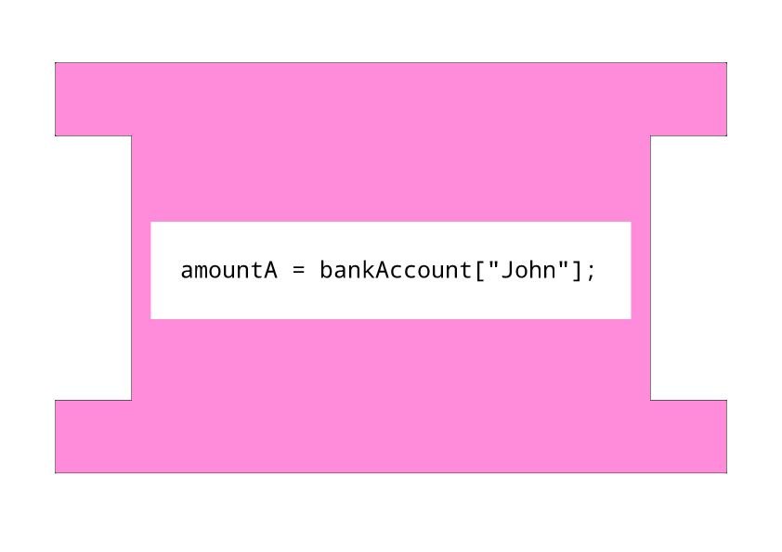

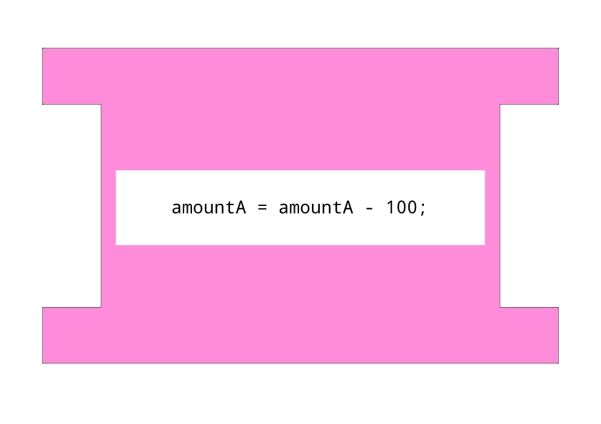

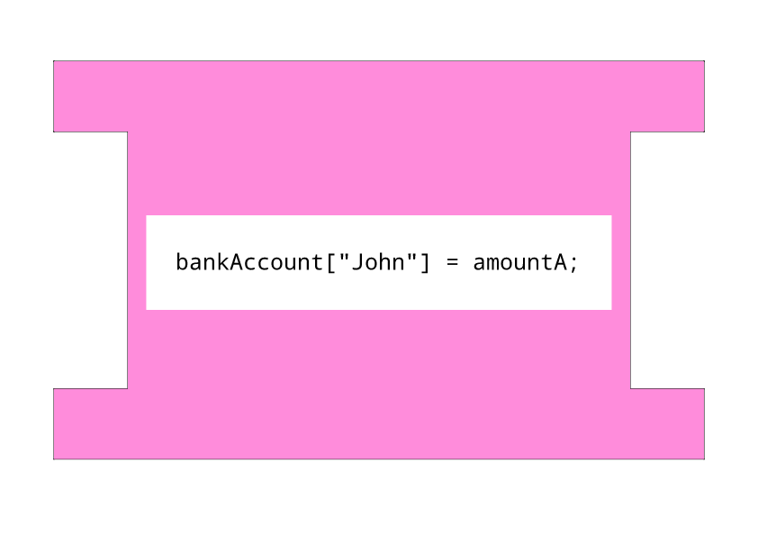

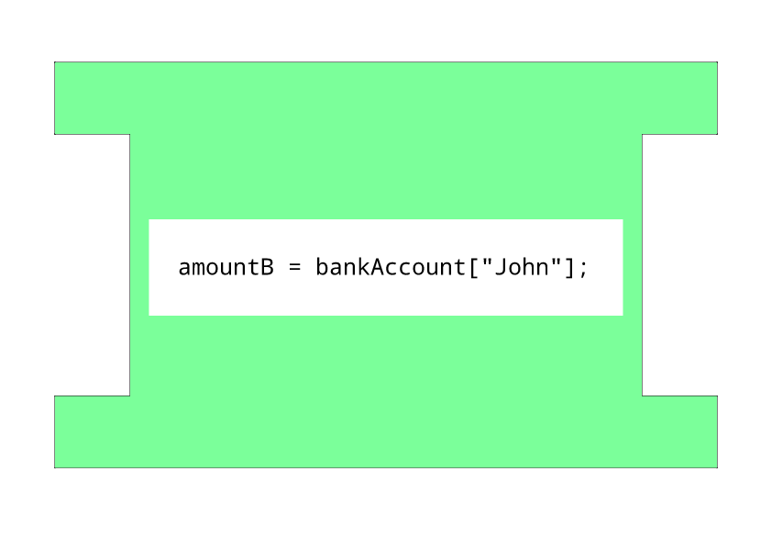

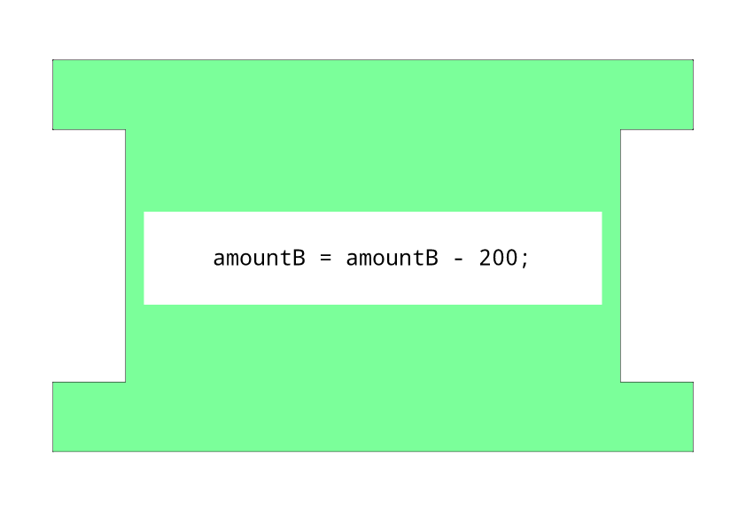

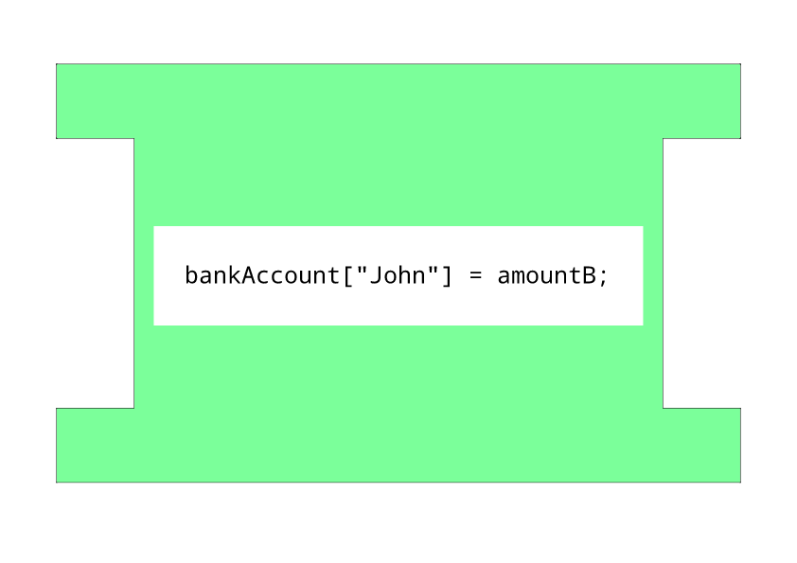

John’s Bank Account:

£5000