- What is an op-amp (operational amplifier)
  - A non-inverting input (+)
  - an inverting input (-)
  - multiplies the votlage difference between the positive and negative inputs by a very high gain value
  - uses five main terminals: two input, one ouput, and two power supply connections (positive and negative)
  - Use external components like reisistors and capaciros with feedback loops to contorl the gain and behavior of the circuit
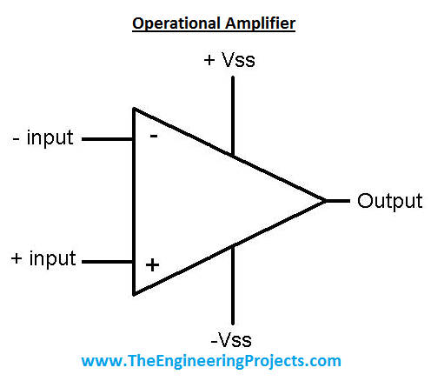
- What is it used for
  - Boosting weak electrical or audio signals
  - removing unwanted frequencies form signal
  - Performing analog computing tasks (addition, subtraction, integration, and differentiation)
  - Comparing two govltage levels to switch an output state
- 5 pins
  - 3 main signal connections
    - +input – non-inveting input
    - -input – inverting input
    - Out – output
  - 2 power connections
    - VCC / V+ - positive power supply
    - VEE / V- - negtaive power supply
- equation
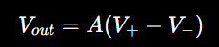
  - Ideal op-amp
  - V+ = 2.01V
  - V- = 2.00V
  - difference is only 0.01V
  - the gain can be a large number like 100000 it can output way more then put in
- use
  - feedback from the output back to the -input
  - lets us contor lthe gain
  - like a non-inverting amplifier
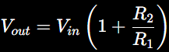
  - Used to calculate the gain
  - like a really smart voltage controller
- The op-amp tries to make its + and – input equal by adjusting its output
- V+~V-

