- Buck IC
  - Pin 1 – GND – For the gorund, electrical return path
  - Pin 2 – SW – high-Speed Switching node that sends energy to the inductor
  - Pin 3 – VIN – Supplied the IC with the inputV
  - Pin 4 – VFB – Sense the output voltage so the IC knows whetehr to increase/Decrease power
  - Pin 5 – EN – Turn sthe IC on or off
  - Pin 6 VBST – provides the voltage need to control the internals
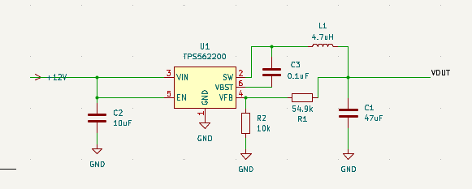
- 12V
  - connects to the Vin for the power supply
  - connects to the EN to show that there is connection
- C2
  - To keep a steady V on the left side
- L1
  - Smoothes the rapdidly switchign voltage form the SW for consistant output
- C3
  - keeps constant power to the VBST so the high-side gate drive stays open
- C1
  - Smoothes the output current so it’s not up and down
- R1
  - Used to choose the voltage measurment system
- R2
  - Used to choose the voltage mesurment system
  - The ratio between the reissitors chooses th eoutput voltage
