**Holo2factory Configurator user guide**

This application has as purpose to create a new list of cotations and set them correctly in the space. You have to correctly set the position and the orientation of the cotations. There is a 3D viewer to help you place the cotation and to have a brief renderer. The exported list will be used in the Unity application to display the cotations.

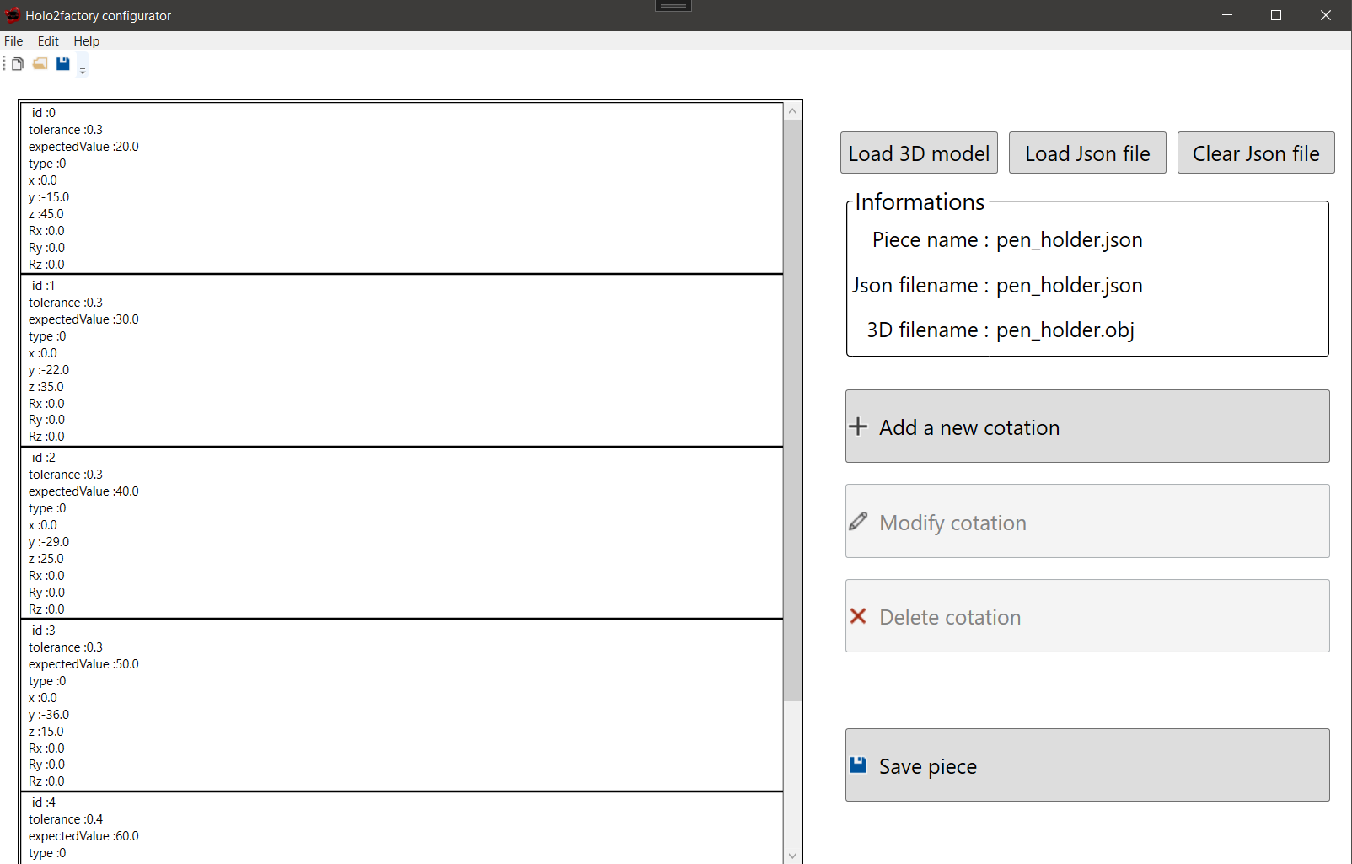

4

3

2

1

1. Load the 3D model, visible on the picture below
2. Open an existing json file (containing a list of cotations)
3. Clear the copy of the opened json file
4. List of cotations

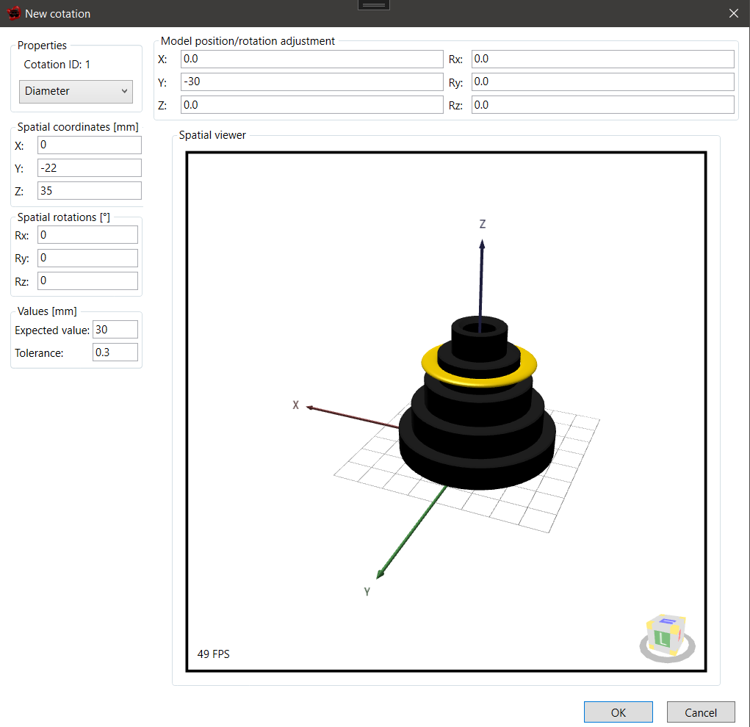

5

6

4

3

2

1

1. Set the type of the cotation (Diameter, rectilign, hole)
2. Set the spatial coordinate of the cotation
3. Set the rotation of the cotation
4. Type the effective value of the cotation and the tolerance
5. Feel free to edit the position of the model
6. Preview, you can drag, rotate the model freely