深 圳 大 学 实 验 报 告

课程名称： python语言程序设计

实验项目名称： 实验3- 列表

学院： 医学部生物医学工程学院

专业： 生物医学工程

指导教师： 黄淦

报告人： 陈嘉鸿

学号： 2021220049

实验时间： 2023年 2 月 22 日

教务处制

- 实验内容
Exercise 1: Short questions
(a) Write a function that prints the elements of a list
(b) Write a function that prints the elements of a list in reverse
(c) Write your own implementation of the len function that returns the number of elements in a list.

Exercise 2: Copying lists
(a) Create a list a with some entries.
(b) Now set b = a
(c) Change b[1]
(d) What happened to a?
(e) Now set c = a[:]
(f) Change c[2]
(g) What happened to a?
Now create a function set_first_elem_to_zero (l) that takes a list, sets its first entry to zero, and
returns the list. What happens to the original list?

Exercise 3: Primes
(a) Write a function is_prime(n) that returns True only if n is prime.
(b) Note that apart from 2 and 3, all primes are of the form 6k ± 1 (though not all numbers of the form 6k ± 1 are prime of course).
Update your function to use this.
(c) Write a function that return a list which holds all primes up to n.
(d) Write a function that returns a list which hold the first n primes.

Exercise 4: Collatz sequence, part 2
Recall the Collatz sequence problem from Experiment 1. Our goal is to find the number n < 1; 000; 000 that leads to the longest Collatz sequence.
(a) Write a function that for any n, returns its Collatz sequence as a list
(b) Write a function that finds the integer x that leads to the longest Collatz sequence with x < n.

Exercise 5: Pivots
Write a function that takes a value x and a list ys, and returns a list that contains the value x and all
elements of ys such that all values y in ys that are smaller than x come first, then we element x and
then the rest of the values in ys
For example, the output of f (3, [6, 4, 1, 7]) should be [1, 3, 6, 4, 7]

- 代码实现过程
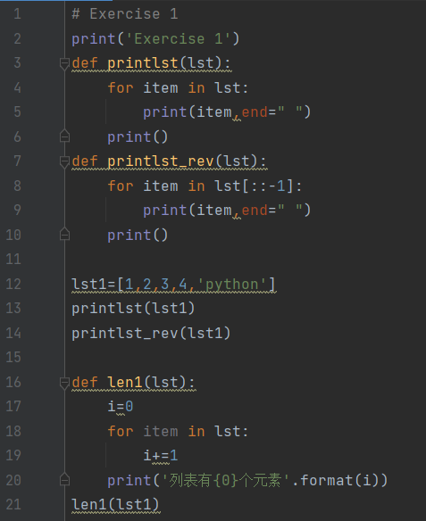
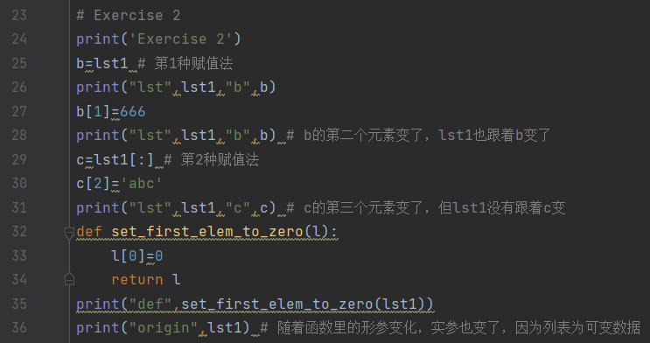
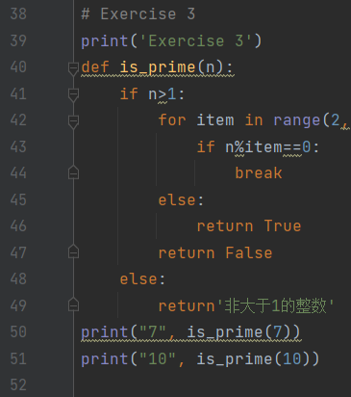
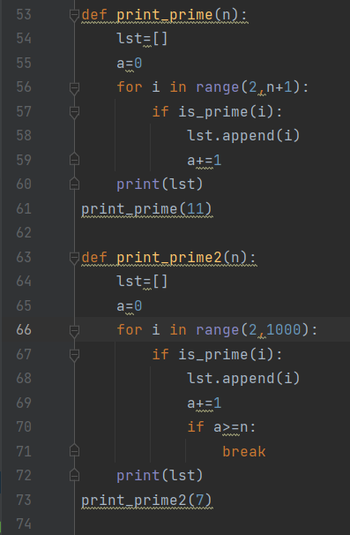
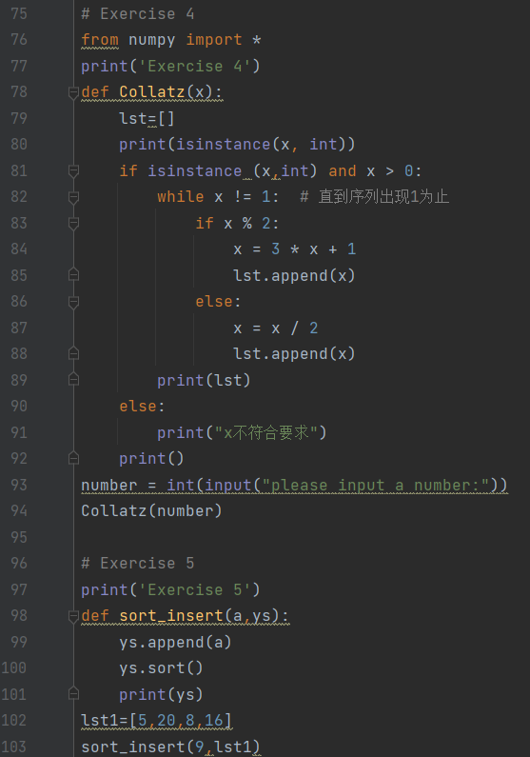

- 运行结果
Exercise 1
1 2 3 4 python
python 4 3 2 1
列表有5个元素
Exercise 2
lst [1, 2, 3, 4, 'python'] b [1, 2, 3, 4, 'python']
lst [1, 666, 3, 4, 'python'] b [1, 666, 3, 4, 'python']
lst [1, 666, 3, 4, 'python'] c [1, 666, 'abc', 4, 'python']
def [0, 666, 3, 4, 'python']
origin [0, 666, 3, 4, 'python']
Exercise 3
7 True
10 False
[2, 3, 5, 7, 11]
[2, 3, 5, 7, 11, 13, 17]
Exercise 4
please input a number:9
True
[28, 14.0, 7.0, 22.0, 11.0, 34.0, 17.0, 52.0, 26.0, 13.0, 40.0, 20.0, 10.0, 5.0, 16.0, 8.0, 4.0, 2.0, 1.0]

Exercise 5
[5, 8, 9, 16, 20]

进程已结束,退出代码0

- 任务实现中遇到的问题以及解决方法。
- For循环下if、else、和break的使用联系有难点，if内break后无法进入和for循环处于同一层的else语句，理通逻辑后合理分布。

- 未注意到input函数输入的是字符串，导致使用int型的判断，格式不正确。后面进行int的转换解决问题。

指导教师批阅意见：
- 实验报告的完整性：
□实验报告完整
□实验报告不够完整
□实验报告缺少内容
- 实验结果的正确性
□实验结果正确无误，
□有小的逻辑错误
□代码有很大错误
- 代码的简洁和效率
□代码简洁优雅，可读性好，能高效运行
□代码具有较好的可读性，但执行效率可进一步优化
□代码可读性不佳，执行效率较好
□代码混乱，效率不佳
成绩评定：

指导教师签字：

2022年 0x 月 xx 日
备注：

