深 圳 大 学 实 验 报 告

课程名称： python语言程序设计

实验项目名称： 实验4- 元组和字典

学院： 医学部生物医学工程学院

专业： 生物医学工程

指导教师： 黄淦

报告人： 陈嘉鸿

学号： 2021220049

实验时间： 2023年 3 月 13 日

教务处制

- 实验内容
Exercise 1: Zip
Suppose we have two lists, x and y that give the x and y coordinates of a set of points.
Create a list with the coordinates (x,y) as a tuple. Hint: Find out about the zip function.
You have decided that actually you need the two separate lists, but unfortunately, you
have thrown them away. How can we use zip to unzip the list of tuples to get two lists
again?
Exercise2: Distances
Suppose we have two vectors, x and y, stored as tuples with n elements. Implement
functions that compute the l1 and l2 distances between x and y. Note that n is not
explicitly given.
Exercise 3: Histogram
Write a function that takes a list, and returns a dictionary with keys the elements of the
list and as value the number of occurrences of that element in the list.
Exercise 4: Reverse look-up
Dictionaries are made to look up values by keys. Suppose however, we want to find the
key that is associated with some value. Write a function that takes a dictionary and a
value, and returns the key associated with this value. What challenges do you face?
How would you deal with those challenges?
Exercise 5: Vector functions
Let's implement some vector functions. There are two types of vectors, normal or dense
vectors, which we can represent using lists. For sparse vectors, where many of the
elements are zero, this is inefficient. Instead, we use a dictionary with keys the indices
of non-zero values, and then the value corresponding to the key is the value of the vector
at that index. Hence, the vector [1; 2; 4] can be stored as a list: [1, 2, 4] or as a dictionary
{0:1, 1: 2, 2: 4}
(a) Write a function that adds two (dense) vectors
(b) Write a function that multiplies (i.e. inner product) two (dense) vectors
(c) Write a function that adds two sparse vectors
(d) Write a function that multiplies two sparse vectors
(e) Write a function that adds a sparse vector and a dense vector
(f) Write a function that multiplies a sparse vector and a dense vector

- 代码实现过程
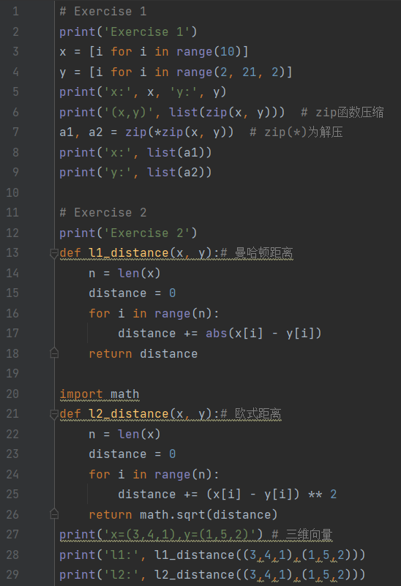
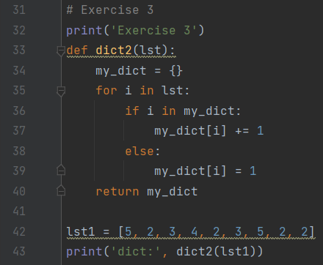
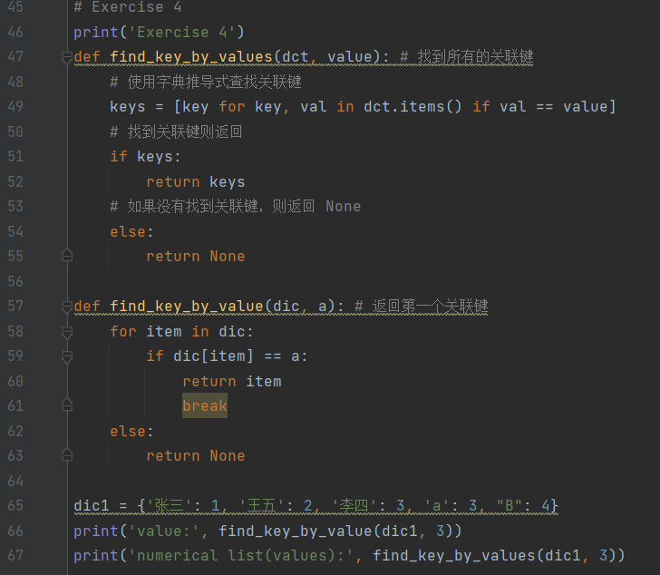
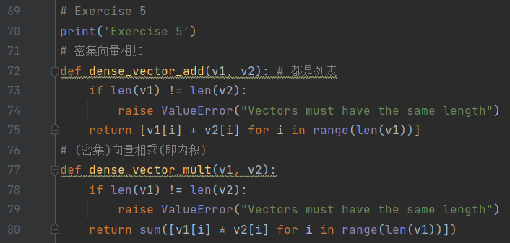
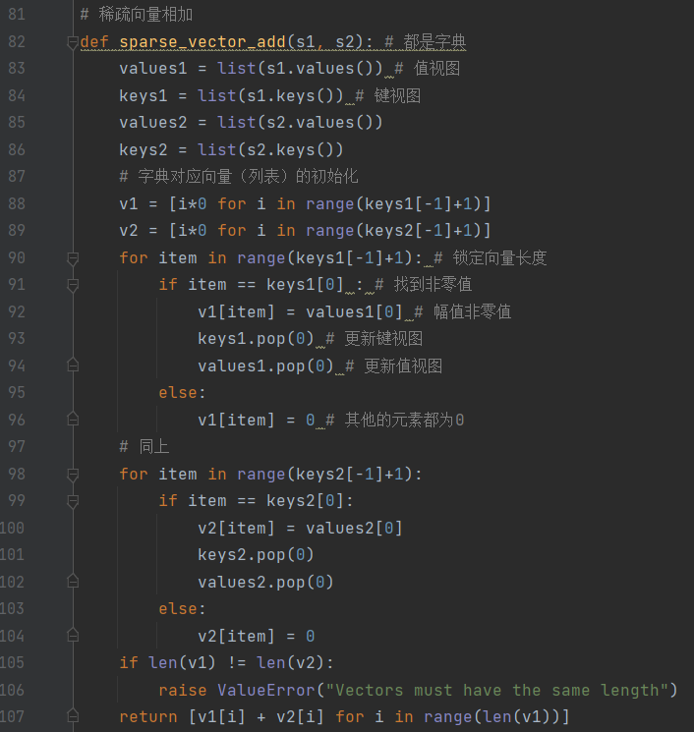
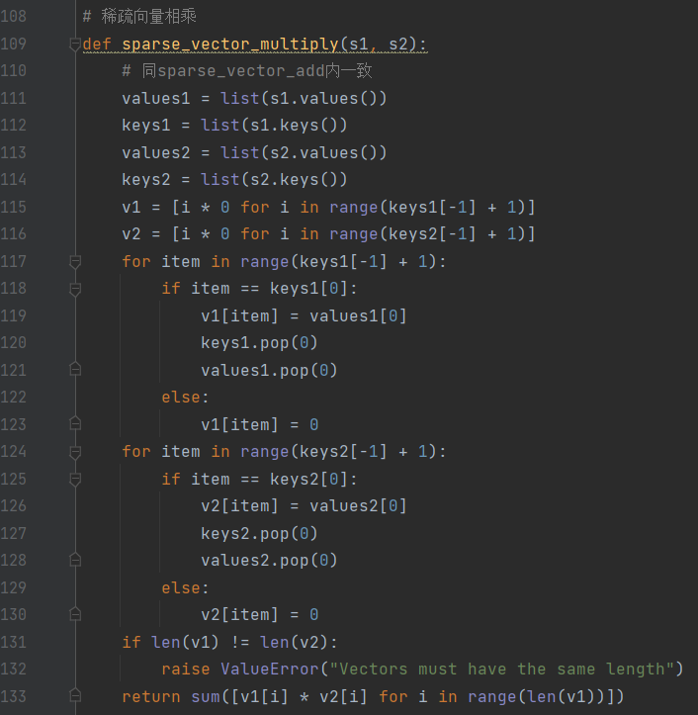
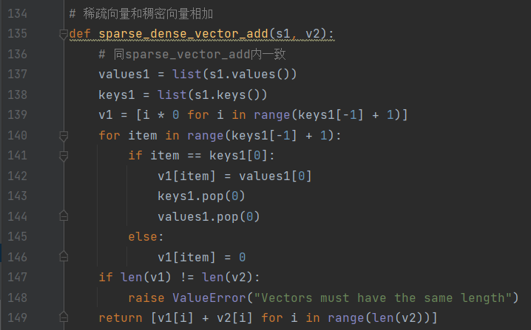
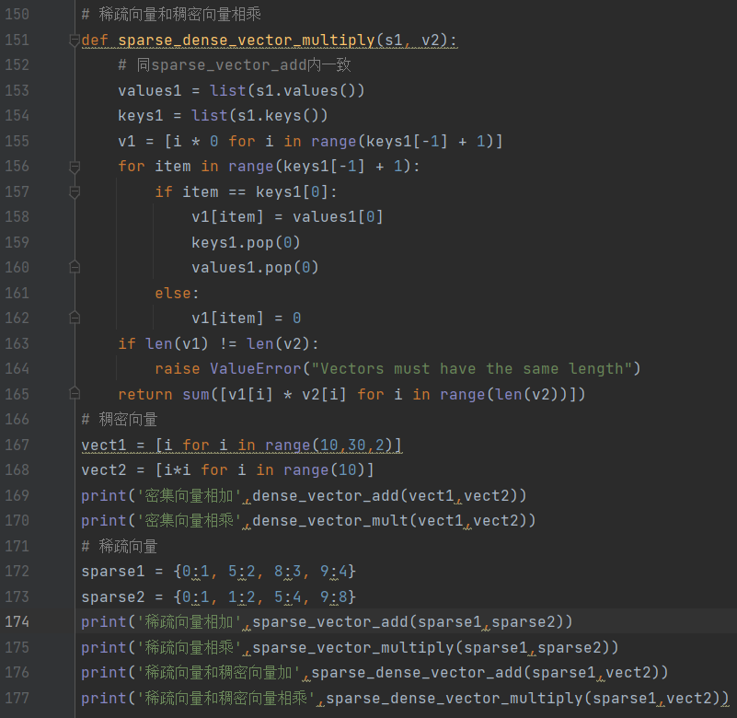

- 运行结果
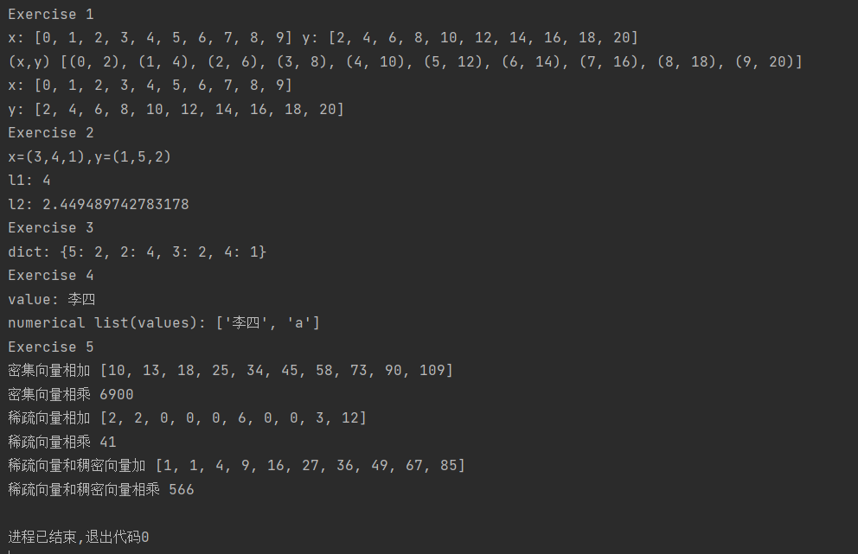
指导教师批阅意见：
- 实验报告的完整性：
□实验报告完整
□实验报告不够完整
□实验报告缺少内容
- 实验结果的正确性
□实验结果正确无误，
□有小的逻辑错误
□代码有很大错误
- 代码的简洁和效率
□代码简洁优雅，可读性好，能高效运行
□代码具有较好的可读性，但执行效率可进一步优化
□代码可读性不佳，执行效率较好
□代码混乱，效率不佳
成绩评定：

指导教师签字：

2022年 0x 月 xx 日
备注：

