深 圳 大 学 实 验 报 告

课程名称： 深度学习

实验项目名称： DL2024-作业二

学院： 医学部

专业： 生物医学工程

指导教师： 黄若冰

报告人： 陈嘉鸿 学号：2021220049 班级： 创新班

实验时间： 2024.5.8

实验报告提交时间： 2024.5.8

教务处制
一、实验目的：
1、评估神经网络模型在处理脑肿瘤MRI数据集时的性能表现：通过使用预处理技术和适当的模型选择，评估模型在分类脑肿瘤MRI图像时的准确度、精确度、召回率、灵敏度和F1分数等性能指标。

2、比较不同模型选择、优化器以及其他参数对性能的影响：通过实验比较不同模型

3、在处理脑肿瘤MRI数据集时的性能差异，进一步了解模型和参数选择对性能的影响

4、探究如何获得更平衡的性能：通过对比实验结果，讨论不同类别之间的性能差异

5、探讨如何通过调整模型、优化器或数据处理技术来获得更平衡的性能，尤其是在处理样本不平衡的情况下。

二、实验内容：
1.Download the Brain Tumor MRI datasets (4 categories).
2.Perform suitable pre-processing, explain your reasons.
3.Build you own mode or select an established one: train, valid and test using this dataset.
4.Report test accuracy, precision, recall, sensitivity and f1 score of each category, respectively. Discuss the difference between the performance of different classes and explain what you should do to obtain a balanced performance.
5.Perform comparison experiments, report your findings and explain the reasons(>100 words each).In specific, compare different:
(Choose at least 1 from) Model choice /Augmentation/Dropout factor/Loss function/Optimizer/whatever you think worth discussing
附加题：
课堂所学的Transformer系列模型在该数据上表现如何？分析结果并阐释对你的启发。
- 实验步骤：
- 下载脑肿瘤MRI数据集(4类)，并进行数据集划分
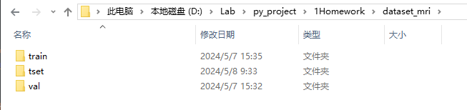
- 数据预处理
训练集数据增强：
transforms.RandomResizedCrop(224): 随机裁剪并调整图像大小为 224x224 像素。这个步骤可以增加模型对图像中不同目标的位置和大小的适应能力。
transforms.RandomHorizontalFlip(): 随机水平翻转图像。这个操作可以增加训练集的多样性，提高模型的泛化能力。
transforms.ToTensor(): 将图像转换为 PyTorch 张量。PyTorch 中的大多数操作都需要输入为张量形式。
transforms.Normalize([0.485, 0.456, 0.406], [0.229, 0.224, 0.225]): 对图像进行标准化处理。这个操作将图像像素值缩放到特定的范围，以便更好地训练模型。这里使用了 ImageNet 数据集的均值和标准差。
验证集数据预处理：
transforms.Resize(256): 调整图像大小为 256x256 像素。这个步骤保证了输入图像的大小符合模型的输入要求。
transforms.CenterCrop(224): 对图像进行中心裁剪，将图像裁剪为 224x224 像素的大小，以保留图像的中心区域。
transforms.ToTensor(): 将图像转换为 PyTorch 张量。
transforms.Normalize([0.485, 0.456, 0.406], [0.229, 0.224, 0.225]): 对图像进行标准化处理，使用了相同的均值和标准差。
- # 数据预处理（数据增强）
- data_transform = {
- "train": transforms.Compose([transforms.RandomResizedCrop(224),
- transforms.RandomHorizontalFlip(),
- transforms.ToTensor(),
- transforms.Normalize([0.485, 0.456, 0.406], [0.229, 0.224, 0.225])]),
- "val": transforms.Compose([transforms.Resize(256),
- transforms.CenterCrop(224),
- transforms.ToTensor(),
- transforms.Normalize([0.485, 0.456, 0.406], [0.229, 0.224, 0.225])])}

- 构建ResNet模型（34和101，最终使用34）
手动构建ResNet集成式模型，通过改动参数，可以变更resnet-34或resnet-101模型，我都进行了构建。因为本次实验数据集较小，我最终使用的是resnet-34。
BasicBlock 类：
expansion: 残差结构中，主分支的卷积核个数是否发生变化，不变则为 1。
__init__ 方法：初始化函数，定义了 BasicBlock 中的卷积层和批归一化层，以及虚线残差结构中的下采样操作。
forward 方法：前向传播函数，实现了 BasicBlock 的计算过程，包括卷积、批归一化、ReLU 激活函数和短路连接。
Bottleneck 类：
expansion: 残差结构中第三层卷积核个数是第一/二层卷积核个数的 4 倍。
__init__ 方法：初始化函数，定义了 Bottleneck 中的 1x1、3x3 和 1x1 的卷积层和批归一化层，以及虚线残差结构中的下采样操作。
forward 方法：前向传播函数，实现了 Bottleneck 的计算过程，包括卷积、批归一化、ReLU 激活函数和短路连接。
ResNet 类：
__init__ 方法：初始化函数，定义了 ResNet 网络的整体结构，包括卷积层、批归一化层、ReLU 激活函数、最大池化层和四个残差层。
_make_layer 方法：创建一个残差层，根据传入的残差结构类型（BasicBlock 或 Bottleneck）和参数，构建对应的残差块。
forward 方法：前向传播函数，实现了 ResNet 网络的计算过程，包括卷积、批归一化、ReLU 激活函数、最大池化和四个残差层的堆叠。
resnet34 和 resnet101 函数：
分别用于创建 ResNet34 和 ResNet101 模型实例，提供了设置类别数和是否包含顶层全连接层的选项。
- import torch.nn as nn
- import torch

- # ResNet18/34的残差结构，用的是2个3x3的卷积
- class BasicBlock(nn.Module):
- expansion = 1 # 残差结构中，主分支的卷积核个数是否发生变化，不变则为1

- def __init__(self, in_channel, out_channel, stride=1, downsample=None): # downsample对应虚线残差结构
- super(BasicBlock, self).__init__()
- self.conv1 = nn.Conv2d(in_channels=in_channel, out_channels=out_channel,
- kernel_size=3, stride=stride, padding=1, bias=False)
- self.bn1 = nn.BatchNorm2d(out_channel)
- self.relu = nn.ReLU()
- self.conv2 = nn.Conv2d(in_channels=out_channel, out_channels=out_channel,
- kernel_size=3, stride=1, padding=1, bias=False)
- self.bn2 = nn.BatchNorm2d(out_channel)
- self.downsample = downsample

- def forward(self, x):
- identity = x
- if self.downsample is not None: # 虚线残差结构，需要下采样
- identity = self.downsample(x) # 捷径分支 short cut

- out = self.conv1(x)
- out = self.bn1(out)
- out = self.relu(out)

- out = self.conv2(out)
- out = self.bn2(out)

- out += identity
- out = self.relu(out)

- return out

- # ResNet50/101/152的残差结构，用的是1x1+3x3+1x1的卷积
- class Bottleneck(nn.Module):
- expansion = 4 # 残差结构中第三层卷积核个数是第一/二层卷积核个数的4倍

- def __init__(self, in_channel, out_channel, stride=1, downsample=None):
- super(Bottleneck, self).__init__()
- self.conv1 = nn.Conv2d(in_channels=in_channel, out_channels=out_channel,
- kernel_size=1, stride=1, bias=False) # squeeze channels
- self.bn1 = nn.BatchNorm2d(out_channel)
- # -----------------------------------------
- self.conv2 = nn.Conv2d(in_channels=out_channel, out_channels=out_channel,
- kernel_size=3, stride=stride, bias=False, padding=1)
- self.bn2 = nn.BatchNorm2d(out_channel)
- # -----------------------------------------
- self.conv3 = nn.Conv2d(in_channels=out_channel, out_channels=out_channel * self.expansion,
- kernel_size=1, stride=1, bias=False) # unsqueeze channels
- self.bn3 = nn.BatchNorm2d(out_channel * self.expansion)
- self.relu = nn.ReLU(inplace=True)
- self.downsample = downsample

- def forward(self, x):
- identity = x
- if self.downsample is not None:
- identity = self.downsample(x) # 捷径分支 short cut

- out = self.conv1(x)
- out = self.bn1(out)
- out = self.relu(out)

- out = self.conv2(out)
- out = self.bn2(out)
- out = self.relu(out)

- out = self.conv3(out)
- out = self.bn3(out)

- out += identity
- out = self.relu(out)

- return out

- class ResNet(nn.Module):
- # block = BasicBlock or Bottleneck
- # block_num为残差结构中conv2_x~conv5_x中残差块个数，是一个列表
- def __init__(self, block, blocks_num, num_classes=1000, include_top=True):
- '''

- :param block: 残差结构
- :param blocks_num:
- :param num_classes:
- :param include_top:
- '''
- super(ResNet, self).__init__()
- self.include_top = include_top
- self.in_channel = 64

- self.conv1 = nn.Conv2d(3, self.in_channel, kernel_size=7, stride=2,
- padding=3, bias=False)
- self.bn1 = nn.BatchNorm2d(self.in_channel)
- self.relu = nn.ReLU(inplace=True)
- self.maxpool = nn.MaxPool2d(kernel_size=3, stride=2, padding=1)
- self.layer1 = self._make_layer(block, 64, blocks_num[0]) # conv2_x
- self.layer2 = self._make_layer(block, 128, blocks_num[1], stride=2) # conv3_x
- self.layer3 = self._make_layer(block, 256, blocks_num[2], stride=2) # conv4_x
- self.layer4 = self._make_layer(block, 512, blocks_num[3], stride=2) # conv5_x
- if self.include_top:
- self.avgpool = nn.AdaptiveAvgPool2d((1, 1)) # output size = (1, 1)
- self.fc = nn.Linear(512 * block.expansion, num_classes)

- for m in self.modules():
- if isinstance(m, nn.Conv2d):
- nn.init.kaiming_normal_(m.weight, mode='fan_out', nonlinearity='relu')

- # channel为残差结构中第一层卷积核个数
- def _make_layer(self, block, channel, block_num, stride=1):
- '''
- :param block: 残差结构
- :param channel: 卷积核个数
- :param block_num: 不同残差结构的数目（数组）
- :param stride:
- :return:
- '''
- downsample = None

- # ResNet50/101/152的残差结构，block.expansion=4
- if stride != 1 or self.in_channel != channel * block.expansion:
- downsample = nn.Sequential(
- nn.Conv2d(self.in_channel, channel * block.expansion, kernel_size=1, stride=stride, bias=False),
- nn.BatchNorm2d(channel * block.expansion))

- layers = []
- layers.append(block(self.in_channel, channel, downsample=downsample, stride=stride))
- self.in_channel = channel * block.expansion

- for _ in range(1, block_num):
- layers.append(block(self.in_channel, channel))

- return nn.Sequential(*layers)

- def forward(self, x):
- x = self.conv1(x)
- x = self.bn1(x)
- x = self.relu(x)
- x = self.maxpool(x)

- x = self.layer1(x)
- x = self.layer2(x)
- x = self.layer3(x)
- x = self.layer4(x)

- if self.include_top:
- x = self.avgpool(x)
- x = torch.flatten(x, 1)
- x = self.fc(x)

- return x

- def resnet34(num_classes=1000, include_top=True):
- return ResNet(BasicBlock, [3, 4, 6, 3], num_classes=num_classes, include_top=include_top)

- def resnet101(num_classes=1000, include_top=True):
- return ResNet(Bottleneck, [3, 4, 23, 3], num_classes=num_classes, include_top=include_top)

- 模型训练并实时进行验证（迁移学习）
定义数据预处理：定义了训练和验证数据的预处理操作，包括随机裁剪、随机水平翻转和归一化。
准备数据集：使用 datasets.ImageFolder 类加载图像数据集，并将其分为训练集和验证集。同时创建了数据加载器 train_loader 和 validate_loader。
创建 ResNet 模型：调用之前定义的 resnet34 函数创建 ResNet34 模型实例。
加载预训练权重：从预定义的 URL 中下载 ResNet34 的预训练权重，并加载到模型中。由于要适应新的分类任务（4 类），因此需要修改全连接层的结构。
修改全连接层：获取模型的输入通道数，并将全连接层的输出节点数修改为 4，以适应新的分类任务。
定义损失函数和优化器：选择交叉熵损失函数和 Adam 优化器。
训练模型：迭代训练模型，共进行 20 个 epoch。在每个 epoch 中，分别对训练集进行前向传播和反向传播，计算损失并更新模型参数。然后在验证集上评估模型性能，并记录最佳准确率及其对应的模型参数。
保存模型：在训练过程中，如果验证集上的准确率提升，则保存对应的模型参数。
完成训练：训练完成后输出相应的提示信息。
- # 预训练的模型参数
- model_urls = {
- 'resnet18': 'https://download.pytorch.org/models/resnet18-5c106cde.pth',
- 'resnet34': 'https://download.pytorch.org/models/resnet34-333f7ec4.pth',
- 'resnet50': 'https://download.pytorch.org/models/resnet50-19c8e357.pth',
- 'resnet101': 'https://download.pytorch.org/models/resnet101-5d3b4d8f.pth',
- 'resnet152': 'https://download.pytorch.org/models/resnet152-b121ed2d.pth',
- 'resnext50_32x4d': 'https://download.pytorch.org/models/resnext50_32x4d-7cdf4587.pth',
- 'resnext101_32x8d': 'https://download.pytorch.org/models/resnext101_32x8d-8ba56ff5.pth',
- 'wide_resnet50_2': 'https://download.pytorch.org/models/wide_resnet50_2-95faca4d.pth',
- 'wide_resnet101_2': 'https://download.pytorch.org/models/wide_resnet101_2-32ee1156.pth',
- }
- import torch
- import torch.nn as nn
- from torchvision import transforms, datasets
- import json
- import matplotlib.pyplot as plt
- import os
- import torch.optim as optim
- from model import resnet34, resnet101
- import torchvision.models.resnet

- # 检测是否有可用的GPU
- device = torch.device("cuda:0" if torch.cuda.is_available() else "cpu")
- print("using device GPU {} .".format(device))

- # 数据预处理（数据增强）
- data_transform = {
- "train": transforms.Compose([transforms.RandomResizedCrop(224),
- transforms.RandomHorizontalFlip(),
- transforms.ToTensor(),
- transforms.Normalize([0.485, 0.456, 0.406], [0.229, 0.224, 0.225])]),
- "val": transforms.Compose([transforms.Resize(256),
- transforms.CenterCrop(224),
- transforms.ToTensor(),
- transforms.Normalize([0.485, 0.456, 0.406], [0.229, 0.224, 0.225])])}

- # 获取图像数据集的路径
- data_root = os.path.abspath(os.getcwd()) # get data root path 返回本层目录
- image_path = data_root + "/dataset_mri/"

- # 创建训练集的数据加载器
- train_dataset = datasets.ImageFolder(root=image_path+"train",
- transform=data_transform["train"])
- train_num = len(train_dataset)

- dataset_list = train_dataset.class_to_idx
- cla_dict = dict((val, key) for key, val in dataset_list.items())

- # 将类别索引写入json文件
- json_str = json.dumps(cla_dict, indent=4)
- with open('class_indices34_mri.json', 'w') as json_file:
- json_file.write(json_str)

- batch_size = 16 # batch_size设为16
- train_loader = torch.utils.data.DataLoader(train_dataset,
- batch_size=batch_size, shuffle=True,
- num_workers=0)
- # 同理创建验证集的数据加载器
- validate_dataset = datasets.ImageFolder(root=image_path + "val",
- transform=data_transform["val"])
- val_num = len(validate_dataset)
- validate_loader = torch.utils.data.DataLoader(validate_dataset,
- batch_size=batch_size, shuffle=False,
- num_workers=0)
- # 创建ResNet模型
- net = resnet34()
- # 加载预训练权重
- model_weight_path = "./resnet34-pre.pth"
- missing_keys, unexpected_keys = net.load_state_dict(torch.load(model_weight_path), strict=False)

- # 修改全连接层的结构，适应新的分类任务（4类）
- inchannel = net.fc.in_features
- net.fc = nn.Linear(inchannel, 4)
- net.to(device)

- # 定义损失函数和优化器
- loss_function = nn.CrossEntropyLoss()
- optimizer = optim.Adam(net.parameters(), lr=0.0001)

- best_acc = 0.0
- save_path = './resNet34_mri_epoch20.pth'
- for epoch in range(20):
- # train
- net.train()
- running_loss = 0.0
- for step, data in enumerate(train_loader, start=0):
- images, labels = data
- optimizer.zero_grad()
- logits = net(images.to(device))
- loss = loss_function(logits, labels.to(device))
- loss.backward()
- optimizer.step()

- # print statistics
- running_loss += loss.item()
- # print train process
- rate = (step+1)/len(train_loader)
- a = "*" * int(rate * 50)
- b = "." * int((1 - rate) * 50)
- print("\rtrain loss: {:^3.0f}%[{}->{}]{:.4f}".format(int(rate*100), a, b, loss), end="")
- print()

- # validate
- net.eval()
- acc = 0.0 # accumulate accurate number / epoch
- with torch.no_grad():
- for val_data in validate_loader:
- val_images, val_labels = val_data
- outputs = net(val_images.to(device)) # eval model only have last output layer
- # loss = loss_function(outputs, test_labels)
- predict_y = torch.max(outputs, dim=1)[1]
- acc += (predict_y == val_labels.to(device)).sum().item()
- val_accurate = acc / val_num
- if val_accurate > best_acc:
- best_acc = val_accurate
- torch.save(net.state_dict(), save_path)
- print('[epoch %d] train_loss: %.3f test_accuracy: %.3f' %
- (epoch + 1, running_loss / step, val_accurate))

- print('Finished Training')
训练过程：
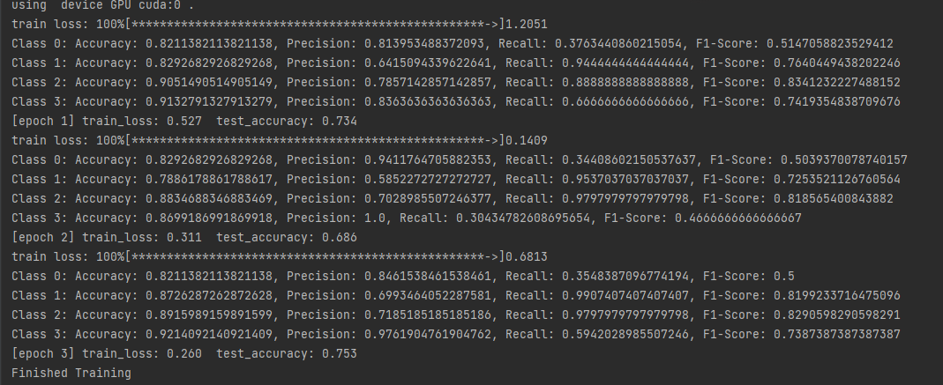
- 模型性能测试
报告每个类别的测试准确率、精密度、召回率、灵敏度和f1分数
- # 计算混淆矩阵
- cm = confusion_matrix(all_labels, all_preds)
- val_precision = precision_score(all_labels, all_preds, average=None)
- val_recall = recall_score(all_labels, all_preds, average=None)
- val_f1 = f1_score(all_labels, all_preds, average=None)

- # Append metrics to the dictionary
- for i in range(len(val_precision)):
- TP = cm[i][i]
- TN = np.sum(np.delete(np.delete(cm, i, 0), i, 1))
- FP = np.sum(cm[:, i]) - TP
- FN = np.sum(cm[i, :]) - TP
- acc = (TP + TN) / (TP + TN + FP + FN)
- class_metrics['accuracy'][i].append(acc)
- class_metrics['precision'][i].append(val_precision[i])
- class_metrics['recall'][i].append(val_recall[i])
- class_metrics['f1_score'][i].append(val_f1[i])
- print(f"Class {i}: Epoch {epoch + 1} - Accuracy: {acc}, Precision: {val_precision[i]}, Recall: {val_recall[i]}, F1-Score: {val_f1[i]}")
- 结果可视化：
读取测试时生成的json文件，通过可视化更清晰地查看模型训练过程、模型性能和不同类别之间模型训练的差异
- import json
- import matplotlib.pyplot as plt

- # 读取class_metrics.json文件
- with open('class_metrics_sgd.json', 'r') as f:
- class_metrics = json.load(f)

- # 定义类别和指标
- classes = ['glioma_tumor', 'meningioma_tumor', 'no_tumor', 'pituitary_tumor']
- metrics = ['accuracy', 'precision', 'recall', 'f1_score']

- # 绘制不同指标上，横坐标为epoch，纵坐标为不同类别的指标
- for metric in metrics:
- plt.figure()
- plt.title(f'{metric.capitalize()} vs Epoch for Different Classes')
- plt.xlabel('Epoch')
- plt.ylabel(f'{metric.capitalize()}')
- for i, cls in enumerate(classes):
- plt.plot(range(1, len(class_metrics[metric][i])+1), class_metrics[metric][i], label=cls)
- plt.legend()
- plt.show()

- # 绘制不同类别上，横坐标为epoch，纵坐标为各的指标数值
- for i, cls in enumerate(classes):
- plt.figure()
- plt.title(f'Metrics vs Epoch for {cls}')
- plt.xlabel('Epoch')
- plt.ylabel('Value')
- for metric in metrics:
- plt.plot(range(1, len(class_metrics[metric][i])+1), class_metrics[metric][i], label=metric.capitalize())
- plt.legend()
- plt.show()

- 对比实验，
使用不同模型：
使用ResNet34、ResNet101、Swin-transformer不同模型进行比较：
- def resnet34(num_classes=1000, include_top=True):
- return ResNet(BasicBlock, [3, 4, 6, 3], num_classes=num_classes, include_top=include_top)

- def resnet101(num_classes=1000, include_top=True):
- return ResNet(Bottleneck, [3, 4, 23, 3], num_classes=num_classes, include_top=include_top)

- def swin_tiny_patch4_window7_224(num_classes: int = 1000, **kwargs):
- model = SwinTransformer(in_chans=3,
- patch_size=4,
- window_size=7,
- embed_dim=96,
- depths=(2, 2, 6, 2),
- num_heads=(3, 6, 12, 24),
- num_classes=num_classes,
- **kwargs)
- return model
对ResNet34使用不同优化器SGD和Adam进行比较：
- optimizer = optim.Adam(net.parameters(), lr=0.0001)
- optimizer = optim.SGD(net.parameters(), lr=0.0001, momentum=0.9)

7.附加：为了观察Transformer系列模型在该数据上表现如何，我使用Swin-transformer模型训练并进行模型性能测试
因为想要充分体现Transformer对于实验数据集的训练表现，对于Transformer模型的训练我是从头开始训练，并没有进行迁移学习
（这里就不展示训练过程，只展示构建的模型）
- import torch
- import torch.nn as nn
- import torch.nn.functional as F
- import torch.utils.checkpoint as checkpoint
- import numpy as np
- from typing import Optional

- def drop_path_f(x, drop_prob: float = 0., training: bool = False):
- """Drop paths (Stochastic Depth) per sample (when applied in main path of residual blocks).

- This is the same as the DropConnect impl I created for EfficientNet, etc networks, however,
- the original name is misleading as 'Drop Connect' is a different form of dropout in a separate paper...
- See discussion: https://github.com/tensorflow/tpu/issues/494#issuecomment-532968956 ... I've opted for
- changing the layer and argument names to 'drop path' rather than mix DropConnect as a layer name and use
- 'survival rate' as the argument.

- """
- if drop_prob == 0. or not training:
- return x
- keep_prob = 1 - drop_prob
- shape = (x.shape[0],) + (1,) * (x.ndim - 1) # work with diff dim tensors, not just 2D ConvNets
- random_tensor = keep_prob + torch.rand(shape, dtype=x.dtype, device=x.device)
- random_tensor.floor_() # binarize
- output = x.div(keep_prob) * random_tensor
- return output

- class DropPath(nn.Module):
- """Drop paths (Stochastic Depth) per sample (when applied in main path of residual blocks).
- """
- def __init__(self, drop_prob=None):
- super(DropPath, self).__init__()
- self.drop_prob = drop_prob

- def forward(self, x):
- return drop_path_f(x, self.drop_prob, self.training)

- def window_partition(x, window_size: int):
- """
- 将feature map按照window_size划分成一个个没有重叠的window
- Args:
- x: (B, H, W, C)
- window_size (int): window size(M)

- Returns:
- windows: (num_windows*B, window_size, window_size, C)
- """
- B, H, W, C = x.shape
- x = x.view(B, H // window_size, window_size, W // window_size, window_size, C)
- # permute: [B, H//Mh, Mh, W//Mw, Mw, C] -> [B, H//Mh, W//Mh, Mw, Mw, C]
- # view: [B, H//Mh, W//Mw, Mh, Mw, C] -> [B*num_windows, Mh, Mw, C]
- windows = x.permute(0, 1, 3, 2, 4, 5).contiguous().view(-1, window_size, window_size, C)
- return windows

- def window_reverse(windows, window_size: int, H: int, W: int):
- """
- 将一个个window还原成一个feature map
- Args:
- windows: (num_windows*B, window_size, window_size, C)
- window_size (int): Window size(M)
- H (int): Height of image
- W (int): Width of image

- Returns:
- x: (B, H, W, C)
- """
- B = int(windows.shape[0] / (H * W / window_size / window_size))
- # view: [B*num_windows, Mh, Mw, C] -> [B, H//Mh, W//Mw, Mh, Mw, C]
- x = windows.view(B, H // window_size, W // window_size, window_size, window_size, -1)
- # permute: [B, H//Mh, W//Mw, Mh, Mw, C] -> [B, H//Mh, Mh, W//Mw, Mw, C]
- # view: [B, H//Mh, Mh, W//Mw, Mw, C] -> [B, H, W, C]
- x = x.permute(0, 1, 3, 2, 4, 5).contiguous().view(B, H, W, -1)
- return x

- class PatchEmbed(nn.Module):
- """
- 2D Image to Patch Embedding
- """
- def __init__(self, patch_size=4, in_c=3, embed_dim=96, norm_layer=None):
- super().__init__()
- patch_size = (patch_size, patch_size)
- self.patch_size = patch_size
- self.in_chans = in_c
- self.embed_dim = embed_dim
- self.proj = nn.Conv2d(in_c, embed_dim, kernel_size=patch_size, stride=patch_size)
- self.norm = norm_layer(embed_dim) if norm_layer else nn.Identity()

- def forward(self, x):
- _, _, H, W = x.shape

- # padding
- # 如果输入图片的H，W不是patch_size的整数倍，需要进行padding
- pad_input = (H % self.patch_size[0] != 0) or (W % self.patch_size[1] != 0)
- if pad_input:
- # to pad the last 3 dimensions,
- # (W_left, W_right, H_top,H_bottom, C_front, C_back)
- x = F.pad(x, (0, self.patch_size[1] - W % self.patch_size[1],
- 0, self.patch_size[0] - H % self.patch_size[0],
- 0, 0))

- # 下采样patch_size倍
- x = self.proj(x)
- _, _, H, W = x.shape
- # flatten: [B, C, H, W] -> [B, C, HW]
- # transpose: [B, C, HW] -> [B, HW, C]
- x = x.flatten(2).transpose(1, 2)
- x = self.norm(x)
- return x, H, W

- class PatchMerging(nn.Module):
- r""" Patch Merging Layer.

- Args:
- dim (int): Number of input channels.
- norm_layer (nn.Module, optional): Normalization layer. Default: nn.LayerNorm
- """

- def __init__(self, dim, norm_layer=nn.LayerNorm):
- super().__init__()
- self.dim = dim
- self.reduction = nn.Linear(4 * dim, 2 * dim, bias=False)
- self.norm = norm_layer(4 * dim)

- def forward(self, x, H, W):
- """
- x: B, H*W, C
- """
- B, L, C = x.shape
- assert L == H * W, "input feature has wrong size"

- x = x.view(B, H, W, C)

- # padding
- # 如果输入feature map的H，W不是2的整数倍，需要进行padding
- pad_input = (H % 2 == 1) or (W % 2 == 1)
- if pad_input:
- # to pad the last 3 dimensions, starting from the last dimension and moving forward.
- # (C_front, C_back, W_left, W_right, H_top, H_bottom)
- # 注意这里的Tensor通道是[B, H, W, C]，所以会和官方文档有些不同
- x = F.pad(x, (0, 0, 0, W % 2, 0, H % 2))

- x0 = x[:, 0::2, 0::2, :] # [B, H/2, W/2, C]
- x1 = x[:, 1::2, 0::2, :] # [B, H/2, W/2, C]
- x2 = x[:, 0::2, 1::2, :] # [B, H/2, W/2, C]
- x3 = x[:, 1::2, 1::2, :] # [B, H/2, W/2, C]
- x = torch.cat([x0, x1, x2, x3], -1) # [B, H/2, W/2, 4*C]
- x = x.view(B, -1, 4 * C) # [B, H/2*W/2, 4*C]

- x = self.norm(x)
- x = self.reduction(x) # [B, H/2*W/2, 2*C]

- return x

- class Mlp(nn.Module):
- """ MLP as used in Vision Transformer, MLP-Mixer and related networks
- """
- def __init__(self, in_features, hidden_features=None, out_features=None, act_layer=nn.GELU, drop=0.):
- super().__init__()
- out_features = out_features or in_features
- hidden_features = hidden_features or in_features

- self.fc1 = nn.Linear(in_features, hidden_features)
- self.act = act_layer()
- self.drop1 = nn.Dropout(drop)
- self.fc2 = nn.Linear(hidden_features, out_features)
- self.drop2 = nn.Dropout(drop)

- def forward(self, x):
- x = self.fc1(x)
- x = self.act(x)
- x = self.drop1(x)
- x = self.fc2(x)
- x = self.drop2(x)
- return x

- class WindowAttention(nn.Module):
- r""" Window based multi-head self attention (W-MSA) module with relative position bias.
- It supports both of shifted and non-shifted window.

- Args:
- dim (int): Number of input channels.
- window_size (tuple[int]): The height and width of the window.
- num_heads (int): Number of attention heads.
- qkv_bias (bool, optional): If True, add a learnable bias to query, key, value. Default: True
- attn_drop (float, optional): Dropout ratio of attention weight. Default: 0.0
- proj_drop (float, optional): Dropout ratio of output. Default: 0.0
- """

- def __init__(self, dim, window_size, num_heads, qkv_bias=True, attn_drop=0., proj_drop=0.):

- super().__init__()
- self.dim = dim
- self.window_size = window_size # [Mh, Mw]
- self.num_heads = num_heads
- head_dim = dim // num_heads
- self.scale = head_dim ** -0.5

- # define a parameter table of relative position bias
- self.relative_position_bias_table = nn.Parameter(
- torch.zeros((2 * window_size[0] - 1) * (2 * window_size[1] - 1), num_heads)) # [2*Mh-1 * 2*Mw-1, nH]

- # get pair-wise relative position index for each token inside the window
- coords_h = torch.arange(self.window_size[0])
- coords_w = torch.arange(self.window_size[1])
- coords = torch.stack(torch.meshgrid([coords_h, coords_w], indexing="ij")) # [2, Mh, Mw]
- coords_flatten = torch.flatten(coords, 1) # [2, Mh*Mw]
- # [2, Mh*Mw, 1] - [2, 1, Mh*Mw]
- relative_coords = coords_flatten[:, :, None] - coords_flatten[:, None, :] # [2, Mh*Mw, Mh*Mw]
- relative_coords = relative_coords.permute(1, 2, 0).contiguous() # [Mh*Mw, Mh*Mw, 2]
- relative_coords[:, :, 0] += self.window_size[0] - 1 # shift to start from 0
- relative_coords[:, :, 1] += self.window_size[1] - 1
- relative_coords[:, :, 0] *= 2 * self.window_size[1] - 1
- relative_position_index = relative_coords.sum(-1) # [Mh*Mw, Mh*Mw]
- self.register_buffer("relative_position_index", relative_position_index)

- self.qkv = nn.Linear(dim, dim * 3, bias=qkv_bias)
- self.attn_drop = nn.Dropout(attn_drop)
- self.proj = nn.Linear(dim, dim)
- self.proj_drop = nn.Dropout(proj_drop)

- nn.init.trunc_normal_(self.relative_position_bias_table, std=.02)
- self.softmax = nn.Softmax(dim=-1)

- def forward(self, x, mask: Optional[torch.Tensor] = None):
- """
- Args:
- x: input features with shape of (num_windows*B, Mh*Mw, C)
- mask: (0/-inf) mask with shape of (num_windows, Wh*Ww, Wh*Ww) or None
- """
- # [batch_size*num_windows, Mh*Mw, total_embed_dim]
- B_, N, C = x.shape
- # qkv(): -> [batch_size*num_windows, Mh*Mw, 3 * total_embed_dim]
- # reshape: -> [batch_size*num_windows, Mh*Mw, 3, num_heads, embed_dim_per_head]
- # permute: -> [3, batch_size*num_windows, num_heads, Mh*Mw, embed_dim_per_head]
- qkv = self.qkv(x).reshape(B_, N, 3, self.num_heads, C // self.num_heads).permute(2, 0, 3, 1, 4)
- # [batch_size*num_windows, num_heads, Mh*Mw, embed_dim_per_head]
- q, k, v = qkv.unbind(0) # make torchscript happy (cannot use tensor as tuple)

- # transpose: -> [batch_size*num_windows, num_heads, embed_dim_per_head, Mh*Mw]
- # @: multiply -> [batch_size*num_windows, num_heads, Mh*Mw, Mh*Mw]
- q = q * self.scale
- attn = (q @ k.transpose(-2, -1))

- # relative_position_bias_table.view: [Mh*Mw*Mh*Mw,nH] -> [Mh*Mw,Mh*Mw,nH]
- relative_position_bias = self.relative_position_bias_table[self.relative_position_index.view(-1)].view(
- self.window_size[0] * self.window_size[1], self.window_size[0] * self.window_size[1], -1)
- relative_position_bias = relative_position_bias.permute(2, 0, 1).contiguous() # [nH, Mh*Mw, Mh*Mw]
- attn = attn + relative_position_bias.unsqueeze(0)

- if mask is not None:
- # mask: [nW, Mh*Mw, Mh*Mw]
- nW = mask.shape[0] # num_windows
- # attn.view: [batch_size, num_windows, num_heads, Mh*Mw, Mh*Mw]
- # mask.unsqueeze: [1, nW, 1, Mh*Mw, Mh*Mw]
- attn = attn.view(B_ // nW, nW, self.num_heads, N, N) + mask.unsqueeze(1).unsqueeze(0)
- attn = attn.view(-1, self.num_heads, N, N)
- attn = self.softmax(attn)
- else:
- attn = self.softmax(attn)

- attn = self.attn_drop(attn)

- # @: multiply -> [batch_size*num_windows, num_heads, Mh*Mw, embed_dim_per_head]
- # transpose: -> [batch_size*num_windows, Mh*Mw, num_heads, embed_dim_per_head]
- # reshape: -> [batch_size*num_windows, Mh*Mw, total_embed_dim]
- x = (attn @ v).transpose(1, 2).reshape(B_, N, C)
- x = self.proj(x)
- x = self.proj_drop(x)
- return x

- class SwinTransformerBlock(nn.Module):
- r""" Swin Transformer Block.

- Args:
- dim (int): Number of input channels.
- num_heads (int): Number of attention heads.
- window_size (int): Window size.
- shift_size (int): Shift size for SW-MSA.
- mlp_ratio (float): Ratio of mlp hidden dim to embedding dim.
- qkv_bias (bool, optional): If True, add a learnable bias to query, key, value. Default: True
- drop (float, optional): Dropout rate. Default: 0.0
- attn_drop (float, optional): Attention dropout rate. Default: 0.0
- drop_path (float, optional): Stochastic depth rate. Default: 0.0
- act_layer (nn.Module, optional): Activation layer. Default: nn.GELU
- norm_layer (nn.Module, optional): Normalization layer. Default: nn.LayerNorm
- """

- def __init__(self, dim, num_heads, window_size=7, shift_size=0,
- mlp_ratio=4., qkv_bias=True, drop=0., attn_drop=0., drop_path=0.,
- act_layer=nn.GELU, norm_layer=nn.LayerNorm):
- super().__init__()
- self.dim = dim
- self.num_heads = num_heads
- self.window_size = window_size
- self.shift_size = shift_size
- self.mlp_ratio = mlp_ratio
- assert 0 <= self.shift_size < self.window_size, "shift_size must in 0-window_size"

- self.norm1 = norm_layer(dim)
- self.attn = WindowAttention(
- dim, window_size=(self.window_size, self.window_size), num_heads=num_heads, qkv_bias=qkv_bias,
- attn_drop=attn_drop, proj_drop=drop)

- self.drop_path = DropPath(drop_path) if drop_path > 0. else nn.Identity()
- self.norm2 = norm_layer(dim)
- mlp_hidden_dim = int(dim * mlp_ratio)
- self.mlp = Mlp(in_features=dim, hidden_features=mlp_hidden_dim, act_layer=act_layer, drop=drop)

- def forward(self, x, attn_mask):
- H, W = self.H, self.W
- B, L, C = x.shape
- assert L == H * W, "input feature has wrong size"

- shortcut = x
- x = self.norm1(x)
- x = x.view(B, H, W, C)

- # pad feature maps to multiples of window size
- # 把feature map给pad到window size的整数倍
- pad_l = pad_t = 0
- pad_r = (self.window_size - W % self.window_size) % self.window_size
- pad_b = (self.window_size - H % self.window_size) % self.window_size
- x = F.pad(x, (0, 0, pad_l, pad_r, pad_t, pad_b))
- _, Hp, Wp, _ = x.shape

- # cyclic shift
- if self.shift_size > 0:
- shifted_x = torch.roll(x, shifts=(-self.shift_size, -self.shift_size), dims=(1, 2))
- else:
- shifted_x = x
- attn_mask = None

- # partition windows
- x_windows = window_partition(shifted_x, self.window_size) # [nW*B, Mh, Mw, C]
- x_windows = x_windows.view(-1, self.window_size * self.window_size, C) # [nW*B, Mh*Mw, C]

- # W-MSA/SW-MSA
- attn_windows = self.attn(x_windows, mask=attn_mask) # [nW*B, Mh*Mw, C]

- # merge windows
- attn_windows = attn_windows.view(-1, self.window_size, self.window_size, C) # [nW*B, Mh, Mw, C]
- shifted_x = window_reverse(attn_windows, self.window_size, Hp, Wp) # [B, H', W', C]

- # reverse cyclic shift
- if self.shift_size > 0:
- x = torch.roll(shifted_x, shifts=(self.shift_size, self.shift_size), dims=(1, 2))
- else:
- x = shifted_x

- if pad_r > 0 or pad_b > 0:
- # 把前面pad的数据移除掉
- x = x[:, :H, :W, :].contiguous()

- x = x.view(B, H * W, C)

- # FFN
- x = shortcut + self.drop_path(x)
- x = x + self.drop_path(self.mlp(self.norm2(x)))

- return x

- class BasicLayer(nn.Module):
- """
- A basic Swin Transformer layer for one stage.

- Args:
- dim (int): Number of input channels.
- depth (int): Number of blocks.
- num_heads (int): Number of attention heads.
- window_size (int): Local window size.
- mlp_ratio (float): Ratio of mlp hidden dim to embedding dim.
- qkv_bias (bool, optional): If True, add a learnable bias to query, key, value. Default: True
- drop (float, optional): Dropout rate. Default: 0.0
- attn_drop (float, optional): Attention dropout rate. Default: 0.0
- drop_path (float | tuple[float], optional): Stochastic depth rate. Default: 0.0
- norm_layer (nn.Module, optional): Normalization layer. Default: nn.LayerNorm
- downsample (nn.Module | None, optional): Downsample layer at the end of the layer. Default: None
- use_checkpoint (bool): Whether to use checkpointing to save memory. Default: False.
- """

- def __init__(self, dim, depth, num_heads, window_size,
- mlp_ratio=4., qkv_bias=True, drop=0., attn_drop=0.,
- drop_path=0., norm_layer=nn.LayerNorm, downsample=None, use_checkpoint=False):
- super().__init__()
- self.dim = dim
- self.depth = depth
- self.window_size = window_size
- self.use_checkpoint = use_checkpoint
- self.shift_size = window_size // 2

- # build blocks
- self.blocks = nn.ModuleList([
- SwinTransformerBlock(
- dim=dim,
- num_heads=num_heads,
- window_size=window_size,
- shift_size=0 if (i % 2 == 0) else self.shift_size,
- mlp_ratio=mlp_ratio,
- qkv_bias=qkv_bias,
- drop=drop,
- attn_drop=attn_drop,
- drop_path=drop_path[i] if isinstance(drop_path, list) else drop_path,
- norm_layer=norm_layer)
- for i in range(depth)])

- # patch merging layer
- if downsample is not None:
- self.downsample = downsample(dim=dim, norm_layer=norm_layer)
- else:
- self.downsample = None

- def create_mask(self, x, H, W):
- # calculate attention mask for SW-MSA
- # 保证Hp和Wp是window_size的整数倍
- Hp = int(np.ceil(H / self.window_size)) * self.window_size
- Wp = int(np.ceil(W / self.window_size)) * self.window_size
- # 拥有和feature map一样的通道排列顺序，方便后续window_partition
- img_mask = torch.zeros((1, Hp, Wp, 1), device=x.device) # [1, Hp, Wp, 1]
- h_slices = (slice(0, -self.window_size),
- slice(-self.window_size, -self.shift_size),
- slice(-self.shift_size, None))
- w_slices = (slice(0, -self.window_size),
- slice(-self.window_size, -self.shift_size),
- slice(-self.shift_size, None))
- cnt = 0
- for h in h_slices:
- for w in w_slices:
- img_mask[:, h, w, :] = cnt
- cnt += 1

- mask_windows = window_partition(img_mask, self.window_size) # [nW, Mh, Mw, 1]
- mask_windows = mask_windows.view(-1, self.window_size * self.window_size) # [nW, Mh*Mw]
- attn_mask = mask_windows.unsqueeze(1) - mask_windows.unsqueeze(2) # [nW, 1, Mh*Mw] - [nW, Mh*Mw, 1]
- # [nW, Mh*Mw, Mh*Mw]
- attn_mask = attn_mask.masked_fill(attn_mask != 0, float(-100.0)).masked_fill(attn_mask == 0, float(0.0))
- return attn_mask

- def forward(self, x, H, W):
- attn_mask = self.create_mask(x, H, W) # [nW, Mh*Mw, Mh*Mw]
- for blk in self.blocks:
- blk.H, blk.W = H, W
- if not torch.jit.is_scripting() and self.use_checkpoint:
- x = checkpoint.checkpoint(blk, x, attn_mask)
- else:
- x = blk(x, attn_mask)
- if self.downsample is not None:
- x = self.downsample(x, H, W)
- H, W = (H + 1) // 2, (W + 1) // 2

- return x, H, W

- class SwinTransformer(nn.Module):
- r""" Swin Transformer
- A PyTorch impl of : `Swin Transformer: Hierarchical Vision Transformer using Shifted Windows` -
- https://arxiv.org/pdf/2103.14030

- Args:
- patch_size (int | tuple(int)): Patch size. Default: 4
- in_chans (int): Number of input image channels. Default: 3
- num_classes (int): Number of classes for classification head. Default: 1000
- embed_dim (int): Patch embedding dimension. Default: 96
- depths (tuple(int)): Depth of each Swin Transformer layer.
- num_heads (tuple(int)): Number of attention heads in different layers.
- window_size (int): Window size. Default: 7
- mlp_ratio (float): Ratio of mlp hidden dim to embedding dim. Default: 4
- qkv_bias (bool): If True, add a learnable bias to query, key, value. Default: True
- drop_rate (float): Dropout rate. Default: 0
- attn_drop_rate (float): Attention dropout rate. Default: 0
- drop_path_rate (float): Stochastic depth rate. Default: 0.1
- norm_layer (nn.Module): Normalization layer. Default: nn.LayerNorm.
- patch_norm (bool): If True, add normalization after patch embedding. Default: True
- use_checkpoint (bool): Whether to use checkpointing to save memory. Default: False
- """

- def __init__(self, patch_size=4, in_chans=3, num_classes=1000,
- embed_dim=96, depths=(2, 2, 6, 2), num_heads=(3, 6, 12, 24),
- window_size=7, mlp_ratio=4., qkv_bias=True,
- drop_rate=0., attn_drop_rate=0., drop_path_rate=0.1,
- norm_layer=nn.LayerNorm, patch_norm=True,
- use_checkpoint=False, **kwargs):
- super().__init__()

- self.num_classes = num_classes
- self.num_layers = len(depths)
- self.embed_dim = embed_dim
- self.patch_norm = patch_norm
- # stage4输出特征矩阵的channels
- self.num_features = int(embed_dim * 2 ** (self.num_layers - 1))
- self.mlp_ratio = mlp_ratio

- # split image into non-overlapping patches
- self.patch_embed = PatchEmbed(
- patch_size=patch_size, in_c=in_chans, embed_dim=embed_dim,
- norm_layer=norm_layer if self.patch_norm else None)
- self.pos_drop = nn.Dropout(p=drop_rate)

- # stochastic depth
- dpr = [x.item() for x in torch.linspace(0, drop_path_rate, sum(depths))] # stochastic depth decay rule

- # build layers
- self.layers = nn.ModuleList()
- for i_layer in range(self.num_layers):
- # 注意这里构建的stage和论文图中有些差异
- # 这里的stage不包含该stage的patch_merging层，包含的是下个stage的
- layers = BasicLayer(dim=int(embed_dim * 2 ** i_layer),
- depth=depths[i_layer],
- num_heads=num_heads[i_layer],
- window_size=window_size,
- mlp_ratio=self.mlp_ratio,
- qkv_bias=qkv_bias,
- drop=drop_rate,
- attn_drop=attn_drop_rate,
- drop_path=dpr[sum(depths[:i_layer]):sum(depths[:i_layer + 1])],
- norm_layer=norm_layer,
- downsample=PatchMerging if (i_layer < self.num_layers - 1) else None,
- use_checkpoint=use_checkpoint)
- self.layers.append(layers)

- self.norm = norm_layer(self.num_features)
- self.avgpool = nn.AdaptiveAvgPool1d(1)
- self.head = nn.Linear(self.num_features, num_classes) if num_classes > 0 else nn.Identity()

- self.apply(self._init_weights)

- def _init_weights(self, m):
- if isinstance(m, nn.Linear):
- nn.init.trunc_normal_(m.weight, std=.02)
- if isinstance(m, nn.Linear) and m.bias is not None:
- nn.init.constant_(m.bias, 0)
- elif isinstance(m, nn.LayerNorm):
- nn.init.constant_(m.bias, 0)
- nn.init.constant_(m.weight, 1.0)

- def forward(self, x):
- # x: [B, L, C]
- x, H, W = self.patch_embed(x)
- x = self.pos_drop(x)

- for layer in self.layers:
- x, H, W = layer(x, H, W)

- x = self.norm(x) # [B, L, C]
- x = self.avgpool(x.transpose(1, 2)) # [B, C, 1]
- x = torch.flatten(x, 1)
- x = self.head(x)
- return x

- def swin_tiny_patch4_window7_224(num_classes: int = 1000, **kwargs):
- # trained ImageNet-1K
- # https://github.com/SwinTransformer/storage/releases/download/v1.0.0/swin_tiny_patch4_window7_224.pth
- model = SwinTransformer(in_chans=3,
- patch_size=4,
- window_size=7,
- embed_dim=96,
- depths=(2, 2, 6, 2),
- num_heads=(3, 6, 12, 24),
- num_classes=num_classes,
- **kwargs)
- return model

- 实验结果与讨论：
训练过程：
环境：
GPU：RTX3060
参数：
轮次Epoch = 20；学习率lr=0.0001；优化器optimizer 为 Adam,；损失函数：CrossEntropyLoss；
预训练权重：https://download.pytorch.org/models/resnet34-333f7ec4.pth
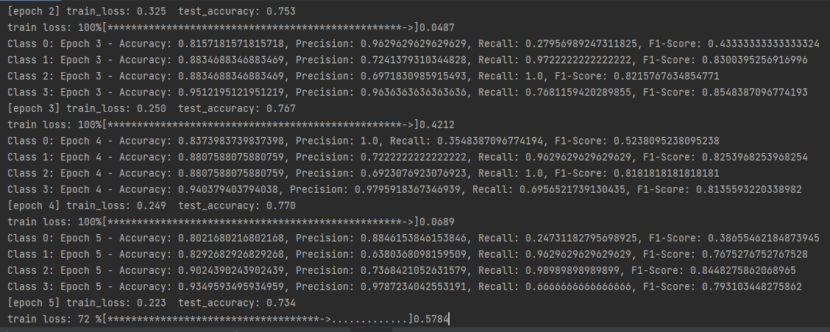
不同类别的测试准确率：
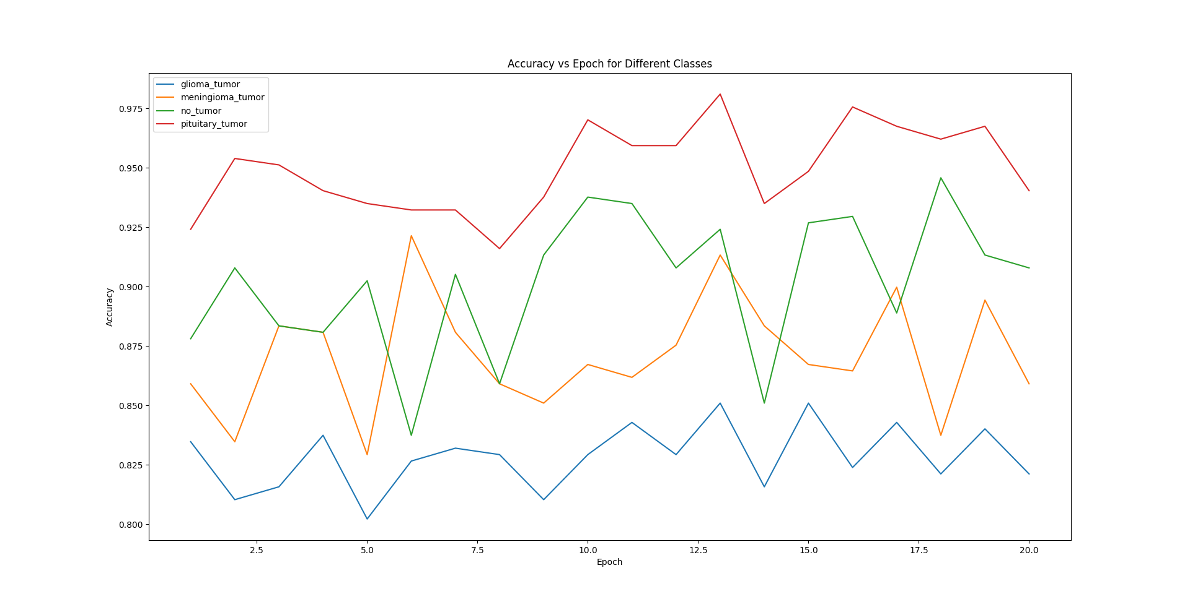

不同类别的测试精密度：

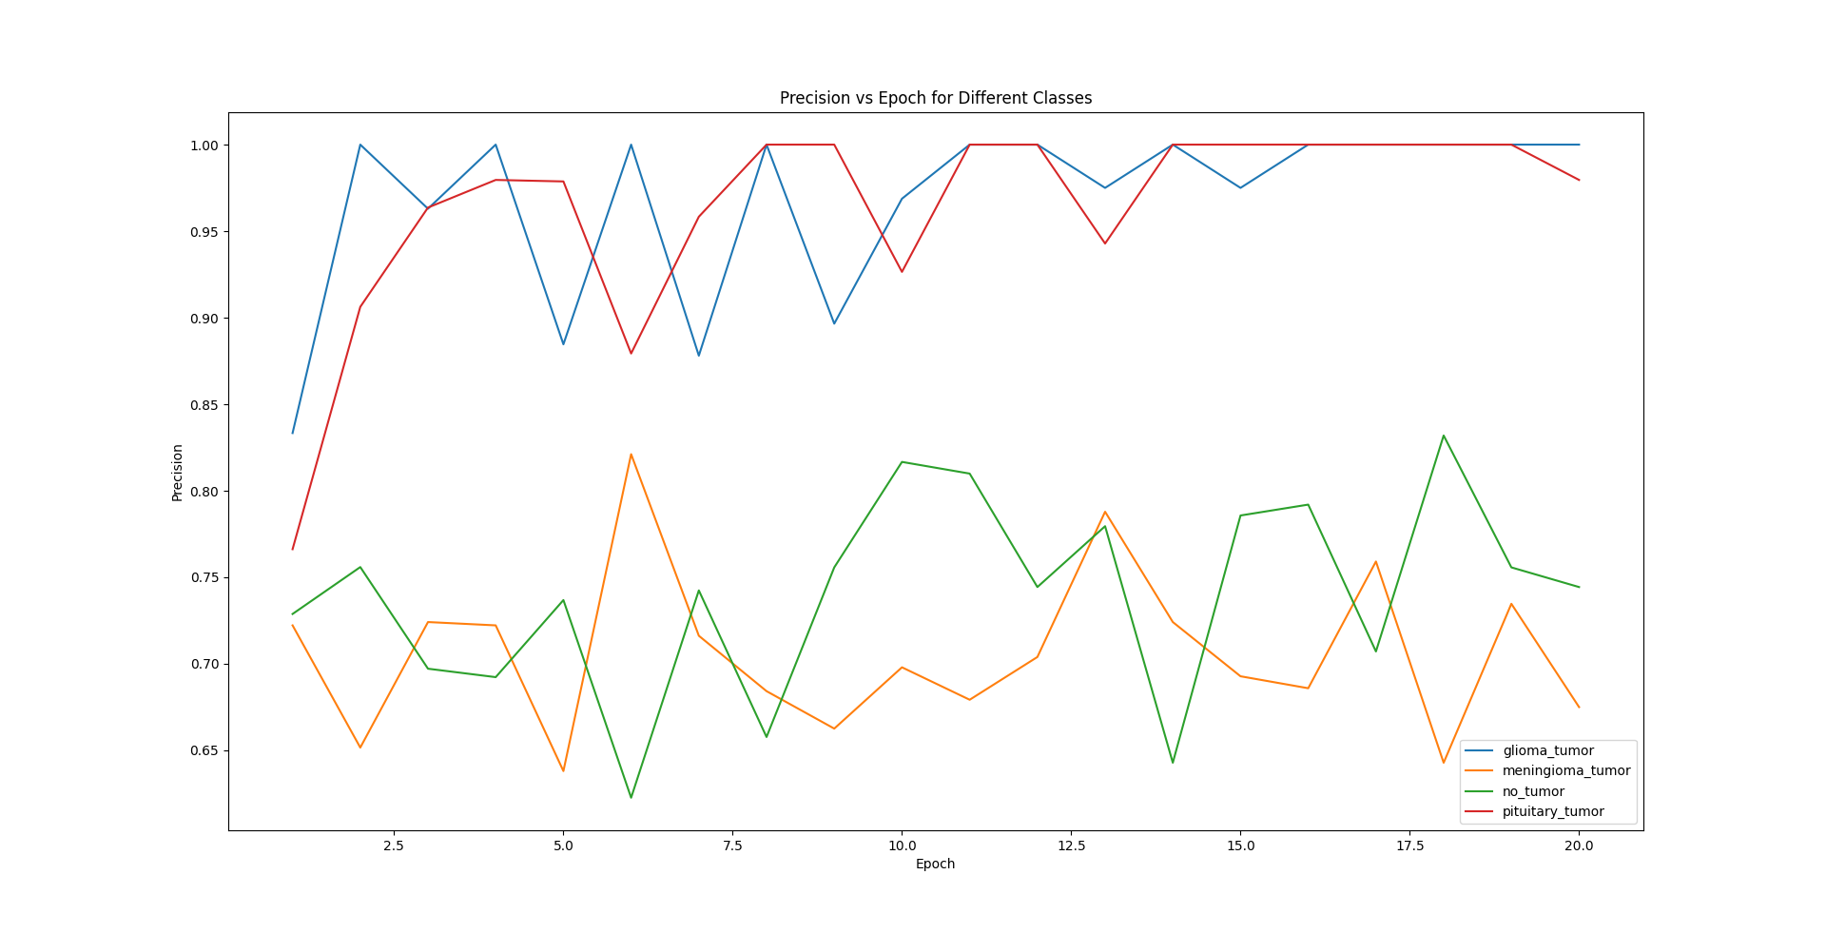
不同类别的测试召回率：
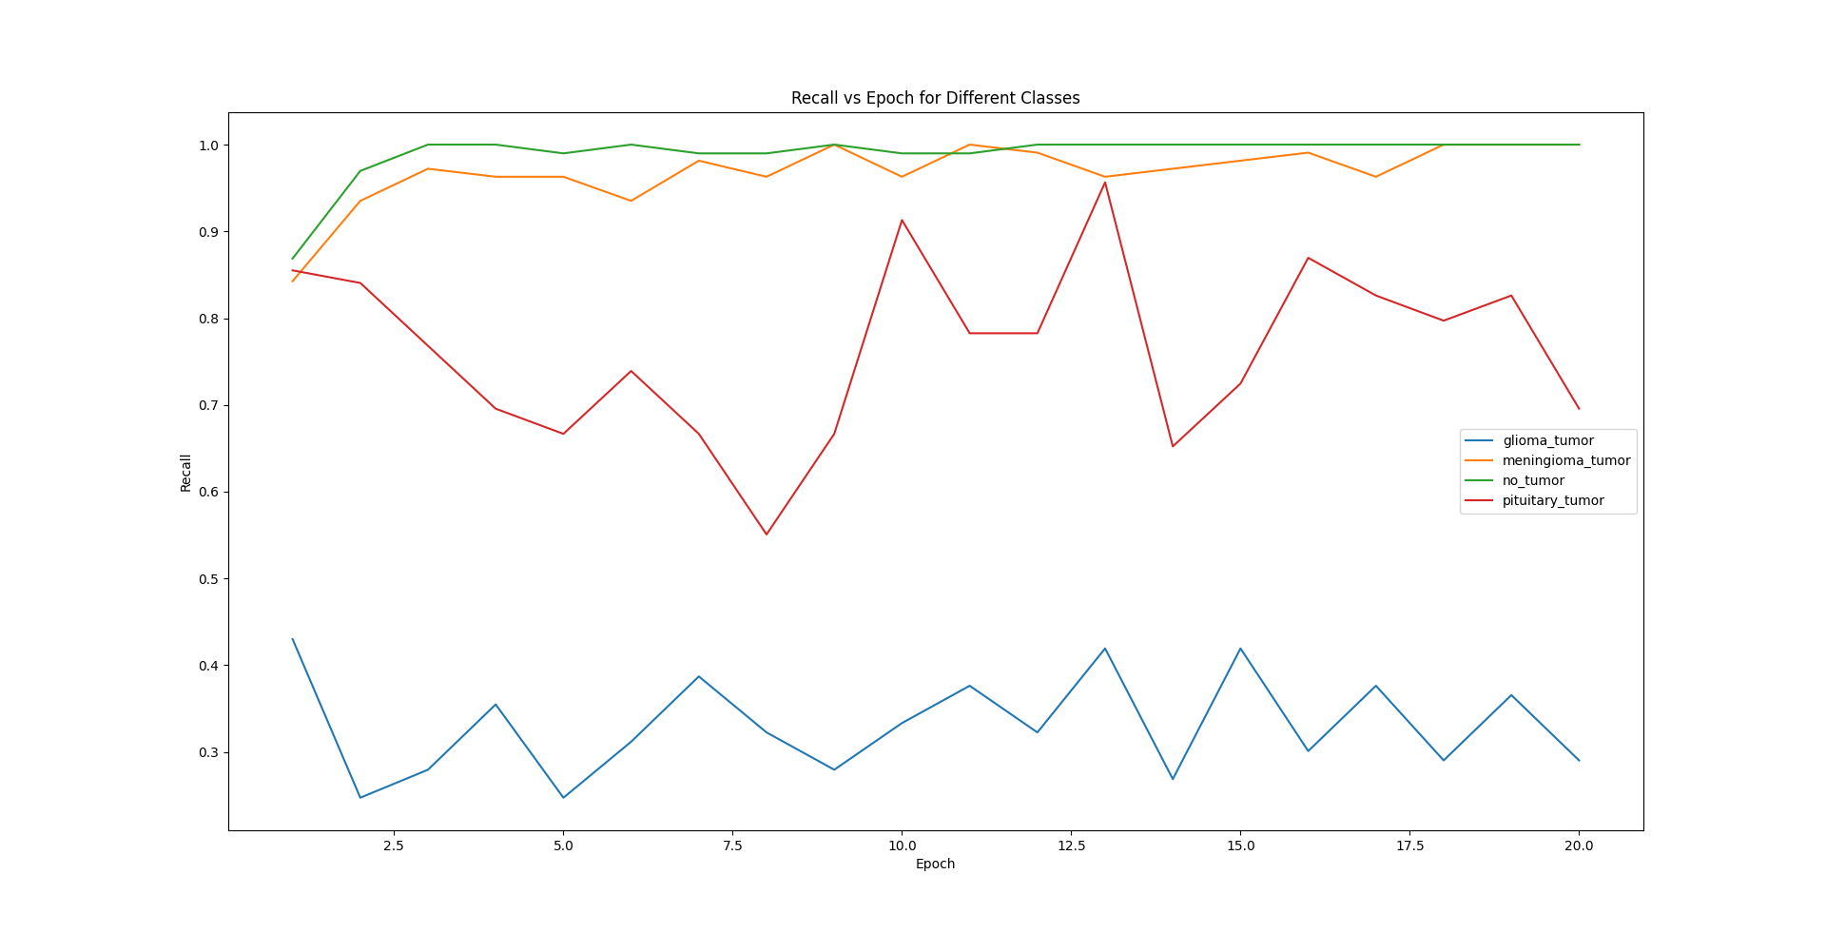
不同类别的测试f1分数：
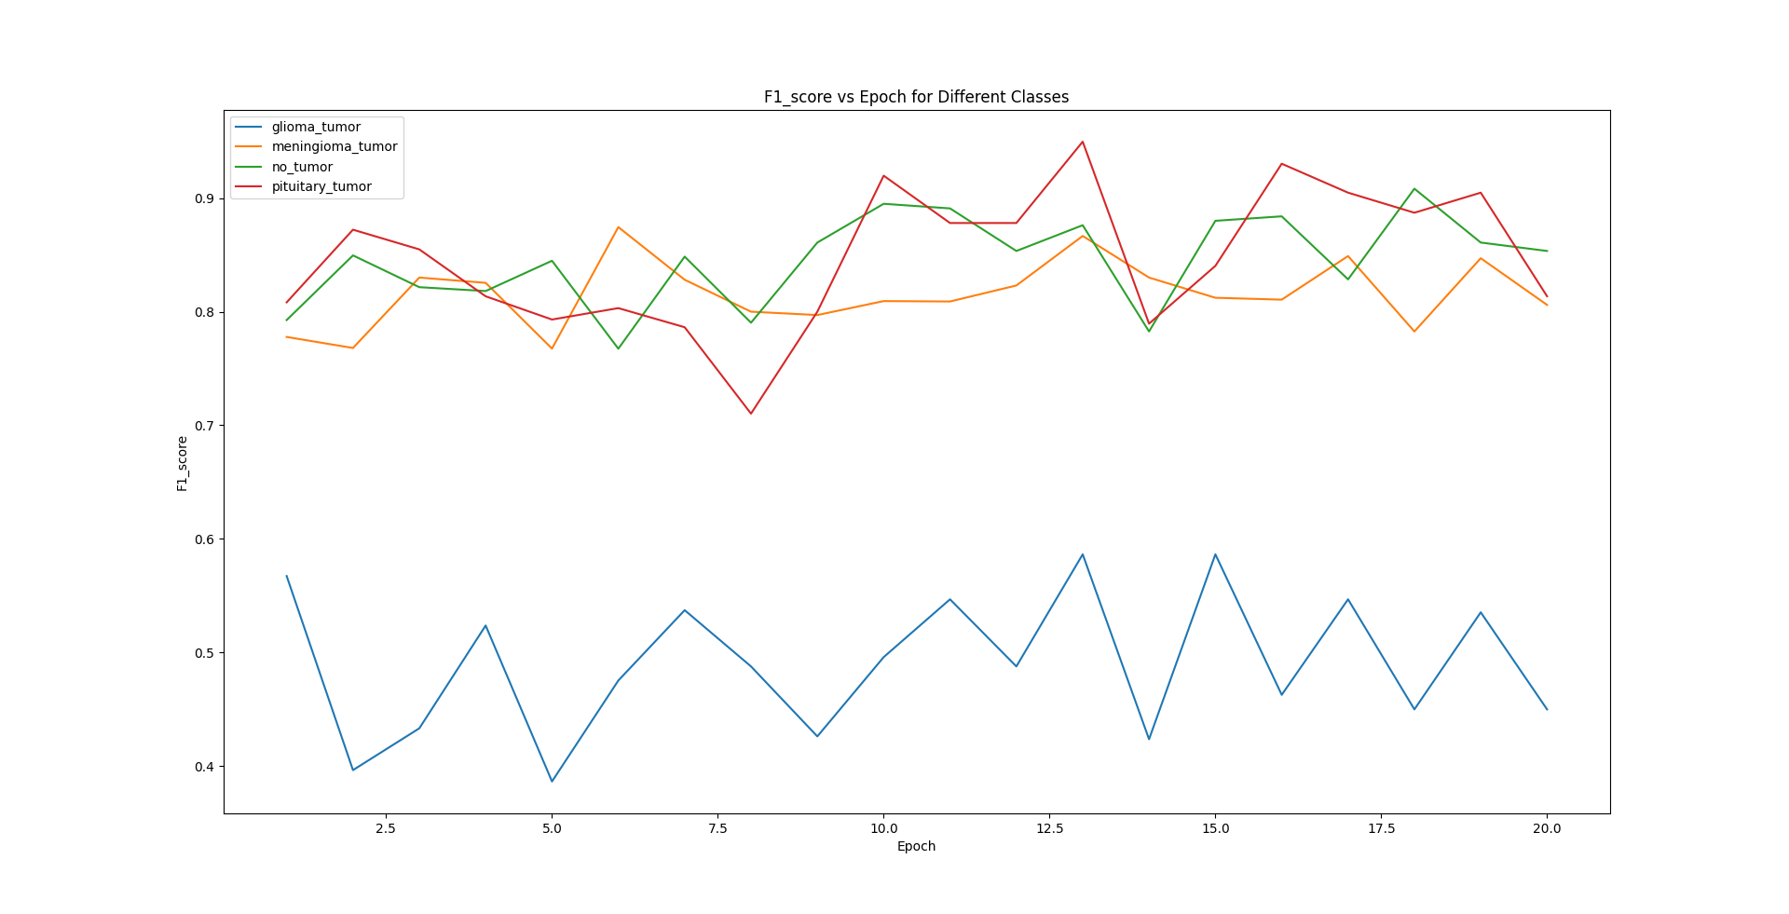
由以上结果可知：
ACC：glioma_tumor的准确率明显高于其他类别，基本在92.5%以上，meningioma_tumor基本上比no_tumo准确率高，二者都是在83%和92%之间浮动，准确率变化较大，稳定性不足（我认为是图像病理特征多且训练数据量太少导致的），pituitary_tumor准确率明显低于其他类别，后面稳定到82%到82.5%之间，稳定性较高。
Precision：glioma_tumor和pituitary_tumor后期可以稳定接近100%，而meningioma_tumor和no_tumo都不稳定，且数值较低，可见meningioma_tumor和no_tumo经常出现混淆的情况。
Recall和sensitivity：meningioma_tumor和no_tumo较高，pituitary_tumor次之，glioma_tumor最低，通过和Precision的对比可得出结论：meningioma_tumor和no_tumo能查全但查不准，glioma_tumor和pituitary_tumor查准但查不全，综合而论pituitary_tumor结果较好。
F1_score：pituitary_tumor、meningioma_tumor和no_tumo较高，而glioma_tumor很低，综合Recall和sensitivity来看，对glioma_tumor的分类效果很差。
每个类别的测试准确率、精密度、召回率、灵敏度和f1分数）：
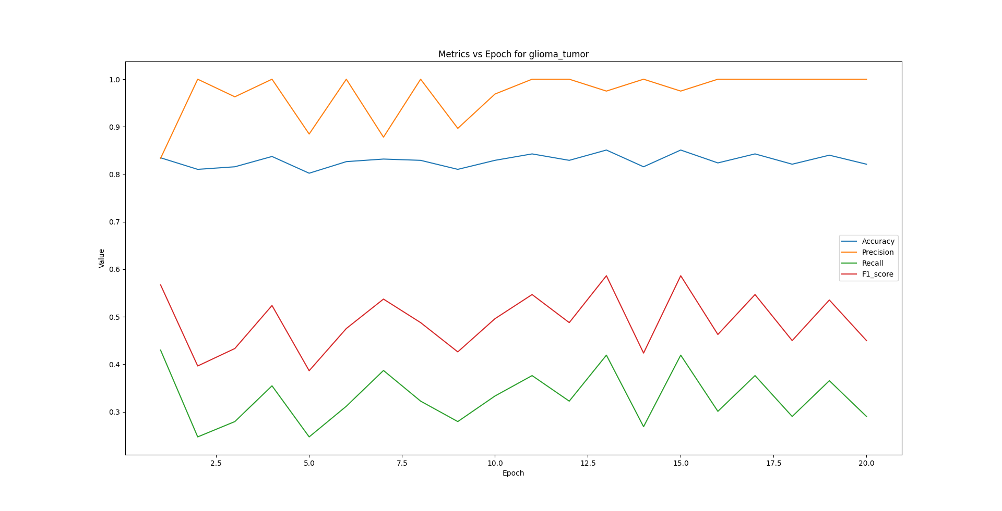
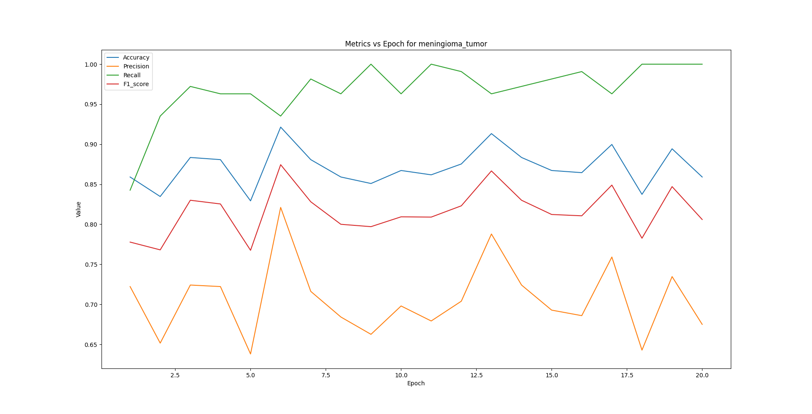
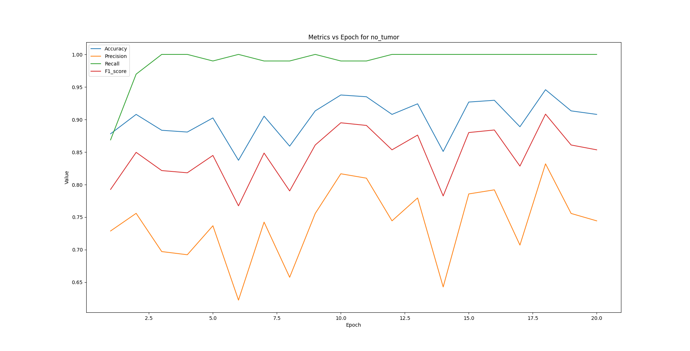
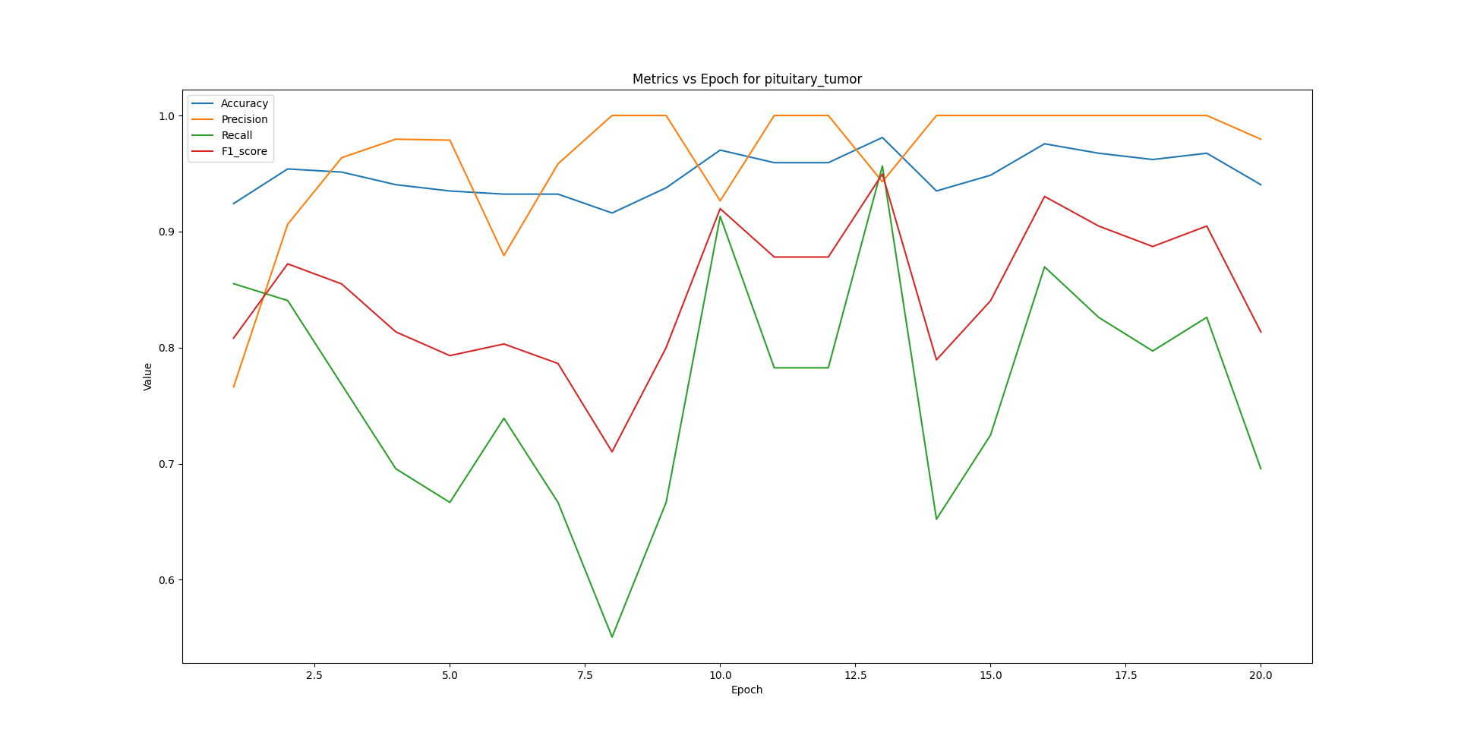
有结果可知：
除了pituitary_tumor外的其他三个类别的指标的高低都有明显的分层：Recall > acc > f1 score > precision。而pituitary_tumor大致是 precision > acc > f1 score > recall。pituitary_tumor的recall明显弱于其他类别的recall，而precision结果不错。
讨论不同类之间的性能差异，并解释如何获得平衡的性能。

对比实验：
对ResNet34使用不同优化器SGD和Adam进行比较：
上文展示的是Adam，下文是使用SGD优化器的结果

不同类别的测试准确率：
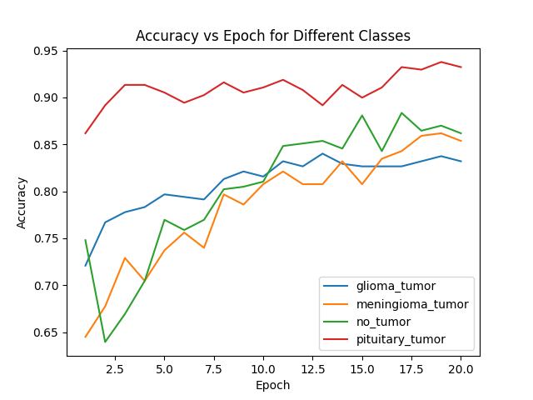
不同类别的测试精准度：
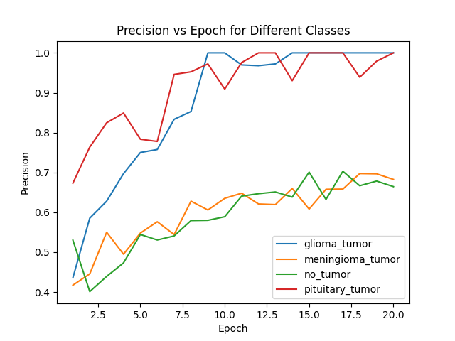

不同类别的测试召回率和敏感性：
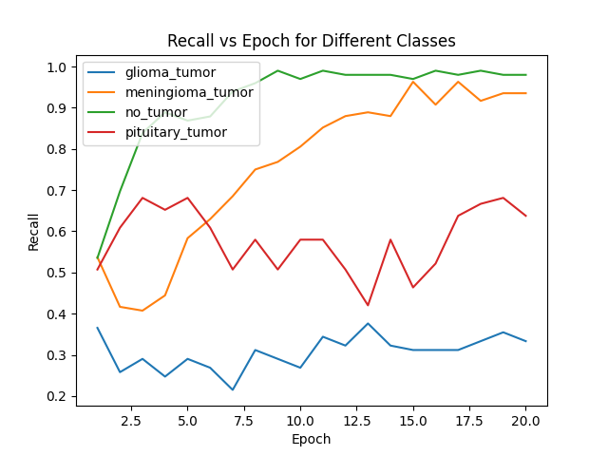
不同类别的测试F1分数：
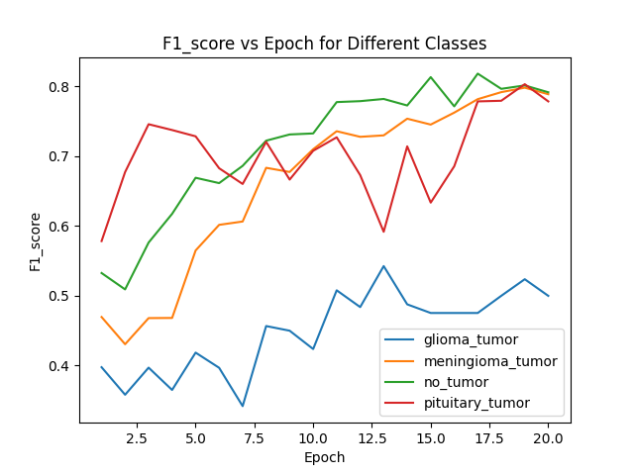

每个类别的测试准确率、精密度、召回率、灵敏度和f1分数）：
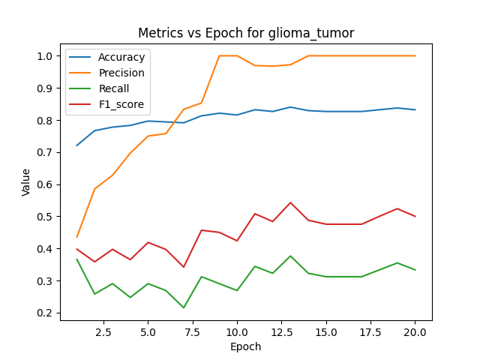
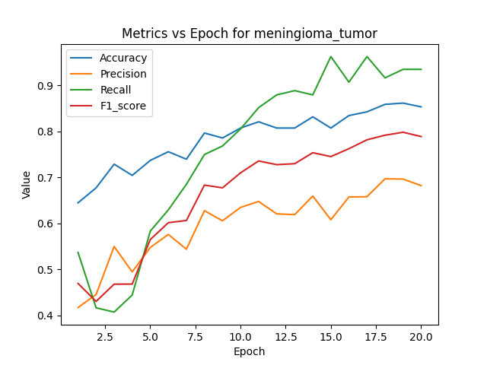
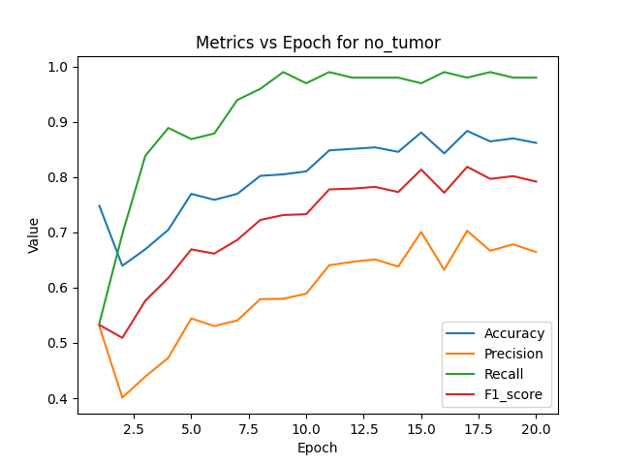
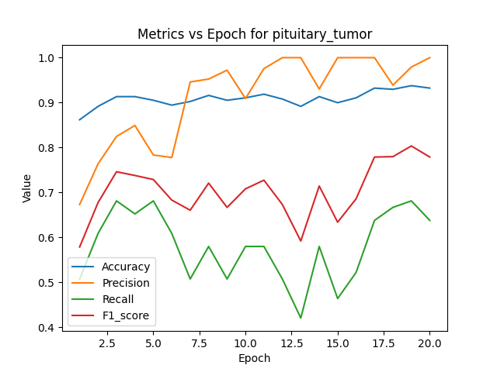
整体来看SGD比起Adam，对数据的学习效率较低，收敛慢。但SGD优化器在训练过程中并没有改变Adam优化器训练结果的变化趋势，也就是说SGD只是学习效率低，不是很适用于ResNet，但不代表SGD对训练有不利的误导作用，使用SGD也可以最终训练出模型性能高的模型，但是训练时间会较长。
使用不同模型：
使用ResNet34、ResNet101、Swin-transformer、ViT不同模型进行比较：
（Swin-transformer在后面讨论）
ResNet101模型的结果和ResNet34基本没有差别，所以图像就不展示了，101实现的代码在实验步骤有展示。
对于结果差不多的分析：部分指标结果无论epoch怎么变都不够好且不稳定的原因在于数据量太少，所以无论怎么调整都无法让模型学到全部的信息，使用ResNet34已经是相对于该数据量较大的模型了，所以哪怕提升模型深度到ResNet101，也不会对模型性能有什么提升，我们的重点应该是在数据增强和数据量上下功夫，本次实验使用了多种的数据增强，起到了不错的效果，但数据量的限制导致结果不够理想。

Transformer系列模型在该数据上表现，分析并进行对比试验：
因为想要充分体现Transformer对于实验数据集的训练表现，对于Transformer模型的训练我是从头开始训练，并没有进行迁移学习，所以前几个epochTransformer的模型性能不够好且loss较高，但在后期会趋于稳定，且模型性能较好，所以可见Transformer是适用于该数据训练的。
对于同轮次的训练，Transformer训练模型所耗时间明显多于ResNet34，Transformer的模型深度比ResNet34要深，而且因为我仅仅采用单片GPU（RTX3060）来跑程序，所以ResNet34模型的训练已经达到了设备的最高算力，所以对于更深的网络模型，计算耗时会增长。
实验结果如下：
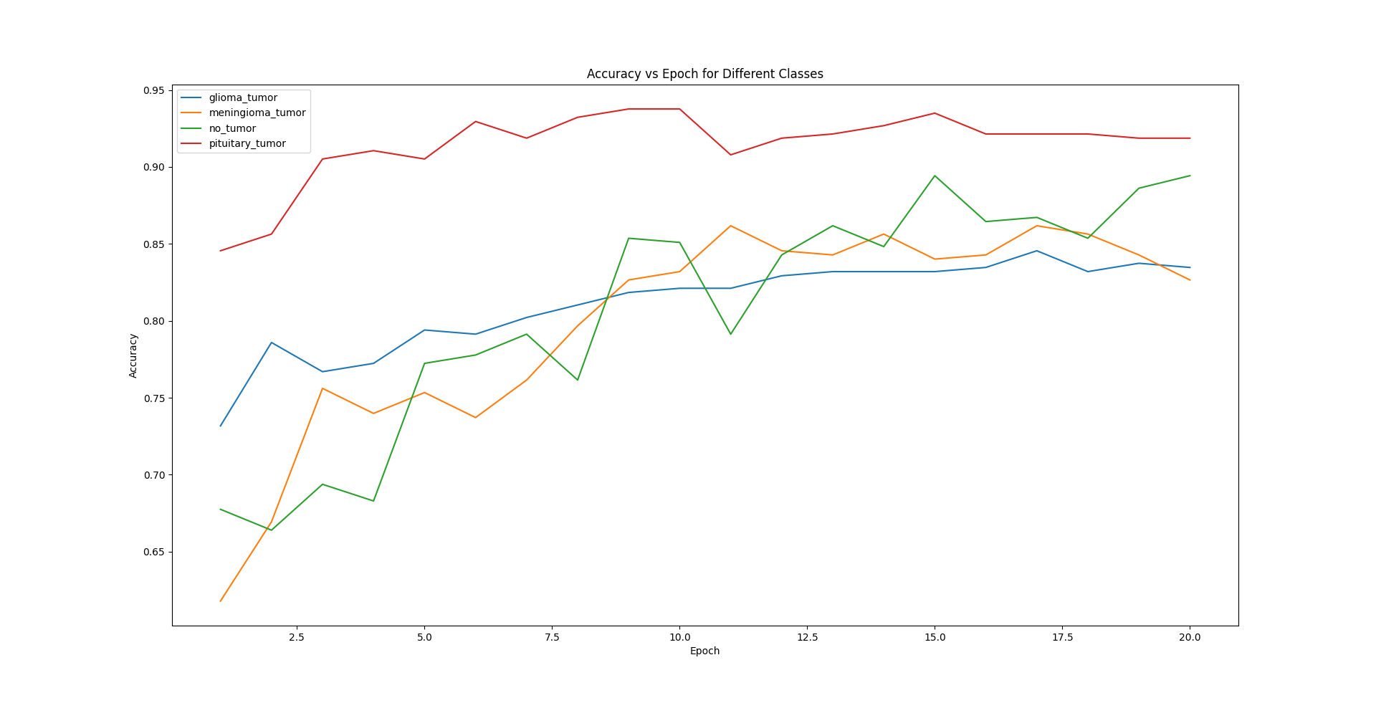
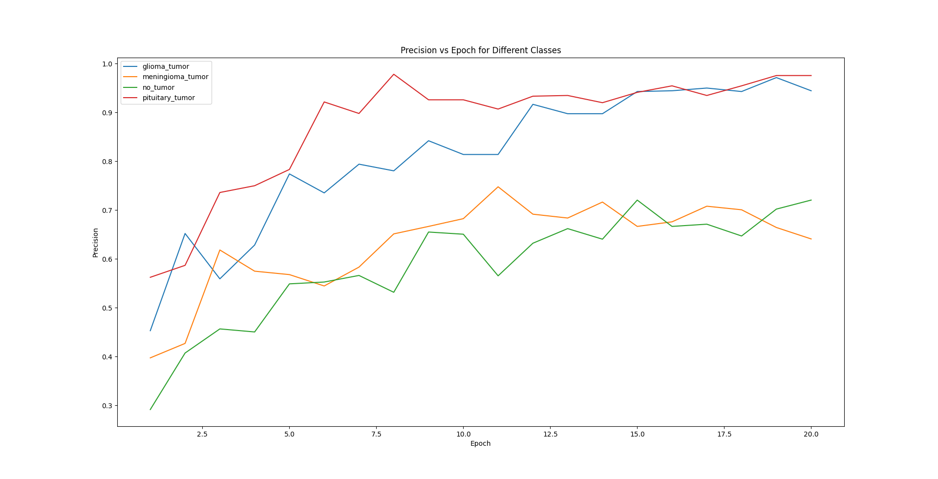
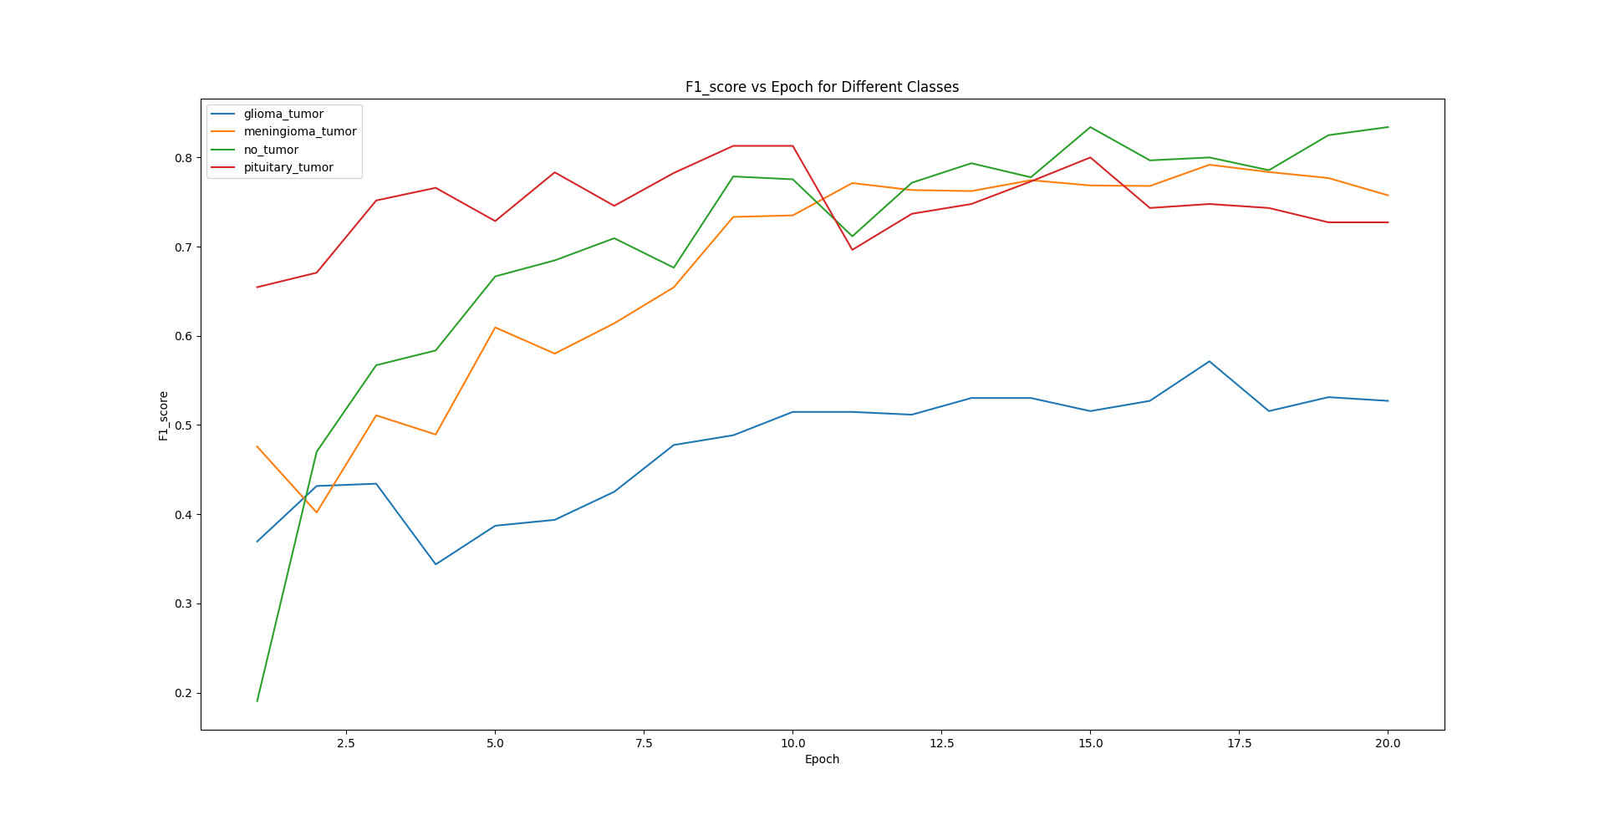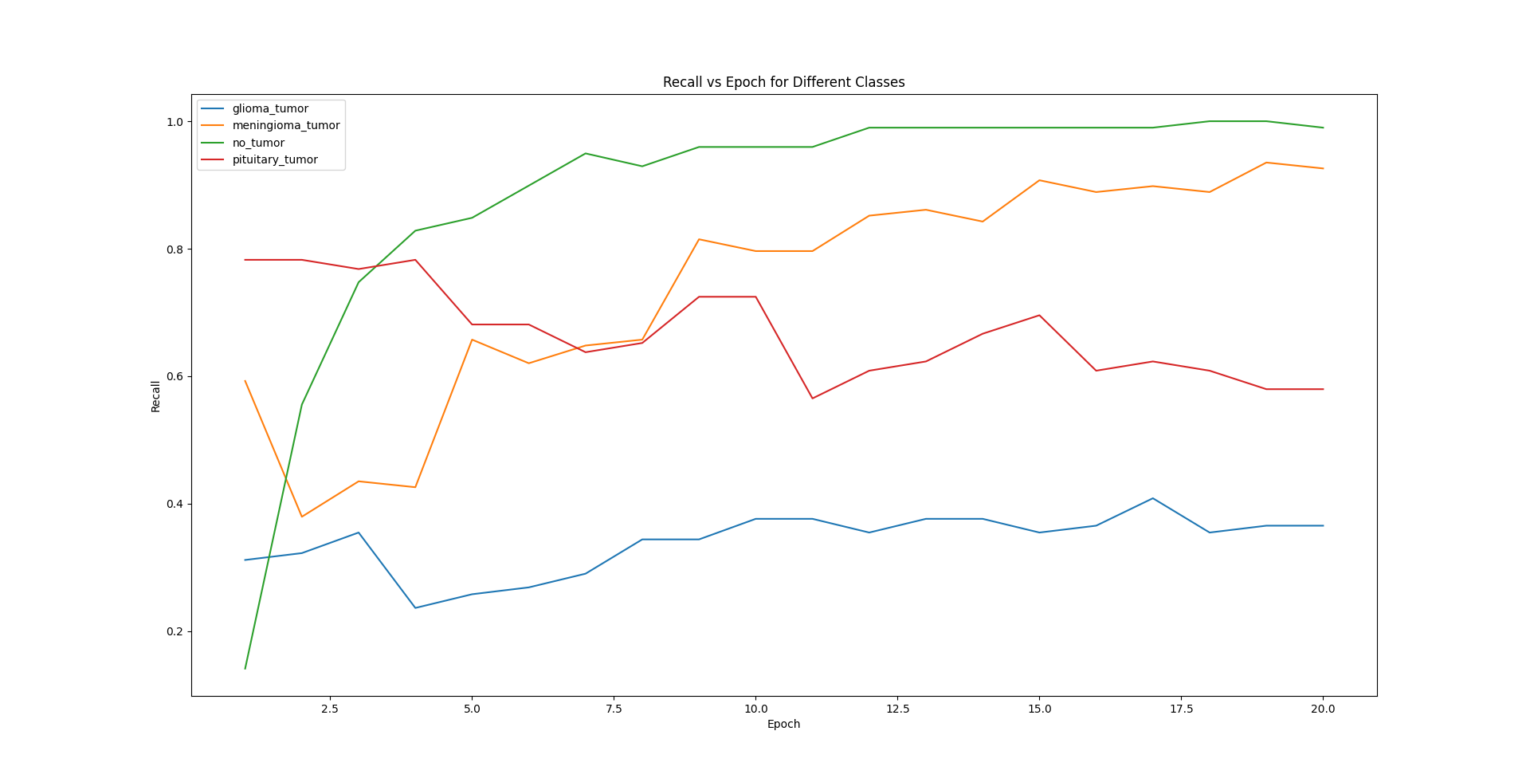
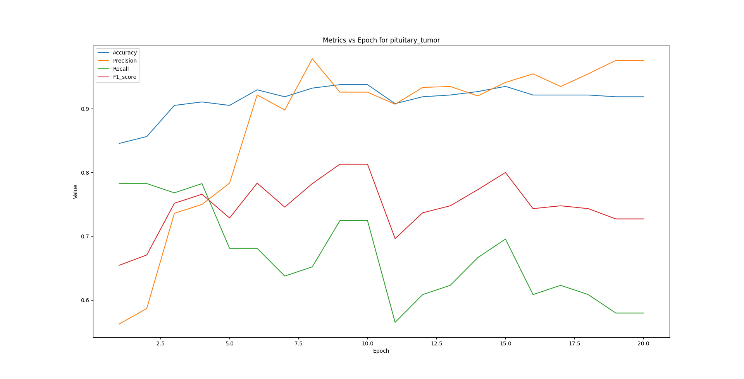
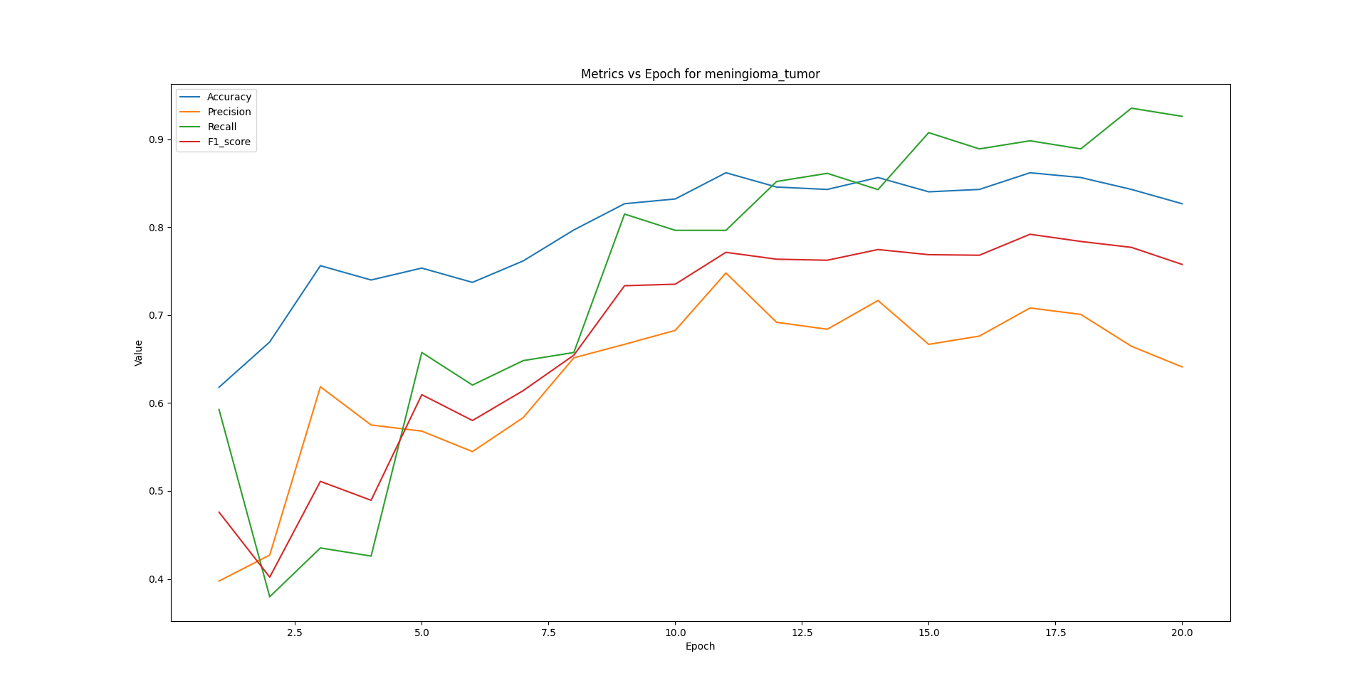
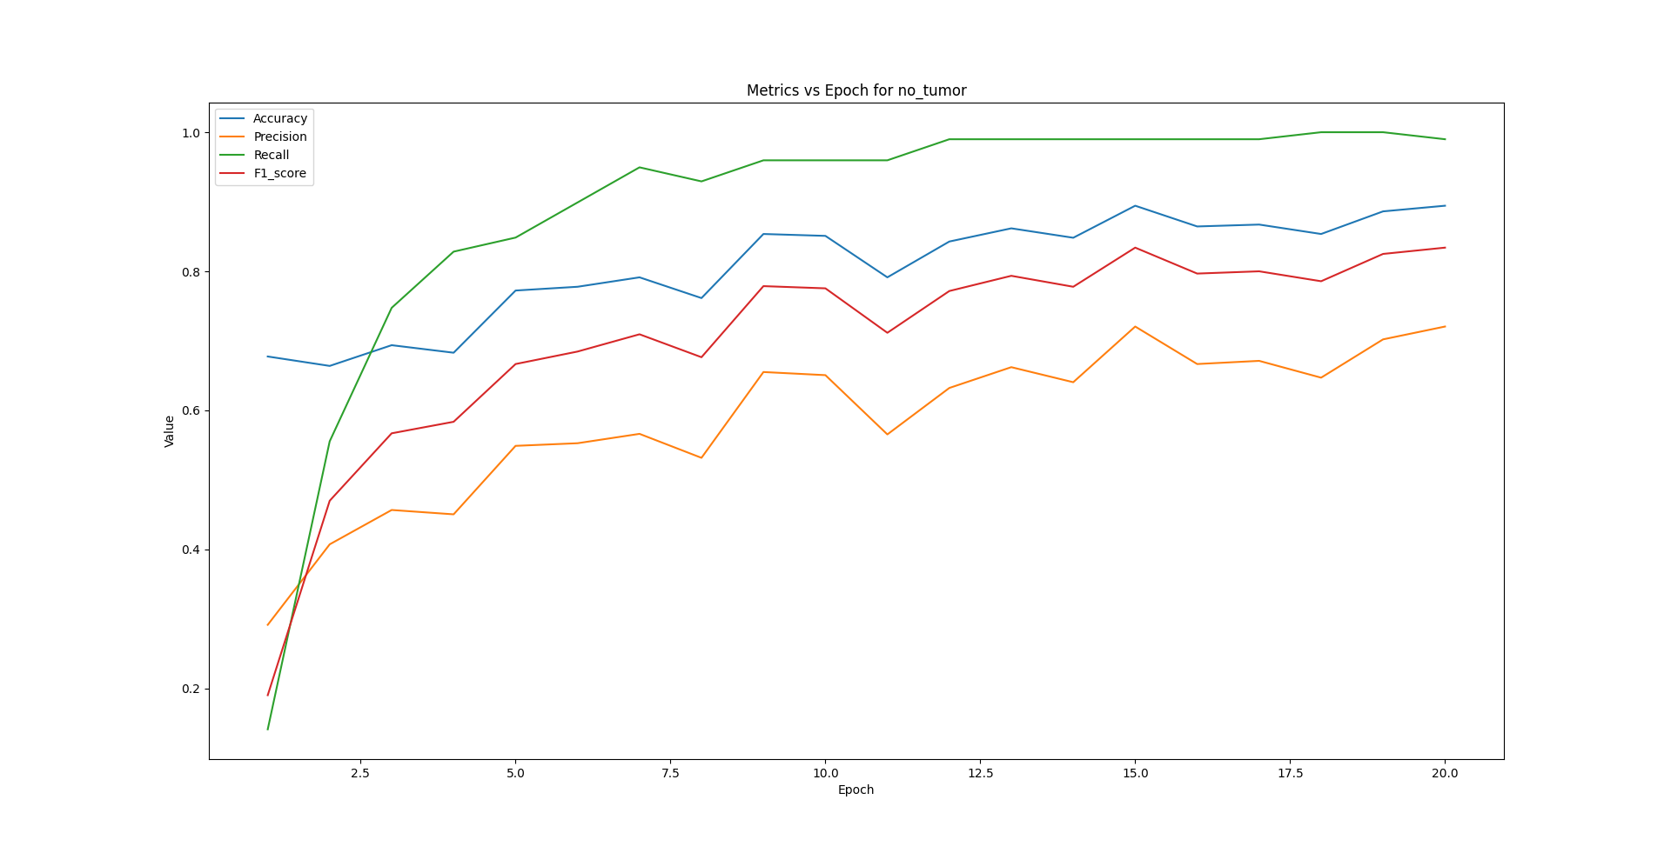
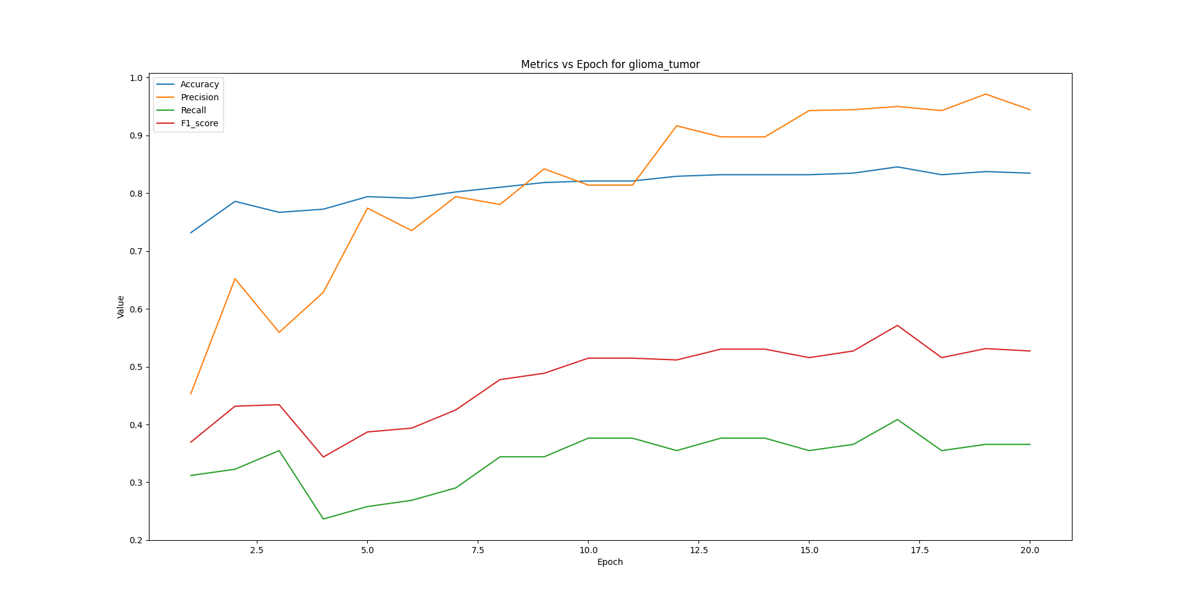
由结果可知，Swin Transformer相比于resnet34测试结果有一定的提升，但是并不多，并且在部分指标上甚至不如resnet34。
与 ResNet相比，Transformer在浅层和深层获得的表征之间具有更多相似性。与 ResNet不同，Transformer从浅层获得全局表示，但从浅层获得的局部表示也很重要。
Transformer中的跳过连接比 CNN (ResNet) 中的影响更大，并且显着影响表示的性能和相似性。Transformer比 ResNet 保留了更多的空间信息，可以用大量数据学习高质量的中间表示。
根据以上Transformer系列模型的特性，我认为Swin Transformer还是更加适用于更加复杂、尺度变化更多的任务，目前实验的数据集并不是Swin Transformer擅长训练学习的数据。

五、实验总结：
通过对Brain Tumor MRI数据集的实验，我们观察到不同类别之间存在明显的性能差异。具体而言，glioma_tumor的准确率明显高于其他类别，而pituitary_tumor则较低，但在精密度方面，pituitary_tumor的表现优于其他类别。
对于模型选择，我们测试了ResNet34、ResNet101、以及Swin Transformer等不同模型，结果显示ResNet34在这一数据集上已经是相对较好的选择，进一步增加模型复杂度并不能显著改善性能。
而Swin Transformer虽然在初期训练中性能较差，但随着训练的进行，表现逐渐稳定且具有一定的提升。Swin Transformer虽然有部分指标提升，但也存在部分指标上甚至不如ResNet34。我推测Swin Transformer在处理更加复杂、尺度变化更多的任务时可能会发挥更大的优势。
另外，我们也比较了不同优化器对模型性能的影响，发现对于ResNet模型而言，Adam优化器相较于SGD更加有效，能大大加快模型loss的收敛。综上所述，为了获得更平衡的性能，我们建议在数据增强和增加数据量方面下功夫，同时根据任务需求选择适当的模型和优化器。

指导教师批阅意见：（在相应栏目中打√ ）

成绩评定：

指导教师签字：

年 月 日
备注：
注：1、报告内的项目或内容设置，可根据实际情况加以调整和补充。
2、教师批改学生实验报告时间应在学生提交实验报告时间后10日内。

