深 圳 大 学 实 验 报 告

课程名称： 医学数字信号处理

实验项目名称： 打包解包小工具设计

学院： 医学院

专业： 生物医学工程

指导教师： 刁现芬

报告人： 陈嘉鸿 学号： 2021220049 班级： 创新班

实验时间： 2023/09/28

实验报告提交时间： 2023/09/28

教务部制
实验目的：
- 学习PCT通信协议。
- 了解Matlab部分控件，如触控按钮、静态文本、可编辑文本和面板等。
实验要求：参照实验指导书《医学数字信号处理实验——基于MATLAB（微课版）》，验证该教材上打包解包小工具设计实验。这一章要求设计一个打包解包小工具，需包含以下功能：
- 可以根据用户输入的模块ID、二级ID以及6字节数据，通过“打包”按钮实现打包操作，并将结果显示到打包结果显示区；
- 可以通过用户输入的10字节待解包数据，通过“解包”按钮实现解包操作，并将结果显示到解包结果显示区。
实验过程：
步骤1：MATLAB软件标准化设置

步骤2∶新建GUI工程
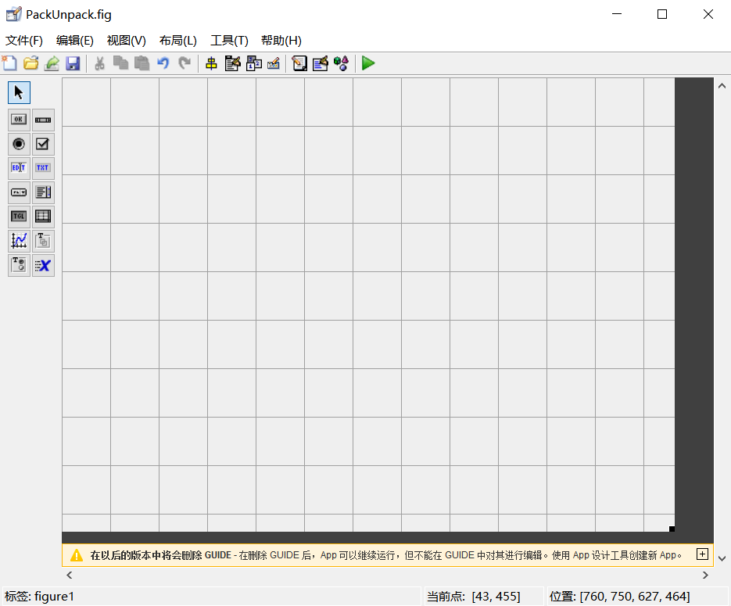
步骤3∶设计GUI
属性设计
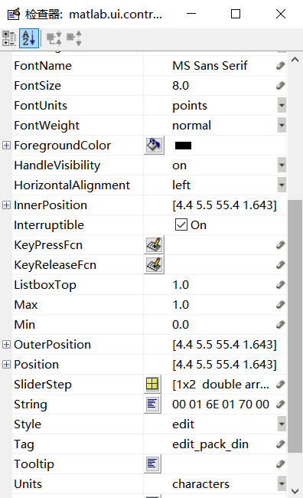
界面设计
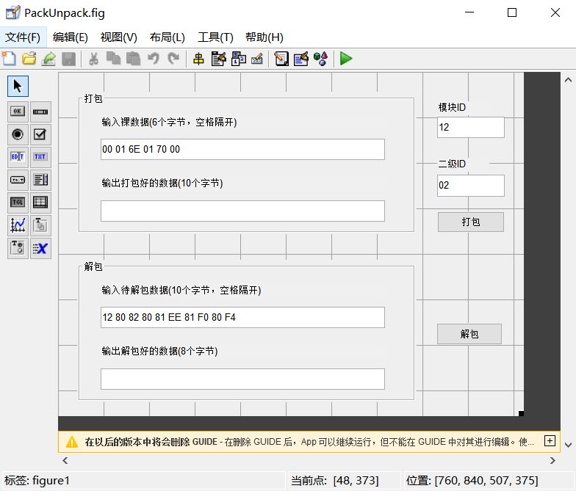
步骤4：进行程序设计
代码具体见后续程序代码部分
步骤5∶验证打包解包小工具
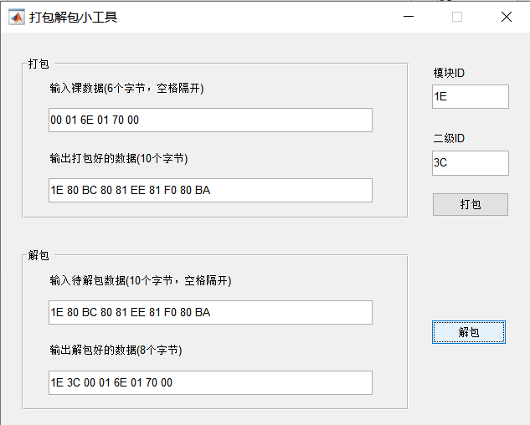

所设计的GUI界面：
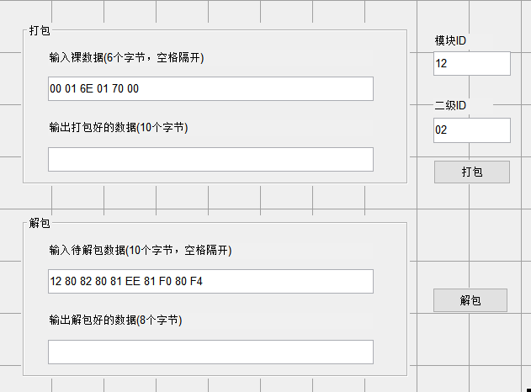
程序代码：
Packunpack.m
function varargout = PackUnpack(varargin)
% PACKUNPACK MATLAB code for PackUnpack.fig
% PACKUNPACK, by itself, creates a new PACKUNPACK or raises the existing
% singleton*.
%
% H = PACKUNPACK returns the handle to a new PACKUNPACK or the handle to
% the existing singleton*.
%
% PACKUNPACK('CALLBACK',hObject,eventData,handles,...) calls the local
% function named CALLBACK in PACKUNPACK.M with the given input arguments.
%
% PACKUNPACK('Property','Value',...) creates a new PACKUNPACK or raises the
% existing singleton*. Starting from the left, property value pairs are
% applied to the GUI before PackUnpack_OpeningFcn gets called. An
% unrecognized property name or invalid value makes property application
% stop. All inputs are passed to PackUnpack_OpeningFcn via varargin.
%
% *See GUI Options on GUIDE's Tools menu. Choose "GUI allows only one
% instance to run (singleton)".
%
% See also: GUIDE, GUIDATA, GUIHANDLES

% Edit the above text to modify the response to help PackUnpack

% Last Modified by GUIDE v2.5 10-Feb-2020 16:32:20

% Begin initialization code - DO NOT EDIT
gui_Singleton = 1;
gui_State = struct('gui_Name', mfilename, ...
'gui_Singleton', gui_Singleton, ...
'gui_OpeningFcn', @PackUnpack_OpeningFcn, ...
'gui_OutputFcn', @PackUnpack_OutputFcn, ...
'gui_LayoutFcn', [] , ...
'gui_Callback', []);
if nargin && ischar(varargin{1})
gui_State.gui_Callback = str2func(varargin{1});
end

if nargout
[varargout{1:nargout}] = gui_mainfcn(gui_State, varargin{:});
else
gui_mainfcn(gui_State, varargin{:});
end
% End initialization code - DO NOT EDIT

% --- Executes just before PackUnpack is made visible.
function PackUnpack_OpeningFcn(hObject, eventdata, handles, varargin)
% This function has no output args, see OutputFcn.
% hObject handle to figure
% eventdata reserved - to be defined in a future version of MATLAB
% handles structure with handles and user data (see GUIDATA)
% varargin command line arguments to PackUnpack (see VARARGIN)

% Choose default command line output for PackUnpack
handles.output = hObject;

set(gcf, 'name', '打包解包小工具'); % 设置当前窗口名字
% movegui('center'); % 将窗口置于屏幕中间
movegui(gcf, [100 200]);

% Update handles structure
guidata(hObject, handles);

% UIWAIT makes PackUnpack wait for user response (see UIRESUME)
% uiwait(handles.figure1);

% --- Outputs from this function are returned to the command line.
function varargout = PackUnpack_OutputFcn(hObject, eventdata, handles)
% varargout cell array for returning output args (see VARARGOUT);
% hObject handle to figure
% eventdata reserved - to be defined in a future version of MATLAB
% handles structure with handles and user data (see GUIDATA)

% Get default command line output from handles structure
varargout{1} = handles.output;

function edit_mod_id_Callback(hObject, eventdata, handles)
% hObject handle to edit_mod_id (see GCBO)
% eventdata reserved - to be defined in a future version of MATLAB
% handles structure with handles and user data (see GUIDATA)

% Hints: get(hObject,'String') returns contents of edit_mod_id as text
% str2double(get(hObject,'String')) returns contents of edit_mod_id as a double

% --- Executes during object creation, after setting all properties.
function edit_mod_id_CreateFcn(hObject, eventdata, handles)
% hObject handle to edit_mod_id (see GCBO)
% eventdata reserved - to be defined in a future version of MATLAB
% handles empty - handles not created until after all CreateFcns called

% Hint: edit controls usually have a white background on Windows.
% See ISPC and COMPUTER.
if ispc && isequal(get(hObject,'BackgroundColor'), get(0,'defaultUicontrolBackgroundColor'))
set(hObject,'BackgroundColor','white');
end

function edit_sec_id_Callback(hObject, eventdata, handles)
% hObject handle to edit_sec_id (see GCBO)
% eventdata reserved - to be defined in a future version of MATLAB
% handles structure with handles and user data (see GUIDATA)

% Hints: get(hObject,'String') returns contents of edit_sec_id as text
% str2double(get(hObject,'String')) returns contents of edit_sec_id as a double

% --- Executes during object creation, after setting all properties.
function edit_sec_id_CreateFcn(hObject, eventdata, handles)
% hObject handle to edit_sec_id (see GCBO)
% eventdata reserved - to be defined in a future version of MATLAB
% handles empty - handles not created until after all CreateFcns called

% Hint: edit controls usually have a white background on Windows.
% See ISPC and COMPUTER.
if ispc && isequal(get(hObject,'BackgroundColor'), get(0,'defaultUicontrolBackgroundColor'))
set(hObject,'BackgroundColor','white');
end

% --- Executes on button press in pushbutton_pack.
function pushbutton_pack_Callback(hObject, eventdata, handles)
% hObject handle to pushbutton_pack (see GCBO)
% eventdata reserved - to be defined in a future version of MATLAB
% handles structure with handles and user data (see GUIDATA)

modIDString = get(handles.edit_mod_id, 'String'); % 通过控件获取模块ID
modIDNum = hex2dec(modIDString); % 将十六进制字符串转换为十进制数
secIDString = get(handles.edit_sec_id, 'String'); % 通过控件获取二级ID
secIDNum = hex2dec(secIDString); % 将十六进制字符串转换为十进制数
rawDat = get(handles.edit_pack_din, 'String'); % 通过控件获取原始数据，共计6个字节

data6 = zeros(1, 6); % 初始化数组，每个元素赋值为0
for m = 1 : 6
% 取出每个数据（共计6个字节），并转换为十进制数
data6(m) = hex2dec(rawDat(3 * m - 2 : 3 * m - 1));
end

packRawDat = zeros(1, 10); % 初始化打包前数据包数组
packRawDat = [modIDNum, secIDNum, data6]; % 组合为打包前的数据包，共计8个字节
packRslt = Pack(packRawDat); % 进行打包操作
packRsltString = ''; % 创建一个空字符串用来存放打包结果

for k = 1 : 10
packRsltString = [packRsltString, dec2hex(packRslt(k), 2), ' ']; % 转换为打包结果字符串
end

set(handles.edit_pack_dout, 'String', packRsltString); % 将打包结果显示到控件

% --- Executes on button press in pushbutton_unpack.
function pushbutton_unpack_Callback(hObject, eventdata, handles)
% hObject handle to pushbutton_unpack (see GCBO)
% eventdata reserved - to be defined in a future version of MATLAB
% handles structure with handles and user data (see GUIDATA)

rawDat = get(handles.edit_unpack_din, 'String'); % 通过控件获取原始数据，共计10个字节
unpackRawDat = zeros(1, 10); % 初始化解包前数据包数组
for k = 1 : 10
% 取出每个数据（共计10个字节），并转换为十进制数
unpackRawDat(k) = hex2dec(rawDat(3 * k - 2 : 3 * k - 1));
end

% 进行解包操作，解包的结果为前8个字节（包括模块ID，二级ID，以及6个字节数据），后面2个字节忽略即可
unpackRslt = Unpack(unpackRawDat);

unpackRsltString = ''; % 创建一个空字符串用来存放解包结果

if unpackRslt == 0 % 返回值为0表示解包错误
set(handles.edit_unpack_dout, 'String', 'error!'); % 将error显示到控件
else
for k = 1 : 8
unpackRsltString = [unpackRsltString, dec2hex(unpackRslt(k), 2), ' ']; % 转化为解包结果字符串
end
set(handles.edit_unpack_dout, 'String', unpackRsltString); % 将解包结果显示到控件
end

function edit_unpack_dout_Callback(hObject, eventdata, handles)
% hObject handle to edit_unpack_dout (see GCBO)
% eventdata reserved - to be defined in a future version of MATLAB
% handles structure with handles and user data (see GUIDATA)

% Hints: get(hObject,'String') returns contents of edit_unpack_dout as text
% str2double(get(hObject,'String')) returns contents of edit_unpack_dout as a double

% --- Executes during object creation, after setting all properties.
function edit_unpack_dout_CreateFcn(hObject, eventdata, handles)
% hObject handle to edit_unpack_dout (see GCBO)
% eventdata reserved - to be defined in a future version of MATLAB
% handles empty - handles not created until after all CreateFcns called

% Hint: edit controls usually have a white background on Windows.
% See ISPC and COMPUTER.
if ispc && isequal(get(hObject,'BackgroundColor'), get(0,'defaultUicontrolBackgroundColor'))
set(hObject,'BackgroundColor','white');
end

function edit_unpack_din_Callback(hObject, eventdata, handles)
% hObject handle to edit_unpack_din (see GCBO)
% eventdata reserved - to be defined in a future version of MATLAB
% handles structure with handles and user data (see GUIDATA)

% Hints: get(hObject,'String') returns contents of edit_unpack_din as text
% str2double(get(hObject,'String')) returns contents of edit_unpack_din as a double

% --- Executes during object creation, after setting all properties.
function edit_unpack_din_CreateFcn(hObject, eventdata, handles)
% hObject handle to edit_unpack_din (see GCBO)
% eventdata reserved - to be defined in a future version of MATLAB
% handles empty - handles not created until after all CreateFcns called

% Hint: edit controls usually have a white background on Windows.
% See ISPC and COMPUTER.
if ispc && isequal(get(hObject,'BackgroundColor'), get(0,'defaultUicontrolBackgroundColor'))
set(hObject,'BackgroundColor','white');
end

function edit_pack_din_Callback(hObject, eventdata, handles)
% hObject handle to edit_pack_din (see GCBO)
% eventdata reserved - to be defined in a future version of MATLAB
% handles structure with handles and user data (see GUIDATA)

% Hints: get(hObject,'String') returns contents of edit_pack_din as text
% str2double(get(hObject,'String')) returns contents of edit_pack_din as a double

% --- Executes during object creation, after setting all properties.
function edit_pack_din_CreateFcn(hObject, eventdata, handles)
% hObject handle to edit_pack_din (see GCBO)
% eventdata reserved - to be defined in a future version of MATLAB
% handles empty - handles not created until after all CreateFcns called

% Hint: edit controls usually have a white background on Windows.
% See ISPC and COMPUTER.
if ispc && isequal(get(hObject,'BackgroundColor'), get(0,'defaultUicontrolBackgroundColor'))
set(hObject,'BackgroundColor','white');
end

function edit_pack_dout_Callback(hObject, eventdata, handles)
% hObject handle to edit_pack_dout (see GCBO)
% eventdata reserved - to be defined in a future version of MATLAB
% handles structure with handles and user data (see GUIDATA)

% Hints: get(hObject,'String') returns contents of edit_pack_dout as text
% str2double(get(hObject,'String')) returns contents of edit_pack_dout as a double

% --- Executes during object creation, after setting all properties.
function edit_pack_dout_CreateFcn(hObject, eventdata, handles)
% hObject handle to edit_pack_dout (see GCBO)
% eventdata reserved - to be defined in a future version of MATLAB
% handles empty - handles not created until after all CreateFcns called

% Hint: edit controls usually have a white background on Windows.
% See ISPC and COMPUTER.
if ispc && isequal(get(hObject,'BackgroundColor'), get(0,'defaultUicontrolBackgroundColor'))
set(hObject,'BackgroundColor','white');
End

Pack.m
function packOut = Pack(packIn)
% 对数据进行打包
% 输入参数packIn，打包前的数据
% 输入参数packout，如果打包成功则为打包后的数据包，如果打包失败则为0
% 注意，数据头的BIT0为二级ID的BIT7，数据头的BIT1为数据1的BIT7，数据头的BIT2为数据2的BIT7，数据头
% 的BIT6为数据6的BIT7。
% COPYRIGHT 2018-2020 LEYUTEK. All rights reserved.

% 打包前的数据包长为8个字节，不为8个字节的包即为错误包，将返回值赋值为0，然后退出函数
if (length(packIn) ~= 8)
packOut = 0;
return;
end

checkSum = packIn(1); % 第一个字节为模块ID，取出模块ID，赋值给校验和变量
dataHead = 0; % 将数据头变量赋值为数0，即清除数据头的各比特位

for i = 9 : -1 : 3
% 数据头变量左移一位，赋值给新的数据头变量
dataHead = bitshift(uint8(dataHead), 1, 'uint8');

% 将最高位置1
packIn(i) = bitor(packIn(i - 1), 128);

% 数据与校验和变量相加，赋值给新的校验和变量
checkSum = checkSum + packIn(i);

% 取出原始数据的最高位，与数据头变量相或，赋值给新的数据头变量
dataHead = bitor(uint8(dataHead), bitshift(bitand(packIn(i - 1), 128), -7, 'uint8'));
end

% 数据头在数据包的第二个位置，仅次于模块ID，数据头的最高位也要置为1
packIn(2) = bitor(dataHead, 128);
% 将数据头变量与校验和变量相加，赋值给新的校验和变量
checkSum = checkSum + packIn(2);
% 将校验和变量的低7位取出，赋值给新的校验和变量
checkSum = bitand(checkSum, 127);
% 校验和的最高位也要置为1
packIn(10) = bitor(checkSum, 128);

packOut = packIn; % 将packIn变量（保存着打包结果）赋值给输出参数

Unpack.m
function unpackOut = Unpack(unpackIn)
% 函数名称: Unpack
% 对数据进行解包
% 输入参数unpackIn，解包前的数据
% 输出参数unpackOut，如果解包成功则为解包后的数据包，如果解包失败则为0
% COPYRIGHT 2018-2020 LEYUTEK. All rights reserved.

% 解包前的数据包长为10个字节，不为10个字节的包即为错误包，将返回值赋值为0，然后退出函数
if (length(unpackIn) ~= 10)
unpackOut = 0;
return;
end

checkSum = unpackIn(1); % 第一个字节为模块ID，取出模块ID，赋值给校验和变量
dataHead = unpackIn(2); % 第二个字节为数据头，取出数据头，赋值给数据头变量

checkSum = checkSum + dataHead; % 校验和变量与数据头变量相加，再赋值给新的校验和变量

for i = 2 : 1 : 8
checkSum = checkSum + unpackIn(i + 1); % 将数据依次与校验和变量相加，再赋值给新的校验和变量
unpackIn(i) = bitor(bitand(unpackIn(i + 1) , 127), bitshift(bitand(dataHead , 1) , 7));
dataHead = bitshift(dataHead, -1); % 数据头右移一位
end

if (bitand(checkSum , 127) ~= bitand(unpackIn(10), 127)) % 如果校验和出错
unpackOut = 0; % 将返回值赋值为0
return; % 然后退出函数
else
unpackOut = unpackIn; % 如果校验和正确，则将packIn变量（保存着解包结果）赋值给输出参数
End

打包解包小工具运行结果界面：
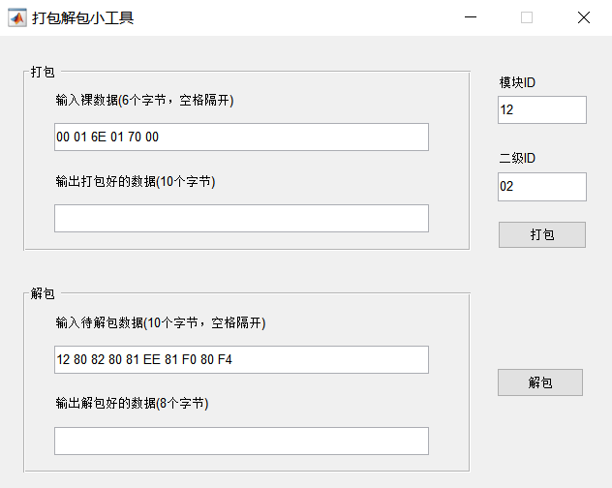
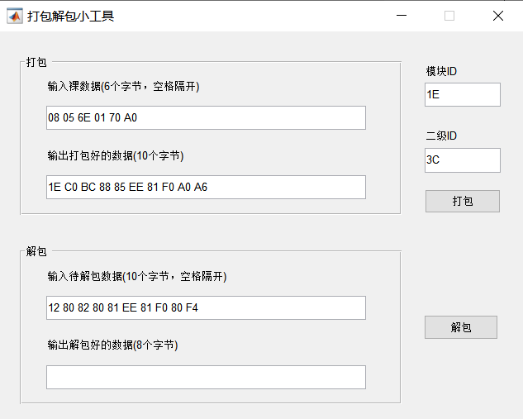
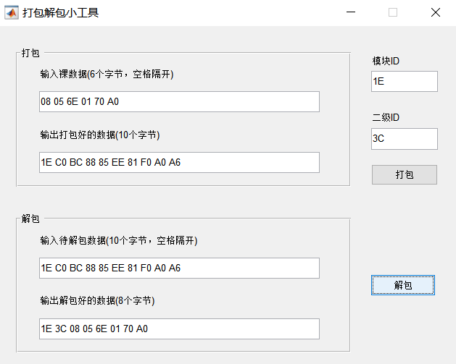
回答问题：
- 根据PCT通信协议，模块ID和二级ID分别有多少种？
答：模块ID有128种，二级ID有256种。
- PCT通信协议规定二级ID的最高位固定为1，那么当一组待打包数据的二级ID小于0x80时，这组数据能否通过打包解包小工具得到打包的正确结果？用你的小完成的打包解包小工具程序验证一下？分析一下原因？
答：能
验证：
首先，设置模块ID为0x01，二级ID为0x40（小于0x80），6字节数据为"00 01 6E 01 70 00"。
然后，点击“打包”按钮，得到打包结果为：12 80 C0 80 81 EE 81 F0 80 B2
接下来，将这个打包结果输入到“解包”中，点击“解包”按钮，得到解包结果为：模块ID：12，二级ID：40，数据：00 01 6E 01 70 00
从结果可以看出，当二级ID小于0x80时，使用打包解包小工具能够正确地打包和解包数据。
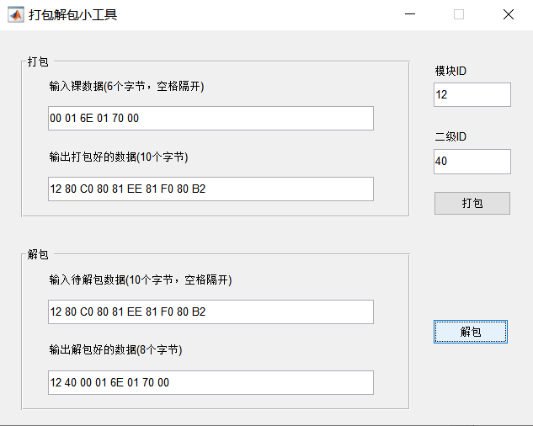
原因：
虽然在打包过程中，PCT通信协议规定二级ID的最高位固定为1，但是原始数据中二级ID的实际最高位的数值已经放入了数据头bit0中（二级ID小于0x80的话就是0）。
然后在解包过程中，二级ID最后bit7的数值由数据头bit0给出。所以打包解包过程中的最高位固定为1的操作不会影响最后解包后二级ID的bit7数值，在打包时真实数值已经传入数据头保存好了，解包再由数据头给出。

指导教师批阅意见：

成绩评定：

指导教师签字：
年 月 日
备注：
注：1、报告内的项目或内容设置，可根据实际情况加以调整和补充。
2、教师批改学生实验报告时间应在学生提交实验报告时间后10日内。

