深 圳 大 学 实 验 报 告

课程名称： 医学数字信号处理

实验项目名称： 串口助手小工具设计

学院： 医学院

专业： 生物医学工程

指导教师： 刁现芬

报告人：陈嘉鸿 学号：2021220049 班级： 创新班

实验时间： 2023年10月7日星期六（补10月5号周四）

实验报告提交时间： 2023年10月7日

教务部制
实验目的与要求：
- 学习串口通信协议。
- 学习MATLAB部分控件和串口相关函数，如serial、fopen、fclose、fread和fread等。
- 参照实验书的完成一个串口助手小工具的设计，需包含以下功能：
- 可以选择计算机上可用的串口号；
- 可以选择波特率、校验位、数据位和停止位；
- 可以将串口接收到的数据显示到串口“接收区”，并允许用户使用“清除接收区”按钮清除串口“接收区”中的内容；
- 可以通过“发送”按钮将串口“发送区”发送到其他设备，并允许用户使用“清除发送区”按钮清除串口“发送区”中的内容；
- 允许用户设置发送间隔，实现定时发送功能。
程序代码：
SerialAssistant.m
function varargout = SerialAssistant(varargin)
gui_Singleton = 1;
gui_State = struct('gui_Name', mfilename, ...
'gui_Singleton', gui_Singleton, ...
'gui_OpeningFcn', @SerialAssistant_OpeningFcn, ...
'gui_OutputFcn', @SerialAssistant_OutputFcn, ...
'gui_LayoutFcn', [] , ...
'gui_Callback', []);
if nargin && ischar(varargin{1})
gui_State.gui_Callback = str2func(varargin{1});
end

if nargout
[varargout{1:nargout}] = gui_mainfcn(gui_State, varargin{:});
else
gui_mainfcn(gui_State, varargin{:});
end
% End initialization code - DO NOT EDIT

% --- Executes just before SerialAssistant is made visible.
function SerialAssistant_OpeningFcn(hObject, eventdata, handles, varargin)
% This function has no output args, see OutputFcn.
% hObject handle to figure
% eventdata reserved - to be defined in a future version of MATLAB
% handles structure with handles and user data (see GUIDATA)
% varargin command line arguments to SerialAssistant (see VARARGIN)

% Choose default command line output for SerialAssistant
handles.output = hObject;

set(gcf,'numbertitle', 'off', 'name', '串口助手小工具'); % 设置当前窗口名字
movegui('center'); % 将窗口置于屏幕中间
% 设置当前窗口各个控件的参数
set(handles.popupmenu_baud_rate, 'string', {'4800', '9600', '14400', '19200', '38400',...
'57600', '76800', '115200'}, 'value', 8); % 波特率
set(handles.popupmenu_data_bits, 'string', {'8', '9'}); % 数据位
set(handles.popupmenu_stop_bits, 'string', {'1', '1.5', '2'}); % 停止位
set(handles.popupmenu_parity, 'string', {'NONE', 'ODD', 'EVEN'}); % 校验位
global gUARTOpenFlag; % 串口开启标志，0-串口为关闭状态，1-串口为开启状态
gUARTOpenFlag = 0; % 串口默认为关闭状态
gotDataFlag = false; % 串口接收到数据标志，默认为未接收到数据
strRec = ''; % 已经接收到的字符串，默认为空
dispFlag = false; % 正在进行数据显示的标志

setappdata(hObject, 'gotDataFlag', gotDataFlag); % 更新gotDataFlag
setappdata(hObject, 'strRec', strRec); % 更新strRec
setappdata(hObject, 'dispFlag', dispFlag); % 更新dispFlag
ScanUART(handles); % 扫描串口

% Update handles structure
guidata(hObject, handles);

% UIWAIT makes SerialAssistant wait for user response (see UIRESUME)
% uiwait(handles.figure1);

% --- Outputs from this function are returned to the command line.
function varargout = SerialAssistant_OutputFcn(hObject, eventdata, handles)
% varargout cell array for returning output args (see VARARGOUT);
% hObject handle to figure
% eventdata reserved - to be defined in a future version of MATLAB
% handles structure with handles and user data (see GUIDATA)

% Get default command line output from handles structure
varargout{1} = handles.output;

function edit_rec_Callback(hObject, eventdata, handles)
% hObject handle to edit_rec (see GCBO)
% eventdata reserved - to be defined in a future version of MATLAB
% handles structure with handles and user data (see GUIDATA)

% Hints: get(hObject,'String') returns contents of edit_rec as text
% str2double(get(hObject,'String')) returns contents of edit_rec as a double

% --- Executes during object creation, after setting all properties.
function edit_rec_CreateFcn(hObject, eventdata, handles)
% hObject handle to edit_rec (see GCBO)
% eventdata reserved - to be defined in a future version of MATLAB
% handles empty - handles not created until after all CreateFcns called

% Hint: edit controls usually have a white background on Windows.
% See ISPC and COMPUTER.
if ispc && isequal(get(hObject,'BackgroundColor'), get(0,'defaultUicontrolBackgroundColor'))
set(hObject,'BackgroundColor','white');
end

% --- Executes on selection change in popupmenu_port_num.
function popupmenu_port_num_Callback(hObject, eventdata, handles)
% hObject handle to popupmenu_port_num (see GCBO)
% eventdata reserved - to be defined in a future version of MATLAB
% handles structure with handles and user data (see GUIDATA)

% Hints: contents = cellstr(get(hObject,'String')) returns popupmenu_port_num contents as cell array
% contents{get(hObject,'Value')} returns selected item from popupmenu_port_num

% --- Executes during object creation, after setting all properties.
function popupmenu_port_num_CreateFcn(hObject, eventdata, handles)
% hObject handle to popupmenu_port_num (see GCBO)
% eventdata reserved - to be defined in a future version of MATLAB
% handles empty - handles not created until after all CreateFcns called

% Hint: popupmenu controls usually have a white background on Windows.
% See ISPC and COMPUTER.
if ispc && isequal(get(hObject,'BackgroundColor'), get(0,'defaultUicontrolBackgroundColor'))
set(hObject,'BackgroundColor','white');
end

% --- Executes on selection change in popupmenu_baud_rate.
function popupmenu_baud_rate_Callback(hObject, eventdata, handles)
% hObject handle to popupmenu_baud_rate (see GCBO)
% eventdata reserved - to be defined in a future version of MATLAB
% handles structure with handles and user data (see GUIDATA)

% Hints: contents = cellstr(get(hObject,'String')) returns popupmenu_baud_rate contents as cell array
% contents{get(hObject,'Value')} returns selected item from popupmenu_baud_rate

% --- Executes during object creation, after setting all properties.
function popupmenu_baud_rate_CreateFcn(hObject, eventdata, handles)
% hObject handle to popupmenu_baud_rate (see GCBO)
% eventdata reserved - to be defined in a future version of MATLAB
% handles empty - handles not created until after all CreateFcns called

% Hint: popupmenu controls usually have a white background on Windows.
% See ISPC and COMPUTER.
if ispc && isequal(get(hObject,'BackgroundColor'), get(0,'defaultUicontrolBackgroundColor'))
set(hObject,'BackgroundColor','white');
end

% --- Executes on selection change in popupmenu_parity.
function popupmenu_parity_Callback(hObject, eventdata, handles)
% hObject handle to popupmenu_parity (see GCBO)
% eventdata reserved - to be defined in a future version of MATLAB
% handles structure with handles and user data (see GUIDATA)

% Hints: contents = cellstr(get(hObject,'String')) returns popupmenu_parity contents as cell array
% contents{get(hObject,'Value')} returns selected item from popupmenu_parity

% --- Executes during object creation, after setting all properties.
function popupmenu_parity_CreateFcn(hObject, eventdata, handles)
% hObject handle to popupmenu_parity (see GCBO)
% eventdata reserved - to be defined in a future version of MATLAB
% handles empty - handles not created until after all CreateFcns called

% Hint: popupmenu controls usually have a white background on Windows.
% See ISPC and COMPUTER.
if ispc && isequal(get(hObject,'BackgroundColor'), get(0,'defaultUicontrolBackgroundColor'))
set(hObject,'BackgroundColor','white');
end

% --- Executes on selection change in popupmenu_data_bits.
function popupmenu_data_bits_Callback(hObject, eventdata, handles)
% hObject handle to popupmenu_data_bits (see GCBO)
% eventdata reserved - to be defined in a future version of MATLAB
% handles structure with handles and user data (see GUIDATA)

% Hints: contents = cellstr(get(hObject,'String')) returns popupmenu_data_bits contents as cell array
% contents{get(hObject,'Value')} returns selected item from popupmenu_data_bits

% --- Executes during object creation, after setting all properties.
function popupmenu_data_bits_CreateFcn(hObject, eventdata, handles)
% hObject handle to popupmenu_data_bits (see GCBO)
% eventdata reserved - to be defined in a future version of MATLAB
% handles empty - handles not created until after all CreateFcns called

% Hint: popupmenu controls usually have a white background on Windows.
% See ISPC and COMPUTER.
if ispc && isequal(get(hObject,'BackgroundColor'), get(0,'defaultUicontrolBackgroundColor'))
set(hObject,'BackgroundColor','white');
end

% --- Executes on selection change in popupmenu_stop_bits.
function popupmenu_stop_bits_Callback(hObject, eventdata, handles)
% hObject handle to popupmenu_stop_bits (see GCBO)
% eventdata reserved - to be defined in a future version of MATLAB
% handles structure with handles and user data (see GUIDATA)

% Hints: contents = cellstr(get(hObject,'String')) returns popupmenu_stop_bits contents as cell array
% contents{get(hObject,'Value')} returns selected item from popupmenu_stop_bits

% --- Executes during object creation, after setting all properties.
function popupmenu_stop_bits_CreateFcn(hObject, eventdata, handles)
% hObject handle to popupmenu_stop_bits (see GCBO)
% eventdata reserved - to be defined in a future version of MATLAB
% handles empty - handles not created until after all CreateFcns called

% Hint: popupmenu controls usually have a white background on Windows.
% See ISPC and COMPUTER.
if ispc && isequal(get(hObject,'BackgroundColor'), get(0,'defaultUicontrolBackgroundColor'))
set(hObject,'BackgroundColor','white');
end

% --- Executes on button press in pushbutton_open.
function pushbutton_open_Callback(hObject, eventdata, handles)
% hObject handle to pushbutton_open (see GCBO)
% eventdata reserved - to be defined in a future version of MATLAB
% handles structure with handles and user data (see GUIDATA)
global gUARTOpenFlag; % 串口开启标志，0-串口为关闭状态，1-串口为开启状态
global gSerial; % 串口对象
delete(instrfindall); % 删除所有串口对象
num = get(handles.popupmenu_port_num, 'value'); % 获取所选项的序号
cellArr = get(handles.popupmenu_port_num, 'string'); % 获取所有选项组成的元胞数组
cellArrPortNum = cellArr(num); % 根据所选项的序号，获取所选串口号的字符串元胞数组

num = get(handles.popupmenu_baud_rate, 'value'); % 获取所选项的序号
cellArr = get(handles.popupmenu_baud_rate, 'string'); % 获取所有选项组成的元胞数组
cellArrBaudRate = cellArr(num); % 根据所选项的序号，获取所选波特率的字符串元胞数组

num = get(handles.popupmenu_data_bits, 'value'); % 获取所选项的序号
cellArr = get(handles.popupmenu_data_bits, 'string'); % 获取所有选项组成的元胞数组
cellArrDataBits = cellArr(num); % 根据所选项的序号，获取所选数据位的字符串元胞数组

num = get(handles.popupmenu_stop_bits, 'value'); % 获取所选项的序号
cellArr = get(handles.popupmenu_stop_bits, 'string'); % 获取所有选项组成的元胞数组
cellArrStopBits = cellArr(num); % 根据所选项的序号，获取所选停止位字符串元胞数组

num = get(handles.popupmenu_parity, 'value'); % 获取所选项的序号
cellArr = get(handles.popupmenu_parity, 'string'); % 获取所有选项组成的元胞数组
cellArrParity = cellArr(num); % 根据所选项的序号，获取所选校验位的字符串元胞数组

strPortNum = cellArrPortNum{1}; % 获取所选串口号字符串
dBaudRate = str2double(cellArrBaudRate); % 将字符串转换为双精度的波特率
dDataBits = str2double(cellArrDataBits); % 将字符串转换为双精度的数据位
dStopBits = str2double(cellArrStopBits); % 将字符串转换为双精度的停止位
strParity = cellArrParity{1}; % 获取所选校验和字符串

% 创建一个串口对象
gSerial = serial(strPortNum, 'BaudRate', dBaudRate, 'DataBits', dDataBits, ...
'StopBits', dStopBits, 'Parity', strParity, 'BytesAvailableFcnCount', 10,...
'BytesAvailableFcnMode', 'byte', 'BytesAvailableFcn', {@ProcRecData, handles},...
'TimerPeriod', 0.05, 'timerfcn', {@DispData, handles});

try
fopen(gSerial); % 打开串口
gUARTOpenFlag = 1; % 将串口打开标志置为已打开
catch
gUARTOpenFlag = 0; % 将串口打开标志置为未打开
msgbox('串口打开失败！');
end

set(handles.checkbox_regular_send, 'Enable', 'on'); % 启用定时发送复选框
set(hObject, 'Enable', 'off'); % 禁用打开串口按钮
set(handles.pushbutton_close, 'Enable', 'on'); % 启用关闭串口按钮

% --- Executes on button press in pushbutton_close.
function pushbutton_close_Callback(hObject, eventdata, handles)
% hObject handle to pushbutton_close (see GCBO)
% eventdata reserved - to be defined in a future version of MATLAB
% handles structure with handles and user data (see GUIDATA)
global gSerial; % 串口对象
global gUARTOpenFlag; % 串口开启标志，0-串口为关闭状态，1-串口为开启状态

if (gUARTOpenFlag == 1) % 如果串口开启标志为1
gUARTOpenFlag = 0; % 将该标志置为0
fclose(gSerial); % 关闭串口
end

t = timerfind; % 查找定时器
if (~isempty(t)) % 如果查找到定时器
stop(t); % 关闭定时器
delete(t); % 删除定时器
end
set(handles.checkbox_regular_send, 'value', 0); % 定时发送复选框设置为不选中
set(hObject,'Enable','off'); % 禁用关闭串口按钮
set(handles.pushbutton_open,'Enable','on'); % 启用打开串口按钮
set(handles.checkbox_regular_send, 'Enable', 'off'); % 禁用定时发送复选框

% --- Executes on button press in checkbox_regular_send.
function checkbox_regular_send_Callback(hObject, eventdata, handles)
% hObject handle to checkbox_regular_send (see GCBO)
% eventdata reserved - to be defined in a future version of MATLAB
% handles structure with handles and user data (see GUIDATA)
% Hint: get(hObject,'Value') returns toggle state of checkbox_regular_send
if get(hObject, 'value') % 如果定时发送复选框
t1 = 0.001 * str2double(get(handles.edit_send_period, 'string')); % 获取定时发送周期
sendTimer = timer('ExecutionMode', 'fixedrate', 'Period', t1, 'TimerFcn',...
{@pushbutton_send_Callback, handles}); % 创建定时器
set(handles.edit_send_period, 'Enable', 'off'); % 定时发送周期文本框禁止编辑
set(handles.edit_send, 'Enable', 'inactive'); % 数据发送文本框禁止编辑
start(sendTimer); % 启动定时器
else
set(handles.edit_send_period, 'Enable', 'on'); % 定时发送周期文本框允许编辑
set(handles.edit_send, 'Enable', 'on'); % 数据发送文本框允许编辑
sendTimer = timerfind; % 查找定时器
stop(sendTimer); % 关闭定时器
delete(sendTimer); % 删除定时器
end

% --- Executes on button press in pushbutton_send.
function pushbutton_send_Callback(hObject, eventdata, handles)
% hObject handle to pushbutton_send (see GCBO)
% eventdata reserved - to be defined in a future version of MATLAB
% handles structure with handles and user data (see GUIDATA)
global gSerial; % 串口对象
global gUARTOpenFlag; % 串口开启标志，0-串口为关闭状态，1-串口为开启状态

sendData = ConvertStr2Dec(handles); % 将串口发送编辑区的十六进制字符串转换为十进制数
if isequal(gUARTOpenFlag, 1) % 判断串口是否已经打开
fwrite(gSerial, sendData, 'uint8', 'async'); % 通过串口发送数据
else
warndlg("串口未打开"); % 弹出警告窗
end

function edit_send_period_Callback(hObject, eventdata, handles)
% hObject handle to edit_send_period (see GCBO)
% eventdata reserved - to be defined in a future version of MATLAB
% handles structure with handles and user data (see GUIDATA)

% Hints: get(hObject,'String') returns contents of edit_send_period as text
% str2double(get(hObject,'String')) returns contents of edit_send_period as a double

% --- Executes during object creation, after setting all properties.
function edit_send_period_CreateFcn(hObject, eventdata, handles)
% hObject handle to edit_send_period (see GCBO)
% eventdata reserved - to be defined in a future version of MATLAB
% handles empty - handles not created until after all CreateFcns called

% Hint: edit controls usually have a white background on Windows.
% See ISPC and COMPUTER.
if ispc && isequal(get(hObject,'BackgroundColor'), get(0,'defaultUicontrolBackgroundColor'))
set(hObject,'BackgroundColor','white');
end

function edit_send_Callback(hObject, eventdata, handles)
% hObject handle to edit_send (see GCBO)
% eventdata reserved - to be defined in a future version of MATLAB
% handles structure with handles and user data (see GUIDATA)

% Hints: get(hObject,'String') returns contents of edit_send as text
% str2double(get(hObject,'String')) returns contents of edit_send as a double

% --- Executes during object creation, after setting all properties.
function edit_send_CreateFcn(hObject, eventdata, handles)
% hObject handle to edit_send (see GCBO)
% eventdata reserved - to be defined in a future version of MATLAB
% handles empty - handles not created until after all CreateFcns called

% Hint: edit controls usually have a white background on Windows.
% See ISPC and COMPUTER.
if ispc && isequal(get(hObject,'BackgroundColor'), get(0,'defaultUicontrolBackgroundColor'))
set(hObject,'BackgroundColor','white');
end

% --- Executes on button press in pushbutton_clr_send.
function pushbutton_clr_send_Callback(hObject, eventdata, handles)
% hObject handle to pushbutton_clr_send (see GCBO)
% eventdata reserved - to be defined in a future version of MATLAB
% handles structure with handles and user data (see GUIDATA)
set(handles.edit_send,'String',[]); % 清空串口发送区

% --- Executes on button press in pushbutton_clr_rec.
function pushbutton_clr_rec_Callback(hObject, eventdata, handles)
% hObject handle to pushbutton_clr_rec (see GCBO)
% eventdata reserved - to be defined in a future version of MATLAB
% handles structure with handles and user data (see GUIDATA)
setappdata(handles.figure1, 'strRec', ''); % 清空要显示的字符串
set(handles.edit_rec,'String',[]); % 清空串口接收区

% --- Executes during object deletion, before destroying properties.
function figure1_DeleteFcn(hObject, eventdata, handles)
% hObject handle to figure1 (see GCBO)
% eventdata reserved - to be defined in a future version of MATLAB
% handles structure with handles and user data (see GUIDATA)
global gSerial; % 串口对象
global gUARTOpenFlag; % 串口开启标志，0-串口为关闭状态，1-串口为开启状态

if (gUARTOpenFlag == 1) % 如果串口开启标志为1
gUARTOpenFlag = 0; % 将该标志置为0
fclose(gSerial); % 关闭串口
end

t = timerfind; % 查找定时器
if (~isempty(t)) % 如果查找到定时器
stop(t); % 关闭定时器
delete(t); % 删除定时器
end

close all;

ScanUART.m
function ScanUART(handles)
% 扫描串口
% 输入参数handles，GUI界面的句柄
% COPYRIGHT 2018-2020 LEYUTEK. All rights reserved.

coms = 0; % 初始化
key = 'HKEY_LOCAL_MACHINE\HARDWARE\DEVICEMAP\SERIALCOMM'; % 串口注册表地址
[~, str] = dos(['REG QUERY ' key]); % 获取到全部串口信息列表（字符串形式）

% 将全部串口信息列表中空格隔开的字符串以字符串数组的形式保存于元胞数组arrStr
arrStr = strread(str, '%s', 'delimiter', ' ');
for i = 1 : numel(arrStr)
if strcmp(arrStr{i}(1 : 3), 'COM') % 在数组中，查找COM前缀
if ~iscell(coms)
coms = arrStr(i);
else
coms{end + 1} = arrStr{i};
end
end
end
% 显示在界面的串口号下拉框中
set(handles.popupmenu_port_num, 'value', length(coms), 'string', coms);

ProcRecData.m
function [ ] = ProcRecData(hObject, ~, handles)
% 处理串口接收到的数据
% 输入参数hObject, handles
% 注意，既为串口可读取的字节数达到设定值后执行的回调函数，又被DispData所调用
% COPYRIGHT 2018-2020 LEYUTEK. All rights reserved.

strRec = getappdata(handles.figure1, 'strRec'); % 获取串口要显示的数据
dispFlag = getappdata(handles.figure1, 'dispFlag'); % 是否正在执行显示数据操作

% 如果正在执行数据显示操作（调用DispData函数），则暂不接收串口数据
if (dispFlag == true)
return;
end

% 获取串口可读取到的字节数
n = get(hObject, 'BytesAvailable');

% 如果串口可读取的字节数不为0
if (n > 0)
% 更新gotDataFlag，说明串口有数据需要显示
setappdata(handles.figure1, 'gotDataFlag', true);
% 读取串口数据，读取出来的数据为十进制的列向量
readData = fread(hObject, n, 'uchar');
% 将数据解析为要显示的字符串
strHex1 = dec2hex(readData')';
strHex2 = [strHex1; blanks(size(readData, 1))];
strReadData = strHex2(:)';
% 更新需要显示的字符串
strRec = [strRec strReadData];
setappdata(handles.figure1, 'strRec', strRec);
end

DispData.m
function DispData(hObject, eventdata, handles)
% 在串口接收区显示接收到的数据
% 输入参数hObject, eventdata, handles
% COPYRIGHT 2018-2020 LEYUTEK. All rights reserved.

gotDataFlag = getappdata(handles.figure1, 'gotDataFlag'); % 获取串口接收到数据标志
strRec = getappdata(handles.figure1, 'strRec'); % 获取已经接收到的数据

% 如果串口没有接收到数据，则尝试接收串口数据
if (gotDataFlag == false)
ProcRecData(hObject, eventdata, handles);
end
% 如果串口有数据，则将这些数据显示到串口接收区
if (gotDataFlag == true)
% 在执行显示数据函数时，不允许读取串口数据，即不执行串口的回调函数（ProcRecData）
setappdata(handles.figure1, 'dispFlag', true);
% 如果要显示的字符串长度超过10000，清空显示区
if (length(strRec) > 10000)
strRec = '';
setappdata(handles.figure1, 'strRec', strRec);
end
% 在串口接收区显示接收到的数据
set(handles.edit_rec, 'string', strRec);
% 更新gotDataFlag，表示串口数据已经显示到串口接收区
setappdata(handles.figure1, 'gotDataFlag', false);
% 执行完显示数据函数后，允许读取串口数据
setappdata(handles.figure1, 'dispFlag', false);
end

ConvertStr2Dec.m
function sendData = ConvertStr2Dec(handles)
% 将串口发送编辑区的十六进制字符串转换为十进制数
% 输入参数handles，GUI界面的句柄
% 输出参数sendData，待发送的十进制数据
% COPYRIGHT 2018-2020 LEYUTEK. All rights reserved.

str = get(handles.edit_send, 'string'); % 获取串口发送区的十六进制字符串
n = find(str == ' '); % 查找空格的索引
n =[0 n length(str) + 1]; % 在首尾增加索引
% 将两个相邻空格之间的十六进制字符串转换为十进制数，将其转化为数值
for k = 1 : length(n) - 1
hexData = str(n(k) + 1 : n(k + 1) - 1); % 获取两个相邻空格之间的十六进制字符串
if (length(hexData) == 2)
strHex{k} = reshape(hexData, 2, [])'; % 将每个十六进制字符串转化为单元数组
else
strHex = []; % 清空
warndlg("输入错误，正确格式：01 23 4A 5F"); % 弹出警告窗口
break; % 跳出循环
end
end
sendData = hex2dec(strHex)'; % 将十六进制字符串转化为十进制数
% setappdata(handles.figure1, 'sendData', sendData); % 更新sendData

运行结果界面：
发送：
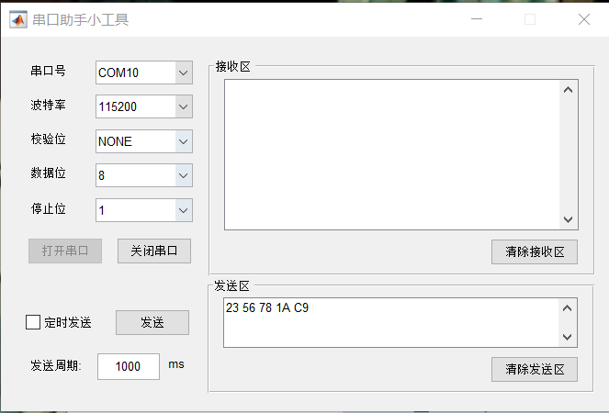
接收：
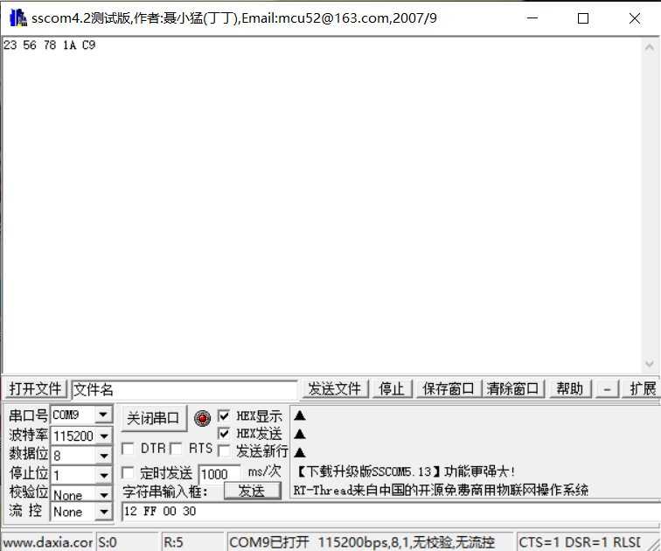

发送：
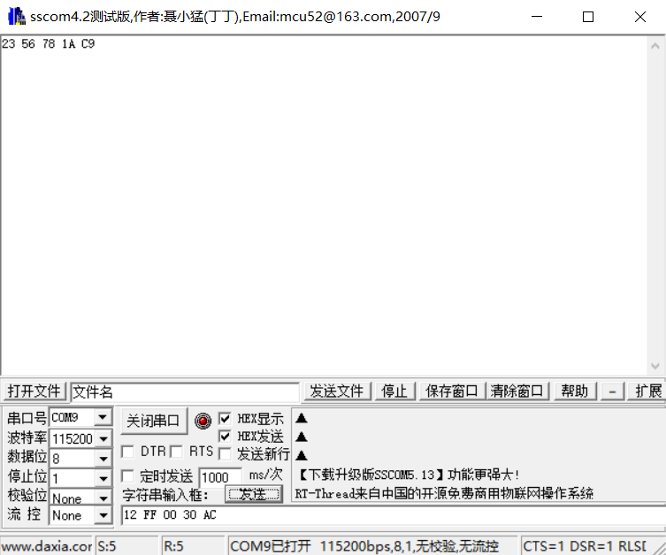
接收：
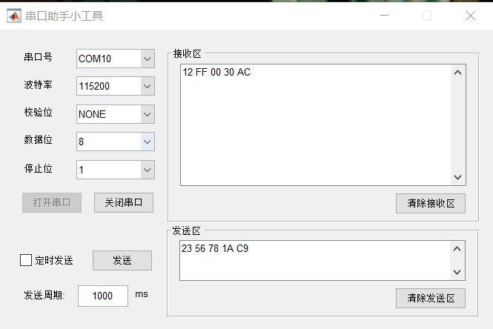

自动发送：
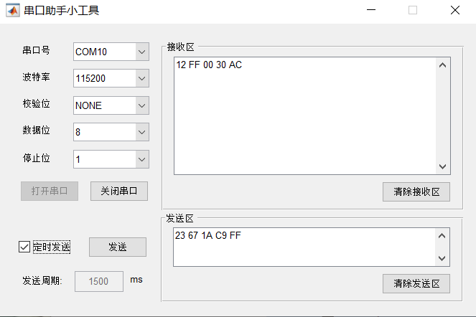
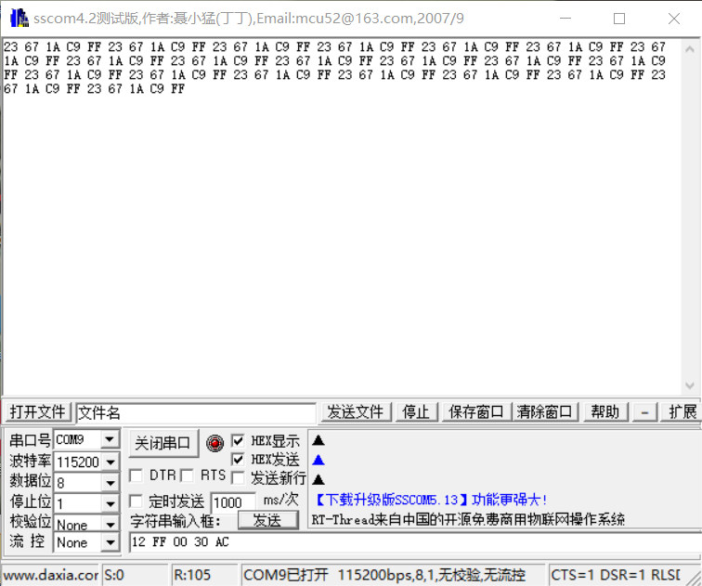

回答以下问题：
- 串口的传输速率用什么表示？传输速率的单位是什么？
串口的传输速率用波特率（Baud Rate）来表示，单位是波特（Baud）。波特率表示每秒传输的符号数或波特的数量，而不是每秒传输的比特数。

- 如果串口的数据位为8位，校验位为奇校验，停止位为1位，波特率为9600，计算每2ms最多可以发送多少字节数据？
计算每秒可以传输的符号数=波特率=9600个
比特数=log2​(数据位+1+校验位+停止位)，在这种情况下，比特数为log2​(8+1+1+1)=log2​(11)。数据的比特数为log2（8）=3
比特数/秒=符号数×比特数
在这种情况下，每秒可以传输 9600×log2(8)个比特。
比特数/2毫秒=500比特数/秒​
这里除以 500是因为 2毫秒是 1/500秒。
字节数/2毫秒=8比特数/2毫秒​
除以 8 ，因为每个字节有 8 位。
最终为每2ms最多可以发送log2(8)*9600/500/8=7.2个字节的数据

指导教师批阅意见：
实验报告内容完整性  （20分） |  |  | 实验数据准确性（程序与程序运行结果）（30分） |  |  | 实验结果分析及结论  （20分） |  |  | 实验报告（格式规范、按时完成）  （20分） |  |  |  | 实验态度（实验课考勤、实验表现）（10分）
完整  20% | 较完整  15  % | 不完整  10  % | 准确  30  % | 较准确  20  % | 不够准确  10  % | 正确  20  % | 较正确  10  % | 不正确  0  % |  | 规  范  20  % | 较规范  15  % | 不够规范  10  % | 好  10  % | 较好  5  % | 一  般  2  %

成绩评定：

指导教师签字：
年 月 日
备注：
注：1、报告内的项目或内容设置，可根据实际情况加以调整和补充。
2、教师批改学生实验报告时间应在学生提交实验报告时间后10日内。

