**ESTIMATION OF SEDIMENT AND PHOSPHORUS CONTRIBUTION FROM ERODING BANKS WITHIN THE NISHNABOTNA WATERSHED**

**Abstract**

Excess sediment and phosphorus (P) contributions from eroding banks are a significant impairment to aquatic systems that lead to loss of habitat, sedimentation of reservoirs, and eutrophic waters. Many studies have focused on constraining these fluxes within small watersheds, and estimating these fluxes within larger watersheds has remained difficult due to the inability to scale previous methods and the heterogeneous nature of bank erosion. Recent advances in remote sensing and GIS technology, as well as the development of the Aerial Image Migration Model (AIMM) provide us with an effective method for estimating bank erosion on large scales. In this study, the AIMM model was used in conjunction with 18 alluvial sediment cores to estimate the contribution of channel migration to the sediment and P budget of the Nishnabotna River in SW Iowa. On average, we found that between the years of 2009 and 2018 there was a net input of 8.7x108 kg of sediment and 4.1x105 kg of P sourced from channel migration per year within the Nishnabotna watershed. This equates to 380 kg of sediment and 0.18 kg of total P per meter of channel length analyzed. Our volume results also indicate that the proportional contribution to net volume loss by stream order increases sharply from third to sixth order, even though total channel length within the watershed displays the opposite trend. These results suggest that within the stream orders studied, large orders contribute more sediment and P than lower order reaches. This result suggests that future conservation and research that attempts to decrease riparian contributions to sediment and P budgets should focus on larger reaches than are currently considered.

**Introduction**

Excess sediment in rivers and streams is a major biological impairment that also decreases water clarity and increases the cost of water treatment (Bosch et al., 2008; Fox, Purvis, & Penn, 2016b; Purvis & Fox, 2016; A Simon & Klimetz, 2008). Additionally, excess sedimentation can lead to embedding of coarse substrate, the consequent loss of habitat for riverine invertebrates, and accelerated filling of reservoirs (Gray, Bieber, Mcdonnell, Chapman, & Mandrak, 2014; Quist & Schultz, 2014). Sediment also carries adsorbed pollutants, such as Phosphorus (P), which is a limiting nutrient within freshwater systems for the cyanobacteria that contribute to harmful algal blooms and the creation of coastal hypoxic zones (Conley, Daniel et al., 2009; Correll, 1998; Dodds & Smith, 2016).

These issues are particularly critical within the Midwestern region of the continental United States, where patterns of land use change related to production agriculture have led to increases in sediment and P flux to receiving waters (Schottler et al., 2014; Andrew Simon & Rinaldi, 2006). It has been shown that the Midwestern states are a major contributor to the hypoxic zone within the Gulf of Mexico (Carpenter et al., 2006). In order to address these issues, many states have adopted nutrient reduction strategies that seek to reduce Nitrogen (N), sediment and P loading from their watersheds. In order accomplish this goal however; it is important to fully understand the sources of sediment and P within watersheds.

An ever-expanding body of research suggests that bank erosion represents a significant source of sediment and P. Within the Midwestern United States, several studies have documented eroding bank contributions to annual sediment loads of 25–60%, and up to 80–96% (Beck et al., 2018; Belmont et al., 2011; Bosch et al., 2008; J. M. Hamlett, J. L. Baker, & H. P. Johnson, 2013; Mukundan, Radcliffe, Ritchie, Risse, & McKinley, 1999; Odgaard, 1987; Thoma, Gupta, Bauer, & Kirchoff, 2005; Wilkin & Hebel, 1982). These studies indicate that sediment and P fluxes from eroding banks are an important aspect of the riparian sediment budgets, and will need to be considered when seeking to reduce sediment and P loading rates. One major hurdle in quantifying these fluxes however is the large area over which bank erosion occurs. In the Nishnabotna watershed of southwest Iowa for example, there are over 2317 km of channel length contained within streams and rivers of Strahler order three and above. Unfortunately, the most common methods used to study bank erosion (pinning, ground-based LiDAR, and channel delineation using aerial photography) are prohibitively time-consuming when scaled to large watersheds with more than 1000 km of channel length. In a review by Fox et al. (2016a), only one study was reported that analyzed a watershed with more than 1000 km of channel length (Boynton, Garber, Summers, & Kemp, 1995). Also, due to heterogeneity in soil types, erodibility, hydrologic conditions, and land management, it is often inappropriate to extrapolate erosion estimates to reaches not found within the study area (Purvis & Fox, 2016). Consequently, a method for estimating bank erosion that can incorporate watershed heterogeneity and analyze large extents quickly would allow for a better estimation of eroding bank contributions to sediment and P budgets.

To accomplish this, we have developed the aerial imagery migration model (AIMM) (Chapter 2) (Figure 3.1). AIMM makes use of techniques found within previous channel migration models (Monegaglia, Zolezzi, Güneralp, Henshaw, & Tubino, 2018; Rowland et al., 2016), while also optimizing these technique for use with higher resolution aerial imagery. AIMM also combines an estimation of eroded area with a DEM analysis to calculate volumes of erosion. Specifically, the model uses Normalized Difference Water Index (NDWI) images derived from aerial photography to classify landscapes into zones of land and water. Water zones representing river and stream channels are then compared between two years to identify areas of erosion and deposition. Finally, AIMM utilizes a LiDAR-derived DEM to estimate the height of erosional and depositional zones in order to calculate the net change in channel volume. We have found this model’s results to be comparable to a change detection analysis based upon hand-delineation of channels, while also being more reproducible and efficient (Chapter 2).

The goal of this study is to quantify sediment and P loading rates within a large watershed using AIMM. Specifically, our study takes place within the Nishnabotna watershed, located in SW Iowa (Figure 3.2), which has a total watershed area of 7253 km2 and 2317 km of total channel length. The use of AIMM in conjunction with stratified randomized soil sampling provides an effective framework for estimating eroding bank sediment and P fluxes on large scales. Additionally, AIMM’s low computational requirements in comparison to other channel migration models, use of publicly available data, and reproducibility make it one of the most effective methods for analyzing bank erosion on large temporal and spatial scales.

**Methods**

**Study Area**

The Nishnabotna watershed is composed of the East and West Nishnabotna Watersheds, HUC 8 watersheds located in southwestern Iowa that have watershed areas of 2,975 km2 and 4,277 km2 respectively (Figure 3.2). These watersheds are composed of Pre-Illinoian Till overlain by loess that was blown east from the Missouri River floodplain during the retreat of Wisconsinan ice sheets (Yahner, 2016). This loess ranges in thickness from 47 m to 62 m and decreases in thickness as you move east (Bettis III, 1990). The channel banks of the Nishnabotna watershed are composed of the DeForest Formation, which itself is composed of three main members: the Camp Creek, Roberts Creek, and Gunder Member (Bettis, 1990). The Gunder Member is composed of oxidized silty and loamy material that is relatively cohesive, and often represents the modern channel bottom. The Roberts and Camp Creek members are both silty and loamy alluvium that are highly erodible. Channel networks are young, and both bank and gully erosion are major conservation issues within the watershed (Thomas, Iverson, Burkart, & Kramer, 2004; Tomer & James, 2004).

**Field and Laboratory Methods**

In order to estimate the sediment and P inputs associated with eroding banks, it was necessary to obtain a representative sample of bank material so that soil bulk density and P concentration could be constrained. To ensure a well-distributed sample population, three coring sites were randomly selected within each stream order present in the watershed (1st order-6th order), for a total of 18 cores (Figure 3.3). Cores were collected on November 6th-9th, and December 8th, of 2017 using a truck-mounted Giddings Probe at sites no more than 5 m from actively eroding banks. Sample stratification by order was included in order to serve as proxy for variations in stream power and channel geometry, both of which have large influences on the channel migration regime within a watershed. Core lengths ranged from 3-5 m and corresponded to the height of the eroding bank from which they were taken. All cores were transported to a lab setting where they were described, classified into the three members of the DeForest Formation, and subsampled at the top, base and at every 0.5 m interval within each member. These samples were then analyzed to identify their bulk density, Total Phosphorus (TP) content, and particle size distribution. In addition to these samples, nine exploratory samples were collected outside of Oakland, IA no more than 20 cm below ground level in order to provide a preliminary estimate of soil TP concentrations.

Bulk density was measured by extracting duplicate 2 cm cylinders at each sample depth, oven drying these samples at 105º C for a minimum of 24 hours, and until their weight had stabilized to determine dry weight. Dry weight of samples was then divided by core volume to calculate bulk density. Total Phosphorus samples were analyzed using the aqua regia method (McGrath & Cunliffe, 1985), and particle size analysis was performed using laser diffractometry (B. A. Miller & Schaetzl, 2011).

**Imagery**

Our analysis was conducted using color infrared photographic imagery of western Iowa from 2009 and 2018 (Iowa DNR, 2009 and 2018). The state of Iowa has conducted aerial photographic surveys for many recent years but has varied the season in which these surveys were conducted. The 2009 and 2018 imagery were selected because they are the two most recent surveys that were conducted during leaf-off conditions. Leaf-off conditions were desired because riparian tree cover limits the accuracy of both hand-delineation and AIMM methods. The 2009 survey was conducted by the Iowa DNR during the spring of 2009, with a Lecia ADS80-SH82 and ADS40-SH51 digital cameras at a flight height of 6100 m agl. Images in GeoTIFF format were georectified, cut into a tiled grid, and then converted to county mosaics in MrSid format with 0.61 m (2 ft) spatial resolution. The measured positional horizontal accuracy of these images is 3 m at a 95% confidence interval. The 2018 survey was conducted by Surdex on the behalf of the Iowa Department of Administrative Services between April 19th and May 5th with a Leica ADS100 Airborne Digital Sensor at a flight altitude of 3750 m agl. The imagery was mosaiced from ADS100 imagery strips, corrected and orthorectified using Surdex’s proprietary “Grouping Tool”, and split into 1524 m by 1524 m GeoTIFF tiles with 0.30 m (1 ft) spatial resolution. The measured positional horizontal accuracy of these images is 0.61 m at a 95% confidence interval.

**AIMM**

The AIMM model described in Chapter 2 was used to estimate the volume of sediment loss associated with the lateral migration of the Nishnabotna River System. When AIMM was run for the entire watershed however, it was found that a single NDWI threshold for the entire watershed over-generalized and did not produce reasonable results. To overcome this, each county was analyzed separately then combined for the final analysis. Training data was collected by obtaining a random selection of NDWI values that fell within a training mask of the watershed. This training mask was created by buffering stream centerlines, provided by the Iowa DNR, by stream order, with a width equal to the average stream width of each order respectively, as measured by our hand delineations. The training mask was used to balance the number of water and non-water pixels found within the training set.

Stream reaches at the eighteen coring sites, along with an additional stratified random sample of eighteen reaches were hand-delineated in order to check the consistency of AIMM (Figure 3.3). Due to inadequate spatial resolution of the imagery, high proportions of canopy cover, and low lateral migration rates, neither AIMM nor hand-delineations could reliably detect channel migration in reaches of order two or less. Consequently, these reaches were excluded from the analysis, lowering the total number of sample reaches to twenty-four, ranging in order from six to three. Hand delineation was conducted at a scale of 1:2000, in keeping with the methods of Tomer and Van Horn (Tomer & Van Horn, 2018). The comparison of the hand-delineation results and AIMM’s results are reported in terms of percent agreement and Cohen’s Kappa for each reach, and a global average normalized to each order’s contribution to the total watershed erosion are reported. Percent agreement is equal to the percent of cells which were classified as the same category (stable land, stable channel, erosion, or deposition), and Cohen’s Kappa is a metric that is designed assess the amount of agreement between two classifications that are not likely due to chance (Flight & Julious, 2015). Both of these statistics were calculated within a two-channel-width buffer surrounding the reach in questions. Net volume loss comparisons are presented in terms of percent deviation from the result of the delineation efforts and are grouped in the same manner.

**Results**

Soil bulk density (n = 229) averaged 1.38 g/cm with a standard deviation of ± 0.2 g/cm (Figure 3.4). Although bulk density varied slightly by stream order (1.30 – 1.46 g/cm), there was no consistent pattern in this variation, and all ordered averages fell within one standard deviation of each other. Due to this lack of a large variation between stream orders, the total average value for bulk density was used in conjunction with our volume analysis to estimate net sediment loss from eroding banks. Although the full results from our total P analysis are not yet available, results from our preliminary samples (n = 9) had total P concentrations of 474 mg/kg with a standard deviation of ± 117 mg/kg and were used for estimating P flux.

In order to better understand the sources of disagreement between AIMM and hand delineation methods, we compared AIMM’s identification of the four change-detection categories (stable land, stable channel, erosion, and deposition), as well as its final estimate of eroded volume. For this comparison, all sites were grouped by order, normalized so that their influence upon the comparison results was proportional to the amount of net erosional volume each order contributed to the watershed. This ensured that contribution to our comparison statistics was proportional to each order’s influence within the watershed. Within a two-channel-width buffer of each delineation reach, AIMM and hand delineation agreed on pixel values 85% of the time with an inter-operator Cohen’s K coefficient of 0.71. As expected, agreement and K increased with stream order. Agreement for sixth and third order reaches were 89% and 78% respectively, while K values were 0.79 and 0.52 respectively. Overall, these differences represented a -6%, 134%, -13%, and 7% difference between AIMM and hand delineation for the pixel classes stable land, deposition, erosion, and stable channel respectively. A large portion of the difference in the deposition pixel counts can however be attributed to erroneous off-channel zones of deposition that were removed when all zones that did not intersect a channel width buffer of our stream layer were eliminated as part of our volume analysis.

When combined and normalized, AIMM predicted 7% less net volume loss than hand-delineation methods within our 24 test reaches (Table 3.1). Most of this disagreement was within third order reaches, where AIMM predicted 99% less volume loss than was predicted by hand delineation (Figure 3.5), (Figure 3.6). Since both methods are prone to higher error as channel sizes decrease, and our 24 sample sites represent a smaller proportion of total third-order channel length however, it is unsurprising that the methods began to diverge when third-order streams were considered. When only orders six through four are consider, there is only a 1% difference in net volume estimates, but we have decided to keep third-order results in our analysis since we believe that a 7% difference in net eroded volume is still a reasonable amount of disagreement.

Overall, AIMM predicted 5.7x106 m3 of net volume loss between 2009 and 2018 within the Nishnabotna watershed (Table 3.2). This represents 0.27 m3 yr-1 of volume loss per meter of channel length. Interestingly, although the third, fourth, and fifth order channels made up 89% of the total channel length analyzed, only 37% of the net volume loss was found within these orders. In contrast, the sixth order reach contained only 11% of the total length, but 63% of the volume loss (Figure 3.7). This is likely due to the large increase in stream power and bank height that is associated with increases in order. Although it was expected that higher orders would have a greater volume of erosion per unit length, the fact that this relationship is still robust when the total length of each order is considered is surprising. This inverse relationship between total channel length and volumetric contribution amongst orders is a key finding of this study that could have important management implications.

Since there were no identified variations in bulk density or TP concentration associated with stream order, global averages were used to calculate sediment and TP contributions per unit length. This study found that 0.38 tons of sediment m-1yr-1 and 0.18 kg of P m-1yr-1 were contributed to the Nishnabotna watershed due to the net loss of floodplain volume associated with channel migration within channels of order three and above.

**Discussion**

We found that within the Nishnabotna watershed, sediment and TP loading rates associated with net bank erosion (volume of bank erosion less the volume of deposition) were equal to 0.38 tons of sediment m-1yr-1 and 0.18 kg of P m-1yr-1 between the years of 2009 and 2018. We found that our average bulk density values conformed well with recent studies involving these members, but we did find less variation between the individual members than has been found in previous studies (Beck et al., 2018). This however could be attributed to both differing methodologies, and spatial variations. Also, although our TP results are only preliminary it is interesting to note that TP concentrations were found to be double the average value found by (Fox et al., 2016b), or by (Beck et al., 2018) for streambank material. Especially since our preliminary samples were taken from the Robert’s and Camp Creek members, which were found to have the lower TP values of the three primary members by (Beck et al., 2018).

Also, since previous studies which do not often account for channel accretion when calculating input from eroding banks, we would also to like to highlight the contribution of eroding banks when accretion is not considered. When only erosive input is considered, our approach estimates total P inputs to be 0.27 kg P m-1yr-1. This result is comparable, albeit higher than the values reported in previous studies (Kronvang, Audet, Baattrup-Pedersen, Jensen, & Larsen, 2012; R. B. Miller et al., 2014; Purvis & Fox, 2016; Sekely, Mulla, & Bauer, 2002; Zaimes, Schultz, & Isenhart, 2008), with the exception of Miller et al (2014), which reported a total P contribution of 1.6 kg P m-1yr-1 (Table 3.3). This is fourteen times greater than average of all other referenced studies (0.12 kg P m-1yr-1). In particular, it is encouraging to see that our results conform to previous work; given that the Nishnabotna river system has a total channel length two orders of magnitude larger than the next largest study cited.

Finally, an important finding of this study is that the proportional contribution to net volume loss by stream order is inversely related to the total channel length of each order (Figure 3.7). It is important to note however that this is only known for sediment and TP inputs related to channel migration and does not include the effects of other geomorphic processes such as down-cutting and gully head migration. Neither AIMM, hand delineation, nor pinning methods are well suited to observe these processes but repeat aerial LiDAR could offer a way to quantify these aspects of the erosional system. Since most streambank erosion studies and bank stabilization projects have been conducted in low order streams where issues related to access, mobility and land ownership patterns are easier to overcome however, these results represent a timely reminder of the importance of higher order reaches. Furthermore, this study indicates, that future work concerning streambank erosion will need to consider larger stream orders and watersheds if accurate patterns and magnitudes of streambank erosion are to be reported.

**Conclusion**

In this study, the AIMM model was used in conjunction with a random sample of 18 sample cores, stratified by stream order, to estimate channel migration’s contribution to the sediment and P budget of the Nishnabotna River in SW Iowa. On average, we found that 0.38 tons of sediment and 0.18 kg of P were added to the Nishnabotna watershed per year per meter of channel length between the years of 2009 and 2018. These values fell within the range found in previous studies, even though the Nishnabotna watershed is orders of magnitude larger than the watersheds considered in previous studies. As this is the first time the AIMM model has been used to predict sediment and total P contributions of eroding banks within a large watershed, we also suggest that this study represents an efficient method for constraining contributions from streambanks to watershed sediment and nutrient budgets. Finally, our volume results also indicate that the proportional contribution to net volume loss by stream order is inversely related to the total channel length of each order within the watershed. These results suggest that future conservation and research that attempts to decrease riparian contributions to sediment and P budgets should focus on larger reaches than are commonly considered.

**Figures**

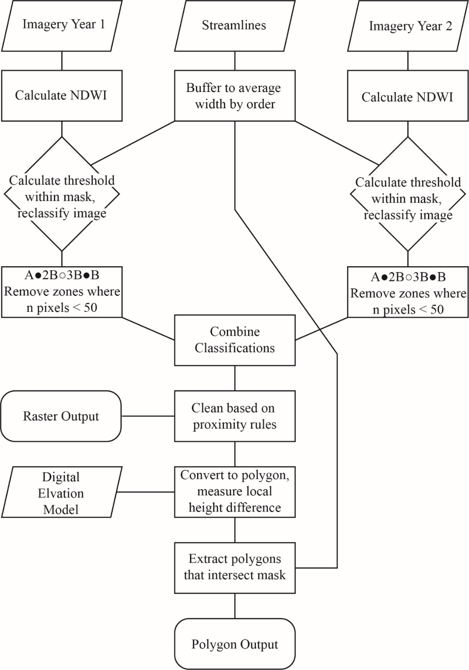

Figure 3.1 AIMM flowchart

. AIMM requires four inputs (two aerial images, a DEM, and a centerline file) and produces a raster and polygonal output. AIMM can be broken down into three primary steps: i) thresholding of an NDWI image ii) overlaying the two binary images to measure migration iii) measuring local height difference around each erosional and depositional polygon.

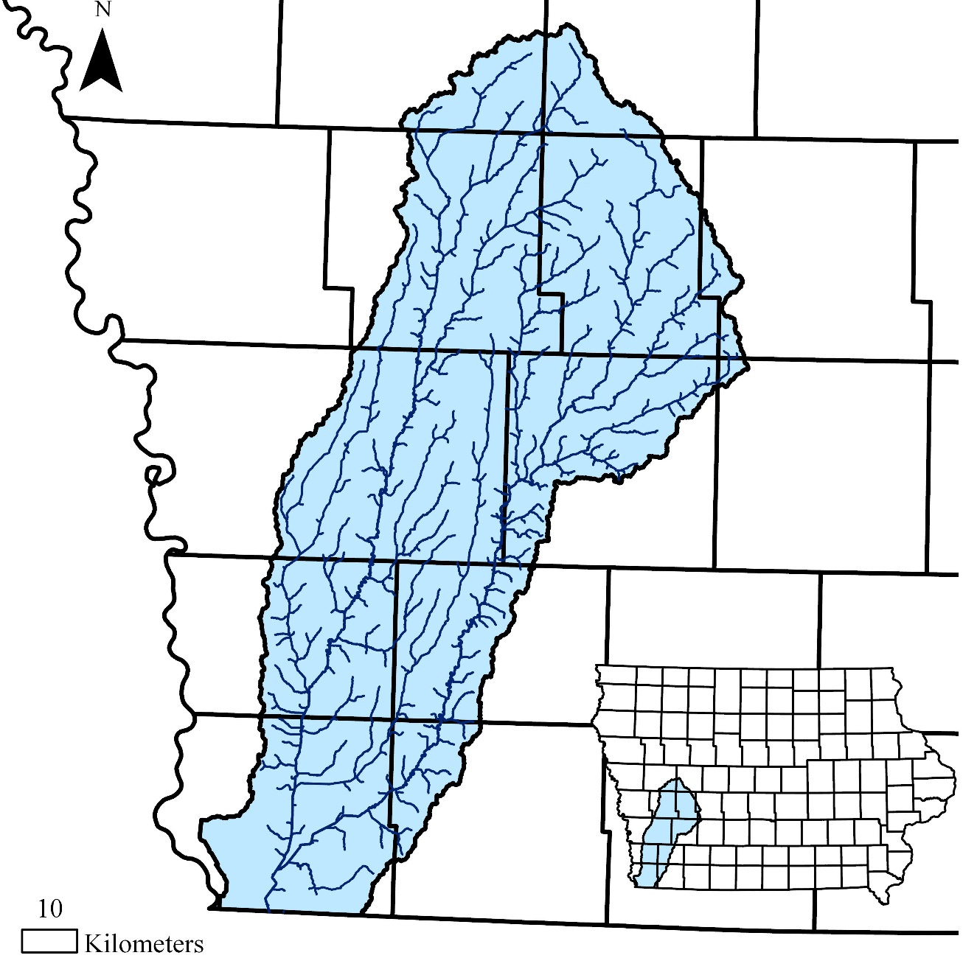

Figure 3.2 Watershed map

. The Nishnabotna watershed is composed of the East and West Nishnabotna river systems. Its soils are dominated by loess, which was blown east from the Missouri river valley.

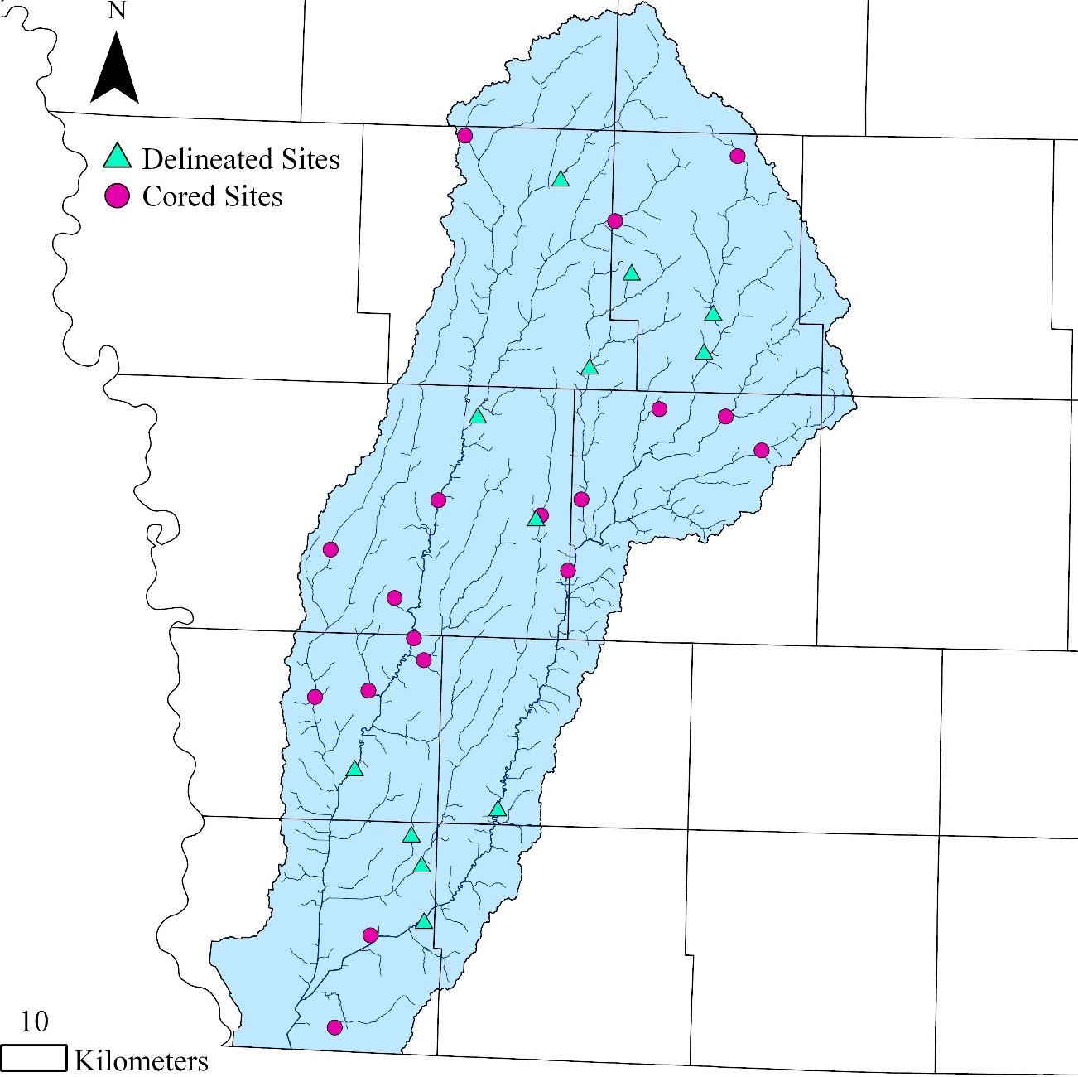

Figure 3.3 Sample sites

. Eighteen randomly selected sites (3 x stream orders 1-6) were cored and delineated, and an additional twelve sites (3 x stream orders 3-6) were delineated in order make a more robust estimation of AIMM’s agreement with hand delineation methods.

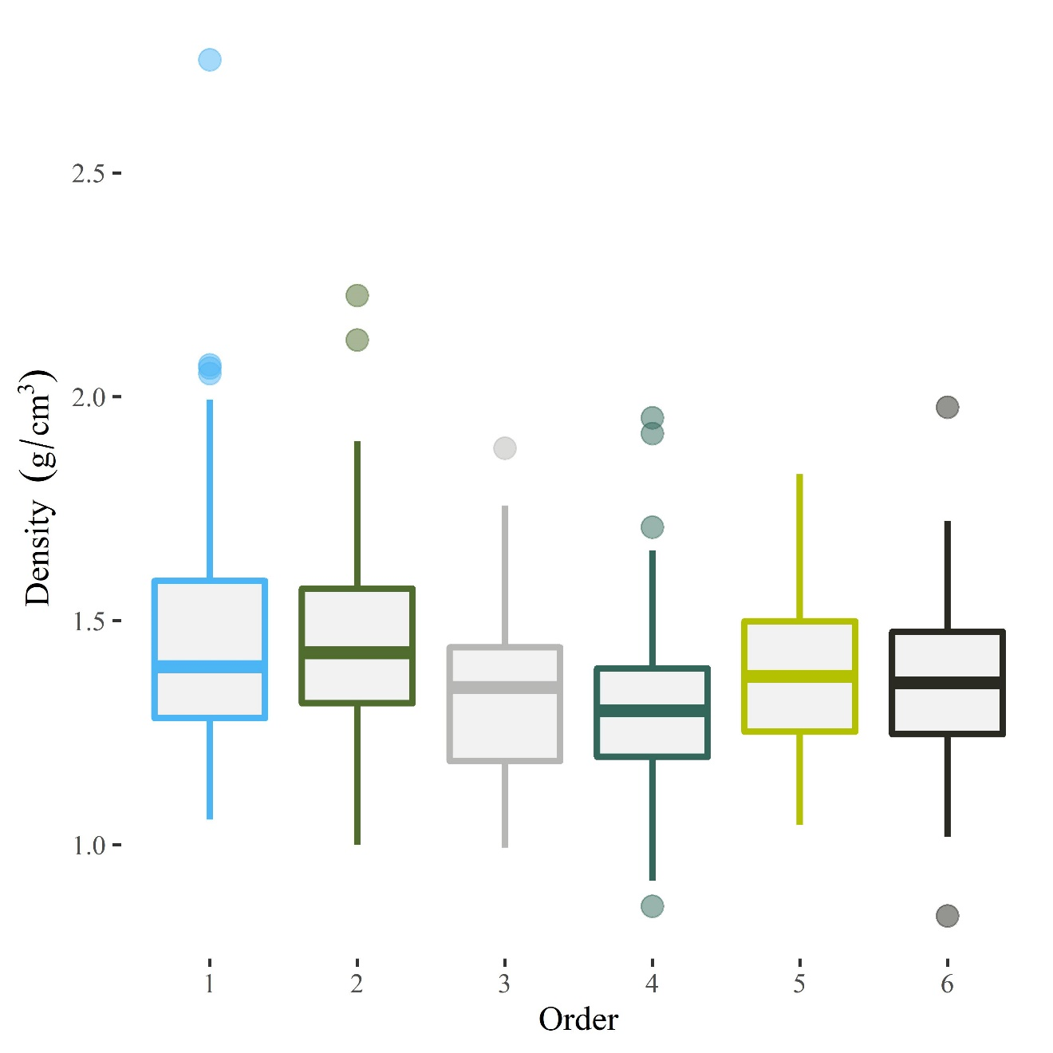

Figure 3.4 Soil density by stream order

. The median value for every order was found to be within one standard deviation of every other stream order. Consequently, a global average for bulk density was used within our erosion analysis.

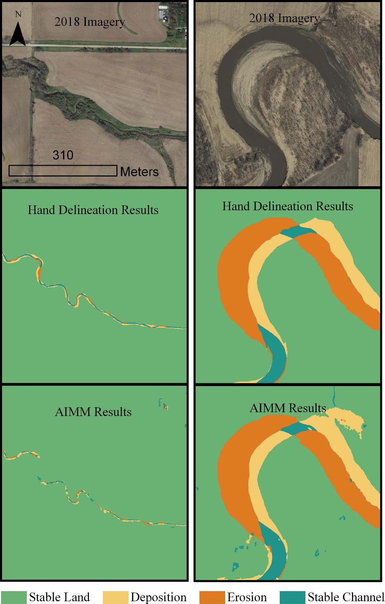

Figure 3.5 AIMM's effectiveness within high and low orders

. AIMM was much more effective within higher orders. This is likely because higher order streams are typically wider, and are less likely to be obscured by tree cover.

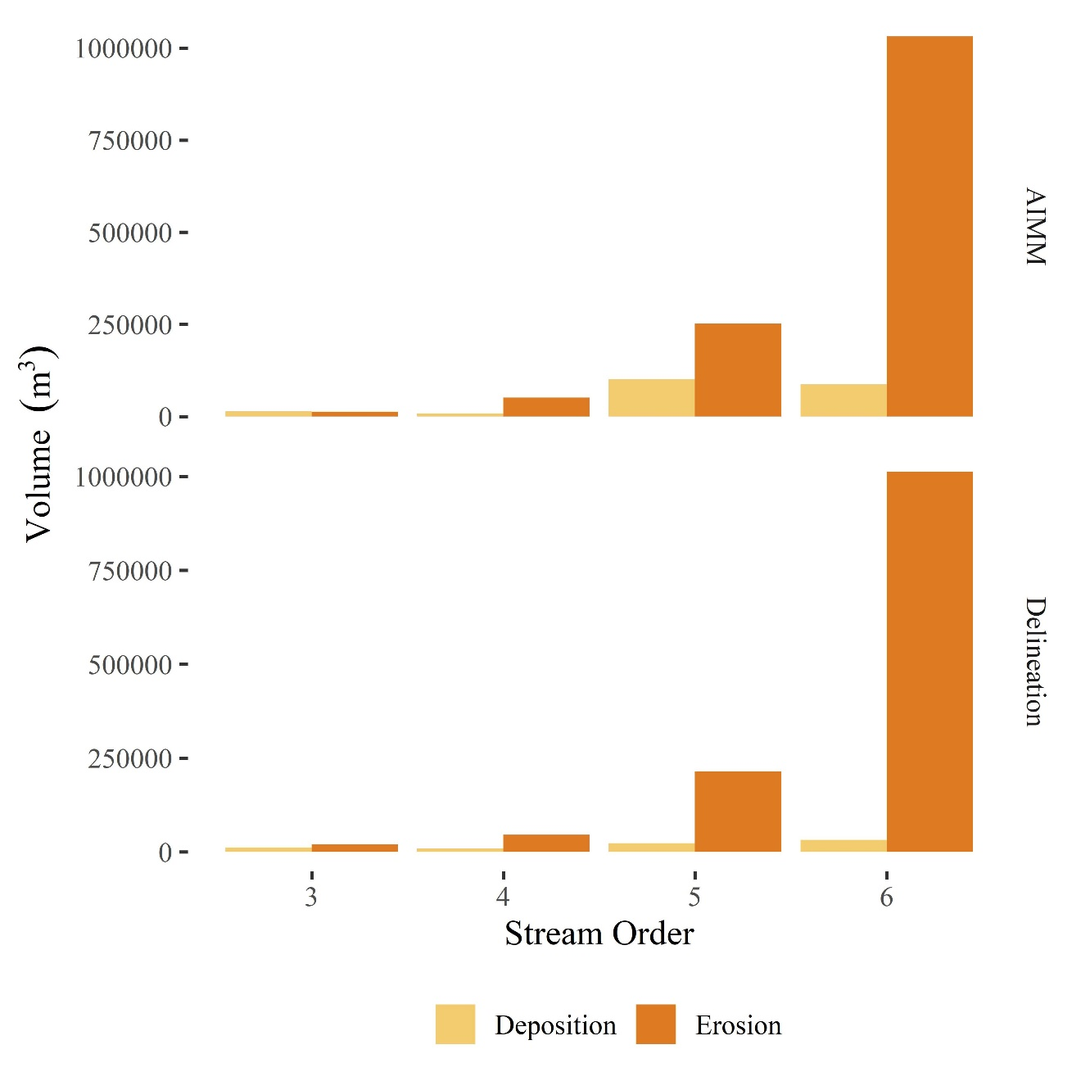

Figure 3.6 AIMM and delineation volume results by order

. Estimations of erosion were consistent between both methods, and AIMM tended to provide a higher estimation of deposition, particularly within third order reaches.

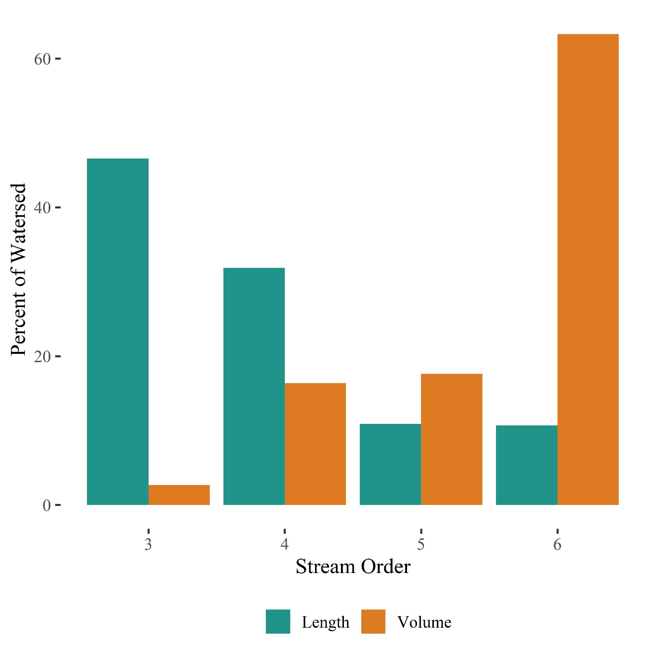

Figure 3.7 Comparison of watershed length and erosional contribution by order

. Although smaller orders dominate the watershed in terms of length, the higher orders contribute much more erosional volume

**Tables**

Table 3.1 Estimation of erosional volume disagreement between methods

. Overall, AIMM estimated there to be 8% less erosional volume than was predicted by hand delineation within the twenty-four test reaches.

|  |  |  |  |  |  |  |
| --- | --- | --- | --- | --- | --- | --- |
|  | Net Volume Change per Channel Length (m3/m) | | |  |  |  |
| Order | Delineation | | AIMM | % Disagreement | Order Weight | % Weighted Disagreement |
| 3 | -0.69 | | 0.0045 | 101% | 0.08 | 8% |
| 4 | -2.3 | | -3.1 | -36% | 0.18 | -6% |
| 5 | -6.8 | | -5.4 | 20% | 0.18 | 4% |
| 6 | -22 | | -21 | 3% | 0.57 | 2% |
|  |  | Weighted Net Volume Change Disagreement | | | | 7% |

Table 3.2 AIMM estimated erosion and deposition by order

|  |  |  |  |  |
| --- | --- | --- | --- | --- |
| Order | Total Length in Watershed (km) | Deposition (m3) | Erosion (m3) | Net (m3) |
| 3 | 1079 | 495675 | -649368 | -153693 |
| 4 | 738 | 1100688 | -2032272 | -931584 |
| 5 | 252 | 755171 | -1755537 | -1000365 |
| 6 | 248 | 545607 | -4141664 | -3596057 |

Table 3.3 Phosphorus contribution estimates from literature

|  |  |  |  |
| --- | --- | --- | --- |
| Author | Channel length (km) | P load from banks (kg yr−1) | P load (kg m-1 yr-1) |
| Boynton et al. (1995) | 11000 | 430000 | 0.039 |
| Kronvang et al. (1997) | Not Provided | 100 |  |
| Sekely et al. (2002) | 170 | 3000 | 0.02 |
| Thoma et al. (2005) | 56 | 200000 | 0.05 |
| Zaimes et al 2008a Zaimes et al. 2008b | Various | 20 |  |
| Kronvang et al. (2012) | 60 | 4600 | 0.08 |
| Miller et al. (2014) | 56 | 90000 | 1.6 |
| Purvis et al. (2016) | 32 | 10000 | 0.31 |
| Ishee et al. (2015) | Various | 200 |  |
| Chapter 3 | 2317 | 628827 | 0.27 |

**References**

Beck, W., Isenhart, T., Moore, P., Schilling, K., Schultz, R., & Tomer, M. (2018). Streambank alluvial unit contributions to suspended sediment and total phosphorus loads, walnut Creek, Iowa, USA. *Water (Switzerland)*, *10*(2). https://doi.org/10.3390/w10020111

Belmont, P., Gran, K. B., Schottler, S. P., Wilcock, P. R., Day, S. S., Jennings, C., … Parker, G. (2011). Large shift in source of fine sediment in the upper Mississippi River. *Environmental Science and Technology*, *45*(20), 8804–8810. https://doi.org/10.1021/es2019109

Bettis, E. A. I. (1990). *Holocene Alluvial Stratigraphy and Selected Aspects of the Quaternary History of Western Iowa*.

Bettis III, E. A. (1990). Holocene Alluvial Stratigraphy and Selected Aspects of the Quaternary History of Western Iowa: Guidebook for the 37th Field Conference of the Midwest Friends of the Pleistocene. In *Iowa Department of Natural Resources, Geological Survey Bureau, Iowa City, IA*. Retrieved from http://publications.iowa.gov/25601/

Bosch, D. D., Kuhnle, R. A., Steiner, J. L., Wilson, G. V., Starks, P. J., Tomer, M. D., & Wilson, C. G. (2008). Quantifying relative contributions from sediment sources in Conservation Effects Assessment Project watersheds. *Journal of Soil and Water Conservation*, *63*(6), 523–532. https://doi.org/10.2489/jswc.63.6.523

Boynton, W. R., Garber, J. H., Summers, R., & Kemp, W. M. (1995). Inputs, Transformations, and Transport of Nitrogen and Phosphorus in Chesapeake Bay and Selected Tributaries. *Estuaries*, *18*(1), 285. https://doi.org/10.2307/1352640

Carpenter, S. R., Smith, V. H., Correll, D. L., Caraco, N. F., Howarth, R. W., & Sharpley, A. N. (2006). Nonpoint Pollution of Surface Waters with Phosphorus and Nitrogen. *Ecological Applications*, *8*(3), 559. https://doi.org/10.2307/2641247

Conley, Daniel, J., Paerl, H. W., Howart, Robert, W., Boesch, Donald, F., Seitzinger, Sybil, P., Havens, Karl, E., & Lancelot, Christiane, Likens, Gene, E. (2009). Controlling Eutrophication: Nitrogen and Phosphorus. *Science*, *323*, 1014–1015. https://doi.org/10.1126/science.1167755

Correll, D. L. (1998). (1998) Role of Phosphorus in the Eutrophication of Receiving Waters: A Review, The. *Journal of Environment Quality*, *27*(2), 261–266. https://doi.org/10.2134/jeq1998.00472425002700020004x

Dodds, W., & Smith, V. (2016). Nitrogen, phosphorus, and eutrophication in streams. *Inland Waters*, *6*(2), 155–164. https://doi.org/10.5268/IW-6.2.909

Flight, L., & Julious, S. A. (2015). The disagreeable behaviour of the kappa statistic. *Pharmaceutical Statistics*, *14*(1), 74–78. https://doi.org/10.1002/pst.1659

Fox, G. A., Purvis, R. A., & Penn, C. J. (2016a). Streambanks: A net source of sediment and phosphorus to streams and rivers. *Journal of Environmental Management*, *181*, 602–614. https://doi.org/10.1016/j.jenvman.2016.06.071

Fox, G. A., Purvis, R. A., & Penn, C. J. (2016b, October 1). Streambanks: A net source of sediment and phosphorus to streams and rivers. *Journal of Environmental Management*, Vol. 181, pp. 602–614. https://doi.org/10.1016/j.jenvman.2016.06.071

Gray, S. M., Bieber, F. M. E., Mcdonnell, laura H., Chapman, lauren J., & Mandrak, N. E. (2014). Experimental evidence for species-specific response to turbidity in imperilled fishes. *Aquatic Conservation: Marine and Freshwater Ecosystems*, *24*(4), 546–560. https://doi.org/10.1002/aqc.2436

J. M. Hamlett, J. L. Baker, & H. P. Johnson. (2013). Channel Morphology Changes and Sediment Yield for a Small Agricultural Watershed in Iowa. *Transactions of the ASAE*, *26*(5), 1390–1396. https://doi.org/10.13031/2013.34138

Kronvang, B., Audet, J., Baattrup-Pedersen, A., Jensen, H. S., & Larsen, S. E. (2012). Phosphorus load to surface water from bank erosion in a Danish lowland river basin. *Journal of Environmental Quality*, *41*(2), 304–313. https://doi.org/10.2134/jeq2010.0434

McGrath, S. P., & Cunliffe, C. H. (1985). A simplified method for the extraction of the metals Fe, Zn, Cu, Ni, Cd, Pb, Cr, Co and Mn from soils and sewage sludges. *Journal of the Science of Food and Agriculture*, *36*(9), 794–798. https://doi.org/10.1002/jsfa.2740360906

Miller, B. A., & Schaetzl, R. J. (2011). *Precision of Soil Particle Size Analysis using Laser Diffractometry*. https://doi.org/10.2136/sssaj2011.0303

Miller, R. B., Fox, G. A., Penn, C. J., Wilson, S., Parnell, A., Purvis, R. A., & Criswell, K. (2014). Estimating sediment and phosphorus loads from streambanks with and without riparian protection. *Agriculture, Ecosystems & Environment*, *189*, 70–81. https://doi.org/10.1016/J.AGEE.2014.03.016

Monegaglia, F., Zolezzi, G., Güneralp, I., Henshaw, A. J., & Tubino, M. (2018). Automated extraction of meandering river morphodynamics from multitemporal remotely sensed data. *Environmental Modelling and Software*, *105*, 171–186. https://doi.org/10.1016/j.envsoft.2018.03.028

Mukundan, R., Radcliffe, D. E., Ritchie, J. C., Risse, L. M., & McKinley, R. a. (1999). Sediment fingerprinting to determine the source of suspended sediment in a southern Piedmont stream. *Journal of Environmental Quality*, *39*(4), 1328–1337. https://doi.org/10.2134/jeq2009.0405

Odgaard, A. J. (1987). Streambank erosion along two rivers in Iowa. *Water Resources Research*, *23*(7), 1225–1236. https://doi.org/10.1029/WR023i007p01225

Purvis, R. A., & Fox, G. A. (2016). Streambank sediment loading rates at the watershed scale and the benefit of riparian protection. *Earth Surface Processes and Landforms*, *41*(10), 1327–1336. https://doi.org/10.1002/esp.3901

Quist, M. C., & Schultz, R. D. (2014). Effects of management legacies on stream fish and aquatic benthic macroinvertebrate assemblages. *Environmental Management*, *54*(3), 449–464. https://doi.org/10.1007/s00267-014-0309-8

Rowland, J. C., Shelef, E., Pope, P. A., Muss, J., Gangodagamage, C., Brumby, S. P., & Wilson, C. J. (2016). A morphology independent methodology for quantifying planview river change and characteristics from remotely sensed imagery. *Remote Sensing of Environment*, *184*, 212–228. https://doi.org/10.1016/j.rse.2016.07.005

Schottler, S. P., Ulrich, J., Belmont, P., Moore, R., Lauer, J. W., Engstrom, D. R., & Almendinger, J. E. (2014). Twentieth century agricultural drainage creates more erosive rivers. *Hydrological Processes*, *28*(4), 1951–1961. https://doi.org/10.1002/hyp.9738

Sekely, A. C., Mulla, D. J., & Bauer, D. W. (2002). Streambank slumping and its contribution to the phosphorus and suspended sediment loads of the Blue Earth River, Minnesota. *Journal of Soil and Water Conservation*, *57*(October), 243–250.

Simon, A, & Klimetz, L. (2008). Relative magnitudes and sources of sediment in benchmark watersheds of the Conservation Effects Assessment Project. *Journal of Soil and Water Conservation*, *63*(6), 504–522. https://doi.org/10.2489/jswc.63.6.504

Simon, Andrew, & Rinaldi, M. (2006). Disturbance, stream incision, and channel evolution: The roles of excess transport capacity and boundary materials in controlling channel response. *Geomorphology*, *79*(3–4), 361–383. https://doi.org/10.1016/j.geomorph.2006.06.037

Thoma, D. P., Gupta, S. C., Bauer, M. E., & Kirchoff, C. E. (2005). Airborne laser scanning for riverbank erosion assessment. *Remote Sensing of Environment*, *95*(4), 493–501. https://doi.org/10.1016/j.rse.2005.01.012

Thomas, J. T., Iverson, N. R., Burkart, M. R., & Kramer, L. A. (2004). Long-term growth of a valley-bottom gully, Western Iowa. *Earth Surface Processes and Landforms*, *29*(8), 995–1009. https://doi.org/10.1002/esp.1084

Tomer, M. D., & James, D. E. (2004). Do soil surveys and terrain analyses identify similar priority sites for conservation? *Soil Science Society of America Journal*, *68*(6), 1905–1915. https://doi.org/10.2136/sssaj2004.1905

Tomer, M. D., & Van Horn, J. D. (2018). Stream bank and sediment movement associated with 2008 flooding, South Fork Iowa River. *Journal of Soil and Water Conservation*, *73*(2), 97–106. https://doi.org/10.2489/jswc.73.2.97

Wilkin, D. C., & Hebel, S. J. (1982). Erosion, redeposition, and delivery of sediment to midwestern streams. *Water Resources Research*, *18*(4), 1278–1282. https://doi.org/10.1029/WR018i004p01278

Yahner, T. (2016). LANDFORMS OF IOWA. *Landscape Journal*, *12*(2), 197–198. https://doi.org/10.3368/lj.12.2.197

Zaimes, G. N., Schultz, R. C., & Isenhart, T. M. (2008). Streambank soil and phosphorus losses under different riparian land-uses in Iowa. *Journal of the American Water Resources Association*, *44*(4), 935–947. https://doi.org/10.1111/j.1752-1688.2008.00210.x