## Results

### Soil Analyses

In total eighteen eroding bank sediment cores, and eighteen channel deposit samples were obtained for analysis and were assessed to determine their TP content and bulk density. All confidence intervals for soil analyses are reported in terms of standard error. According to an ANOVA test, both sets of samples showed significant variation in TP content by stream order. For erosional banks, first order samples had the lowest mean TP content (245 ± 20 mg/kg), and fourth order samples had the highest (587 ± 66 mg/kg). In general, eroding bank TP content increased from first to fourth order, then decreased from fourth to six (Figure 1). Both fifth and sixth order samples had TP concentrations that were less than third order, but greater than second order. Depositional feature samples generally decreased in TP content from first (505 ± 72 mg/kg) to sixth order (235 ± 40). There was no significant difference in TP content between erosional and depositional samples, but depositional samples had higher TP content in first and second order samples, and lower TP content in all other orders.

Unlike TP content, there was a significant difference in bulk density between erosional and depositional features (Figure 2). On average, erosional samples were 3.5 times denser. While this is a large difference, it is unsurprising since the erosional samples are made of Holocene alluvial and glacial materials that have undergone a high degree of compaction, and the deposition samples represent relatively young, freshly eroded sediments that are unlikely to have experienced significant compaction since their deposition. Variations in bulk density by stream order were also significant for both feature types. For erosional banks, the highest average bulk densities were found in first and sixth orders (1.29 ± 0.3 and 1.30 ± 0.4 g/cm3 respectively), while the lowest average bulk density was found in the fourth order (1.15 ± 0.3 g/cm3). The peak in TP content and a low point in bulk density average within the fourth order erosion samples is an interesting result of this analysis. The depositional samples displayed a steady increase in average bulk density with increasing stream order from first (0.26 ± 0.02 g/cm3) to fifth (0.40 ± 0.1) order, but slightly decreased from fifth to sixth order.

### AIMM results

Our initial investigations of the AIMM results within the first and second order reaches of the Nishnabotna river system suggested that the one-meter resolution of the imagery combined with the relatively narrow width and large influence of canopy cover led to inaccurate results within these reaches. Consequently, we decided to exclude these reaches from our analysis, and will focus on stream orders three and above for the remainder of this paper. All confidence intervals for channel input estimates are reported in terms of a propagation of error analysis.

During the nine-year study period from 2009 to 2018, our analysis estimates that river migration contributed a net sediment volume of (1.17 ± 0.47) x 107 m3 to the Nishnabotna River system. When combined with our soil analyses, this corresponds to a net input of (1.81 ± 0.57) x 107 Mg of sediment and (8.26 ± 2.5) x 103 Mg of P. While a full sediment budget is beyond the scope of this paper, the results of the Daily Erosion Project (DEP) (Gelder et al., 2018), an event-based implementation of the WEPP model for Iowa, can be used to contextualize these results. For the same time period, the DEP model estimates that the total mass of surface erosion within the Nishnabotna River system was 8.95 x 107 Mg, which when combined with a sediment delivery ratio of 33%, results in a total sediment contribution from on-field sources of 2.95 x 107 Mg. If we assume that channel migration and on-field erosion were the only sources of sediment contribution to the watershed, channel migration represents 28% of the total sediment mass contribution during the study period.

Sediment volume contribution also varied significantly by order (Figure 3). Total depositional volume increased from third to fourth order reaches, but then decreased in orders five and six. Depositional volume was greatest in fourth order reaches, and deposition had the largest proportional impact in third order reaches, where depositional volume was 92% of erosional volume. Conversely, erosional volume was smallest in third order reaches, was relatively similar in third and fourth order reaches, and largest in sixth order reaches. Overall, sixth order reaches were by far the largest contributors of sediment by volume, having both the largest volumes of erosion, and lowest volumes of deposition. This resulted in sixth order reaches contributing 67% of the net sediment export even though they only represent 11% of the total analyzed channel length (Figure 4). These general trends are also found when export is assessed in terms of mass (Figure 5) and TP load (Figure 6). The relative contribution of deposition is minimized in both these scenarios however due to the large difference in average bulk density between erosional and depositional samples.

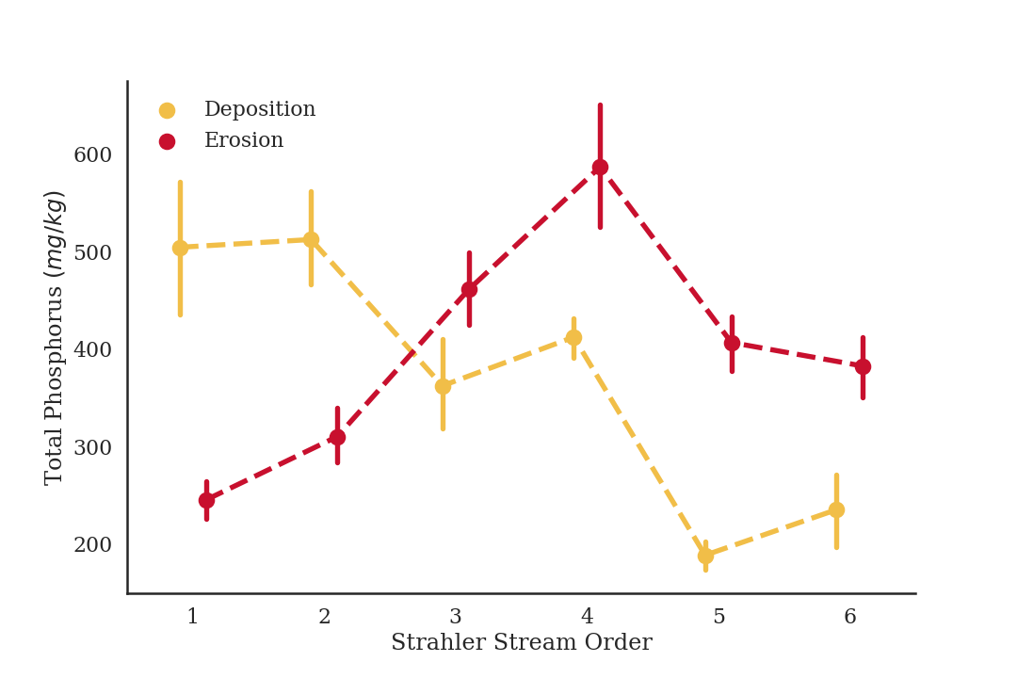

Figure . Total Phosphorus (TP) content of erosional and depositional samples by stream order. TP content generally decreased from first to sixth order for depositional samples, and erosional TP content peaked in the fourth order samples. Errors bars display standard error.

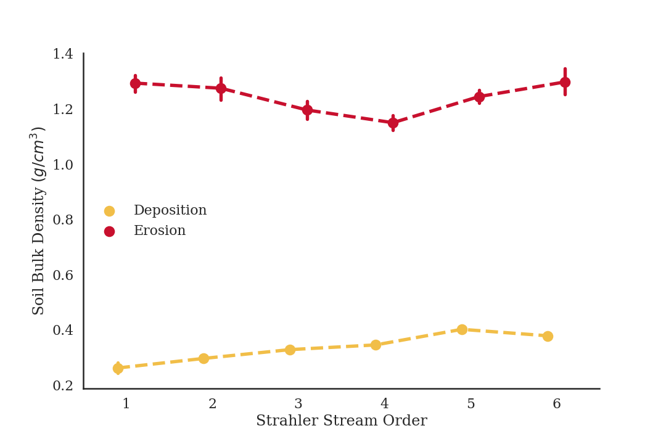

Figure . Soil bulk density by stream order. Bulk density generally increased with stream order for depositional samples, but bulk density for erosional samples followed the inverse trend to the one displayed in TP content. Bulk density decreased from first to fourth order, then increased from fourth to six. Overall, erosional material was 3.5 times denser than depositional material.

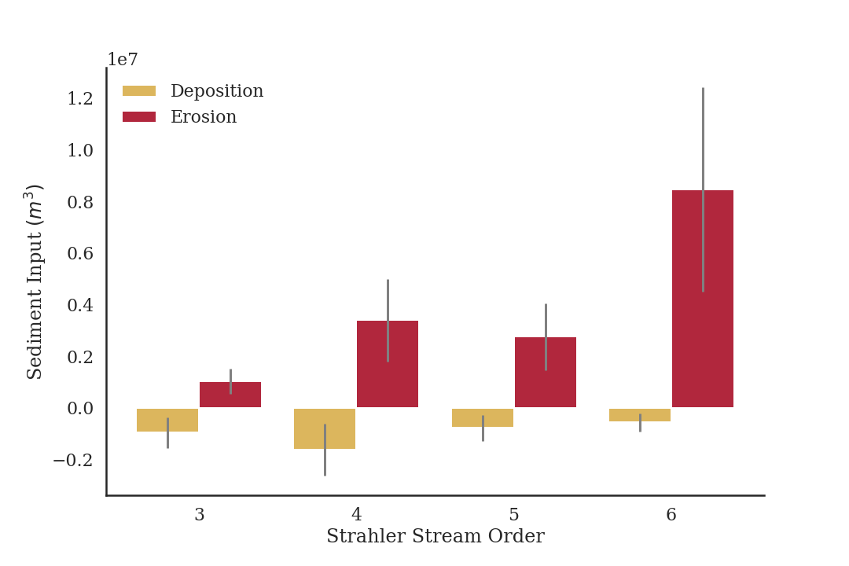

Figure . Volume of sediment contribution by stream order. Erosional volume generally increased from third to sixth order, depositional volume peaked in the fourth order. Overall, sixth order reaches contributed the majority of sediment volume even though their they represent a small portion of the watershed.

Figure . Net sediment input by volume and total channel length by stream order. Within this study, there is an inverse relationship between total channel length and the amount of sediment contributed. This effect is most pronounce in the sixth order, where 11% of the total channel length contributes 67% of the sediment input.

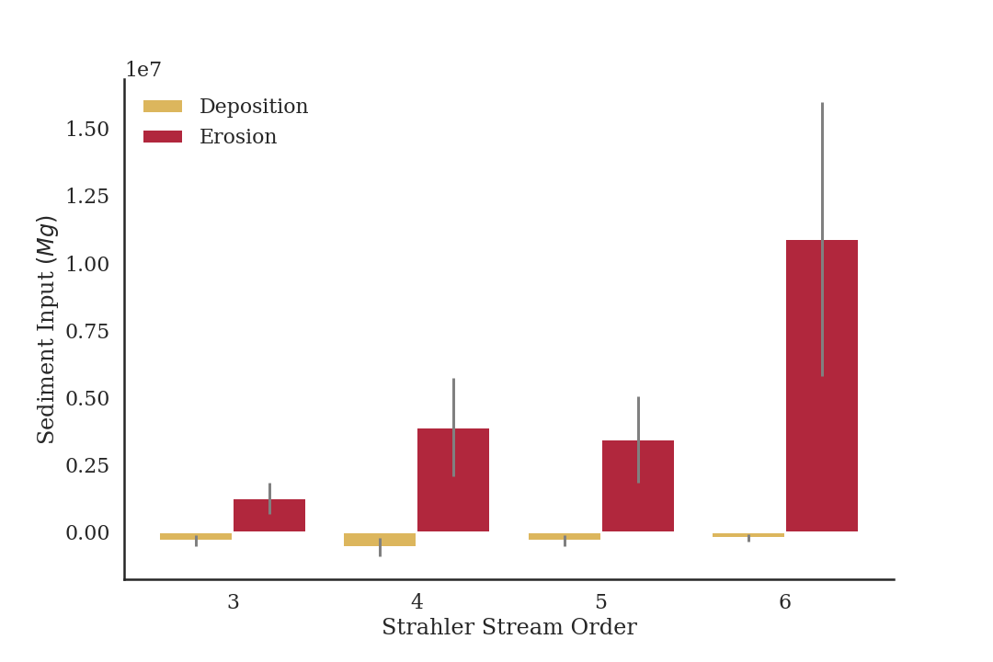

Figure . Mass of sediment contribution by stream order. Trends in sediment contribution by order are similar are similar to those in Figure 3, but the amount of deposition in comparison to erosion is significantly less due to the large difference in average density between erosional and depositional material.

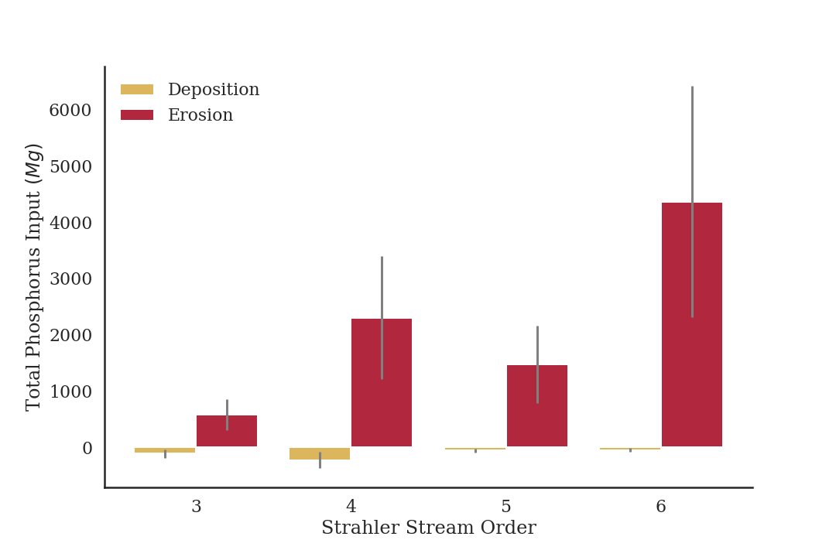

Figure . Total Phosphorus input by stream order. Trends are similar to those discussed in figures 3 and 4, but the influence of fourth reaches is larger due to the increase in TP content within fourth order samples.

Figure . I can also produce input graphs in terms of net input, but was unsure if this was better or worse.