// int pour un entier (integer, entier)
// double pour un chiffre a virgule fjusqu'a 7 décimales après la virgule
// float
// string pour du texte (chaine)
// final pour une constante (final int, final string)

// int "nom" "opération" "valeur" exemple :
// int savings = 500;

// pour raccourcir une opération : savings = savings = 100
// on écrira "savings += 100"

types de données

public static

classes

while :
for ; boucles
https://koor.fr/Java/Tutorial/java_poo_heritage.wp
héritages

operateurs

Tableaux

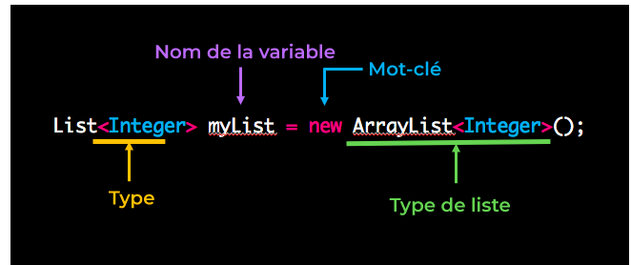

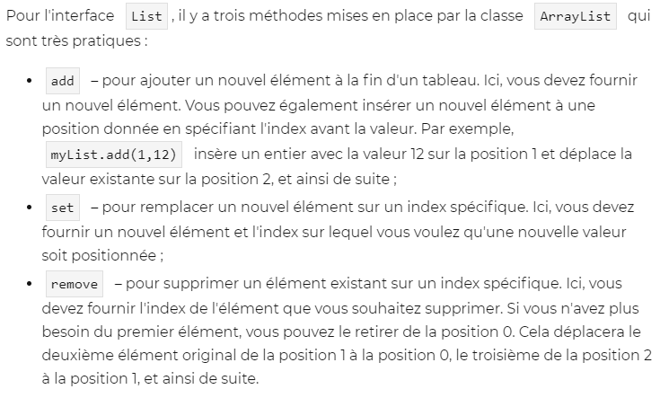
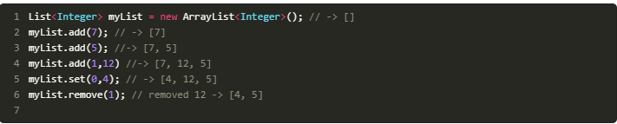
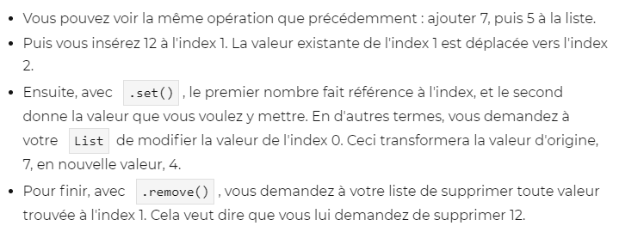
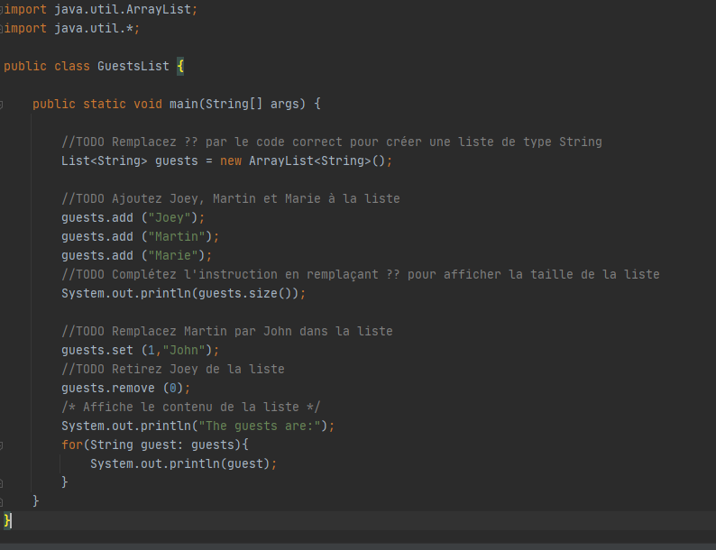
3
The guests are:
John
Marie
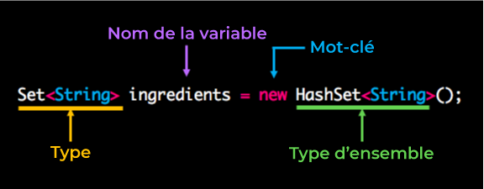
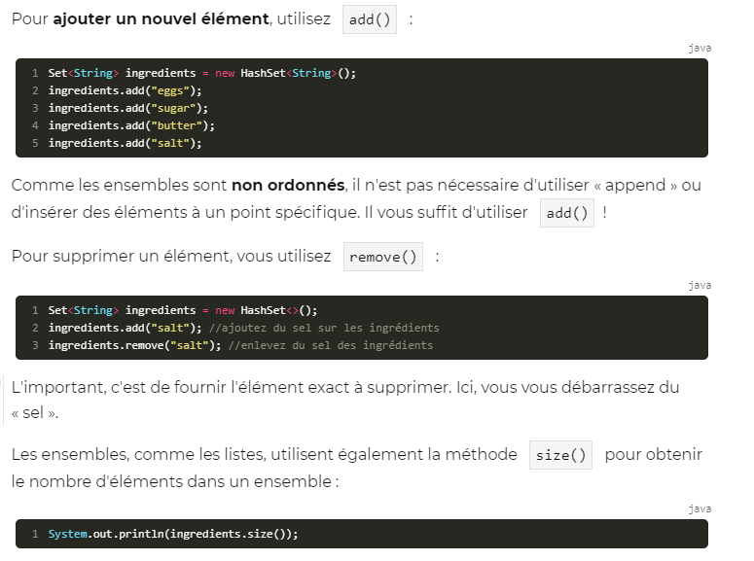
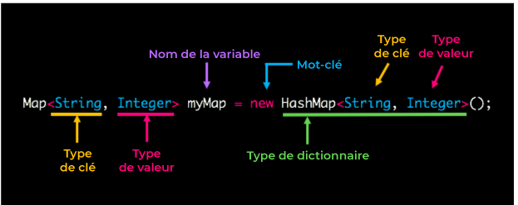
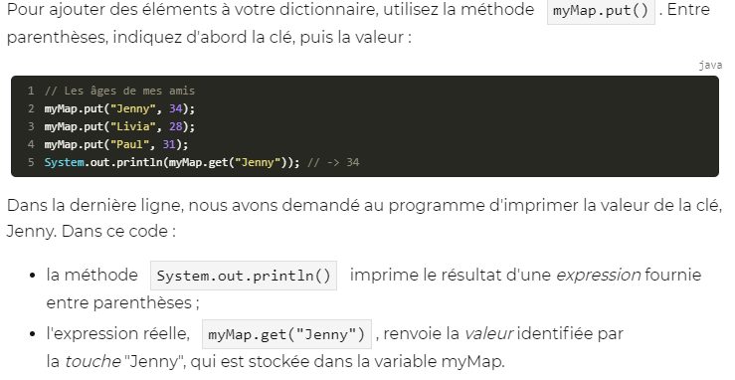
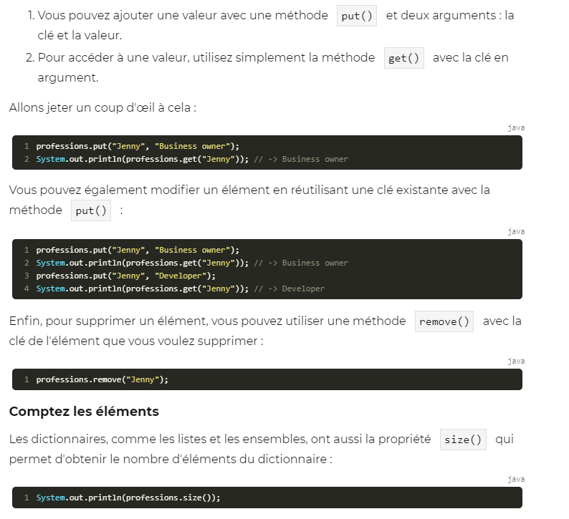
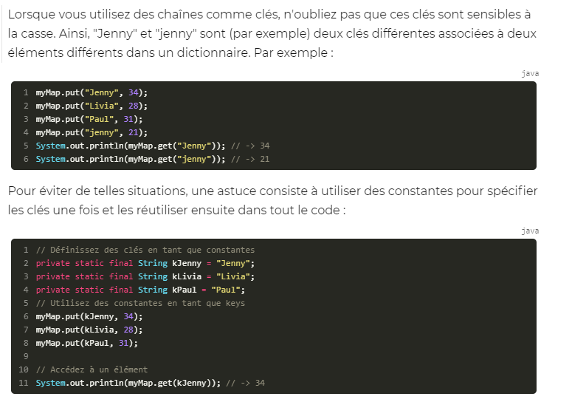
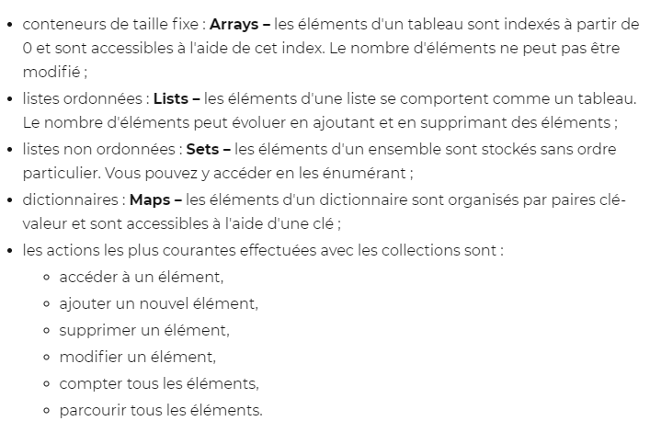
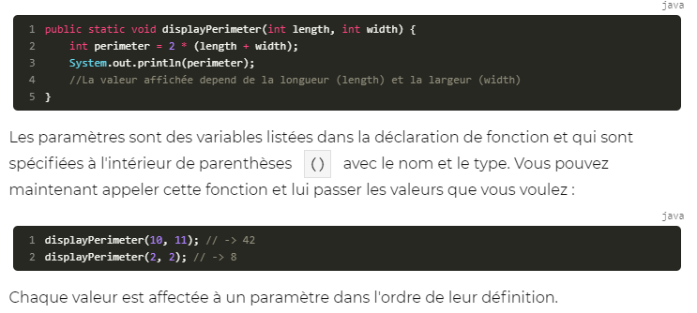
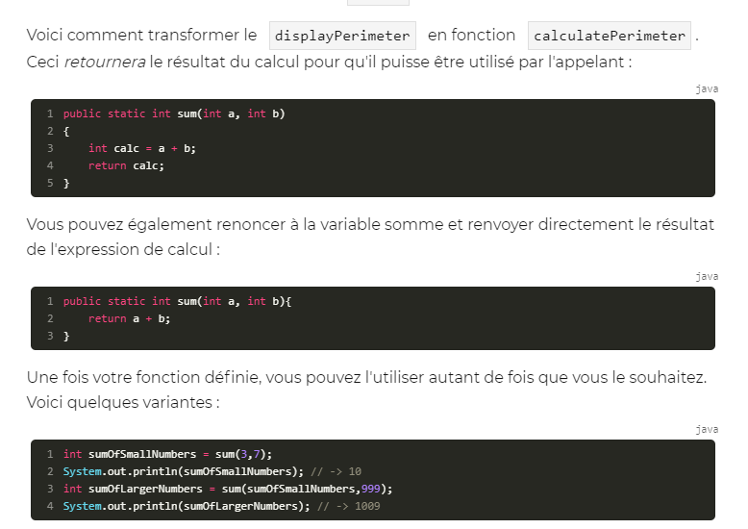
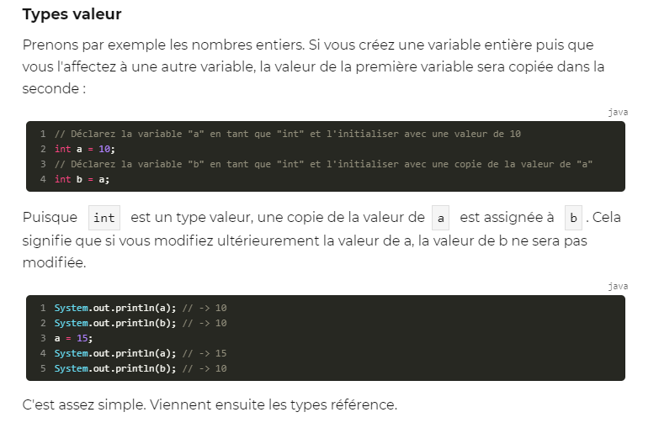
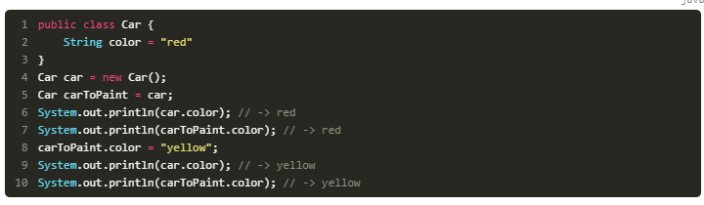

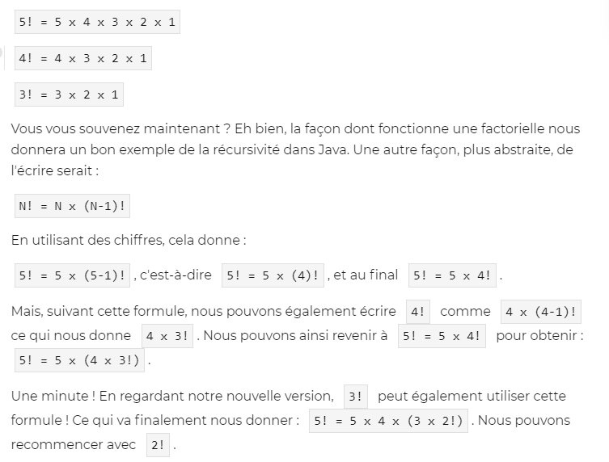
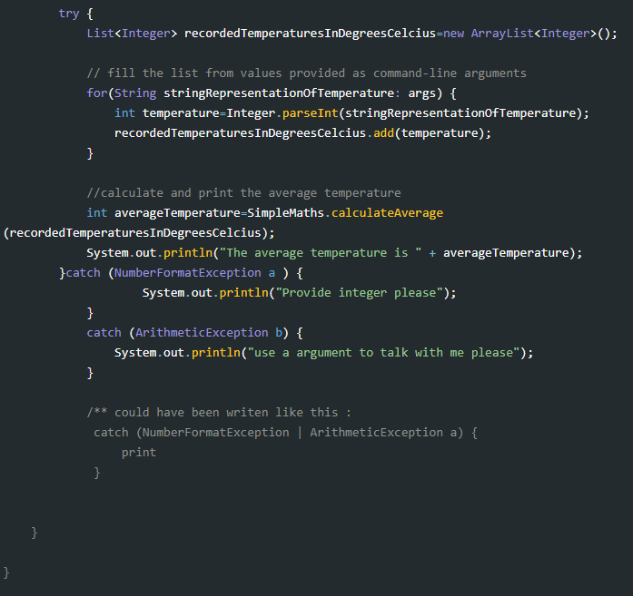
try en dessous de la fonction main, accolade fermer avant le « catch »

This has been possible since Java 7. The syntax for a multi-catch block is:
try {
...
} catch (IllegalArgumentException | SecurityException | IllegalAccessException |
NoSuchFieldException e) {
someCode();
}
Remember, though, that if all the exceptions belong to the same class hierarchy, you can simply catch that base exception type.
Also note that you cannot catch both ExceptionA and ExceptionB in the same block if ExceptionB is inherited, either directly or indirectly, from ExceptionA. The compiler will complain:
Alternatives in a multi-catch statement cannot be related by subclassing
Alternative ExceptionB is a subclass of alternative ExceptionA
The fix for this is to only include the ancestor exception in the exception list, as it will also catch exceptions of the descendant type.
