No Evidence for the Affective Expectation Model: Replication of Geers and Lassiter (2003)

Lukas Röseler^{1,2,3}, Christopher Doetsch¹, Nico Förster⁴, Anna Maria Müller ¹, Amelie Seitz¹, Eva Rieger¹, Antonia Angelika Wild¹, Ann-Kathrin Bruzsa¹, Charlotte Luisa Schmidt¹, Marie Barbara Deublein¹
^{yed1} University of Bamberg, ²University of Münster, ³Münster Center for Open Science, ⁴Harz University of Applied Sciences

Lukas Röseler https://orcid.org/0000-0002-6446-1901
Christopher Doetsch
Nico Förster
Ann-Kathrin Bruzsa
Marie Barbara Deublein
Anna Maria Müller
Eva Rieger
Charlotte Luisa Schmidt
Amelie Seitz
Antonia Angelika Wild

Author Note
Correspondence concerning this article should be addressed to Lukas Röseler, University of Münster, Email: lukas.roeseler@uni-muenster.de
Abstract
According to the Affective Expectation Model (AEM), people’s evaluation of experiences depends on their expectations. This generally happens in an assimilative (positive expectations lead to positive experiences) way unless there is a strong discrepancy between the expectation and the experience. In this case, a contrast effect occurs (positive expectations lead to negative experiences). We conducted an online replication of Study 1 from Geers and Lassiter (2003) where people’s expectations were positively correlated with their expectations for people with a low need for cognition and negatively correlated for people with a high need for cognition. None of the original effects could be replicated, that is, affective experiences did not differ between the groups and were not moderated by need for cognition. The study’s preregistration, data, and materials are available online (https://osf.io/rge23/).
Keywords: affective expectations, replication, assimilation and contrast, need for cognition
No Evidence for the Affective Expectation Model: Replication of Geers and Lassiter (2003)
“Life is like a box of chocolate – you never know what you are going to get.” (REF) Forrest Gump leads us through the film named after him with his life philosophy, which sticks to him and his experiences throughout the film. While we will never know what will await us in the future, we often form expectations of events which have not yet taken place and lie in the future. Although expectations are often formed spontaneously, we have some control over what to expect from a certain situation. For example, big expectations could not be fulfilled and lead to a feeling of disappointment, following an adjustment of expectations to avoid a repetition of said feeling. But is this really the best coping strategy? According to the Affective Expectation Model (AEM), this might not be the case. Here, expectations are defined as ‘‘people’s predictions about how they will feel in a particular situation or toward a specific stimulus’’. According to the AEM “affect and emotion are often formed in an expectation-driven fashion” (Wilson et al., 1989). Thus, the affective evaluation of an event (i.e., how said or funny we find something) does not only depend on its quality but also our affective expectations (i.e., how said or funny we expect to find something). Generally, affective expectations are positively associated with affective experiences (assimilation effect) unless the affective expectation of a stimulus and its actual valence are incongruent and the incongruence is noticed (contrast). Geers and Lassiter demonstrated assimilation and contrast effects by inducing a finer unitization of information regarding the stimulus and therefore enhancing the likeliness to detect an incongruence (Geers & Lassiter, 1999) and by including participants’ optimism (Geers & Lassiter, 2002) and need for cognition (Geers & Lassiter, 2003) in the model. Further experiments have also shown a hedonic contrast to a previously formed expectation when evaluating the taste of a specific food item, about which participants received varying information (Zellner et al., 2004).

Choice of target study
We replicated Study 1 from Geers and Lassiter (2003) to re-test the hypothesis that participants with a high need for cognition are more likely to notice incongruence between expectation and experience and therefore produce contrast effects. The concept of need for cognition is understood as “the tendency for an individual to engage in and enjoy thinking” ( Cacioppo & Petty, 1982, p.116). Especially the tendency to “seek, acquire, think about, and reflect back on information to make sense of stimuli, relationships, and events in their world” ( Cacioppo & Petty, 1982, p. 198) is what enhances the probability of a finer, more pronounced elaboration of information and therefore could influence one’s capability to detect an incongruence of expectation-stimulus relation. Individuals with high need for cognition scores thus evaluate messages more strongly in dependence of their quality (Cacioppo et al., 1983), are more likely to have an information-oriented identity style (Berzonsky & Sullivan, 1992) and divide experiences into more meaningful actions and therefore memorize them better (Lassiter et al., 1991) than individuals low in need for cognition. The tendency of persons with a high need for cognition to be “more likely to scrutinize their environment than individuals low in need for cognition” (Geers & Lassiter, 2003, p. 315) should lead to a contrast effect of expectations on experiences.
We chose to replicate an experiment that includes assimilation and contrast due to its role in research application: Creating and managing affective expectations is an important skill in politics, management, or marketing. In such scenarios, it is important to know how an induced expectation can influence the evaluation of a policy, recommendation, or directive. Moreover, models that reconcile contradictory findings of assimilation and contrast can be found throughout many areas of psychology and need for cognition is listed as a (potential) moderator in several of these models (Röseler & Schütz, 2024). For example, need for cognition as a moderator of anchoring effects is argued to work in a similar way but could not be replicated (Röseler et al., 2022). Finally, of the works on affective expectations and simultaneous assimilation and contrast, the chosen study is the most cited one with 164 Google Scholar citations (as of May 2024).

Method
We conducted a replication of Study 1 from Geers and Lassiter (2003). In their study, 160 undergraduates were asked to watch and evaluate a video. They were told in advance that the movie “has won many awards and has received much praise from other students” (p. 316, positive expectations) or that the movie is “has been described as boring and tedious by other students” (p. 316, negative expectation) or they did not receive any information (no expectation). They were also informed that some students will be chosen at random to have their impressions of the film recorded, too but no students were actually contacted. In the positive and negative conditions, participants were shown the expectation induction videos as example of what they might have to do later. Participants then watched the movie Don’t Shove or a clip from City Lights, rated the movie (affect index), and their need for cognition was measured.
In line with the affective expectation model, Geers and Lassiter found that expectations were positively associated with the movie rating but that this relationship turned negative for participants with a high need for cognition.
In our replication, we tried to closely mirror the original study but had to deviate in critical aspects: None of the original study’s materials were available anymore, the materials were likely not transferable due to us using an online setting, and we had to adapt the materials to a modern German sample.

Open Science Practices
The entire study and analysis plan including the script have been preregistered before data collection (https://osf.io/kx5gw). All materials are available online (https://osf.io/rge23/). We report how we determined our sample size, all data exclusions, all manipulations, and all measures in the study (Simmons et al., 2012). All materials are openly available at https://osf.io/rge23/. These include the preregistered and final analysis scripts, the data sets, and the preregistrations. We declare that we have emptied our file drawer on affective expectation studies.

Materials and Procedure
We created new expectation induction films where, like in the original study, a female student describes the for 30 s in a positive (https://osf.io/ad239) and a negative (https://osf.io/xzyh3) way. According to an informal exchange with Andrew Geers, the original study was conducted in 1998 in a lab at Ohio University and none of the materials were available anymore. For the original study, the videos of the persons talking about the movie and inducing expectations were recorded in the same room as that the study sessions were conducted whereas in our online replication, this was not possible. Thus, we changed the cover story to match the online setting and have the prerecorded video being filmed at the home of another student. It remained similar to the original study’s cover story, namely that some participants would be randomly selected to record their own opinion about the film.
With the help of Andrew Geers, we could recreate the excerpt from the target film Don’t Shove (https://osf.io/kqxe2). The first 30 s of the film and the section after 6:30 were removed so that the movie ended with a man (Gus Leonard) screaming “My hat!”. Thus, the original 9 min long video was cut to 6 minutes and is available in the OSF project. Moreover, we added German translations. Due to the two movies having the same effect in the original study an unknown time-stamps of the second, 87 min long movie, we omitted City Lights from the design.
The affect index was comprised of three items (How much did you like the movie? How funny did you find the movie? How pleasant was watching the movie?) with a 7-point-scale from 1 = not at all to 7 = very much. Three further items were used to support the cover story (How often do you go to the cinema? How often do you use streaming services? When choosing a film, how often do you pay attention to whether it has received any awards?) with a 7-point-scale from 1 = never to 7 = very often. As a quasi-manipulation check, we included an additional item asking how much people expected to like the movie before they saw it (1 = not at all, 7 = very much). For exploratory purposes, we also asked participants to indicate which of four things happened in the movie (check all that apply; the present was switched with a feather [false], everybody is going to the roller-skating rink [correct], the little brother willie is beaten [false], the protagonist fell on somebody’s hat in the end [true]). To measure need for cognition, we used a German version with 16 items (Bless et al., 1994). Participants were asked about their age, gender, occupation, field of study, and if they would like to receive course credit for their participation (students of the University of Bamberg were eligible). The final questionnaire is available online (in German, https://osf.io/rnt74).

A Priori Sample Size Determination
In their study, Geers and Lassiter found that, overall, “[t]he affective reactions of the negative-expectation participants were less positive than those of the no-expectation participants, regardless of their level of need for cognition, F(1, 156) = 12.09, MSE = 3.30, p = .001, r2 = .07” (p. 317) and that “relative to no-expectation participants, the affective reactions of those in the positive-expectation condition became more positive as the need for cognition decreased (i.e., an assimilation effect), and less positive as level of need for cognition increased (i.e., a contrast effect), F(1, 154) = 6.40, MSE = 3.21, p = .01, r2 = .04” (p. 318, N = 160).
To achieve 95% power for the smaller effect of f = 0.2, we would have needed 390 participants. We rounded this number to N = 400 (see https://osf.io/6ua4s for the preregistered power analysis code). Note that we did not achieve this sample size. Instead, only N = 252 participants took part in the study and could be used for the data analysis after applying exclusion criteria (see analysis plan). Achieved power was thus 81.37% for f = 0.2.

Analysis Plan
To conduct a manipulation check, Data analysis was examined using R version 4.3.2 (R Core Team, 2018) and the packages esc (for effect size calculation, Dragulescu, 2014), psych (for reliability analysis and descriptives, Revelle, 2018), ggplot2 (for plotting, Wickham, 2016), dplyr (for na_if(), Wickham et al., 2018) and effectsize (the calculation of effect sizes, Ben-Shachar et al., 2020). The entire analysis script was preregistered, and changes or additions are marked as “CHANGED” or “ADDED,” respectively (https://osf.io/2m3w6). The raw (https://osf.io/2s3tv) and processed (https://osf.io/4qwyt) datasets are available online.
At first, the preregistered exclusion criteria were applied. Participants were excluded if they did not give responses for all of the following variables: need for cognition, affect index, experimental group.
Demographics of the final sample were analyzed (age, gender and occupancy of the subjects). Subsequently, the internal consistency of the affect index and the Need for Cognition Scale was analyzed. A one-way ANOVA was run to examine the influence of the explanation film on the expected liking of the film. For the main analysis, an ANOVA was run to test the interaction effect of need for cognition and the expectation towards the film. In addition, the effect size of the single variables and their interaction was calculated. Furthermore, a plot similar to the one in the original paper (see Geers & Lassiter, 2003, p. 318) was created to show the interaction effect of need for cognition with the affective reactions of the participants in dependence of their induced expectation. Finally, a main effect between the participants’ expectations and the affect index was analyzed, as well as the remembered positivity of expectation and affect index.

Replication closeness evaluation
We reached out to Andrew Geers, one of the original authors, who helped us in reconstructing some of the materials, more precisely which parts of the films were used, how the materials were created and other details. In our replication, we tried to stay as close to the original study as possible. However, we deemed some changes necessary, such as translating the study from English to German, providing German subtitles for the English movie, conducting the study online instead of on site. An overview of all differences is provided in Table 1.

Table 1
Differences between the original study and the replication.
Study feature | Original Study | Replication | Reason for change
Language of questionnaire | English | German | German participants
Type of sample | University undergraduates | Mixed sample, containing students, employed and unemployed subjects | Heterogeneous sample should increase NFC variance and thereby the effect size
Compensation | Partial course credit | Course credit and feedback | Facilitate participant recruitment
Type of instructions | Watching and evaluation of a video segment | Watching and evaluation of a video segment | —
Main variables that were collected | NFC, affective experience, affective expectation | NFC, affective experience, affective expectation | —
Further variables that were collected | Age, sex, viewing behavior | Age, sex, profession, viewing behavior, study program, substantive questions | —
Items used | Need for Cognition Scale by Cacioppo et al. (1984); affective experience items adapted from Klaaren et al. (1994) | Need for Cognition Scale by Bless et al. (1994) | German participants
Exclusion criteria | Not reported | Participants must have completed all of the following variables: NFC, affect index, experimental group | Data analysis required non-missing values
Administration | In person (lab) | Online | Facilitate participant recruitment
Manipulation check | None | Remembered expectation | Non-working manipulation check could uncover faulty induction of expectations
Presented movies | Don’t Shove, City Lights | Don’t Shove | Using different movies may increase variance and reduce statistical power

Results
Our sample consisted of N = 252 participants, which is more than 1.5 times the original study’s sample size. This sample size is sufficient to detect effects of f = 0.249 with 95% power. The achieved power for the original effect size of f = 0.200 was 81.37%.
Only 138 participants reported their age (114 missing values). The reported mean age was M = 47.11 (SD = 16.42) with a range from 19 to 77. 76 male, 169 female and four diverse persons participated in the study (3 missing values). 31 participants reported that they were either bachelor- or master students, while only one person was in an apprenticeship. 153 subjects were employed, 5 in search for employment, and 61 in retirement (1 missing value).

Data Quality Checks
Affective experience in the original experiment was measured via three items, which were adapted from the work by Klaaren et al. (1994) on the role of affective expectations on subjective experience and decision-making. Responses of those items were averaged to gain a single affect index, which reached an internal consistency of α = .93. To test if this would also hold true for our questionnaire, we analyzed the internal consistency of our affect index items and found α = .96 (95% CI [0.95, 0.97]).
To measure NFC in the original experiment, the 18-item version of the scale developed by Cacioppo et al. (1984) was used. However, no internal consistency analysis was run, which we added in our analysis. In our sample and using the scale by Bless et al. (1994), we found a value of α = 0.85 (95% CI [0.83, 0.88], 16 items).
To test whether participants’ affective expectations were successfully manipulated, we asked them to remember their affective expectations at the end of the experiment. a one-way ANOVA revealed a significant influence of induced expectation on remembered expectations, F(2, 249) = 3.90, p = .021. Subsequently, we conducted a Tukey’s test for multiple comparisons of the expectation groups’ means. Here, only a significant difference between the positive (M = 5.21, SD = 2.00, N = 75) and the negative (M = 4.35, SD = 1.94, N = 94) expectation group was found (Δ = 0.862, 95% CI [0.127, 1.597], p = .02). The control group’s values were between the other two groups (M = 4.63, SD = 2.11, N = 83). A distribution of the data can be seen in Figure 1. It should be noted that the interpretation of the pattern should be taken with caution, as people may succumb to hindsight biases when estimating their remembered emotions.
Figure 1
Remembered expectation by induced expectation
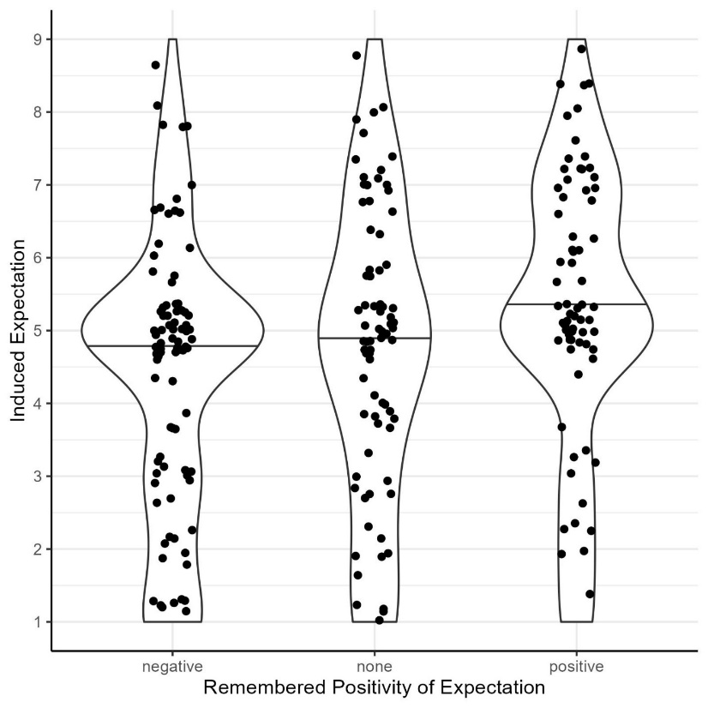
Note. Solid lines represent medians. Remembered positivity of expectations was measured on a 9 point scale (1 = not at all, 9 = very much).

Hypothesis Tests
Affect scores were predicted by expectation condition and NFC in a linear model. The overall model test was not significant, F(5, 246) = 1.86, p = .103, R² = 0.036. In line with this, none of the model’s effects were significant (all ps > .143). Furthermore, an ANOVA was run to test for general effects of NFC, expectation and their interaction. Again, no significant effect was found (all ps ≥ .051). Specifically, there was no main effect of expectation condition on the affect index, F(2, 246) = 3.00, p = .051, η² = 0.02, 95% CI [0, 0.07], need for cognition F(1, 246) = 1.43, p = .233, η² < 0.01, 95% CI [0, 0.04] or an interaction effect F(2, 246) = 0.92, p = .398, η² < 0.01, 95% CI [0, 0.04]. Subsequently, as in the original study (see Geers & Lassiter, 2003, p. 318), the slopes for the linear regression model for all expectation conditions were calculated. None of them was significantly different from zero:
- Positive expectations: b = 0.288, se = 0.306, t(1, 73) = 0.94, p = .349
- Negative expectations: b = 0.420, se = 0.275, t(1, 92) = 1.53, p = .130
- Control group (no specific expectations): b = -0.131, se = 0.312, t(1, 81) = -0.420, p = .675.

Figure 2
Regression lines predicting affect scores from need for cognition and expectation condition.
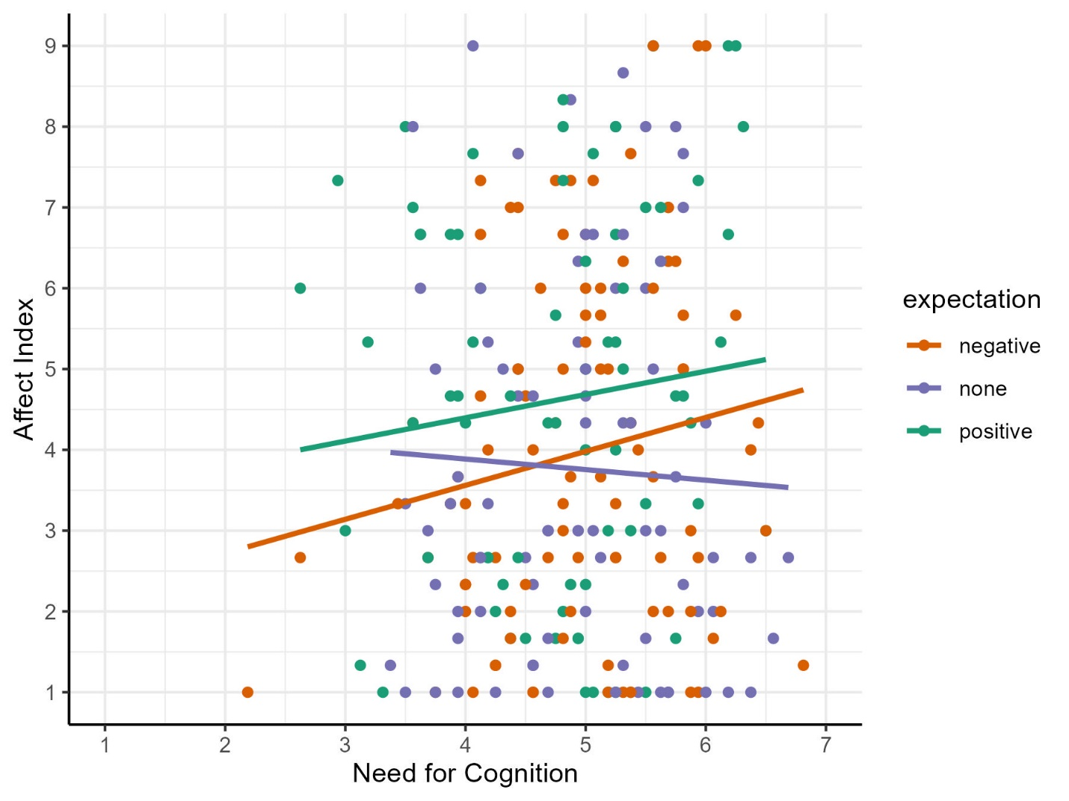 Note. Affect index was measured on a 9-point scale with higher values reflecting positive assessment. Need for cognition was measured on a 7-point scale (1 = completely disagree, 7 = completely agree).

Table 1
Comparison of original and replication results with interpretations according to LeBel et al. (2019).
Test | Original Study | Replication | Interpretation
Expectation × NFC | F(1, 154) = 6.40, MSE = 3.21, p = .01, r²= .04 | F(2, 246) = 0.92, p = .398, η² < 0.01, 95% CI [0, 0.04] | No signal, inconsistent
Slope for the positive expectation condition | b = -0.03, SE = .02, t(154) = 1.91, p = .05 | b = 0.288, se = 0.306, t(1, 73) = 0.94, p = .349 | No signal, inconsistent
Slope for the negative expectation condition | b = -.008, SE = .019, t(154) = 0.42, p = .67 | b = 0.420, se = 0.275, t(1, 92) = 1.53, p = .130 | No signal, consistent¹
Slope for the no expectation condition | b = .03, SE = .02, t(154) = 1.62, p = .10 | b = -0.131, se = 0.312, t(1, 81) = -0.420, p = .675 | No signal, consistent¹
Note. Original effect sizes were taken from Geers and Lassiter (2003, pp. 317-318).
¹The classification by LeBel et al. (2019) does not include cases where original effects are non-significant.

Exploratory Analyses
We assessed variance of the affect index and need for cognition to evaluate whether the target movie was ambivalent enough to be evaluated positively and negatively and to check whether participants may have only experienced one type of effect. The distribution of affect index was skewed towards negative evaluations and need for cognition scores were positively skewed. Nevertheless, both scales had variance (see Figure 3 and Figure 4).

Figure 3
Distribution of Affect Index Scores
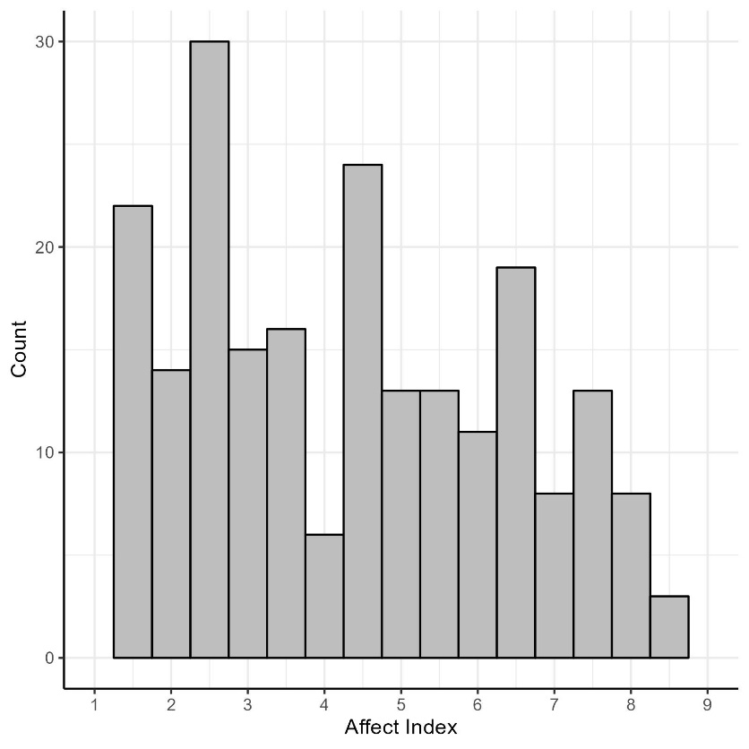
Note. N = 252.

Figure 4
Distribution of Need for Cognition Scores

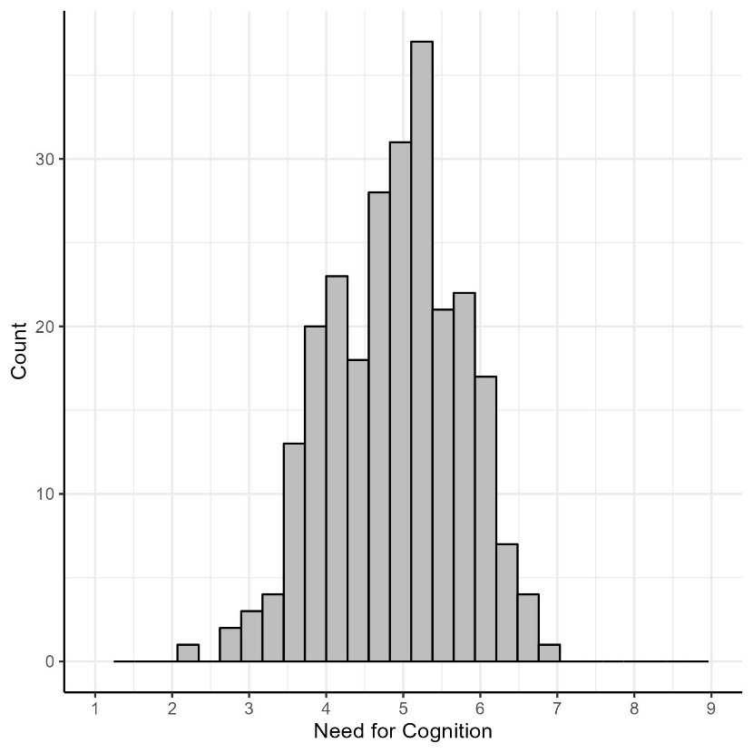
Note. N = 252.

To test whether induction of expectations has led to an overall assimilation effect without any contrast effects or moderations, we ran an exploratory one-way ANOVA. Mean differences between the three expectation conditions did not differ overall, F(2, 249) = 3.00, p = .052. Responses are presented in Figure 5, exact values are available from the analysis script (https://osf.io/2m3w6).

Figure 5
Affect scores by expectation condition.
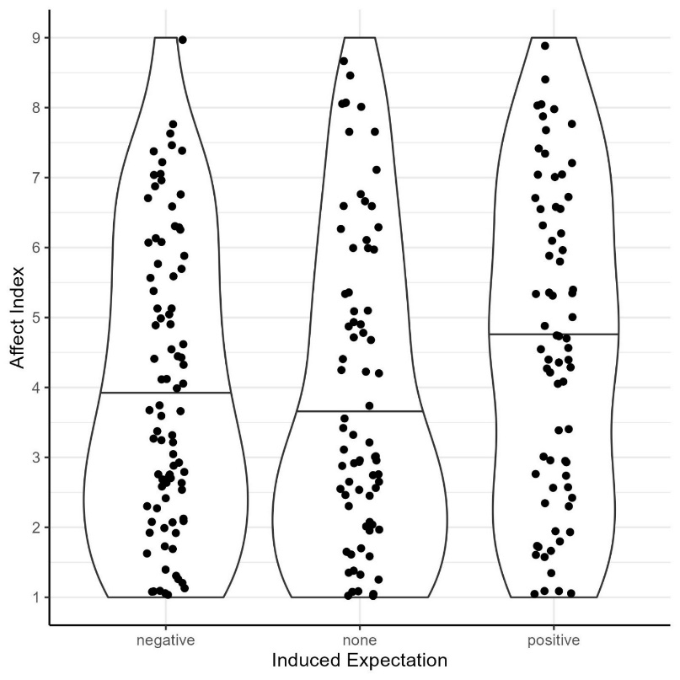
Note. Solid lines represent medians. Affect index was measured on a 9-point scale with higher values reflecting positive assessment

When asked to identify the correct ones of four statements about the movie, 149 participants (59.13%) identified all statements correctly, 77 (30.56%) identified 3/4, 22 (8.73%) identified 2/4, and 3 (1.19%) only identified 1/4 (1 missing value). No participant got all four statements wrong. Running the main hypothesis’ model only on the 149 participants that responded correctly to the four attention check items did not affect the results, F(5, 143) = 0.94, p = .459, R² = .032.

Discussion and Limitations
In our replication of Geers and Lassiter (2003) Study 1, we could not find an effect of affective expectations on affective experience nor a moderation of that effect by participants’ need for cognition. It remains unclear whether the affective expectation model or the derived hypotheses are wrong or whether the study quality was insufficient to detect the effects.
Creating the materials from scratch and not piloting the induction (whether people’s expectations actually change) may have led to a non-working manipulation. However, we could show that participants remembered expectations were in line with the manipulation. It is also unlikely that this difference was due to a hindsight bias as it did not affect the affective experience. Another interpretation is that the manipulation did work but it was too weak. Making the evaluations in the expectation induction movies even more extreme would put their credibility at risk but may be necessary to produce the effects predicted by the AEM.
The movie may also not be well suited for different types of expectations. The affect index was skewed towards negative ratings. However, variance of the affect index was large and with a generally negatively rated movie, main effects of affective expectations should have been detectable.
Finally, there has been little research on whether switching to online for a replication study affects replication outcomes with the only evidence known to us revealing a small and imprecise negative effect (Boyce et al., 2023, Table 2). While attentiveness of participants was high in our replication, the cover story may not have worked. Together with a sample size that was only about 1.5 times larger than the original study, statistical power may still have been insufficient.

Deviations from the Preregistration
Sample size. We did not achieve our preregistered target sample size for N = 400 participants but only N = 252, which still had >80% power for the original effect. However, replication effects are usually about 40-50% the size of original effects (Röseler et al., 2024) and the replication may thus have been underpowered.
Changes in the analysis code. We made changes to the preregistered analysis code (https://osf.io/6ua4s) that we highlighted with “ADDED” or “CHANGED” in the final analysis code (https://osf.io/2m3w6). These changes only included aesthetic changed or fixing of erroneous code.
Conclusion

Given our failure to replicate the effects of affective expectation on ratings of a film, we believe that the generalizability and robustness of the finding from Geers and Lassiter (2003) Study 1 is limited. We believe further research is necessary to assess the validity of the Affective Expectation Model and identify the precise background conditions that are necessary for the assimilation and contrast patterns to arise. At the same time, we believe that conducting research on the Affective Expectation Model requires significant resources. Ideally, future research should use a controlled laboratory setting closer to the original study, create new and credible materials (e.g., the expectation induction film should be set in an environment similar to that of the participants), conduct thorough pilot tests on the expectation induction and the target movie, use a freely available and non-copyrighted movie that should not need to be translated, include manipulation checks of the induction method, test for demand characteristics, and use a very large sample size (N ≥ 400). Obviously, it should adhere to modern standards of open science (e.g., preregistered, open materials, open access) to facilitate reproduction and replication. We hope that our study and materials will help to explore the limits of the AEM and encourage further replication attempts of studies on assimilation and contrast effects.

Acknowledgments
We thank Andrew Geers for his willingness to help in reconstructing the original experiment, his comments on our method, and for the nice conversation. We thank Hannah Kloß, Madeleine Bauer, Kathrin Friedinger, Jessica van den Bergh, and Katharina Drach for their help in designing and conducting the study.

CRediT Author Statement
- Lukas Röseler: Conceptualization, Data curation, Formal analysis, Investigation, Methodology, Project administration, Resources, Software, Supervision, Validation, Visualization, Writing – original draft, Writing – review & editing
- Christopher Doetsch: Conceptualization, Investigation, Methodology, Resources, Writing – original draft, Writing – review & editing
- Nico Förster: Writing – original draft, Writing – review & editing
- Ann-Kathrin Bruzsa: Conceptualization, Investigation, Methodology, Resources, Writing – review & editing
- Marie Barbara Deublein: Conceptualization, Investigation, Methodology, Resources, Writing – review & editing
- Anna Maria Müller: Conceptualization, Investigation, Methodology, Resources, Writing – review & editing
- Eva Rieger: Conceptualization, Investigation, Methodology, Resources, Writing – review & editing
- Charlotte Luisa Schmidt: Conceptualization, Investigation, Methodology, Resources, Writing – review & editing
- Amelie Seitz: Conceptualization, Investigation, Methodology, Resources, Writing – review & editing
- Antonia Angelika Wild: Conceptualization, Investigation, Methodology, Resources, Writing – review & editing

Transparency and Openness Statement
All materials are openly available at https://osf.io/rge23/. These include the preregistered and final analysis scripts, the data sets, and the preregistrations. The authors declare that they have emptied their file drawer on affective expectation studies.

Declaration of Conflict Interest Statement
The authors declare that they have no conflicts of interest.

Financial Support Statement
The authors report no financial support for this work.

References
Ben-Shachar, M., Lüdecke, D., & Makowski, D. (2020). effectsize: Estimation of Effect Size Indices and Standardized Parameters. Journal of Open Source Software, 5(56), 2815. https://doi.org/10.21105/joss.02815
Berzonsky, M. D., & Sullivan, C. (1992). Social-Cognitive Aspects of Identity Style. Journal of Adolescent Research, 7(2), 140–155. https://doi.org/10.1177/074355489272002
Bless, H., Wänke, M., Bohner, G., Fellhauer, R. F., & Schwarz, N. (1994). Need for cognition: eine Skala zur Erfassung von Engagement und Freude bei Denkaufgaben: Need for cognition: a scale measuring engagement and happiness in cognitive tasks. Zeitschrift Für Sozialpsychologie, 25, 147–154.
Boyce, V., Mathur, M., & Frank, M. C. (2023). Eleven years of student replication projects provide evidence on the correlates of replicability in psychology. Royal Society Open Science, 10(11), 231240. https://doi.org/10.1098/rsos.231240
Cacioppo, J. T., & Petty, R. E [Richard E.] (1982). The need for cognition. Journal of Personality and Social Psychology, 42(1), 116–131. https://doi.org/10.1037/0022-3514.42.1.116
Cacioppo, J. T., Petty, R. E [R. E.], & Kao, C. F. (1984). The efficient assessment of need for cognition. Journal of Personality Assessment, 48(3), 306–307. https://doi.org/10.1207/s15327752jpa4803_13
Cacioppo, J. T., Petty, R. E [Richard E.], & Morris, K. J. (1983). Effects of need for cognition on message evaluation, recall, and persuasion. Journal of Personality and Social Psychology, 45(4), 805–818. https://doi.org/10.1037/0022-3514.45.4.805
Dragulescu, A. A. (2014). xlsx: Read, write, format Excel 2007 and Excel 97/2000/XP/2003 files. R package version 0.5.7 [Computer software]. https://CRAN.R-project.org/package=xlsx
Geers, A. L., & Lassiter, G. D. (1999). Affective Expectations and Information Gain: Evidence for Assimilation and Contrast Effects in Affective Experience. Journal of Experimental Social Psychology, 35, 394–413. https://doi.org/10.1006/jesp.1999.1377
Geers, A. L., & Lassiter, G. D. (2002). Effects of Affective Expectations on Affective Experience: The Moderating Role of Optimism-Pessimism. Personality and Social Psychology Bulletin, 28(8), 1026–1039. https://doi.org/10.1177/01461672022811002
Geers, A. L., & Lassiter, G. D. (2003). Need for Cognition and Expectations as Determinants of Affective Experience. Basic and Applied Social Psychology, 25(4), 313–325. https://doi.org/10.1207/S15324834BASP2504_5
Klaaren, K. J., Hodges, S. D., & Wilson, T. D. (1994). The Role of Affective Expectations in Subjective Experience and Decision-Making. Social Cognition, 12(2), 77–101. https://doi.org/10.1521/soco.1994.12.2.77
Lassiter, G. D., Briggs, M. A., & Bowman, R. E. (1991). Need for Cognition and the Perception of Ongoing Behavior. Personality and Social Psychology Bulletin, 17(2), 156–160. https://doi.org/10.1177/014616729101700206
LeBel, E. P., Vanpaemel, W., Cheung, I., & Campbell, L. (2019). A Brief Guide to Evaluate Replications. Meta-Psychology, 3. https://doi.org/10.15626/MP.2018.843
R Core Team. (2018). R [Computer software]. R Foundation for Statistical Computing. https://www.R-project.org/
Revelle, W. (2018). psych: Procedures for Personality and Psychological Research, Version = 1.8.3 [Computer software]. Northwestern University, Evanston, Illinois, USA. https://CRAN.R-project.org/package=psych
Röseler, L., Bögler, H. L., Koßmann, L., Krueger, S., Bickenbach, S., Bühler, R., Della Guardia, J., Köppel, L.‑M., Ponader, S., Roßmaier, K., & Sing, J. (2022). Replicating Epley and Gilovich: Need for Cognition, Cognitive Load, and Forewarning do not Moderate Anchoring Effects. Advance online publication. https://doi.org/10.31234/osf.io/bgp3m
Röseler, L., Kaiser, L., Doetsch, C. A., Klett, N., Seida, C., Schütz, A., Aczel, B., Adelina, N., Agostini, V., Alarie, S., Albayarak-Aydemir, N., AlDoh, A., Al-Hoorie, A. H., Azevedo, F., Baker, B. J., Barth, C. L., Beitner, J., Brick, C., Brohmer, H., . . . Zhang, Y. (2024). The Replication Database: Documenting the Replicability of Psychological Science. Advance online publication. https://doi.org/10.31222/osf.io/me2ub
Röseler, L., & Schütz, A. (2024). Assimilation and Contrast are Everywhere. Advance online publication. https://doi.org/10.31234/osf.io/krwcn
Simmons, J. P., Nelson, L. D., & Simonsohn, U. (2012). A 21 Word Solution. SSRN Electronic Journal. Advance online publication. https://doi.org/10.2139/ssrn.2160588
Wickham, H. (2016). ggplot2: Elegant graphics for data analysis (Second edition). Use R! Springer.
Wickham, H., Francois, R., Henry, L., & Müller, K. (2018). dplyr: A Grammar of Data Manipulation. R package version 0.7.6 [Computer software]. https://CRAN.R-project.org/package=dplyr
Wilson, T. D., Lisle, D. J., Kraft, D., & Wetzel, C. G. (1989). Preferences as expectation-driven inferences: Effects of affective expectations on affective experience. Journal of Personality and Social Psychology, 56(4), 519–530. https://doi.org/10.1037/0022-3514.56.4.519
Zellner, D. A., Strickhouser, D., & Tornow, C. E. (2004). Disconfirmed Hedonic Expectations Produce Perceptual Contrast, Not Assimilation. The American Journal of Psychology, 117(3), 363. https://doi.org/10.2307/4149006

The entire movie is available in the public domain (e.g., https://en.wikipedia.org/wiki/Don%27t_Shove).

