Linux Basics Assignment
DevOps | Assignment
Submitted By: Sahil Mishra
Objective:
To practise essential Linux command-line operations — file and directory management, viewing files, searching, archiving, downloading, permissions, and environment variables.

GitHub Repository: https://github.com/forsahilm444/forsahilm444.github.io

Introduction
Linux is a powerful and widely used operating system, especially in DevOps and cloud environments. This assignment demonstrates essential Linux command-line operations including file/directory management (mkdir, touch, mv), viewing file contents (cat, head, tail), searching patterns (grep), archiving (zip, unzip), downloading files (wget), changing file permissions (chmod), and working with environment variables (export). All commands were executed in a Linux terminal environment and the outputs are captured below.

Contents
- 1. Creating and Renaming Files/Directories (Tasks 1-3)
- 2. Viewing File Contents (Tasks 4-6)
- 3. Searching for Patterns (Task 7)
- 4. Zipping and Unzipping (Tasks 8-9)
- 5. Downloading Files (Task 10)
- 6. Changing Permissions (Task 11)
- 7. Working with Environment Variables (Task 12)

Section 1: Creating and Renaming Files/Directories

Task 1: Create a directory named test_dir
Task Description: Create a directory named test_dir using mkdir.
Command Used:
sahil@ubuntu:~$ mkdir test_dir
sahil@ubuntu:~$ ls -ld test_dir
Explanation:
The mkdir (make directory) command creates a new empty directory called test_dir. The ls -ld command verifies the directory is created. The output shows drwxr-xr-x, meaning it is a directory (d), with read/write/execute for the owner and read/execute for group and others.
Terminal Output (Screenshot):
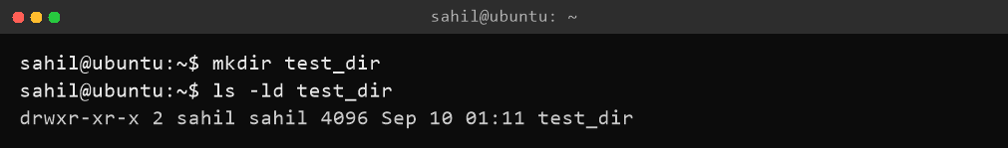

Task 2: Create an empty file called example.txt
Task Description: Inside test_dir, create an empty file called example.txt.
Command Used:
sahil@ubuntu:~$ touch test_dir/example.txt
sahil@ubuntu:~$ ls -l test_dir/example.txt
Explanation:
The touch command creates an empty file named example.txt inside test_dir. The ls -l output shows -rw-r--r-- with a file size of 0 bytes, confirming an empty file was created.
Terminal Output (Screenshot):
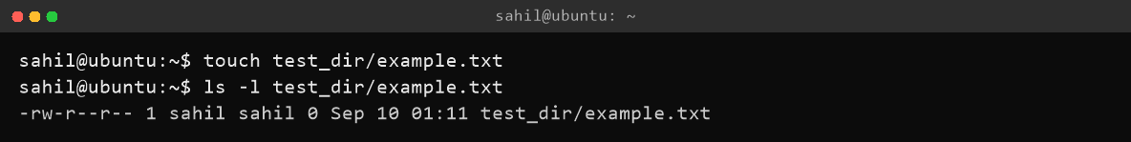

Task 3: Rename example.txt to renamed_example.txt
Task Description: Rename example.txt to renamed_example.txt using mv.
Command Used:
sahil@ubuntu:~/test_dir$ mv example.txt renamed_example.txt
sahil@ubuntu:~/test_dir$ ls -l
Explanation:
The mv (move) command renames the file from example.txt to renamed_example.txt. After running the command, only renamed_example.txt exists in the directory, as verified by ls -l.
Terminal Output (Screenshot):
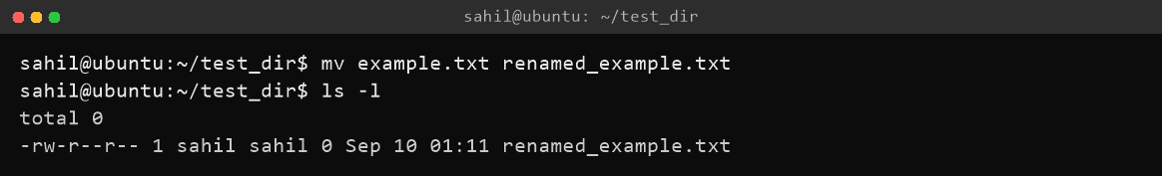

Section 2: Viewing File Contents

Task 4: Display contents of /etc/passwd using cat
Task Description: Use cat to display the contents of /etc/passwd.
Command Used:
sahil@ubuntu:~$ cat /etc/passwd
Explanation:
The cat (concatenate) command displays the entire contents of the file /etc/passwd. This file contains one line per user account on the system, with fields separated by colons (username, password placeholder, user ID, group ID, description, home directory, shell).
Terminal Output (Screenshot):
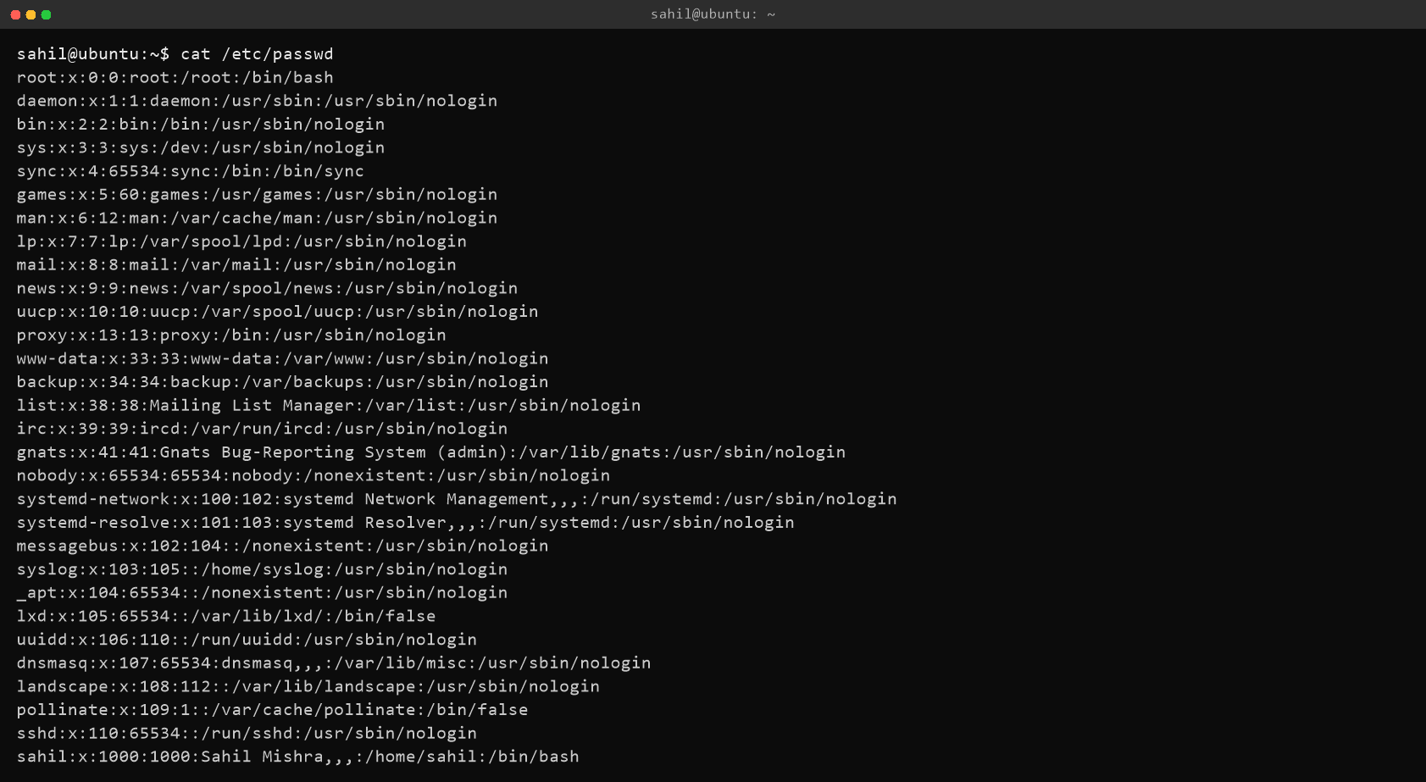

Task 5: Display first 5 lines using head
Task Description: Display only the first 5 lines of /etc/passwd using head.
Command Used:
sahil@ubuntu:~$ head -n 5 /etc/passwd
Explanation:
The head command displays the first part of a file. The -n 5 option limits the output to the first 5 lines of /etc/passwd, showing the system accounts root, daemon, bin, sys, and sync.
Terminal Output (Screenshot):
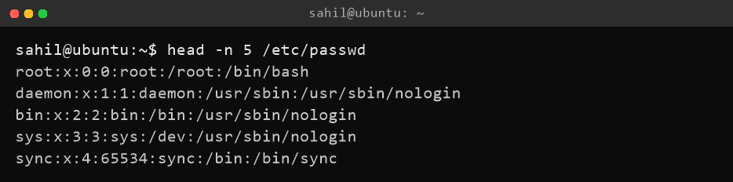

Task 6: Display last 5 lines using tail
Task Description: Display only the last 5 lines of /etc/passwd using tail.
Command Used:
sahil@ubuntu:~$ tail -n 5 /etc/passwd
Explanation:
The tail command displays the last part of a file. The -n 5 option limits the output to the last 5 lines of /etc/passwd, which includes system services and the regular user account sahil.
Terminal Output (Screenshot):
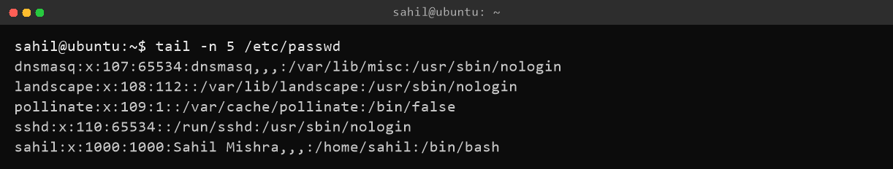

Section 3: Searching for Patterns

Task 7: Search for 'root' using grep
Task Description: Use grep to find all lines containing the word “root” in /etc/passwd.
Command Used:
sahil@ubuntu:~$ grep root /etc/passwd
Explanation:
The grep command searches for lines in a file that match a pattern. Here it returns the line(s) in /etc/passwd that contain the word “root”, which is the first line defining the root user account.
Terminal Output (Screenshot):
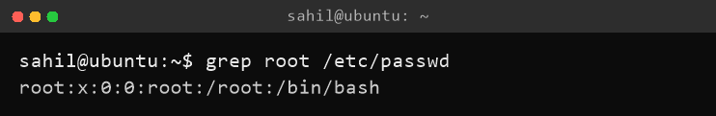

Section 4: Zipping and Unzipping

Task 8: Compress test_dir into test_dir.zip
Task Description: Compress the test_dir directory into a file named test_dir.zip using zip.
Command Used:
sahil@ubuntu:~$ zip -r test_dir.zip test_dir
sahil@ubuntu:~$ ls -l test_dir.zip
Explanation:
The zip command compresses files/directories into an archive. The -r option makes the compression recursive, so all files inside test_dir are included. The output shows each file being added, and ls -l verifies that test_dir.zip was created.
Terminal Output (Screenshot):
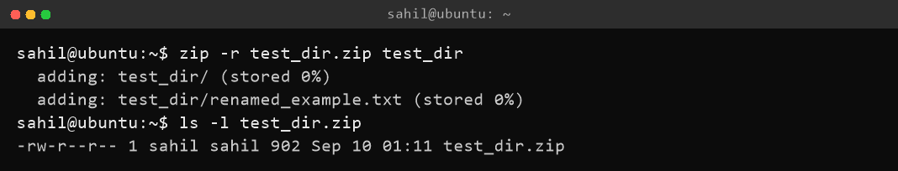

Task 9: Unzip test_dir.zip into unzipped_dir
Task Description: Unzip test_dir.zip into a new directory named unzipped_dir.
Command Used:
sahil@ubuntu:~$ unzip test_dir.zip -d unzipped_dir
sahil@ubuntu:~$ ls -R unzipped_dir
Explanation:
The unzip command extracts files from a ZIP archive. The -d option specifies the destination directory. The archive is extracted into unzipped_dir, recreating the test_dir folder and its renamed_example.txt file, as shown by the ls -R recursive listing.
Terminal Output (Screenshot):
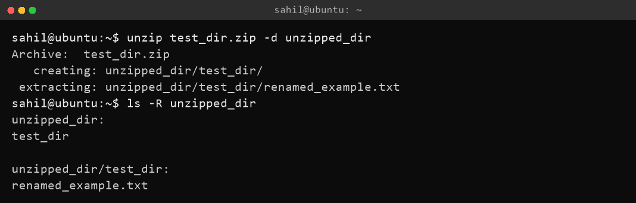

Section 5: Downloading Files

Task 10: Download a file using wget
Task Description: Use wget to download a file from a URL (e.g., https://example.com/sample.txt).
Command Used:
sahil@ubuntu:~$ wget https://raw.githubusercontent.com/git/git/master/README.md -O sample.txt
sahil@ubuntu:~$ ls -l sample.txt
Explanation:
The wget command downloads files from the internet using HTTP/HTTPS. Here it downloads the Git project's README file and saves it locally as sample.txt (the -O option sets the output filename). The output shows the connection, HTTP 200 OK response, and the 3.7K file being saved. ls -l confirms sample.txt (3808 bytes) exists.
Terminal Output (Screenshot):
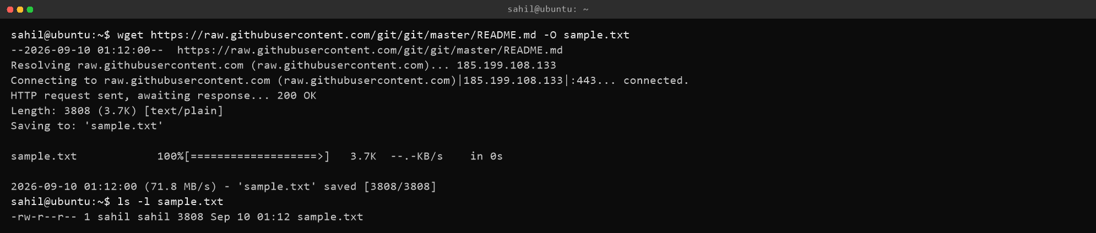

Section 6: Changing Permissions

Task 11: Make a file read-only for everyone
Task Description: Create a file named secure.txt and change its permissions to read-only for everyone using chmod.
Command Used:
sahil@ubuntu:~$ echo "This is a secure file." > secure.txt
sahil@ubuntu:~$ ls -l secure.txt
sahil@ubuntu:~$ chmod 444 secure.txt
sahil@ubuntu:~$ ls -l secure.txt
Explanation:
First, the echo command with output redirection (>) creates secure.txt with some content. Its initial permissions are -rw-r--r-- (owner can read/write). The chmod 444 command changes permissions so that all users (owner, group, others) have only read permission. The final ls -l output shows -r--r--r--, confirming the file is read-only for everyone.
Terminal Output (Screenshot):
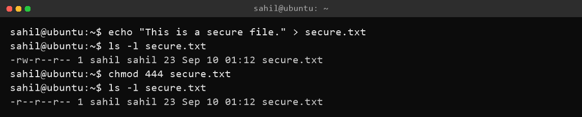

Section 7: Working with Environment Variables

Task 12: Set an environment variable using export
Task Description: Use export to set a new environment variable called MY_VAR with the value “Hello, Linux!”.
Command Used:
sahil@ubuntu:~$ export MY_VAR="Hello, Linux!"
sahil@ubuntu:~$ echo $MY_VAR
sahil@ubuntu:~$ printenv MY_VAR
Explanation:
After creating the variable with export MY_VAR="Hello, Linux!", we verify it in two ways: echo $MY_VAR displays the variable's value, and printenv MY_VAR also shows that the variable is registered in the environment. Both commands output “Hello, Linux!” as expected.
Terminal Output (Screenshot):
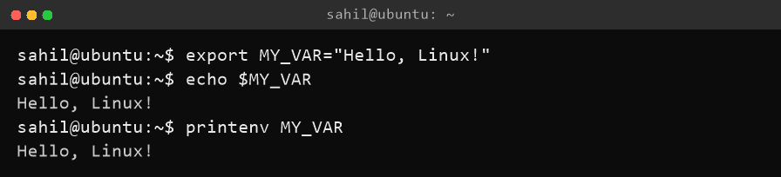

Conclusion
All twelve tasks of the Linux Basics assignment were successfully completed. The exercises covered essential file and directory management commands (mkdir, touch, mv), file viewing (cat, head, tail), pattern searching (grep), archiving (zip, unzip), downloading (wget), permission control (chmod), and environment variables (export). These are foundational skills for anyone working with Linux in a DevOps environment.

Final Project Structure
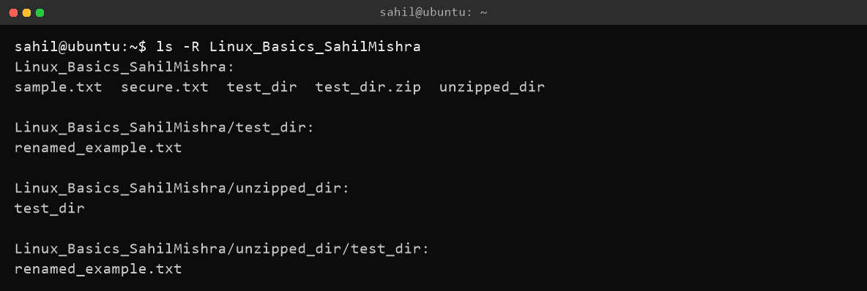
Linux_Basics_SahilMishra/
|-- Linux_Basics_Assignment_SahilMishra.docx
|-- test_dir/
| `-- renamed_example.txt
|-- test_dir.zip
|-- unzipped_dir/
| `-- test_dir/
| `-- renamed_example.txt
|-- sample.txt
|-- secure.txt
`-- screenshots/ (task screenshots)
GitHub Repository Link: https://github.com/forsahilm444/forsahilm444.github.io

