Question(s): | 2 |  | Meeting, date: |  | Geneva, 26 October – 6 November, 2009
Study Group: | 16 | Working Party: | 2 | Intended type of document (R-C-TD): |  | TD
Source: | Editor H.323 IG
Title: | Draft revised H.323 Implementors’ Guide (for consent)
Contact: | Muthu Arul Mozhi Perumal  Cisco Systems, Inc.  USA |  |  |  | Tel: +91-80-41033563  Fax: +91-80-22230167  Email: mperumal@cisco.com
Contact: |  |  |  |  | Tel:  Fax:  Email:
Please don’t change the structure of this table, just insert the necessary information.

This document contains the revised H.323 System Implementors’ Guide (IG). The following summarizes the changes introduced:
- Emptied the Technical and Editorial Corrections to H.323
- Emptied the Technical and Editorial Corrections to H.225.0
- Emptied the Technical and Editorial Corrections to H.245

(Full text available only in the electronic version)

Summary
This document is a compilation of reported defects identified in the versions of ITU-T Recommendation H.323 and its related Recommendations currently in force. It must be read in conjunction with the Recommendations to serve as an additional authoritative source of information for implementors. The changes, clarifications and corrections defined herein are expected to be included in future versions of affected H.323-series Recommendations.
This revision contains all updates submitted up to and including those at Study Group 16 meeting in Geneva, 26 October – 6 November, 2009.
This Implementors’ Guide was approved by ITU-T Study Group 16 on 6 November 2009 (TD ___/Plen) and it obsoletes the earlier version of this Implementors’ Guide approved on 6 February 2008.

Contact Information
ITU-T Study Group 16 / Rapporteur Question 2/16 | Paul E. Jones  Cisco Systems, Inc.  7025 Kit Creek Road  Research Triangle Park, NC 27709. USA | Tel: +1 919 476 2048  Fax:  E-mail: paulej@packetizer.com
ITU-T Study Group 16 / Rapporteur Question 3/16 | NTEC Australia Pty. Ltd.  48 Percy St, Newport  Victoria 3015. Australia | Tel: +61 3 9391 3457  Fax: +61 3 9391 3457  Email: Christian.Groves@nteczone.com
ITU-T Study Group 16 /  Editor ITU-T Rec. H.235.0  Editor Rec. H.235 series Implementors’ Guide | Martin Euchner  Siemens AG  Hofmannstr 51  81359 Munich, Germany | Tel: +49 89 722 5 57 90  Fax: +49 89 722 6 23 66  E-mail: martin.euchner@siemens.com
Editor ITU-T Rec. H.323 | Stephen Botzko  Polycom  100 Minuteman Road  Andover, MA 01810, USA | Tel: +1 978 292-5395  Fax: +1 978 292-5395  Email: Stephen.Botzko@polycom.com
Editor ITU-T Rec. H.341 | Craig Blasberg  Cisco Systems, Inc.  7025 Kit Creek Road  Research Triangle Park, NC 27709. USA | Tel: +1 919 392 5760x  Fax: +1 919 392 6801  E-mail: blasberg@cisco.com
Editor ITU-T Rec. H.225.0  Editor ITU-T Rec. H.323 Series Implementors’ Guide | Muthu Arul Mozhi Perumal  Cisco Systems, Inc.  Divyashree Chambers ‘B’ Wing, No.11  O’Shaugnessey Road, Off Langford Road  Bangalore, India – 560027 | Tel: +91-80-41033563  Fax: +91-80-22230167  E-mail: mperumal@cisco.com
Editor ITU-T Rec. H.225.0 Annex G | Miner Gleason  Cisco Systems, Inc.  7025 Kit Creek Road  Research Triangle Park, NC 27709. USA | Tel: +1 919 392 8752  Fax: +1 919 392 7065  E-mail: mgleason@cisco.com
Editor ITU-T Rec. H.245 | Mike Nilsson  BT Labs  Ipswitch. United Kingdom | Tel: +44 1 473 645413  Fax: +44 1 473 643791  E-mail: mike.nilsson@bt.com
Editor ITU-T Rec. H.246 | Ogishi Hisataka | E-mail: ogishi.hisataka@lab.ntt.co.jp
ITU-T Study Group 16 / Rapporteur Question 5/16 & Editor ITU-T Rec. for H.450.{1,2,3,4,5, 6,9,10,11,12} | Ernst Horvath  Siemens Austria  Gudrunstrasse 11  A-1101 Vienna. Austria | Tel: +43 5 1707 45897  Fax: +43 5 1707 56992  E-mail: ernst.horvath@siemens.com
Editor ITU-T Rec. H.450.7 | Dave Walker  SS8 Networks  135 Michael Cowpland Drive, Suite 200  Kanata, Ontario, K2M 2E9. Canada | Tel: +1 613 592 8450  Fax: +1 613 592 9634  E-mail: dwalker@ss8networks.com
Editor ITU-T Rec. H.450.8 | Glen Freundlich  Avaya Communication  1300 W. 120th Avenue  Westminster, CO 80234. USA | Tel: +1 303 538 2899  Fax: +1 303 538 3007  E-mail: ggf@avaya.com
Editor ITU-T Rec. H.460.1 | P. Cordell | E-mail: pete@tech-know-ware.com
Editor ITU-T Rec. H.460.4 | Gary Thom | E-mail: gthom@delta-info.com
Editor ITU-T Rec. H.460.5 | Sasha Ruditsky | E-mail: sasha@radvision.com
Editor ITU-T Rec. H.460.6 | Bob Gilman | E-mail: rrg@avaya.com
Editor ITU-T Rec. H.460.{2,7,8} | Paul Jones (see above for Q.2/16) | E-mail: paulej@packetizer.com
Editor ITU-T Rec. H.460.3 | Louis Fourie | E-mail: lfourie@cisco.com
Editor ITU-T Rec. H.460.9 | Ernst Horvath (see above for Q.5/16) | E-mail: ernst.horvath@siemens.at
Note: Not all Recommendations indicated above have IG issues in this document. The information above is provided for completeness.
Table of Contents

1 Scope 7
2 Introduction 7
3 References 7
4 Nomenclature 9
5 Technical and Editorial Corrections to H.323 Series Recommendations 10
5.1 Technical and Editorial Corrections to ITU-T Recommendation H.323 (2009) 10
5.2 Technical and Editorial Corrections to ITU-T Recommendation H.225.0 (2009) 10
5.3 Technical and Editorial Corrections to ITU-T Recommendation H.245 (2009) 10
5.4 Technical and Editorial Corrections to ITU-T Recommendation H.246 (2006) 10
5.5 Technical and Editorial Corrections to ITU-T Recommendation H.235 Series 10
5.6 Technical and Editorial Corrections to ITU-T Recommendation H.450 Series 10
5.6.1 Technical and Editorial Corrections to H.450.1 (1998) 10
5.6.2 Technical and Editorial Corrections to H.450.2 (1998) 14
5.6.3 Technical and Editorial Corrections to H.450.3 (1998) 18
5.6.4 Technical and Editorial Corrections to H.450.4 (1999) 19
5.6.5 Technical and Editorial Corrections to H.450.5 (1999) 28
5.6.6 Technical and Editorial Corrections to H.450.7 (1999) 28
5.6.7 Technical and Editorial Corrections to H.450.8 (2000) 29
5.6.8 Technical and Editorial Corrections to H.450.12 (2001) 29
5.7 Technical and Editorial Corrections to ITU-T Recommendation H.341 (1999) 33
5.7.1 Corrections to H.341 Annex B-1 H225-MIB 33
5.7.2 Corrections to H.341 Annex B-2 RAS-MIB 39
5.7.3 Support for Expanded Country Code Values in T.35 in H.341 Annex B-3 42
5.8 Technical and Editorial Corrections to ITU-T Recommendation H.283 (1999) 42
5.8.1 Support for Expanded Country Code Values in T.35 42
5.9 Technical and Editorial Corrections to ITU-T Recommendation H.460 Series 43
5.9.1 Technical and Editorial Corrections to H.460.1 (2002) 43
5.9.2 Technical and Editorial Corrections to H.460.2 (2001) 43
5.9.3 Technical and Editorial Corrections to H.460.6 (2002) 44
5.9.4 Technical and Editorial Corrections to H.460.7 (2002) 48
5.9.6 Technical and Editorial Corrections to H.460.18 (2005) 51
5.9.7 Technical and Editorial Corrections to H.460.19 (2005) 53
3 Definition 54
3 Definitions 54
4 Abbreviations 56
6 Architecture 56
6.1 General requirements 57
7.1.1 Capabilities signalling 57
7.1.2 Logical channel signalling 57
7.3.1 NAT/FW traversal procedure 60
7.3.3 Multiplexed media mode – SRTP/SRTCP 61
6 Implementation Clarification 62
6.1 Token Usage in H.323 Systems 62
6.2 H.235 Random Value Usage in H.323 Systems 62
6.3 Gateway Resource Availability Messages 62
6.4 OpenLogicalChannel in fastStart 63
6.5 Clarification in Q.931 (1993) 63
6.6 Graceful Closure of TCP Connections 63
6.7 Race Condition on Simultaneous Close of Channels 63
6.8 Acceptance of Fast Connect 63
6.9 Semantic Differences between Lightweight RRQs and IRQ/IRR Messages 63
6.10 Specifying the Payload Format for a Channel 64
6.11 Version Dependencies in Annexes 64
6.12 Routing through Signaling Entities and Detecting Loops 65
6.13 Packetization for G.729, G.729a, G.711, and G.723.1 66
6.14 Checking versions for T.38 and V.150.1 66
7 Allocated Object Identifiers and Port Numbers 66
7.1 Allocated Object Identifiers 67
7.2 Allocated Port Numbers 67
8 Use of E.164 and ISO/IEC 11571 Numbering Plans 68
8.1 E.164 numbering plan 68
8.2 Private Network Number 70
9 ASN.1 Usage, Guidelines, and Conventions 71
9.1 NULL, BOOLEAN, and NULL/BOOLEAN OPTIONAL 71
9.2 ASN.1 Usage in H.450-Series Recommendations 72
9.2.1 ASN.1 version and encoding rules 72
9.2.2 Tagging 72
9.2.3 Basic ASN.1 Types 72
9.2.4 Value sets, subtyping and constraints used in H.450.x: 73
9.2.5 Object classes, parameterization, general constraints, and ROS 73
9.2.6 Extensibility and non-standard information 74
9.2.7 List of Operation and Error Codes 74
Annex: Defect Report Form for Recommendations of the H.323 System 78

Implementors’ Guide for Recommendations of the H.323 System (Packet-based multimedia communications systems)

1 Scope
This guide resolves defects in the following categories:
- editorial errors
- technical errors, such as omissions and inconsistencies
- ambiguities
In addition, the Implementors’ Guide may include explanatory text found necessary as a result of interpretation difficulties apparent from the defect reports.
This Guide will not address proposed additions, deletions, or modifications to the Recommendations that are not strictly related to implementation difficulties in the above categories. Proposals for new features should be made in through contributions to the ITU-T.

2 Introduction
This document is a compilation of reported defects identified in the versions of ITU-T Recommendation H.323 and its related Recommendations currently in force. It must be read in conjunction with the Recommendations to serve as an additional authoritative source of information for implementors. The changes, clarifications and corrections defined herein are expected to be included in future versions of affected H.323-series Recommendations.
Upon discovering technical defects with any components of the H.323 Recommendations series, please provide a written description directly to the editors of the affected Recommendations with a copy to the Q2/16 Rapporteur. The template for a defect report is located at the end of the Guide. Contact information for these parties is included at the front of the document. Return contact information should also be supplied so a dialogue can be established to resolve the matter and an appropriate reply to the defect report can be conveyed. This defect resolution process is open to any interested party. Formal membership in the ITU is not required to participate in this process.

3 References
This document refers to the following ITU-T Recommendations:
– ITU-T Recommendation H.323 (2006), Packet-Based multimedia communications systems
– ITU-T Recommendation H.225.0 (2006), Call signaling protocols and media stream packetization for packet based multimedia communications Systems
– ITU-T Recommendation H.245 (5/2006), Control protocol for multimedia communication
– ITU-T Recommendation H.246 (2006), Interworking of H-Series multimedia terminals with H-Series multimedia terminals and voice/voiceband terminals on GSTN and ISDN
– ITU-T Recommendation H.235.0 – H.235.9 (2005), Security and encryption for H Series (H.323 and other H.245 based) multimedia terminals
– ITU-T Recommendation H.450.1 (1998), Generic functional protocol for the support of supplementary services in H.323
– ITU-T Recommendation H.450.2 (1998), Call transfer supplementary service for H.323
– ITU-T Recommendation H.450.3 (1998), Call diversion supplementary service for H.323
– ITU-T Recommendation H.450.4 (1999), Call hold supplementary service for H.323
– ITU-T Recommendation H.450.5 (1999), Call park and call pickup supplementary services for H.323
– ITU-T Recommendation H.450.6 (1999), Call waiting supplementary service for H.323
– ITU-T Recommendation H.450.7 (1999), Message waiting indication supplementary service for H.323
– ITU-T Recommendation H.450.8 (2000), Name identification supplementary service for H.323
– ITU-T Recommendation H.450.9 (2000), Call Completion Supplementary Services for H.323
– ITU-T Recommendation H.450.10 (2001), Call offer supplementary service for H.323
– ITU-T Recommendation H.450.11 (2001), Call intrusion supplementary services
– ITU-T Recommendation H.450.12 (2001), Call Information Additional Network Feature for H.323
– ITU-T Recommendation H.460.1 (2002), Guidelines for the use of generic extensibility framework
– ITU-T Recommendation H.460.2 (2001), Number Portability interworking between H.323 and SCN networks
– ITU-T Recommendation H.460.3 (2002), Circuit status map within H.323 systems
– ITU-T Recommendation H.460.4 (2002), Call priority designation for H.323 calls
– ITU-T Recommendation H.460.5 (2002), H.225.0 transport of multiple Q.931 IE of the same type
– ITU-T Recommendation H.460.6 (2002), Extended Fast Connect Feature
– ITU-T Recommendation H.460.7 (2002), Digit Maps Within H.323 Systems
– ITU-T Recommendation H.460.8 (2002), Querying for alternate routes within H.323 systems
– ITU-T Recommendation H.460.9 (2002), Support for online QoS-Monitoring report
– ITU-T Recommendation H.460.10 (2004), Call party category within H.323 systems
– ITU-T Recommendation H.460.11 (2004), Delayed call establishment within H.323 systems
– ITU-T Recommendation H.460.12 (2004), Glare control indicator within H.323 systems
– ITU-T Recommendation H.460.13 (2004), Called user release control
– ITU-T Recommendation H.460.14 (2004), Support for Multi-Level Precedence and Preemption (MLPP) within H.323 systems
– ITU-T Recommendation H.460.15 (2004), Call signalling transport channel suspension and redirection within H.323 systems
– ITU-T Recommendation H.460.16 (2005), Multiple message release sequence capability
– ITU-T Recommendation H.460.17 (2005), Using H.225.0 call signalling connection as transport for H.323 RAS messages
– ITU-T Recommendation H.460.18 (2005), Traversal of H.323 signalling across network address translators and firewalls
– ITU-T Recommendation H.460.19 (2005), Traversal of H.323 media across network address translators and firewalls
– ITU-T Recommendation H.460.20 (2005), Location number within H.323 systems
– ISO/IEC 11571 (1998), Information technology – Telecommunications and information exchange between systems – Private Integrated Services Networks – Addressing
– ITU-T Recommendation Q.931 (1998), ISDN user-network interface layer 3 specification for basic call control
– ITU-T Recommendation H.283, Remote device control logical channel transport

4 Nomenclature
In addition to traditional revision marks, the following marks and symbols are used to indicate to the reader how changes to the text of a Recommendation should be applied:
Symbol | Description
[Begin Correction] | Identifies the start of revision marked text based on extractions from the published Recommendations affected by the correction being described.
[End Correction] | Identifies the end of revision marked text based on extractions from the published Recommendations affected by the correction being described.
... | Indicates that the portion of the Recommendation between the text appearing before and after this symbol has remained unaffected by the correction being described and has been omitted for brevity.
--- SPECIAL INSTRUCTIONS --- {instructions} | Indicates a set of special editing instructions to be followed.

5 Technical and Editorial Corrections to H.323 Series Recommendations

5.1 Technical and Editorial Corrections to ITU-T Recommendation H.323 (2009)

None for this version of the H.323 System IG.

5.2 Technical and Editorial Corrections to ITU-T Recommendation H.225.0 (2009)

None for this version of the H.323 System IG.

5.3 Technical and Editorial Corrections to ITU-T Recommendation H.245 (2009)

None for this version of the H.323 System IG.

5.4 Technical and Editorial Corrections to ITU-T Recommendation H.246 (2006)
None for this version of the H.323 System IG.

5.5 Technical and Editorial Corrections to ITU-T Recommendation H.235 Series
Corrections to H.235 series Recommendations are specified in H.235 Series Implementors’ Guide.

5.6 Technical and Editorial Corrections to ITU-T Recommendation H.450 Series

5.6.1 Technical and Editorial Corrections to H.450.1 (1998)

5.6.1.1 Actions at a Destination Entity
Description: | Typographical errors have been discovered in section 6.6 of H.450.1 (1998). The text below outlines the necessary changes.
[Begin Correction]
1) Section 6.6, line 6
Change:
"rejectUnrecognizedInvokePdu"
to
"rejectAnyUnrecognizedInvokePdu"
2) Section 6.6, line 12
Change:
"discardAnyUnrecognizedInvokePDU"
to
"discardAnyUnrecognizedInvokePdu"
[End Correction]

5.6.1.2 Corrections to the ASN.1
Description: | H.225.0 (1999) introduces redundancy with H.450.1 in that both H.225.0 (1999) and H.450.1 have screening and presentation information. To remove the redundancy, it was decided that H.225.0 was the proper place for this information and the redundant elements shall be removed from H.450.1. Below shows the revision to the ASN.1 found in Table 6/H.450.1.
[Begin Correction]
Addressing-Data-Elements
{ itu-t recommendation h 450 1 version1(0) addressing-data-elements(9)}
DEFINITIONS AUTOMATIC TAGS ::=
BEGIN
IMPORTS AliasAddress, PartyNumber, PresentationIndicator, Screening Indicator FROM H323-MESSAGES; -- see H.225.0
...
-- PartyNumber defined in Recommendation H.225.0
-- PublicPartyNumber defined in Recommendation H.225.0
-- PrivatePartyNumber defined in Recommendation H.225.0
-- NumberDigits defined in Recommendation H.225.0
-- PublicTypeOfNumber defined in Recommendation H.225.0
-- PrivateTypeOfNumber defined in Recommendation H.225.0
-- PresentationIndicator defined in Recommendation H.225.0 (v3 and beyond)
-- ScreeningIndicator defined in Recommendation H.225.0 (v3 and beyond)

EndpointAddress ::= SEQUENCE{
destinationAddress SEQUENCE OF AliasAddress,
-- multiple alias addresses may be used to address the same H.323 endpoint
remoteExtensionAddress AliasAddress OPTIONAL,
…,
destinationAddressPresentationIndicator PresentationIndicator OPTIONAL,
-- Note 1, 2
destinationAddressScreeningIndicator ScreeningIndicator OPTIONAL,
remoteExtensionAddressPresentationIndicator PresentationIndicator OPTIONAL,
-- Note 1, 2
remoteExtensionAddressScreeningIndicator ScreeningIndicator OPTIONAL
}
-- Note 1: If this element is not available, presentation allowed shall be assumed.
-- Note 2: If an H.450 APDU that carries this element EndpointAddress also
-- contains an element PresentationAllowedIndicator, then the setting of the
-- element PresentationAllowedIndicator shall take precedence in case of
-- conflicting presentation information.
...

[End Correction]

5.6.1.3 Clarifications to ROS APDUs
Description: | The ASN.1 specification of ROS APDUs has caused some uncertainty over the correct encoding of invoke identifiers. A correct encoding is essential for interoperability between different implementations. The text below attempts to clarify the uncertainty.
Add the following note below Table 4/H.450.1:
[Begin Correction]
Note:
In the Invoke APDU, the invokeID is an INTEGER constrained by a PER-visible constraint (InvokeIdSet = 0..65535) and is therefore encoded as a constrained INTEGER (16 bits, no length field). In the ReturnResult and ReturnError APDUs, however, the invokeID is encoded as an unconstrained INTEGER (with explicit length field) because the applicable constraint (“must be that for an outstanding operation…“) is not PER-visible. In the Reject APDU the invokeID is also encoded as an unconstrained INTEGER (with explicit length field) since no constraint applies.
[End Correction]

5.6.1.4 Error Definitions

Description: | Error description as defined in Table 8 need to be clarified. The text below provides the needed clarifications.
[Begin Correction]
10.3 General error list
Table 8 contains the definitions of general errors that may be used within H.450.x Recommendations.
Note – Every operation defined in any H.450.x Recommendation lists all permitted error values explicitly. This means that the errors defined here are not automatically part of another H.450.x Recommendation. An H.450.x Recommendation that uses one of the error values below must import it from the module defined below before it can be used for an operation of H.450.x.
Table 8/H.450.1 – H.450.1 General Error List
H4501-General-Error-List
{ itu-t recommendation h 450 1 version1(0) general-error-list (1) }

DEFINITIONS AUTOMATIC TAGS ::=
BEGIN
IMPORTS ERROR FROM Remote-Operations-Information-Objects
{ joint-iso-itu-t remote-operations(4) informationObjects(5) version1(0) };

-- The following errors are based on the error definitions of Recommendation Q.950.

userNotSubscribed ERROR ::= {CODE local:0}
-- is an indication that the user has not subscribed to this service.

rejectedByNetwork ERROR ::= {CODE local:1}
-- is an indication that the requested service is rejected by the network
-- (e.g. gatekeeper).

rejectedByUser ERROR ::= {CODE local:2}
-- is an indication that
the remote user has rejected this service request.

notAvailable ERROR ::= {CODE local:3}
-- is an indication that the
-- requested service is not available under the specific circumstances
.

insufficientInformation ERROR ::= {CODE local:5}
-- is an indication that some essential information is missing,
--although the operation argument is formally correct.

invalidServedUserNumber ERROR ::= {CODE local:6}
-- is an indication that the requested service cannot be performed
-- because of the usage of an invalid served user number.

Table 8/H.450.1 – H.450.1 General Error List (concluded)
invalidCallState ERROR ::= {CODE local:7}
-- is an indication that the service request is
-- incompatible with the current H.225.0 call state

.
basicServiceNotProvided ERROR ::= {CODE local:8}
-- is an indication that the service request refers to an unsupported
-- terminal capability.

notIncomingCall ERROR ::= {CODE local:9}
-- is an indication that the service request has been invoked for an
-- outgoing call, which is not permitted for that service.

supplementaryServiceInteractionNotAllowed ERROR ::= {CODE local:10}
-- is an indication that the service request is not permitted in
-- combination with either a further requested or active supplementary
-- service.
resourceUnavailable ERROR ::= {CODE local:11}
-- is an indication that the service provider has temporarily no
-- resource available for the provision of the requested service.
callFailure ERROR ::= {CODE local:25}
-- is an indication that the requested supplementary service was not executable by virtue
-- of a Basic Call Failure.

proceduralError ERROR ::= {CODE local:43}
-- is an indication that a
-- received operation APDU
--is not compatible with the procedural context in which it is received
.

END -- of H4501-General-Error-List
[End Correction]

5.6.2 Technical and Editorial Corrections to H.450.2 (1998)

5.6.2.1 Editorial Corrections
Description: | Typographical errors have been discovered in sections 11.4.2, 11.5.2, 11.6.2, and 13.4 of H.450.2. The text below outlines the necessary changes.
[Begin Correction]
1) Editorial - Clause 11.4.2, line 4 c)
Change:
"The CTSetup.request primitive is used to request call establishment from TRTSE."
to
"The CTSetup.request primitive is used to request call establishment to TRTSE"
2) Editorial - Clause 11.4.2, line 5 d)
Change:
"The CTSetup.confirm primitive is used to indicate success of call establishment to TRTSE."
to
"The CTSetup.confirm primitive is used to indicate success of call establishment from TRTSE."
3) Editorial - Clause 11.5.2, line 6 e)
Change:
"The CTIdentify.indication primitive is used to request a call identification."
to
"The CTIdentify.indication primitive is used to indicate a call identification."
4) Editorial - Clause 11.5.2, line 11,12 j)
Change:
"The CTComplete.request primitive may be used by GKs to request sending of call transfer information to the transferred-to user."
to
"The CTComplete.request primitive may be used by GKs to request sending of call transfer information to the transferred-to endpoint."
5) Editorial - Clause 11.5.2, line 13,14 k)
Change:
"The CTComplete.indication primitive is used to indicate call transfer information to the transferred-to endpoint."
to
"The CTComplete.indication primitive is used to indicate call transfer information to the transferred-to user."
6) Editorial - Clause 11.6.2, line 2
Change:
"CT-T1 - Timer CT-T1 shall operate at the TRGSE during state CT-Await-Identify-Response. Its purpose is to protect against the absence of response to the CTIdentify.request."
to
"CT-T1 - Timer CT-T1 shall operate at the TRGSE during state CT-Await-Identify-Response. Its purpose is to protect against the absence of response to the CTIdentify.invoke."
7) Editorial – Clause 13.4, FIGURE 25 (sheet 2 of 3, 4th branch) of H.450.2
(i.e. FIGURE 22/H.450.2 (sheet 2 of 3, 4th branch) of H.450.2 (2/98) publication)
Change:
"T4 Timeout"
to
"CT-T4 Timeout"
In addition, the type of symbol was mistake. Time-Out event is an internal event.
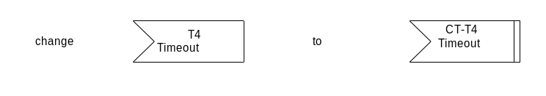
[End Correction]

5.6.2.2 Clarification of CallIdentifier and ConferenceIdentifier
Description: | A clarification of the setting of H.225.0 elements CallIdentifier and ConferenceIdentifier values in conjunction with H.450.2 transferred calls has been added within a new clause 10.7 "Interactions with H.225.0 parameters".  Special Note: This section appeared in the May 1999 Implementors’ Guide, but stated that the CallIdentifier should be the same for transferred calls. That definition contradicted H.323v2's definition of the CallIdentifier, so this section has been changed to align with H.323v2 and higher.
[Begin Correction]
10.7 Interactions with H.225.0 parameters
The H.225.0 CallIdentifier value of the transferred call shall use a new value, rather than the value that was used in the primary call.
The H.225.0 ConferenceIdentifier of a transferred call may use a new value. However, the ConferenceIdentifier of an existing conference (multipoint conference) shall not be altered.
[End Correction]

5.6.2.3 Transfer without Consultation
Description: | An exceptional procedure for a transferred endpoint B actions has been added in clause 8.2.1 to allow call transfer without consultation to take place successfully even if the transferred-to endpoint C does either not support H.450.2 or not support H.450 at all. Furthermore, clause 6 was enhanced to allow a different Interpretation APDU setting.
[Begin Correction]
6 Messages and Information elements
...
When conveying the invoke APDU of operation callTransferSetup, the Interpretation APDU shall contain value clearCallIfAnyInvokePduNotRecognized in case of Transfer with Consultation. In case of Call Transfer without Consultation, the Interpretation APDU shall be set to value discardAnyUnrecognizedInvokePdu.
[End Correction]
[Begin Correction]
8.2.1 Transfer without Consultation with transferred-to endpoint C not supporting H.450.2
a) When receiving a CONNECT message from endpoint C (that does not include a response to the callTransferSetup Invoke APDU) while being in state CT-Await-Setup-Response, the transferred endpoint B should continue as if a callTransferSetup Return Result APDU would have been received. This allows endpoint B to successfully continue with the Call Transfer procedures (including appropriate internal call transfer state handling and clearing of the primary call to the transferring endpoint A). This exceptional procedure enables successful Call Transfer even if the transferred-to endpoint C does not support H.450 at all.
b) When a RELEASE COMPLETE message as a response to a SETUP message containing callTransferSetup Invoke APDU is received in endpoint B on the transferred call attempt, possibly containing callTransferSetup Return Error or Reject APDU, then endpoint B may retry call establishment to endpoint C using a normal basic call. Upon receiving the CONNECT message from endpoint C, endpoint B may continue with the procedures as described in a) above.
Note that this procedure may apply if endpoint C supports H.450.1 but no H.450.2 and if endpoint B has not selected the recommended Interpretation APDU value discardAnyUnrecognizedInvokePdu but has set the value to clearCallIfAnyInvokePduNotRecognized.
[End Correction]

5.6.3 Technical and Editorial Corrections to H.450.3 (1998)

5.6.3.1 Editorial Correction in H.450.3
Description: | Typographical errors have been discovered in H.450.3 clause 12 SDLs.
[Begin Correction]
Editorial – Clause 12 SDL FIGURES 21 (most right branch), 22 (most right branch), 23 (most right branch), 28 (sheet 1 of 4, second right branch) of H.450.3
(i.e. FIGURES 19,20,21 and 24 (sheet 1 of 4) of H.450.3 of H.450.3 (2/98) published).
The type of symbol was mistake. Time-Out event is an internal event.
Note: The text within the referred symbols remains unchanged.


[End Correction]

5.6.3.2 Clarification of the CallIdentifier and ConferenceIdentifier
Description: | A clarification of the setting of H.225.0 elements CallIdentifier and ConferenceIdentifier values in conjunction with H.450.3 forwarded calls has been added within a new clause 9.9.3 "Interactions with H.225.0 parameters".  Special Note: This section appeared in the May 1999 Implementors’ Guide, but stated that the CallIdentifier should be the same for diverted calls. That definition contradicted H.323v2's definition of the CallIdentifier, so this section has been changed to align with H.323v2 and higher.
[Begin Correction]
9.9.3 Interactions with H.225.0 parameters
The H.225.0 CallIdentifier of a forwarded call shall use a new value, rather than the value that was used in the forwarding call.
The H.225.0 ConferenceIdentifier of a forwarded call may use a new value. However, the ConferenceIdentifier of an existing conference (multipoint conference) shall not be altered.
[End Correction]

5.6.3.3 Correction to the ASN.1
Description: | A typographical error has been discovered in the ASN.1 definitions presented in H.450.3, Chapter 11.
[Begin Correction]
H225InformationElement FROM H225-generic-parameters-definition
[End Correction]

5.6.4 Technical and Editorial Corrections to H.450.4 (1999)

5.6.4.1 Change Relating to Interpretation APDU
Description: | In order to align H.450.4 with other H.450-series A modified description of the Call Hold Interpretation APDU (i-apdu) setting has been added in clause 6 of Recommendation H.450.4.  This information will be contained in the revision 2 of H.450.4 Recommendation to be published by the ITU-T. The modified text is shown below.
[Begin Correction]
6 Messages and Information elements
...
When conveying the Invoke APDU of operations remoteHold and remoteRetrieve, the Interpretation APDU shall be omitted or shall contain the value rejectAnyUnrecognizedInvokePdu.
[End Correction]

5.6.4.2 Feature Interaction between H.450.4 and H.450.2
Description: | A modified description of the Call Hold interaction with Call Transfer has been added in clause 9.2.1 of Recommendation H.450.4.  This information will be contained in the revision 2 of H.450.4 Recommendation to be published by the ITU-T. The modified text is shown below.
[Begin Correction]
9.2.1 Call Transfer (H.450.2)
If prior to Consultation, the first call has been put on hold, the served User endpoint shall decide whether or not to automatically retrieve the held User before Call Transfer is invoked.
- If the served User endpoint decides for the automatic retrieve option, a retrieveNotific Invoke APDU (in case of near end call hold) or a remoteRetrieve Invoke APDU (in case of remote-end call hold) may either be sent by the served user prior to the message containing the callTransferInitiate Invoke APDU or may be sent within the same message containing the callTransferInitiate Invoke APDU.
If call transfer fails after retrieval from hold was successful (i.e. if callTransferInitiate Return Error or Reject APDU is received or if timer CT-T3 expires), the served user endpoint may automatically re-invoke SS-Hold.
If remote-end call hold retrieval is unsuccessful, in order to proceed with call transfer the remoteRetrieve Return Error or remoteRetrieve Reject APDU should be disregarded.
- If the served User endpoint decides to not choose the automatic retrieve option, call hold applies to the primary call until call transfer has been completed successfully (i.e. until the primary call is cleared). If transfer fails, the primary call remains being held by User A.
[End Correction]

5.6.4.3 Correction to Section 11/H.450.4 Title
Description: | Section 11/H.450.4 describes both near-end and remote-end call-hold. The section title is corrected so that is does not refer to near-end hold alone.  This information will be contained in the revision 2 of H.450.4 Recommendation to be published by the ITU-T. The modified text is shown below.
[Begin Correction]
11 Dynamic description for call hold
11.1 Operational models and signalling flows
11.1.1 Near-end call hold
[End Correction]

5.6.4.4 Corrections relating to Held State in text and Remote Hold SDLs
Description: | (i) Hold_RE_Held state is used to indicate successful call hold state on both holding and held endpoints. This can be confusing, especially when reading the SDL. New Hold_xx_Holding states, that indicate successful call-hold, are introduced for near-end and remote-end hold procedures.  (ii) First diagram in Figure 18/H.450.4 indicates that if the served endpoint sends a remoteHold.req primitive then the state changes to Hold_RE_Retrieve_Req even though call retrieval has not been requested. The state should remain unchanged instead.  (iii) Second diagram in Figure 18/H.450.4 incorrectly mentions remoteRetrieve.rr instead of remoteRetrieve.re (ReturnResult instead of ReturnError).  This information will be contained in the revision 2 of H.450.4 Recommendation to be published by the ITU-T. The modified text is shown below.
[Begin Correction]
7.1.1 Near-end call hold
On receiving a near-end call hold request from the local User when SS-HOLD is allowed, the holding endpoint shall send a FACILITY message with a holdNotific Invoke APDU to the remote endpoint and shall enter the Hold_NE_Holding state. MOH shall be provided to the held user.
On receiving a near-end retrieve request from the local User, the holding endpoint shall check whether the call to which the retrieve request applies is in state Hold_NE_Holding. If so, the holding endpoint shall send a FACILITY message with a retrieveNotific Invoke APDU to the held endpoint and shall stop sending MOH to the remote endpoint. User A and User B may then continue communicating with each other.
…
7.1.2 Remote-end call hold
…
On receipt of a FACILITY message with a remoteHold Return Result APDU, timer T1 shall be stopped and the Hold_RE_Holding state shall be entered.
…
Upon receiving a remote retrieve request from the local User, the served endpoint shall check whether the call to which the retrieve request applies is in state Hold_RE_Holding. If so, the served endpoint shall send a FACILITY message with a remoteRetrieve Invoke APDU to the held endpoint, start timer T2 and enter state Hold_RE_Retrieve_Req.
…
7.2.1 Near-end call hold
A Reject APDU received as a response to a holdNotific Invoke APDU or as a response to retrieveNotific Invoke APDU while in state Hold_NE_Holding shall be ignored (meaning that the remote endpoint does not understand the SS-HOLD supplementary service). In such cases, the held user B knows about the hold condition only by the reception of MOH and about the retrieval condition by the cessation of MOH and the resumption of normal communications.
7.2.2 Remote-end call hold
The holding endpoint shall not allow the local User to invoke multiple, simultaneous remote-hold requests for the same call. That is, the holding endpoint shall not send a remoteHold Invoke APDU for a call:
1) while timer T1 is running for that call; or
2) when that call is already in the Hold_RE_Holding state.
…
11.2.4 States
Hold_Idle No call hold procedure has been initiated.
Hold_NE_Holding Near-end call hold has been invoked by holding endpoint.

Hold_RE_Requested Remote-end call hold has been requested, waiting for response.
Hold_RE_Holding Remote-end call hold has been invoked successfully.

Hold_RE_Retrieve_Req Remote-end call hold retrieval has been requested.
…
12 Operations in support of SS-call hold
…
remoteRetrieve OPERATION ::=
{ -- sent from holding to held H.323 endpoint to invoke retrieval of remote-end call hold feature
ARGUMENT RemoteRetrieveArg OPTIONAL TRUE
RESULT RemoteRetrieveRes OPTIONAL TRUE
ERRORS {invalidCallState |
-- Call to which retrieve request applies is not in state Hold_RE_Holding
undefined -- undefined reason
}
CODE local: 104
}
…
13.1 Near-end call hold SDLs
See Figures 14 and 15.
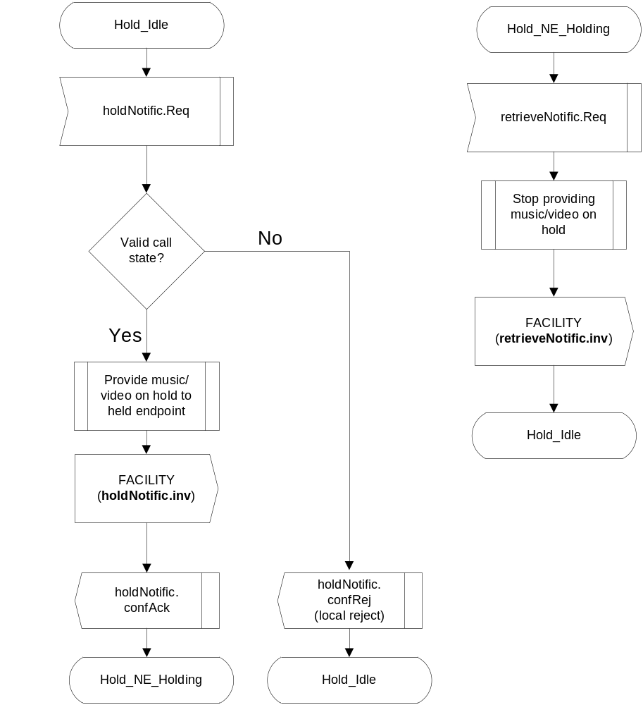
Figure 14/H.450.4 – Near-end call hold – Holding SDL
…

13.2 Remote-end call hold SDLs
…
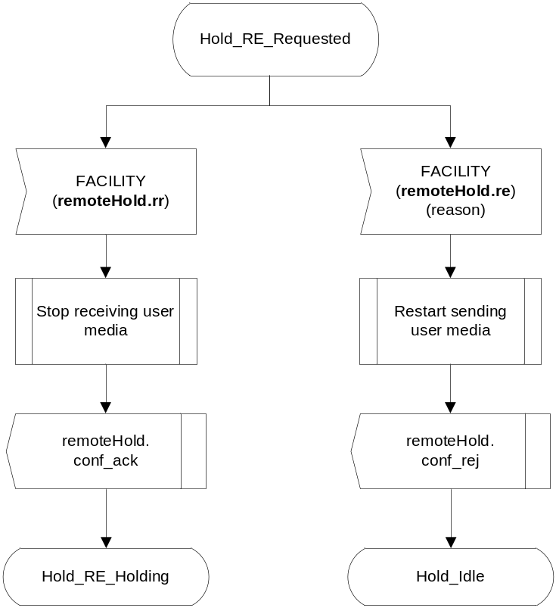
Figure 17/H.450.4 – Remote-end call hold – Holding SDL (sheet 2 of 3)
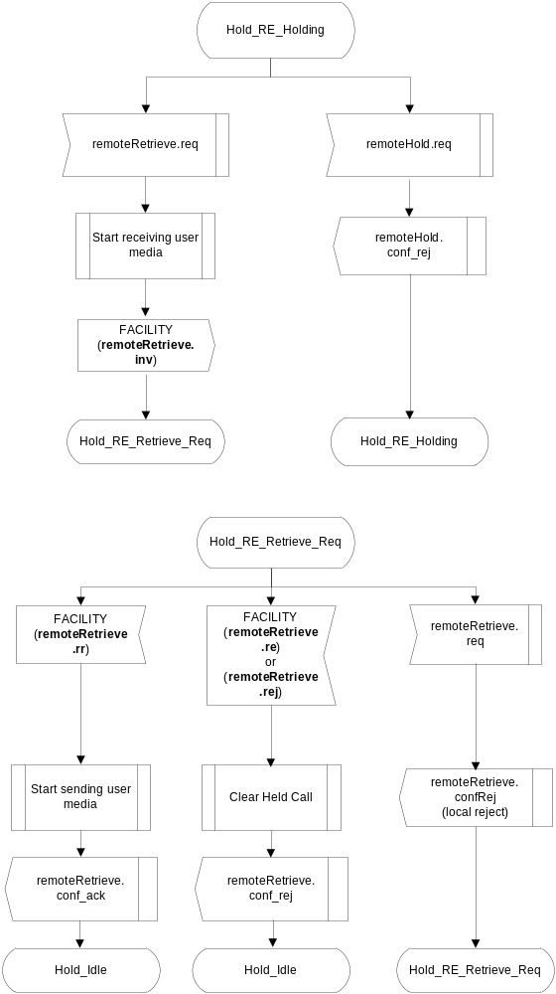
Figure 18/H.450.4 – Remote-end call hold – Holding SDL (sheet 3 of 3)
[End Correction]

5.6.5 Technical and Editorial Corrections to H.450.5 (1999)

5.6.5.1 Clarification of the CallIdentifier
Description: | A clarification of the setting of H.225.0 element CallIdentifier in conjunction with H.450.5 parked calls has been added within clause 8.3 "Interactions with H.225.0 parameters".  This information will be contained in the revision 2 of H.450.5 Recommendation to be published by the ITU-T. The modified text is shown below.
[Begin Correction]
8.3 Interaction with H.225.0 parameters
The H.225.0 CallIdentifier value within a parked call shall use a new value, rather the CallIdentifier value that was used in the primary call. For all other SETUP messages carrying SS-PARK or SS-PICKUP related APDUs as defined within this Recommendation, new CallIdentifier values shall be used. Note that the CallIdentifier value of the parked/alerting call is preserved during the SS-PARK / SS-PICKUP procedure within the H.450 APDUs.
[End Correction]

5.6.6 Technical and Editorial Corrections to H.450.7 (1999)

5.6.6.1 Change Relating to Interpretation APDU
Description: | In order to align H.450.7 with other H.450-series, a modified description of the Message Waiting Indication Interpretation APDU (i-apdu) setting has been added in clause 7.1.1 of Recommendation H.450.7.  This information will be contained in the revision 2 of H.450.7 Recommendation to be published by the ITU-T. The modified text is shown below.
[Begin Correction]
7.1.1 H.450.1 Supplementary Service APDU
...
When conveying the Invoke APDU of operations mwiActivate, mwiDeactivate, and mwiInterrogate, the interpretation APDU shall be omitted or shall contain the value rejectAnyUnrecognizedInvokePdu.
[End Correction]

5.6.7 Technical and Editorial Corrections to H.450.8 (2000)

5.6.7.1 Usage of CalledName and AlertingName
Description: | An editorial error has been found in the H.450.8 (2000) Recommendation in the usage of calledName and alteringName. The following text corrects the errors.
[Begin Correction]
7.2 Terminals or MCU as Originating Endpoint
…
A terminal or MCU in receipt of an H.225.0 Connect, Alerting, or Release Complete message containing a connectedName, alertingName, or busyName APDU should not present name information if the Name element indicates namePresentationRestricted.

8.2 Terminals or MCU as Terminating Endpoint
A terminal or MCU in receipt of the H.225.0 Setup message may include name information in the Connect, Alerting or Release Complete as described above in 6.2, 6.3 or 6.4. If presentation of the name to the calling party is desirable, the Name element in the alertingName, connectedName, or busyName operation should indicate namePresentationAllowed. If presentation of the name to the called party is to be restricted, the Name element in the alertingName, connectedName, or busyName operation should indicate namePresentationRestricted.
[End Correction]

5.6.8 Technical and Editorial Corrections to H.450.12 (2001)

5.6.8.1 Technical Correction
Description: | The receipt of a CmnInform APDU at User A’s Endpoint is not described. Therefore add the text below at the end of section 7.1.1.1 ANF-CMN invocation.
[Begin Correction]
7.1.1.1 ANF-CMN invocation
...
Upon receipt of a CmnInform invoke APDU in any message, the Originating endpoint shall remain in the current state.
[End Correction]

5.6.8.2 Add definition of the states CMN-Wait-Response and CMN-Wait-Answer-Response
Description: | The states CMN-Wait-Response and CMN-Wait-Answer-Response are used only in the SDL diagrams but are not defined anywhere. To avoid confusion, a definition of their meaning is added in section 13.
[Begin Correction]
13. Specification and Description Language (SDL) Diagrams for ANF-CMN
...
In the following SDLs the states CMN-Wait-Response and CMN-Wait-Answer-Response are used to describe the behavior of the Endpoints using explicit primitive exchange.
The state CMN-Wait-Response is entered at the Endpoint after a primitive CMNRequest indication is received and the previous state was CMN-Idle.
The state CMN-Wait-Answer-Response is entered at the Endpoint after a primitive CMNRequest indication is received and the previous state was CMN-Wait-Answer.
[End Correction]

5.6.8.3 Redesign the SDL Diagrams, add two missing collision branches and delete an erroneous message symbol
Description: | Two collision branches are missing: add in section 13.1 Figure 8/H.450.12 the possible receipt of a CMNInform request from the application in state CMN-Wait-Answer and in Figure 9/H.450.12 the possible receipt of a CMNRequest request in state CMN-Wait-Response.  In Figure 9/H.450.12 the receipt of a CMNInform Request in state CMN-Wait-Response shall be ignored and the message with CMNInform invoke APDU shall not be forwarded to endpoint B.
[Begin Correction]
Editorial - Replace the indicated diagrams by the following:

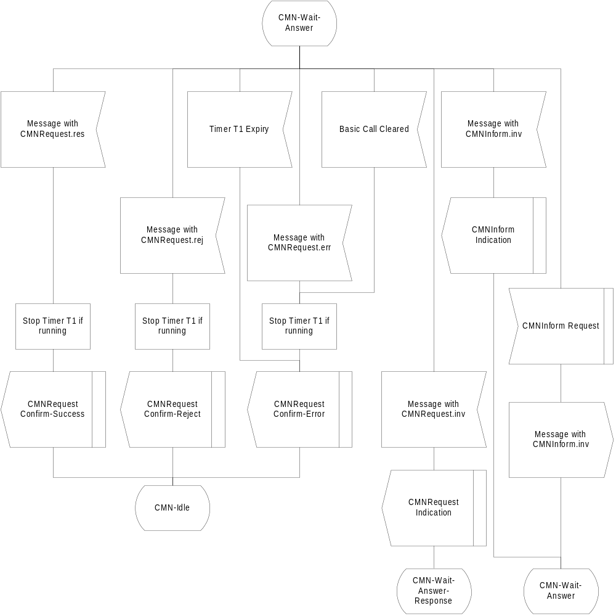
Figure 8/H.450.12 – SDL Representation of ANF-CMN at Endpoint A (Part 3)

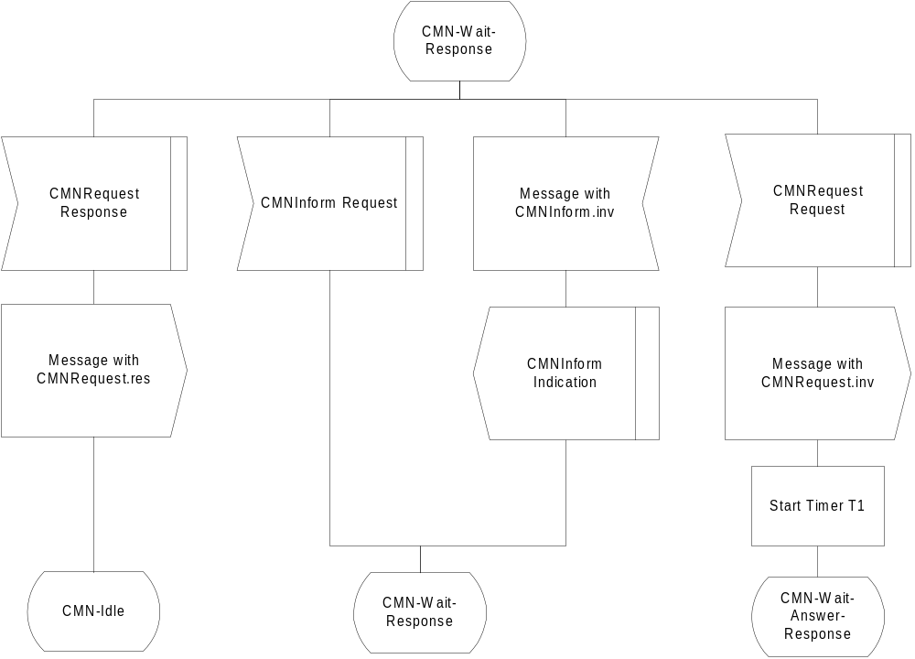
Figure 9/H.450.12 – SDL Representation of ANF-CMN at Endpoint A (Part 3)

[End Correction]

5.6.8.4 Message Flow of ANF-CMN
Description: | Timer T1 is started if cmnRequest invoke is sent in FACILITY message, but not if it is sent in a SETUP message. However, the message flow diagram in Figure 2/H.450.12 erroneously contains timer T1. The erroneous diagram should be replaced by the corrected diagram as below.
[Begin Correction]

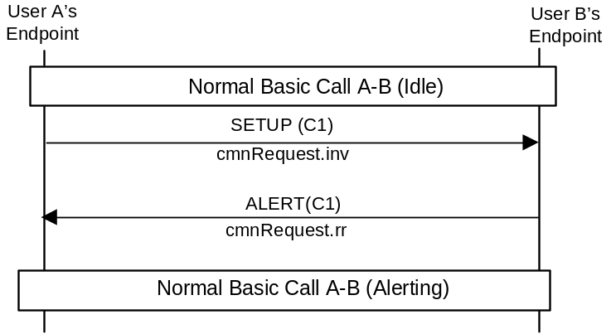
[End Correction]

5.7 Technical and Editorial Corrections to ITU-T Recommendation H.341 (1999)

5.7.1 Corrections to H.341 Annex B-1 H225-MIB
Description: | Each field in CallSignalStatsEntry SEQUENCE referred to the number of messages received ("In") and the number of messages transmitted ("Out"). These counters shall be combined.
[Begin Correction]
CallSignalStatsEntry::= SEQUENCE {
callSignalStatsCallConnectionsIn
Counter32,
callSignalStatsCallConnectionsOut
Counter32,
callSignalStatsAlertingMsgsIn
Counter32,
callSignalStatsAlertingMsgsOut
Counter32,
callSignalStatsCallProceedingsIn
Counter32,
callSignalStatsCallProceedingsOut
Counter32,
callSignalStatsSetupMsgsIn
Counter32,
callSignalStatsSetupMsgsOut
Counter32,
callSignalStatsSetupAckMsgsIn
Counter32,
callSignalStatsSetupAckMsgsOut
Counter32,
callSignalStatsProgressMsgsIn
Counter32,
callSignalStatsProgressMsgsOut
Counter32,
callSignalStatsReleaseCompleteMsgsIn
Counter32,
callSignalStatsReleaseCompleteMsgsOut
Counter32,
callSignalStatsStatusMsgsIn
Counter32,
callSignalStatsStatusMsgsOut
Counter32,
callSignalStatsStatusInquiryMsgsIn
Counter32,
callSignalStatsStatusInquiryMsgsOut
Counter32,
callSignalStatsFacilityMsgsIn
Counter32,
callSignalStatsFacilityMsgsOut
Counter32,
callSignalStatsInfoMsgsIn
Counter32,
callSignalStatsInfoMsgsOut
Counter32,
callSignalStatsNotifyMsgsIn
Counter32,
callSignalStatsNotifyMsgsOut
Counter32,
callSignalStatsAverageCallDuration
Integer32,
callSignalStatsCallConnections
Counter32,
callSignalStatsAlertingMsgs
Counter32,
callSignalStatsCallProceedings
Counter32,
callSignalStatsSetupMsgs
Counter32,
callSignalStatsSetupAckMsgs
Counter32,
callSignalStatsProgressMsgs
Counter32,
callSignalStatsReleaseCompleteMsgs
Counter32,
callSignalStatsStatusMsgs
Counter32,
callSignalStatsStatusInquiryMsgs
Counter32,
callSignalStatsFacilityMsgs
Counter32,
callSignalStatsInfoMsgs
Counter32,
callSignalStatsNotifyMsgs
Counter32
}

callSignalStatsCallConnectionsIn OBJECT-TYPE
SYNTAX Counter32
MAX-ACCESS read-only
STATUS deprecated
DESCRIPTION
"The number of successful connections in which this entity
has been a callee."
::= { callSignalStatsEntry 1 }
callSignalStatsCallConnectionsOut OBJECT-TYPE
SYNTAX Counter32
MAX-ACCESS read-only
STATUS deprecated
DESCRIPTION
"The number of successful connections in which this entity
has been a caller."
::= { callSignalStatsEntry 2 }
callSignalStatsAlertingMsgsIn OBJECT-TYPE
SYNTAX Counter32
MAX-ACCESS read-only
STATUS deprecated
DESCRIPTION
"The number of alerting messages received by this entity."
::= { callSignalStatsEntry 3 }
callSignalStatsAlertingMsgsOut OBJECT-TYPE
SYNTAX Counter32
MAX-ACCESS read-only
STATUS deprecated
DESCRIPTION
"The number of alerting messages sent by this entity."
::= { callSignalStatsEntry 4 }
callSignalStatsCallProceedingsIn OBJECT-TYPE
SYNTAX Counter32
MAX-ACCESS read-only
STATUS deprecated
DESCRIPTION
"The number of call proceeding messages received by this
entity."
::= { callSignalStatsEntry 5 }
callSignalStatsCallProceedingsOut OBJECT-TYPE
SYNTAX Counter32
MAX-ACCESS read-only
STATUS deprecated
DESCRIPTION
"The number of call proceeding messages sent by this entity."
::= { callSignalStatsEntry 6 }

callSignalStatsSetupMsgsIn OBJECT-TYPE
SYNTAX Counter32
MAX-ACCESS read-only
STATUS deprecated
DESCRIPTION
"The number of setup messages received by this entity."
::= { callSignalStatsEntry 7 }
callSignalStatsSetupMsgsOut OBJECT-TYPE
SYNTAX Counter32
MAX-ACCESS read-only
STATUS deprecated
DESCRIPTION
"The number of setup messages sent by this entity."
::= { callSignalStatsEntry 8 }
callSignalStatsSetupAckMsgsIn OBJECT-TYPE
SYNTAX Counter32
MAX-ACCESS read-only
STATUS deprecated
DESCRIPTION
"The number of setupAck messages received by this entity."
::= { callSignalStatsEntry 9 }
callSignalStatsSetupAckMsgsOut OBJECT-TYPE
SYNTAX Counter32
MAX-ACCESS read-only
STATUS deprecated
DESCRIPTION
"The number of setupAck messages sent by this entity."
::= { callSignalStatsEntry 10 }
callSignalStatsProgressMsgsIn OBJECT-TYPE
SYNTAX Counter32
MAX-ACCESS read-only
STATUS deprecated
DESCRIPTION
"The number of progress messages received by this entity."
::= { callSignalStatsEntry 11 }
callSignalStatsProgressMsgsOut OBJECT-TYPE
SYNTAX Counter32
MAX-ACCESS read-only
STATUS deprecated
DESCRIPTION
"The number of progress messages sent by this entity."
::= { callSignalStatsEntry 12 }

callSignalStatsReleaseCompleteMsgsIn OBJECT-TYPE
SYNTAX Counter32
MAX-ACCESS read-only
STATUS deprecated
DESCRIPTION
"The number of release complete messages received by this
entity."
::= { callSignalStatsEntry 13 }
callSignalStatsReleaseCompleteMsgsOut OBJECT-TYPE
SYNTAX Counter32
MAX-ACCESS read-only
STATUS deprecated
DESCRIPTION
"The number of release complete messages sent by this
entity."
::= { callSignalStatsEntry 14 }
callSignalStatsStatusMsgsIn OBJECT-TYPE
SYNTAX Counter32
MAX-ACCESS read-only
STATUS deprecated
DESCRIPTION
"The number of status messages received by this entity."
::= { callSignalStatsEntry 15 }
callSignalStatsStatusMsgsOut OBJECT-TYPE
SYNTAX Counter32
MAX-ACCESS read-only
STATUS deprecated
DESCRIPTION
"The number of status messages sent by this entity."
::= { callSignalStatsEntry 16 }
callSignalStatsStatusInquiryMsgsIn OBJECT-TYPE
SYNTAX Counter32
MAX-ACCESS read-only
STATUS deprecated
DESCRIPTION
"The number of status inquiry messages received by this
entity."
::= { callSignalStatsEntry 17 }

callSignalStatsStatusInquiryMsgsOut OBJECT-TYPE
SYNTAX Counter32
MAX-ACCESS read-only
STATUS deprecated
DESCRIPTION
"The number of status inquiry messages sent by this
entity."
::= { callSignalStatsEntry 18 }
callSignalStatsFacilityMsgsIn OBJECT-TYPE
SYNTAX Counter32
MAX-ACCESS read-only
STATUS deprecated
DESCRIPTION
"The number of connect messages received by this entity."
::= { callSignalStatsEntry 19 }
callSignalStatsFacilityMsgsOut OBJECT-TYPE
SYNTAX Counter32
MAX-ACCESS read-only
STATUS deprecated
DESCRIPTION
"The number of connect messages sent by this entity."
::= { callSignalStatsEntry 20 }
callSignalStatsInfoMsgsIn OBJECT-TYPE
SYNTAX Counter32
MAX-ACCESS read-only
STATUS deprecated
DESCRIPTION
"The number of info messages received by this entity."
::= { callSignalStatsEntry 21 }
callSignalStatsInfoMsgsOut OBJECT-TYPE
SYNTAX Counter32
MAX-ACCESS read-only
STATUS deprecated
DESCRIPTION
"The number of info messages sent by this entity."
::= { callSignalStatsEntry 22 }

callSignalStatsNotifyMsgsIn OBJECT-TYPE
SYNTAX Counter32
MAX-ACCESS read-only
STATUS deprecated
DESCRIPTION
"The number of notify messages received by this entity."
::= { callSignalStatsEntry 23 }
callSignalStatsNotifyMsgsOut OBJECT-TYPE
SYNTAX Counter32
MAX-ACCESS read-only
STATUS deprecated
DESCRIPTION
"The number of notify messages sent by this entity."
::= { callSignalStatsEntry 24 }

callSignalStatsAverageCallDuration OBJECT-TYPE
SYNTAX Integer32
MAX-ACCESS read-only
STATUS current
DESCRIPTION
"The average duration of the call in minutes since
system boot time. "
::= { callSignalStatsEntry 25 }

callSignalStatsCallConnections OBJECT-TYPE
SYNTAX Counter32
MAX-ACCESS read-only
STATUS current
DESCRIPTION
"The number of successful connections ."
::= { callSignalStatsEntry 26 }

callSignalStatsAlertingMsgs OBJECT-TYPE
SYNTAX Counter32
MAX-ACCESS read-only
STATUS current
DESCRIPTION
"The number of alerting messages."
::= { callSignalStatsEntry 27 }

callSignalStatsCallProceedings OBJECT-TYPE
SYNTAX Counter32
MAX-ACCESS read-only
STATUS current
DESCRIPTION
"The number of call proceeding messages."
::= { callSignalStatsEntry 28 }

callSignalStatsSetupMsgs OBJECT-TYPE
SYNTAX Counter32
MAX-ACCESS read-only
STATUS current
DESCRIPTION
"The number of setup messages."
::= { callSignalStatsEntry 29 }

callSignalStatsSetupAckMsgs OBJECT-TYPE
SYNTAX Counter32
MAX-ACCESS read-only
STATUS current
DESCRIPTION
"The number of setupAck messages."
::= { callSignalStatsEntry 30 }

callSignalStatsProgressMsgs OBJECT-TYPE
SYNTAX Counter32
MAX-ACCESS read-only
STATUS current
DESCRIPTION
"The number of progress messages."
::= { callSignalStatsEntry 31 }

callSignalStatsReleaseCompleteMsgs OBJECT-TYPE
SYNTAX Counter32
MAX-ACCESS read-only
STATUS current
DESCRIPTION
"The number of release complete messages."
::= { callSignalStatsEntry 32 }

callSignalStatsStatusMsgs OBJECT-TYPE
SYNTAX Counter32
MAX-ACCESS read-only
STATUS current
DESCRIPTION
"The number of status messages."
::= { callSignalStatsEntry 33 }

callSignalStatsStatusInquiryMsgs OBJECT-TYPE
SYNTAX Counter32
MAX-ACCESS read-only
STATUS current
DESCRIPTION
"The number of status inquiry messages."
::= { callSignalStatsEntry 34 }

callSignalStatsFacilityMsgs OBJECT-TYPE
SYNTAX Counter32
MAX-ACCESS read-only
STATUS current
DESCRIPTION
"The number of connect messages."
::= { callSignalStatsEntry 35 }

callSignalStatsInfoMsgs OBJECT-TYPE
SYNTAX Counter32
MAX-ACCESS read-only
STATUS current
DESCRIPTION
"The number of info messages."
::= { callSignalStatsEntry 36 }

callSignalStatsNotifyMsgs OBJECT-TYPE
SYNTAX Counter32
MAX-ACCESS read-only
STATUS current
DESCRIPTION
"The number of notify messages."
::= { callSignalStatsEntry 37 }
[End Correction]

5.7.2 Corrections to H.341 Annex B-2 RAS-MIB
Description: | A few editorial errors have been identified in the RAS MIB in H.341. The rasAdmissionCallIdentifier field is inserted twice in the RasAdmissionTableEntry SEQUENCE. The ASN type of rasRegistrationEndpointType field in RasRegistrationTableEntry SEQUENCE should be changed to MmH323EndpointType.
[Begin Correction]
RAS-MIB DEFINITIONS ::= BEGIN
IMPORTS
Counter32, Integer32, OBJECT-TYPE,
MODULE-IDENTITY, NOTIFICATION-TYPE
FROM SNMPv2-SMI
TAddress, RowStatus, TruthValue, DateAndTime
FROM SNMPv2-TC
MODULE-COMPLIANCE, OBJECT-GROUP
FROM SNMPv2-CONF
ifIndex
FROM IF-MIB
MmGatekeeperID, MmTAddressTag,MmEndpointID, MmGlobalIdentifier,
MmAliasTag, MmAliasAddress, mmH323Root, MmH323EndpointType,
MmH225Crv, MmCallType
FROM MULTI-MEDIA-MIB-TC;
...
RasRegistrationTableEntry ::=
SEQUENCE {
rasRegistrationCallSignallingAddressTag
MmTAddressTag,
rasRegistrationCallSignallingAddress
TAddress,
rasRegistrationSrcRasAddressTag
MmTAddressTag,
rasRegistrationSrcRasAddress
TAddress,
rasRegistrationIsGatekeeper
TruthValue,
rasRegistrationGatekeeperId
MmGatekeeperID,
rasRegistrationEndpointId
MmEndpointID,
rasRegistrationEncryption
TruthValue,
rasRegistrationWillSupplyUUIE
TruthValue,
rasRegistrationIntegrityCheckValue
TruthValue,
rasRegistrationTableNumberOfAliases
Integer32,
rasRegistrationTableRowStatus
RowStatus,
rasRegistrationEndpointType
MmH323EndpointType,
rasRegistrationPregrantedARQ
TruthValue,
rasRegistrationIsregisteredByRRQ
TruthValue
}
...
rasRegistrationEndpointType OBJECT-TYPE
SYNTAX MmH323EndpointType
MAX-ACCESS read-only
STATUS current
DESCRIPTION
"Terminal type represents the type of H.323 terminal:
…
RasAdmissionTableEntry ::=
SEQUENCE {
rasAdmissionSrcCallSignallingAddressTag
MmTAddressTag,
rasAdmissionSrcCallSignallingAddress
TAddress,
rasAdmissionDestCallSignallingAddressTag
MmTAddressTag,
rasAdmissionDestCallSignallingAddress
TAddress,
rasAdmissionCallIdentifier
MmGlobalIdentifier,
rasAdmissionConferenceId
MmGlobalIdentifier,
rasAdmissionRasAddressTag
MmTAddressTag,
rasAdmissionRasAddress
TAddress,
rasAdmissionCRV
MmH225Crv,
rasAdmissionIsGatekeeper
TruthValue,
rasAdmissionSrcAliasAddressTag
MmAliasTag,
rasAdmissionSrcAliasAddress
MmAliasAddress,
rasAdmissionDestAliasAddressTag
MmAliasTag,
rasAdmissionDestAliasAddress
MmAliasAddress,
rasAdmissionAnswerCallIndicator
INTEGER,
rasAdmissionTime
DateAndTime,

rasAdmissionEndpointId
MmEndpointID,
rasAdmissionBandwidth
Integer32,
rasAdmissionIRRFrequency
Integer32,
rasAdmissionCallType
MmCallType,
rasAdmissionCallModel
INTEGER,
rasAdmissionSrcHandlesBandwidth
TruthValue,
rasAdmissionDestHandlesBandwidth
TruthValue,
rasAdmissionSecurity
TruthValue,
rasAdmissionSrcWillSupplyUUIE
TruthValue,
rasAdmissionDestWillSupplyUUIE
TruthValue,
rasAdmissionTableRowStatus
RowStatus
}
[End Correction]

5.7.3 Support for Expanded Country Code Values in T.35 in H.341 Annex B-3
Description: | T.35 (1999) expanded the available country codes from one octet to two octets. In order to support the expanded country codes going forward, it is recommended that implementers make the following changes to these definitions in H.341 Annex B-3 H323TERMINAL-MIB.
[Begin Correction]
h323TermSystemt35CountryCode OBJECT-TYPE
SYNTAX INTEGER (0..255)
MAX-ACCESS read-only
STATUS current
DESCRIPTION
"Country code, per T.35 Annex A."
::= { h323TermSystemEntry 5 }
h323TermSystemt35CountryCodeExtention OBJECT-TYPE
SYNTAX INTEGER (0..255)
MAX-ACCESS read-only
STATUS current
DESCRIPTION
"Assigned nationally, unless the country code
is 255, in which case this value shall contain
the country code found in T.35 Annex B."
::= { h323TermSystemEntry 6 }
[End Correction]

5.8 Technical and Editorial Corrections to ITU-T Recommendation H.283 (1999)

5.8.1 Support for Expanded Country Code Values in T.35
Description: | T.35 (1999) expanded the available country codes from one octet to two octets. In order to support the expanded country codes going forward, it is recommended that implementers take note of the following usage guidelines for fields in H.283.
[Begin Correction]
...
H221NonStandard ::= SEQUENCE
{
t35CountryCode INTEGER(0..255), -- country, as per T.35 Annex A
t35Extension INTEGER(0..255), -- assigned nationally, unless the
-- t35CountryCode is binary 1111 1111,
-- in which case this field shall
-- contain the country code found
-- in T.35 Annex B
manufacturerCode INTEGER(0..65535) -- assigned nationally
}
...
[End Correction]

5.9 Technical and Editorial Corrections to ITU-T Recommendation H.460 Series

5.9.1 Technical and Editorial Corrections to H.460.1 (2002)

5.9.1.1 Encoding rules
Description: | Currently, H.460.1 requires each individual Recommendation to specify the encoding that it will use for parameters in the raw format. It would be better to specify the default encoding in H.460.1 and let individual Recommendations change it only if needed. The textual changes are shown below.
[Begin Correction]
7.2 Encoded in Raw Method
…
If the feature is defined using ASN.1, then it is recommended that the basic aligned variant of the PER encoding rules be used. However, irrespective of this, encoding rules that are used, if different from the above, shall be explicitly stated in the specification of the feature.
[End Correction]

5.9.2 Technical and Editorial Corrections to H.460.2 (2001)

5.9.2.1 Typographical Error in Section 4.1
Description: | A typographical error has been discovered in that the parameter qorPortedNumber in the ASN.1 is referred to as qorPortedAddress in Section 4.1 of H.460.2 (2001). The text below outlines the necessary change.
[Begin Correction]
4.1 Messages and Signaling
…
5) When a Gatekeeper receives an ARQ or LRQ and determines that the destination number is ported out of the network and it may wish to invoke number portability Query on Release (QoR) procedures (as specified in Annex C/Q.769.1). In such cases, the Gatekeeper must respond with ARJ or LRJ that contains a reject reason of genericDataReason. The Gatekeeper should include the genericData of the ARJ/LRJ that contains the NumberPortabilityGenericData with the numberPortabilityRejectReason. The numberPortabilityRejectReason now will have a value of qorPortedNumber (=1). This maps to the ISUP release cause value = #14 (QoR: ported number) as specified in Addendum 1/Q.850.
[End Correction]

5.9.2.2 Cardinality of Number
Description: | A typographical error has been discovered in that the parameter qorPortedNumber in the ASN.1 is referred to as qorPortedAddress in Section 4.1 of H.460.2 (2001). The text below outlines the necessary change.
[Begin Correction]
5 H.225.0 Generic Data Usage
…
Generic Extensibility Type | Fields | Field name | Value
EnumeratedParameter
GenericIdentifier | id | standard | 1
Contents | content | raw | ASN.1 PER encoding of the NumberPortabilityInfo
Parameter Cardinality |  |  | Once and Only Once
[End Correction]

5.9.3 Technical and Editorial Corrections to H.460.6 (2002)

5.9.3.1 Close All Channels
Description: | The intent of the Close All Media Channels request described in section 4.1.2 is to close all open media channels and cancel all available sessions, as described in section 4.5. To this end, text in sections 4.1.2 and 4.5.2 should be changed as follows.
[Begin Correction]
4.1.2 Close All Channels
This parameter may be used by a party to request that the receiving endpoint close all open media channels and cancel all available sessions. Support for this parameter is optional, and shall be negotiated during EFC feature negotiation.
…
4.5.2 Requesting Close-All-Channels
An endpoint or a third party may request that the other endpoint close all open media channels and cancel all available sessions by sending a genericData element with the EFC featureID and parameter 2 present in any convenient call signalling message (e.g., FACILITY). The receiving endpoint is expected to silently close all open channels without any response (e.g., without issuing any Null-OLCs.)
[End Correction]

5.9.3.2 Signaling of EFC Support in supportedFeatures
Description: | It is held that signalling of EFC in supportedFeatures by the originating party is unnecessary. The text in section 4.2 should be corrected as below.
[Begin Correction]
4.2 Invocation of Extended Fast Start
An originating party shall indicate its desire to use EFC when it issues a SETUP message. The SETUP shall contain a request for EFC support in the desiredFeatures element, or a requirement for EFC support in the neededFeatures element. The EFC feature is symmetric, hence requestor support for the feature may be inferred from a request for EFC, and the supportedFeatures element need not be included to indicate support for EFC. In addition, the SETUP message shall include a genericData element specifying EFC Proposal (parameter 1) and a fastStart element containing one or more proposals. That is, EFC procedures shall include the standard Fast Connect procedures.
[End Correction]

5.9.3.3 Prevention of Race Condition in Master/Slave Determination
Description: | There is a possible race condition that may occur, depending on the order in which an endpoint processes fastStart elements versus tunnelled H.245 master/slave negotiation messages embedded in the same H.225.0 message. Thus, it is suggested that the following paragraph be added to the end of section 4.2.1.
[Begin Correction]
4.2.1 Master/Slave Determination
Parties supporting Extended Fast Connect should use the H.245 tunnel to carry out master/slave negotiation. For the initial Fast Connect exchange, the caller (sender of the SETUP with proposals) shall be considered the slave, and the called party (acceptor of proposals) shall act as the master. Although this convention will suffice for simple A-to-B calls, it can lead to complications in more complex call scenarios.
Different implementations may process fastStart elements and tunnelled H.245 messages in different orders. EFC proposals or acceptances shall not be included in any H.225.0 message that carries an H.245 MasterSlaveDeterminationAck message that conveys a change in master/slave status. Doing so could lead to temporary confusion about which party is master and how to respond to the EFC elements.
[End Correction]

5.9.3.4 Remote Endpoint Type and Version after Re-routing
Description: | An endpoint may not be aware of the H.323 protocol version number supported by the remote endpoint, especially if the call gets re-routed one or more times. In some cases it might be helpful for the endpoint to have this information. The following additions should be made to H.460.6 document.
[Begin Correction]
5.5 EFC Third-party Pause and Rerouting
EFC supports third-party pause and rerouting, as described in H.323 Annex F for SETs, when used by a routing gatekeeper. The third party (the gatekeeper in the example in Figure 5) may idle the caller’s transmit and/or receive channels via Null-OLCs, then supply the caller’s proposal fastStart to a new party (e.g., in a SETUP). The acceptance fastStart will appear to the caller as a redirection or reconfiguration, asillustrated in Figure 5.
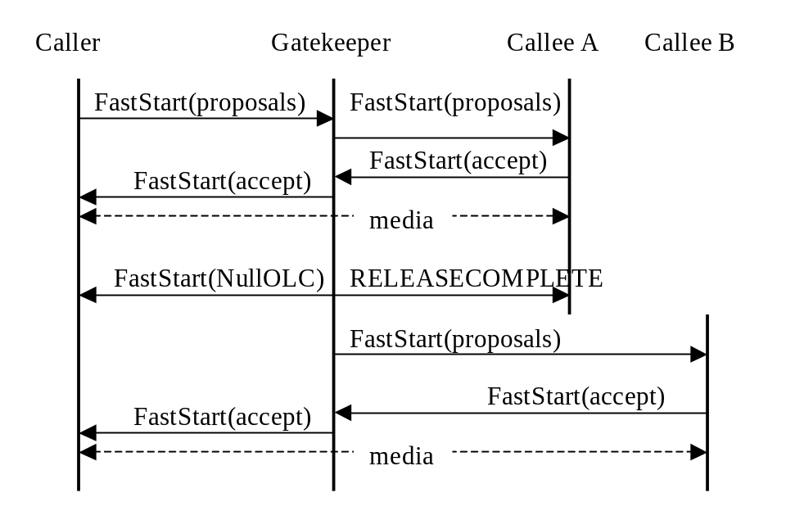
Figure 5/H.460.6 - Third-Party Redirection
In the above diagram, the Gatekeeper, or the entity that re-routes a call should send a Facility message containing the destinationInfo field upon completion of the re-routing to the entity that gets re-routed, i.e., Caller. An endpoint should examine this message for the H.225.0 version information at any point that a Facility message is received containing this field.
After coming out of the “paused” state an endpoint should examine the version-id fields in TCS messages to determine the H.245 version supported by the remote endpoint.
In addition, an endpoint interested in knowing the version of the remote endpoint should send a Status Inquiry message and wait for the receipt of the Status message to determine the version of the H.225.0 in use when it exits the paused state when the above Facility message is not received within a reasonable amount of time. The length of this time is left to the implementation.
[End Correction]

5.9.3.5 Termination of Extended Fast Connect
Description: | It is held that extended fast connect shall not be terminated when an H.245 address is present in a message returned by the called party. Instead, EFC shall be terminated when a connection is established to the H.245 address. To this end, text in section 4.2 should be changed as follows.
[Begin Correction]
4.2 Invocation of Extended Fast Connect
…
Extended Fast Connect requires that H.245, if used, shall be tunnelled in the H.225.0 signalling channel. If a calling party offers Extended Fast Connect support in SETUP, and the called party returns a message including h245Address before returning an EFC response, the calling party shall presume that EFC is not supported and may proceed with establishment of the requested connection. Including h245address in messages does not by itself terminate EFC, but establishing a connection to an H.245 address will cause termination of EFC.
[End Correction]

5.9.3.6 Clarification on simultaneous use of EFC acceptance and acceptance fastStart
Description: | EFC acceptance and acceptance fastStart can be simultaneously included in any message up to and including Connect. Having both the fields in the same message can cause undue processing on the recipient and must be avoided when it is possible. To this end, text in section 4.2 should be changed as follows.
[Begin Correction]
4.2 Invocation of Extended Fast Connect
…
Note that the EFC acceptance and acceptance fastStart can be returned in any message up to and including the CONNECT message, but the identical acceptance should not be repeated in any subsequent message.
[End Correction]

5.9.3.7 Clarification on orientation of logical channels
Description: | Orientation of logical channels proposed using EFC are not related to the direction of the call. The following paragraph should be added to Section 4.3 to clarify this.
[Begin Correction]
4.3 Opening New Sessions
Opening new media sessions proceeds just like standard Fast Connect, except that either party may invoke EFC at any time to propose new media sessions by sending a message (e.g., FACILITY) containing a proposal fastStart element with one or more OLCs for one or more sessionIDs, along with a genericData element indicating “EFC Proposal”. As for standard Fast Connect, multiple OLCs with the same sessionID are considered to be alternative proposals for a single media stream. The other party may reply with a fastStart element containing OLCs for the accepted channels and sessions. A slave party will supply a non-zero sessionID for any media channels it proposes. Parties may use EFC to propose and open any number of sessions. Session IDs may take any valid value and need not be limited to the “well-known” values of 1, 2, or 3.
For each logical channel, the EFC proposal establishes the orientation of the forward and reverse logical channels: the forward logical channel carries media from the proposer to the acceptor, and the reverse logical channel carries media from the acceptor to the proposer; the order is not determined from the direction of the call as a whole.
As in standard Fast Connect, once a proposed alternative is selected by another party, the issuing endpoint may suspend any reception of media on the other alternatives. Nevertheless, it shall be prepared for the other party to replace the initially-selected alternative with another (see section 4.7, below).
…
[End Correction]

5.9.4 Technical and Editorial Corrections to H.460.7 (2002)

5.9.4.1 Compound Type Parameter Usage
Description: | The contents of the compound parameter in Section 6.4, Table 9 are not well defined. The text below clarifies its usage.
[Begin Correction]
6.4 Digit map string parameters
…
Table 9/H.460.7 – Type of Number Associated Digit Maps
Parameter name: | ToN Associated Digit Map
Parameter description: | This compound type conveys Digit Map associated with a particular Type of Number
Parameter identifier type: | Standard
Parameter identifier value: | 5
Parameter type: | Compound
Parameter cardinality: | Zero or more
Within the compound type defined in Table 9, the parameters defined in Table 2 and Table 11 shall be included to convey one or more Digit Map strings for a particular Type of Number:
Table 10/H.460.7 – Type of Number Parameter
Parameter name: | Type of Number (ToN)
Parameter description: | This parameter indicates the type of number
Parameter identifier type: | Standard
Parameter identifier value: | 1
Parameter type: | Number8
Parameter valid values: | 1 International number  2 National number  3 Network specific number  4 Subscriber number  6 Abbreviated number
Parameter cardinality: | Once
The Digit Map strings comprising the Digit Map associated with a Type of Number are conveyed as additional parameters within the compound type of the Type of Number Associated Digit Maps parameter shown in Table 9. This is shown in Table 11.
Table 11/H.460.7 - Digit Map strings for ToN Parameter
Parameter name: | Digit Map Strings for ToN
Parameter description: | This parameter contains a single Digit Map string
Parameter identifier type: | Standard
Parameter identifier value: | 2
Parameter type: | Text
Parameter cardinality: | One or more
The syntax of the text field, which holds a single Digit Map string, is described in section 10.
The order of the Digit Map strings in the parameters field has no significance.
[End Correction]

5.9.4.2 Duplicate Parameters
Description: | Section 6.3 (Table 3) and Section 6.5 (Table 12) both define a parameter with ID 2. They can be used in the same place (in an RCF), so it is not possible to distinguish between them. The parameter identifier value should be changed to 2 as below.
[Begin Correction]
6.5 URL parameter
…
Table 12/H.460.7 - URL Parameter
Parameter name: | Digit Map URL
Parameter description: | This parameter contains a URL to Digit Map information accessible via HTTP
Parameter identifier type: | Standard
Parameter identifier value: | 6
Parameter type: | Alias
Parameter cardinality: | Zero or one
[End Correction]

5.9.6 Technical and Editorial Corrections to H.460.18 (2005)

5.9.6.1 Editorial corrections to clause 4 – Abbreviations
Description: | Some abbreviations in Clause 4 need corrections. The text below specifies these corrections.
[Begin Correction]
This Recommendation uses the following abbreviations:
ACF Admission Confirm (H.225.0)
ARQ Admission Request (H.225.0)
…
[End Correction]

5.9.6.2 Editorial corrections to clause 8.1 – Traversal server mode selection
Description: | The text “supported features” is changed to reflect how it appears elsewhere in the Recommendation. The text of clause 8.1 is corrected as follows.

[Begin Correction]
If the TS has prior knowledge that there is no NAT/FW between itself and the endpoint, it may elect not to use the procedures described in this Recommendation. If NAT/FW traversal is not required, the TS may omit Signalling Traversal from the supportedFeatures field of the RCF. Signalling then proceeds without the procedures described in this Recommendation.
[End Correction]

5.9.6.3 Editorial corrections to clause 8.2 – Registration when H.460.18 mode selected by traversal server
Description: | Typographical errors appear in the title and the text. The text of clause 8.2 is corrected as follows.
[Begin Correction]
8.2 Registration when H.460.18 mode selected by traversal server
…
If the TS accepts a gatekeeper discovery or registration, it shall send a GCF or RCF with Signalling Traversal in the supportedFeatures field. The TS shall set the timeToLive in the RCF to a value that is short enough to prevent intermediate NAT/FW devices from blocking connectivity. This value shall be determined as described in clause 14.
…
[End Correction]

5.9.6.4 Editorial corrections to Figure 4 – Indicative outgoing call message sequence
Description: | Figure 4 incorrectly displays H.225 instead of H.225.0. The text in the figure is corrected as follows.
[Begin Correction]
EP
A
TS
RAS ARQ
RAS ACF
TCP Connect (For H.225.0 connection)
H.225.0 Setup
H.225.0 Connect (+ TS H.245 Address)
TCP Connect (For H.245 connection)
H.245

GenericIndication
H.245

TermCaps
.
.
.
Figure 4/H.460.18 Indicative Outgoing Call Message Sequence
[End Correction]

5.9.6.5 Editorial corrections to clause 10 – Incoming call procedure
Description: | The text below corrects a typographical error in Clause 10.
[Begin Correction]
EP_{A} is located on the internal network, EP_{B} is on the external network. EP_{B} is H.323 conformant and is outside the scope of this Recommendation.
1) To establish a call to EP_{A} in the internal network (for example, in response to an H.225.0 call setup from EP_{B}), the TS shall send an H.225.0 SCI RAS message to EP_{A}. The genericData field of the SCI shall contain an IncomingCallIndication as defined in Table 2.
…
[End Correction]

5.9.6.6 Editorial corrections to Figure 5 – Indicative incoming call message sequence
Figure 5 incorrectly displays H.225 instead of H.225.0 and contains some typographical errors. The text in the figure is corrected as follows:
[Begin Correction]
.
.
H.225.0 Facility (start H.245 + TS H.245 Address)
H.225.0 Connect (+ EP_{A}a H.245 Address)
H.245 TermCaps
H.245 GenericIndication
TCP Connect (For H.245 connection)
RAS ACF
RAS ARQ
H.225.0 Setup
H.225.0 Facility (incoming Call Indication)
TCP Connect (For H.225.0 connection)
RAS SCR
RAS SCI (Incoming Call Indication + TS H.225.0 Addr)
EP_{A}

TS
Figure 5/H.460.18 Indicative Incoming Call Message Sequence
[End Correction]

5.9.7 Technical and Editorial Corrections to H.460.19 (2005)

5.9.7.1 Editorial corrections to Scope
Description: | The text would be modified to  (i) clarify that H.460.19 addresses the following types of media streams.  - RTP stream  - RTP stream encrypted using H.235  - SRTP stream  (ii) clarify minor editorial issues.
[Begin Correction]

3 Definition
…
This Recommendation addresses NAT/FW traversal for the following types of media streams.
- RTP
- RTP encrypted using H.235
- SRTP
NAT/FW traversal for media transported by other protocols is for further study.
It also defines a mechanism to use the same transport address for several media channels, which permits reduction of the number of "pinholes" opened in the NAT/FW device and reduces the number of Media Channel and Media Control Channel transport addresses used by H.323 entities.
[End Correction]

5.9.7.2 Editorial corrections to Section 3/H.460.19
Description: | (i) Minor editorial clarifications.  (ii) There is a case in Fast Connect that an "OLC response" message is carried earlier in time than the corresponding "OLC request" message. A note is added to clarify what constitutes and OLC request and an OLC response as used in this specification.  (iii) Added definition for ‘demilitarized zone’.
[Begin Correction]

3 Definitions
…
3.3 demilitarized zone: a network that sits between an organization's internal network and an external network, usually the Internet. Connections from the internal and the external network to the DMZ are permitted, whereas connections from the DMZ are only permitted to the external network
…
3.5 external network: A network connected to the firewall through its public interface; typically, but not limited to, the Internet.
3.6 H.460.19 entity: A client or server.
3.7 internal network: A network connected to the NAT/FW through the NAT/FW's private interface.
3.8 media channel: An RTP or an SRTP channel.
3.9 media control channel: An RTCP or SRTCP channel.
3.10 multiplexed media mode: A mechanism which enables managing multiple RTP/RTCP or SRTP/SRTCP sessions on a single pair of transport addresses as described in ‎7.2. Receivers choose whether or not to multiplex.
3.11 OLC request: Any one of:
• the openLogicalChannel message;
• the openLogicalChannel Fast Connect proposal message for transmission from caller to callee;
• the openLogicalChannel Fast Connect proposal accept message for transmission from callee to caller.
3.12 OLC response: Any one of:
• the openLogicalChannelAck message;
• the openLogicalChannel Fast Connect proposal accept message for transmission from caller to callee;
• the openLogicalChannel Fast Connect proposal message for transmission from callee to caller.
NOTE: An OLC request message is the message that contains information relevant to the OLC for the media stream that is received by the addressee of this OLC request message, while an OLC response message is the message that contains information relevant to the OLC for the media stream that is sent by the addressee of this OLC response message.
3.13 peer: An H.460.19 entity with which a particular H.460.19 entity is communicating.
3.14 pinhole: A temporary binding of an internal and an external transport address in the NAT/FW which allows the bidirectional passage of packets between those addresses.
3.15 server: An H.323 entity compliant with H.460.19 specifications and performing H.460.19 server functionality.
3.16 transport address: IP address and UDP/TCP port number.
[End Correction]

5.9.7.3 Editorial corrections to Section 4/H.460.19
Description: | Minor editorial clarifications
[Begin Correction]

4 Abbreviations
…
RTCP Real-time Transport Control Protocol (according to RFC 3550)
RTP Real-time Transport Protocol (according to RFC 3550)
SRTCP Secure Real-time Transport Control Protocol (according to RFC 3711)
SRTP Secure Real-time Transport Protocol (according to RFC 3711)
[End Correction]

5.9.7.4 Editorial corrections to Section 6/H.460.19
Description: | Minor editorial clarifications
[Begin Correction]

6 Architecture
…
Media Channel traffic is unidirectional. To permit Media Channel packets toward the internal network, this Recommendation defines a keep-alive channel. The client sends keep-alive media packets to the keepAliveChannel transport address provided by the server.
In the NAT/FW traversal procedure, the H.460.19 server sends Media Channel and Media Control Channel packets to the H.460.19 client to the address from which Keep Alive Channel and Media Control Channel packets were received by the H.460.19 server, instead of to the addresses specified in the H2250LogicalChannelParameters.mediaChannel and H2250LogicalChannelParameters.mediaControlChannel H.245 structures as in normal H.323 operation. The NAT/FW traversal procedure also requires usage of a keep-alive mechanism. The goal of the keep-alive mechanism is to ensure that there are no extended periods of "network silence" between the communicating Transport Addresses, which might result in closure of pinholes by the NAT/FW. Implementation of the keep-alive mechanism is mandatory in client to server direction.
…
In Figure 3, Organization A on the left has a mix of H.460.19-enabled endpoints, and of non-H.460.19 H.323 endpoints making use of an H.460.19 proxy. Organization A has an H.460.19 server on their demilitarized zone (shown as part of the external network in the figure), which provides media traversal and access to the external network for Organization A endpoints.
…

6.1 General requirements
…
Support of multiplexed media mode transmission defined in ‎7.3.2 is mandatory for H.460.19 clients and optional for H.460.19 servers.
Support of multiplexed media mode reception defined in ‎7.3.2 is optional for both H.460.19 clients and H.460.19 servers.
[End Correction]

5.9.7.5 Editorial corrections to Section 7/H.460.19
Description: | (i) Minor editorial corrections  (ii) Keep-alives have to be sent at an interval less than the one specified by the server, but the text indicates the opposite. This is corrected.  (iii) A note advising against the use of very short keep-alive intervals is added.
[Begin Correction]

7.1.1 Capabilities signalling
…
The capability to transmit in multiplexed media mode shall be signalled by the servers by including the supportTransmitMultiplexedMedia parameter, defined in ‎7.4.2, in the same supportedFeatures field.
…
The capability to receive in multiplexed media mode (to de-multiplex) shall be indicated by the presence of the multiplexID field in the Traversal Parameters in the OLC Request and OLC Response messages as defined in ‎7.4.5.
…

7.1.2 Logical channel signalling
…
In all cases, the H.460.19 client shall send keep-alive packets as defined in ‎7.3.1.1.
…
Table 2/H.460.19 – Transport addresses for channels between H.460.19 client and server
Channel | Source | Source transport address | Dest. | Destination transport address
Media Channel | client | Any port on H.460.19 client. | server | mediaChannel destination address on H.460.19 server in server's OLC Response message.
Media Channel | server | keepAliveChannel destination address on H.460.19 server in server's OLC Request message. | client | Apparent keep-alive source address on H.460.19 client (media sent only after receipt of keep-alive from H.460.19 client).
Keep-alives | client | H.460.19 client's desired Media Channel destination port. | server | keepAliveChannel destination address on H.460.19 server in server's OLC Request message.
Media Control Channel | client | H.460.19 client's desired Media Control Channel destination port.  The mediaControlChannel destination address in all OLC Request and OLC Response messages sent by a given client for a given call and value of sessionID shall contain this same transport address.  NOTE – The H.460.19 server ignores this mediaControlChannel value. | server | mediaControlChannel destination address on H.460.19 server in server's OLC Request or OLC Response message – whichever was received more recently for the given call and value of sessionID.
Media Control Channel | server | mediaControlChannel destination address on H.460.19 server in H.460.19 server's OLC Request or OLC Response message – whichever was transmitted more recently for the given call and value of sessionID. | client | Apparent Media Control Channel source address on H.460.19 client (media control packets are sent only after receipt of media control packets from H.460.19 client).
…
7.1.2.2 Establishment of LCs from H.460.19 server to H.460.19 client
…
The H.460.19 client shall transmit Media Control Channel and keep-alive packets to the transport addresses indicated in the mediaControlChannel and keepAliveChannel fields, respectively, of the H.460.19 server's OLC Request message.
The H.460.19 server shall wait for receipt of at least one keep-alive packet from the H.460.19 client for the LC, and then send Media Channel packets for the LC to the H.460.19 client, with a destination transport address equal to the apparent source transport address of the keep-alive packet received from the H.460.19 client.
…
7.1.2.3 Overlapping establishment of LCs between H.460.19 client and H.460.19 server
…
The H.460.19 client shall transmit Media Channel, Media Control Channel, and keep-alive packets to the transport addresses indicated in the mediaChannel, mediaControlChannel, and keepAliveChannel fields, respectively, of the H.460.19 server's OLC Request or OLC Response message, whichever was received more recently for the same call and using the same value of sessionID.
The H.460.19 server shall wait for receipt of at least one keep-alive packet from the H.460.19 client for the LC, and then send Media Channel packets for the LC to the H.460.19 client, with a destination transport address equal to the apparent source transport address of the keep-alive packet received from the H.460.19 client.

…
7.1.2.4 Establishment of LCs from H.460.19 client to H.460.19 client
…
The H.460.19 client shall not transmit keep-alive packets when the peer is also H.460.19 client.
…
7.1.2.5 Establishment of LCs from H.460.19 server to H.460.19 server
…
The H.460.19 server shall not transmit keep-alive packets when the peer is also H.460.19 server.
…
7.2.1 Requesting the multiplexed media mode
…
An H.460.19 entity "A" (either an H.460.19 server or an H.460.19 client) may initiate multiplexing of the Media, Media Control and keep-alive channels sent from an H.460.19 client to entity A.
An H.460.19 entity "A" (either an H.460.19 server or an H.460.19 client) may initiate multiplexing of the Media, Media Control and keep-alive channels sent from an H.460.19 server to entity A, only if the H.460.19 server supports multiplexing as indicated by supportTransmitMultiplexedMedia parameter of the server's feature identifier as defined in 7.4.2.
…
NOTE 1 – A multiplexID field may be included in an OLC Request message in order to request multiplexing of the Media Control Channel and keep-alive channel in the direction toward the requesting entity.
…
NOTE 2 – The pair of LCs for the given call and value of sessionID establishes a Media Channel and a Media Control Channel in the direction toward the client and a keep-alive channel and a Media Control Channel in the direction toward the server. The packets, of these channels, sent towards either of the entities include the multiplexID provided by the entity.
If the multiplexID field was present in the message, the peer H.460.19 entity shall transmit Media Channel, Media Control Channel and keep-alive packets for the LCs in the multiplexed mode, identifying each packet with the multiplexID value as defined in 7.3.2.
Entity A shall receive Media Channel, Media Control Channel and keep-alive packets for the LCs in the multiplexed media mode, and use the received value of the multiplexID in each packet as defined in 7.3.2.
…
If an OLC Request message contains multiplexID and keepAliveChannel fields, then the keepAliveChannel field shall contain the destination transport address for the multiplexed keep-alive packets.
…

7.3.1 NAT/FW traversal procedure
…
The Media Channel, Media Control Channel and keep-alive channel are considered established for the purpose of the keep-alive procedure when the H.460.19 entity receives the OLC Request or OLC Response message containing the transport address for each channel
…

7.3.1.1 NAT/FW traversal procedure – Clients
…
Upon establishment of each keep-alive channel, the H.460.19 client shall transmit one Media Channel keep-alive packet.
Upon establishment of each Media Control Channel, the H.460.19 client shall transmit one Media Control Channel keep-alive packet.
For each established Media Control Channel and keep-alive Channel, the H.460.19 client shall transmit a Media Channel and Media Control Channel keep-alive packet at intervals less than the value specified by the H.460.19 server in the keepAliveInterval field in the Traversal Parameters defined in ‎7.4.5, unless there is other traffic on the channel within the given interval.
A keep-alive interval in the range of 5 to 30 seconds should be used except in cases where it is known (for example, from the specifics of the network) that a longer interval will not result in the closure of pinholes.
NOTE: Keep-alive packets should not be sent in an unduly short interval compared to the keepAliveInterval value. This is to avoid waste of the network and processing resources.

7.3.1.1.1 RTP keep-alive packet
The RTP keep-alive packet is an RTP packet with an empty payload field. The payload type value shall be equal to the value specified by the client in keepAlivePayloadType field in the Traversal Parameters defined in ‎7.4.5. The sequence number header field shall start from any arbitrary value and increment by one for each keep-alive packet.
The SSRC and timestamp header fields may have arbitrary values.

7.3.1.1.2 RTCP keep-alive packet
The RTCP keep-alive packet is an RTCP packet containing only an SR (sender report) specified in RFC 3550.

7.3.1.1.3 SRTP keep-alive packet
The SRTP keep-alive packet is the same as the RTP keep-alive packet. In addition, the optional authentication tag (as defined by RFC 3711) should be added to the packet.

7.3.1.1.4 SRTCP keep-alive packet
The SRTCP keep-alive packet is an SRTCP packet containing an SR (sender report) authenticated and optionally encrypted with the same parameters which are used for regular SRTCP packets in the same SRTP session.

7.3.1.2 NAT/FW Traversal procedure – Servers
All H.460.19 servers shall implement the NAT/FW Traversal procedure defined in this clause.
H.460.19 servers shall not forward any RTP or SRTP keep-alive packet as defined in the previous clause to any H.323 endpoint which has not indicated support for the procedures of this Recommendation.
…
For each established Media Channel, the H.460.19 server entity shall wait for receipt of at least one keep-alive media packet from the H.460.19 client and then send media packets destined for the H.460.19 client to the source transport address of the keep-alive media packet received from the H.460.19 client.
…

7.3.3 Multiplexed media mode – SRTP/SRTCP
The multiplexed media mode for SRTP/SRTCP is identical to the RTP/RTCP procedure in the previous clause, with the 4-byte multiplexID inserted between the UDP header and the SRTP/SRTCP headers.
…
7.4.5.1 Traversal Parameters semantics
…
keepAliveChannel
Keep-alive channel packets shall be sent to the transport address received in this field. This field is used only to specify the address for the keep-alive packets which need to be sent in the opposite direction to that of the Media Channel. This field shall be specified only by H.460.19 servers in OLC Request messages.
keepAlivePayloadType
The keep-alive channel packets shall have the payload type value equal to the value specified in this field by the sender of the keep-alive packets. This field shall be specified in the OLC Response messages by the H.460.19 client communicating with H.460.19 server or with an entity whose H.460.19 type is still unknown.
keepAliveInterval
This value is signalled by an H.460.19 server and represents the maximum interval, in seconds, of the absence of the Media Channel or Media Control Channel packet traffic, within which the corresponding keep-alive packets shall be sent.
[End Correction]

6 Implementation Clarification

6.1 Token Usage in H.323 Systems
There has been some confusion on the usage of individual CryptoH323Tokens as passed in RAS messages. There are two main categories of CryptoH323Tokens; those used for H.235 procedures and those used in an application specific manner. The use of these tokens should be according to the following rules:
- All H.235 defined (e.g. cryptoEPPwdHash, cryptoGKPwdHash, cryptoEPPwdEncr, cryptoGKPwdEncr, cryptoGKCert, and cryptoFastStart). shall be utilized with the procedures and algorithms as described in H.235.
- Application specific or proprietary use of tokens shall utilize the nestedcryptoToken for their exchanges.
- Any nestedcryptoToken used should have a tokenOID (object identifier) which unambiguously identifies it.

6.2 H.235 Random Value Usage in H.323 Systems
The random value that is passed in xRQ/xCF sequence between endpoints and Gatekeepers may be updated by the Gatekeeper. As described in section 4.2 of H.235 this random value may be refreshed in any xCF message to be utilized by a subsequent xRQ messages from the endpoint. Due to the fact that RAS messages may be lost (including xCF/xRJ) the updated random value may also be lost. The recovery from this situation may be the reinitializing of the security context but is left to local implementation.
Implementations that require the use of multiple outstanding RAS requests will be limited by the updating of the random values used in any authentication. If the updating of this value occurs on every response to a request, parallel requests are not possible. One possible solution, is to have a logical "window" during which a random value remains constant. This issue is a local implementation matter.

6.3 Gateway Resource Availability Messages
The Resources Available Indication (RAI) is a notification from a gateway to a gatekeeper of its current call capacity for each H-series protocol and data rate for that protocol. The gatekeeper responds with a Resources Available Confirmation (RAC) upon receiving a RAI to acknowledge its reception. A Gatekeeper should ignore any RAI notifications (e.g. send no RAC) upon receiving a RAI which contains bogus information (i.e. a bad endpointIdentifier).

6.4 OpenLogicalChannel in fastStart
In the H.225.0 ASN.1, fastStart is defined as SEQUENCE OF OCTET STRING OPTIONAL. The text definition states "This uses the OpenLogicalChannel structure defined in H.245…" Each OCTET STRING in fastStart is to contain the OpenLogicalChannel structure, not an entire request message.

6.5 Clarification in Q.931 (1993)
Table 4-3/Q.931 (1993) (Information Element Identifier Coding) shows that the Progress Indicator IE identifier is 0x1e, but Figure 4-29/Q.931 (octet layout of Progress Indicator IE) shows the identifier as 0x1f. Note that the identifier should be 0x1e.

6.6 Graceful Closure of TCP Connections
When a TCP connection is closed, the graceful closure procedure documented in section 3.5 of RFC 793 should always be used.

6.7 Race Condition on Simultaneous Close of Channels
Section 8.5 of H.323 describes the procedures that an endpoint follows to terminate a call. It should be noted that as prescribed in Step 6, both endpoints shall issue a Release Complete simultaneously. Endpoints should be prepared for this potential race condition.

6.8 Acceptance of Fast Connect
When an endpoint accepts the Fast Connect procedure, it may select from the proposed channels as specified in section 8.1.7.1/H.323. The Recommendation clearly specifies what fields shall be modified by the endpoint to accept both the forward and the reverse channels. An endpoint shall not modify any fields other than those specified in 8.1.7.1/H.323 when returning the proposed channels.
Newer versions of H.245 may introduce new fields into the OpenLogicalChannel sequence or one of the structures contained therein, as well as new procedures. An older endpoint is obviously not required to decode such new fields or to return such new fields when accepting any proposal. Implementers should consider the consequences of transmitting a newer H.245 OLC to an older endpoint. For the purposes of Fast Connect, the calling endpoint shall assume that the called endpoint's version of H.245 is the minimum version of H.245 necessary to be complaint with an H.323 device that advertises the version of H.225.0 transmitted in the messages from the called endpoint (refer to the "Summary" section of H.323).

6.9 Semantic Differences between Lightweight RRQs and IRQ/IRR Messages
The lightweight RRQ and the IRR message serve two different functions with an H.323 system. While both are a means of allowing the Gatekeeper to discover that an endpoint is alive, they also each serve separate, unique functions.
The lightweight RRQ is intended to prevent a registration with a Gatekeeper from expiring. The message is generated by the endpoint and does not require the Gatekeeper to poll each endpoint on a regular interval. This message is also a means of allowing the Gatekeeper to provide updated registration information, such as a new list of Alternate Gatekeepers, after the initial registration.
Version 1 of H.323 did not have the concept of a lightweight RRQ, so the IRQ/IRR exchange is the only mechanism available to determine endpoint status of Version 1 devices. However, the lightweight RRQ may be a better choice for determining endpoint status for Version 2 and higher devices.
The IRQ/IRR exchange allows the Gatekeeper to poll the endpoint periodically to discover if the endpoint is still alive. However, an IRR is also intended to convey details about current active calls. This can be used by the Gatekeeper to discover calls that have terminated, which may happen if the endpoint fails to properly send a DRQ message for a call. The IRR message also provides specific details about active calls.

6.10 Specifying the Payload Format for a Channel
Implementers should be conscientious of the fact that there are possibly multiple payload formats defined for media formats. For example, two payload formats are defined for H.263—one is defined for the Recommendation H.263 (1996) and one for Recommendation H.263 (1998). Other payload formats may be defined for existing codecs or revisions of those codecs. For interoperability, it is strongly advised that implementers provide the mediaPacketization element of the h2250LogicalChannelParameters sequence in the OpenLogicalChannel message so that there is no ambiguity at to which payload format is being used.

6.11 Version Dependencies in Annexes
It was noted that the Annexes to H.323 often fail to indicate the minimum version of H.323 and H.245 required for the Annex. This table is an attempt to clarify the version relationships:

H.323 Annex | Minimum H.323 Version | Minimum H.245 Version
Annex Dv1 (1998) | 1998 (Version 2) | 1998 (Version 4)
Annex Dv2 (2000) | 2000 (Version 4) | 2000 (Version 7)
Annex Dv3 (2005) | 2000 (Version 4) | 2005 (Version 11)
Annex E | 1998 (Version 2) | N/A
Annex F | 1998 (Version 2) | N/A
Annex G | 1998 (Version 2) | 1998 (Version 4)
Annex Gv2 (2006) | 1998 (Version 2) | 2000 (Version 7)
Annex J | 1998 (Version 2) | N/A
Annex K | 1998 (Version 2) | N/A
Annex L | 1998 (Version 2) | N/A
Annex M.1 | 2000 (Version 4) | N/A
Annex M.2 | 2000 (Version 4) | N/A
Annex M.3 (2001) | 2000 (Version 4) | N/A
Annex M.4 (2004) | 2000 (Version 4) | N/A
Annex O | 2000 (Version 4) | N/A
Annex P | 2000 (Version 4) | 2003 (Version 9)
Annex Q | 1998 (Version 2) | 2000 (Version 7)
Annex R | 2000 (Version 4) | N/A

6.12 Routing through Signaling Entities and Detecting Loops
In some call scenarios, a call may be routed though a signaling entity multiple times. For example, a call from Endpoint 1 (EP1) may be routed through Gatekeeper 1 (GK1) and Gatekeeper 2 (GK2) to Endpoint 2 (EP2) as shown in Figure 1.
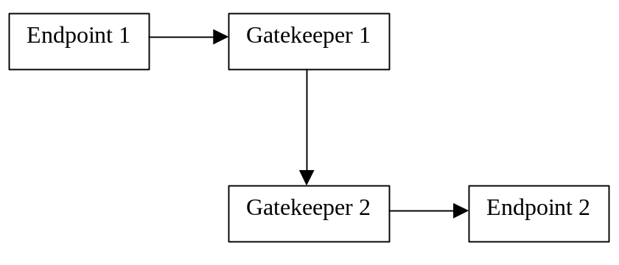
Figure 1 - Call placed through multiple gatekeepers
If EP2 redirects the call to a third endpoint, such as Endpoint 3 (EP3), signaling entities such as GK1 and GK2 should be prepared to handle such call rerouting. For this example, assume that EP2 returned a Facility message with a reason of callForwarded upon receiving a Setup message. Rather than propagate that response back to EP1, GK2 may choose to handle the call forward operation. GK2 would send a Release Complete to EP2 and begin rerouting the call. Suppose that GK2 sends an LRQ message to GK1 for EP3 and that GK1 replies with its address so that that calls routed to EP3 are routed through it. GK2 would then send a Setup message for this call to GK1 as shown in Figure 2.
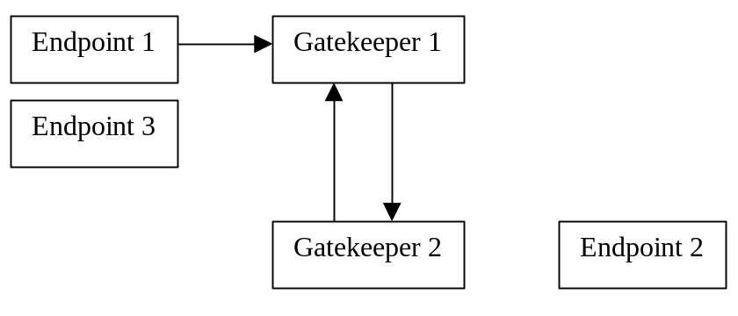
Figure 2 - Gatekeeper 2 re-routes call back to Gatekeeper 1
When GK1 receives the Setup message from GK2, it may inadvertently mistake the call as "bogus", since the Call Identifier will match an already existing call within the Gatekeeper. Implementers should consider this type of call scenario and be prepared to receive incoming calls that contain Call Identifiers for calls that are already being routed through the routing entity. The routing entity should examine not only the Call Identifier, but also the destination address of the call (the call signaling address, aliases, or Called Party Number of the destination). In this case, the call is routed through GK1 with a destination address of EP2 is rerouted by GK2 to GK1, but with a destination address of EP3. In this way, the GK1 will properly handle call routing and rerouting, as well as prevent loops in the call signaling path.
In this example, there was a dependency on the H.323v2 Call Identifier. Unfortunately, H.323 version 1 systems did not have Call Identifiers. For this reason, these loop detection and rerouting procedures are not possible. Nonetheless, it is advisable for routing entities to make an effort to prevent loops properly. For example, if the entities in Figure 2 were version 1 devices, the GK1 may examine the source address, destination address, and Conference Identifier (CID) of the call. The first time the call is presented to the Gatekeeper, the destination address is EP2, just as before. However, when GK re-routes the call back to GK1, the destination address is EP3. In this way, GK1 may allow proper rerouting of the call to EP3.
The logic for Version 1 devices seems similar to that for Version 2 and higher devices, but there are issues when EP2 and EP3 are MCUs, for example. Suppose that EP2 is an MCU that is directing all calls to EP3. The first time a call is redirected to GK1, GK1 may realize that this is, indeed, a call redirection as described above. However, when the second call is redirected, GK1 has no means of distinguishing between the first redirected call and the second: the source address may be the same, the destination address is the same as the previously rerouted call (EP3), and the Conference ID is the same. So in this case, GK1 may have no choice but to assume that a loop has occurred and release the offending call. Although this is unfortunate, H.323v2 and higher systems do not suffer from this problem. What is important, though, is that loop detection is possible—even with version 1 systems.

6.13 Packetization for G.729, G.729a, G.711, and G.723.1
The delay associated with codec processing and packetization should be kept as short as possible. To accomplish this objective when G.729 or G.729A is used, two frames per packet should be considered as the maximum packet size. Similarly, G.711 may be used with packet sizes of 10 ms (80 frames) or 20 ms (160 frames) to achieve this objective. Finally, when G.723.1 is used, only one frame should be included in each packet. The 30 ms frame size of G.723.1 results in speech collection and coding delay of at least 60 ms, contributing to difficulty of interactive communications.

6.14 Checking versions for T.38 and V.150.1
It is important that devices properly negotiate the version of the T.38 or V.150.1 to be used and agree to use the same version. At the present time there are few guidelines for version negotiation. Until the guidelines are developed the following note applies:
Devices supporting multiple versions of T.38 and V.150.1 may offer multiple proposals in Fast Connect, each with a different version specified. A device shall not accept a proposal for a version that it does not support.

7 Allocated Object Identifiers and Port Numbers
Information in this section is provided for informational purposes and convenience. This section does not supercede nor replace proper references in H.225.0, H.225, H.235, or other Recommendations.

7.1 Allocated Object Identifiers
The following object identifiers have been allocated for protocols associated with H.323. Any future object IDs that are allocated should be indexed here to prevent duplication.
Note that object IDs below that are allocated below the arc { itu-t(0) recommendation(0) } are show with an abbreviated prefix of "0 0" below.

{ 0 0 h(8) 2250 version(0) [v] } | H225.0 version numbers
Assigned values of v: 1-4
{ 0 0 h(8) 2250 annex(1) g(7) version(0) [v] } | H225.0 Annex G version numbers
Assigned values of v: 1-2
{ 0 0 h(8) 2250 annex(1) g(7) usage(1) [u] } | H225.0 Annex G usage tags
Assigned values of u: none
{ 0 0 h(8) 245 version(0) [v] } | H245 version numbers
Assigned values of v: Please refer to Table D.1/H.245
{ 0 0 h(8) 245 generic-capabilities(1) video(0) [c] } | Generic video capabilities
Assigned values of c: Please refer to Table D.1/H.245
{ 0 0 h(8) 245 generic-capabilities(1) audio(1) [c] } | Generic audio capabilities
Assigned values of c: Please refer to Table D.1/H.245
{ 0 0 h(8) 245 generic-capabilities(1) data(2) [c] } | Generic data capabilities
Assigned values of c: Please refer to Table D.1/H.245
{ 0 0 h(8) 245 generic-capabilities(1) control(3) [c] } | Generic control capabilities
Assigned values of c: Please refer to Table D.1/H.245
{ 0 0 h(8) 245 generic-capabilities(1) multiplex(4) [c] } | Generic multiplex capabilities
Assigned values of c: Please refer to Table D.1/H.245
{ 0 0 h(8) 283 generic-capabilities(1) 0 } | H.283 Capability
{iso (1) identified-organization (3) icd-ecma (0012) private-isdn-signalling-domain (9)} | Identifies QSIG as the tunneled protocol within an H.225.0 Call Signalling Channel

7.2 Allocated Port Numbers
The following IP port numbers have been allocated for various components of H.323:

1300 | TLS secured call signalling
1718 | Multicast RAS Signalling
1719 | Unicast RAS Signalling
1720 | TCP call signalling
2099 | Annex G/H.225.0 Signalling
2517 | Annex E/H.323 Signalling

8 Use of E.164 and ISO/IEC 11571 Numbering Plans

8.1 E.164 numbering plan
ITU-T Recommendation defines E.164 numbers the following way for geographic areas:

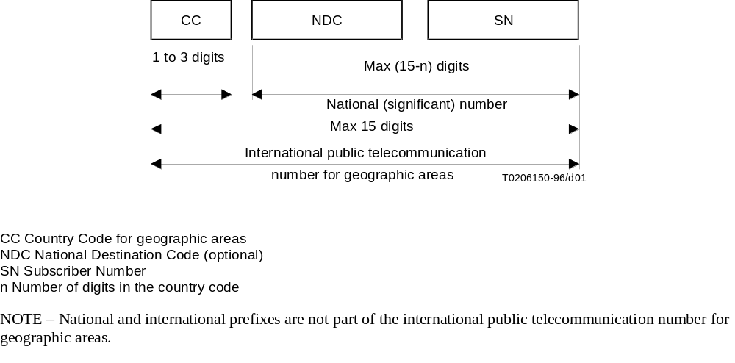
Figure – International public telecommunication number structure for geographic areas
Similar descriptions are also defined for non-geographic areas. Recommendation E.164 further defines country codes (CC) for all the countries and regions of the world.
An international E.164 number always starts with a country code and its total length is always 15 digits or less. More importantly, it does not include any prefixes that are part of a dialing plan (for example, "011" for an international call placed in North America, or "1" for a long-distance call), nor does it include "#" or "*". The number "49 30 345 67 00" is an E.164 number with CC=49 for Germany. A national number is the international number stripped of the country code, "30 345 67 00" in this case. The subscriber number is the national number stripped of the national destination code, "345 67 00" in this case.
An E.164 number has global significance: any E.164 number can be reached from any location in the world. A "dialed digit sequence", however, only has significance within a specific domain. Within a typical private numbering plan in an enterprise, for example, a prefix, such as "9", may indicate that a call goes "outside", at which point the local telephone company's dialing plan takes over. Each telephone company or private network is free to choose its own dialing plan. It is also free to change it as it pleases—and frequently does so (adding new area codes, for example).
In a typical geographically determined network where users input telephone numbers manually and where users do not travel too much, having different dialing plans everywhere is usually a problem. However, when a user travels, the user must determine the other network's numbering plan in order to place calls. When computer systems perform the dialing automatically, the user is usually required to customize the dialing software for every region or network.
Because of these issues with varying dialing plans and automated dialing, it is essential to be able to refer to an absolute "telephone number" instead of "what you have to dial to reach it from a specific location." Proper usage of E.164 numbers can resolve these issues. Many systems use E.164 numbers instead of dialed digits: for example, a PBX may gather the dialed digits from a user on a telephone and then initiate a call to the local phone company using an E.164 number in the Called Party Number information element in Q.931. When completing the Called Party Number IE, specifying the numbering plan as "ISDN/telephony numbering plan (Recommendation E.164)" indicates an E.164 number. Specifying the type of number as "unknown" and the specifying the numbering plan as "unknown" indicates dialed digits.
The following are a set of definitions from E.164:
number
A string of decimal digits that uniquely indicates the public network termination point. The number contains the information necessary to route the call to this termination point.
A number can be in a format determined nationally or in an international format. The international format is known as the International Public Telecommunication Number which includes the country code and subsequent digits, but not the international prefix.
numbering plan
A numbering plan specifies the format and structure of the numbers used within that plan. It typically consists of decimal digits segmented into groups in order to identify specific elements used for identification, routing and charging capabilities, e.g. within E.164 to identify countries, national destinations, and subscribers.
A numbering plan does not include prefixes, suffixes, and additional information required to complete a call.
The national numbering plan is the national implementation of the E.164 numbering plan.
dialing plan
A string or combination of decimal digits, symbols, and additional information that define the method by which the numbering plan is used. A dialing plan includes the use of prefixes, suffixes, and additional information, supplemental to the numbering plan, required to complete the call.
address
A string or combination of decimal digits, symbols, and additional information which identifies the specific termination point(s) of a connection in a public network(s) or, where applicable, in interconnected private network(s).
prefix
A prefix is an indicator consisting of one or more digits, that allows the selection of different types of number formats, networks and/or service.
international prefix
A digit or combination of digits used to indicate that the number following is an International Public Telecommunication Number.
country code (CC) for geographic areas
The combination of one, two or three digits identifying a specific country, countries in an integrated numbering plan, or a specific geographic area.
national (significant) number [N(S)N]
That portion of the number that follows the country code for geographic areas. The national (significant) number consists of the National Destination Code (NDC) followed by the Subscriber Number (SN). The function and format of the N(S)N is nationally determined.
national destination code (NDC)
A nationally optional code field, within the E.164 number plan, which combined with the Subscriber's Number (SN) will constitute the national (significant) number of the international public telecommunication number for geographic areas. The NDC will have a network and/or trunk code selection function.
The NDC can be a decimal digit or a combination of decimal digits (not including any prefix) identifying a numbering area within a country (or group of countries included in one integrated numbering plan or a specific geographic area) and/or network/services.
national (trunk) prefix
A digit or combination of digits used by a calling subscriber, making a call to a subscriber in his own country but outside his own numbering area. It provides access to the automatic outgoing trunk equipment.
subscriber number (SN)
The number identifying a subscriber in a network or numbering area.

8.2 Private Network Number
Private Network Numbers are used in private or virtual private telephony networks, e.g., a corporate network of PBXs and virtual private lines.
ISO/IEC 11571 defines Private Network Number (PNP) as having up to three regional levels.
A PNP Number shall comprise a sequence of x decimal digits (0,1,2,3,4,5,6,7,8,9) with the possibility that different PNP Numbers within the same PNP can have different values of x. The maximum value of x shall be the same as for the public ISDN numbering plan, see ITU-T Recommendation E.164.
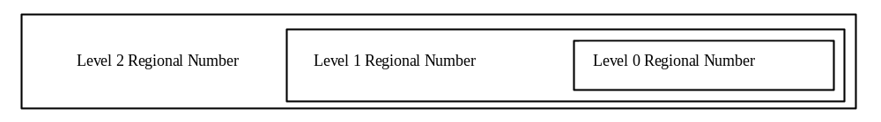
Figure – H.323 - Structure of a PNP Number with three levels of regions
A level n Regional Number (RN) shall have significance only within the level n region to which it applies. When that number is used outside that level n region, it shall be in the form of an RN of level greater than n. Only a Complete Number shall have significance throughout the entire PNP.
A typical example in North America would be a 4-digit "extension" as the Level 0 Regional Number: a 3-digit "location code" combined with the 4 digit "extension" would form the Level 1 Regional Number. The Level 2 Regional Number would be nil.
A prefix could also be used to signal which regional number is used, and would not be part of the regional number per se, but only part of the dialing plan. Again, a typical example would be the use of digit "6" to access a Level 1 Regional Number, and no digit for a Level 0 Regional Number.
The following are a set of definitions from ISO/IEC 11571:
Private Numbering Plan (PNP)
The numbering plan explicitly relating to a particular private numbering domain, defined by the PISN Administrator of that domain.
PNP Number
A number belonging to a PNP.
Region
The entire domain or a sub-domain of a PNP. A region does not necessarily correspond to a geographical area of a PISN.
Region Code (RC)
The leading digits of a PNP Number which identify a region. The RC may be omitted to yield a shortened form of a PNP Number for use internally to that region.
Regional Number (RN)
A particular form of a PNP Number which is unambiguous in the region concerned.
Complete Number
A number which is unambiguous in the entire PNP, i.e. which corresponds to the highest regional level employed in that PISN.

9 ASN.1 Usage, Guidelines, and Conventions

9.1 NULL, BOOLEAN, and NULL/BOOLEAN OPTIONAL
Throughout the ASN.1 used in H.323-series documents, the reader will see the types NULL and BOOLEAN used, along with the modifier OPTIONAL in some cases. People have questioned when NULL should be used or when BOOLEAN should be used and what the semantic differences are.
The BOOLEAN type allows a TRUE or FALSE value to be conveyed in the protocol. When used in conjunction with OPTIONAL, it actually allows three values to be conveyed through the protocol: TRUE, FALSE, and absent. The question is what does absent mean? In some instances, the absence of a BOOLEAN OPTIONAL means should be interpreted as FALSE, while in other cases, it should be interpreted as "I don't care" or "I don't know"—but not always. For example, the additiveRegistration field in the RRQ of H.225.0 Version 4 is defined as a BOOLEAN OPTIONAL. When present, it clearly indicates that the endpoint supports the feature or does not support the feature. However, absence of this field shall also be interpreted as FALSE. The reason is that an older endpoint would not know anything about the field and would obviously not be able to include it. Moreover, they certainly do not support the feature. Another example is the originator field in the perCallInfo sequence. When present, the meaning is quite clear: the caller is the originator or the terminator of the call. However, if the field is not present, it may mean that the endpoint does not know or cannot supply this information for some reason.
The NULL type is often used to select one of several CHOICE options. NULL carries no particular value, as it merely indicates presence. In selecting the conference goal in a Setup message, for example, the goal CHOICEes are simply NULL types to allow the endpoint to indicate a selection. Another common use of NULL is with the OPTIONAL modifier. A NULL OPTIONAL type allows an endpoint to indicate support for a feature, for example. It is similar in semantics to a BOOLEAN in that the presence of a NULL field indicates TRUE and absence of the NULL field indicates a FALSE. As an example, the fastConnectRefused field in the Alerting message is a NULL OPTIONAL. Absence of the field is interpreted as FALSE—Fast Connect is not (yet) refused. Presence of the field, though, clearly indicates refusal of Fast Connect. So why was BOOLEAN not used as the type for this field? It would not have made the encoding any clearer, because the field is past the extension marker (ellipsis). A version 1 and 2 device, for example, would not know to send this field, so there would be three values to consider if BOOLEAN were used: TRUE, FALSE, and absent.
Ideally, a field will convey no more values than makes sense. In most cases, these types indicate only two possible values: TRUE/present or FALSE/absent. However, there may be cases where three values are intended and the reader should refer to the appropriate Recommendation to determine if, indeed, there is significance in tri-state fields.

9.2 ASN.1 Usage in H.450-Series Recommendations
This section summarizes the use of ASN.1 in the current H.450.x Recommendations. This information is provided for implementers of the H.450.x protocols, as well as authors of new H.450.x Recommendations.

9.2.1 ASN.1 version and encoding rules
The ASN.1 code in H.450.x is based on the 1994 version of X.680-683, including the amendments on “Rules of extensibility”.
The basic aligned variant of packed encoding rules (PER) is used as specified in X.691 (1995).

9.2.2 Tagging
All modules defined in Recommendations H.450.x use the tag default AUTOMATIC TAGS.
The ROS APDUs (see below) are defined in H.450.1 as tagged types within the CHOICE type ROS. No other type defined in H.450.x is a tagged type, i.e. all sets, sequences and choices (except ROS) are automatically tagged.

9.2.3 Basic ASN.1 Types
The following types occur in ASN.1 definitions of H.450.x:

BMPString, NumericString | NULL
BOOLEAN | OBJECT IDENTIFIER
CHOICE | OCTET STRING
CLASS (see below) | Open type (see below)
ENUMERATED | SEQUENCE
GeneralizedTime | SEQUENCE OF
INTEGER | SET OF

No use is currently foreseen for the following basic types (needs consideration on a case-by-case basis):
CHARACTER STRING | ObjectDescriptor
EMBEDDED PDV | REAL
EXTERNAL | UTCTime
GeneralString, GraphicString, PrintableString, TeletexString (T61String), UniversalString, VideotexString, VisibleString (ISO646String)

Use of the following basic types in future Recommendations H.450.x should not be precluded (needs consideration on a case-by-case basis):

BIT STRING | Selection Type (out of a CHOICE)
IA5String | SET
INSTANCE OF | TYPE-IDENTIFIER (see X.681)
Note: Some of these types are already used by other Recommendations in the H.323 universe, e.g. BIT STRING and TYPE-IDENTIFIER in H.235.

9.2.4 Value sets, subtyping and constraints used in H.450.x:
H.450.x Recommendations use size constraints (strings, set-of and sequence-of) and value range constraints (integers). In H.450.1 inner subtyping (“WITH COMPONENTS”) is used occasionally.
The use of value sets, single values, contained subtypes and permitted alphabets should be possible if needed by future services. The type constraint (for restricting an open type) may be useful, too.
Explicit set arithmetic (UNION, INTERSECTION, EXCEPT, ALL EXCEPT) is currently not used on subtype specifications.

9.2.5 Object classes, parameterization, general constraints, and ROS
H.450.1 defines a remote operations service (ROS) based on X.880. ROS uses object classes (X.681), parameterization (X.683) and constraints (X.682) for its generic part.
Two object classes OPERATION and ERROR are defined and then used to define four PDU types (Invoke, ReturnResult, ReturnError and Reject) as sequences containing individual parts of these classes. The first three PDU types contain an optional open type component which is tied by a table constraint (“at (@)” notation) to the code value identifying the particular operation or error.
For each supplementary service the actual operations and errors are then defined as object instances of the generic classes OPERATION and ERROR in the corresponding Rec. H.450.x. Each operation and error is identified uniquely (within the context of the H.450.x series) by a code value (type INTEGER). A list of currently assigned operation and error values is contained in section 10.8 below.
Each supplementary service defines an object set containing all operations defined for that service.

9.2.6 Extensibility and non-standard information
Wherever meaningful, an extension marker (ellipsis “...”) is included in the definitions.
All operations, and some errors, include placeholders for non-standard (e.g. manufacturer-specific) information. This non-standard information can either be of type NonStandardParameter (imported from H.225.0) or of type Extension, which is defined in H.450.1 and consists of an object identifier followed by an open type. The definition of the Extension type uses an object class (EXTENSION) with parameterization and constraints similar to the ROS definition.
Usually there is space for more than one addition of non-standard information in an operation. Additions of both types (NonStandardParameter and Extension) can be mixed in any order.

9.2.7 List of Operation and Error Codes
Table 10.1: ASN.1 Operation values used in H.450 series
Value number | Value name | Defined in standard:
0 | callingName | H.450.8
1 | alertingName | H.450.8
2 | connectedName | H.450.8
3 | busyName | H.450.8
7 | callTransferIdentify | H.450.2
8 | callTransferAbandon | H.450.2
9 | callTransferInitiate | H.450.2
10 | callTransferSetup | H.450.2
11 | callTransferActive | H.450.2
12 | callTransferComplete | H.450.2
13 | callTransferUpdate | H.450.2
14 | subaddressTransfer | H.450.2
15 | activateDiversionQ | H.450.3
16 | deactivateDiversionQ | H.450.3
17 | interrogateDiversionQ | H.450.3
18 | checkRestriction | H.450.3
19 | callRerouting | H.450.3
20 | divertingLegInformation1 | H.450.3
21 | divertingLegInformation2 | H.450.3
22 | divertingLegInformation3 | H.450.3
23 | cfnrDivertedLegFailed | H.450.3
27 | ccnrRequest | H.450.9
28 | ccCancel | H.450.9
29 | ccExecPossible | H.450.9
31 | ccRingout | H.450.9
32 | ccSuspend | H.450.9
33 | ccResume | H.450.9
34 | callOfferRequest | H.450.10
40 | ccbsRequest | H.450.9
43 | callIntrusionRequest | H.450.11
44 | callIntrusionGetCIPL | H.450.11
45 | callIntrusionIsolate | H.450.11
46 | callIntrusionForcedRelease | H.450.11
47 | callIntrusionWOBRequest | H.450.11
49 | cfbOverride | H.450.10  (re-used in H.450.11)
80 | mwiActivate | H.450.7
81 | mwiDeactivate | H.450.7
82 | mwiInterrogate | H.450.7
84 | cmnRequest | H.450.12
85 | cmnInform | H.450.12
100 | divertingLegInformation4 | H.450.3
101 | holdNotific | H.450.4
102 | retrieveNotific | H.450.4
103 | remoteHold | H.450.4
104 | remoteRetrieve | H.450.4
105 | callWaiting | H.450.6 (re-used in H.450.10, H.450.11)
106 | cpRequest | H.450.5
107 | cpSetup | H.450.5
108 | groupIndicationOn | H.450.5
109 | groupIndicationOff | H.450.5
110 | pickrequ | H.450.5
111 | pickup | H.450.5
112 | pickExe | H.450.5
113 | cpNotify | H.450.5
114 | cpickupNotify | H.450.5
115 | remoteUserAlerting | H.450.10  (re-used in H.450.11)
116 | callIntrusionSilentMonitor | H.450.11
117 | callIntrusionNotification | H.450.11

Table 10.2: ASN.1 Error Values used in H.450 series
Value number | Value name | Defined in standard:
0 | userNotSubscribed | H.450.1
1 | rejectedByNetwork | H.450.1
2 | rejectedByUser | H.450.1
3 | notAvailable | H.450.1
5 | insufficiantInformation | H.450.1
6 | invalidServedUserNumber | H.450.1
7 | invalidCallState | H.450.1
8 | basicServiceNotProvided | H.450.1
9 | notIncomingCall | H.450.1
10 | supplementaryServiceInteractionNotAllowed | H.450.1
11 | resourceUnavailable | H.450.1
12 | invalidDivertedNumber | H.450.3
14 | specialServiceNumber | H.450.3
15 | diversionToServedUserNumber | H.450.3
24 | numberOfDiversionsExceeded | H.450.3
25 | callFailure | H.450.1
31 | notActivated | H.450.7
43 | proceduralError | H.450.1
1000 | temporarilyUnavailable | H.450.3, H.450.11
1004 | invalidReroutingNumber | H.450.2
1005 | unrecognizedCallIdentity | H.450.2
1006 | establishmentFailure | H.450.2
1007 | notAuthorized | H.450.3, H.450.11
1008 | unspecified | H.450.2, H.450.3
1009 | notBusy | H.450.11
1010 | shortTermRejection | H.450.9
1011 | longTermRejection | H.450.9
1012 | remoteUserBusyAgain | H.450.9
1013 | failureToMatch | H.450.9
1018 | invalidMsgCentreId | H.450.7
2000 | callPickupIdUnvalid | H.450.5
2001 | callAlreadyPickedUp | H.450.5
2002 | undefined | H.450.4, H.450.5, H.450.7(re-used in H.450.9, H.450.11, H.450.12)

Annex: Defect Report Form for Recommendations of the H.323 System

DATE:
CONTACT INFORMATION
NAME:
COMPANY:
ADDRESS:

TEL:
FAX:
EMAIL:
AFFECTED RECOMMENDATIONS:
DESCRIPTION OF PROBLEM:
SUGGESTIONS FOR RESOLUTION:

NOTE - Attach additional pages if more space is required than is provided above.
___________________

