Object-Oriented Thinking

Chess

1. Requirements:

Functional:

- choose desired color

- play against computer or another human

Non-functional:  
 - the system should respond to user input within 1 second.

- the computer should make its move within 3 seconds of the player's turn.

2. Use cases:

Title: Choose desired color

Primary actor: Player

Success Scenario:

1. The system displays an option to choose the player's color.

2. The player selects their preferred color.

Title: Play against computer or another human

Primary Actor: Player

Success Scenario:

1. The system displays options for the type of opponent.

2. The player selects their desired opponent type.

3. Relationships classes:

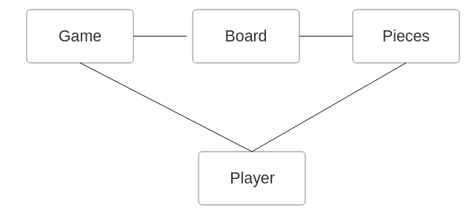

4. Class diagram:

