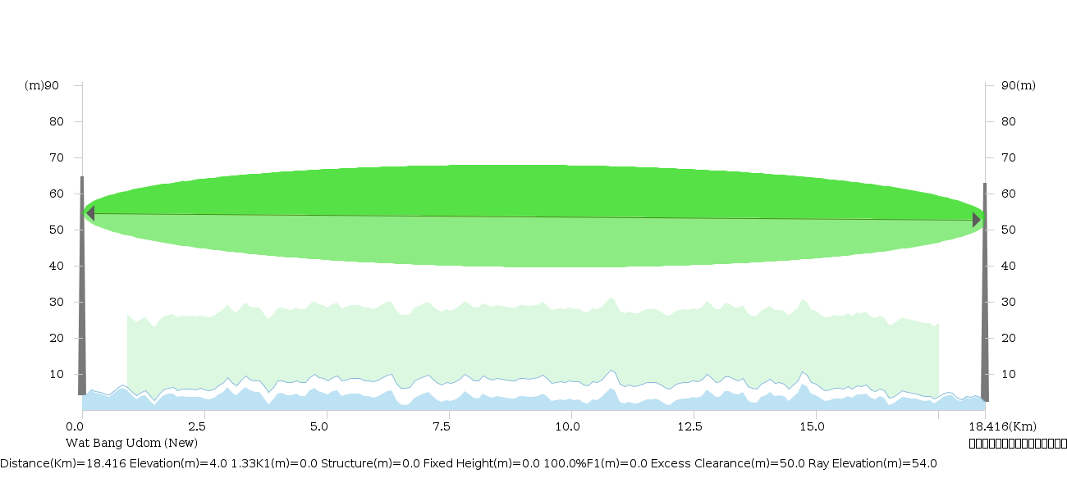
Wat Bang Udom (New)  Site Name Wat Bang Udom (New)  Latitude 8.20579  Longitude 100.25374  Elevation(m) 4.0  TX(MHz) NA  Polarization Dual-Polarized  Antenna Model A7WD09MAC-3NX  Diversity Antenna Model  Antenna Height(m) 50.0  Diversity Antenna Height(m) 0.0  Antenna Diameter(m) 0.9  Diversity Antenna Diameter(m) 0.0 | Frequency = 7575.00  Protection = 2+0  Distance(km) = 18.416  XPIC = Enable  Radio Model = 7G_XMC3E_32Q_28M_112M  Capacity(M) = 224.0  Thermal Fade Margin(dB) = 42.78  RX Signal(dBm) = -36.21  Annual Availability(%) = 99.999486  Site1 Annual Multipath Availability(%) = 99.999876  Site2 Annual Multipath Availability(%) = 99.999876  Annual Rain Availability(%) = 99.999733 | ที่ว่าการอำเภอหัวไทร  Site Name ที่ว่าการอำเภอหัวไทร  Latitude 8.04059  Longitude 100.27467  Elevation(m) 2.19  TX(MHz) NA  Polarization Dual-Polarized  Antenna Model A7WD09MAC-3NX  Diversity Antenna Model  Antenna Height(m) 50.0  Diversity Antenna Height(m) 0.0  Antenna Diameter(m) 0.9  Diversity Antenna Diameter(m) 0.0

Link Id | จุด A สถานีต้นทาง
Link Name | จุด A สถานีต้นทาง
Site Id | (New) | จุด A สถานีต้นทาง
Site Name | (New) | จุด A สถานีต้นทาง
Elevation(m)  Latitude  Longitude  Antenna azimuth(°)  Vertical angle(°) | 4.0  8.20579  100.25374  172.8511  -0.01 | 2.19  8.04059  100.27467  352.8511  0.01
Antenna S to D | NO
Antenna model  Antenna height(m)  Antenna gain(dBi) | A7WD09MAC-3NX  50.0  34.9 | A7WD09MAC-3NX  50.0  34.9
Frequency(MHz)  Polarization  Path length (km)  Free space loss(dB)  Atmospheric absorption loss (dB)  Field margin(dB)  Diffraction loss(dB) | 7575.0  H+V  18.416  135.33  0.19  1.0  0.0
AM Status | Enable
ATPC Status | Disable
CA Mode | Disable
Power Booster | NA
Radio model  Radio file name  Emission designator  TX channels  RX threshold criteria | 7G_XMC3E_32Q_28M_112M  7GXMC3E32Q28MX  28M0D7W  NA  10-6 | 7G_XMC3E_32Q_28M_112M  7GXMC3E32Q28MX  28M0D7W  NA  10-6
Average annual temperature(°C) | 25.0
LogK  Worst month multipath outage (sec) | -5.35041  11.07 | -5.35041  11.07
0.01% Rain rate(mm/hr)  Rain region  Link rain attenuation(dB) | 95.0  N  12.03

Modulation mode | TX power (dBm) |  | RX threshold level (dBm) |  | EIRP (dBm) |  | Receive signal (dBm) |  | TR-DR signal (dBm) |  | Flat fade margin - multipath (dB)
512QAM 424.0Mbps  256QAM 380.0Mbps  128QAM 334.0Mbps  64QAM 282.0Mbps  32QAM 224.0Mbps | 28.5  28.5  30.5  30.5  30.5 | 28.5  28.5  30.5  30.5  30.5 | -60.3  -63.6  -66.6  -69.9  -79.0 | -60.3  -63.6  -66.6  -69.9  -79.0 | 63.4  63.4  65.4  65.4  65.4 | 63.4  63.4  65.4  65.4  65.4 | -38.21  -38.21  -36.21  -36.21  -36.21 | -38.21  -38.21  -36.21  -36.21  -36.21 | 0.0  0.0  0.0  0.0  0.0 | 0.0  0.0  0.0  0.0  0.0 | 20.11  22.66  25.43  27.3  33.95 | 20.11  22.66  25.43  27.3  33.95
Modulation mode | Thermal fade margin (dB) |  | Worst month multipath (%) |  | Annual multipath (%) |  | Annual rain (%) |  | Total annual (%) |  | Time in mode (%)
512QAM 424.0Mbps  256QAM 380.0Mbps  128QAM 334.0Mbps  64QAM 282.0Mbps  32QAM 224.0Mbps | 22.08  25.38  30.38  33.68  42.78 | 22.08  25.38  30.38  33.68  42.78 | 99.989788  99.994324  99.996998  99.998046  99.999573 | 99.989788  99.994324  99.996998  99.998046  99.999573 | 99.997042  99.998356  99.99913  99.999434  99.999876 | 99.997042  99.998356  99.99913  99.999434  99.999876 | 99.995417  99.997208  99.998546  99.999066  99.999733 | 99.995417  99.997208  99.998546  99.999066  99.999733 | 99.989502  99.993921  99.996807  99.997934  99.999486 |  | 99.989502  0.004419  0.002886  0.001127  0.001552
Modulation mode | XPD threshold degradation - multipath(dB) |  |  |  | XPD threshold degradation - rain(dB) |  |  |  | SD Improvement Factor
512QAM 424.0Mbps  256QAM 380.0Mbps  128QAM 334.0Mbps  64QAM 282.0Mbps  32QAM 224.0Mbps | 1.96  2.71  4.94  6.37  8.82 |  | 1.96  2.71  4.94  6.37  8.82 |  | 2.11  2.02  2.17  1.98  0.86 |  | 2.11  2.02  2.17  1.98  0.86 |  | 1.0  1.0  1.0  1.0  1.0 |  | 1.0  1.0  1.0  1.0  1.0

