Hello, we are nucleus team. Nucleus team has four person who are Furkan ANŞİN ( Back-end Developer) , Ali BİÇİCİ ( Front-end Developer) , Eren GÜLTEKİN(Back-end Developer) , Batuhan TOPEL(Cyber security and networking).We were got a meeting about an app idea at yesterday.We found an idea about vet clinic application to protect save of animals life.

İf we work together , we will be stronger because we get along well and respect each other.

İf one person didnt come meeting , other person will tell schedule and topics about meeting to him.

Joining all meets are required and we use to meeting zoom app.The preapering of this meet is thinking about idea of this project .Furkan is the leader of the group. We talked about contract of nucleus team. The contract contaıns three ımportant caluses.

contract clauses are:

Clause 1; nobody can leave before the project ends

Clause 2; the project idea belongs to the nucleus team.

Clause 3; No decision can be taken without voting

[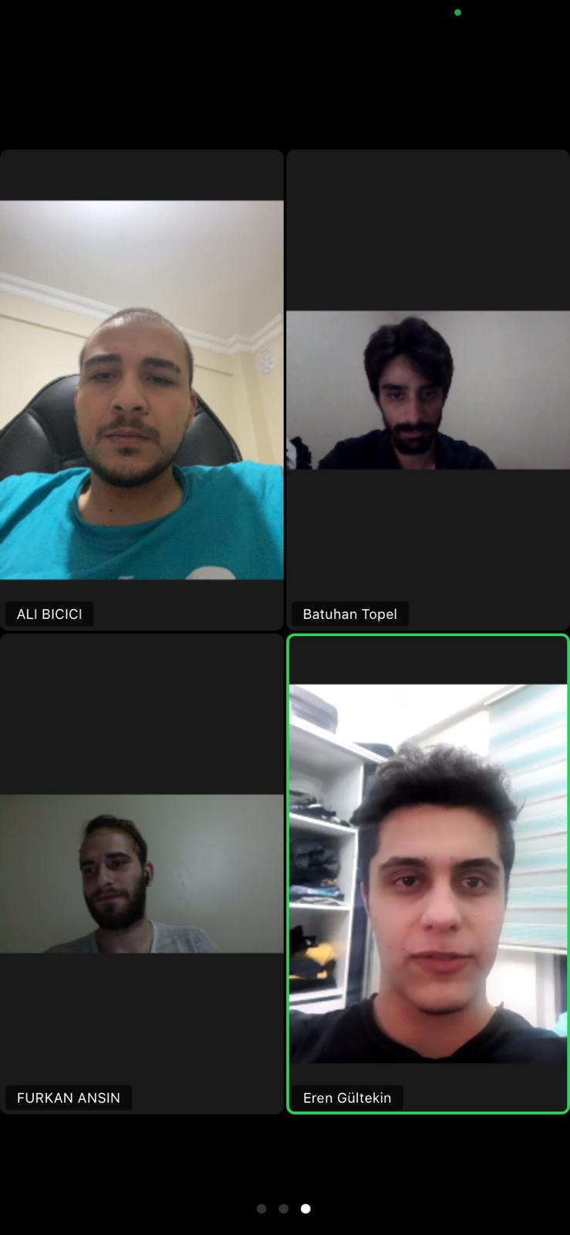](https://github.com/alibicici)

Our meeting took 1 hour 16 minutes.

<https://github.com/alibicici>

https://github.com/furkanansn

https://github.com/forthis09

https://github.com/BatuhanTopel