**Process**

Zach downloaded the default SSC Security At A Glance Report and replace the where clause using the parameter for projectversionid with a simple projectversionid != -1. The diff report is listed at end of document.

**Uploading the Global Security At a Glance report**

From the SSC Administration/Templates/Report Tab click New and then enter the following:

***NOTE: you will still have to add two parameters as shown to support SSC Birt Report default includes. The projectversionid is never used.***

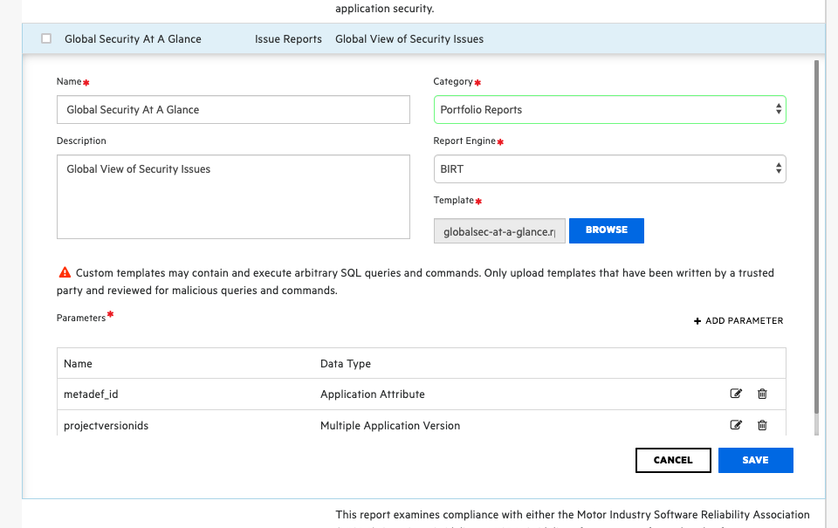

Create Report:

To create and run the report you will need to add on project version but it is never used. See below. NOTE: This report may take a long time or fail if it runs out of memory because of the size of the data.

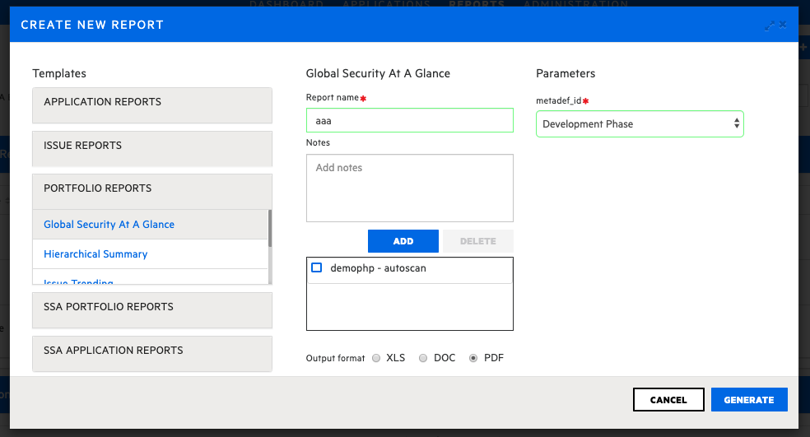

**Diff Report:**

122c122

< AND {{util.getProjectVersionIdsInClause('i.projectVersion_id')}}

---

> AND i.projectVersion_id != -1

171c171

< AND {{util.getProjectVersionIdsInClause('mv.projectVersion_id')}}

---

> AND mv.projectVersion_id != -1

301c301

< WHERE {{util.getProjectVersionIdsInClause('pv.id')}}

---

> WHERE pv.id != -1

319c319

< WHERE {{util.getProjectVersionIdsInClause('pv.id')}}

---

> WHERE pv.id != -1

365c365

< where {{util.getProjectVersionIdsInClause('pv.id')}}

---

> where pv.id != -1

415c415

< where {{util.getProjectVersionIdsInClause('p.id')}}

---

> where p.id != -1

467c467

< {{util.getProjectVersionIdsInClause('i.projectVersion_id')}}

---

> i.projectVersion_id != -1

597c597

< AND {{util.getProjectVersionIdsInClause('i.projectVersion_id')}}

---

> AND i.projectVersion_id != -1

633c633

< and {{util.getProjectVersionIdsInClause('pv.id')}} AND mvs.metaOption_id IS NULL

---

> and pv.id != -1 AND mvs.metaOption_id IS NULL

899c899

< where {{util.getProjectVersionIdsInClause('pv.id')}} AND ( startDate=(select max(startDate) from scan s where s.projectVersion_id=ls.projectVersion_id and s.engineType=ls.engineType) or startDate is null )

---

> where pv.id != -1 AND ( startDate=(select max(startDate) from scan s where s.projectVersion_id=ls.projectVersion_id and s.engineType=ls.engineType) or startDate is null )