- Provision a Linux (Ubuntu 24.04 LTS) Virtual Machine (Take note of which one it was!) — Do not use labuser/Cyberlab123! for credentials (or any other easy password). Your VM will most certainly get breached by a bad actor if it’s on long enough. This has already happened once.

- Create an AUTHENTICATED scan in Tenable, based off of the User Defined Template (Linux DISA/STIG):
CYBER RANGE___Linux - Vulnerabilities + DISA STIG ← Copy this
  - Choose “Internal Scanner” for Scanner Type. If it’s Offline, use the Tenable Cloud Scanner, just be sure to use the VM’s public IP address if you use the Cloud Scanner
  - Add your credentials: elevate with “sudo”, sudo user “root”. It should look like this:
  - 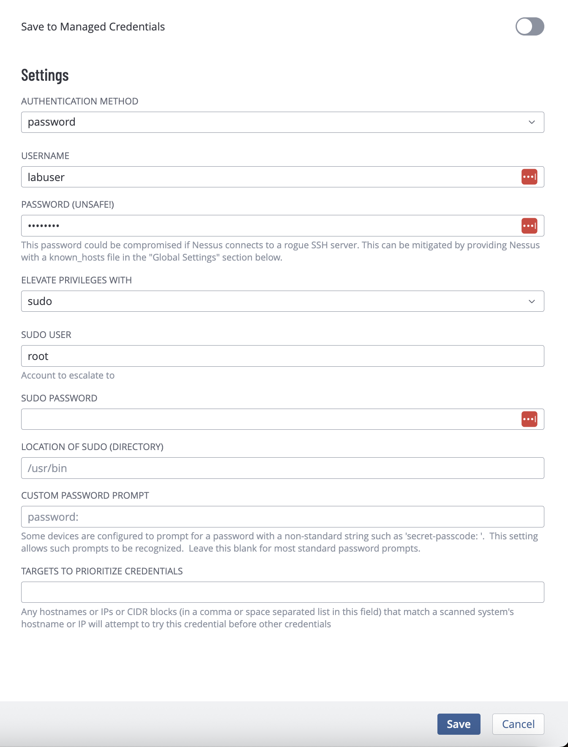
- Scan the VM
- Ensure credentials worked export the results
  - Observe the vulnerabilities, if any.
    - perhaps OpenSSL is out of date, we will fix this in subsequent labs, it’s complicated
- Login to your Linux Virtual Machine via SSH and create some Vulnerabilities:

  - Log into your VM:
VULNERABILITY 1 — Enable SMBv1

- Step 1 — Install SMBv1 Server
# Update the local package index from configured repositories
sudo apt update

# Install the Samba file-sharing service without prompting for confirmation
sudo apt install samba -y

- Step 2
# Open the Samba configuration file in the nano text editor with admin privileges
sudo nano /etc/samba/smb.conf

Go to the very bottom and paste:
[global]
server min protocol = NT1

Save:
CTRL+X → Y → ENTER

- Step 3
# Restart the Samba (SMB) service to apply configuration changes
sudo systemctl restart smbd

# Enable the Samba (SMB) service to start automatically at boot
sudo systemctl enable smbd

- Step 4 (Verify)
# Show which process is listening on port 445 (SMB); filter output for that port
sudo ss -tulpn | grep :445

You should see a LISTEN entry.

VULNERABILITY 2 — Anonymous FTP Enabled

- STEP 1 — Install FTP Server
# Update the local package index from configured repositories
sudo apt update

# Install the vsftpd FTP server without prompting for confirmation
sudo apt install vsftpd -y

- STEP 2 — Enable Anonymous Access
# Open the vsftpd config file in the nano text editor with admin privileges
sudo nano /etc/vsftpd.conf

Find:
anonymous_enable=NO

Change to:
anonymous_enable=YES

If you don’t see it, add at the bottom:
anonymous_enable=YES

Save:
CTRL+X → Y → ENTER

- STEP 3 — Restart FTP
# Restart the vsftpd FTP service to apply configuration changes
sudo systemctl restart vsftpd

# Enable the vsftpd FTP service to start automatically at boot
sudo systemctl enable vsftpd

- STEP 4 — Verify FTP Port
# Show which process is listening on port 21 (FTP); filter the output for that port
sudo ss -tulpn | grep :21
Should show something like this:
You should see LISTEN.

- OPTIONAL QUICK TEST
# Connect to the FTP server running on your own machine (localhost)
ftp localhost

Username: anonymous
Password: anything

If it logs in → vulnerability exists.

- Run your AUTHENTICATED scan
- Observe some of the Vulnerabilities
- Export scan results

- Remediate Vulnerabilities:

  - CLEANUP — VULNERABILITY 1 Disable SMBv1 (Samba):

- Step 1 — Edit Samba Config
sudo nano /etc/samba/smb.conf

Find and DELETE these lines completely:
[global]
server min protocol = NT1

Save:
CTRL+X → Y → ENTER

- Step 2 — Restart Samba
# Restart the Samba (SMB) service
sudo systemctl restart smbd

- Step 3 — Stronger Cleanup
# Remove the Samba package and its configuration files without prompting
sudo apt purge samba -y

- Step 4 — Verify
# Check the effective Samba config; show minimum SMB protocol version set
testparm | grep "min protocol"

If nothing prints → SMBv1 is disabled.

  - CLEANUP — VULNERABILITY 2 Disable Anonymous FTP:
- Step 1 — Edit FTP Config
# Open vsftpd config file in the nano text editor with admin privileges
sudo nano /etc/vsftpd.conf

Find:
anonymous_enable=YES

Change to:
anonymous_enable=NO

If multiple exist, make sure only one line exists and it says NO.

Save:
CTRL+X → Y → ENTER

- Step 2 — Restart FTP
# Restart the vsftpd FTP service to apply configuration changes
sudo systemctl restart vsftpd

- Step 3 - Remove FTP Completely
# Remove the vsftpd package and its configuration files without prompting
sudo apt purge vsftpd -y

# Automatically remove unused packages and dependencies without prompting
sudo apt autoremove -y

- Step 4 — Verify
# Connect to the FTP server running on your own machine (localhost)
ftp localhost

Should show something like this:
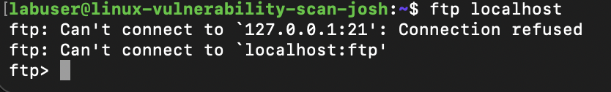

FINAL VERIFICATION
# Show which processes are listening on FTP (21) and SMB (445) ports and filter for those port
sudo ss -tulpn | egrep ':21|:445'

If no output → both services are closed.

- Rescan, observe the results of your remediation attempt

- Delete the VM

Vulnerability Creations and Fixes in GitHub

