Warning: For your trigger file, please use stat.txt (not dishsoap.lol like I tried)

- Provision a Windows Virtual Machine (Take note of which one it was!) — Do not use labuser/Cyberlab123! for credentials (or any other easy password). Your VM will most certainly get breached by a bad actor if it’s on long enough. This has already happened once.
- Create an Agent Group if one doesn’t already exist (Settings -> Sensors -> Nessus Agents -> Agent Groups -> +Add Agent Group (name it what you want)
- Create another scan: Basic Agent Scan
  - Select the group you created in Step 3.
  - Create a Triggered Scan, take note of the filename you choose for the trigger (For Example: start.txt)
- Log into the Windows Virtual Machine with the new username and password
- Login to the Tenable Portal https://cloud.tenable.com/
- Start Provisioning a Tenable Agent (settings -> Sensors -> Nessus Agents -> +Add Nessus Agent)
- Copy the PowerShell command within the browser. It looks like this:
  - Invoke-WebRequest -Uri "https://sensor.cloud.tenable.com/install/agent/installer/ms-install-script.ps1" -OutFile "./ms-install-script.ps1"; & "./ms-install-script.ps1" -key "xxx" -type "agent" -name "<agent name>" -groups 'student'; Remove-Item -Path "./ms-install-script.ps1"
    - In notepad, EDIT the line so it fits what you want to do
    - Copy the line
- In your Windows Virtual Machine, open a PowerShell as an admin and paste/run the command.
  - If you can’t paste it, login to Tenable within the VM and copy it from within there
- It should finish installing and look like this (see below). If there is an error, make sure you did step 4.a. Correctly. Also inspect the error to see if you find out what’s wrong!
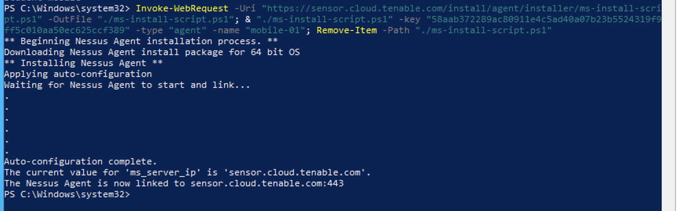

- To trigger the scan, create the trigger file (start.txt) in the trigger directory:
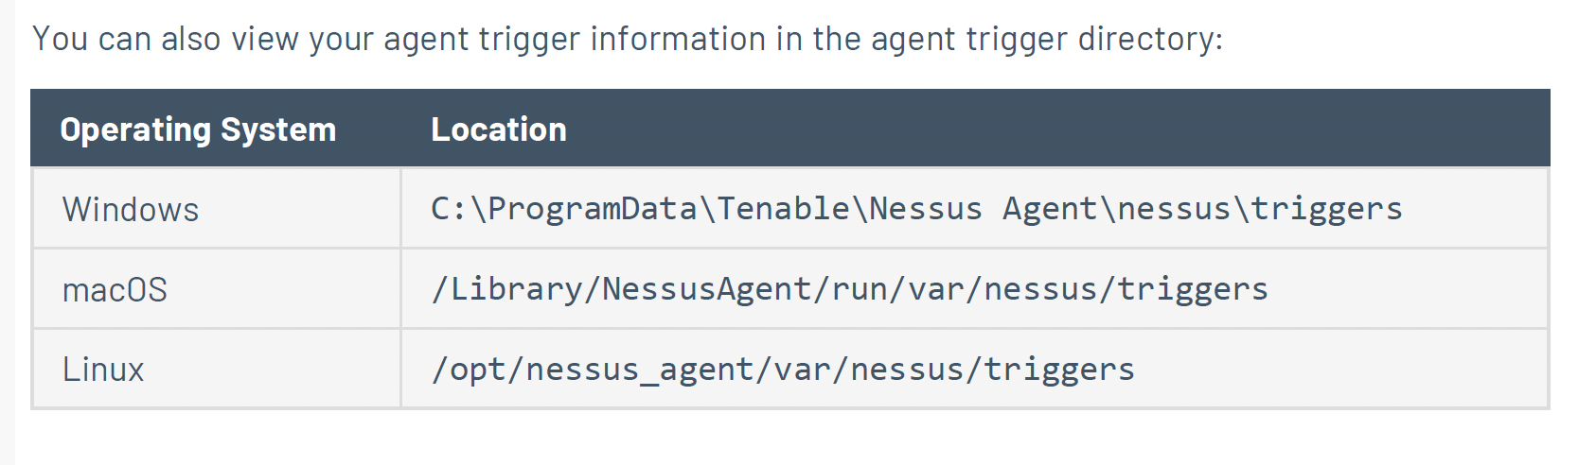
- Watch until the file disappears. This signifies the local agent scan has begun.
- Go back to the Tenable Portal (https://cloud.tenable.com/) and observe your nessus agent should be showing up in: (settings -> Sensors -> Nessus Agents)
  - Ensure YOURS is in there; there could be some in there already from other people. See the “LINKED ON” date and name to find yours. If it’s not there, you may have to wait a bit longer. If it still doesn’t show up after like 30 minutes, ask in the community 🙂
- Once your agent shows up, it will still take time for the vulnerabilities to be populated.
  - Wait 30-60 min
- Check “Scans”, select your scan, then “See all details”
- When the local agent scan finishes:
  - Observe the results/vulnerabilities
- Delete your Scan
- Delete your agent group
- Unlink your agents
- Delete the VM

Troubleshooting steps:
- Re-image vm
- Delete the scan and re-create it
- Create a new scan group (you can delete the old one if noone is using it)
- Hard delete asset from Tenable

