Lets first create a query that uses the AzureActivity table.- we wil need to know the name of the user to for identity mapping later on down the line so a good key would make iit easier for the team to contact later on.

let ResourceCreations = AzureActivity
| extend ClaimsJson = parse_json(Claims)
| extend ObjectIdentifier = tostring(ClaimsJson["http://schemas.microsoft.com/identity/claims/objectidentifier"])
| where OperationNameValue !startswith "MICROSOFT.SECURITYINSIGHTS/ALERTRULES" and OperationNameValue !startswith "MICROSOFT.SECURITYINSIGHTS/INCIDENTS"
| where OperationNameValue endswith "WRITE" and ActivityStatusValue == "Success"
| summarize NumberOfResourceCreations = count() by Caller, ObjectIdentifier, CallerIpAddress;
let ResourceDeletions = AzureActivity
| extend ClaimsJson = parse_json(Claims)
| extend ObjectIdentifier = tostring(ClaimsJson["http://schemas.microsoft.com/identity/claims/objectidentifier"])
| where OperationNameValue !startswith "MICROSOFT.SECURITYINSIGHTS/ALERTRULES" and OperationNameValue !startswith "MICROSOFT.SECURITYINSIGHTS/INCIDENTS"
| where OperationNameValue endswith "DELETE" and ActivityStatusValue == "Success"
| summarize NumberOfResourceDeletions = count() by Caller, ObjectIdentifier, CallerIpAddress;
ResourceCreations
| join kind=fullouter ResourceDeletions on ObjectIdentifier, Caller, CallerIpAddress
| project
ObjectIdentifier,
Caller,
CallerIpAddress,
NumberOfResourceCreations,
NumberOfResourceDeletions
| where NumberOfResourceCreations >= 5 or NumberOfResourceDeletions >= 5
| order by NumberOfResourceCreations, NumberOfResourceDeletions
, NumberOfResourceDeletions

Here is the query which showed the machines with multiple instances.

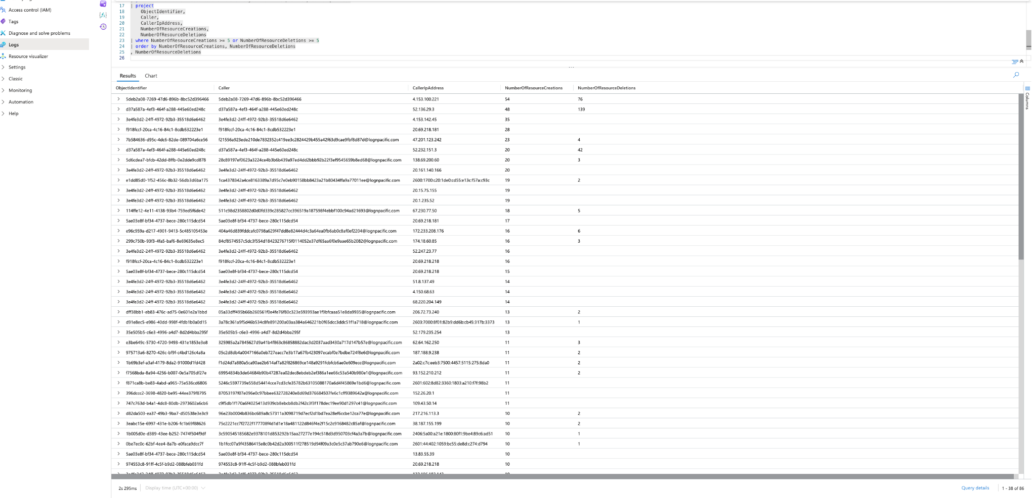
We found 9 entities with excessive resiursce creation

52.136.29.3
20.69.218.181
20.69.218.218
4.153.52.1
4.153.100.221
13.87.247.19
20.161.140.166
132.196.224.105
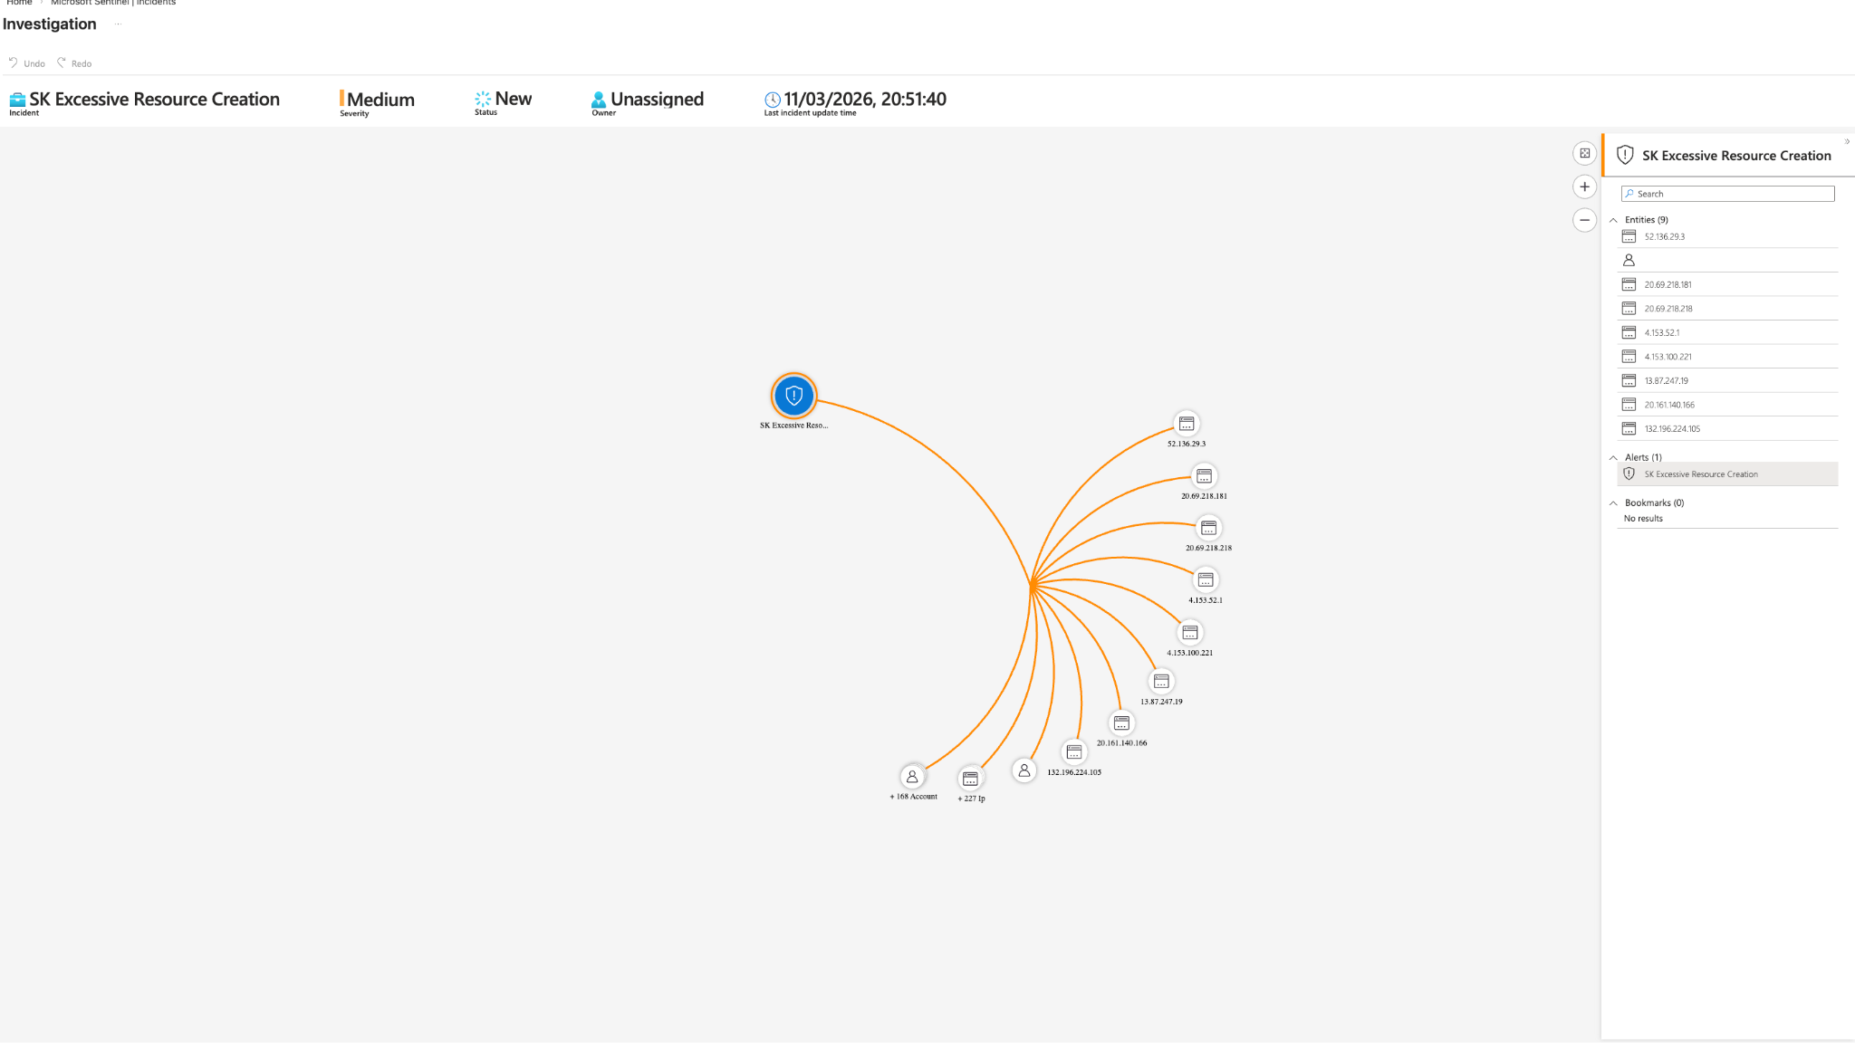

The next screenshot is the observation of the other pcs that were creating and some of the usage on there

