Using a Scan Template to Scan a Windows 11 VM
Sign into Azure: https://portal.azure.com
Sign into Tenable: https://cloud.tenable.com
Reset Account Credentials (if needed)
Tenable_Vulnerability_Management-User_Guide.pdf

- Create a Windows 11 Virtual Machine
- Log into the VM and disable the Windows Firewall if you haven’t
- Try to create a vulnerability for the scan to discover
  - create/enable administrator account
  - set a blank password with no expiration
  - Add “administrator” account to the “administrators” group
  - Enable and add the “guest” account to the “administrators” group, w/no password
- Open the NSG completely (all traffic allowed inbound)
- From your personal computer, test with Ping against the VM’s public IP address
- Log into Tenable
- Create a scan template (Advanced Network Scan) with the following settings:

  - Basic:
    - Name: Name it anything, for example “Win-11-STIG-test”-- __Template-Windows-11-STIG-TEST
    - Start the Remote Registry service during the scan [X]
    - Enable administrative shares during the scan [X]
    - Start the Server service during the scan [X]
  - Discovery:
    - Ping the remote host [X]
    - Use fast network discovery [X]
    - Network Port Scanners: TCP [X]
  - Assessment:
    - Perform thorough tests [X]
    - Only use credentials provided by the user [ ] (UNCHECK)
  - Credentials: Enter the credentials for the administrator account that we set earlier (labuser / <password>)
  - Compliance:
- Add Compliance Audits for DISA Microsoft Windows 11 STIG v2r5 or something similar:
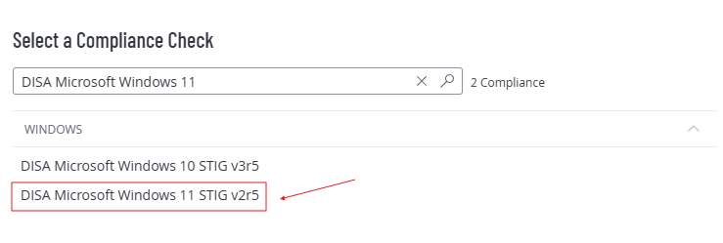

  - Plugins:
- General [X]
- Policy Compliance [X]
  - Windows Compliance Checks [X]
- Settings [X]
- Windows [X]
- Windows : Microsoft Bulletins [X]
- Windows : User management [X]

- Save the Scan Template
- Create a new scan with the scan template we previously created
  - Enter the credentials you set in (if you have to change the credentials)
  - Set the IP address
- Launch the scan
- Observe the results
  - Observe Vulns by Plugin
  - Observe Audits
  - Observe Remediations
- Delete your Windows Virtual Machine (Make sure it’s the correct one!)

