SigninLogs
| where CreatedDateTime >= ago(7d)
| where ResultType == 0
| extend LocationJson = parse_json(LocationDetails)
| extend Country = tostring(LocationJson.countryOrRegion)
| where isnotempty(UserPrincipalName)
| where isnotempty(Country)
| summarize
DistinctCountryCount = dcount(Country),
Countries = make_set(Country, 10),
IPs = make_set(IPAddress, 10),
FirstSeen = min(CreatedDateTime),
LastSeen = max(CreatedDateTime)
by UserPrincipalName
| where DistinctCountryCount >= 2
| project
UserPrincipalName,
DistinctCountryCount,
Countries,
IPs,
FirstSeen,
LastSeen
| order by LastSeen desc

Created this query to help with the creation of a rule that shows any devices logging in from any two locations within a 7 day period. I changed it to two countries because I felt like If i just used the two geographical locations the radius would trigger too many alerts if someone just travelled to another part of town and used a different tower or cell tower for there internet. I now have changed it to two different countries within 7 days it triggers an alert.

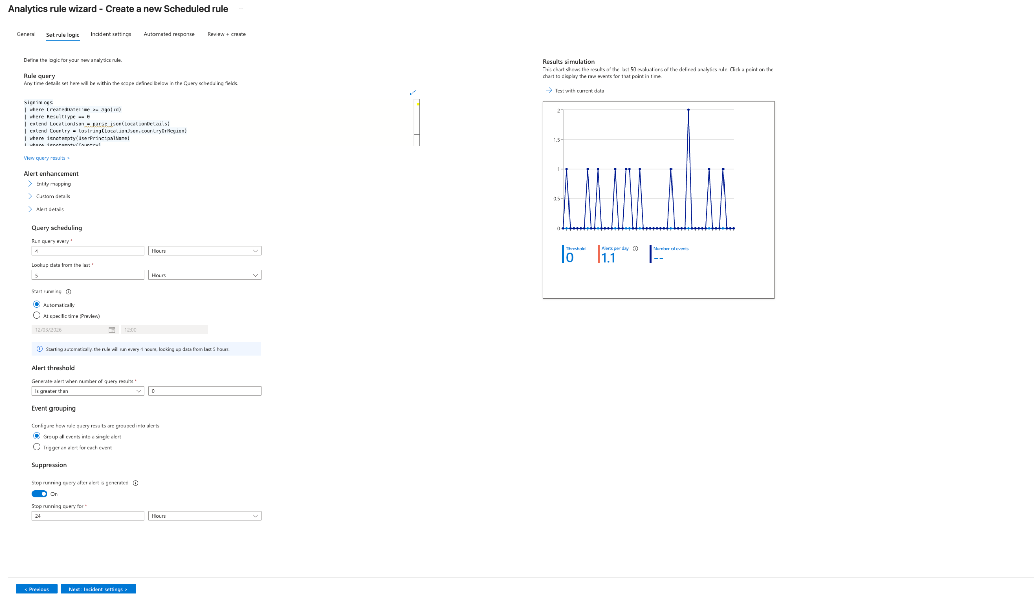

Image showing the set up of the event in the analytics incident triggers. I have set it up witht he correct parameters.

I also mapped the entities so it will definitely be picked up by the trigger too.

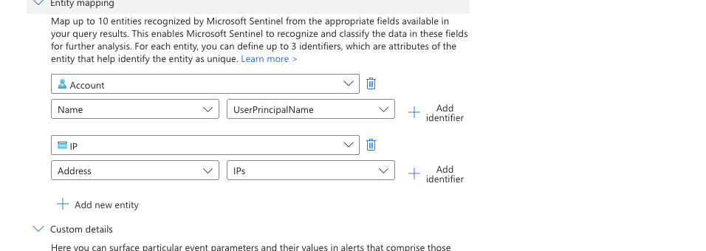

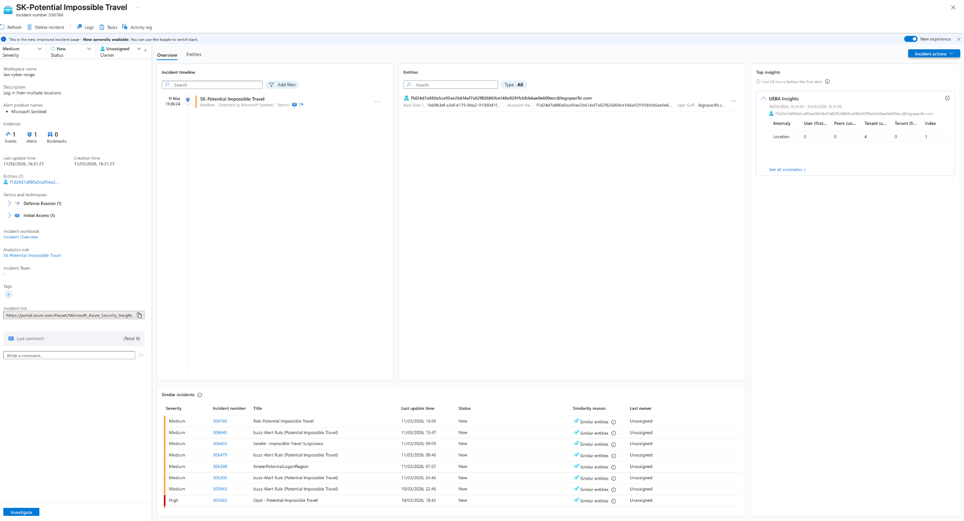

I have now assigned the incident to me. In doing this I have found that. I found that there were 3 locations showing in the device. With this information- UserPrincipalName
f1d24d7a880a5ca90ae2b614af7a82f826869ce148a9291fcbfcb6ae0e609ecc@lognpacific.com
DistinctCountryCount
3
Countries
["GB","ES","US"]
IPs
["2a02:c7c:eeb3:7500:4457:5115:275:8da0","2001:ac8:23:85::e02e","172.210.137.59","90.193.39.141","2a02:c7c:eeb3:7500:8893:d5df:9640:5560"]
FirstSeen [UTC]
2026-03-10T17:42:57.7627048Z
LastSeen [UTC]
2026-03-11T16:16:22.2507388Z
Heres the data from the three users that had this flag -

f1d24d7a880a5ca90ae2b614af7a82f826869ce148a9291fcbfcb6ae0e609ecc@lognpacific.com
3
["GB","ES","US"]
["2a02:c7c:eeb3:7500:4457:5115:275:8da0","2001:ac8:23:85::e02e","172.210.137.59","90.193.39.141","2a02:c7c:eeb3:7500:8893:d5df:9640:5560"]
10/03/2026, 17:42:57.762
11/03/2026, 16:16:22.250
UserPrincipalName
f1d24d7a880a5ca90ae2b614af7a82f826869ce148a9291fcbfcb6ae0e609ecc@lognpacific.com
DistinctCountryCount
3
Countries
["GB","ES","US"]
IPs
["2a02:c7c:eeb3:7500:4457:5115:275:8da0","2001:ac8:23:85::e02e","172.210.137.59","90.193.39.141","2a02:c7c:eeb3:7500:8893:d5df:9640:5560"]
FirstSeen [UTC]
2026-03-10T17:42:57.7627048Z
LastSeen [UTC]
2026-03-11T16:16:22.2507388Z
f015f6e1d5bd409168f403ac501de095f7bc726d47a05effaf580fa49733bb7c@lognpacific.com
2
["NL","JP"]
["185.107.56.104","37.19.205.154"]
11/03/2026, 04:33:26.995
11/03/2026, 11:58:22.985
UserPrincipalName
f015f6e1d5bd409168f403ac501de095f7bc726d47a05effaf580fa49733bb7c@lognpacific.com
DistinctCountryCount
2
Countries
["NL","JP"]
IPs
["185.107.56.104","37.19.205.154"]
FirstSeen [UTC]
2026-03-11T04:33:26.995166Z
LastSeen [UTC]
2026-03-11T11:58:22.9850035Z
0cb9d4a461fbcbcefd6a2c8967c44125388af460573fedd88589086fb86266b8@lognpacific.com
2
["FR","US"]
["2a01:e0a:b8:9df0:7d08:4c1a:3d18:28ae","146.70.211.95"]
10/03/2026, 19:56:17.227
10/03/2026, 21:09:43.415
UserPrincipalName
0cb9d4a461fbcbcefd6a2c8967c44125388af460573fedd88589086fb86266b8@lognpacific.com
DistinctCountryCount
2
Countries
["FR","US"]
IPs
["2a01:e0a:b8:9df0:7d08:4c1a:3d18:28ae","146.70.211.95"]
FirstSeen [UTC]
2026-03-10T19:56:17.2274835Z
LastSeen [UTC]
2026-03-10T21:09:43.4151099Z
.

To then do further testing I contacted the staff member to see if they had been using any sort of vpn or proxy when logging in as for device 1 thewew no way you can be in nether lands and then to japan in that time. The same for france and USA and then then same for gb, spain and usa in the same time.

Working this incident would mean checking the users that have logged in seeing if its possible to getting into these locations in that time frame. I would personally call the user and ask them if it was them logging in in said place or send an sms yes or no coud be another way to save the phone call. I would isolate, disable the machine and contact management for this.

To prevent this in the future policies should be in place like system wide ones to prevalent people logging in from ips outside where they would normally geographically be and if this location is to change then it should be requested through the team and we allow the access from these ip addresses. I would say true positive because its impossible to be in 3 places within one day geographiclally. To remediate wr isolate the machines bloc the logins contact relevant teams.make the user change there credentials on next sign in and monitor the traffic going forward for suspicious logins.

