Threat Hunt & Incident Investigation Report
Incident: Unauthorized TOR Browser Installation and Use
Endpoint: skfinalthreat
Investigation Platform: Microsoft Defender for Endpoint & Microsoft Sentinel (Advanced Hunting / Log Analytics)
Framework Reference: NIST 800‑61 Incident Response Lifecycle

1. Incident Overview
Management suspected employees may be using TOR browsers to bypass corporate monitoring and network security controls after unusual encrypted traffic patterns were observed. A threat hunt was conducted to determine whether TOR was installed or executed within the environment.

2. Investigation Methodology (NIST 800‑61)

2.1 Detection & Analysis
Microsoft Defender Advanced Hunting queries were used to identify TOR indicators. The investigation focused on file creation, process execution, and network communication.

2.2 Containment
If TOR usage was confirmed, the device would be isolated from the network to prevent further anonymized traffic or potential policy violations.

2.3 Eradication
TOR browser binaries and associated artifacts would be removed from the endpoint and the user would be notified regarding policy violations.

2.4 Recovery
The system would be returned to normal operation after verifying that TOR artifacts were removed and monitoring rules were implemented to detect future TOR related activity.

2.5 Lessons Learned
Detection rules can be created to monitor for TOR related file creation, tor.exe execution, or network traffic consistent with TOR nodes.

3. MITRE ATT&CK Mapping
T1090 – Proxy – Adversaries may use proxy tools such as TOR to hide network traffic
T1071.001 – Application Layer Protocol: Web Protocols
T1105 – Ingress Tool Transfer – Download of TOR browser package
T1036 – Masquerading – Use of legitimate browser components to disguise traffic

4. Evidence Collection – KQL Queries
File Event Detection
DeviceFileEvents
| where FileName startswith "tor"
| where DeviceName == "skfinalthreat"
Process Execution Detection
DeviceProcessEvents
| where FileName startswith "tor"
| where DeviceName == "skfinalthreat"
Network Activity Review
DeviceNetworkEvents
| where DeviceName == "skfinalthreat"

5. Investigation Evidence

5.1 TOR File Artifacts Identified
File telemetry confirmed that TOR browser files were created on the endpoint including tor.exe and launcher related artifacts.
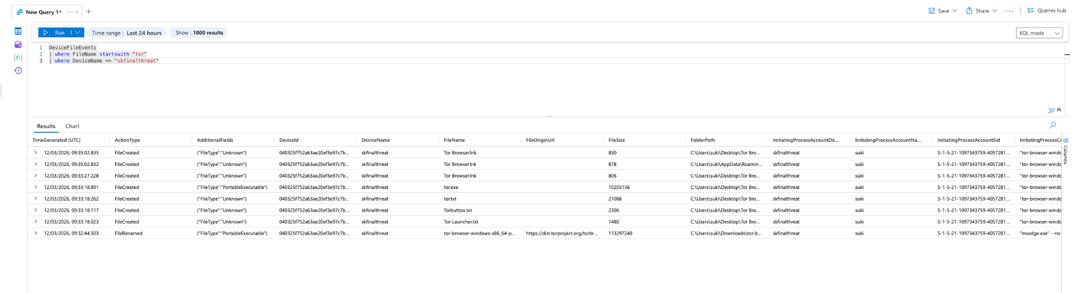

5.2 TOR Process Execution
Process telemetry confirmed execution of tor.exe and related browser components by the user account 'suki'.
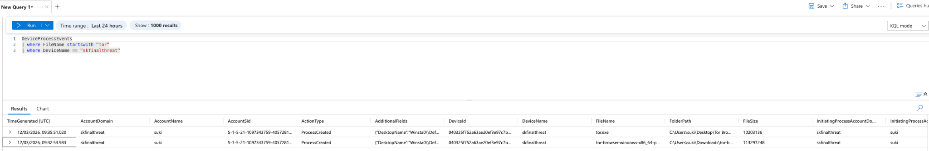

5.3 Network Activity Observed
Network telemetry showed encrypted outbound traffic consistent with TOR communications.
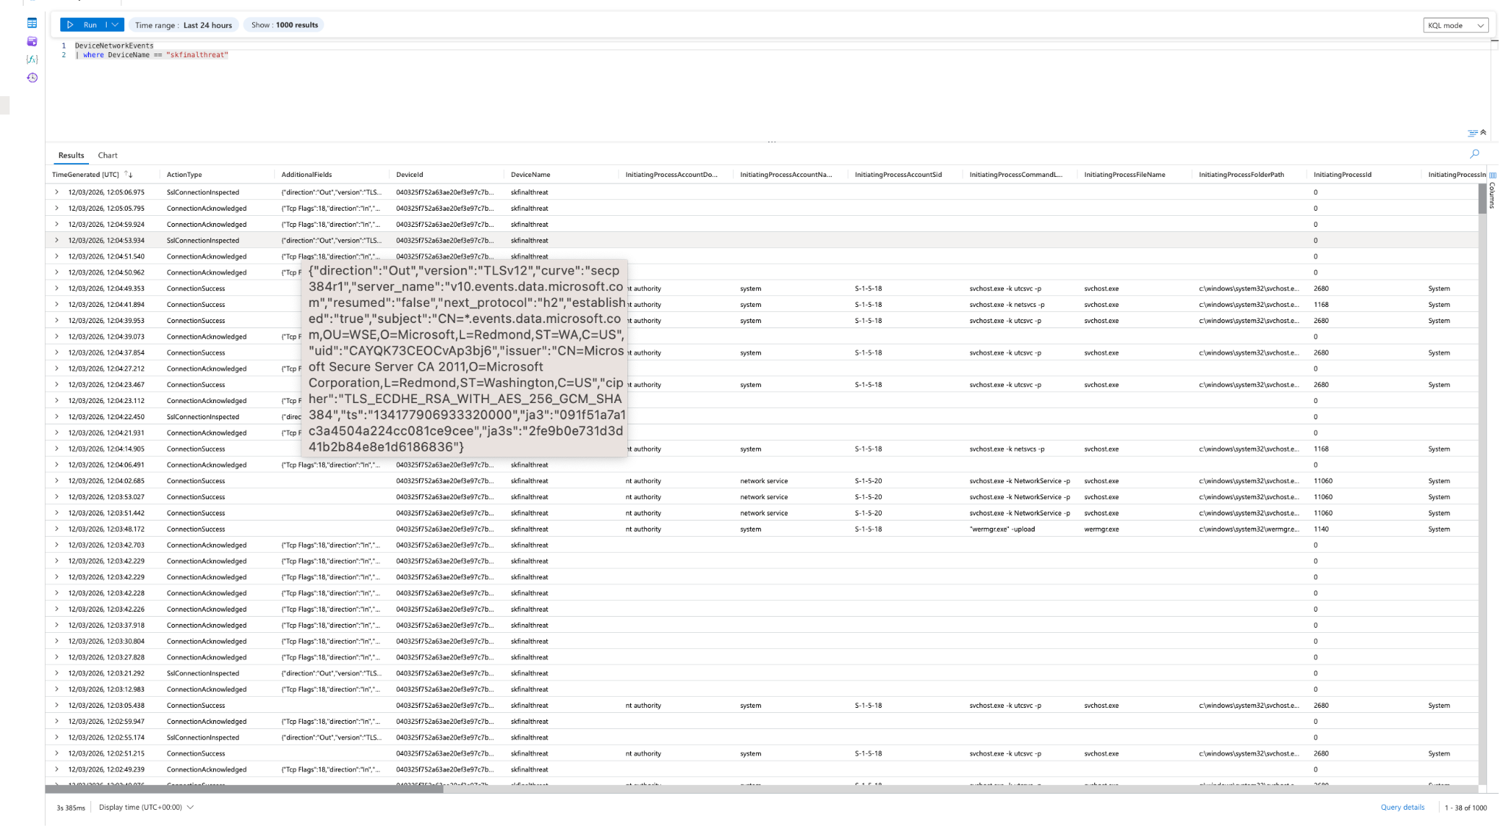

6. Timeline of Events
1. TOR browser package downloaded to the workstation.
2. TOR related files created on the endpoint.
3. tor.exe executed by the user account.
4. Outbound encrypted traffic observed.

7. Investigation Summary
The investigation confirmed that the TOR browser was installed and executed on endpoint 'skfinalthreat'. Evidence was identified across file, process, and network telemetry. This activity indicates a potential attempt to bypass network monitoring.

8. Response Actions
• Device should be isolated for further investigation
• TOR software removed from endpoint
• User notified of policy violation
• Detection rules implemented to monitor TOR usage

