Create a (Windows) VM if you don’t already have one — Do not use labuser/Cyberlab123! for credentials (or any other easy password). Your VM will most certainly get breached by a bad actor if it’s on long enough. This has already happened once.

Disable the Windows Firewall (start → run → wf.msc → turn firewall off for all profiles), this is just to let the VM be discovered by bad actors on the Internet more easily

Onboard it to MDE if it’s not already: Onboarding a VM to MDE, Isolation, and Investigation

Ensure it’s appearing as onboarded in the MDE Portal: https://security.microsoft.com/machines

Ensure the logs are showing up in one of the tables. For example, go to Hunting → Advanced Hunting and search for your device in one of the tables. Example query:

DeviceLogonEvents
| where DeviceName startswith "mydevice-"
| order by Timestamp desc

Example:
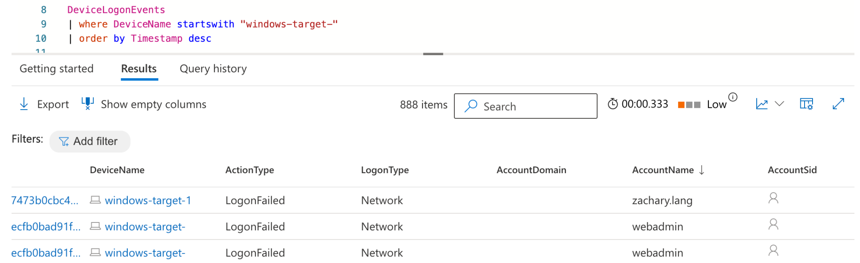

Create a detection rule SPECIFIC to your Virtual Machine For Example #4 (or all)
We only want the rule firing on your VM because we are going to quarantine the VM as part of the automated response. We do not want to randomly quarantine someone else’s VM

We are going to create a detection rule for possible Remote Code Execution events, specifically, using PowerShell to automate the download and installation of an application.

We will use the following command to automate the downloading and installation of 7zip:

cmd.exe /c powershell.exe -ExecutionPolicy Bypass -NoProfile -Command "Invoke-WebRequest -Uri 'https://sacyberrange00.blob.core.windows.net/vm-applications/7z2408-x64.exe' -OutFile C:\ProgramData\7z2408-x64.exe; Start-Process 'C:\programdata\7z2408-x64.exe' -ArgumentList '/S' -Wait"

Write a KQL Query that looks for any PowerShell calling Invoke-WebRequest (optionally “Start-Process” as well) in the last hour for your particular VM

Create a Detection Rule based on this query

Spoiler, Highlight to see query/code
let VMName = "my-vm-name";
DeviceProcessEvents
| where DeviceName == VMName
| where InitiatingProcessCommandLine contains "Invoke-WebRequest" and InitiatingProcessCommandLine contains "Start-Process"

Fill out the Detection Rule Settings:
[X] Isolate Device
[X] Collect Investigation Package

Do the thing that triggers your alert—in our case, run the command above

Wait/search for logs. When the logs appear, your machine should be isolated and you can move to the next step. If you can no longer connect to your VM, it’s possible the Detection Rule already executed and isolated your VM. That was the case for me:
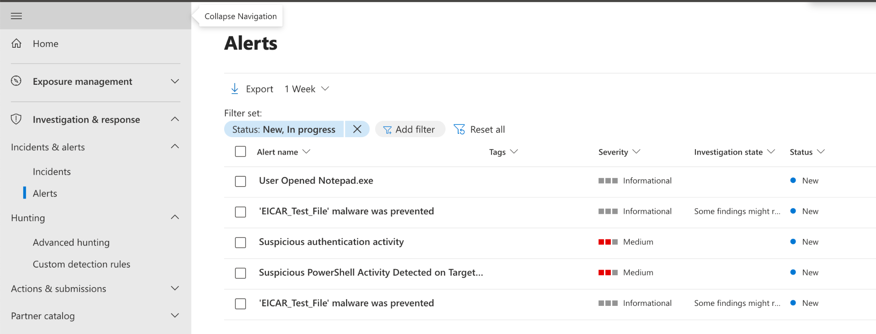

Browse to your VM within the MDE Portal (https://security.microsoft.com/machines)
Select the VM and then click the three dots menu. If it’s isolated, observe that you can release your VM from isolation here. For now, click “Action Center” and check out the Investigation Package that was created (if it’s ready)

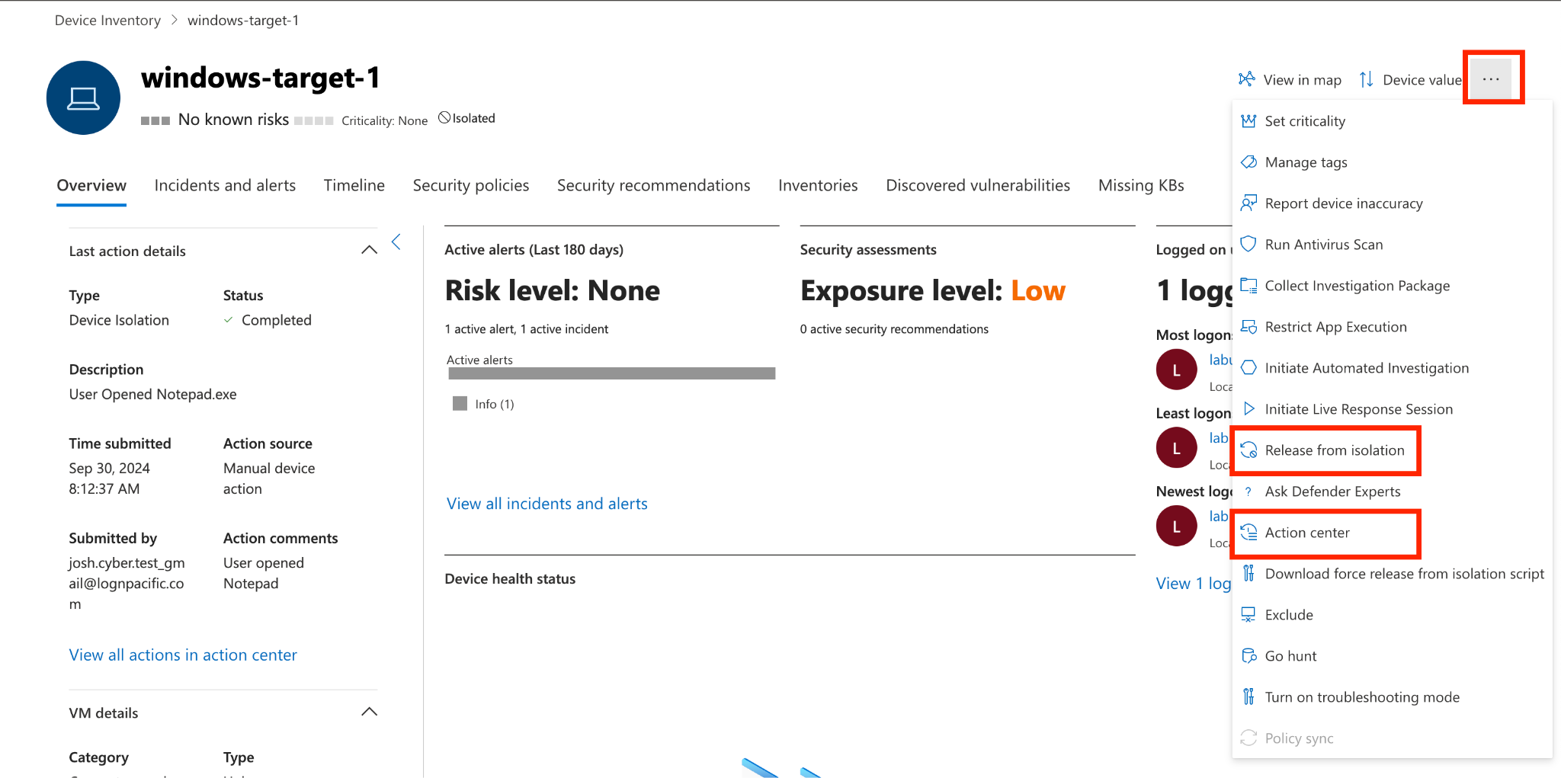

Feel free to look through the investigation package. The investigation package is a comprehensive collection of data and artifacts, including process trees, file and registry changes, network connections, event logs, and memory dumps, generated from virtual machines to facilitate detailed analysis and investigation of security incidents.

Assign your Alert to your user account and “Resolve” it (the one specific to YOUR Custom Detection, not someone else's)

Delete your Detection Rule (please.)

Release your VM from isolation

By the way, in addition to Custom Detection Rules, Microsoft will automatically alert on random different stuff—basically anything that it deems “malicious” “enough”, whatever that means to Microsoft. Look at it in the portal!

