Robot Design

**Choice:** Aluminium

Between the two metals we decided to use aluminium for most of the frame of the robot. This is because although it have the disadvantage of being expensive the advantages of being both strong and light outweighs this because for this challenge being able to expand upwards quickly is essentially and having a heavy robot would make this significantly harder.

**Pros:**

* Strong
* Cheap

**Cons:**

* Heavy

**Pros:**

* Strong
* Light

**Cons:**

* Expensive

For this robot due to the fact we are a high school team and not a university team (they can 3d print plastic) we are limited to using two different materials for this challenge, Steel and aluminium

### Steel

### Aluminium

## Material for chassis

# General design considerations

The design of a robot for this challenge can be broken down into three main sections. The drive, the lift and manipulator. The robot is lifted to only having one drive however it can have multiple lifts/manipulators if necessary. In this document, we will be going over the different sections of the robot and we evaluate the different designs we can use in each of these sections.

**Choice:** No Pneumatic

For this robot, we have the choice of using either twelve motors or 10 motors and a pneumatics system

### Pneumatics

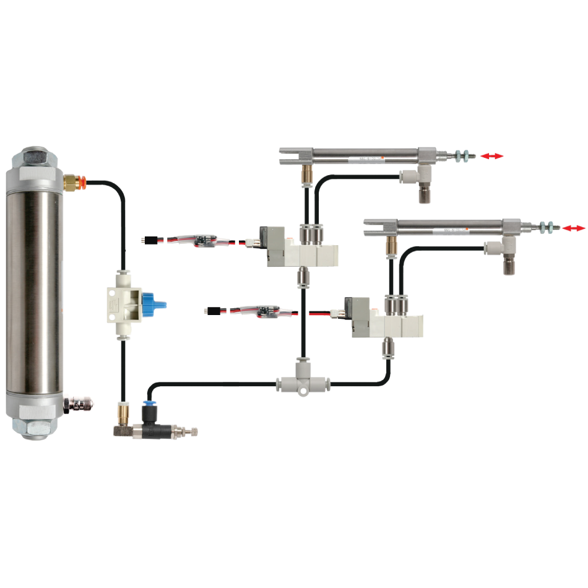

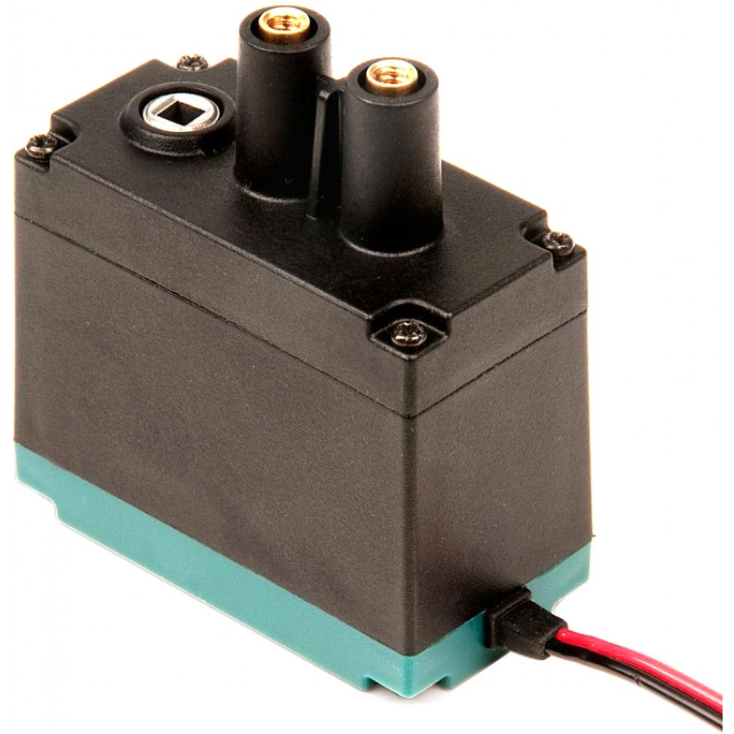

**Pros:**

* Linear motion
* Light

**Cons:**

* Expensive
* Must repump every match

Between the two choices we have decided to go for two extra motor over pneumatics. This is not because we think that using motors is better it is just that at this moment we do not feel the benefits of being light and having linear motion justify the high price tag that they currently have. If we do end up purchasing them in the future we will probably use them on our robot.

**Pros:**

* Stronger
* Cheap
* Reliable

**Cons:**

* Heavy
* Nonlinear motion

### No Pneumatics

## Pneumatics

When building a drive there are a few different wheel types to pick from.

## Wheel type

# Drive design considerations

### Traction wheel

### Omni wheels

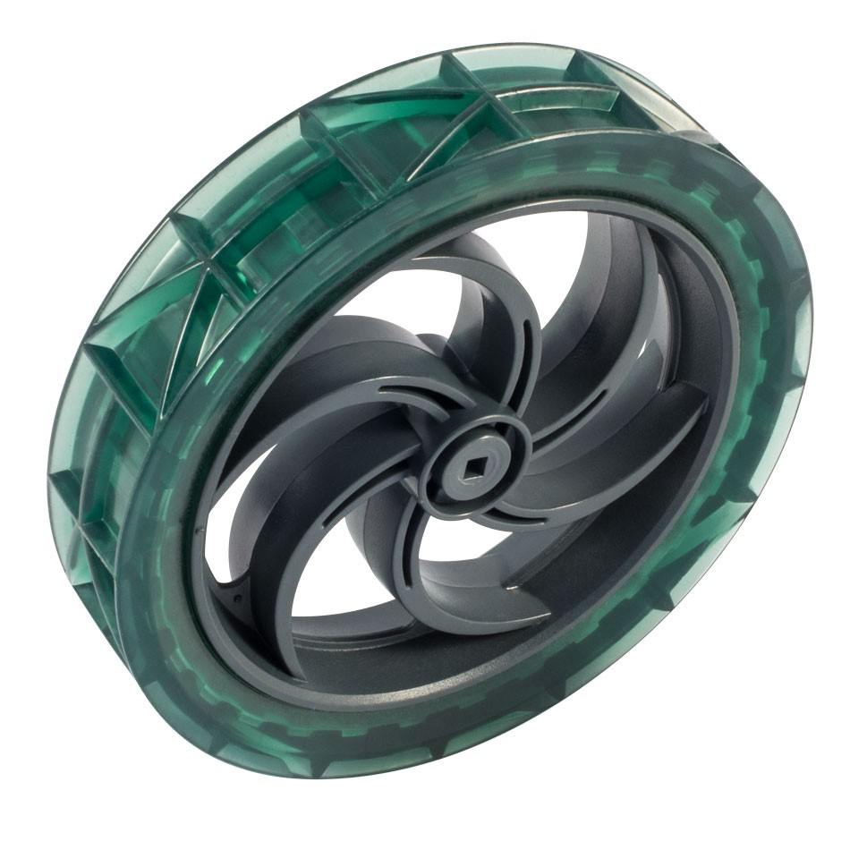

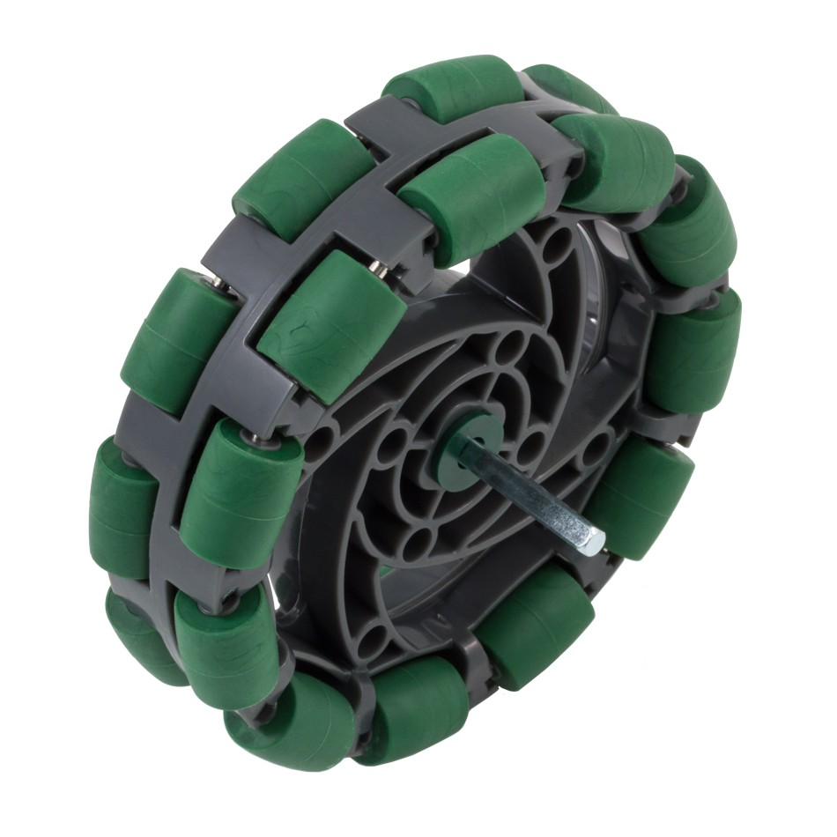

**Pros:**

* Cheap
* Reliable
* High traction
* No internal friction

**Cons:**

* 1 axis of movement

**Pros:**

* Cheap
* 2 axis of movement

**Cons:**

* Less traction

### Mecanum wheels

Between the three different wheels we have decided to use a mixture of omni wheels and traction wheels. Most likely two traction wheels at the front and two omni wheels at the back. The reason for this is that we can use the traction wheels at the front to get over the first bar into the 10-point zone and we can use the omni wheels at the back to have low friction turning. We are not using Mecanum wheels because they are inferior in every way to omni wheels.

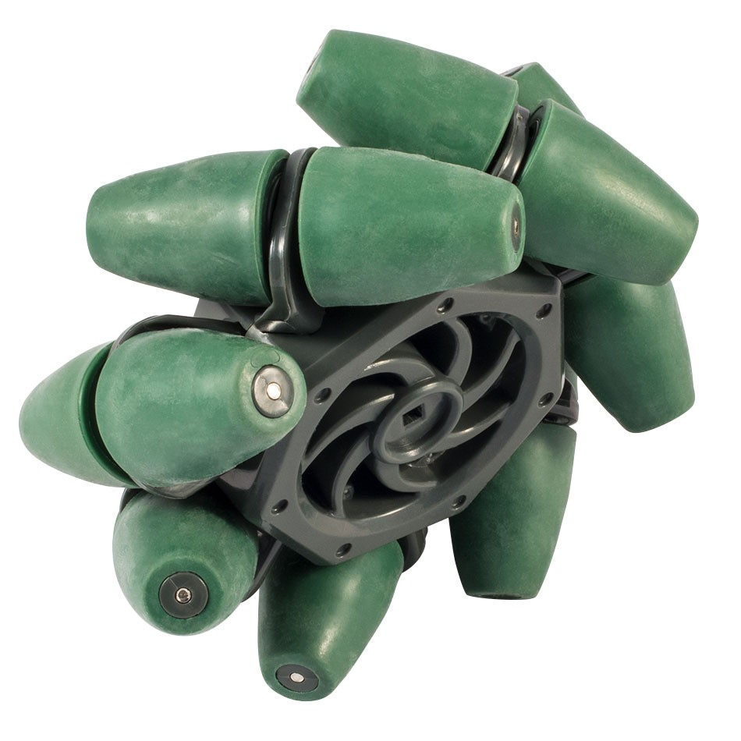

**Choice:** Omni and traction wheels

**Pros:**

* 2 axis of movement

**Cons:**

* Less traction
* Expensive
* High Internal friction
* Less grip