Problem 1: Chain problem

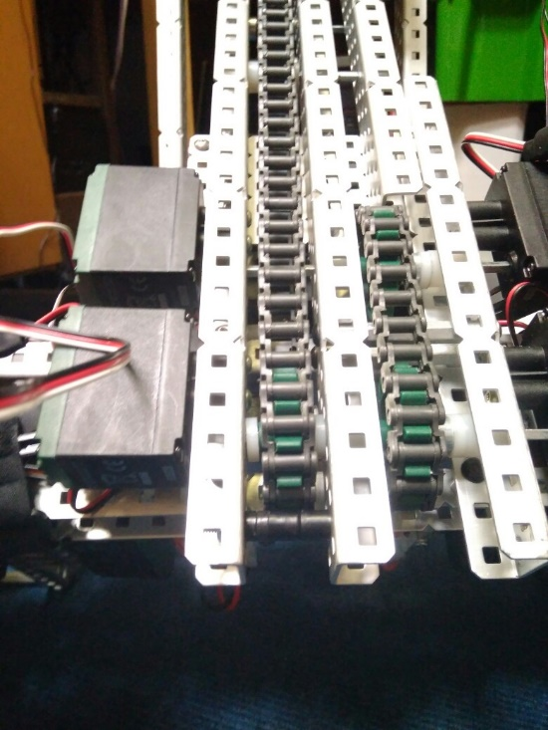

**Description:**

We found that when attempting to lift heavy weights with our robot the lift struggled and the chain skipped sprockets rather than lift the object.

By Robbie Buxton

19/7/2017 – 17:23

**Process:**

Initially we though the problem was mainly to do with the chain being not tense enough. To solve this problem with the recommendation of Luke from VEXU team VIRUS who we have been in communication with through the VEX UK discord channel we took one of the section of the chain from the primary chain and replaced it with two zip ties. This allowed us to get the tension exactly right. This helped however it did not solve the problem. The next step we took towards fixing the problem was changing how the chain was attached to each stage. The main method we were using was a screw through the chain screwed tight. This worked as a method of securing the chain however resulted in the chain being pulled out towards the next stage. To fix this we added standoffs to the screws which resulted in the chain being pulled out less than before. This still did not fix the problem. We had more experiments with the chain and we saw that when the motor was running the chain became very loose around the gear. We decided to put a standoff under the primary drive sprocket which stopped the chain from becoming lose. This turned out to solve the problem.

**Cause and solution:**

**Hardware:**

We installed a single long screw with lots of spacers on it below the primary lift drive sprocket. This is highlighted in the picture above. The way this device works is that because of its proximity to the drive gear it forces the gear to stay on the sprocket always therefore stopping the chain from being able to skip. At the moment, it is only on the primary lift gear as no other gears have a problem with chain skipping.

**Probable causes we thought at the time:**

**Hardware:**

* Chain tension too low
* Sprockets are too small
* Bad attachments to stages

**Software:**

N/A