Problem 1: Lift problem

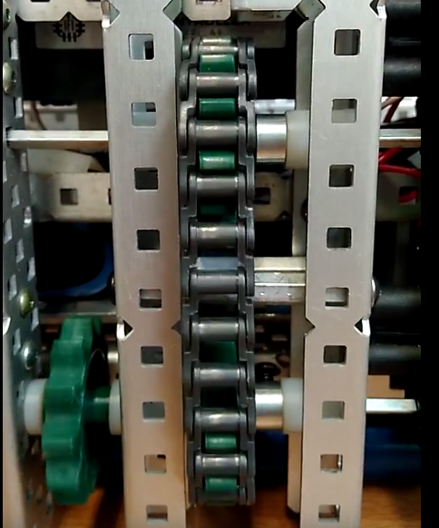

**Description:**

After completing the two stages lift and mounting to our robot we found that there was a problem. When the lift pulled the chain upwards It worked perfectly. However when the chain was pulled down it jittered and shook.

By Robbie Buxton

14/7/2017 – 13:46

**Process:**

Initially we though the problem was doing with motors being on differing gear ratios as we had had to switch the internals of some off the motors out. The first thing we did was take the lift apart and replace all four motors with fresh ones to be safe. This resulted in the problem having a lesser effect but still being present. We then decided that the problem must have something to do with chain tension as when the direction of the lift changed the tension of the chain also appeared to change. After messing with the tension of the chain for a while we concluded that this wasn’t the source of the problem. At this point we decided to manually reverse the ports of motors to see if this would have any effect. Surprisingly this did. The direction the motors were struggling in reverse. We then concluded that the problem must be software based. We all have a look at the code but we could not figure out the source of the problem. In the end, we went onto the “Vex teams of the world” discord channel and asked if someone might have a look at our code. User Geo#1066 kindly gave us a hand and showed us what was the problem with our code. We tested the latest version of the code and the problem was fixed.

**Cause and solution:**

**Software:**

One of the else statements always triggered as the buttons were never pressed at the same time. Putting them in one statement meant that it was only if neither were pressed they'd stop

**Probable causes we thought at the time:**

**Hardware:**

* Motors on differing gear ratios
* Faulty motors
* Chain tension problems

**Software:**

* Problem with individual motor directions when reversing direction of whole lift

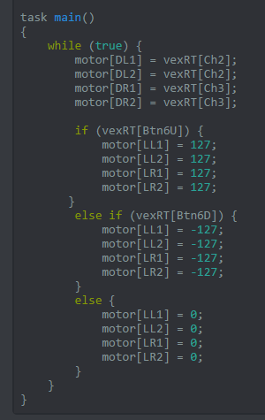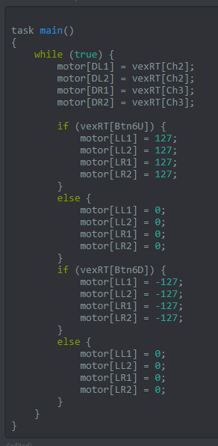

**After:**

**Before:**

## Code before and after