Problem 3: Drive problem

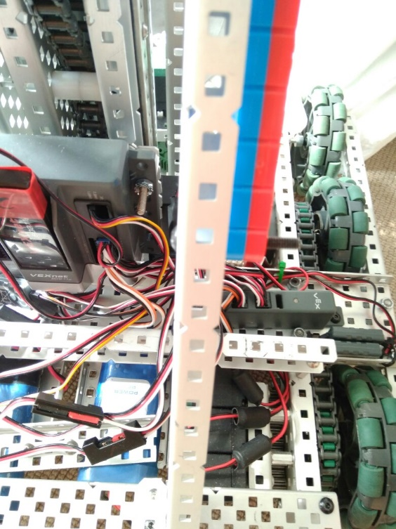

**Description:**

We found that when driving the robot around on a flat surface it would overload the motors on the drive and the robot would stop.

By Robbie Buxton

19/7/2017 – 17:23

**Process:**

The first thing we did was take apart the drive and start putting flat bearing blocks on the drive shaft because we had forgot to when we initially built the drive. This reduced friction however did not fix the problem (we were going to do this at some point anyway). Our next approach was to buy lubrication and apply it to the drive block however this still did not solve the problem. At this point we were out of ideas so we went the Vex UK discord where Joel from 4941 (Vex Alumni) suggested that we move some of the drive onto our power expander. We did this and it fixed the problem.

**Cause and solution:**

**Hardware:**

We switched the ports of the drive from all being in the main cortex to having the left side of the drive in the power expander, this resulted in us also doing the same thing lift however moving half of the motors over to the cortex. This fix suggests that problem must have been that the drive was drawing too much power from a single source causing the robot to overload.

**Probable causes we thought at the time:**

**Hardware:**

* Too much friction between gears
* Wheels were rubbing against frame causing friction
* Bad/dead motors

**Software:**

* Motors being programmed incorrectly