CHAPTER THREE
METHODOLOGY
3.1 Data Collection
VulnScanner is a software artefact rather than a survey-based study, so the project did not rely on primary data-collection instruments such as questionnaires or interviews. “Data collection” here refers instead to the process of determining what the scanner needed to detect and how it should behave, and this was drawn from secondary sources: the OWASP documentation on SQL Injection and Cross-Site Scripting, the literature already reviewed in Chapter Two, and the source code and published behaviour of comparable open-source scanners of the kind assessed by Alsaleh et al. (2017) and Zhang et al. (2023). These sources fed directly into three design inputs — the payload set used by the injection module, the response signals treated as evidence of a vulnerability, and the list of HTTP security headers checked against the OWASP baseline.
A second, more practical source of information came from development itself. OWASP Juice Shop, a deliberately vulnerable application maintained for exactly this purpose, was used throughout development as a known-vulnerable target: a detector was not considered complete until it could be shown to fire correctly against a Juice Shop endpoint known to contain the corresponding flaw.
3.2 Description of the Proposed System
VulnScanner is a Flask web application backed by an SQLite database accessed through SQLAlchemy. A tester submits a target URL through a web form; the request is validated, a scan record is created, and the scanning work itself is handed to a background thread (the run_scan function in core/scanner.py) so that the web interface stays responsive while a scan that may run for several minutes proceeds. The system is organised around five cooperating components:
- a web interface (app.py) that accepts new scans, serves a polling status page, and renders the final report;
- a crawler that discovers pages, HTML forms, and query-string parameters, preferring a Playwright-driven Chromium browser for JavaScript-heavy targets and falling back to a plain HTTP crawler when Chromium is not installed;
- a payload injector and detector pair that submits SQL Injection and Cross-Site Scripting payloads to each discovered entry point and inspects the resulting response for evidence of the vulnerability;
- a header checker that inspects the HTTP response headers returned by the target for missing or misconfigured security controls; and
- a persistence layer, the Scan and Finding SQLAlchemy models, that records scan progress, live logs, and findings as they are produced.
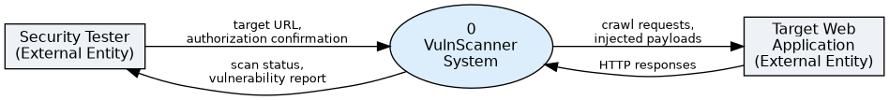
Figure 3.1: Context-level (Level 0) data flow diagram of VulnScanner
Figure 3.1 shows the system at context level: the tester supplies a target URL and an authorization confirmation, VulnScanner exchanges HTTP requests and responses with the target application, and the tester receives a live scan status and, on completion, a vulnerability report.
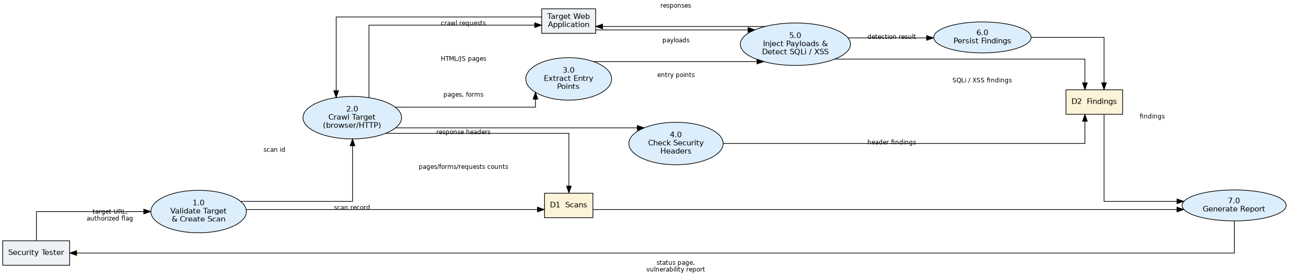
Figure 3.2: Level 1 data flow diagram, showing the seven processes executed by run_scan and the two supporting data stores
Figure 3.2 decomposes the single process of Figure 3.1 into the seven processing steps that run_scan executes in sequence — target validation, crawling, header checking, entry-point extraction, payload injection and detection, findings persistence, and report generation — together with the two data stores, Scans and Findings, that back onto the Scan and Finding models respectively.
3.3 Analysis of the Proposed System
(i) Input
The only input a tester provides is on the “New Scan” form: a target URL and a checkbox confirming that they are authorized to test it. Both fields are mandatory — submitting the form without a checked authorization box is rejected with an inline error before a scan record is even created. The target URL is then passed to _validate_target, which rejects the request if the URL has no scheme, embeds a username or password, contains a fragment or control characters, or fails to match one of the regular expressions in Config.ALLOWED_TARGET_PATTERNS. By default that allowlist covers only localhost, 127.0.0.1, and *.local addresses, which keeps the scanner from being pointed at arbitrary hosts on the public internet; an operator who has authorization to test a further target adds a pattern through the ALLOWED_TARGET_EXTRA environment variable rather than editing the source code.
(ii) Output
Output is delivered through three channels. The scan status page polls /api/scan/<id> and /api/scan/<id>/logs to display the current phase — queued, connecting, checking-headers, building-entry-points, testing-inputs, complete, or failed/cancelled — together with a progress percentage and a scrolling log. /api/scan/<id>/findings exposes every finding as JSON, including its vulnerability type, parameter, payload, and captured evidence. The final report page groups persisted findings by vuln_type and sub_type and summarises them by severity (critical, high, medium, low, info), alongside the pages crawled, requests sent, and scan duration returned by Scan.duration_seconds().
(iii) Database
VulnScanner uses SQLite through SQLAlchemy, with two tables. scans holds one row per submitted scan, tracking its target URL, status/phase/progress, crawl statistics (pages_crawled, forms_found, requests_sent), and an error category and message if the scan failed. findings holds one row per suspected or confirmed vulnerability, linked to its parent scan by a foreign key, and records the vulnerability type and sub-type, severity, confidence, the URL/parameter/method/payload involved, the evidence captured from the response, and a human-readable description, impact, and recommendation. Because the project evolved from an earlier version of the scanner, app.py includes _ensure_sqlite_columns, a small migration helper that inspects the existing scanner.db at start-up and adds any column introduced since v2, so a tester upgrading from an earlier copy of the tool does not need to discard their existing database.
Table 3.1: Data dictionary for the Finding table
Field | Type | Purpose
vuln_type | String(40) | Top-level category: sqli, xss, or security-header
sub_type | String(40) | Detection variant, e.g. error-based, boolean-blind, reflected, stored
severity / confidence | String(10) | Assigned by the detector that raised the finding
url / parameter / method | String | The entry point where the payload was submitted
payload / evidence | Text | The test input sent and the response text that justified the finding
confirmed | Boolean | Set automatically when confidence is high
3.4 System Design
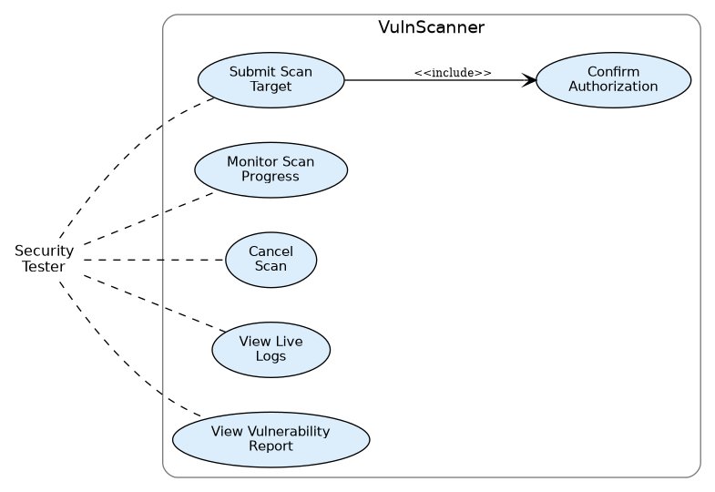
Figure 3.3: Use case diagram for VulnScanner
Figure 3.3 sets out the use cases available to the single actor in this system, the security tester: submitting a scan target (which includes confirming authorization), monitoring progress, cancelling a running scan, viewing live logs, and viewing the final report.
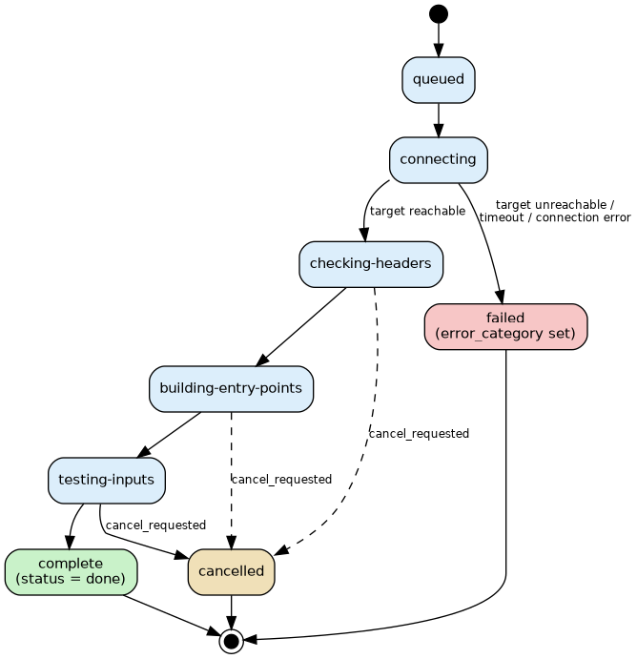
Figure 3.4: Activity diagram of the states a scan moves through under run_scan
Figure 3.4 traces the states a scan moves through once submitted, matching the phase progression documented for testers in the project’s setup guide. A scan that cannot reach its target during the connecting phase moves directly to failed with a specific error_category (target-unreachable, timeout, connection, http, or scanner) rather than a generic failure message, so a tester is told why a scan did not proceed rather than only that it did not. A cancellation request raised after crawling has started is honoured at the next checkpoint rather than instantly, since the payload-injection loop only checks cancel_requested between individual HTTP requests.
The technical feasibility of this design rests on running the scan in a background thread rather than blocking the request/response cycle that serves the web page: because Playwright navigation and the payload-injection loop can each take longer than a typical HTTP timeout, decoupling scan execution from the web request lets the tester’s browser return immediately to a status page instead of holding an open connection for several minutes.
CHAPTER FOUR
SYSTEM IMPLEMENTATION AND RESULTS PRESENTATION
4.1 System Requirements
VulnScanner has modest requirements because it is a black-box tool that drives HTTP requests and, optionally, a headless browser rather than performing heavy local computation.
Table 4.1: Minimum hardware requirements
Component | Minimum specification
Processor | Dual-core, 2.0 GHz or equivalent
Memory (RAM) | 4 GB (8 GB recommended when the Playwright/Chromium crawler is enabled)
Storage | 500 MB free space for the application, its dependencies, and the SQLite database
Network | Local network or loopback access to the target application
Table 4.2: Software requirements
Component | Requirement
Operating system | Windows, Linux, or macOS capable of running Python 3
Language / runtime | Python 3 with pip
Web framework | Flask, with Flask-SQLAlchemy for the ORM layer
Database | SQLite (bundled; no separate server required)
Browser automation | Playwright with the Chromium browser (python -m playwright install chromium); optional — the scanner falls back to an HTTP-only crawler if this step is skipped
HTTP client | The requests library, used for the injector and the fallback crawler
Test target | Docker, to run a local instance of OWASP Juice Shop for controlled testing
Testing | pytest, run via python -m pytest -q
4.2 System Implementation
Input interface
The tester-facing input is the “New Scan” form rendered by new_scan.html and handled by the new_scan route. It exposes a single text field for the target URL and a checkbox confirming authorization to test that target. A failed submission — a missing field, an unauthorized-box left unchecked, or a URL outside the allowlist — re-renders the same form with an inline error rather than a generic HTTP error page, so the tester can correct the input without losing their place.
Output interface
Once a scan is created, the tester is redirected to scan_status.html, which polls the JSON endpoints described in section 3.3(ii) to show phase, progress, and live logs without a full page reload. On completion, report.html presents the grouped findings, the severity summary, and the crawl statistics for that scan; scan_report also exposes the same data through /api/scan/<id> for any external tooling that wants to consume it programmatically.
Database interface
All database access goes through the SQLAlchemy ORM rather than hand-written SQL, using the Scan and Finding models described in section 3.3(iii). The one piece of raw SQL in the codebase is the migration helper _ensure_sqlite_columns, which uses SQLAlchemy’s inspector to compare the live schema against the columns the current version of the models expects and issues ALTER TABLE statements only for the columns that are missing, leaving existing data untouched.
4.3 Results Presentation
The tables and chart layout below reproduce the structure that scan_report.html actually populates from a completed scan. No scan had been run against a live target at the time this chapter was written, so the figures shown are an illustrative example, not real scan output. They are built from vulnerabilities that OWASP Juice Shop is publicly documented to contain — a SQL Injection login bypass on the email field of /rest/user/login, a reflected Cross-Site Scripting weakness in the q parameter of /rest/products/search, and a stored Cross-Site Scripting weakness in its product review/feedback form — so the shape of the table is realistic, but every count below must be replaced with the actual numbers your own scan produces before this chapter is submitted.
Table 4.3: Summary of findings by severity (illustrative example — replace with actual scan output)
Severity | SQL Injection | Cross-Site Scripting | Security Header | Total
Critical | 1 | 0 | 0 | 1
High | 1 | 2 | 0 | 3
Medium | 0 | 1 | 2 | 3
Low | 0 | 0 | 3 | 3
Info | 0 | 0 | 1 | 1
Total | 2 | 3 | 6 | 11
Table 4.4: Detail of individual findings (illustrative example — replace with actual scan output)
# | Type / Sub-type | URL | Parameter | Severity | Confidence
1 | sqli / boolean-blind | /rest/user/login | email | Critical | High
2 | sqli / error-based | /rest/user/login | email | High | Medium
3 | xss / reflected | /rest/products/search | q | High | High
4 | xss / reflected | /rest/products/search | q | High | Medium
5 | xss / stored | /rest/products/reviews | message | Medium | Medium
A bar chart of Table 4.3 (severity on the horizontal axis, finding count on the vertical axis, one series per vulnerability type) is the natural companion figure once real numbers are in place, and can be generated directly from the /api/scan/<id>/findings JSON without any further instrumentation of the scanner.
4.4 System Evaluation / Testing
Validation
The project ships an automated pytest suite, run with python -m pytest -q, which is exercised on every change to confirm that core components — target validation, the SQLAlchemy models, and the migration helper among them — continue to behave as expected before the scanner is run against a live target.
Verification
Verification was carried out manually by following the project’s own setup guide against a locally hosted instance of OWASP Juice Shop: installing dependencies, starting the Juice Shop container, submitting its URL as a scan target, and confirming that the status page moves through the documented phase sequence (queued → connecting → checking-headers → building-entry-points → testing-inputs → complete) with pages crawled, requests sent, and progress all advancing rather than remaining static. Failure handling was verified separately by pointing the scanner at a target outside the allowlist and at an unreachable port, and confirming that each case surfaces its own error_category rather than a single undifferentiated failure state.
Evaluation
In line with the fourth objective in section 1.3, the scanner’s detection accuracy is evaluated against the same class of deliberately vulnerable test application used in comparable studies, rather than against production systems. Alsaleh et al. (2017) found that no single open-source scanner in their comparison consistently outperformed the others across every vulnerability category, which sets a realistic bar for this evaluation: the aim is not to claim superiority over existing tools, but to confirm that VulnScanner’s narrower, SQLi/XSS-focused detectors reliably catch the vulnerability classes documented in Juice Shop for those two categories, consistent with the scope defined in section 1.5.
4.5 System Documentation
Program documentation
app.py defines the Flask routes, request validation, and the SQLite migration helper. models.py defines the Scan and Finding ORM models. config.py centralises every tunable the scanner uses — crawl limits, request limits, payload limits, browser settings, and the target allowlist — as environment-overridable class attributes rather than values hard-coded inside the scanning logic. core/scanner.py orchestrates a scan end to end, calling out to core/crawler.py to discover pages and forms, core/injector.py to submit payloads and capture baselines, core/payloads.py to load the SQLi/XSS payload sets, and core/detectors/ (sqli.py, xss.py, headers.py) to decide whether a response constitutes a finding.
System documentation
The system's objective, scope, and architecture are set out in sections 1.3, 1.5, and 3.2 respectively; this sub-section exists in the final report to point a future maintainer back to those sections rather than repeat them.
Operational documentation
Operating the scanner is described step by step in the project’s SETUP.md, reproduced in Appendix [X]: installing Python dependencies, installing the Playwright Chromium browser, starting the Flask application, starting an authorized local test target such as OWASP Juice Shop, and running the pytest suite.
User documentation
From a tester’s point of view, using VulnScanner is a three-step loop: open the “New Scan” form, enter a target URL that falls within the configured allowlist and confirm authorization, then watch the status page until it reaches complete and open the resulting report. The report itself explains, in its interpretation note, that “no vulnerabilities detected” reflects the limited set of detectors implemented rather than a guarantee that the target is secure.
4.6 Benefits of the System
- Gives students and small teams a free, source-available alternative to the commercial scanners that Alazmi and De Leon (2022) found priced beyond the reach of many individual developers.
- Narrowing detection to SQL Injection and Cross-Site Scripting, rather than the full OWASP Top Ten, keeps each detector’s logic simple enough to inspect and verify, in contrast to the opaque scoring used by some general-purpose commercial tools.
- Configurable scan limits (MAX_PAGES_PER_SCAN, MAX_REQUESTS_PER_SCAN, MAX_PAYLOADS_PER_ENTRY) let a tester bound how aggressively the scanner behaves against a given target.
- The mandatory authorization checkbox and the target allowlist reduce the risk of the tool being pointed, whether by accident or otherwise, at a system the operator is not authorized to test.
- Explicit, categorised error reporting (target-unreachable, timeout, connection, http, scanner) gives a tester a starting point for troubleshooting instead of an unexplained failure.
- The modular separation between crawling, injection, and detection, informed by Aliero et al. (2020), allows a future contributor to add a new detector or payload set without needing to understand the rest of the pipeline.

