GIT

Topics
- Installation: Git
- Intro to git (add, push, pull, commit, clone)
- Branching structure
- Merging
- Merge conicts,
- Advanced commands
- Code reviews with pull requests

Installation: Git
https://www.javatpoint.com/how-to-install-git-on-windows

What is Git
Git is a modern and widely used distributed version control system in the world. It is developed to manage projects with high speed and efficiency. The version control system allows us to monitor and work together with our team members at the same workspace.

What is GitHub?
GitHub is a Git repository hosting service. GitHub also facilitates with many of its features, such as access control and collaboration. It provides a Web-based graphical interface.
GitHub is an American company. It hosts source code of your project in the form of different programming languages and keeps track of the various changes made by programmers.
It offers both distributed version control and source code management (SCM) functionality of Git. It also facilitates with some collaboration features such as bug tracking, feature requests, task management for every project.

Git Vs GitHub
Git | GitHub
Git is a distributed version control tool that can manage a programmer's source code history. | GitHub is a cloud-based tool developed around the Git tool.
A developer installs Git tool locally. | GitHub is an online service to store code and push from the computer running the Git tool.
Git focused on version control and code sharing. | GitHub focused on centralized source code hosting.
It is a command-line tool. | It is administered through the web.
It facilitates with a desktop interface called Git Gui. | It also facilitates with a desktop interface called GitHub Gui.
Git does not provide any user management feature. | GitHub has a built-in user management feature.
It has minimal tool configuration feature. | It has a market place for tool configuration.

Git Vs SVN
Git | SVN
It's a distributed version control system. | It's a Centralized version control system
Git is an SCM (source code management). | SVN is revision control.
Git has a cloned repository. | SVN does not have a cloned repository.
The Git branches are familiar to work. The Git system helps in merging the files quickly and also assist in finding the unmerged ones. | The SVN branches are a folder which exists in the repository. Some special commands are required For merging the branches.
Git does not have a Global revision number. | SVN has a Global revision number.
Git has cryptographically hashed contents that protect the contents from repository corruption taking place due to network issues or disk failures. | SVN does not have any cryptographically hashed contents.
Git stored content as metadata. | SVN stores content as files.
Git has more content protection than SVN. | SVN's content is less secure than Git.
Linus Torvalds developed git for Linux kernel. | CollabNet, Inc developed SVN.
Git is distributed under GNU (General public license). | SVN is distributed under the open-source license.

Git Terminology
  - Branch
A branch is a version of the repository that diverges from the main working project. It is an essential feature available in most modern version control systems. A Git project can have more than one branch. We can perform many operations on Git branch-like rename, list, delete, etc.
  - Checkout
In Git, the term checkout is used for the act of switching between different versions of a target entity. The git checkout command is used to switch between branches in a repository.
  - Cherry-Picking
Cherry-picking in Git is meant to apply some commit from one branch into another branch. In case you made a mistake and committed a change into the wrong branch, but do not want to merge the whole branch. You can revert the commit and cherry-pick it on another branch.
  - Clone
The git clone is a Git command-line utility. It is used to make a copy of the target repository or clone it. If I want a local copy of my repository from GitHub, this tool allows creating a local copy of that repository on your local directory from the repository URL.
  - Fetch
It is used to fetch branches and tags from one or more other repositories, along with the objects necessary to complete their histories. It updates the remote-tracking branches.
  - Head
HEAD is the representation of the last commit in the current checkout branch. We can think of the head like a current branch. When you switch branches with git checkout, the HEAD revision changes, and points the new branch.
  - Index
The Git index is a staging area between the working directory and repository. It is used as the index to build up a set of changes that you want to commit together.

  - Master
Master is a naming convention for Git branch. It's a default branch of Git. After cloning a project from a remote server, the resulting local repository contains only a single local branch. This branch is called a "master" branch. It means that "master" is a repository's "default" branch.
  - Merge
Merging is a process to put a forked history back together. The git merge command facilitates you to take the data created by git branch and integrate them into a single branch.
  - Origin
In Git, "origin" is a reference to the remote repository from a project was initially cloned. More precisely, it is used instead of that original repository URL to make referencing much easier.
  - Pull/Pull request
The term Pull is used to receive data from GitHub. It fetches and merges changes on the remote server to your working directory. The git pull command is used to make a Git pull.
Pull requests are a process for a developer to notify team members that they have completed a feature. Once their feature branch is ready, the developer files a pull request via their remote server account. Pull request announces all the team members that they need to review the code and merge it into the master branch.
  - Push
The push term refers to upload local repository content to a remote repository. Pushing is an act of transfer commits from your local repository to a remote repository. Pushing is capable of overwriting changes; caution should be taken when pushing.
  - Rebase
In Git, the term rebase is referred to as the process of moving or combining a sequence of commits to a new base commit. Rebasing is very beneficial and visualized the process in the environment of a feature branching workflow.
From a content perception, rebasing is a technique of changing the base of your branch from one commit to another.

  - Remote
In Git, Repository is like a data structure used by VCS to store metadata for a set of files and directories. It contains the collection of the file as well as the history of changes made to those files. Repositories in Git is considered as your project folder. A repository has all the project-related data. Distinct projects have distinct repositories.
  - Staging
Sometimes you want to switch the branches, but you are working on an incomplete part of your current project. You don't want to make a commit of half-done work. Git stashing allows you to do so. The git stash command enables you to switch branch without committing the current branch.
  - Tag
Tags make a point as a specific point in Git history. It is used to mark a commit stage as important. We can tag a commit for future reference. Primarily, it is used to mark a projects initial point like v1.1. There are two types of tags.
- Light-weighted tag
- Annotated tag
Upstream And Downstream
The term upstream and downstream is a reference of the repository. Generally, upstream is where you cloned the repository from (the origin) and downstream is any project that integrates your work with other works. However, these terms are not restricted to Git repositories.
  - Git Revert
In Git, the term revert is used to revert some commit. To revert a commit, git revert command is used. It is an undo type command. However, it is not a traditional undo alternative.
  - Git Reset
In Git, the term reset stands for undoing changes. The git reset command is used to reset the changes. The git reset command has three core forms of invocation. These forms are as follows.
- Soft
- Mixed
- Hard

Git Ignore
In Git, the term ignore used to specify intentionally untracked files that Git should ignore. It doesn't affect the Files that already tracked by Git.
  - Git Diff
Git diff is a command-line utility. It's a multiuse Git command. When it is executed, it runs a diff function on Git data sources. These data sources can be files, branches, commits, and more. It is used to show changes between commits, commit, and working tree, etc.
  - Git Cheat Sheet
A Git cheat sheet is a summary of Git quick references. It contains basic Git commands with quick installation. A cheat sheet or crib sheet is a brief set of notes used for quick reference. Cheat sheets are so named because the people may use it without no prior knowledge.
  - Git Flow
GitFlow is a branching model for Git, developed by Vincent Driessen. It is very well organized to collaborate and scale the development team. Git flow is a collection of Git commands. It accomplishes many repository operations with just single commands.
  - Git Squash
In Git, the term squash is used to squash previous commits into one. Git squash is an excellent technique to group-specific changes before forwarding them to others. You can merge several commits into a single commit with the powerful interactive rebase command.
  - Git Rm
In Git, the term rm stands for remove. It is used to remove individual files or a collection of files. The key function of git rm is to remove tracked files from the Git index. Additionally, it can be used to remove files from both the working directory and staging index.
  - Git Fork
A fork is a rough copy of a repository. Forking a repository allows you to freely test and debug with changes without affecting the original project.Great use of using forks to propose changes for bug fixes. To resolve an issue for a bug that you found, you can:
- Fork the repository.
- Make the fix.
- Forward a pull request to the project owner.
  - Command Summary

Command | Usage
Git Config command | Configures the user. This command sets the author name and email address to be used with your commits.  - $ git config --global user.name "Ashu"  - $ git config --global user.email "ashujauhari@gmail.com"
Git init command | Create a local repository.  $ git init Demo
Git clone command | To make a copy of a repository from an existing URL. If I want a local copy of my repository from GitHub, this command allows creating a local copy of that repository on your local directory from the repository URL.
 | $ git clone URL
Git add command | To add one or more files to staging (Index) area.
 | $ git add . $ git add Filename
Git commit command | -m : It records or snapshots the file permanently in the version history with a message.  $ git commit -m " Commit Message"  -a : commits any files added in the repository with git add and also commits any files you've changed since then.  $ git commit -a
Git status command | Used to display the state of the working directory and the staging area. It allows you to see which changes have been staged, which haven't, and which files aren?t being tracked by Git. It does not show you any information about the committed project history. For this, you need to use the git log. It also lists the files that you've changed and those you still need to add or commit.  $ git status
Git push Command | It is used to upload local repository content to a remote repository. Pushing is an act of transfer commits from your local repository to a remote repo. It's the complement to git fetch, but whereas fetching imports commits to local branches on comparatively pushing exports commits to remote branches. Remote branches are configured by using the git remote command. Pushing is capable of overwriting changes, and caution should be taken when pushing.
 | $ git push Origin master
 | -all: This command pushes all the branches to the server repository.This command pushes all the branches to the server repository.
 | $ git push --all
Git Branch Command | Lists all the branches available in the repository.
 | $ git branch
Git Merge Command | To merge the specified branch?s history into the current branch.
 | $ git merge BranchName
Git log command | used to check the commit history.
 | $ git log or $ git log -3
Git remote command
Git pull command | To receive data from GitHub. It fetches and merges changes on the remote server to your working directory.  $ git pull URL

  - Create a Repository
- Create Git hub repository.
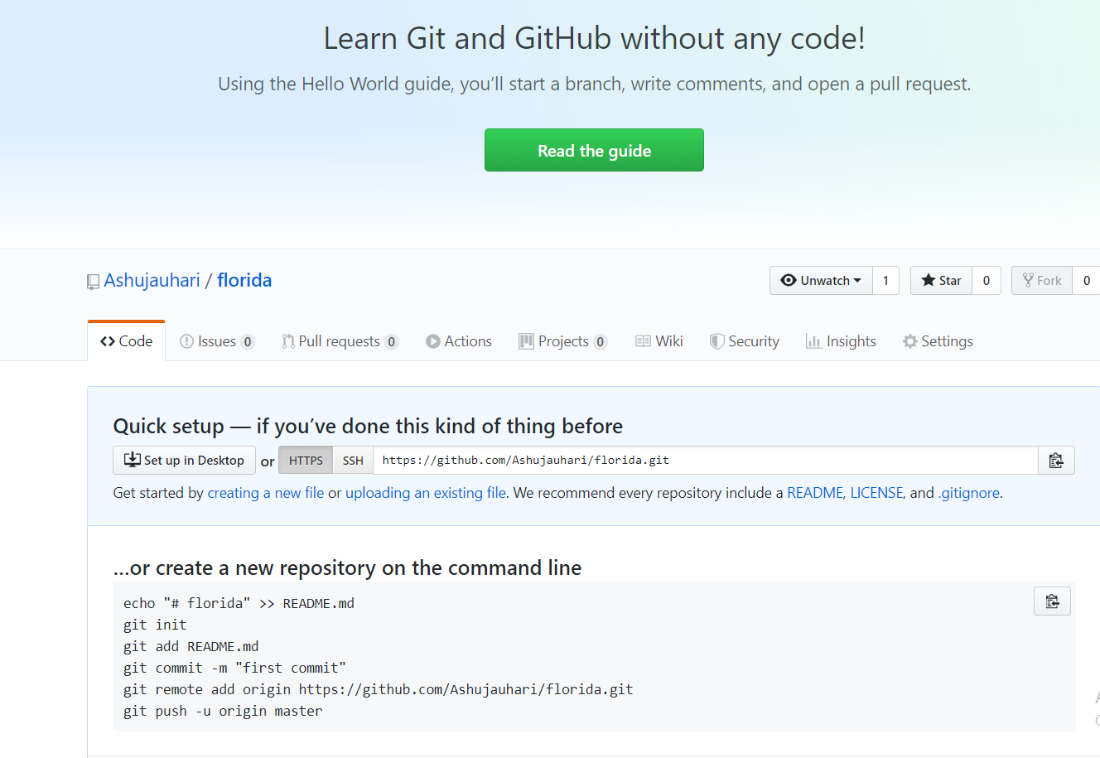
Notice github link: https://github.com/Ashujauhari/florida.git
- Download template demo.zip https://start.spring.io/
- Extract in a folder in TestGitSpring workspace and paste demo.zip and extract it.
  - Import demo folder in TestGotSpring workspace.
  - Run Maven Update.
  - Update code : 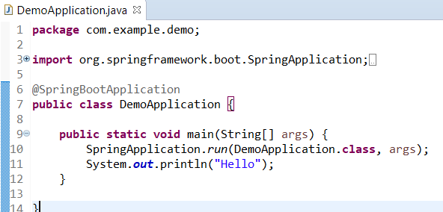

  - Push the “Demo” to Master Branch of FloridaRepository
- Create a local repository @ F:\Revature-Florida\TestGitSpring folder.
- Add the demo folder to Staging (Index)
  - 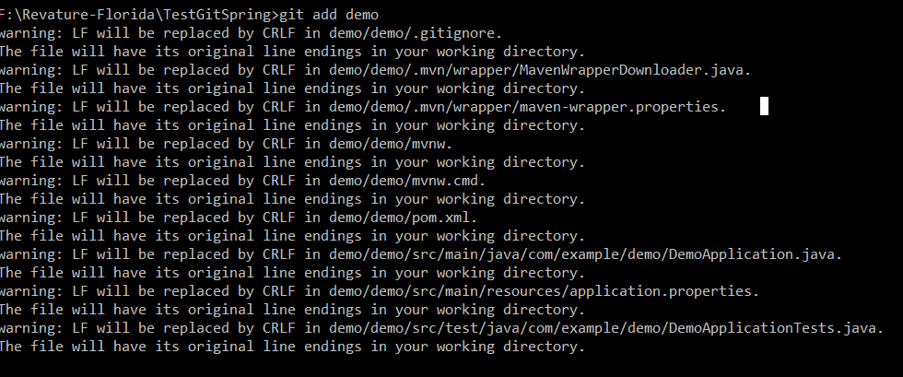
- Save the changes to local repository
  - 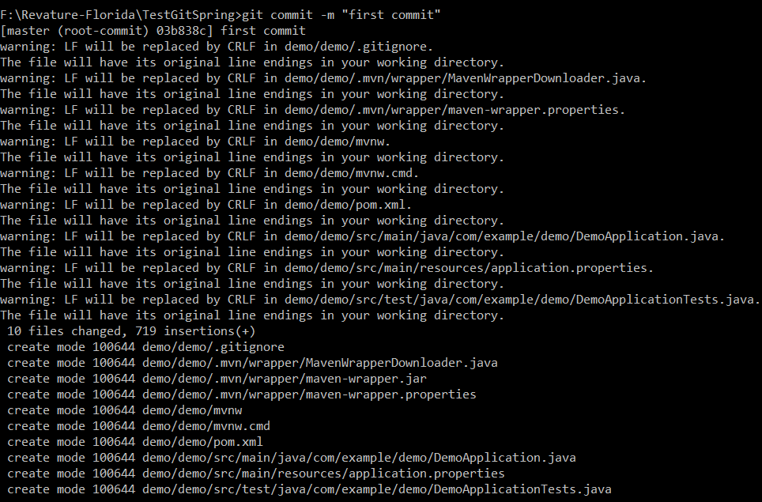
- Setup a connection of local repo with master branch of Remote Repo.

- Push the current folder to Origin master
  - 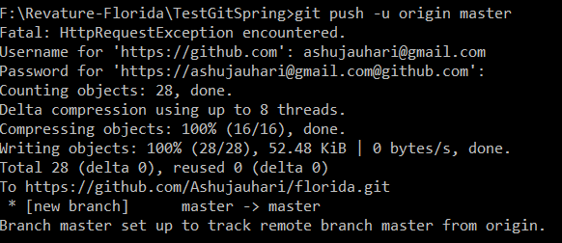
- Check git status
  - 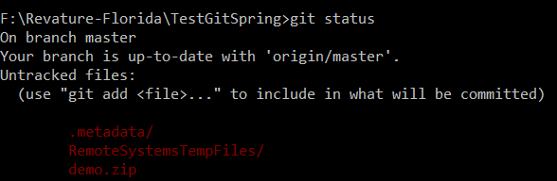
- Goto Git Repo and verify
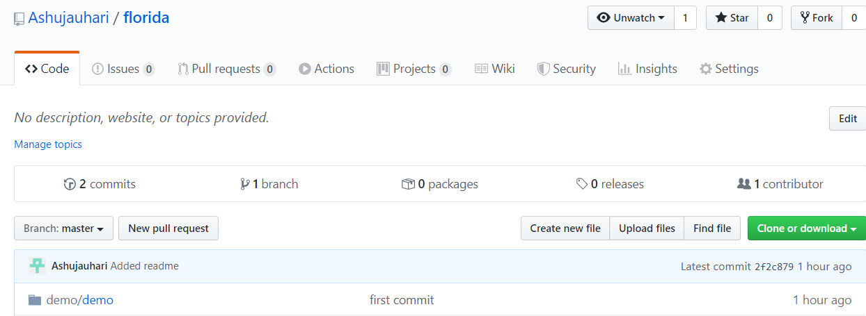

  - Push the “Readme.txt” to Master Branch of FloridaRepository
- Create a Readmetxt in TestGitSprint
- Verify : 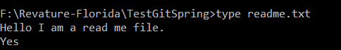
- Add readme.txt to index
- Save it in Local repo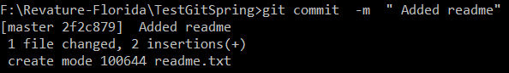
- Push it to Master branch
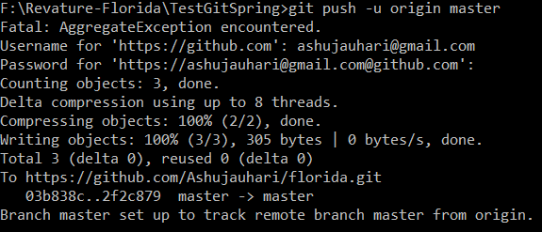
- Refresh Repository
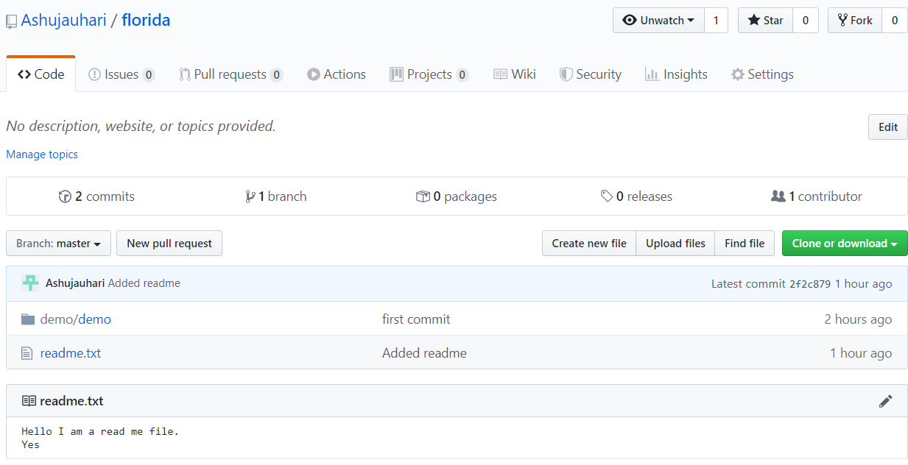

  - Branches:
  - What are Branches?

  - Branches:
  - Create Branches – Developer Branch
- Go to Repository

- Verify status
  - 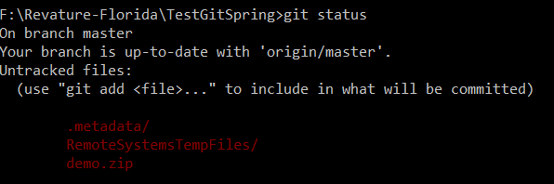
- Create branch – Feature1
  - We are still on feature1 branch

- To start working on feature1 branch. You have to checkout
  - Now the changes on local repo will go to new branch that is feature1.
Before | After
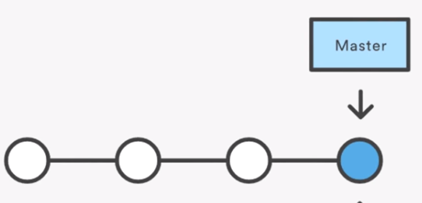 | 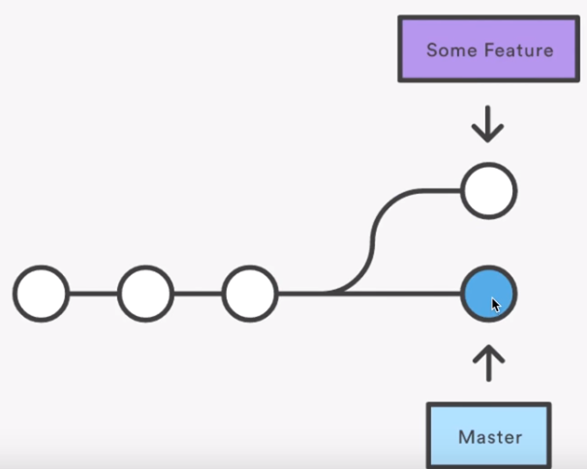

- Refresh the repository and review – Still it shows one branch because we have pushed it to remote repo
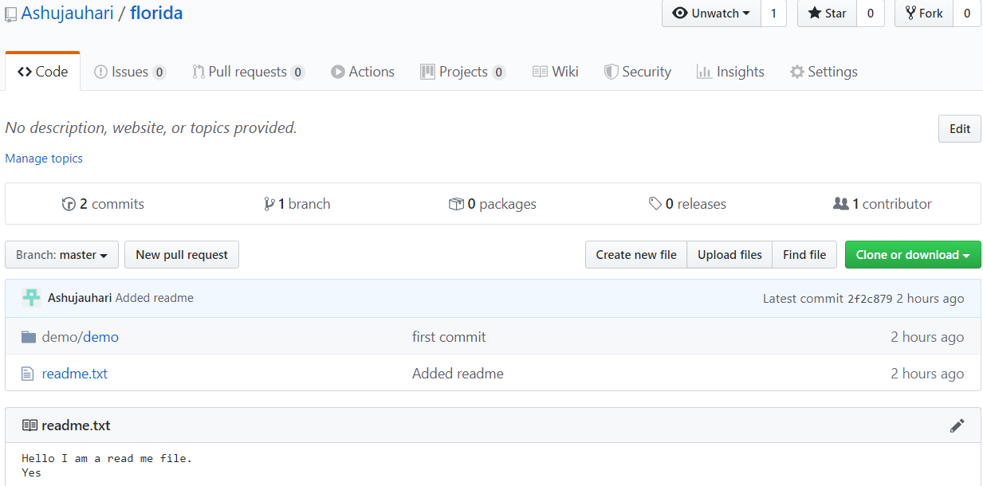

- Add a new file . Note because you have checkout feature1 branch so the below file to go to feature1.
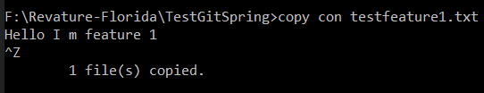

- Check status
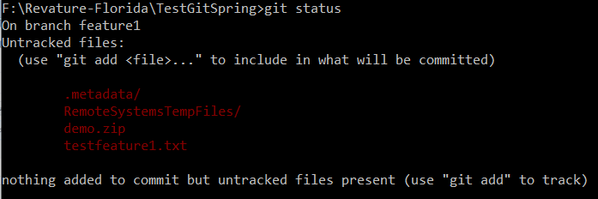
Note: All files in red are not pushed to master branch.
- Add the testfeature1.txt to staging
- Save changes to local repo
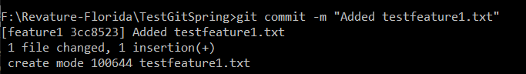
- Checks status
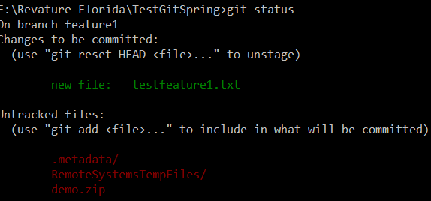

- Push changes to feature1 branch on remote repo
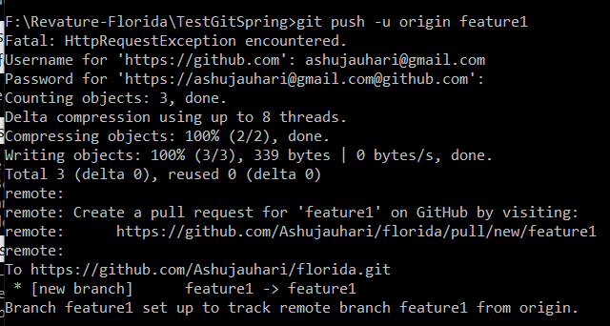
- Refresh the repo now
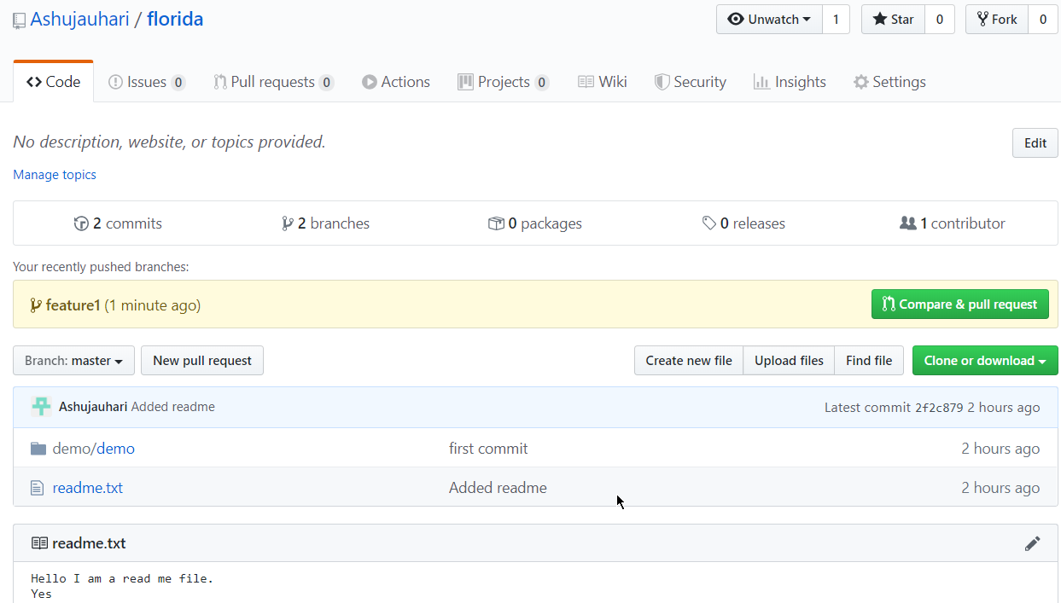
- Now we have two branches: Master consist of demo and readme.txt

- Notice: Feature1 branch consist of demo, reademe.txt and testfeature1.txt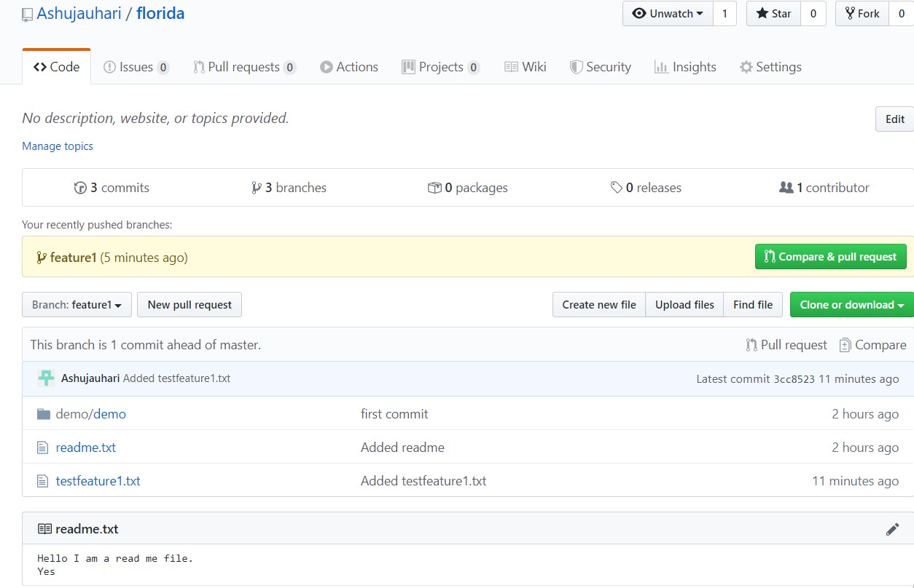
- Create release branch from git : Click on Branch and enter nameof new branch called Release
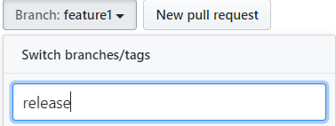
- Refresh Repo now you will see 3 branches
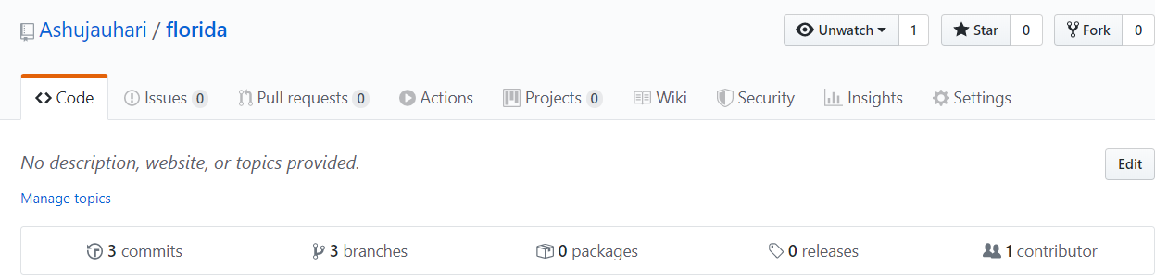
Click on 3 branches

- It shows all branches
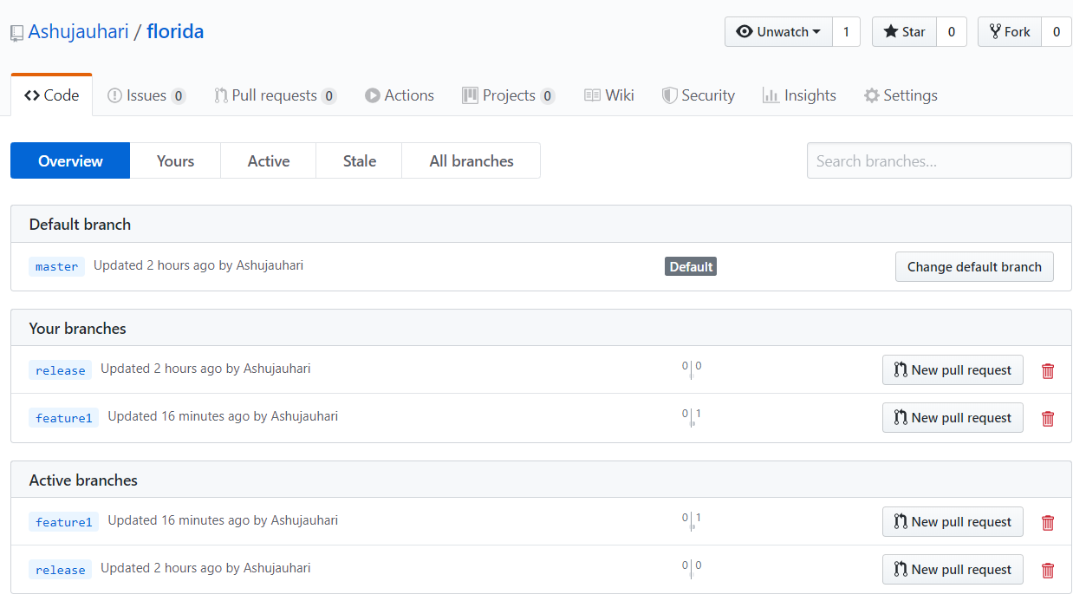
- Check out master branch and notice that testfeature1.txt is invisible.
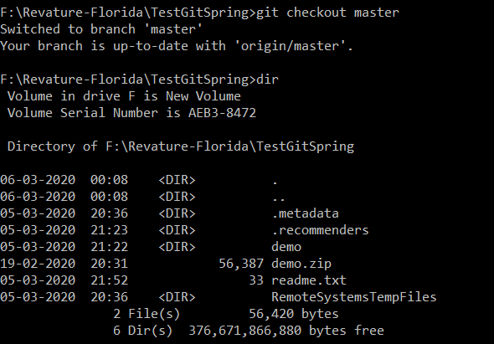

  - Merge Feature1 branch to Master branch
- Make sure you have checkout master branch to make it current branch
- Merge the feature1 branch to master branch
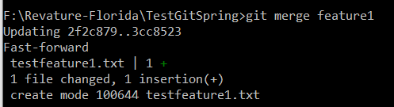
- Verify the master branch. Notice that testfeaturebranch.txt is added successfully in LOCAL Repo. 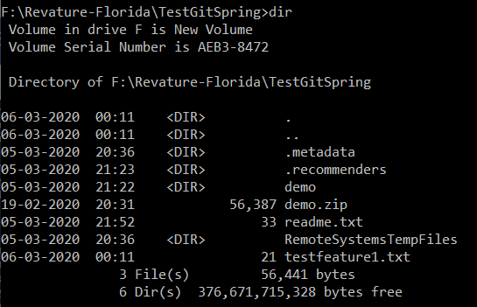

- It is still not available in remote repo because we have not pushed changes to master branch in remote repo.
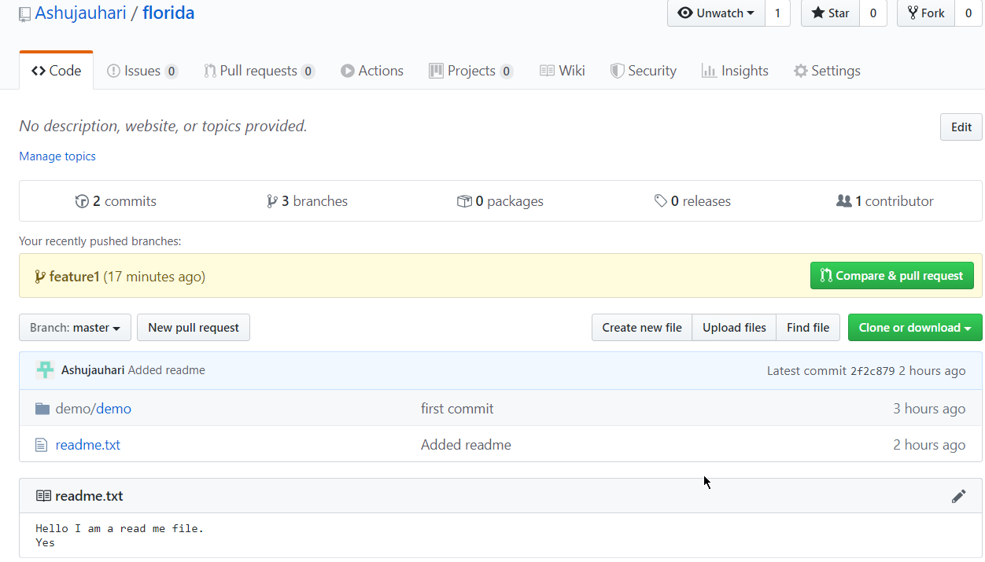
- Push changes to master branch of remote repo.
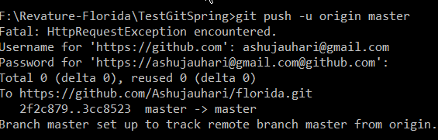
- Refresh Repository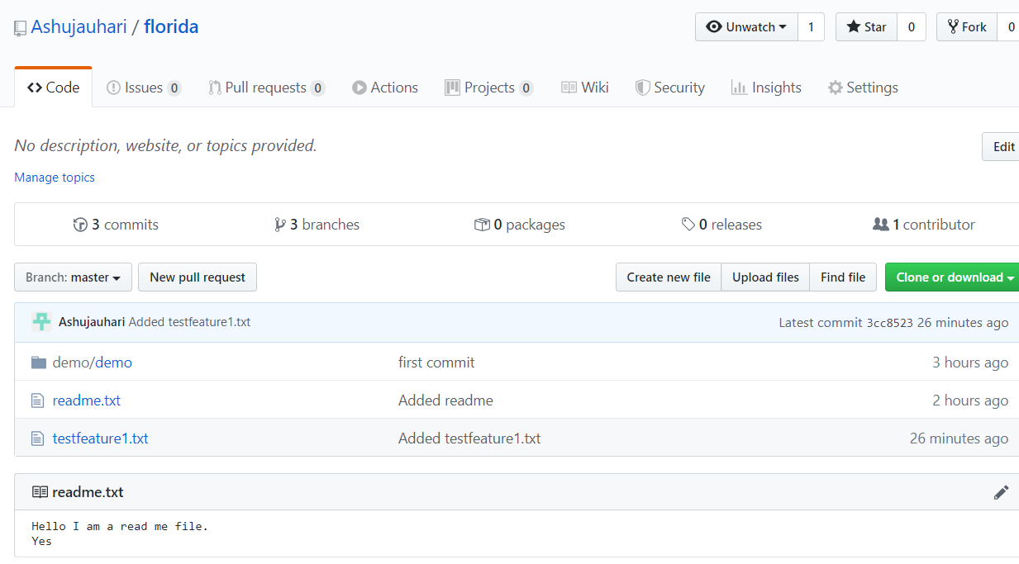

https://git-scm.com/book/en/v2/Git-Branching-Basic-Branching-and-Merging
Switch to your production branch.
Create a branch to add the hotfix.
After it’s tested, merge the hotfix branch, and push to production.
Switch back to your original user story and continue working.

  - Merge Branches
  - Case Study : Create local repo by cloning remote repo in a folder. Create a dev branch from master branch. Create two feature1 and feature2 branch from dev branch. Merge feature 2 in dev branch.
Step 1: Create a folder in GIT and clone the remote repo.
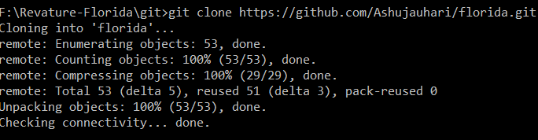
Step 2: Check current branch
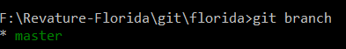
Step 3: Create dev branch.
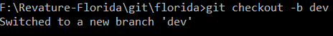
Step 4: Create feature1 and feature2 branch
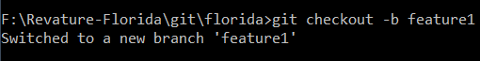
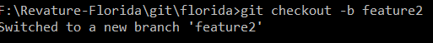
Step 5: Add file a.txt in feature1 branch
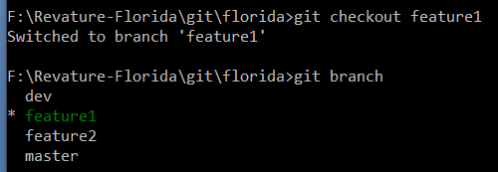
    - Create a.txt
- 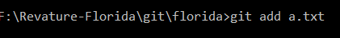
- 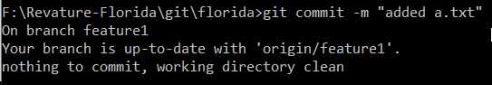
- Verify Git hub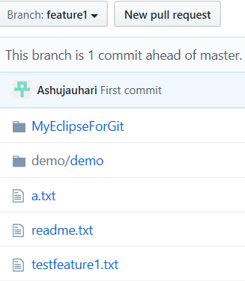

Step 6: Add b.txt in feature2 branch
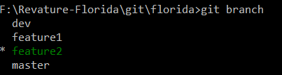
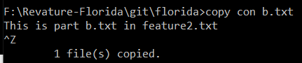
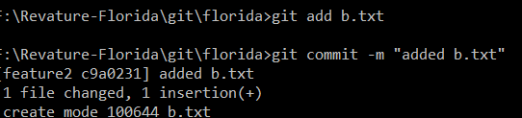
- Verify in GitHub 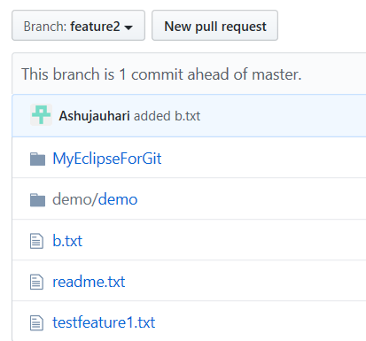
Observe the update on screen
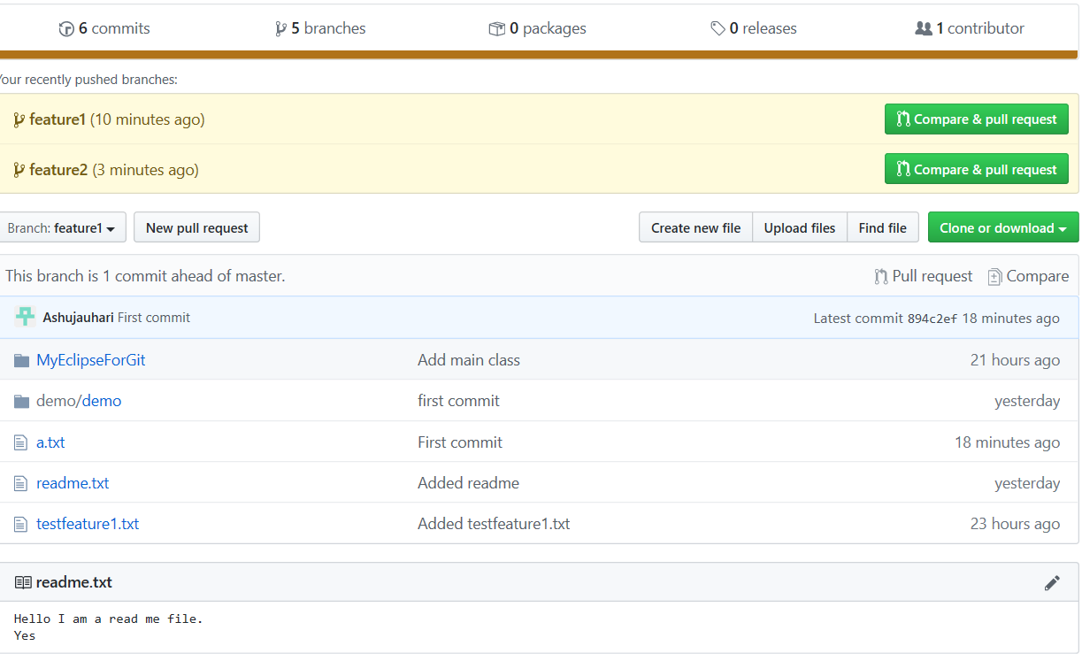
Step 7: Merge the changes of feature 2 to feature1.
- Make sure you are in feature2 branch. 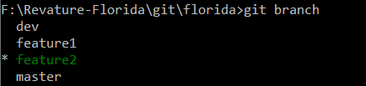
- 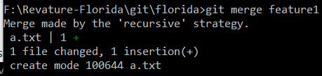
- Verify in local repo
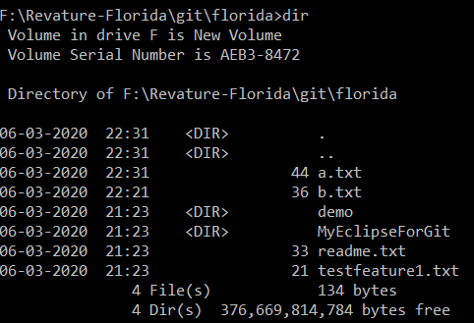
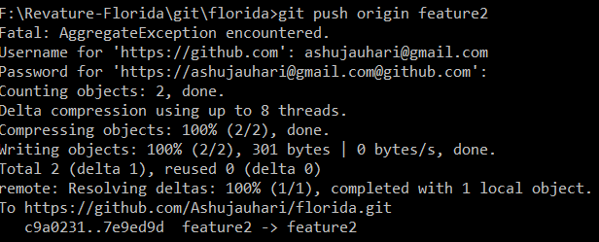
Verify -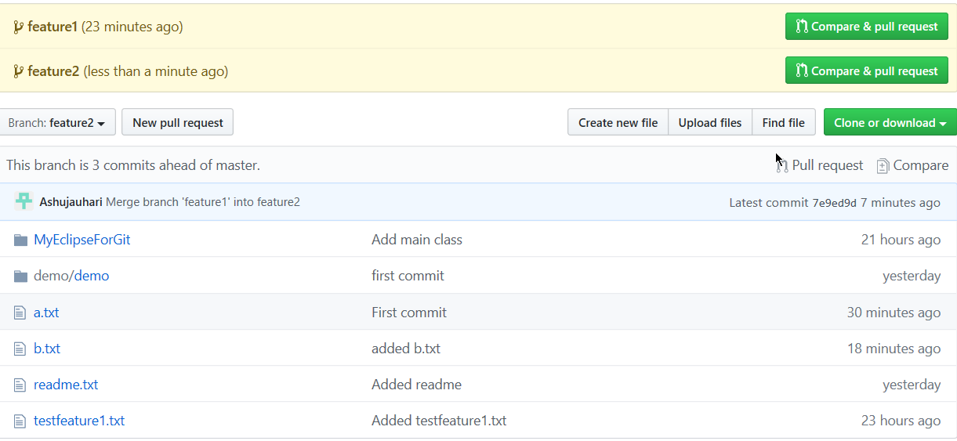

Step 8: Merge changes of feature2 into dev branch.
- Switch to dev branch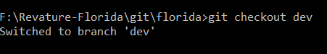
- Merge feature2 in dev branch
- 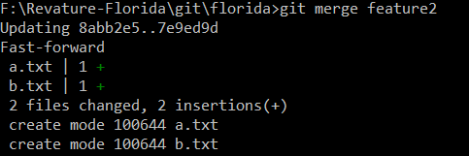
Step 9: Push local dev branch to remote dev branch
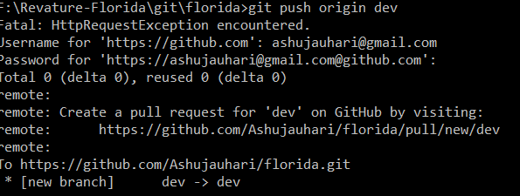
Verify : 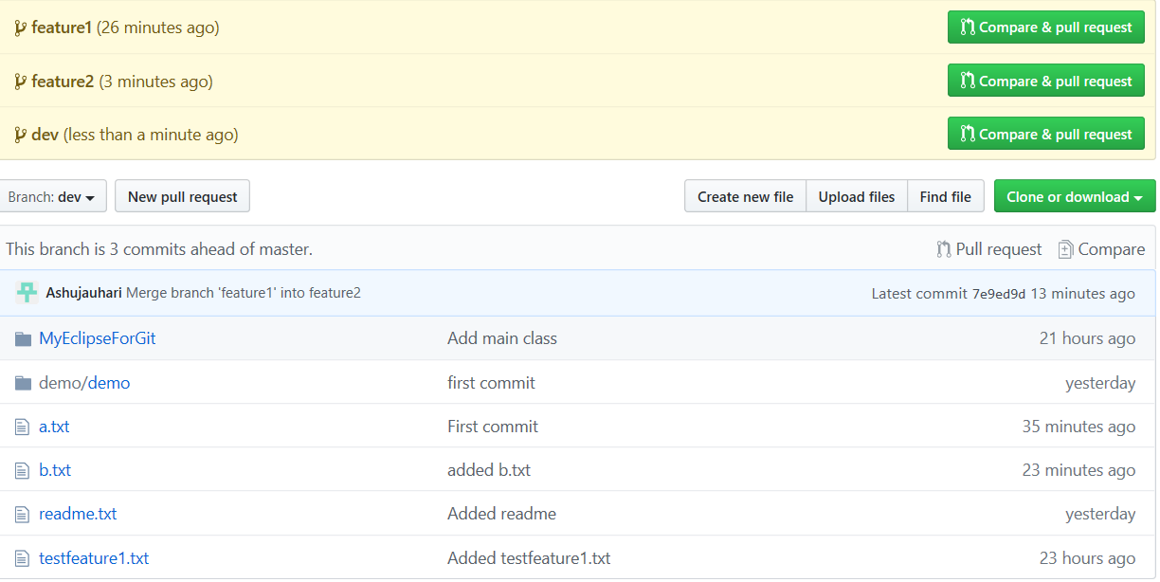

  - Pull: Use Case: In remote repo, in dev branch, update a.txt. Update the dev branch of local repo
GIT PULL = GIT FETCH + GIT MERGE
Step 1: Go to remote repo / dev branch -> a.txt
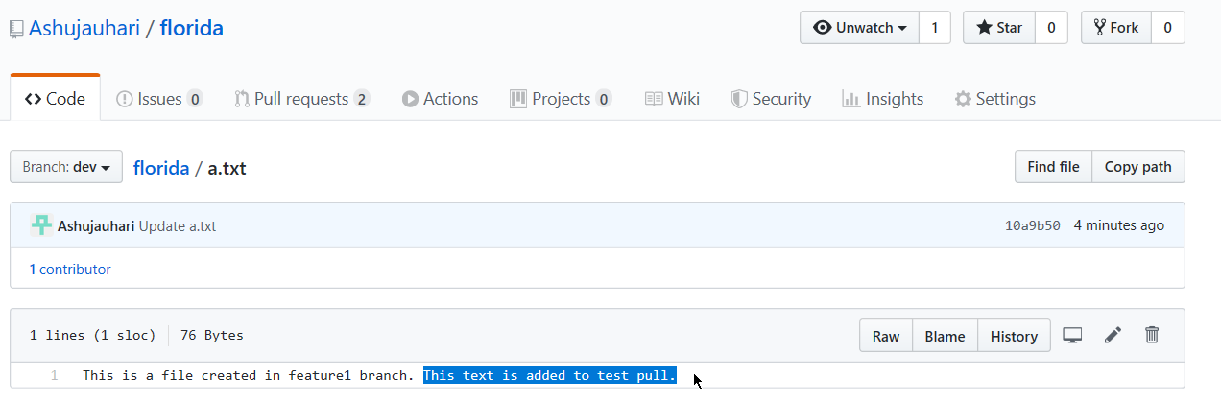
Step 2: Switch to dev branch in local repo.
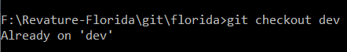
Step 3: Run Pull on Dev
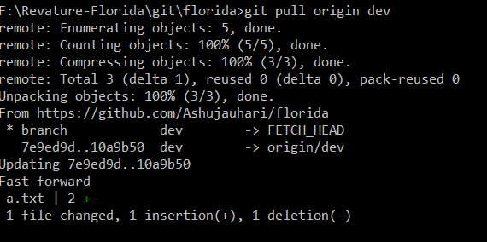
Step 4: Verify on local repo
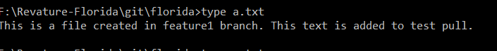

  - Delete the branch – feature1
After merging when you do not need the branch anymore, you can delete the branch.
- Display all branches
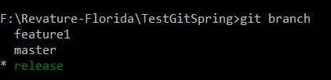
- Switch to master branch
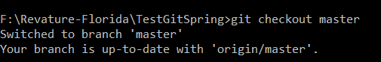
- Delete feature1 branch from LOCAL Repo
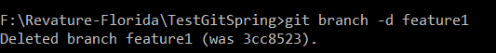

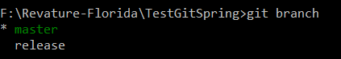
- If you will go remote repo it will still show
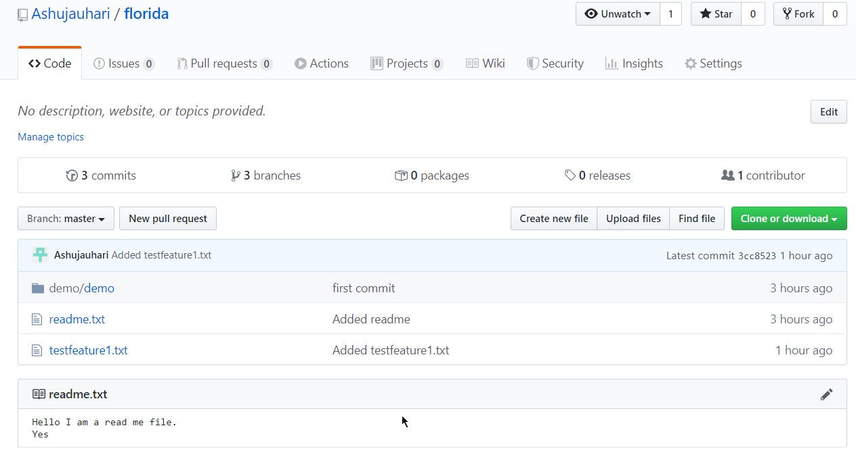
- To delete branch from Remote Repo
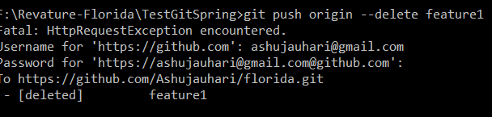

- Go back and check now
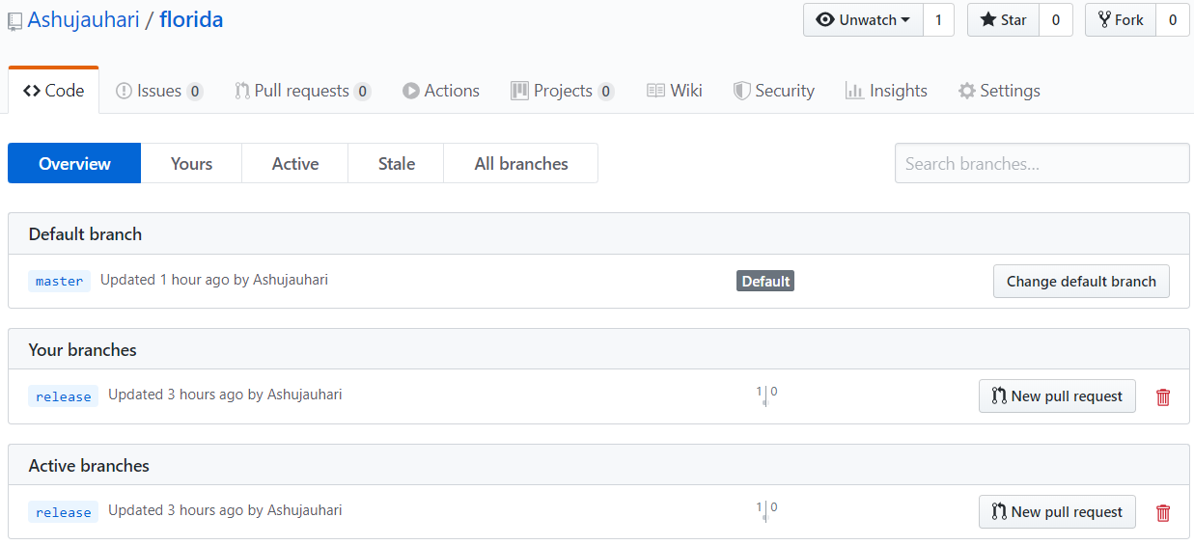

  - GitHub Project to ECLIPSE
Step 1 : Create GitHub account and SignIn
Step 2 : Start a Project = Create a repository
Step 3 : Start Eclipse
Step 4 : Goto Perspective - Git Repositories and click on Add Git Repo
Step 5 : Create a project in Eclipse
Step 6 : Do a right click on Project - Team - Share - Add to git repo
Step 7 : Commit and Push the project to the repo
Step 8 : Commit and Push every change to the repo
- Login to github account
- Open eclipse in GIT prospective
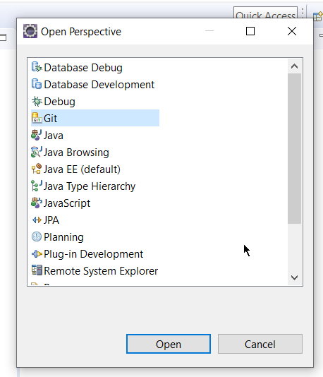
- 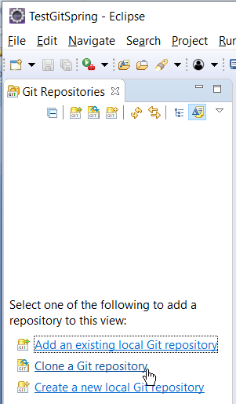
- Click on “Clone a git repo” . Enter Git URL and credential.
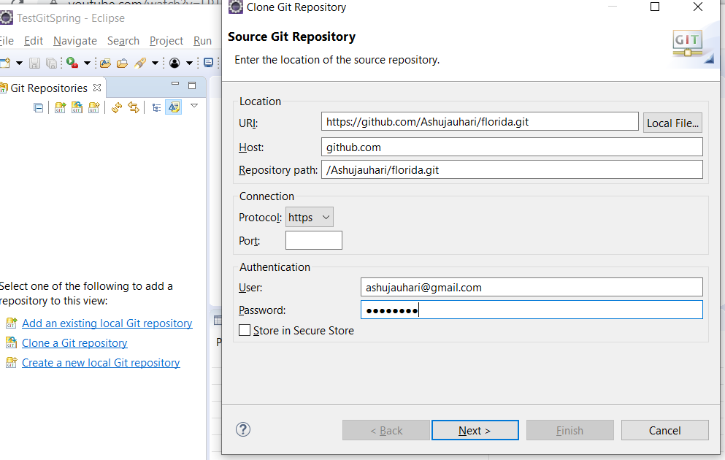
- Click on Next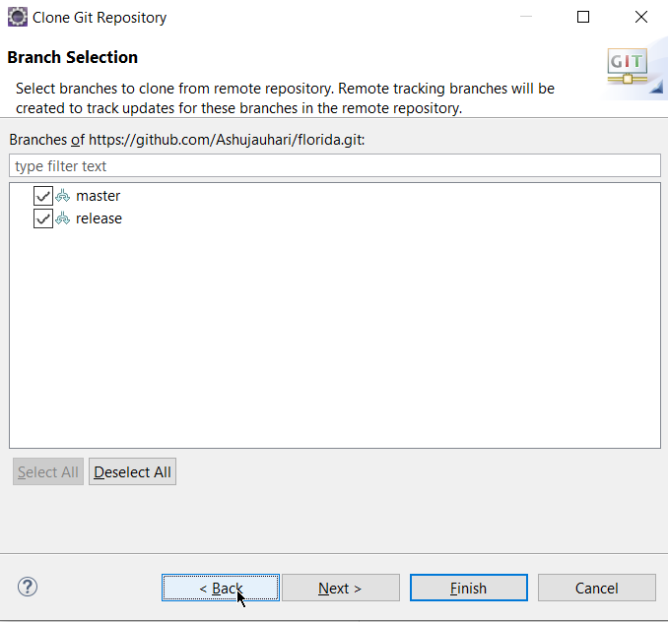

- Click on Next
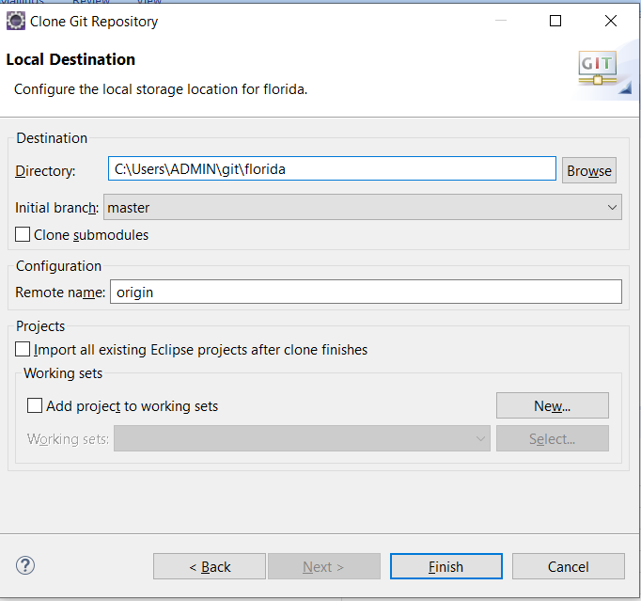
- Notice Git Repositories
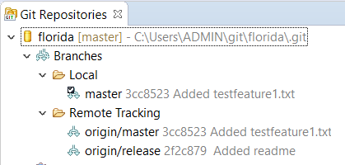
- Create a new Project in Eclipse package manger

- Clone git repository in eclipse

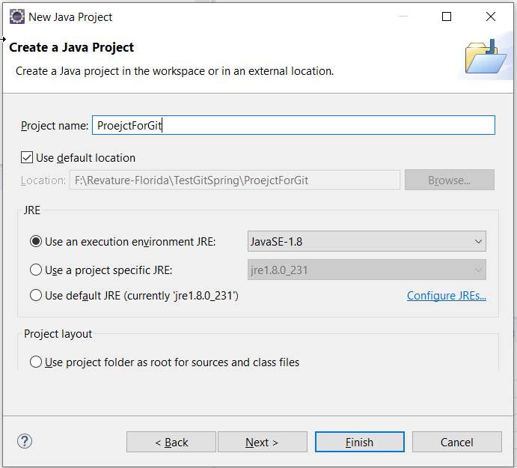
- It has been created
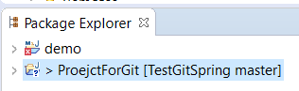
- Rc Project-> Team-> Add to index

- Ec-> Project -> Team -> Commit and Push
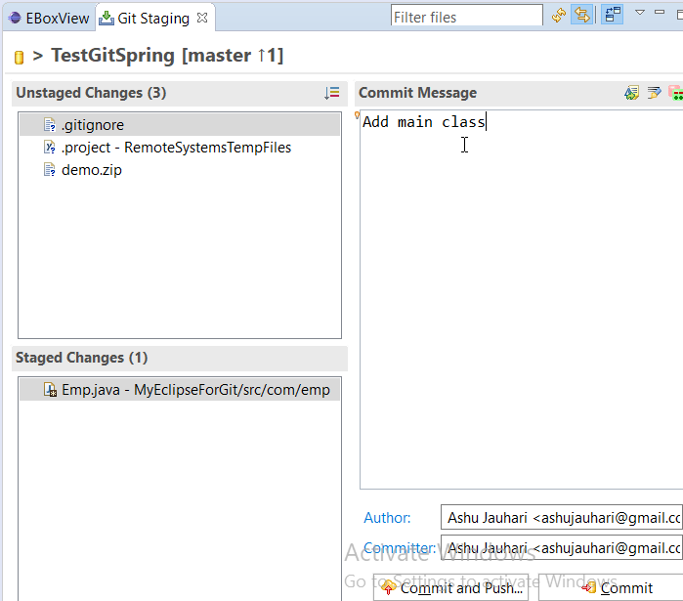
- Click on Save and Push
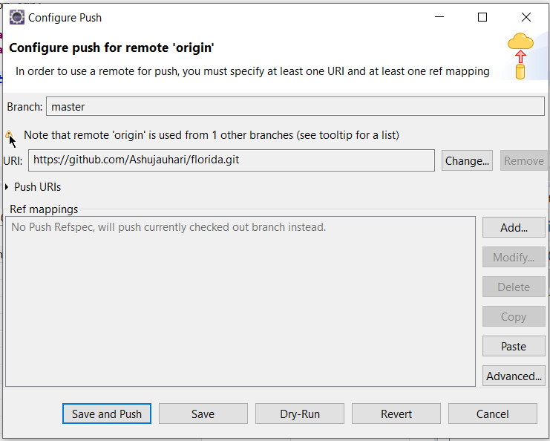+Ok

- Verify in Remote repo
