AWS RDS

https://docs.aws.amazon.com/AmazonRDS/latest/UserGuide/CHAP_Oracle.html

AWS RDS
https://docs.aws.amazon.com/AmazonRDS/latest/UserGuide/Welcome.html
AWS RDS is an environment in which you run Oracle DB.Amazon Relational Database Service (Amazon RDS) is a web service that makes it easier to set up, operate, and scale a relational database in the AWS Cloud. It provides cost-efficient, resizable capacity for an industry-standard relational database and manages common database administration tasks.

Why do you want a managed relational database service?
- Server=CPU+Memory+IOPS -> AWS split them and allows you to scale them independently.
- Allows you to manage backups + software patching + automatic failure detection + recovery
- Automated backup however you can also manually create your own backup snapshot to restore database. More reliable and efficient.
- High availability with a primary instance and a synchronous secondary instance that you can fail over to when problems occur.
- Supports use of database products you are already familiar with: MySQL, MariaDB, PostgreSQL, Oracle, Microsoft SQL Serve.
- Helps controlling who can access your RDS databases by using AWS Identity and Access Management (IAM) to define users and permissions.

Terminologies
DB Instance
AWS Region and Availability Zones
Security

How to Work with Amazon RDS

AWS management Console

Command Line Interface

Programming with AWS RDS

AWS Purchasing Option
- On-Demand Instances- Pay by the hour for the DB instance hours that you use. Pricing is listed on a per-hour basis, but bills are calculated down to the second and show times in decimal form. RDS usage is now billed in one second increments, with a minimum of 10 minutes.

- Reserved Instances -Reserve a DB instance for a one-year or three-year term and get a significant discount compared to the on-demand DB instance pricing. With Reserved Instance usage, you can launch, delete, start, or stop multiple instances within an hour and get the Reserved Instance benefit for all of the instances

DB Instance Billing for Amazon RDS
- DB instance hours (per hour) – Based on the DB instance class of the DB instance (for example, db.t2.small or db.m4.large). Pricing is listed on a per-hour basis, but bills are calculated down to the second and show times in decimal form. RDS usage is billed in one second increments, with a minimum of 10 minutes.
- Storage (per GiB per month) – Storage capacity that you have provisioned to your DB instance. If you scale your provisioned storage capacity within the month, your bill is pro-rated.
- I/O requests (per 1 million requests per month) – Total number of storage I/O requests that you have made in a billing cycle, for Amazon RDS magnetic storage only.
- Provisioned IOPS (per IOPS per month) – Provisioned IOPS rate, regardless of IOPS consumed, for Amazon RDS Provisioned IOPS (SSD) storage only. Provisioned storage for EBS volumes are billed in one second increments, with a minimum of 10 minutes.
- Backup storage (per GiB per month) – Backup storage is the storage that is associated with automated database backups and any active database snapshots that you have taken. Increasing your backup retention period or taking additional database snapshots increases the backup storage consumed by your database. Per second billing doesn't apply to backup storage (metered in GB-month).
- Data transfer (per GB) – Data transfer in and out of your DB instance from or to the internet and other AWS Regions.

Best Practices
https://docs.aws.amazon.com/AmazonRDS/latest/UserGuide/CHAP_BestPractices.html

Create a DB Instance Running Oracle
https://docs.aws.amazon.com/AmazonRDS/latest/UserGuide/USER_CreateOracleInstance.html
- Sign in to the AWS Management Console and open the Amazon RDS console at https://console.aws.amazon.com/rds/.
In the upper-right corner of the AWS Management Console, choose the AWS Region in which you want to create the DB instance.
- In the navigation pane, choose Databases.

- Choose Create database.
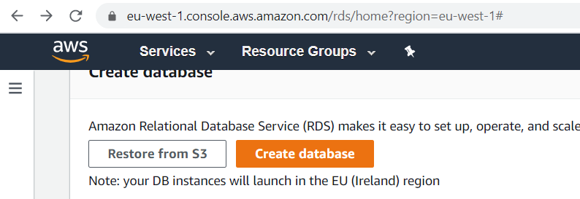
- In Choose a database creation method, choose Standard Create.
The Oracle editions that are available vary by AWS Region.
- In Engine options, choose Oracle.
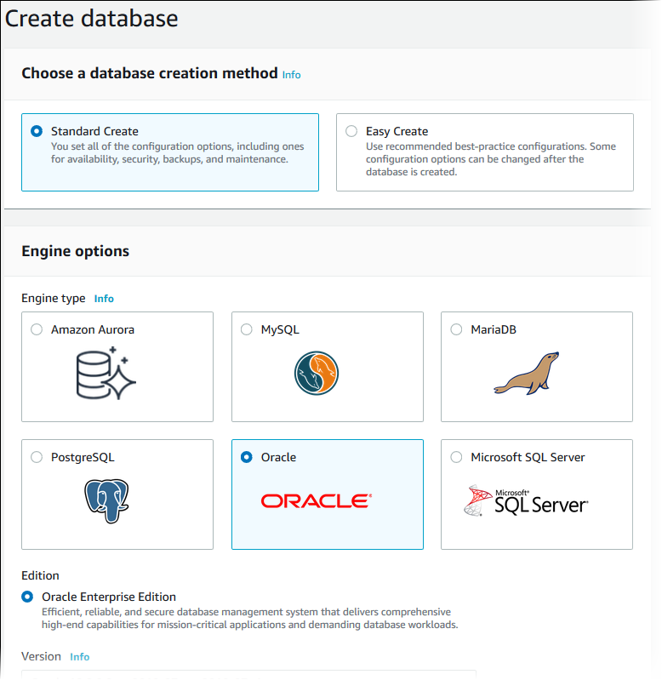
- For Edition, choose the Oracle DB engine edition that you want to use. The Oracle editions that are available vary by AWS Region.
- For Version, choose the Oracle version and name of DB.
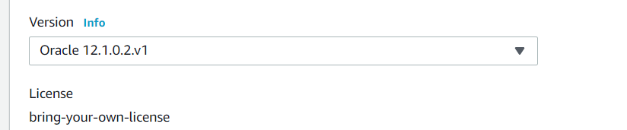
- The next step asks if you are planning to use the DB instance that you are creating for production.
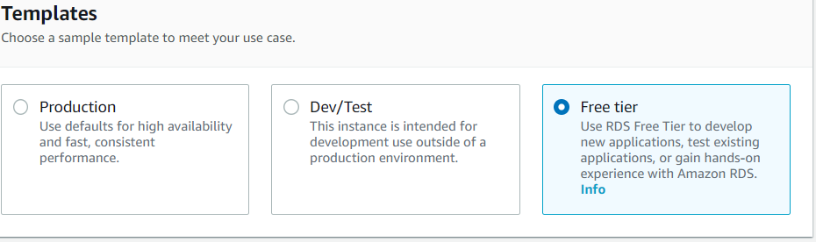

Enter DBIdentifier: MyOracleDB
Username: admin
Master password: rootroot
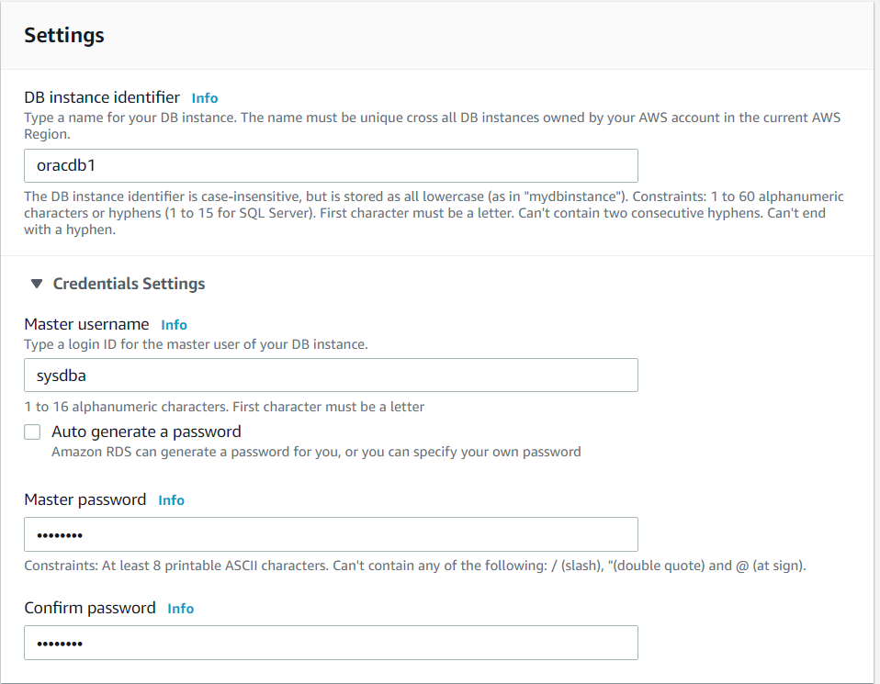
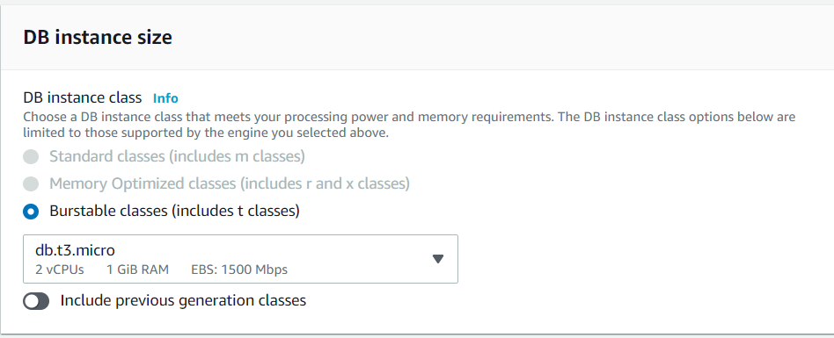
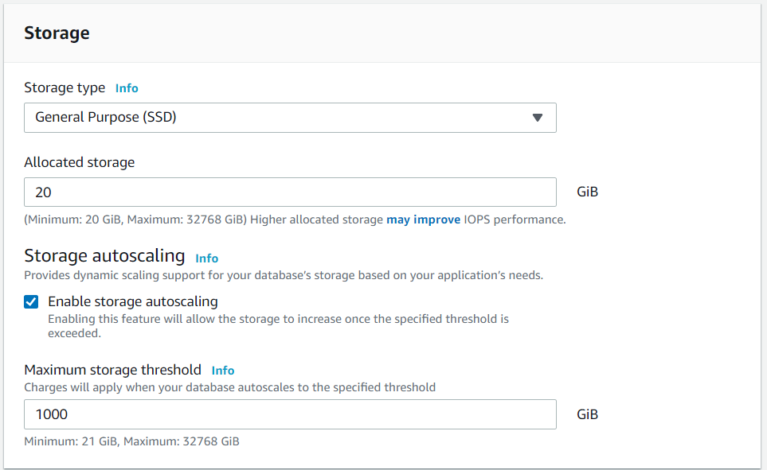
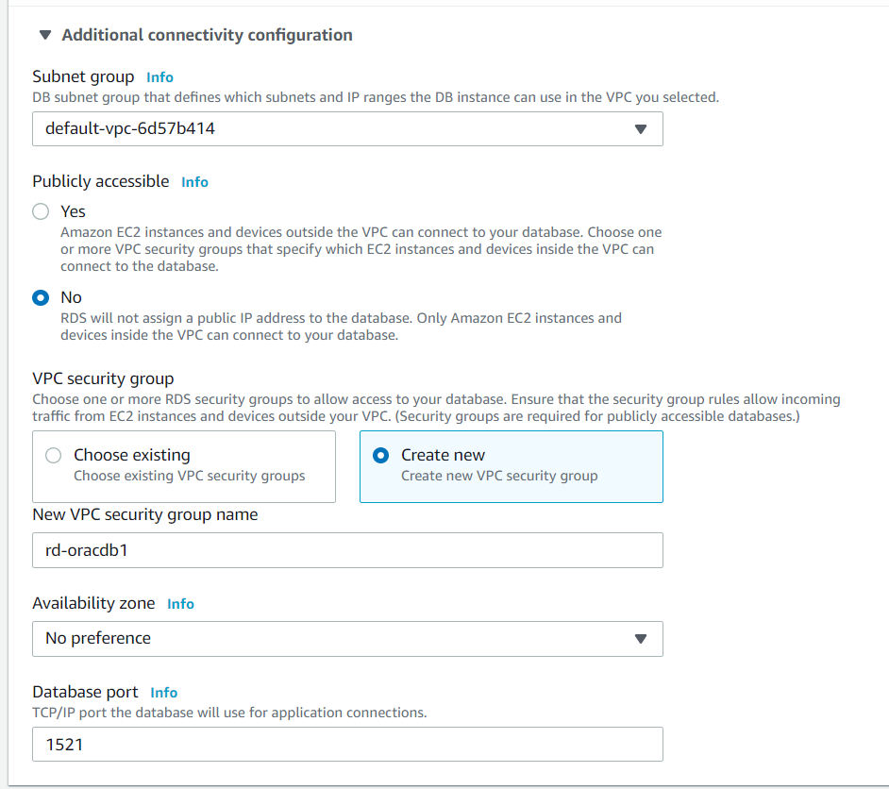
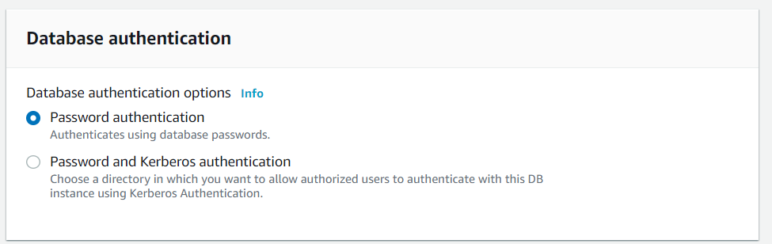
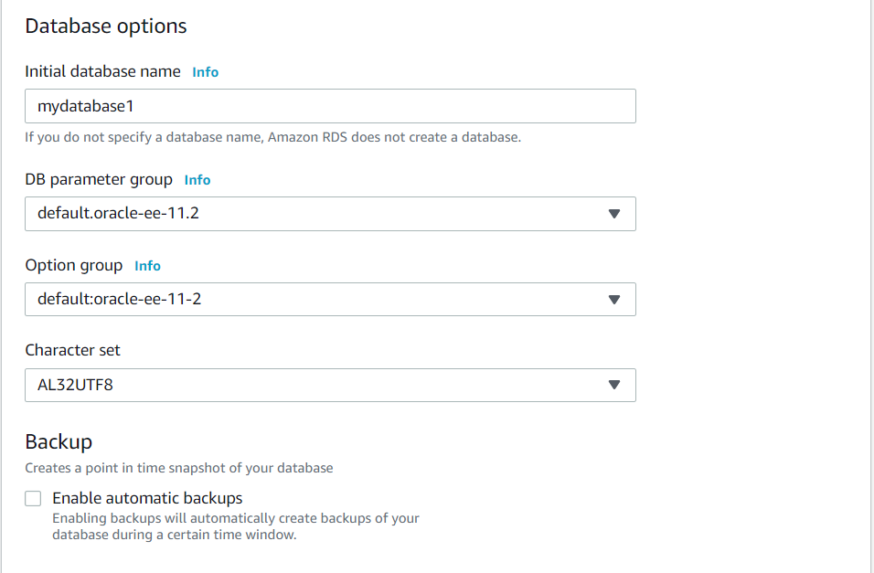
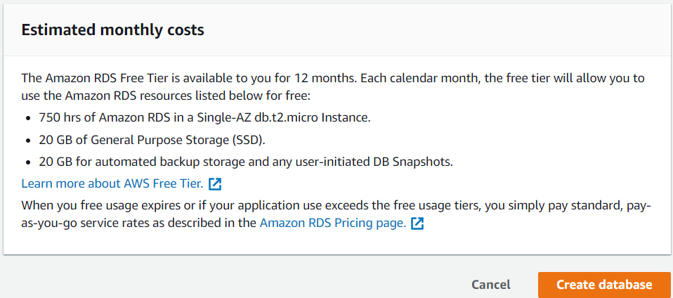
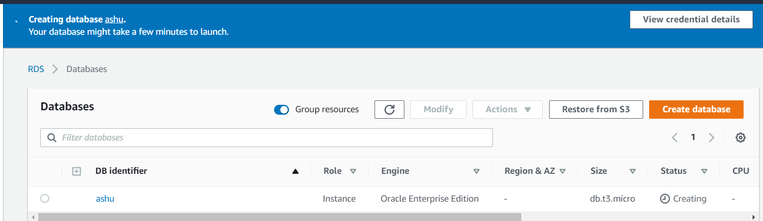
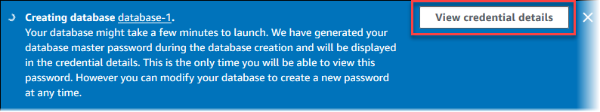
To connect to the DB instance as the master user, use the user name and password that appear.
Important
You can't view the master user password again. If you don't record it, you might have to change it. If you need to change the master user password after the DB instance is available, you can modify the DB instance to do so. For more information about modifying a DB instance, see Modifying an Amazon RDS DB Instance.
- For Databases, choose the name of the new Oracle DB instance.
On the RDS console, the details for the new DB instance appear. The DB instance has a status of creating until the DB instance is created and ready for use. When the state changesto available, you can connect to the DB instance. Depending on the DB instance class and storage allocated, it can take several minutes for the new instance to be available.
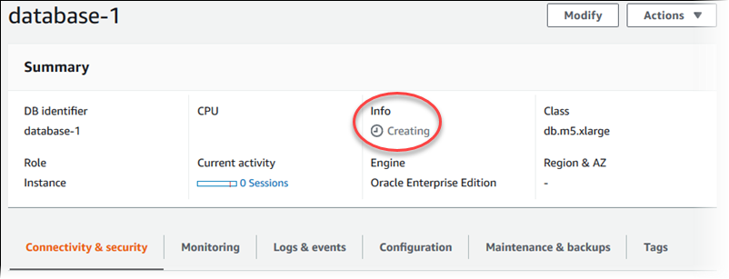

How to launch AWS RDS instance?

Connect to SQL Developer
- Start Oracle SQL Developer.
- On the Connections tab, choose the add (+) icon.
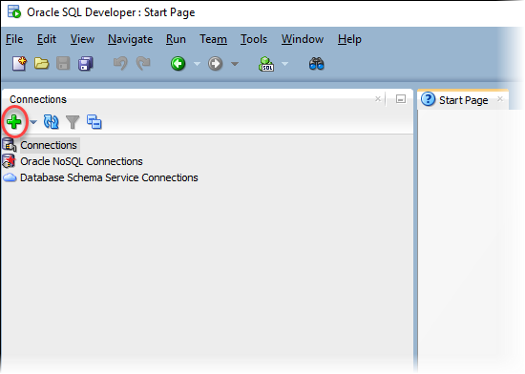
- In the New/Select Database Connection dialog box, provide the information for your DB instance:
  - For Connection Name, enter a name that describes the connection, such as Oracle-RDS.
  - For Username, enter the name of the database administrator for the DB instance.
  - For Password, enter the password for the database administrator.
  - For Hostname, enter the DNS name of the DB instance.
  - For Port, enter the port number.
  - For SID, enter the Oracle database SID.
The completed dialog box should look similar to the following.
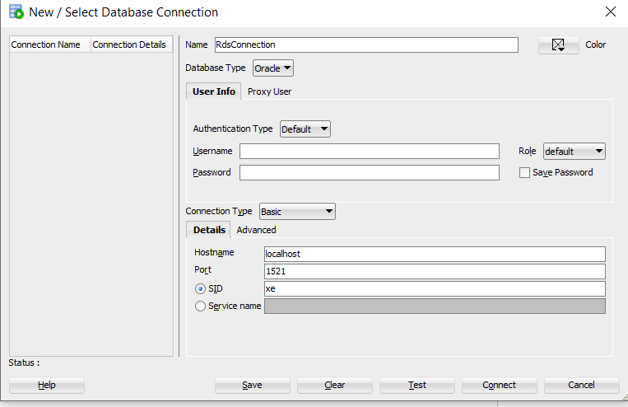
We need Username, Password, Hostname, Port and SID.

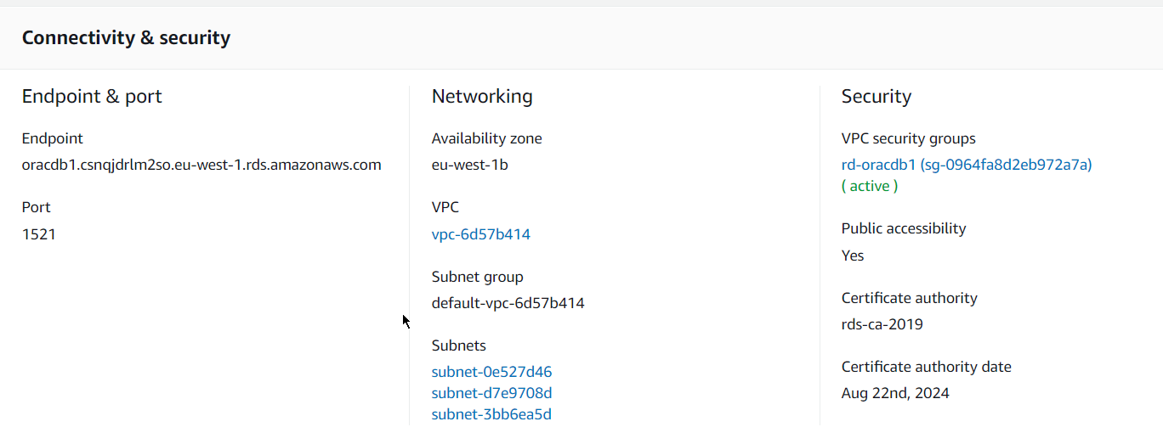
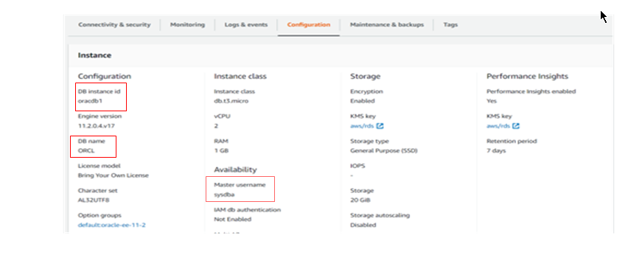
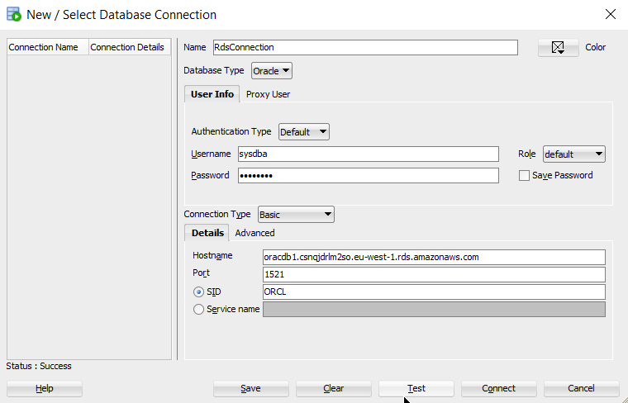
- Choose Connect.
- You can now start creating your own databases and running queries against your DB instance and databases as usual. To run a test query against your DB instance, do the following:
  - In the Worksheet tab for your connection, enter the following SQL query.

  - SELECTNAMEFROM V$DATABASE;

  - Choose the execute icon to run the query.
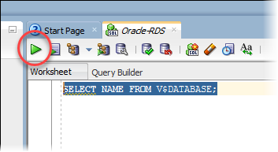
SQL Developer returns the database name.
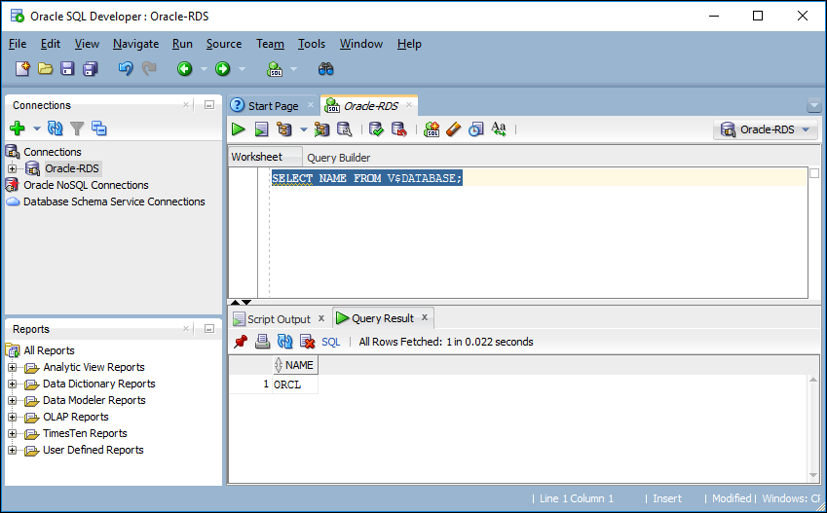

Enable Line in SQL Developer

Tools->preferences->Line Gutter-> Enable line number

Show All Users
- select * from all_users
