Bootstrap

Index
BTSP-T01 Identify the applications and benefits of Bootstrap
BTSP-T01 Demonstrate bootstrap usage with starter template
BTSP-T01 Demonstrate RWD using Grid System
BTSP-T01 Demonstrate creation of navigation bar
BTSP-T02 Demonstrate creation of navigation bar items
BTSP-T02 Demonstrate collapsing navigation items
BTSP-T02 Demonstrate troubleshooting UI issues using Chrome Developer Tools
BTSP-T02 Demonstrate using badge component
BTSP-T02 Demonstrate using third party icons in web page design
BTSP-T02 Demonstrate displaying a list of items
BTSP-T03 Demonstrate displaying a card with image, title and body
BTSP-T03 Demonstrate displaying list of cards with RWD
BTSP-T04 Demonstrate using third party date picker in web page
BTSP-T04 Demonstrate displaying form elements with RWD
BTSP-T04 Demonstrate customizing bootstrap styles

  - Identify the applications and benefits of Bootstrap

  - Demonstrate bootstrap usage with starter template
https://getbootstrap.com/docs/4.3/getting-started/introduction/
Popper.js - Dropdowns for displaying and positioning (also requires Popper.js)
Tooltips and popovers for displaying and positioning (also requires Popper.js)
Doctype - <!DOCTYPE html> means "this page is written in HTML5" as opposed to, say HTML 4.01.
Responsive meta tag –
<meta name="viewport" content="width=device-width, initial-scale=1, shrink-to-fit=no">

<!doctype html>
<html lang="en">
<head>
<!-- Required meta tags -->
<meta charset="utf-8">
<meta name="viewport" content="width=device-width, initial-scale=1, shrink-to-fit=no">

<!-- Bootstrap CSS -->
<link rel="stylesheet" href="https://stackpath.bootstrapcdn.com/bootstrap/4.3.1/css/bootstrap.min.css" integrity="sha384-ggOyR0iXCbMQv3Xipma34MD+dH/1fQ784/j6cY/iJTQUOhcWr7x9JvoRxT2MZw1T" crossorigin="anonymous">

<title>Hello, world!</title>
</head>
<body>
<h1>Hello, world!</h1>

<!-- Optional JavaScript -->
<!-- jQuery first, then Popper.js, then Bootstrap JS -->
<script src="https://code.jquery.com/jquery-3.3.1.slim.min.js" integrity="sha384-q8i/X+965DzO0rT7abK41JStQIAqVgRVzpbzo5smXKp4YfRvH+8abtTE1Pi6jizo" crossorigin="anonymous"></script>
<script src="https://cdnjs.cloudflare.com/ajax/libs/popper.js/1.14.7/umd/popper.min.js" integrity="sha384-UO2eT0CpHqdSJQ6hJty5KVphtPhzWj9WO1clHTMGa3JDZwrnQq4sF86dIHNDz0W1" crossorigin="anonymous"></script>
<script src="https://stackpath.bootstrapcdn.com/bootstrap/4.3.1/js/bootstrap.min.js" integrity="sha384-JjSmVgyd0p3pXB1rRibZUAYoIIy6OrQ6VrjIEaFf/nJGzIxFDsf4x0xIM+B07jRM" crossorigin="anonymous"></script>
</body></html>

  - Demonstrate RWD using Grid System
https://getbootstrap.com/docs/4.3/layout/overview/
Containers are used to pad the content inside of them, and there are two container classes available:
- The .container class provides a responsive fixed width container
- The .container-fluid class provides a full width container, spanning the entire width of the viewport
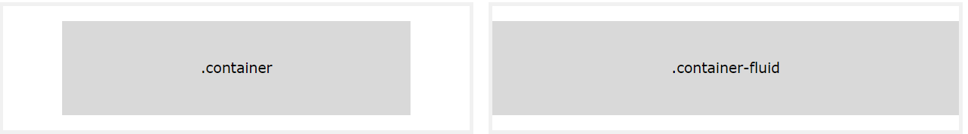

Fixed Width Container - Use the .container class to create a responsive, fixed-width container.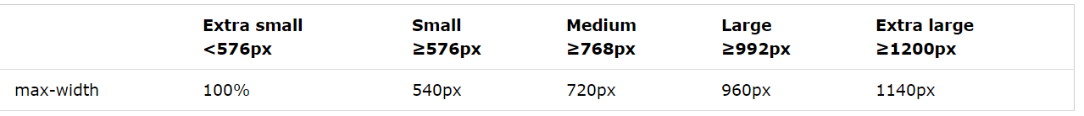

Fluid Container - Use the .container-fluid class to create a full width container, that will always span the entire width of the screen (width is always 100%):

Bootstrap's grid system is built with flexbox and allows up to 12 columns across the page.
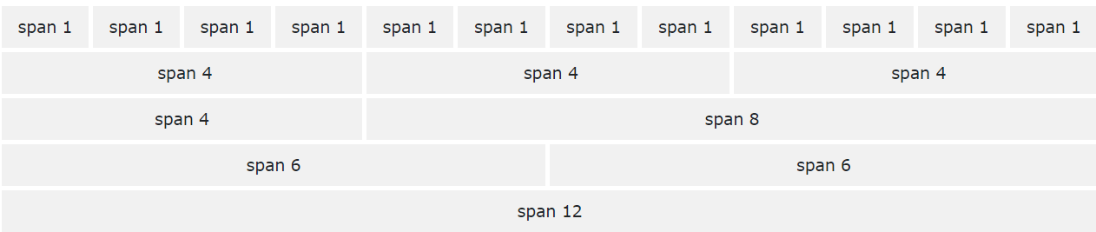

GRID Classes
- .col- (extra small devices - screen width less than 576px)
- .col-sm- (small devices - screen width equal to or greater than 576px)
- .col-md- (medium devices - screen width equal to or greater than 768px)
- .col-lg- (large devices - screen width equal to or greater than 992px)
- .col-xl- (xlarge devices - screen width equal to or greater than 1200px)
GRID system
Syntax
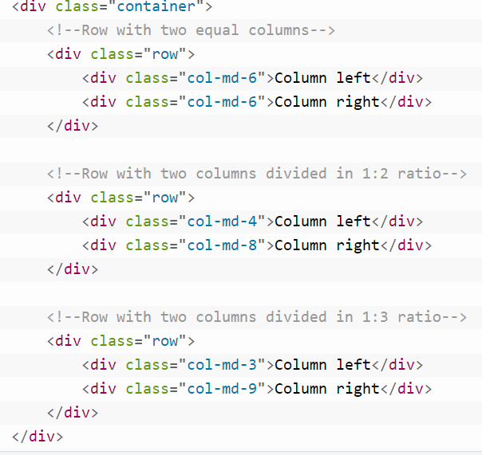
Example : Add custom style and implement the style on grid cell.
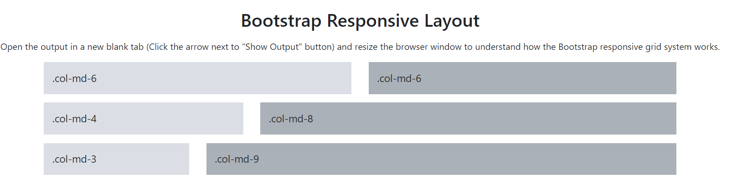

Three Column grid
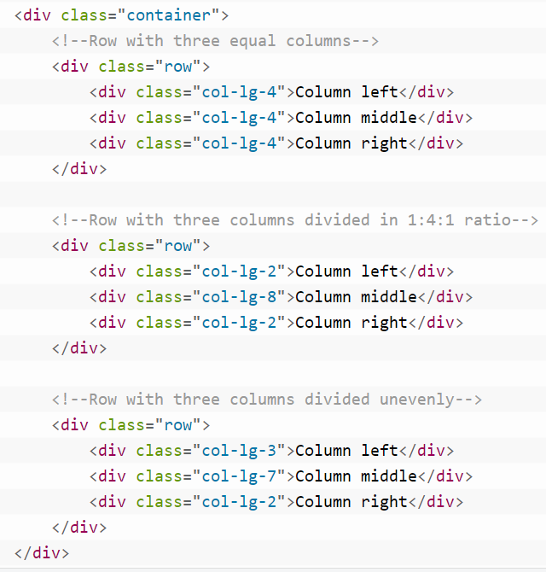
Example: Applu style to 3 column in grid
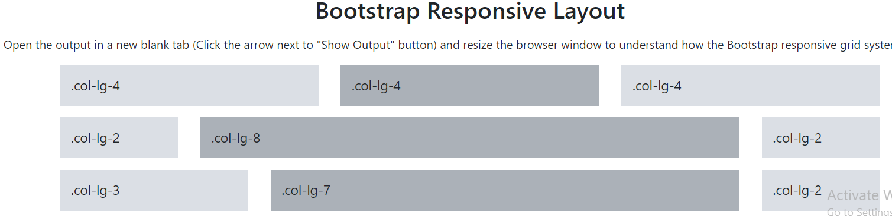
<!DOCTYPE html>
<html lang="en">
<head>
<meta charset="utf-8">
<meta name="viewport" content="width=device-width, initial-scale=1, shrink-to-fit=no">
<title>Bootstrap 4 Three Column Grid Layouts for Tablets (landscape) and Desktops</title>
<link rel="stylesheet" href="https://stackpath.bootstrapcdn.com/bootstrap/4.3.1/css/bootstrap.min.css">
<link rel="stylesheet" href="https://maxcdn.bootstrapcdn.com/font-awesome/4.7.0/css/font-awesome.min.css">
<script src="https://ajax.googleapis.com/ajax/libs/jquery/3.3.1/jquery.min.js"></script>
<script src="https://cdnjs.cloudflare.com/ajax/libs/popper.js/1.14.7/umd/popper.min.js"></script>
<script src="https://stackpath.bootstrapcdn.com/bootstrap/4.3.1/js/bootstrap.min.js"></script>
<style>
/* Some custom styles to beautify this example */
.demo-content{
padding: 15px;
font-size: 18px;
background: #dbdfe5;
margin-bottom: 15px;
}
.demo-content.bg-alt{
background: #abb1b8;
}
</style>
</head>
<body>
<h2 class="text-center my-3">Bootstrap Responsive Layout</h2>
<div class="text-center">Open the output in a new blank tab (Click the arrow next to "Show Output" button) and resize the browser window to understand how the Bootstrap responsive grid system works.</div>
<div class="container mt-3">
<!--Row with three equal columns-->
<div class="row">
<div class="col-lg-4">
<div class="demo-content">.col-lg-4</div>
</div>
<div class="col-lg-4">
<div class="demo-content bg-alt">.col-lg-4</div>
</div>
<div class="col-lg-4">
<div class="demo-content">.col-lg-4</div>
</div>
</div>

<!--Row with three columns divided in 1:4:1 ratio-->
<div class="row">
<div class="col-lg-2">
<div class="demo-content">.col-lg-2</div>
</div>
<div class="col-lg-8">
<div class="demo-content bg-alt">.col-lg-8</div>
</div>
<div class="col-lg-2">
<div class="demo-content">.col-lg-2</div>
</div>
</div>

<!--Row with three columns divided unevenly-->
<div class="row">
<div class="col-lg-3">
<div class="demo-content">.col-lg-3</div>
</div>
<div class="col-lg-7">
<div class="demo-content bg-alt">.col-lg-7</div>
</div>
<div class="col-lg-2">
<div class="demo-content">.col-lg-2</div>
</div>
</div>
</div>
</body>
</html>

  - Demonstrate creation of navigation bar
navbar-nav, nav-item, nav-link
NavBar
Bootstrap navbar component to create responsive navigation header for your website or application.
These responsive navbar initially collapsed on devices having small viewports like cell-phones but expand when user click the toggle button
.navbar | A standard navigation bar is created. or a full-height and lightweight navigation (including support for dropdowns).
.navbar-expand-xl|lg|md|sm | Responsive collapsing
<ul> element with class="navbar-nav" | To add links inside navbar
<li> with .nav-item followed by an <a> element with a .nav-link class: | To nav items
navbar-expand-sm | To bring items in width wise rather than vertical
navbar-dark bg-dark | 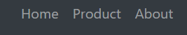
navbar-dark bg-primary | 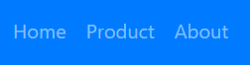
navbar-light | 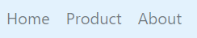
Navbar-brand | for your company, product, or project name.
.navbar-toggler | for use with our collapse plugin and other navigation toggling behaviors.
Lab: Create a NavBar 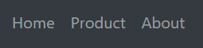
<nav class="navbar navbar-expand-sm navbar-dark bg-dark">
<ul class="navbar-nav">
<li class="nav-item">
<a class="nav-link" href="#">Home</a>
</li>
<li class="nav-item">
<a class="nav-link" href="#">Product</a>
</li>
<li class="nav-item">
<a class="nav-link" href="#">About</a>
</li>
</nav>

Lab: Create a NavBar 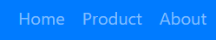
<nav class="navbar navbar-expand-sm navbar-dark bg-primary">
<!-- Navbar content -->
<ul class="navbar-nav">
<li class="nav-item">
<a class="nav-link" href="#">Home</a>
</li>
<li class="nav-item">
<a class="nav-link" href="#">Product</a>
</li>
<li class="nav-item">
<a class="nav-link" href="#">About</a>
</li>
</nav>

Lab: Create a NavBar 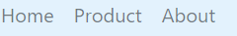
<nav class="navbar navbar-expand-sm navbar-light" style="background-color: #e3f2fd;">
<!-- Navbar content -->
<ul class="navbar-nav">
<li class="nav-item">
<a class="nav-link" href="#">Home</a>
</li>
<li class="nav-item">
<a class="nav-link" href="#">Product</a>
</li>
<li class="nav-item">
<a class="nav-link" href="#">About</a>
</li>
</nav>

Brand
The .navbar-brand can be applied to most elements, but an anchor works best as some elements might require utility classes or custom styles.
Ref the image from unsplash.com -> RC image-> copy image address -> Eg: https://images.unsplash.com/photo-1508709633064-0101a1487dc8?ixlib=rb-1.2.1&ixid=eyJhcHBfaWQiOjEyMDd9&auto=format&fit=crop&w=334&q=80
Lab: Create a Navbar with Product Brand LOGO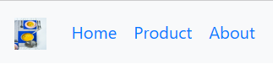
<!-- Just an image -->
<nav class="navbar navbar-expand-sm nanavbar-light bg-light">
<a class="navbar-brand" href="#">
<img src="https://images.unsplash.com/photo-1508709633064-0101a1487dc8?ixlib=rb-1.2.1&ixid=eyJhcHBfaWQiOjEyMDd9&auto=format&fit=crop&w=334&q=80" width="30" height="30" alt="">
</a>
<!--To add nav items-->
<ul class="navbar-nav">
<li class="nav-item">
<a class="nav-link" href="#">Home</a>
</li>
<li class="nav-item">
<a class="nav-link" href="#">Product</a>
</li>
<li class="nav-item">
<a class="nav-link" href="#">About</a>
</li>
</ul>
</nav>

  - Demonstrate creation of navigation bar items
navbar-toggler, navbar-toggler-icon, collapse, navbar-collapse, ml-auto
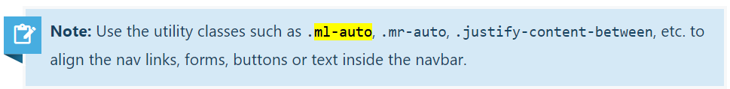
Navbar togglers are left-aligned by default, but should they follow a sibling element like a .navbar-brand, they’ll automatically be aligned to the far right. Reversing your markup will reverse the placement of the toggler. Below are examples of different toggle styles.
https://getbootstrap.com/docs/4.0/utilities/spacing/#notation
Where property is one of:
- m - for classes that set margin
- p - for classes that set padding
Where sides is one of:
- t - for classes that set margin-top or padding-top
- b - for classes that set margin-bottom or padding-bottom
- l - for classes that set margin-left or padding-left
- r - for classes that set margin-right or padding-right
- x - for classes that set both *-left and *-right
- y - for classes that set both *-top and *-bottom
- blank - for classes that set a margin or padding on all 4 sides of the element
Where size is one of:
- 0 - for classes that eliminate the margin or padding by setting it to 0
- 1 - (by default) for classes that set the margin or padding to $spacer * .25
- 2 - (by default) for classes that set the margin or padding to $spacer * .5
- 3 - (by default) for classes that set the margin or padding to $spacer
- 4 - (by default) for classes that set the margin or padding to $spacer * 1.5
- 5 - (by default) for classes that set the margin or padding to $spacer * 3
- auto - for classes that set the margin to auto
Aria-disabled: indicates that the element is perceivable but disabled, so it is not editable or otherwise operable. See related aria-hidden and aria-readonly . For example, irrelevant options in a radio group may be disabled. Disabled elements might not receive focus from the tab order.

  - Demonstrate collapsing navigation items
Lab: Add a Search bar on right side
<nav class="navbar navbar-expand-lg navbar-light bg-light">
<a class="navbar-brand" href="#">Navbar</a>
<button class="navbar-toggler" type="button" data-toggle="collapse" data-target="#navbarTogglerDemo02" aria-controls="navbarTogglerDemo02" aria-expanded="false" aria-label="Toggle navigation">
<span class="navbar-toggler-icon"></span>
</button>

<div class="collapse navbar-collapse" id="navbarTogglerDemo02">
<ul class="navbar-nav mr-auto mt-2 mt-lg-0">
<li class="nav-item active">
<a class="nav-link" href="#">Home <span class="sr-only">(current)</span></a>
</li>
<li class="nav-item">
<a class="nav-link" href="#">Link</a>
</li>
<li class="nav-item">
<a class="nav-link disabled" href="#" tabindex="-1" aria-disabled="true">Disabled</a>
</li>
</ul>
<form class="form-inline my-2 my-lg-0">
<input class="form-control mr-sm-2" type="search" placeholder="Search">
<button class="btn btn-outline-success my-2 my-sm-0" type="submit">Search</button>
</form>
</div>
</nav>

  - Demonstrate troubleshooting UI issues using Chrome Developer Tools
https://developers.google.com/web/tools/chrome-devtools/
Element selection
1) using Inspect
2) selection tool in Developer Console
3) Hovering over the elements in the HTML code within the "Element" section of Developer Tool
Applying Styles directly using Developer Tools
1) Add new style in the style window
Refer : 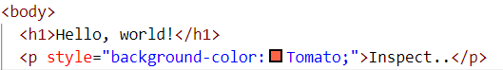
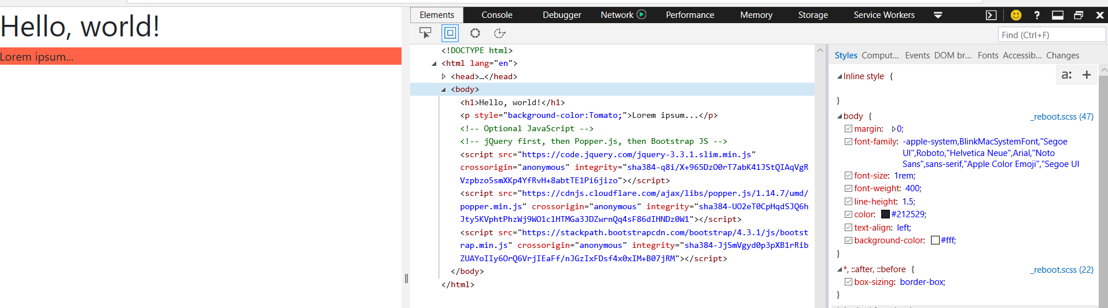
2) Disable an existing style using the checkbox
3) Change value of an existing style

  - Demonstrate using badge component
https://getbootstrap.com/docs/4.3/components/badge/
Badges scale to match the size of the immediate parent element by using relative font sizing and em units. Badges are used to add additional information to any content.
Use the .badge class together with a contextual class (like .badge-secondary) within <span> elements to create rectangular badges.
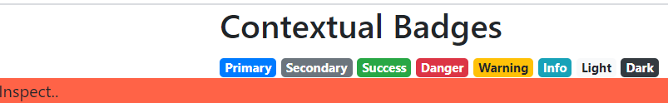

<div class="container">
<h2>Contextual Badges</h2>
<span class="badge badge-primary">Primary</span>
<span class="badge badge-secondary">Secondary</span>
<span class="badge badge-success">Success</span>
<span class="badge badge-danger">Danger</span>
<span class="badge badge-warning">Warning</span>
<span class="badge badge-info">Info</span>
<span class="badge badge-light">Light</span>
<span class="badge badge-dark">Dark</span>
</div>

  - Demonstrate using third party icons in web page design
Google Material Icon, Content Delivery Network (CDN), include icons in web page
https://material.io/resources/icons/?icon=notification_important&style=baseline

<link rel="stylesheet" href="https://fonts.googleapis.com/icon?family=Material+Icons">
<i class="material-icons" style="color:red">delete</i>

  - Demonstrate displaying a list of items
List groups are a flexible and powerful component for displaying a series of content. Modify and extend them to support just about any content within.
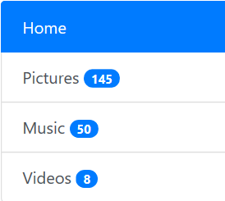
<link rel="stylesheet" href="https://maxcdn.bootstrapcdn.com/font-awesome/4.7.0/css/font-awesome.min.css">
<style>
.bs-example{
margin: 20px;
}
</style>
</head>
<body>
<div class="bs-example">
<div class="list-group">
<a href="#" class="list-group-item list-group-item-action active">
<i class="fa fa-home"></i> Home
</a>
<a href="#" class="list-group-item list-group-item-action">
<i class="fa fa-camera"></i> Pictures <span class="badge badge-pill badge-primary pull-right">145</span>
</a>
<a href="#" class="list-group-item list-group-item-action">
<i class="fa fa-music"></i> Music <span class="badge badge-pill badge-primary pull-right">50</span>
</a>
<a href="#" class="list-group-item list-group-item-action">
<i class="fa fa-film"></i> Videos <span class="badge badge-pill badge-primary pull-right">8</span>
</a>
</div>
</div>

  - Demonstrate displaying a card with image, title and body
card, card-title, card-body, card-text, change mouse cursor on hovering an icon
https://getbootstrap.com/docs/4.3/components/card/
 | <style>  .bs-example{  margin: 20px;  }  </style>  </head>  <body>  <div class="bs-example">  <div class="card" style="width: 300px;">  <img src="https://images.unsplash.com/photo-1584143962303-0dfa46b1e0d0?ixlib=rb-1.2.1&ixid=eyJhcHBfaWQiOjEyMDd9&auto=format&fit=crop&w=500&q=60" class="card-img-top" alt="...">  <div class="card-body text-center">  <h5 class="card-title">Alisha Chinoy</h5>  <p class="card-text">Alice is a developer. She is specialized in HTML5, CSS3, JavaScript, Bootstrap, etc.</p>  <a href="#" class="btn btn-primary stretched-link">View Profile</a>  </div>  </div>  </div>

  - Demonstrate displaying list of cards with RWD

  - Demonstrate using third party date picker in web page
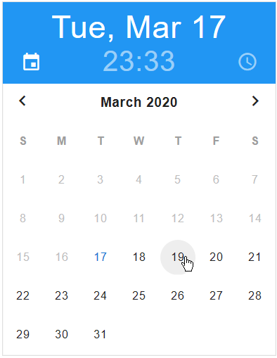 | <script src="https://code.jquery.com/jquery-3.3.1.min.js"></script>  <script src="https://unpkg.com/gijgo@1.9.11/js/gijgo.min.js" type="text/javascript"></script>  <link href="https://unpkg.com/gijgo@1.9.11/css/gijgo.min.css" rel="stylesheet" type="text/css" />  </head>  <body style="padding: 8px;">  <input id="datetimepicker" width="312" />  <script>  $('#datetimepicker').datetimepicker({  datepicker: {  disableDates: function (date) {  const currentDate = new Date();  return date > currentDate ? true : false;  }  }  });  </script>  </body>

  - Demonstrate displaying form elements with RWD
Develop form with textbox, password, drop down, date using gijgo, radio button and checkbox form-row, form-group, form-control, form-check, form-check-input, form-check-label, form-check-input

Built in Registration Form

  - Demonstrate customizing bootstrap styles
It overrides the bootstrap class styling. There is no need to edit any of the original Bootstrap styles directly
By default button have sharp corners in bootstrap. You can apply style to make it rounded.
<style>  .btn {  border-radius: 10px;  }  </style>  </head>  <body>  <h1>Hello, world!</h1>  <button type="button" class="btn btn-primary">Primary</button>  <button type="button" class="btn btn-success">Success</button>  <button type="button" class="btn btn-info">Info</button>  <button type="button" class="btn btn-warning">Warning</button>  <button type="button" class="btn btn-danger">Danger</button>  <button type="button" class="btn btn-link">Link</button> | 