Ajax

Index
- AJAX Introduction
- AJAX Work􀃻ow
- AJAX with XMLHttpRequest Object
- Working with JSON in AJAX

Ajax Introduction
Ajax stands for Asynchronous Javascript And Xml. Ajax is just a means of loading data from the server and selectively updating parts of a web page without reloading the whole page.
Ajax does is make use of the browser's built-in XMLHttpRequest (XHR) object to send and receive information to and from a web server asynchronously, in the background, without blocking the page or interfering with the user's experience.
Example:
Gmail, Google Maps, Google Docs, YouTube, Facebook, Flickr
Ajax is just a term to describe the process of exchanging data from a web server asynchronously through JavaScript, without refreshing the page.

AJAX Workflow
To perform Ajax communication JavaScript uses a special object built into the browser—an XMLHttpRequest (XHR) object—to make HTTP requests to the server and receive data in response.
All modern browsers (Chrome, Firefox, IE7+, Safari, Opera) support the XMLHttpRequest object.
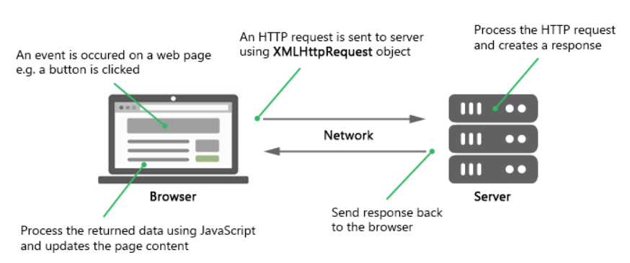
Ajax requests are usually asynchronous, execution of the script continues as soon as the Ajax request is sent, i.e. the browser will not halt the script execution until the server response comes back.

Sending Request and Retrieving the Response
Instantiate an XMLHttpRequest object:
var request = new XMLHttpRequest();
Open() –To instantiate the new request object before sending the request to the Accepts two parameter “Get”/”Post” and URL
request.open("GET", "info.txt")
GET | POST
Used to send small amount of data to the server. | Used to send large amount of data, such as form data.
Data is sent as URL parameters | Data is sent to the server as a part of the HTTP request body.
GET request is typically used to get or retrieve some kind of information from the server that doesn't require any manipulation or change in database,

Send() - Send the request to the server using the send() method of the XMLHttpRequest object.
request.send()

The status property returns the numerical HTTP status code of the XMLHttpRequest's response. Some of the common HTTP status codes are listed below:
- 200 — OK. The server successfully processed the request.
- 404 — Not Found. The server can't find the requested page.
- 503 — Service Unavailable. The server is temporarily unavailable.

AJAX with XMLHttpRequest Object

Working with JSON in AJAX
Display The JSON file content on Browser on button click
<!DOCTYPE html>
<html lang="en">
<head>
<meta charset="utf-8">
<title>JavaScript Ajax GET Demo</title>
<script>
function displayFullName() {
// Creating the XMLHttpRequest object
var request = new XMLHttpRequest();

// Instantiating the request object
request.open("GET", "http://jsonplaceholder.typicode.com/users/1",true);

// Defining event listener for readystatechange event
request.onreadystatechange = function() {
// Check if the request is compete and was successful
if(this.readyState === 4 && this.status === 200) {
// Inserting the response from server into an HTML element
document.getElementById("result").innerHTML = this.responseText;
}
};

// Sending the request to the server
request.send();
}
</script>
</head>
<body>
<div id="result">
<p>Content of the result DIV box will be replaced by the server response</p>
</div>
<button type="button" onclick="displayFullName()">Display Full Name</button>
</body>
</html>
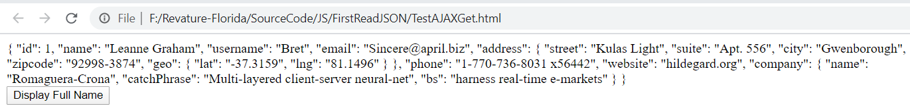
Servlet Returns JSON
https://www.baeldung.com/servlet-json-response

