UNIX

Unix
The Unix operating system is a set of programs that act as a link between the computer and the user.
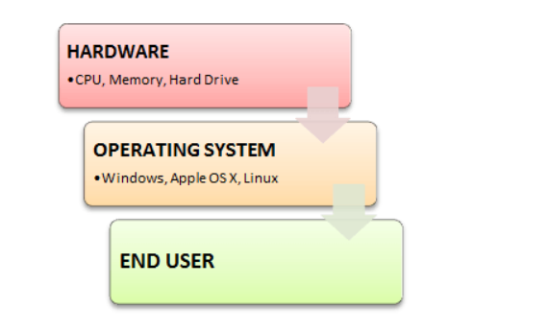
Users communicate with the kernel through a program known as the shell. The shell is a command line interpreter; it translates commands entered by the user and converts them into a language that is understood by the kernel.
- Unix was originally developed in 1969 by a group of AT&T employees Ken Thompson, Dennis Ritchie, Douglas McIlroy, and Joe Ossanna at Bell Labs.
- There are various Unix variants available in the market. Solaris Unix, AIX, HP Unix and BSD are a few examples. Linux is also a flavor of Unix which is freely available.
- Several people can use a Unix computer at the same time; hence Unix is called a multiuser system.
- A user can also run multiple programs at the same time; hence Unix is a multitasking environment.

Parts of UNIX
Kernel- The kernel is the core of the Unix operating system. It allocates the time and memory to the programs and handles the communications is response to the system calls.
Shell - The Shell acts an interface between Kernel and User. The Shell is a command line interpreter (CLI). It interprets the user commands and arranges them to be carried out. In other words, Command Interpreter that turns text that you type (at the command line) in to actions
- The Shell acts as an interface to the Unix system. It gathers input from user and execute the programs based on the input. When the program execution is complete, it displays the program’s output.
- Shell is an environment in which we can run our commands, programs and shell scripts.

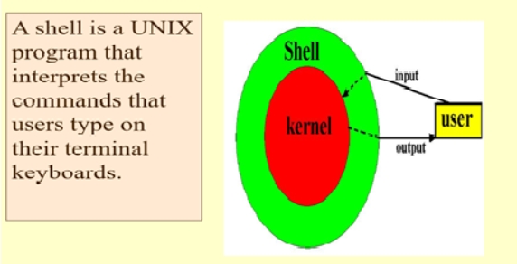
Sh - à Bourne Shell
Ksh - à Korn Shell
Bash - à Bourne-Again Shell
C Shell - The default command prompt of a C Shell is character %
Programs - The commands are themselves called as programs in Unix. The UNIX shell program interprets user commands, which are either directly entered by the user, or which can be read from a file called the shell script or shell program. Shell scripts are interpreted, not compiled.

File Management
All the data in Unix is organized into files. All the files are organized into Directories. The people working in Unix will spend most of the time in working with files.
ORDINARY FILES:
This is a normal text file on the system that can contains any details on it.
DIRECTORIES:
The directories in the Unix File management is the storage of files. In other words, it can be called as folders in windows.

Commands
  - File Permission
Every file in Unix has the following attributes −
- Owner permissions − The owner's permissions determine what actions the owner of the file can perform on the file.
- Group permissions − The group's permissions determine what actions a user, who is a member of the group that a file belongs to, can perform on the file.
- Other (world) permissions − The permissions for others indicate what action all other users can perform on the file.

The Permission Indicators
While using ls -l command, it displays various information related to file permission as follows 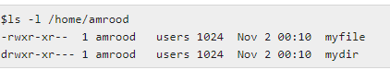
Here, the first column represents different access modes, i.e., the permission associated with a file or a directory.
The permissions are broken into groups of threes, and each position in the group denotes a specific permission, in this order: read (r), write (w), execute (x) −
- The first three characters (2-4) represent the permissions for the file's owner. For example, -rwxr-xr-- represents that the owner has read (r), write (w) and execute (x) permission.
- The second group of three characters (5-7) consists of the permissions for the group to which the file belongs. For example, -rwxr-xr-- represents that the group has read (r) and execute (x) permission, but no write permission.
- The last group of three characters (8-10) represents the permissions for everyone else. For example, -rwxr-xr-- represents that there is read (r) only permission.

File Access Mode
The permissions of a file are the first line of defense in the security of a Unix system. The basic building blocks of Unix permissions are the read, write, and execute permissions, which have been described below −

Read
Grants the capability to read, i.e., view the contents of the file.

Write
Grants the capability to modify, or remove the content of the file.

Execute
User with execute permissions can run a file as a program.

Directory Access Modes
Directory access modes are listed and organized in the same manner as any other file. There are a few differences that need to be mentioned −

Read
Access to a directory means that the user can read the contents. The user can look at the filenames inside the directory.

Write
Access means that the user can add or delete files from the directory.

Execute
Executing a directory doesn't really make sense, so think of this as a traverse permission.
A user must have execute access to the bin directory in order to execute the ls or the cd command

Changing Permissions
To change the file or the directory permissions, you use the chmod (change mode) command. There are two ways to use chmod — the symbolic mode and the absolute mode.
Using chmod in Symbolic Mode
The easiest way for a beginner to modify file or directory permissions is to use the symbolic mode. With symbolic permissions you can add, delete, or specify the permission set you want by using the operators in the following table.
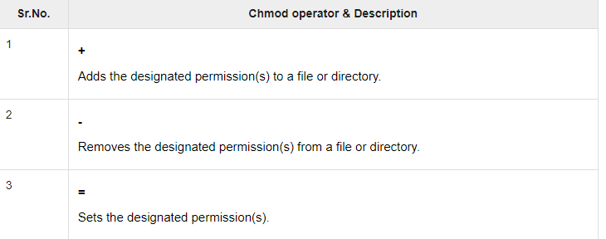

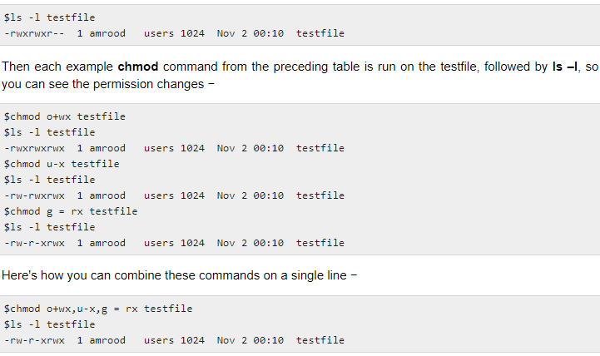

Using chmod with Absolute Permissions
The second way to modify permissions with the chmod command is to use a number to specify each set of permissions for the file.
Each permission is assigned a value, as the following table shows, and the total of each set of permissions provides a number for that set.
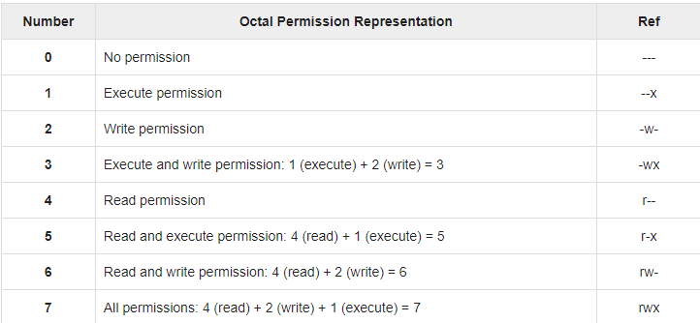
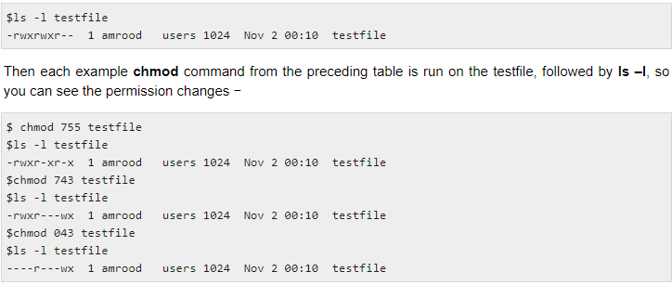

Changing Owners and Groups
While creating an account on Unix, it assigns a owner ID and a group ID to each user. All the permissions mentioned above are also assigned based on the Owner and the Groups.
Two commands are available to change the owner and the group of files −
- chown − The chown command stands for "change owner" and is used to change the owner of a file.
- chgrp − The chgrp command stands for "change group" and is used to change the group of a file.

Changing Ownership
The chown command changes the ownership of a file. The basic syntax is as follows –
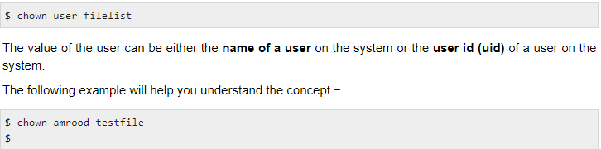
Changes the owner of the given file to the user amrood.
NOTE − The super user, root, has the unrestricted capability to change the ownership of any file but normal users can change the ownership of only those files that they own.

Changing Group Ownership
The chgrp command changes the group ownership of a file. The basic syntax is as follows −
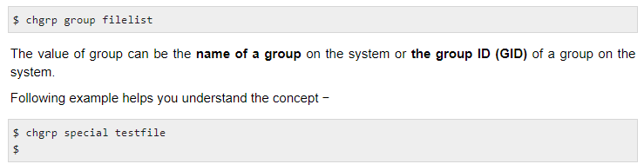
Long listing of files. List in long format, giving mode, number of links, owner, group, size in bytes and time of last modification for each file.

- To sort by time modified (latest first) before sorting alphabetically.
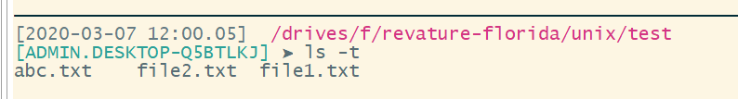
- To reverse the order of sort to get reverse (descending) collation or oldest first, as appropriate.
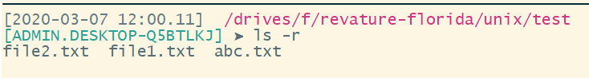

  - MAN
- List all manual entries whose one-line description contains any of a specified set of keywords.
- Display the one-line descriptions of entries specified by name.
- Search on-line manual directories by entry name and display the specified entry.
- Search a specified on-line manual section and display the specified entry in that section.
> Man cat

  - Touch
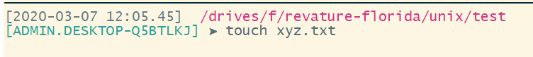
This command is used to create the empty files in Unix system. The size of the file created using touch command in UNIX will be 0 bytes. We will be able to add the contents into the file using vi command.
  - CP
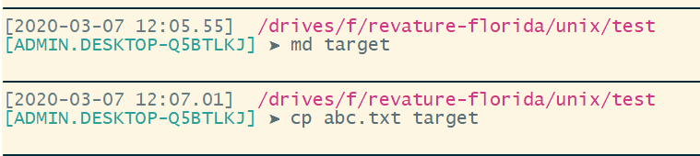
  - MV
MV command in Unix, we have an ability to move the files to different name or can move the file to different directory . The below command is used to move the file to different name within the directory.
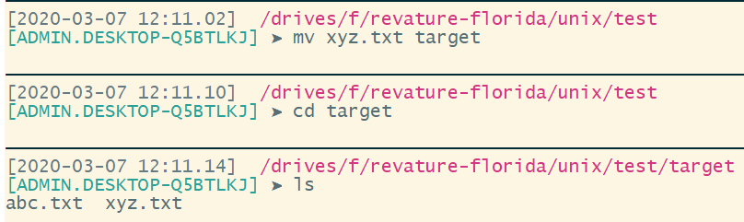
  - RM
This command is used to remove the file.
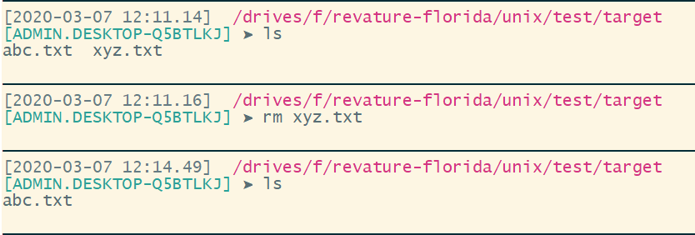

  - WC
This command is used to find the number of lines, words and characters in the file.
I t has 25 lines, 34 words and 245 characters on it.
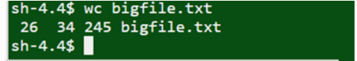

  - CHMOD
This command is used to change the file permissions. Basically, this command defines who can do what operations on the files. By default, when we create the files, it will be created with Read & Write access to User and Read access to both group and others.
With this access, the User (Owner) can Read and modify (update) the files and group & Others can only view the files but cannot be modified.
Example:
The file “file.txt” has the permission “rw-r–r—”. First 3 fields represents the User (Owner) permission, next 3 fields represents the group permissions and next 3 fields represents Others permission.
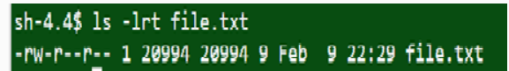
Example :
Chmod 744 file.txt : To provide execute permission
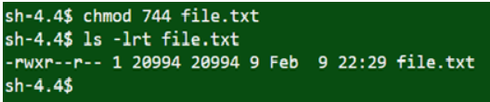

User has “rw” which means Read and Write access.
Group has “r” which means Read access only
Others has “r” which means Read only access

Shell Scripting

