AWS CICD with Jenkins

Topics
- Cloud Computing
- AWS Introduction
- Elastic Cloud Compute (EC2)
- Amazon Machine Image (AMI)
- Elastic Block Store (EBS)
- Security Group
- Simple Storage Service
- EC2 Scaling
- Continuous Integration

Continuous Integration
Use Case:
Robert and Ginni working on a project, coding and well tested individually however when they integrated it crashes and everything breaks. Code fails to compile and bugs so HOW TO integrate?
Issues due to this ->
- Difficult to resolve how long it will take to resolve.
  - May exceed budget
  - May exceed our schedule
Solution
CI - Integrate early and integrate often ( on every change)- everytime code is changes to repository it should be test out and build, compile and component interoperate correctly.

Continuous Integration Server
http://www.methodsandtools.com/tools/tools.php?hudson
Continuous Integration (CI) is a software development practice where members of a team integrate their work frequently, usually each person integrates at least daily - leading to multiple integrations per day. Each integration is verified by an automated build (including test) to detect integration errors as quickly as possible. Many teams find that this approach leads to significantly reduced integration problems and allows a team to develop cohesive software more rapidly."
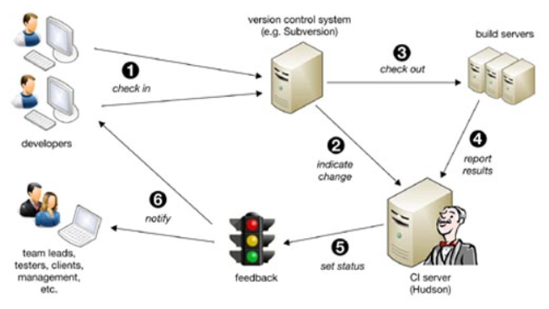
(1). Hudson polls this system regularly for changes, e.g. every minute
(2). If changes are indicated, the new code is checked out to build severs
(3) and a new build of your project is executed. The results are reported back to Hudson
(4) that will set the new status of the project
(5): stable, instable, or failed. Finally notifications are sent to developers and other stakeholders
(6), which will either fix any problems found or proceed implementing new features. This complete cycle typically does not exceed 15 minutes.

Benefits
- Developer might forgot to run tests
- It might take too long to run the tests
- We might need to test code in various environments
- Reports provides insight to team
  - Can track metrics like line coverage
    - Percentage of lines executed by program’s test
  - Can run all sort of utilities on our code
    - Checkstyle, findbugs….
- Can deploy automatically
  - Deploy a web project to staging server
  - Deploy latest stable build of a desktop application to web site for download
Lab https://www.youtube.com/watch?v=zEQUuo5nWbo
https://www.youtube.com/watch?v=LFkGtg-ZTko
https://www.youtube.com/watch?v=Z9G5stlXoyg
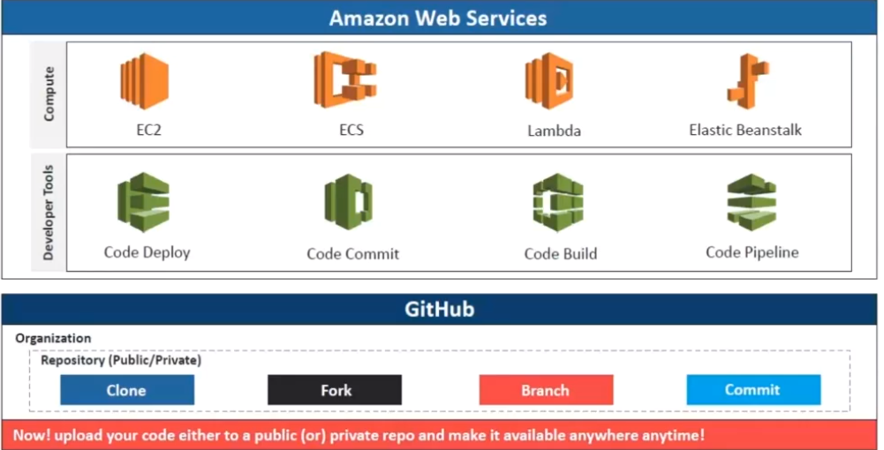
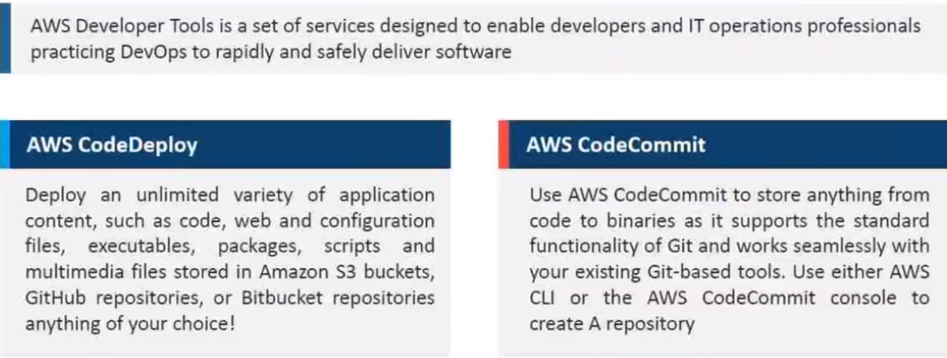

Overview of Jenkins
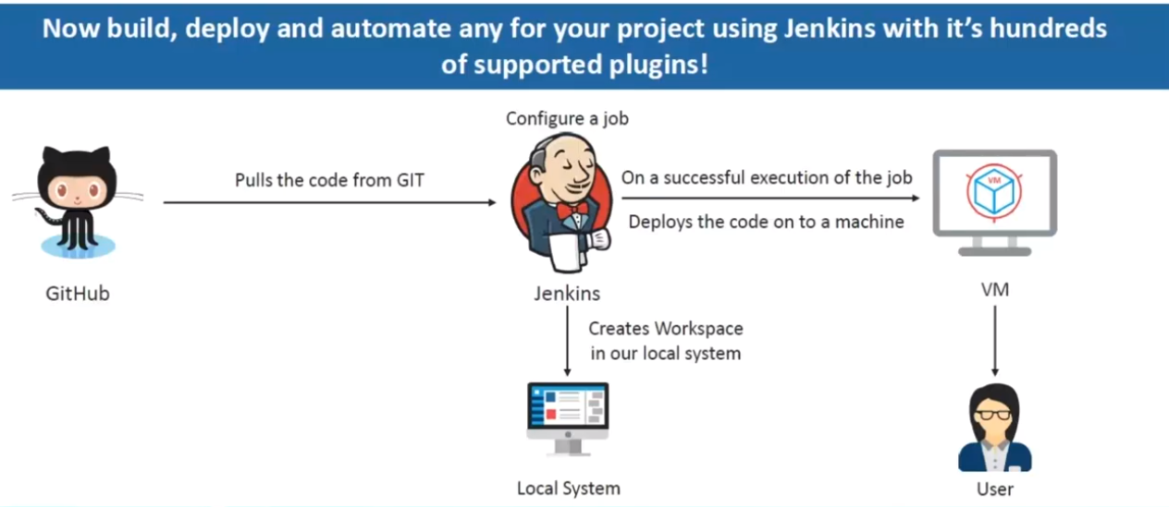

Delivery Pipeline Architecture

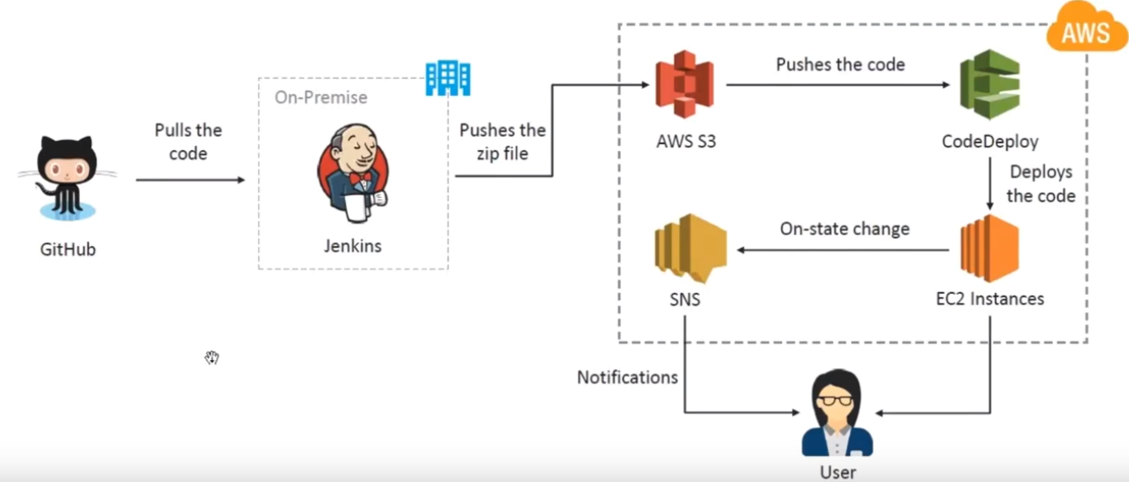
Step 1: Create EC2 instance with http protocol
Step 2: Connect using ssh
Step 3:

