AWS EC2, Security Group, EBS

Topics
- Cloud Computing
- AWS Introduction
- Elastic Cloud Compute (EC2)
- Amazon Machine Image (AMI)
- Elastic Block Store (EBS)
- Security Group
- Simple Storage Service
- EC2 Scaling
- Continuous Integration

Simple Storage Service
Amazon S3 is a repository for Internet data. Amazon S3 provides access to reliable, fast, and inexpensive data storage infrastructure. It is designed to make web-scale computing easier by enabling you to store and retrieve any amount of data, at any time, from within Amazon EC2 or anywhere on the web. Amazon S3 stores data objects redundantly on multiple devices across multiple facilities and allows concurrent read or write access to these data objects by many separate clients or application threads. You can use the redundant data stored in Amazon S3 to recover quickly and reliably from instance or application failures.

Amazon EC2 uses Amazon S3 for storing Amazon Machine Images (AMIs). You use AMIs for launching EC2 instances. In case of instance failure, you can use the stored AMI to immediately launch another instance, thereby allowing for fast recovery and business continuity.

Amazon EC2 also uses Amazon S3 to store snapshots (backup copies) of the data volumes. You can use snapshots for recovering data quickly and reliably in case of application or system failures. You can also use snapshots as a baseline to create multiple new data volumes, expand the size of an existing data volume, or move data volumes across multiple Availability Zones, thereby making your data usage highly scalable.

Basics
- Object based
  - Key – name of the object
  - Value - Data
  - Version ID – versioning
  - Metadata- Data about data
- File can be from 0 bytes to 5 TB.
- S3 is a universal Namespace, means name must be unique
- When you will upload a file you will receive HTTP 200 code in case it is successful.

Data Consistency Model for S3
- Read after Write consistency for PUTS of new Objects
- Eventual Consistency for overwrite PUTS and DELETES .

S3 Guarantees
- Built for 99.99% availability
- 99.999999999% durability

Features

Tiered Storage Available

Life Cycle Management

Versioning

Encryption

MFA Delete

Secure data using Access Control List and Bucket Policies

Storage Classes
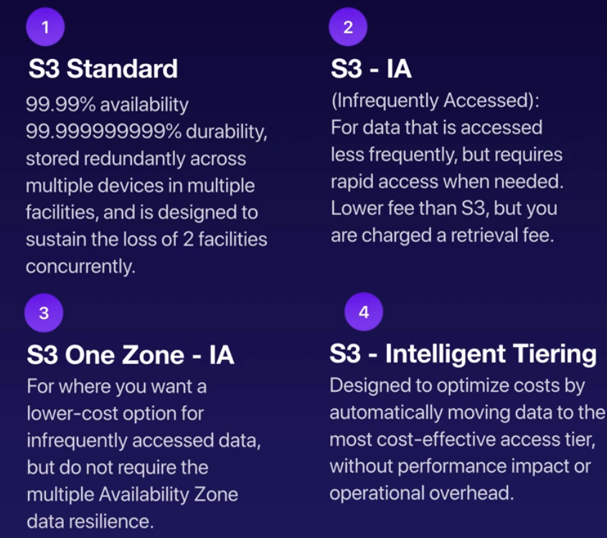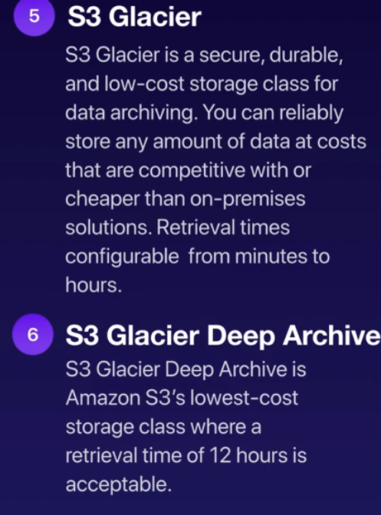

S3 Charges
- Storage
- Requests
- Storage management Pricing
LAB: Create a bucket and upload a file
Step 1: Notice Region – N. Verginia (First launch for new services)
Step2: Click on Services -> S3
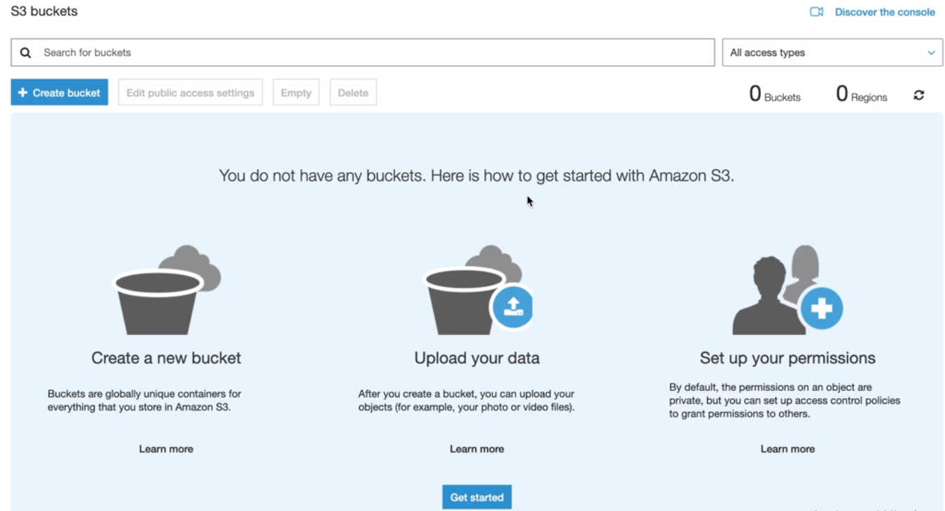
Notice – Region changed to global
Step 3: Click on Create Bucket
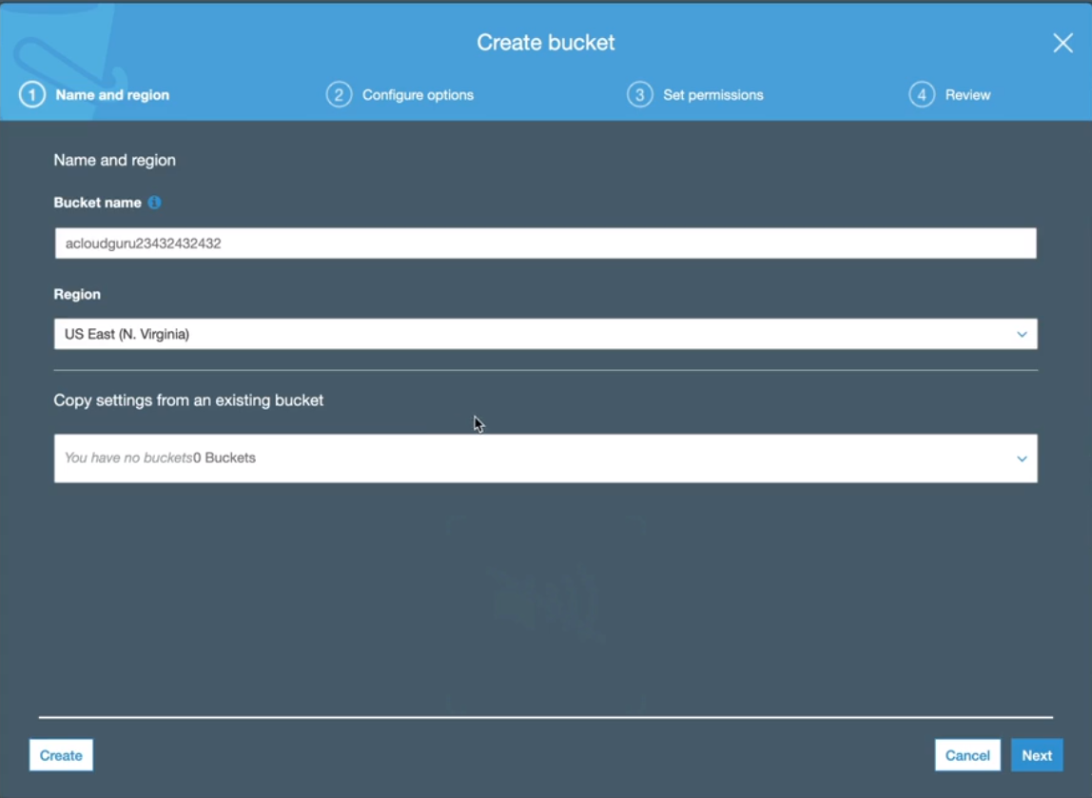

Step 4: Click on Next -> Leave everything default
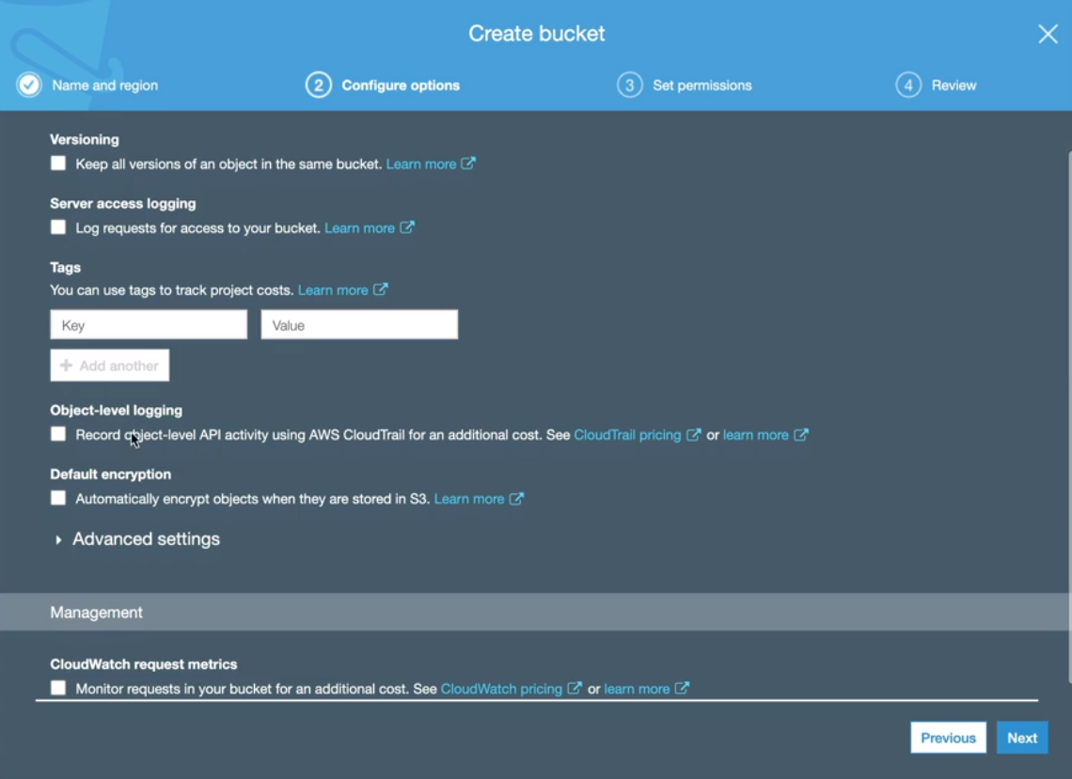
Click on Next
Step 5: Click on checkbox “ Block all public access”

Step 6: Click Upload
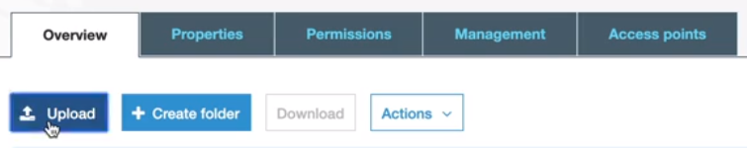
Step 7:Select file
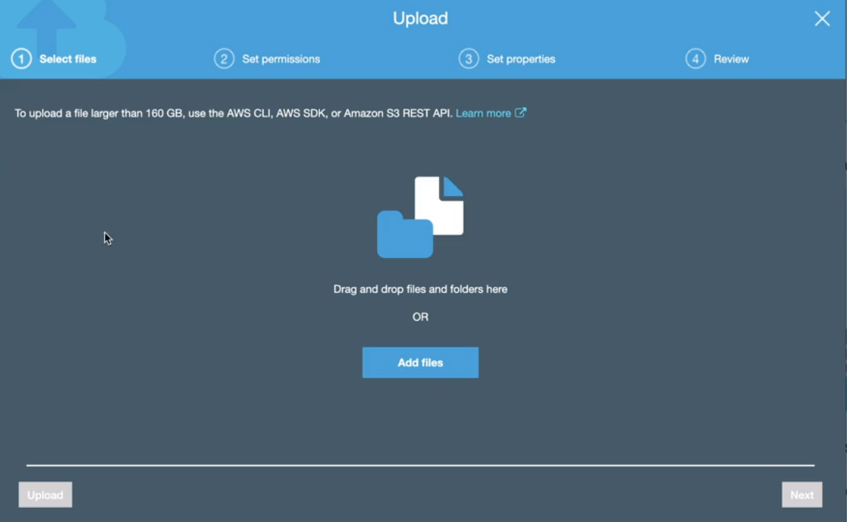
Click on upload
Step 8: It shows file -> Click on Chekcbox
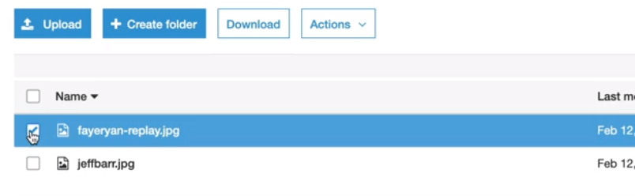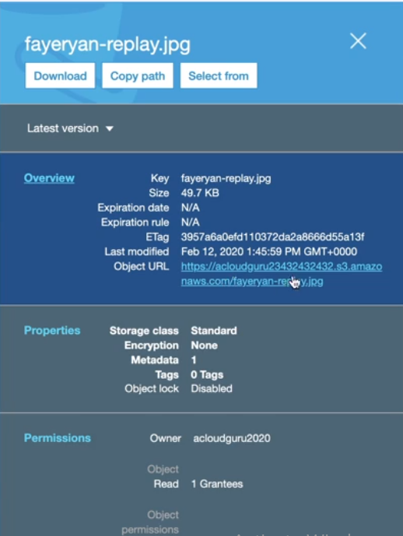
LAB : Make the object as Public
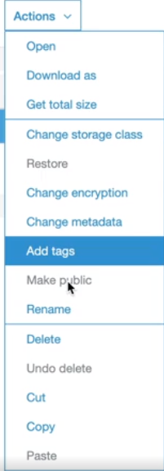
Step 1: Go to bucket and click on it
Step 2: click Edit public access
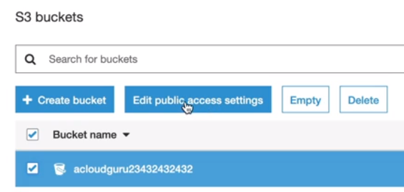
Step3: Uncheck the check box
Confirm it.
Now, object is public
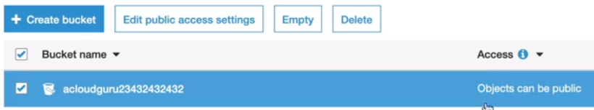
Step 4: Click on file in bucket
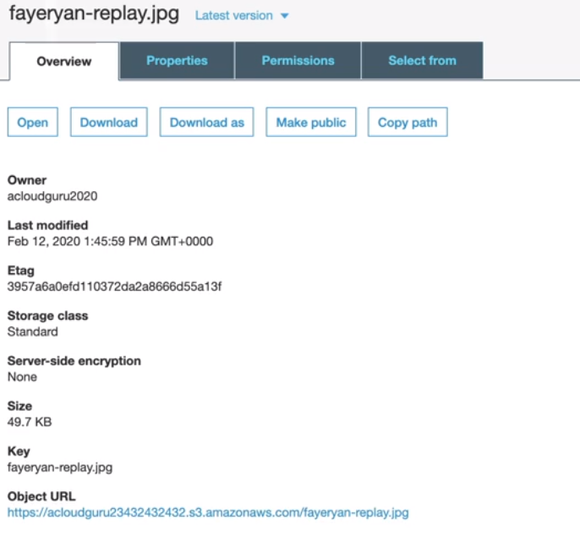

Step 5 : Copy url and paste in browser and you will find it is still inaccessible
Step 6: Click on File -> Action -> Make public and now check URL

AutoScaling
Automatic scaling is the ability to increase or decrease the target capacity of your Spot Fleet automatically based on demand. A Spot Fleet can either launch instances (scale out) or terminate instances (scale in), within the range that you choose, in response to one or more scaling policies.

