AWS Introduction

Topics
- Cloud Computing
- AWS Introduction
- Elastic Cloud Compute (EC2)
- Amazon Machine Image (AMI)
- Elastic Block Store (EBS)
- Security Group
- Simple Storage Service
- EC2 Scaling
- Continuous Integration

Cloud Computing

https://aws.amazon.com/what-is-cloud-computing/

https://aws.amazon.com/types-of-cloud-computing/?WICC-N=tile&tile=types_of_cloud

What is Cloud Computing?
Cloud computing is the on-demand delivery of IT resources over the Internet with pay-as-you-go pricing. Instead of buying, owning, and maintaining physical data centers and servers, you can access technology services, such as computing power, storage, and databases, on an as-needed basis from a cloud provider like Amazon Web Services (AWS).

Who is using Cloud Computing?
Organizations of every type, size, and industry are using the cloud for a wide variety of use cases, such as data backup, disaster recovery, email, virtual desktops, software development and testing, big data analytics, and customer-facing web applications. For example, healthcare companies are using the cloud to develop more personalized treatments for patients.
Financial services companies are using the cloud to power real-time fraud detection and prevention. And video game makers are using the cloud to deliver online games to millions of players around the world.

Types of Cloud Computing
Cloud computing is providing developers and IT departments with the ability to focus on what matters most and avoid undifferentiated work like procurement, maintenance, and capacity planning. As cloud computing has grown in popularity, several different models and deployment strategies have emerged to help meet specific needs of different users. Each type of cloud service, and deployment method, provides you with different levels of control, flexibility, and management. Understanding the differences between Infrastructure as a Service, Platform as a Service, and Software as a Service, as well as what deployment strategies you can use, can help you decide what set of services is right for your needs.

Cloud Computing Models

 | IaaS | Paas | SaaS
What it is? | Cloud-based services, pay-as-you-go for services such as storage, networking, and virtualization. | Hardware and software tools available over the internet. | Software that’s available via a third-party over the internet.
Eg: | AWS EC2, Rackspace, Google Compute Engine (GCE), Digital Ocean, | AWS Elastic Beanstalk, Heroku, Windows Azure, Force.com, OpenShift, | Google Apps, Salesforce, Dropbox, Slack,
Advantages | With IaaS, you can buy what you need, as you need it, and purchase more as your business grows.  It puts control over the infrastructure back in your hands | A PaaS solution provides the platform for developers to create unique, customizable software. | You no longer need to engage an IT specialist to download the software onto multiple computers throughout your office or worry about keeping the software on every computer up-to-date.
When to use? | beneficial to businesses of all shapes and sizes, as it allows complete control over your infrastructure, and operates on a pay-as-you-use model, so it fits into most budgets. | PaaS is often the most cost-effective and time-effective way for a developer to create a unique application.  PaaS allows the developer to focus on the creative side of app development, as opposed to menial tasks such as managing software updates or security patches. All of their time and brainpower will go into creating, testing, and deploying the app. | SaaS platforms are ideal for when you want an application to run smoothly and reliably with minimal input from you.
Summary | To provide you with maximum flexibility when it comes to hosting custom-built apps, as well as a providing a general data center for data storage. | Most often built on top of an IaaS platform to reduce the need for system administration. It allows you to focus on app development instead of infrastructure management. | Offers ready-to-use, out-of-the-box solutions that meet a particular business need (such as website or email). Most modern SaaS platforms are built on IaaS or PaaS platforms.

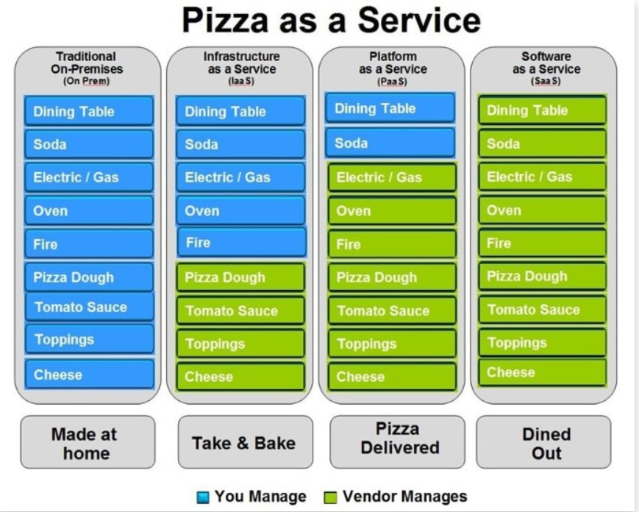
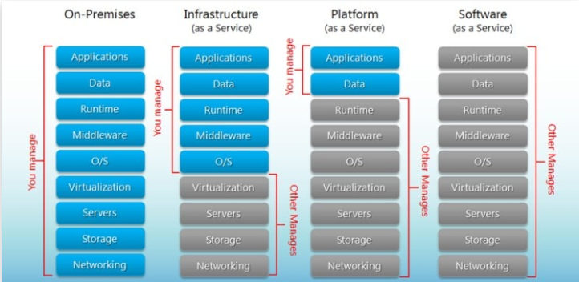

Benefits of cloud computing
Agility
The cloud gives you easy access to a broad range of technologies so that you can innovate faster and build nearly anything that you can imagine. You can quickly spin up resources as you need them–from infrastructure services, such as compute, storage, and databases, to Internet of Things, machine learning, data lakes and analytics, and much more.
You can deploy technology services in a matter of minutes, and get from idea to implementation several orders of magnitude faster than before. This gives you the freedom to experiment, test new ideas to differentiate customer experiences, and transform your business.
Elasticity
With cloud computing, you don’t have to over-provision resources up front to handle peak levels of business activity in the future. Instead, you provision the amount of resources that you actually need. You can scale these resources up or down to instantly to grow and shrink capacity as your business needs change.
Cost savings
The cloud allows you to trade capital expenses (such as data centers and physical servers) for variable expenses, and only pay for IT as you consume it. Plus, the variable expenses are much lower than what you would pay to do it yourself because of the economies of scale.
Deploy globally in minutes
With the cloud, you can expand to new geographic regions and deploy globally in minutes. For example, AWS has infrastructure all over the world, so you can deploy your application in multiple physical locations with just a few clicks. Putting applications in closer proximity to end users reduces latency and improves their experience.

Cloud Computing Deployment Model
Cloud | Hybrid | On-Premises
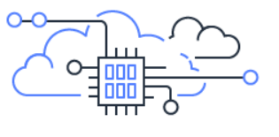 |  | 
A cloud-based application is fully deployed in the cloud and all parts of the application run in the cloud. Applications in the cloud have either been created in the cloud or have been migrated from an existing infrastructure to take advantage of the benefits of cloud computing. Cloud-based applications can be built on low-level infrastructure pieces or can use higher level services that provide abstraction from the management, architecting, and scaling requirements of core infrastructure. | A hybrid deployment is a way to connect infrastructure and applications between cloud-based resources and existing resources that are not located in the cloud. The most common method of hybrid deployment is between the cloud and existing on-premises infrastructure to extend, and grow, an organization's infrastructure into the cloud while connecting cloud resources to internal system. For more information on how AWS can help you with your hybrid deployment, please visit our hybrid page. | Deploying resources on-premises, using virtualization and resource management tools, is sometimes called “private cloud”. On-premises deployment does not provide many of the benefits of cloud computing but is sometimes sought for its ability to provide dedicated resources. In most cases this deployment model is the same as legacy IT infrastructure while using application management and virtualization technologies to try and increase resource utilization.

What is AWS?
https://www.youtube.com/watch?v=rIk19Cn50-A
Amazon web service is a platform that offers flexible, reliable, scalable, easy-to-use and cost-effective cloud computing solutions.

LAB: Create AWS Account – Signup to AWS – Using free tier
How to signup to AWS account
https://aws.amazon.com/premiumsupport/knowledge-center/create-and-activate-aws-account/ Create your account
- Go to the Amazon Web Services home page.
- Choose Create an AWS Account.
Note: If you've signed in to AWS recently, the button might say Sign In to the Console.
- Enter your account information, and then choose Continue.
Important: Be sure that you enter your account information correctly, especially your email address. If you enter your email address incorrectly, you won't be able to access your account. If Create a new AWS account isn't visible, first choose Sign in to a different account, and then choose Create a new AWS account.
- Choose Personal or Professional.
Note: Personal accounts and professional accounts have the same features and functions.
- Enter your company or personal information.
- Read and accept the AWS Customer Agreement.
Note: Be sure that you read and understand the terms of the AWS Customer Agreement.
- Choose Create Account and Continue.
You receive an email to confirm that your account is created. You can sign in to your new account using the email address and password you supplied. However, you can't use AWS services until you finish activating your account.
Add a payment method
On the Payment Information page, enter the information about your payment method, and then choose Secure Submit.
Note: If you want to use a different address for your AWS account, choose Use a new address before you choose Secure Submit.
Verify your phone number
- Choose whether you want to verify your account by Text message (SMS) or a Voice call.
- Choose your country or region code from the list.
- Enter a phone number where you can be reached in the next few minutes.
- Enter the code displayed in the captcha.
- When you're ready, choose Contact me. In a few moments, an automated system will contact you.
Note: If you chose to verify your account by SMS, choose Send SMS instead.
- Enter the PIN you receive by text message or voice call, and then choose Continue.
Choose an AWS Support plan
On the Select a Support Plan page, choose one of the available Support plans. For a description of the available Support plans and their benefits, see Compare AWS Support Plans.
Wait for account activation
After you choose a Support plan, a confirmation page indicates that your account is being activated. Accounts are usually activated within a few minutes, but the process might take up to 24 hours.
You can sign in to your AWS account during this time. The AWS home page might display a button that shows "Complete Sign Up" during this time, even if you've completed all the steps in the sign-up process.
When your account is fully activated, you'll receive a confirmation email. After you receive this email, you have full access to all AWS services.
Global Infrastructure
https://aws.amazon.com/about-aws/global-infrastructure/

- Availability Zone- Data Center is building filled with Servers. One or more discrete data centers , each with redundant power, networking and connectivity , housing in separate facilities. An availability zone may be several data centers bit they are close together , they are counted as 1 Availability Zone.

- Region – Region is physical location in world consist of two or more availability Zones.
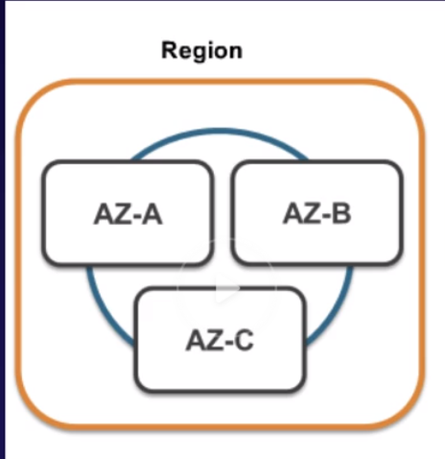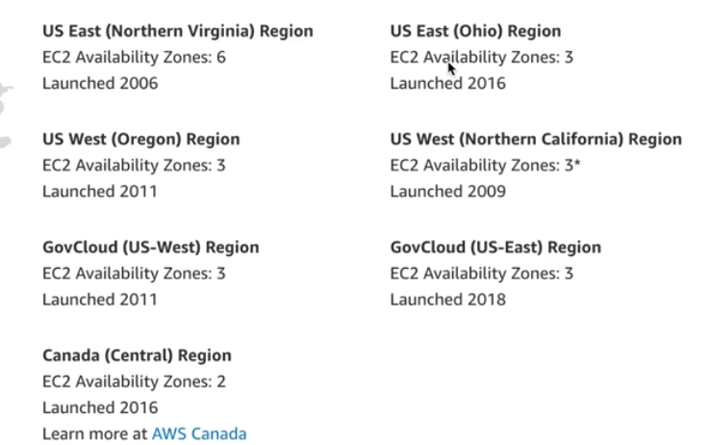

- Edge Location – Location are endpoints for AWS which are used for caching content. Typically consist of cloudFront, Amazon’s content Delivery Network(CDN).
They are endpoints for AWS which are used for caching content. Currently 205 edge locations.

Regions 22
Announced regions 5
Availability Zones 69

AWS Services
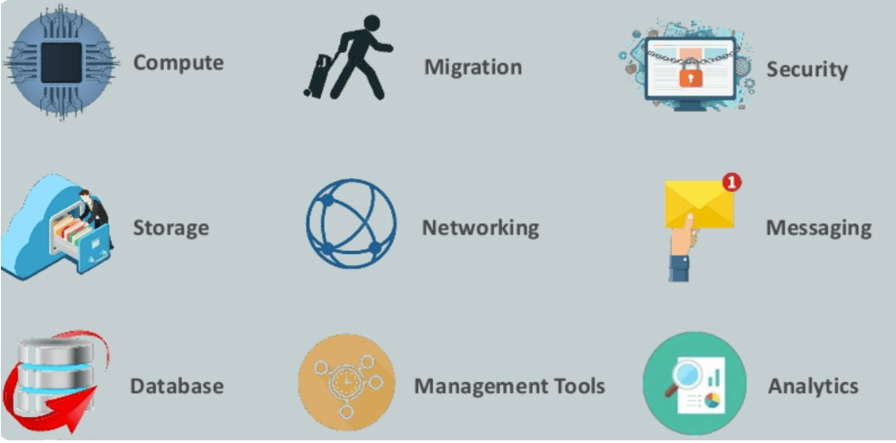
Compute
EC2(Elastic Compute Cloud) | Virtual machine in the cloud on which you have OS level control.
LightSail - | Automatically deploys and manages the computer, storage, and networking capabilities required to run your applications.
ElasticBeanstalk | offers automated deployment and provisioning of resources like a highly scalable production website.
Elastic Container Service for Kubernetes | Allows you to Kubernetes on Amazon cloud environment without installation.
AWS Lambda | Allows you to run functions in the cloud. The tool is a big cost saver for you as you to pay only when your functions execute.
Migration
DMS(Database Migration Service) | Can be used to migrate on-site databases to AWS. It helps you to migrate from one type of database to another — for example, Oracle to MySQL.
SMS(Server Migration Service) | Allows you to migrate on-site servers to AWS easily and quickly.
Snowball | small application which allows you to transfer terabytes of data inside and outside of AWS environment.
Storage
Amazon Glacier | offers secure and fast storage for data archiving and backup.
Amazon Elastic Block Store (EBS) | It provides block-level storage to use with Amazon EC2 instances.
AWS Storage Gateway | It is connecting on-premises software applications with cloud-based storage. It offers secure integration between the company's on-premises and AWS's storage infrastructure.
Security Services
IAM | Helps you to manage users, assign policies, form groups to manage multiple users.
Inspector | An agent that you can install on your virtual machines, which reports any security vulnerabilities.
Certificate Manager | Offers free SSL certificates for your domains that are managed by Route53.
KMS (Key Management Service) | This security service helps you to create and control the encryption keys which allows you to encrypt your data.
Shield | Managed DDoS (Distributed Denial of Service protection service). It offers safeguards against web applications running on AWS.
GuardDuty | Offers threat detection to protect your AWS accounts and workloads.
Database Services
Amazon RDS | Easy to set up, operate, and scale a relational database in the cloud.
Amazon DynamoDB | Fully managed NoSQL database service.
Neptune | reliable and scalable graph database service.
Amazon RedShift | Amazon's data warehousing solution which you can use to perform complex OLAP queries.
Analytics
CloudSearch | To create a fully managed search engine for your website.
Athena | Allows perm SQL queries on your S3 bucket to find files.
ElasticSearch | It offers more features like application monitoring.
Kinesis | To stream and analyzing real-time data at massive scale.
EMR (Elastic Map Reduce) | Used for big data processing like Spark, Splunk, Hadoop, etc.
Data Pipeline | To move data from one place to another. For example from DynamoDB to S3.
QuickSight | It helps you to create visualizations in a dashboard for data in Amazon Web Services. For example, S3, DynamoDB, etc.
Management Services
CloudWatch | To monitor AWS environments like EC2, RDS instances, and CPU
CloudFormation | It is a way of turning infrastructure into the cloud. You can use templates for providing a whole production environment in minutes.
CloudTrail | It offers an easy method of auditing AWS resources. It helps you to log all changes.
Config | Allows you to automated Chef/Puppet deployments on AWS environment.
Service Catalog | This service helps large enterprises to authorize which services user will be used and which won't.
OpsWorks | The service allows you to automated Chef/Puppet deployments on AWS environment. The service allows you to automated Chef/Puppet deployments on AWS environment.

Application Services
Step Functions | It is a way of visualizing what's going inside your application and what different microservices it is using.
SWF (Simple Workflow Service) | The service helps you to coordinate both automated tasks and human-led tasks.
SNS (Simple Notification Service) | You can use this service to send you notifications in the form of email and SMS based on given AWS services.
SQS (Simple Queue Service) | Use this AWS service to decouple your applications. It is a pull-based service.
Elastic Transcoder | This AWS service tool helps you to changes a video's format and resolution to support various devices like tablets, smartphones, and laptops of different resolutions.
Deployment and Management
AWS CloudTrail
Amazon CloudWatch
AWS CloudHSM
Developer Tools
CodeStar | Codestar is a cloud-based service for creating, managing, and working with various software development projects on AWS.
CodeCommit | It is AWS's version control service which allows you to store your code and other assets privately in the cloud.
CodeDeploy | It is a way of deploying your code in EC2 instances automatically.
CodePipeline | It helps you create a deployment pipeline like testing, building, testing, authentication, deployment on development and production environments.
Cloud9 | It is an Integrated Development Environment for writing, running, and debugging code in the cloud.
Mobile Services
Mobile Hub | Allows you to add, configure and design features for mobile apps.
Cognito | Allows users to signup using his or her social identity.

Quiz
1.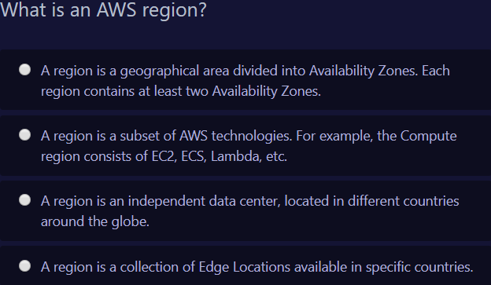
A.
2. 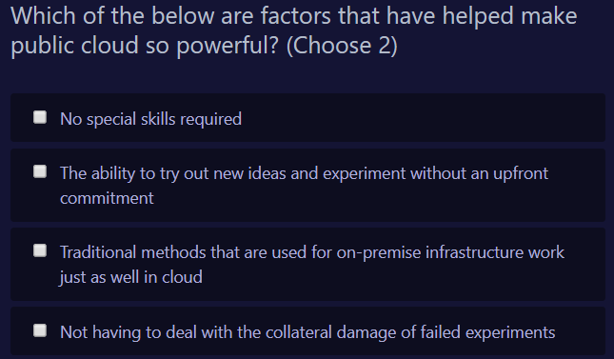
B&D
- 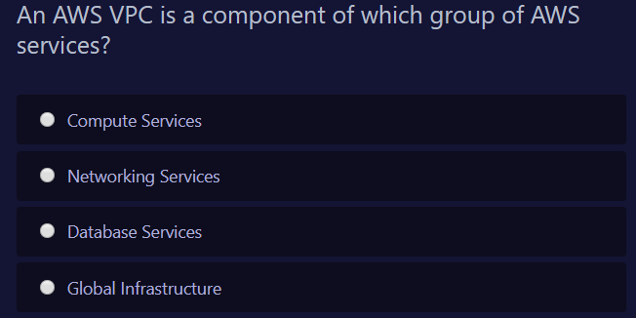
B
- 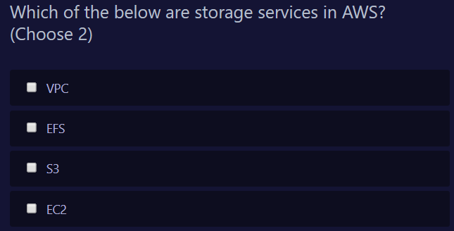
B,C
- 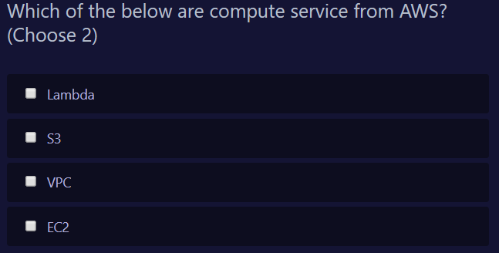
A,D
- 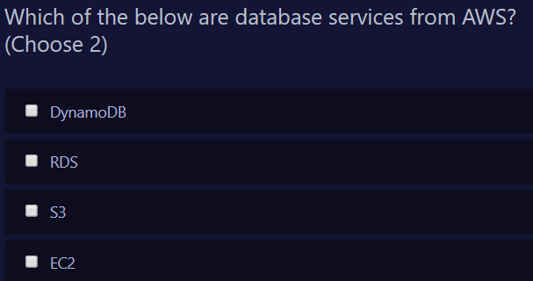
A,B
- 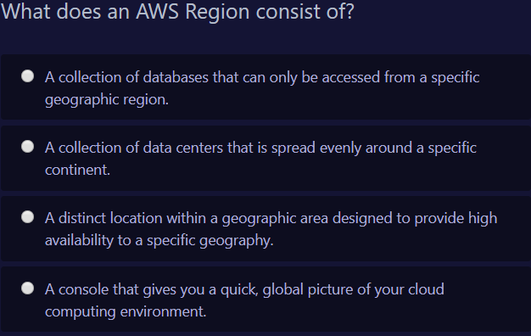
C
- 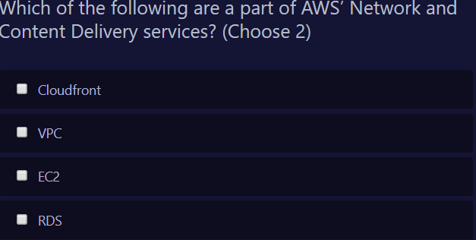
A,B
- 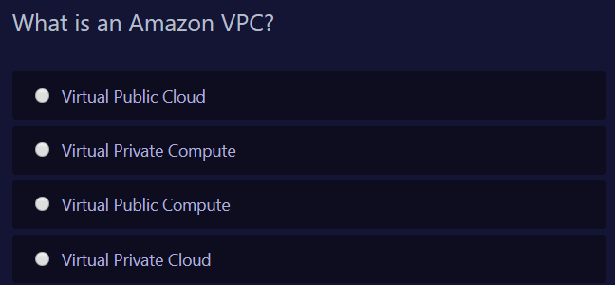
D
- 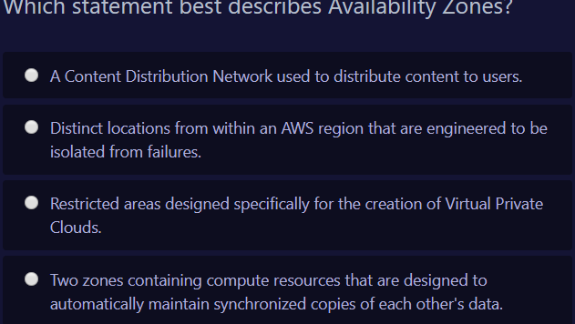
B
- 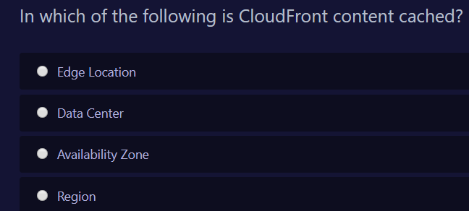
A
- 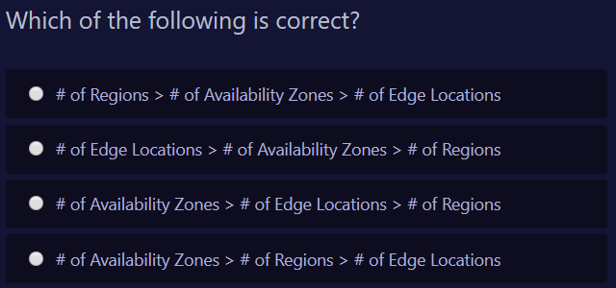
B

AWS EC2

