WebService-ApacheCXF
SOAP based WS architecture
WS online example
WSDL Contract
Building SOAP services with Apache CXF and Maven
Viewing SOAP messages

References:
https://www.youtube.com/watch?v=fRrBFguxL9Y
https://www.tutorialspoint.com/apache_cxf/apache_cxf_with_pojo.htm

WebServices
Use Case: You are creating a website which shows weather information of important cities in the world. You can actually consume already exposed web services and get the data for the cities. You will get the response in form of XML or JSON, you can parse it and show it on your website.

Web service is a way of communication that allows interoperability between different applications on different platforms, for example, a Java based application on Windows can communicate with a .Net based one on Linux. The communication can be done through a set of XML messages over HTTP protocol.Web services are browsers and operating system independent service, which means it can run on any browser without the need of making any changes. Web Services take Web-applications to the Next Level.

“Web Services are the message-based design frequently found on the Web and in enterprise software. The Web of Services is based on technologies such as HTTP, XML, SOAP, WSDL, SPARQL, and others.”
  - Why Web Service

Reuse already developed(old) functionality into new software:
Let’s understand with the very simple example.Let’s say you are developing a finance software for a company on java and you have old .net software which manages salary of employees.So rather than developing new software for employee part, you can use old software and for other parts like infrastructure, you can develop your own functionalities.

Usability :
Web Services allow the business logic of many different systems to be exposed over the Web. This gives your applications the freedom to chose the Web Services that they need. Instead of re-inventing the wheel for each client, you need only include additional application-specific business logic on the client-side. This allows you to develop services and/or client-side code using the languages and tools that you want.

Interoperability :
This is the most important benefit of Web Services. Web Services typically work outside of private networks, offering developers a non-proprietary route to their solutions.Web Services also let developers use their preferred programming languages. In addition, thanks to the use of standards-based communications methods, Web Services are virtually platform-independent.

Loosely Coupled:
Each service exists independently of the other services that make up the application. Individual pieces of the application to be modified without impacting unrelated areas.

Ease of Integration:
Data is isolated between applications creating ’silos’. Web Services act as glue between these and enable easier communications within and across organizations.

Deployability :
Web Services are deployed over standard Internet technologies. This makes it possible to deploy Web Services even over the firewall to servers running on the Internet on the other side of the globe. Also thanks to the use of proven community standards, underlying security (such as SSL) is already built-in.

Types of Web Services

  - Rest
- REST is an architectural style which was brought in by Roy Fielding in 2000
- REST is a stateless client-server architecture in which the web services are viewed as resources and can be identified by their URIs. Web service clients that want to use these resources access via globally defined set of remote methods that describe the action to be performed on the resource.
- It consists of two components REST server which provides access to the resources and a REST client which accesses and modify the REST resources.
- Clients and servers exchange representations of resources by using a standardized interface and protocol.REST isn’t protocol specific, but when people talk about REST they usually mean REST over HTTP.
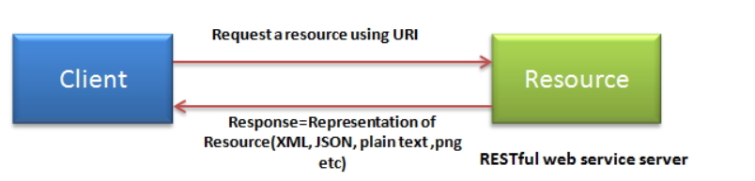
- Supports XML and JSON.

HTTP methods
GET: It defines a reading access of the resource without side-effects.This operation is idempotent i.e.they can be applied multiple times without changing the result
PUT : It is generally used for updating resouce.It must also be idempotent.
DELETE : It removes the resources. The operations are idempotent i.e. they can get repeated without leading to different results.
POST :It is used for creating a new resource. It is not idempotent.

Idempotent means result of multiple successful request will not change state of resource after initial application
For example :
Delete is idempotent method because when you first time use delete, it will delete the resource (initial application) but after that, all other request will have no result because resource is already deleted.
Post is not idempotent method because when you use post to create resource , it will keep creating resource for each new request, so result of multiple successful request will not be same.

  - SOAP
Simple Object Access Protocol (SOAP) is a standard protocol specification for message exchange based on XML. Communication between the web service and client happens using XML messages.
A simple web service architecture have two components
- Client
- Service provider
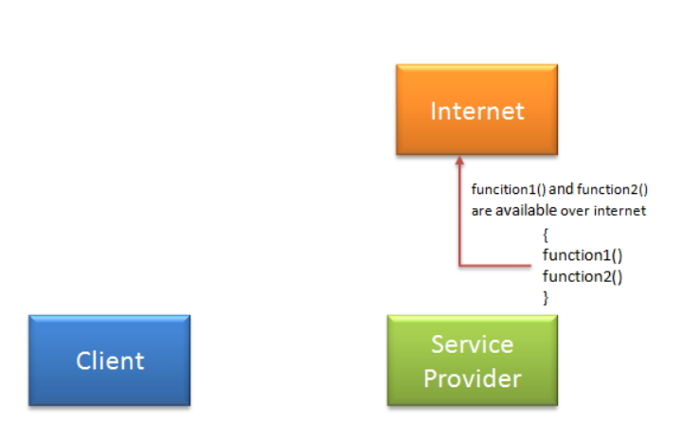
In order to communicate client must know some information for e.g.
- Location of webservices server
- Functions available,signature and return types of function.
- Communication protocol
- Input output formats

Service provider will create a standard XML file which will have all above information.So If this file is given to client then client will be able to access web service. This XML file is called WSDL.

WSDL
XML file that describes
the technical details of how to implement a web service, more specifically the URI,
port, method names, arguments, and data types. Since WSDL is XML, it is both
human-readable and machine-consumable, which aids in the ability to call and bind to
services dynamically.using this WSDL file we can understand things like,
- Port / Endpoint – URL of the web service
- Input message format
- Output message format
- Security protocol that needs to be followed
- Which protocol the web service uses

Ways to access web service
If Service provider knows client: | Service provider register its WSDL to UDDI and client can access it from UDDI
If service provider knows its client then it will provide its wsdl to client and client will be able to access web service. | UDDI stands for Universal Description, Discovery and Integration.It is a directory service. Web services can register with a UDDI and make themselves available through it for discovery.So following steps are involved.  - Service provider registers with UDDI.  - Client searches for service in UDDI.  - UDDI returns all service providers offering that service.  - Client chooses service provider  - UDDI returns WSDL of chosen service provider.  - Using WSDL of service provider,client accesses web service.
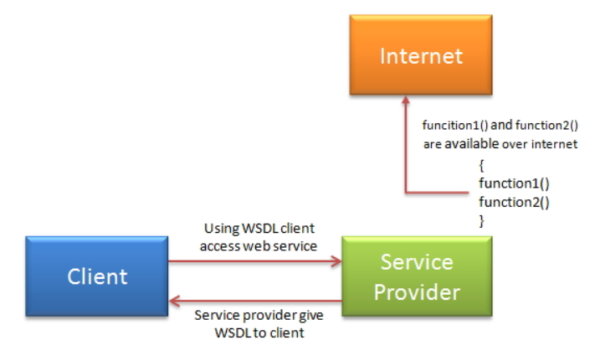 | 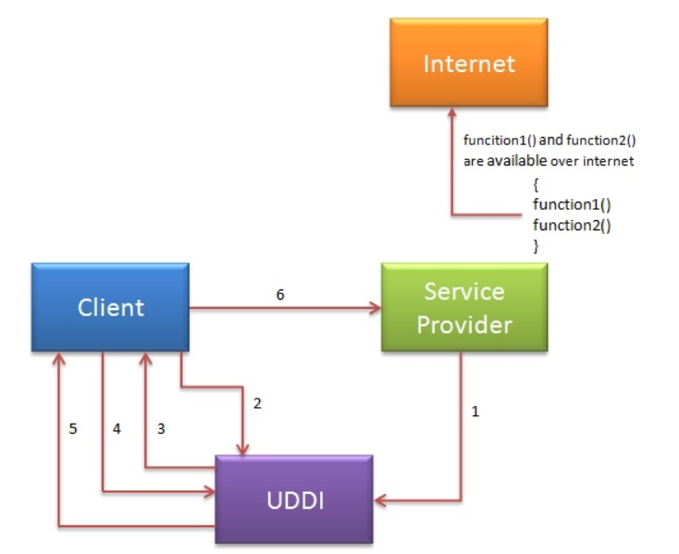

  - SOAP Vs REST

Parameter | SOAP | REST
Acronym | SOAP stands for simple object access protocol | REST stands for REpresentational State Transfer
Protocol vs Architectural style | SOAP is a standard protocol to create web services | Rest is architectural style to create web services.
Contract | Client and Server are bind with WSDL contract | There is no contract between client and Server.
Format Support | SOAP supports only XML format | REST web services supports XML, json and plain text etc.
Maintainability | SOAP web services are hard to maintain as if we do any changes in WSDL , we need to create client stub again | REST web services are generally easy to maintain.
Service interfaces vs URI | SOAP uses Service interfaces to expose business logic | Rest uses URI to expose business logic
Security | SOAP has its own security : WS-security | Rest inherits its security from underlying transport layer.
Bandwidth | SOAP requires more bandwidth and resources as it uses XML messages to exchange information | REST requires less bandwith and resources. It can use JSON also.
Learning curve | SOAP web services are hard to learn as you need to understand WSDL , client stub | REST web services are easy to understand as you need to annotate plain java class with JAX-RS annotations to use various HTTP methods.

Java Web Services API
Two main API’s defined by Java for developing web service applications.
JAX-WS | JAX-RS
Mainly for SOAP web services. | mainly for RESTful web services
Two ways to write JAX-WS application code: by RPC style and Document style. | Implementation currently in use for creating JAX-RS application: Jersey and RESTeasy.

  - Build SOAP web Service using Java in eclipse
1.Create new dynamic web project and name it “SimpleSOAPExample”.
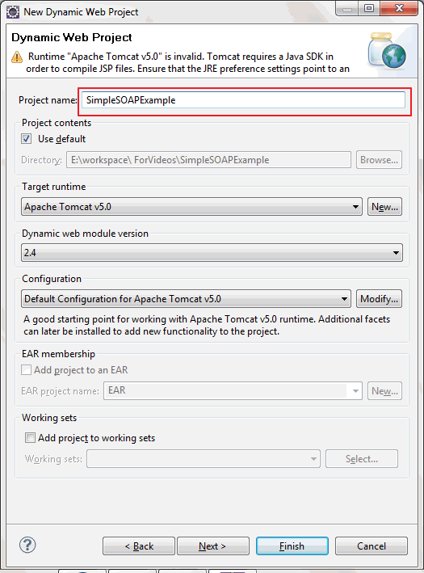
2.Create new package named “org.arpit.javapostsforlearning.webservices”
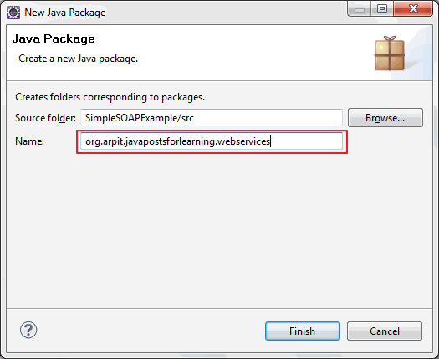
3.Create a simple java class named “HelloWorld.java”
package org.arpit.javapostsforlearning.webservices;
public class HelloWorld {
public String sayHelloWorld(String name) {
return "Hello world from "+ name; }
}
4. Right click on project->new->web service
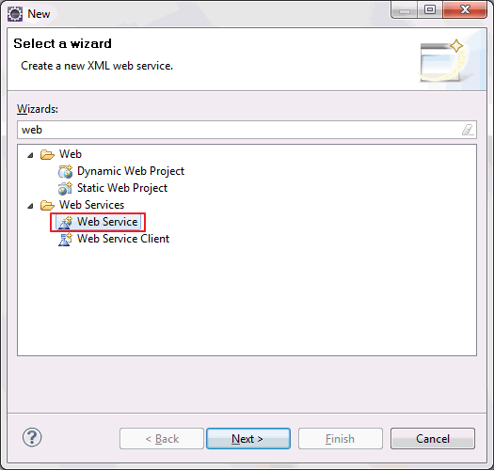In

5.Click on next.
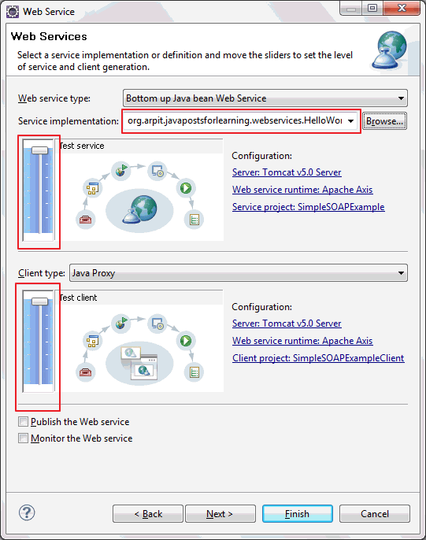
In service implementation text box,write fully qualified class name of above created class(HelloWorld.java) and move both above slider to maximum level (i.e. Test service and Test Client level) and click on finish.You are done!!A new project named “SimpleSOAPExampleClient” will be created in your work space.
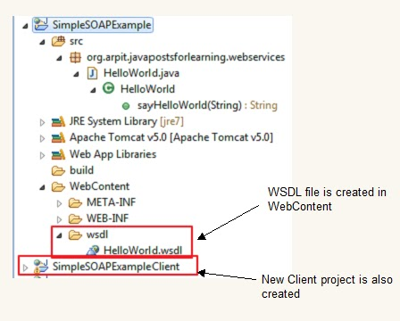
6.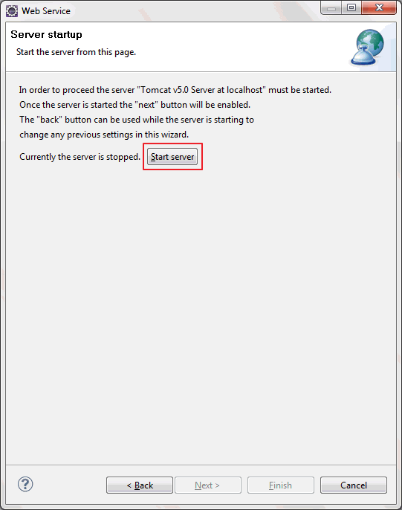
Click on start server.
7.After clicking start server,eclipse will open test web service API.With this test API,you can test your web service.
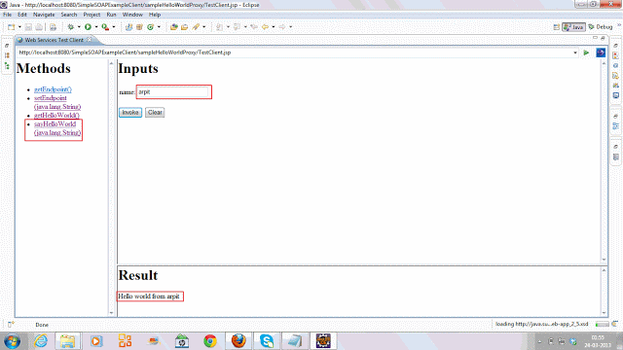
  - WSDL
https://www.w3schools.com/xml/xml_wsdl.asp
<definitions>
<types>
data type definitions........
</types>
<message>
definition of the data being communicated....
</message>
<portType>
set of operations......
</portType>
<binding>
protocol and data format specification....
</binding>
</definitions>

https://java2blog.com/jaxws-web-service-eclipse-tutorial/
  - Build a JAX-WS web service using WSIMPORT
Example:
F:\Revature-Florida\Revature_Project1\TestJaxWSJavaProjClient
F:\Revature-Florida\Revature_Project1\TestJaxWSJavaProj
Two main steps are

Steps for creating JAX-WS webservice endpoint.
1) Open Eclipse IDE
2) Create java project named “JAXWSServer”
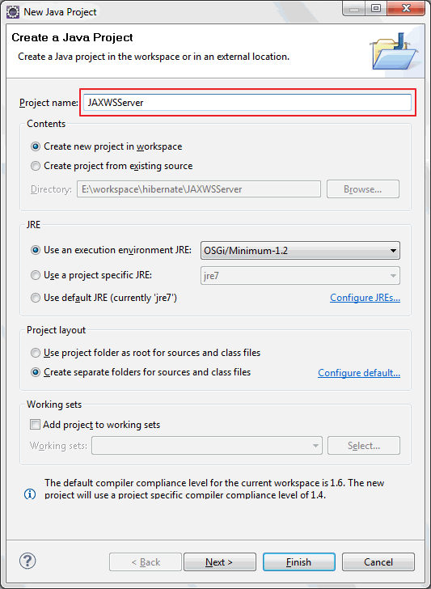

3)Create new package named “org.arpit.javapostsforlearning.webservice”
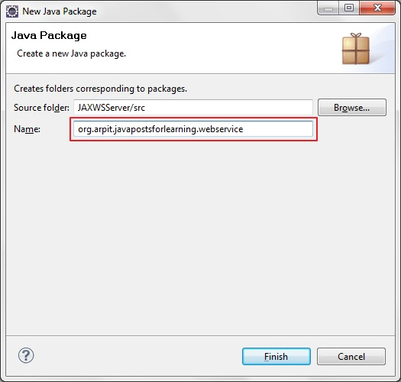
4)Create JAXWSService Endpoint Interface.
HelloWorld.java
package org.arpit.javapostsforlearning.webservice;
import javax.jws.WebMethod;
import javax.jws.WebService;

@WebService
public interface HelloWorld {

@WebMethod public String helloWorld(String name);
}

5)Create JAXWSService Endpoint implementation class.
HelloWorldImpl.java
package org.arpit.javapostsforlearning.webservice;
import javax.jws.WebService;

@WebService(endpointInterface="org.arpit.javapostsforlearning.webservice.HelloWorld")
public class HelloWorldImpl implements HelloWorld{

public String helloWorld(String name) {
return "Hello world from "+name;
}

}

6) Create Endpoint publisher.
HelloWorldWSPublisher.java
package org.arpit.javapostsforlearning.webservice;
import javax.xml.ws.Endpoint;

public class HelloWorldWSPublisher {
public static void main(String[] args) {
Endpoint.publish("http://localhost:8080/WS/HelloWorld",new HelloWorldImpl());
}}

Run above program.Your webservice is published.You can check your service wsdl at http://localhost:8080/WS/HelloWorld?wsdl

Steps for creating JAXWS Client
1)Open eclipse and create a new java project JAXWSClient.
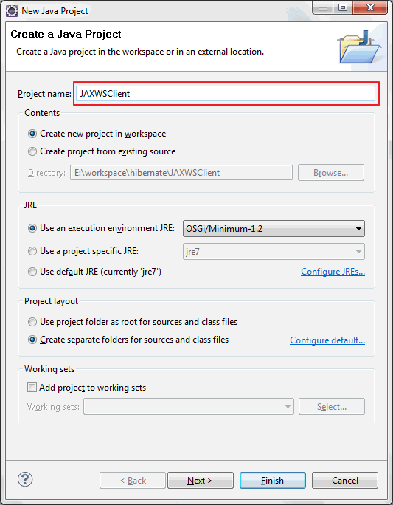
3) Now we need to generate the client stubs.So open your command line, and enter the wsimport command:
cd %project_home%/src
wsimport -s . http://localhost:8080/WS/HelloWorld?wsdl

you will find java classes generated and compiled under src->org->arpit->javapostsforlearning->webservice
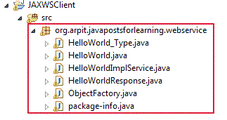
4) Lets create client class now.
create JAXWSClient.java under src->org.arpit.javapostsforlearning.webservice.client
package org.arpit.javapostsforlearning.webservice.client;
import org.arpit.javapostsforlearning.webservice.HelloWorld;
import org.arpit.javapostsforlearning.webservice.HelloWorldImplService;
public class JAXWSClient {
public static void main(String[] args) {

HelloWorldImplService helloWorldService = new HelloWorldImplService();
HelloWorld helloWorld = helloWorldService.getHelloWorldImplPort();
System.out.println(helloWorld.helloWorld("Aashu"));
}
}

5) Run above program and you will get following output.
Hello world from Aashu

  - Web Services development Approcahes
https://www.javajee.com/overview-of-top-down-and-bottom-up-soap-web-service-development
Top-down web services development | Bottom-up web services development
Creating a WSDL and then creating the Web service using the WSDL file.  - In top-down approach, first you design the implementation of the Web service by creating a WSDL file. You can then create the Web service skeleton Java classes from the wsdl, and add the required code. | When creating a Web service using a bottom-up approach, first you write the java classes for the web service and then create the WSDL file and publish the web service.  - Although bottom-up Web service development may be faster and easier, the top-down approach is the recommended way of creating a Web service.
JAX-WS tool wsimport can be used for creating a top down web service.  - The wsimport can create stubs from a wsdl.  - JAX-WS tools wsimport and wsgen. | JAX-WS tool wsgen can be used for creating a bottoms up web service.  - The wsgen tool reads an existing web service implementation class (SIB) and generates the required JAX–WS portable artifacts for web service development and deployment.​  - See notes on JAX-WS tools wsimport and wsgen.
Also called as contract first or WSDL first approach. | Also called as Service first or code first approach.
Most common in production scenarios. | Ideal for learning web services.
Eg: Users will be responsible for developing their own clients using different frameworks, based on a published WSDL. | - Eg: Situations which need quick and faster completion may prefer Java approach  - Java first approach is often the fastest and easiest approach.  - Code reuse is required.  - It may be better to write code first if you want to reuse code.

Wsgen | WsGen
Reads a WSDL and generates all the required artifacts for web service development, deployment, and invocation. | Reads an existing web service implementation class (SIB) and generates the required JAX–WS portable artifacts for web service development and deployment.
Supports the top-down approach to developing JAX-WS Web services, where you are starting from a wsdl. | Used for bottoms-up approach, where you are starting from a service endpoint implementation (SIB) rather than a wsdl.

  - Build JAX-WS webservice deployment on tomcat
https://java2blog.com/jaxws-webservice-deployement-on-tomcat/

  - Build Restful web services example in java
https://java2blog.com/restful-web-services-example-java/

  - Build RESTful web services JAXRS json example using jersey

Apache CXF
Apache CXF to create a web service and a client that consumes the service.
Apache CXF is a popularly used services framework and its available as open source. Apache community has now added support for Spring Boot starter dependency so you don’t have to add each capability separately.
CXF support three major types of services:
- SOAP - this page summarizes the options for creating SOAP services.
- REST-ful - REST support is described here.
- CORBA

The CXF allows you to hide this WSDL model by providing a simple frontend to map Java APIs to the underlying WSDL. In this simplest project, the interface of the web service will be directly exposed to the client and the client would use native Java APIs to call the web service. we will create a web service. Every service has an interface that is exposed to the client. We may write this interface as a simple Java interface or as a WSDL document.

  - Develop a simple web application that sends a greetings message to the user.
https://www.youtube.com/watch?v=159EsQyqtIY
Step 1: Create Maven Webapp project – Test helloCXF
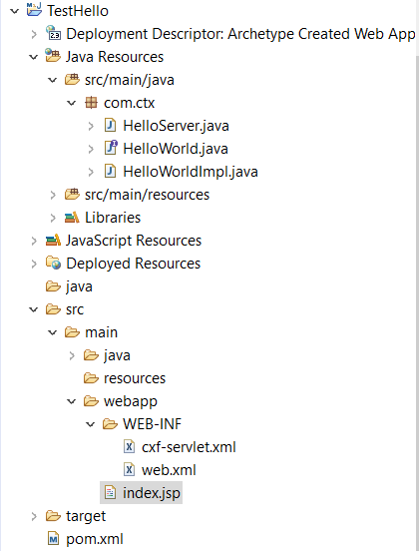
Step 2: Add index.jsp
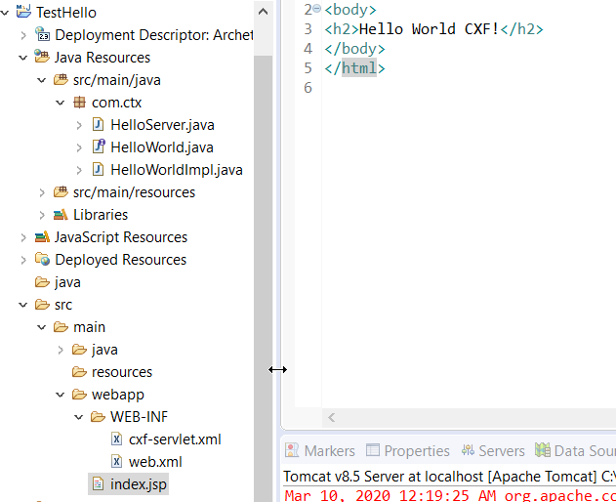
Step 3: Add cxf-servlet.xml
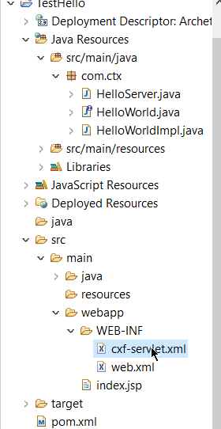
<?xml version="1.0" encoding="UTF-8"?>
<beans xmlns="http://www.springframework.org/schema/beans"
xmlns:xsi="http://www.w3.org/2001/XMLSchema-instance"
xmlns:core="http://cxf.apache.org/core"
xmlns:jaxws="http://cxf.apache.org/jaxws"
xmlns:soap="http://cxf.apache.org/bindings/soap"
xsi:schemaLocation="http://cxf.apache.org/jaxws http://cxf.apache.org/schemas/jaxws.xsd
http://cxf.apache.org/core http://cxf.apache.org/schemas/core.xsd
http://www.springframework.org/schema/beans http://www.springframework.org/schema/beans/spring-beans.xsd
http://cxf.apache.org/bindings/soap http://cxf.apache.org/schemas/configuration/soap.xsd">
<jaxws:endpoint id="op" implementor="com.ctx.HelloWorldImpl" address="/op"/>

</beans>

Step 4: Create hello server
package com.ctx;
import org.apache.cxf.frontend.ServerFactoryBean;
public class HelloServer { protected HelloServer() throws Exception {
ServerFactoryBean factory = new ServerFactoryBean();
factory.setServiceClass(HelloWorld.class);
factory.setAddress("http://localhost:8080/Hello");
factory.setServiceBean(new HelloWorldImpl());
factory.create();
}
public static void main(String[] args) throws Exception {
new HelloServer();
System.out.println("Listening on port 5000 ...");
Thread.sleep(5 * 60 * 1000);
System.out.println("Server exiting ...");
System.exit(0);}}
Step 5: Create interface
//HelloWorld.java
package com.ctx;
public interface HelloWorld {
String greetings(String text);
}

Step 6: Create Implementation
//HelloWorldImpl.java
package com.ctx;
public class HelloWorldImpl implements HelloWorld {
@Override
public String greetings(String text) {
return "Hi " + text;
}
}
-
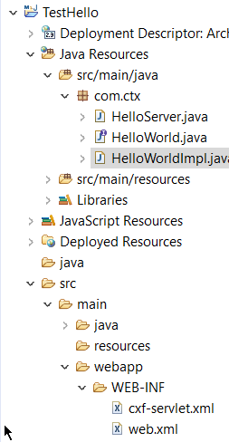
Step 10: Install TOMCAT and run

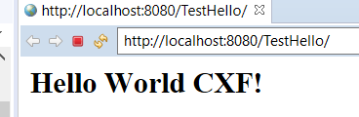

Step 11: Explore
