

TASK
Exploratory Data Analysis on the Forbes Richest Athletes 1990-2020 Dataset



Introduction
Summary of the data set
The project aims to analyze the Forbes Richest Athletes dataset. The dataset to be explored in the below EDA is that of the performance of highest paid athletes between the year 1990 and 2020 according to Forbes. The dataset provides information on the earnings of athletes from various sports, allowing for an in-depth exploration of their financial success over the years. The research question revolves around understanding the trends, patterns, and factors influencing athlete earnings and identifying the top-earning athletes across different time periods.
The data set contains 301 records collected over a period of 3 decades since the year 1990, suggesting that the data represent lists of the top 10 highest earnings athletes for each of the 30 years. There are 8 series in the set describing the athlete, their sports profession, through to their yearly total earnings.
By conducting a comprehensive analysis of the Forbes Richest Athletes dataset, this project aims to provide valuable insights into the financial dynamics of professional sports, understand the factors influencing athlete earnings, and identify trends and patterns in the highest-earning athletes. The findings can be utilized by sports organizations, athletes, sponsors, and investors to make informed decisions and understand the financial landscape of the sports industry.
Purpose of EDA
As part of this EDA, the main goals are to extract the underlying pattens of athlete's performances in annual earnings over the years of their involvement in sports. The distribution of earnings over different sports, countries, and time will be explored. This data set only includes yearly total earnings of each sports personality, where total earnings are a sum of salaries and endorsements. There are huge some of earnings generated by sports personalities in other avenues other than the field of play through endorsements, such as promotions, sponsorships, appearances at events, and businesses to name a few. As such, an athlete can be the richest athlete with minimal field appearances in a particular year due to the offset of endorsements. We notice that the dataset does not contain data about the number of appearances of each sports personality reasonably so because these vary incredibly from sport to sport.

Description of the Data Set Variables
The data is of mixed type comprising of both categorical and continuous variables.
* S.NO: This column represents a serial number or unique identifier assigned to each record or row in the dataset.
* Name: This column contains the name of the athlete.
* Nationality: This column indicates the nationality or country to which the athlete belongs.
* Current Rank: This column represents the current rank of the athlete based on their earnings in the ranking list among other athletes.
* Previous Year Rank: This column contains the rank of the athlete in the previous year's rankings.
* Sport: This column specifies the sport in which the athlete is involved or has achieved success.
* Year: This column indicates the year for which the earnings and rankings are recorded.
* earnings ($ million): This column represents the earnings of the athlete in millions of dollars. It shows the amount of money the athlete has earned during the specified year through various means, such as prize money, endorsements, sponsorships, and other sources.

DATA CLEANING
Data Accuracy
Forbes changed its methodology or criteria for selecting and ranking the richest athletes, which resulted in the exclusion of the year 2001 from the dataset.
Editor’s note: In 2002, Forbes changed its reporting period from the full calendar year to June-to-June. As such, there is no list for the highest-paid athletes of 2001. This figure was sourced from a report by Men’s Health.
Source: https://finance.yahoo.com/news/highest-paid-athlete-every-1990-090000092.html#:~:text=2001&text=Editor's%20note%3A%20In%202002%2C%20Forbes,a%20report%20by%20Men's%20Health. Accessed on 23 May 2023

Validity
A popular language in the Philippines (country) is Filipino (language). The language ‘Filipino’ has been replaced by the country to which it originates from.
Uniqueness
There are sports that have been given different names whereas, only one name should have been used. In some instances, the league to which an athlete belonged was used as their sport. These anomalies were corrected to reflect only one sport name.
Consistency
Seeing an athlete who made it in the Forbes list playing 2 sports deserves a bit of research. Deion Sanders, also known as "Prime Time," is a former professional athlete who played in both the National Football League (NFL) and Major League Baseball (MLB).
Outliers
Looking at the earnings of athletes over a 3 decades, there are outliers on the upper side. There are 5 earnings that are out of the norm over a 3-decade period.

Looking at each year, there are high earnings that would be regarded as outliers for each year. However, seeing that these high earnings are consistent for almost each year, it would be harsh to consider these as outliers.

The 5 outliers are not anomalies but a true reflection of the athlete's achievements. As such, they cannot be ignored in the below analysis and will be used as they are. Two of the outliers are as a result of the great fight between Floyd Mayweather and Manny Pacquiao which short them to first and second spot respectively on the Forbes list in 2015.

The purpose of this EDA is to draw insights. When looking at forecasting future earnings, these outliers can be reduced to yield accurate predictions. They will be replaced by the maximum of the box plot where skewness is important in future engineering.

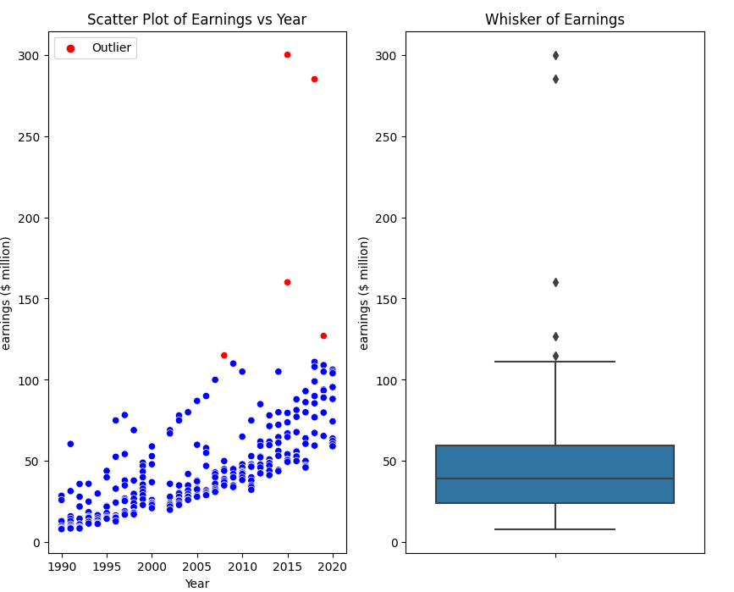
Figure 1: Outliers in Athlete Earnings

MISSING DATA
Completeness or Missing Values
Use of a Missingo chart visualization shows the distribution of missing values for the previous year rank variable over the total number of records. We will look at the missing data closely to determine possible reasons for its missingness. There are 3 major periods of missing previous year ranks during 1990, 1998, and 2017.

The first major period, which consists of the entire top 8 of 1990 shows that none of the athletes had been ranked before.

Forbes began listing athletes by wealth in 1990 with the introduction of their annual "Forbes 400" list, which initially focused on the wealthiest individuals in the United States. Over the years, Forbes expanded its coverage of athletes' wealth and began publishing specific lists such as the "Forbes Highest-Paid Athletes" and the "Forbes World's Highest-Paid Athletes.
The missingness of the previous year rank is classified as MCAR. Having explored the missingness of previous year ranks above, the previous year rank column has too many missing values and ranks that have little meaning. As a result, this column will be dropped.
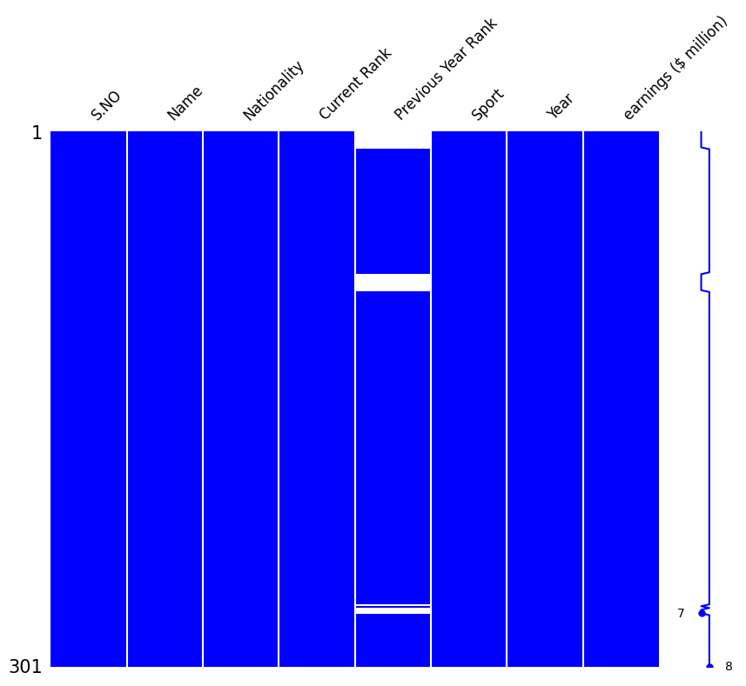
Figure 2 : Distribution of Missing Values

DATA STORIES AND VISUALISATIONS
History of Appearances by Athletes, Sports, and Countries
We seek to find Athletes, Sports and Countries that have dominated the Forbes list in throughout the 3-decade period.

Michael Jordan dominated the list every year since the list's inception for 19 years until 2009. Despite having retired in 2003, he continued to dominate the Forbes list due endorsements, and most notably his deal with Nike for the Air Jordan brand. Michael Jordan stops appearing on the Forbes Richest Athletes List in 2009. In 2006 he part-owned the Charlotte Bobcats (Now the Hornets). He later purchased 89% of the shares of the Hornets in 2010. On the Forbes list, he is now ranked in other categories other than an 'Athlete' since his fortunes are now partly derived from other sources other than his athletic career.
Tiger Woods scooped 19 appearances out of the 23 years between his first and recent appearances. As will be seen below, he has been ranked the highest paid at the top 11 times out of the 19.
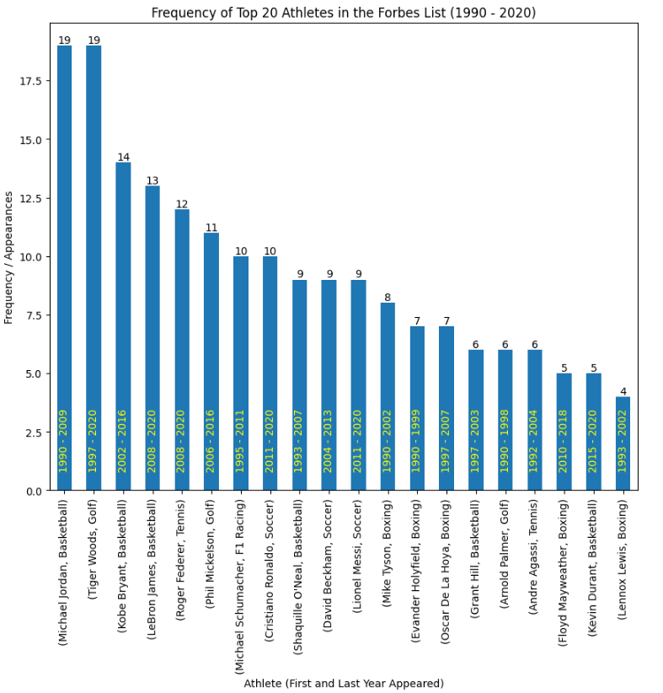
Figure 3: Number of Appearances of each Athlete on the Forbes List

Only less than 10 athletes have attained the Number 1 highest paid athlete in 30 years, with Tiger Woods and Michael Jordan accounting for just over 50% of this position.

Tiger Woods held this position 10 years continuously from 2002 to 2011 and for the eleventh time in 2013. We see that 6 out of 10 times Woods has attained first position on the list.

Soccer and Tennis are newest sports to take first position in highest paid athletes in 2016 (Cristiano Ronald) and 2020 (Roger Feder) respectively.

Note the absence of rankings in 2001 due to changes in Forbes reporting period.
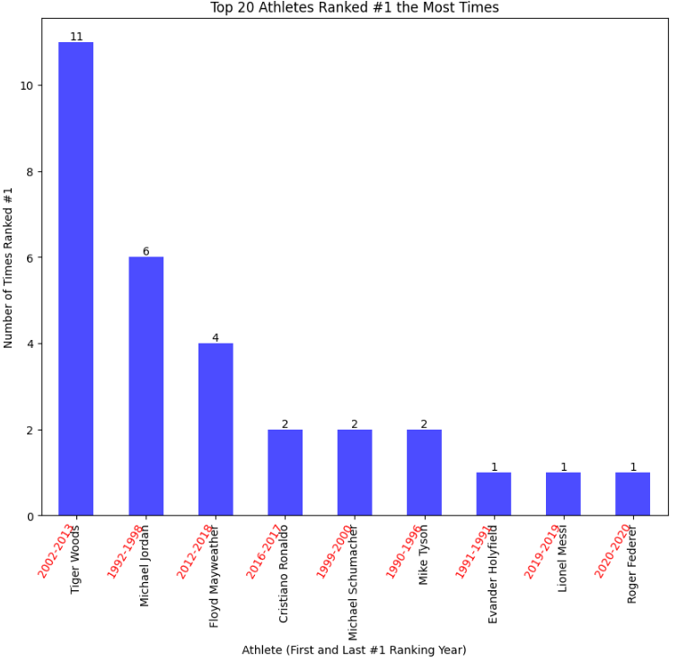
Figure 4: Highest Earners (Years in which they attained their first and most recent #1 Rank)
Basketball has the most appearances on the Forbes list, thankfully to Michael Jordan, the late Kobe Bryant, and LeBron James. Cycling, and Martial Arts have only appeared once in the Forbes List.

Lance Armstrong (Cycling) made a top 10 debut in 2005 and that was the first and last time a cyclist made it to the Forbes list. He has since admitted to doping n his career and lost opportunities to put cycling on the map.

Deon Sanders (American Football / Baseball) has only appeared once in the list simultaneously representing American Football and Baseball. Conor McGregor (MMA - Mixed Martial Arts) has also appeared once in the list in 2018.

One of the Tennis athletes Monica Seles is the only female to make it into the top 10 of the Forbes lists and this was in 1992, just 3 years after the list was established.

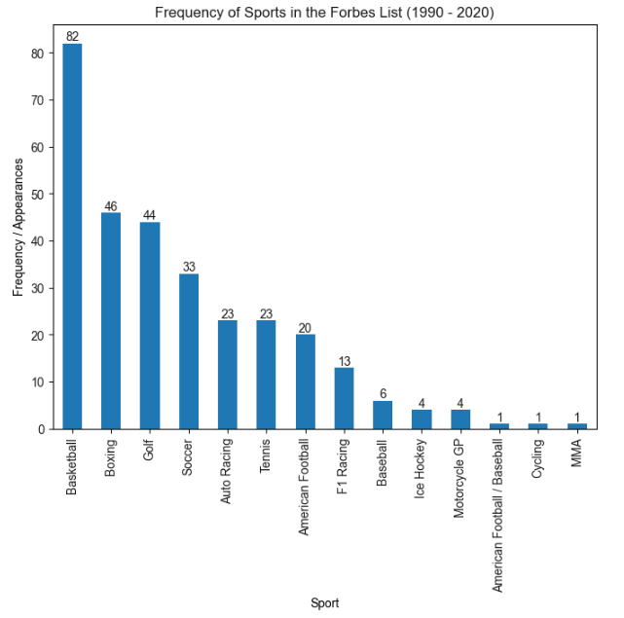
Figure 5: Frequency of Sport
Michael Schumacher, Roger Feder, Cristiano Ronaldo, and Lionel Messi have single handed represented Germany, Switzerland, Portugal and Argentina respectively.

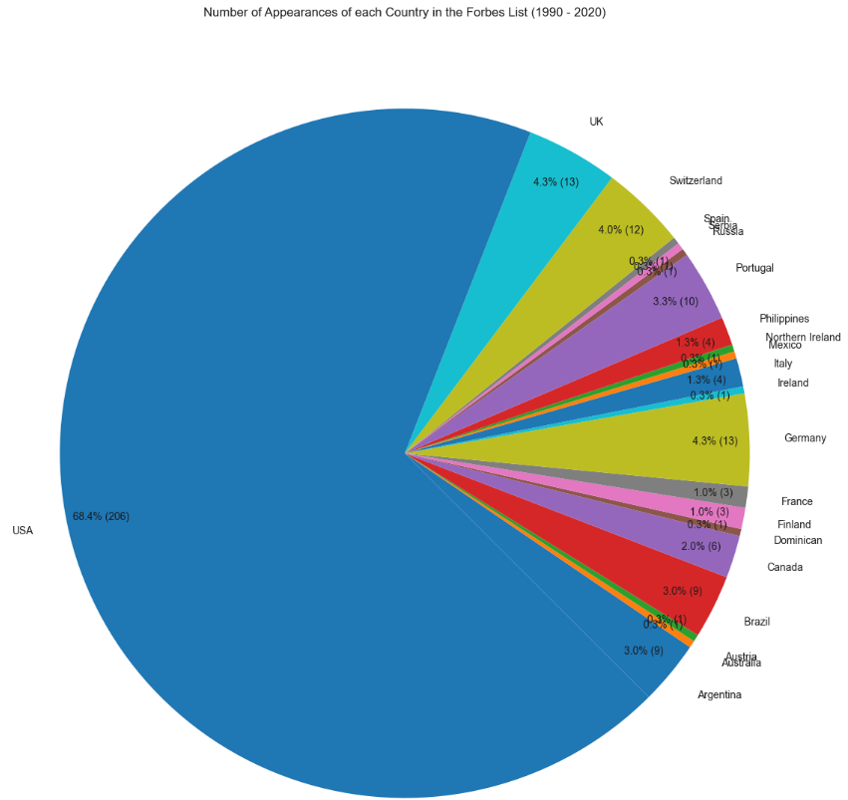
Figure 6: Appearance on Forbes Lists by Country

Of the 82 athletes to ever make it into the top 10 highest earning athletes of the annual Forbes list, 55 are from the United States alone. After the USA, there are only 3 countries with multiple representatives namely Canada (4), UK (3), and Bazil (3).

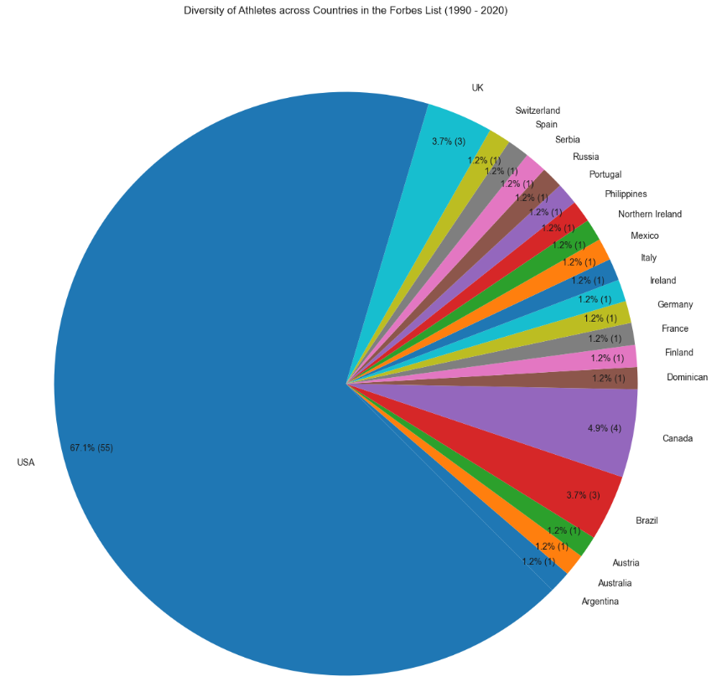
Figure 7: Distribution of Athletes by Country

The USA has been active in the list since the list was established in 1990. Australia and Austria have only made it once in the list in the early 90s and have since disappeared.

Reading the chart horizontally, we see that in the years, 1996, 1999, and 2000, the USA almost scooped all top 10 positions. In all these years Michael Schumacher made an entry denying the USA a whitewash into the list. In 2011 the greatest number of countries was represented in the Forbes list by 7 nations with USA represented by only 4 entries.

Brazil has made periodic appearances. In the early 90s Arton Senna, won World Championships in 1988, 1990, and 1991. He passed on while leading a race in 1994, hence his last appearance on the list in 1993.

The second period is that of Ronaldinho who once played for Barcelona FC. As much as he is great football player, one wonders how the likes of Ronaldo who led Brazil to world cup victory never made it on the list, even as a recipient of the FIFA player of the year awards in 3 occasions.

Neymar Jr takes the third period while playing for PSG. Neymar had played for Barcelona FC before joining PSG.

See Figure 8 below.

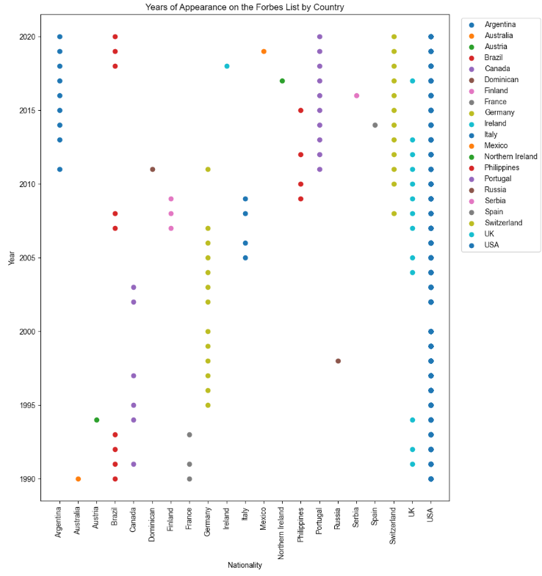
Figure 8: Appearance of a Country over Years

More than 50% of athletes are involved in American Football (19%), Boxing (17%), and Basketball (14.5%).
All American Football and Basketball athletes are American nationals. Of the 12 in boxing, Manny Pacquiao or former senator of the Philippines, is 1 of 3 non-US nationals in the boxing arena. These numbers are primary reason of the USA’s domination in the Forbes Lists.

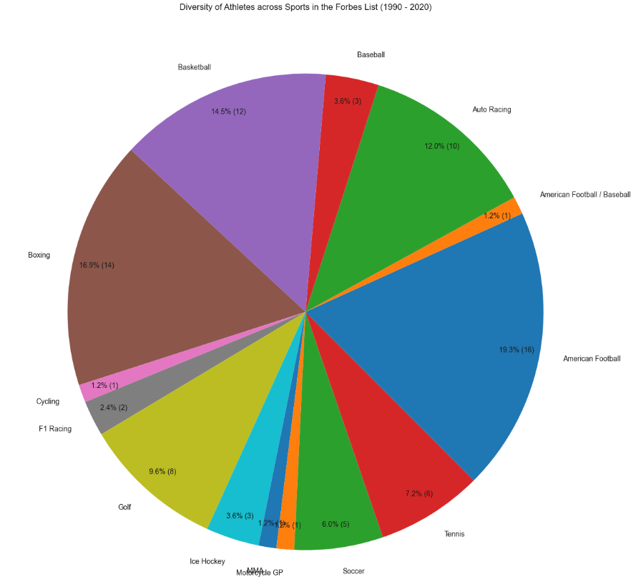
Figure 9: Distribution of Sport Personalities over Sports

Looking at the highest earning athletes of each decade, we see that Michael Jordan (Basketball) dominated the 90s decade, followed by Tiger Woods (Golf) after 2000, and finally Cristiano Ronaldo (Soccer) after 2010. Tiger woods has a strong presence in all 3 decades.

For the 1990s- and 2000s-decades Michael Jordan and Tiger Woods were easily accumulating high earnings with little competition. For the 2010s-decade, competition is high with all the top 5 earners falling within a range of 700 and 800 million dollars.

Boxing, Golf, and Basketball are dominating the first 2 decades. The last decade is seeing a rise in soccer and tennis athletes take up the top rankings of the Forbes lists.

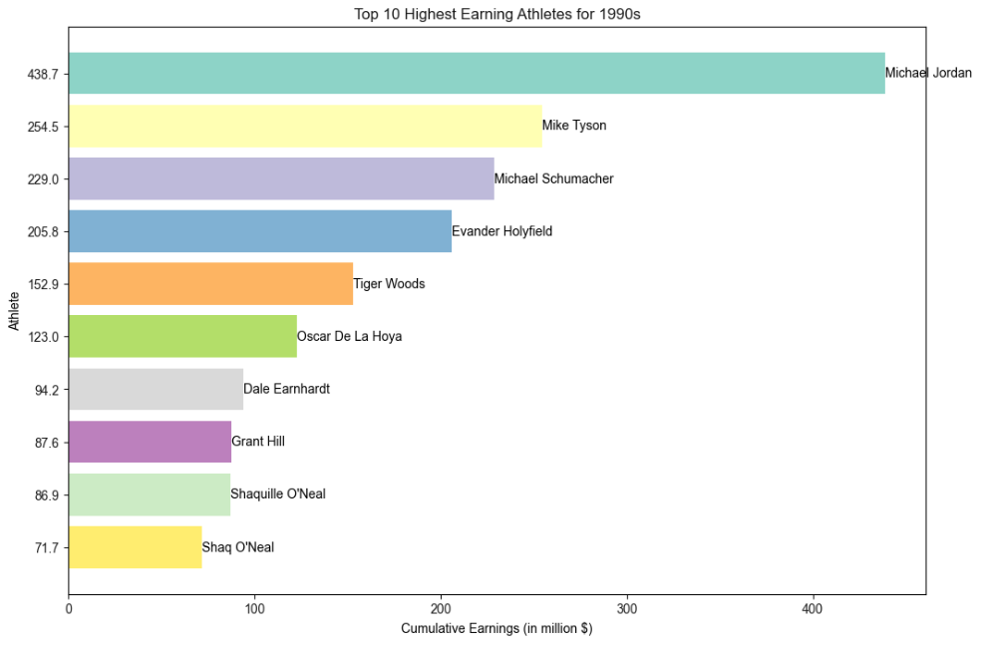
Figure 10: The Top Highest Earners of 1990 -1999
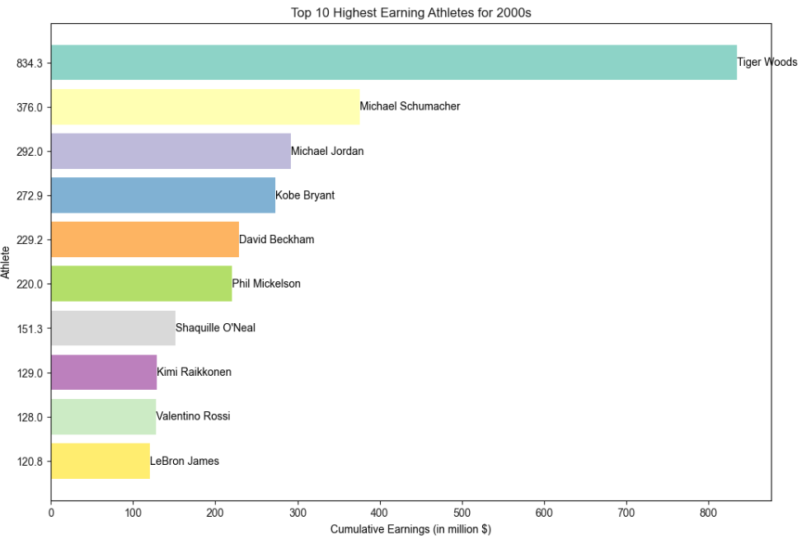
Figure 11:The Top Highest Earners of 2000 - 2009
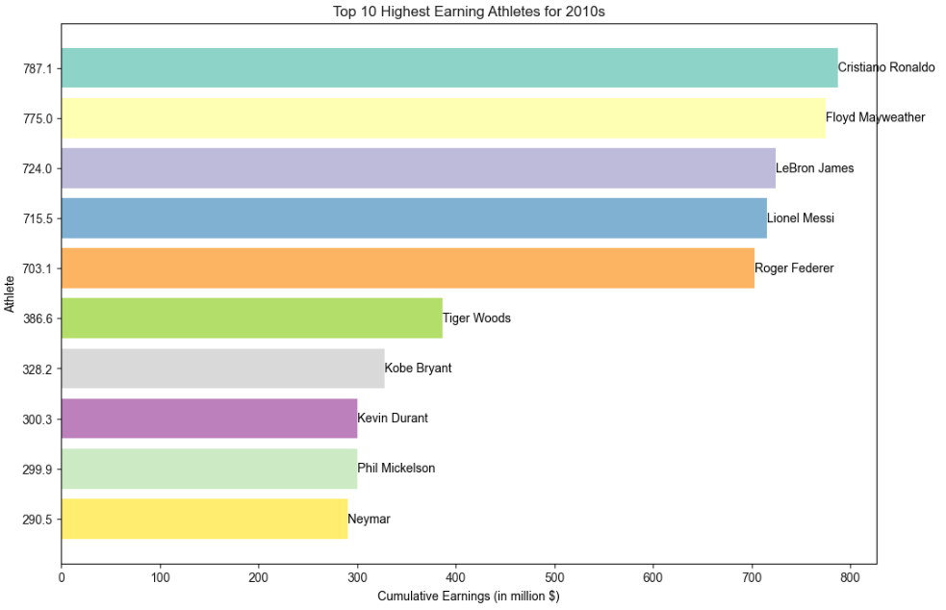
Figure 12:The Top Highest Earners of 2010 - 2020

Average earnings are calculated over all sport personalities in that sport including the very high and very earners in that sport.

As popular as it may seem, on average soccer started paying athletes very highly in 2004, with David Beckham breaking the inexistence. Except for 2006, soccer has been paying athletes highly with more athlete’s part taking in the Forbes list. Tennis earnings are consistently rising, much thanks to Rodgr Feder who in 202 was the number highest paid athlete. He truly has put tennis on a global map. However, Roger is the only Tennis athlete to ever gain the top spot of highest athlete earners.

The very high spikes in average earning for boxing seen in 2015 are that of Floyd Mayweather Jr and Manny Pacquiao. These have earlier been recorded as very excessive earnings with their respective earnings of 300 million and 160 million dollars totalling to460 million compared to the 490 million dollars of all the 8 highest athlete earners of 2015.

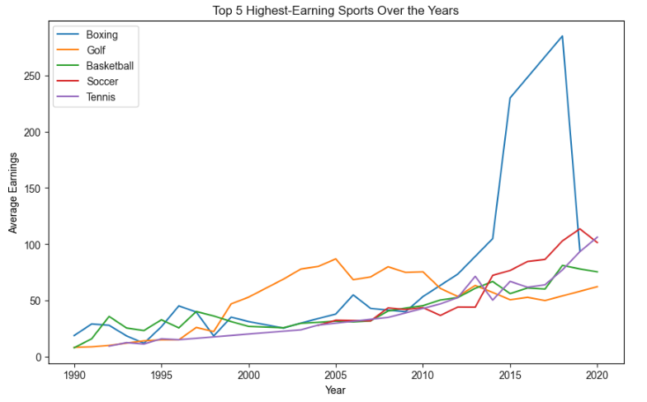
Figure 13: Top 5 High Earning Sports

The Philippines average earnings were as a result of Manny, after his bid fight with Floyd Mayweather. Germany’s average earnings have dropped since Michael Schumacher's aging and eventually retirement from F1 racing. Switzerland, Portugal, Argentina, and Brazil have dominated rising earnings in recent years. However, these earnings are as a result of individual sportsman.

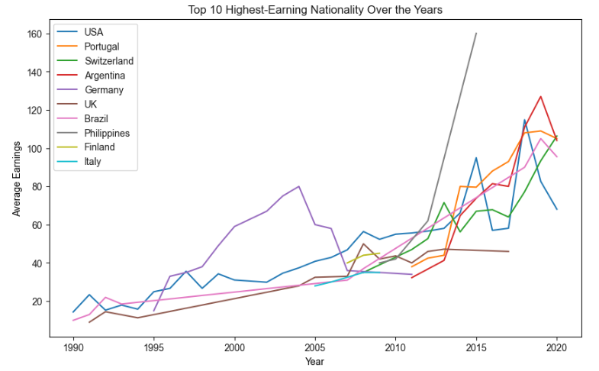
Figure 14: Top 10 High Earning Nations

Finally, to conclude the EDA, we examine the accumulated earnings of each athlete and show only the top 20 performing athletes at a time.

A race of accumulated earnings amongst athletes is shown on the video below.

Follow the link below:

athlete_earnings_race.mp4

THIS REPORT WAS WRITTEN BY : FORTUNE NCUBE

