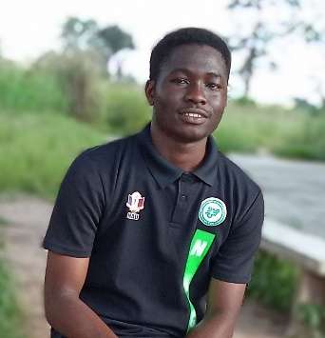FORTUNE SOMTOCHUKWU NWOHIRI

* No 10 Aiyefo Street Anibaba Bus stop,

Iyana Ishashi , off Badagry expressway , Lagos , Nigeria

* [fortunenwohiri@gmail.com](mailto:fortunenwohiri@gmail.com)
* 09161261344
  + - * 27/02/2004

Hi there , am a full stack web developer with both frontend and backend knowledge.

|  |  |
| --- | --- |
| PROFESSIONAL  SUMMARY | Am a detail-oriented team player with strong organizational skills and am seeking the opportunity in creating dynamic and user-friendly web applications. I have the ability to handle multiple projects simultaneously with a high degree of accuracy. Am a motivated individual who seeks experience in web development positions to develop strong programming skills.  I plan and prioritise well to complete multiple tasks simultaneously and within deadlines. I learn quickly to develop skills required for success |
| SKILLS | * HTML5 & CSS3 * Javascript * Bootstrap 5 framework * Core PHP * PHP Frameworks * PHP Laravel * MySQL Database * Version Control e.g Git and GitHub * Front end and Backend Web Development * Team contributor * Great communication skills * Great team membership skills * Problem solving |
| WORK HISTORY | **OPEN SOURCE CONTRIBUTOR** 11/2021- Current  ***Self-employed***, Nigeria   * Reviewed code to ensure no bugs and increase code quality * Attracted open source contributors to the project by establishing proper contributing guidelines and creating templates for pull requests * Facilitated the project development by assigning tasks to team members   ------------------------------------------------------------------------------------------------------  **FRONTEND WEB DEVELOPER** 11/2020-Current  D&B & COs, Nigeria   * Developed and maintained responsive web applications using HTML, CSS3, Bootstrap 5 and Javascript * Implemented responsive design principles and ensured optimal user experience across devices * Integrated and utilized Bootstrap framework for streamlined development   ------------------------------------------------------------------------------------------------------  **FRONTEND & BACKEND WEB DEVELOPER** 09/2021-Current  ***Adrenaline Express***, Nigeria   * Implemented responsive design principles and ensured optimal user experience across devices * Utilized Core PHP and PHP Laravel to build web applications, in order to improve speed, efficiency and code maintainability * Designed and implemented database structures, optimizing data storage and retrieval * Collaborated with clients to gather requirements and delivered tailored solutions * Collaborated with cross-functional teams to meet project goals and deadlines |
| EDUCATION | ***Nnamdi Azikiwe University,*** Awka, Nigeria 05/2023 - Current  **Bachelor of Science Computer Science**  ------------------------------------------------------------------------------------------------------  ***Federal Government College Ijanikin*** , Lagos, Nigeria 09/2015-07/2021-Past  **GCSEs, WASSCEs, JAMB** |
| LANGUAGES | Fluent in English |

Available Upon Request