EE414 — Numerical Methods Assignment
First-Order RL Circuit: Analytic Solution and Numerical ODE Solvers
Fortune Olose · Student ID 21455956 · R = 4 MΩ, L = 580 µH

Q1 — Derivation of the ODE model for y = vR
The step-excited series RL circuit supplies a 1 V source at t = 0. Applying Kirchhoff’s Voltage Law around the loop gives
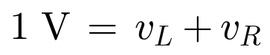
The same current i flows through both elements, so vR = iR and the resistor voltage is y = iR. Rearranging gives i = y/R, which lets vL be written in terms of y:
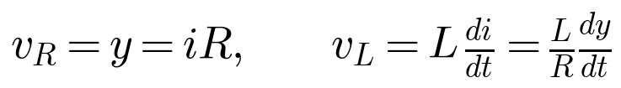
Substituting into KVL and dividing through by R:
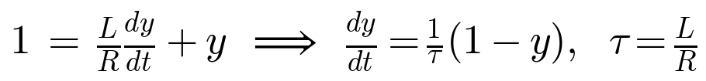
which is the required first-order linear ODE:
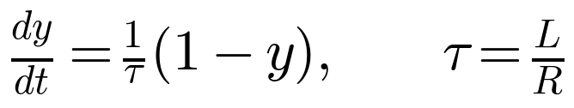
For the assigned parameters R = 4 MΩ and L = 580 µH, the time constant is
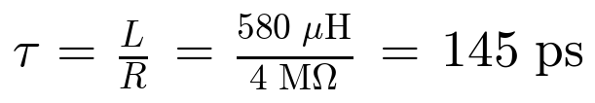
Time is expressed in picoseconds throughout the assignment, so τ = 145 (no trailing units inside the update formulas). The initial condition is y(0) = 0 because the inductor current — and hence vR — is zero immediately before the step.

Q2 — Analytic solution (elegant substitution)
The initial-value problem is
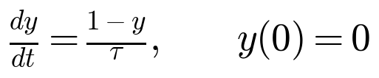
The right-hand side depends only on the quantity (1 − y) — the deviation of y from its equilibrium value 1. It is therefore natural to track that deviation directly. Let u(t) = 1 − y(t):
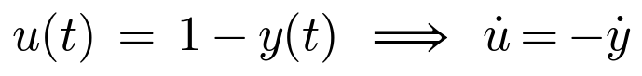
and the ODE becomes the canonical exponential-decay equation
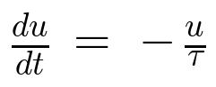
whose general solution is
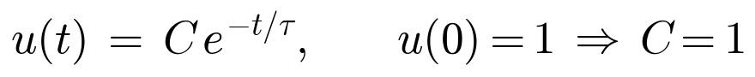
Back-substituting u = 1 − y gives the analytic solution:
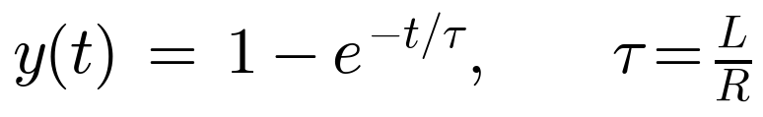
Verification. At t = 0, y(0) = 1 − 1 = 0 ✓. Differentiating, dy/dt = (1/τ) e^(−t/τ) = (1 − y)/τ ✓.
The physical reading is clean: y relaxes from 0 toward the steady-state value 1 with a single time constant τ = 145 ps. At t = τ it has covered 1 − e⁻¹ ≈ 63.2% of the gap, and at 5τ more than 99.3% — the standard first-order RL step response.
This substitution route sidesteps the logarithm integral that separation of variables would introduce: one change of variable reveals that the error from steady state is what actually obeys pure exponential decay, and the answer falls out by inspection.

Numerical solvers (Q3 – Q5)
All three methods approximate the solution on the grid tᵢ = i·h for i = 0, 1, …, N where N·h = 240 ps. The right-hand side is
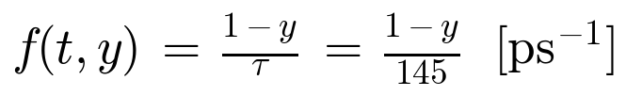
The exact solution y(tᵢ) from Q2 is used to evaluate the truncation error
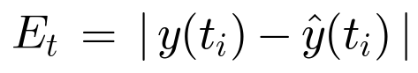
In the tables below, ŷ(tᵢ) is the numerical estimate, y(tᵢ) is the analytic value from Q2, and Et is tabulated to two significant figures in scientific notation. All values ŷ and y are shown to five significant figures. The driver code (common to all three methods) is:
% EE414 – Individual parameters: R = 4 MΩ, L = 580 µH => tau = 145 ps
R = 4e6; L = 580e-6;
tau = (L/R)*1e12; % tau in picoseconds (= 145)

f = @(t,y) (1 - y)/tau; % ODE right-hand side (t in ps)
y_exact = @(t) 1 - exp(-t/tau);
t_end = 240; % simulate from 0 to 240 ps
hVec = [40, 20, 10]; % step sizes

Q3 — Euler’s method
Euler advances the solution using the slope at the start of each interval:
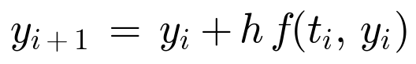
It is the simplest explicit method but also the least accurate — global error is O(h). For this IVP the method always overshoots, because f decreases as y grows, so the start-of-interval slope over-estimates the mean slope across the step. The implementation is the single line inside the for-loop below.
function [t,y] = euler(f, t0, y0, h, tEnd)
N = round((tEnd - t0)/h);
t = (t0:h:tEnd).';
y = zeros(N+1, 1); y(1) = y0;
for i = 1:N
y(i+1) = y(i) + h*f(t(i), y(i));
end
end
Results for h = 40, 20, 10 ps:
h = 40 ps  i tᵢ ŷ(tᵢ) y(tᵢ) Eₜ  0 0 0.00000 0.00000 0  1 40 0.27586 0.24108 3.5×10⁻²  2 80 0.47562 0.42404 5.2×10⁻²  3 120 0.62028 0.56290 5.7×10⁻²  4 160 0.72503 0.66827 5.7×10⁻²  5 200 0.80088 0.74825 5.3×10⁻²  6 240 0.85581 0.80894 4.7×10⁻² |  | h = 20 ps  i tᵢ ŷ(tᵢ) y(tᵢ) Eₜ  0 0 0.00000 0.00000 0  1 20 0.13793 0.12884 9.1×10⁻³  2 40 0.25684 0.24108 1.6×10⁻²  3 60 0.35934 0.33886 2.0×10⁻²  4 80 0.44771 0.42404 2.4×10⁻²  5 100 0.52389 0.49825 2.6×10⁻²  6 120 0.58956 0.56290 2.7×10⁻²  7 140 0.64617 0.61921 2.7×10⁻²  8 160 0.69497 0.66827 2.7×10⁻²  9 180 0.73705 0.71101 2.6×10⁻²  10 200 0.77332 0.74825 2.5×10⁻²  11 220 0.80458 0.78068 2.4×10⁻²  12 240 0.83154 0.80894 2.3×10⁻² |  | h = 10 ps  i tᵢ ŷ(tᵢ) y(tᵢ) Eₜ  0 0 0.00000 0.00000 0  1 10 0.06897 0.06664 2.3×10⁻³  2 20 0.13317 0.12884 4.3×10⁻³  3 30 0.19296 0.18690 6.1×10⁻³  4 40 0.24861 0.24108 7.5×10⁻³  5 50 0.30043 0.29166 8.8×10⁻³  6 60 0.34868 0.33886 9.8×10⁻³  7 70 0.39360 0.38292 1.1×10⁻²  8 80 0.43542 0.42404 1.1×10⁻²  9 90 0.47436 0.46243 1.2×10⁻²  10 100 0.51061 0.49825 1.2×10⁻²  11 110 0.54436 0.53169 1.3×10⁻²  12 120 0.57578 0.56290 1.3×10⁻²  13 130 0.60504 0.59203 1.3×10⁻²  14 140 0.63228 0.61921 1.3×10⁻²  15 150 0.65764 0.64459 1.3×10⁻²  16 160 0.68125 0.66827 1.3×10⁻²  17 170 0.70323 0.69038 1.3×10⁻²  18 180 0.72370 0.71101 1.3×10⁻²  19 190 0.74275 0.73027 1.2×10⁻²  20 200 0.76049 0.74825 1.2×10⁻²  21 210 0.77701 0.76502 1.2×10⁻²  22 220 0.79239 0.78068 1.2×10⁻²  23 230 0.80671 0.79530 1.1×10⁻²  24 240 0.82004 0.80894 1.1×10⁻²

Q4 — Heun’s method (classical RK2)
Heun’s method averages the slope at the start of the interval with the slope at a predicted end-point:
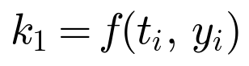
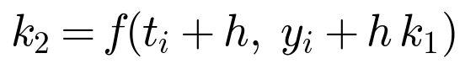
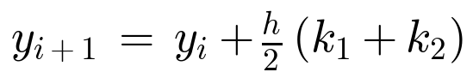
Two function evaluations per step, global error O(h²). For the RL step response the trapezoidal averaging cancels most of Euler’s systematic overshoot.
function [t,y] = rk2(f, t0, y0, h, tEnd) % Heun's method
N = round((tEnd - t0)/h);
t = (t0:h:tEnd).';
y = zeros(N+1, 1); y(1) = y0;
for i = 1:N
k1 = f(t(i), y(i));
k2 = f(t(i) + h, y(i) + h*k1);
y(i+1) = y(i) + (h/2)*(k1 + k2);
end
end
Results for h = 40, 20, 10 ps:
h = 40 ps  i tᵢ ŷ(tᵢ) y(tᵢ) Eₜ  0 0 0.00000 0.00000 0  1 40 0.23781 0.24108 3.3×10⁻³  2 80 0.41907 0.42404 5.0×10⁻³  3 120 0.55722 0.56290 5.7×10⁻³  4 160 0.66252 0.66827 5.8×10⁻³  5 200 0.74278 0.74825 5.5×10⁻³  6 240 0.80395 0.80894 5.0×10⁻³ |  | h = 20 ps  i tᵢ ŷ(tᵢ) y(tᵢ) Eₜ  0 0 0.00000 0.00000 0  1 20 0.12842 0.12884 4.2×10⁻⁴  2 40 0.24035 0.24108 7.4×10⁻⁴  3 60 0.33790 0.33886 9.6×10⁻⁴  4 80 0.42293 0.42404 1.1×10⁻³  5 100 0.49703 0.49825 1.2×10⁻³  6 120 0.56162 0.56290 1.3×10⁻³  7 140 0.61792 0.61921 1.3×10⁻³  8 160 0.66698 0.66827 1.3×10⁻³  9 180 0.70975 0.71101 1.3×10⁻³  10 200 0.74702 0.74825 1.2×10⁻³  11 220 0.77951 0.78068 1.2×10⁻³  12 240 0.80783 0.80894 1.1×10⁻³ |  | h = 10 ps  i tᵢ ŷ(tᵢ) y(tᵢ) Eₜ  0 0 0.00000 0.00000 0  1 10 0.06659 0.06664 5.4×10⁻⁵  2 20 0.12874 0.12884 1.0×10⁻⁴  3 30 0.18676 0.18690 1.4×10⁻⁴  4 40 0.24091 0.24108 1.7×10⁻⁴  5 50 0.29145 0.29166 2.0×10⁻⁴  6 60 0.33863 0.33886 2.3×10⁻⁴  7 70 0.38267 0.38292 2.5×10⁻⁴  8 80 0.42378 0.42404 2.7×10⁻⁴  9 90 0.46215 0.46243 2.8×10⁻⁴  10 100 0.49796 0.49825 2.9×10⁻⁴  11 110 0.53139 0.53169 3.0×10⁻⁴  12 120 0.56259 0.56290 3.0×10⁻⁴  13 130 0.59172 0.59203 3.1×10⁻⁴  14 140 0.61891 0.61921 3.1×10⁻⁴  15 150 0.64428 0.64459 3.1×10⁻⁴  16 160 0.66797 0.66827 3.1×10⁻⁴  17 170 0.69008 0.69038 3.0×10⁻⁴  18 180 0.71072 0.71101 3.0×10⁻⁴  19 190 0.72998 0.73027 3.0×10⁻⁴  20 200 0.74796 0.74825 2.9×10⁻⁴  21 210 0.76474 0.76502 2.8×10⁻⁴  22 220 0.78041 0.78068 2.8×10⁻⁴  23 230 0.79503 0.79530 2.7×10⁻⁴  24 240 0.80868 0.80894 2.6×10⁻⁴

Q5 — Classical fourth-order Runge–Kutta (RK4)
RK4 combines four carefully-weighted slope estimates per step:

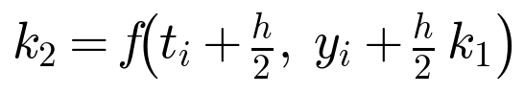
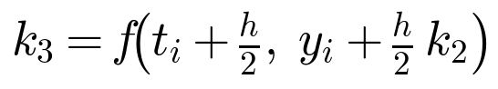
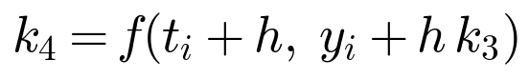
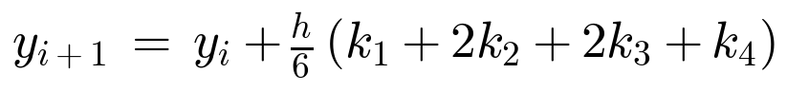
Four function evaluations per step, global error O(h⁴). For this smooth, non-stiff IVP the error at h = 10 ps is already at the 10⁻⁸ level — below any meaningful modelling error from the resistor/inductor tolerances.
function [t,y] = rk4(f, t0, y0, h, tEnd)
N = round((tEnd - t0)/h);
t = (t0:h:tEnd).';
y = zeros(N+1, 1); y(1) = y0;
for i = 1:N
k1 = f(t(i), y(i));
k2 = f(t(i) + h/2, y(i) + h*k1/2);
k3 = f(t(i) + h/2, y(i) + h*k2/2);
k4 = f(t(i) + h, y(i) + h*k3);
y(i+1) = y(i) + (h/6)*(k1 + 2*k2 + 2*k3 + k4);
end
end
Results for h = 40, 20, 10 ps:
h = 40 ps  i tᵢ ŷ(tᵢ) y(tᵢ) Eₜ  0 0 0.00000 0.00000 0  1 40 0.24107 0.24108 1.3×10⁻⁵  2 80 0.42402 0.42404 1.9×10⁻⁵  3 120 0.56287 0.56290 2.2×10⁻⁵  4 160 0.66825 0.66827 2.2×10⁻⁵  5 200 0.74823 0.74825 2.1×10⁻⁵  6 240 0.80892 0.80894 1.9×10⁻⁵ |  | h = 20 ps  i tᵢ ŷ(tᵢ) y(tᵢ) Eₜ  0 0 0.00000 0.00000 0  1 20 0.12884 0.12884 4.1×10⁻⁷  2 40 0.24108 0.24108 7.1×10⁻⁷  3 60 0.33886 0.33886 9.3×10⁻⁷  4 80 0.42404 0.42404 1.1×10⁻⁶  5 100 0.49825 0.49825 1.2×10⁻⁶  6 120 0.56290 0.56290 1.2×10⁻⁶  7 140 0.61921 0.61921 1.2×10⁻⁶  8 160 0.66827 0.66827 1.2×10⁻⁶  9 180 0.71101 0.71101 1.2×10⁻⁶  10 200 0.74825 0.74825 1.2×10⁻⁶  11 220 0.78068 0.78068 1.1×10⁻⁶  12 240 0.80894 0.80894 1.1×10⁻⁶ |  | h = 10 ps  i tᵢ ŷ(tᵢ) y(tᵢ) Eₜ  0 0 0.00000 0.00000 0  1 10 0.06664 0.06664 1.3×10⁻⁸  2 20 0.12884 0.12884 2.4×10⁻⁸  3 30 0.18690 0.18690 3.4×10⁻⁸  4 40 0.24108 0.24108 4.2×10⁻⁸  5 50 0.29166 0.29166 4.9×10⁻⁸  6 60 0.33886 0.33886 5.5×10⁻⁸  7 70 0.38292 0.38292 5.9×10⁻⁸  8 80 0.42404 0.42404 6.3×10⁻⁸  9 90 0.46243 0.46243 6.7×10⁻⁸  10 100 0.49825 0.49825 6.9×10⁻⁸  11 110 0.53169 0.53169 7.1×10⁻⁸  12 120 0.56290 0.56290 7.2×10⁻⁸  13 130 0.59203 0.59203 7.3×10⁻⁸  14 140 0.61921 0.61921 7.3×10⁻⁸  15 150 0.64459 0.64459 7.3×10⁻⁸  16 160 0.66827 0.66827 7.3×10⁻⁸  17 170 0.69038 0.69038 7.2×10⁻⁸  18 180 0.71101 0.71101 7.2×10⁻⁸  19 190 0.73027 0.73027 7.1×10⁻⁸  20 200 0.74825 0.74825 6.9×10⁻⁸  21 210 0.76502 0.76502 6.8×10⁻⁸  22 220 0.78068 0.78068 6.6×10⁻⁸  23 230 0.79530 0.79530 6.5×10⁻⁸  24 240 0.80894 0.80894 6.3×10⁻⁸

