Design and Verification of a Quantised FPGA Accelerator
for Real-Time Neural Image Reconstruction

  - Software-to-hardware co-design, quantised inference, bit-exact verification and KV260 deployment

Fortune Olose

Independent Research and Development Project
FPGA and Digital Hardware Research

Independent technical report documenting research, implementation and verification.

September 2026

Abstract
This project investigates the design and verification of a compact quantised neural-network accelerator for two-times grayscale image reconstruction on an AMD Kria KV260 platform. The work combines residual image reconstruction, integer quantisation, high-level synthesis, register-transfer-level verification and programmable-logic system integration. A 737-parameter residual convolutional network was trained on 500 grayscale patches and evaluated on 20 held-out images. The recovered Round 3 checkpoint is hash-verified, and the floating-point network achieves a mean peak signal-to-noise ratio of 29.054 decibels compared with 28.270 decibels for bicubic interpolation, outperforming bicubic on all 20 validation images. The integer model retains approximately 29.028 decibels. The hardware accelerator uses eight-bit integer weights, wider integer biases and a fixed requantisation step, and targets 200 megahertz on the Kria K26 device. Standalone register-transfer-level testing is bit-exact for 196,608 output pixels under baseline and deterministic interface-backpressure conditions. High-level-synthesis co-simulation also passes for all three golden vectors with zero mismatches. The routed design closes timing and produces preserved deployable artifacts. Physical KV260 validation remains the principal outstanding technical milestone.

Declaration
I declare that this report and the project it describes are exclusively my own work, except where specifically noted. I confirm that I have appropriately cited all information derived from the published and unpublished work of others.

Table of Contents
Abstract 2
Declaration 2
1 Introduction 1
1.1 Problem Statement and Scope 1
1.2 Aim, research question and objectives 2
1.3 Approach and Methodology 3
1.4 Evaluation Strategy and Success Criteria 3
1.5 Broader Impact 4
1.6 Original Contributions and Externally Provided Resources 4
1.7 Structure of report 5
2 Technical Background 6
2.1 Neural image reconstruction and super-resolution 6
2.2 Image-quality metrics 6
2.3 Residual convolutional networks 7
2.4 Quantisation and integer inference 7
2.5 FPGA acceleration and high-level synthesis 8
2.6 KV260 platform and AXI integration 8
2.7 Verification methodology 9
3 Software Reconstruction Methodology and Results 10
3.1 Data preparation and evaluation split 10
3.2 Network architecture and training procedure 10
3.3 Baselines and held-out results 11
3.4 Summary of Software Design Decisions 12
4 Quantisation and Integer Reference Model 12
4.1 Integer parameter export 12
4.2 Golden-vector strategy 12
5 FPGA Accelerator Design and HLS Implementation 13
5.1 Top-level architecture and interfaces 13
5.2 Convolution datapath and parallelism 13
5.3 High-level-synthesis verification and latency 14
5.4 Summary of Accelerator Design Decisions 14
6 Verification Methodology and RTL Validation 14
6.1 Independent standalone harness 14
6.2 Baseline and deterministic-backpressure regressions 14
6.3 Co-simulation recovery and historical-source control 15
7 Vivado System Integration and Implementation 15
7.1 Block design, reset topology and address map 15
7.2 Reproducible block-design replay 16
7.3 Synthesis, implementation and timing closure 16
7.4 Deployable artifacts and provenance 17
8 Results and Analysis 17
8.1 Software quality and quantisation trade-off 17
8.2 Functional-verification evidence 17
8.3 Timing, resources and implementation margin 17
8.4 Current limitations of the evidence 18
8.5 Summary of Established Results 18
9 Physical KV260 Validation and Experimental Results 18
9.1 Hardware setup and board bring-up 18
9.2 Processing-system control and DDR/AXI validation 18
9.3 Golden-vector correctness on physical hardware 18
9.4 Latency, throughput, repeatability and power 18
9.5 Measured versus predicted behaviour 18
10 Discussion 18
10.1 Reconstruction-quality versus hardware-cost trade-off 19
10.2 Software, simulation and physical-hardware agreement 19
10.3 Bottlenecks and generalisability 19
10.4 Reproducibility, limitations and validity 19
11 Conclusions and Future Work 20
11.1 Conclusions 20
11.2 Limitations 20
11.3 Future Work 20
Glossary of terms 21
Nomenclature 21
References 21
Risk Assessment 23
Appendix A - Reproducibility and Artifact Provenance 23
Appendix B - Generative AI Usage Declaration 24

Introduction
Image reconstruction and super-resolution attempt to recover a higher-resolution representation from lower-resolution measurements. The task is intrinsically ill-posed because downsampling removes spatial information: more than one high-resolution image may be consistent with the same low-resolution observation. Conventional interpolation provides a deterministic estimate, whereas learning-based methods use image statistics learned from data to estimate likely high-frequency corrections. Early convolutional approaches demonstrated that end-to-end nonlinear mappings can improve reconstruction quality over conventional interpolation [1], while later work showed that architectural choices strongly affect computational cost and real-time feasibility [2].
The engineering focus of this project is not to maximise neural-network scale. Instead, it investigates whether a deliberately compact reconstruction network can retain a measurable quality advantage after integer quantisation and then be mapped through high-level synthesis to field-programmable gate-array hardware with bit-exact verification, timing closure and a clear path to physical deployment. The result is a software-to-hardware co-design problem spanning machine learning, digital signal processing, fixed-point arithmetic, computer architecture, verification and embedded-system integration.
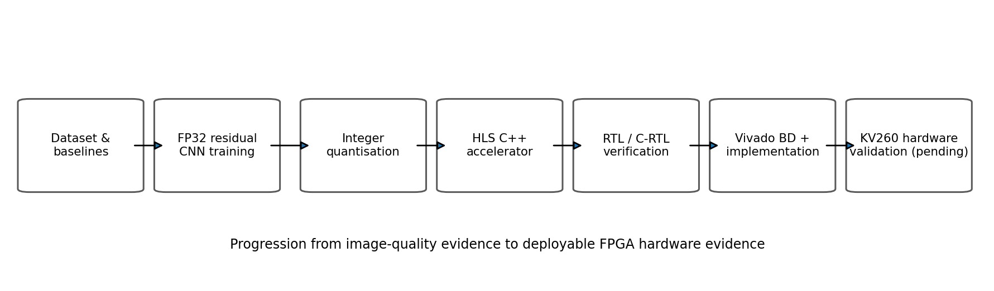
Figure 1 Overall software-to-hardware project flow and the current physical-validation boundary.

Problem Statement and Scope
Neural image reconstruction is usually developed and benchmarked in floating-point software. Edge deployment changes the constraints: arithmetic precision, memory traffic, deterministic latency, resource use, clock frequency and interface behaviour become first-class engineering concerns. Field-programmable gate arrays are attractive because they permit application-specific parallelism and deterministic datapaths, but that flexibility creates a verification burden. A visually plausible software result is not sufficient evidence that the synthesized hardware implements the intended numeric algorithm.
The technical problem addressed in this project is therefore to design a transparent, compact two-times grayscale neural reconstruction model; quantise it to an integer representation suitable for programmable logic; implement the datapath using high-level synthesis; establish a verification chain from software metrics through bit-exact register-transfer-level simulation and routed implementation; and finally evaluate the design on a physical Kria KV260 board.
The scope is intentionally narrow. Single-channel 128 × 128 low-resolution images are reconstructed to 256 × 256 grayscale outputs using a compact residual network. The project does not attempt to reproduce a proprietary commercial upscaler, a large generative model, colour-image reconstruction or a complete video-processing pipeline. The emphasis is on transparent arithmetic, reproducibility, traceable verification and hardware implementation. Physical-board validation is treated as a separate boundary rather than being inferred from simulation.

Aim, research question and objectives
The project aim is to demonstrate a reproducible software-to-field-programmable-gate-array workflow for neural image reconstruction in which image-quality improvement and hardware correctness are both supported by measurable evidence.
The working research question is: can a compact quantised convolutional neural network for two-times grayscale reconstruction be mapped to the AMD Kria KV260 with negligible quality loss relative to the floating-point model, bit-exact agreement between the integer reference and generated hardware, and timing closure at a 200 MHz target clock?
1. Establish bilinear and bicubic reconstruction baselines and a fixed evaluation methodology.
2. Train a compact residual convolutional network that improves mean reconstruction quality on held-out data without relying on a large opaque model.
3. Quantise the trained network to explicit integer parameters and establish golden vectors for exact verification.
4. Implement and optimise the integer datapath in Vitis High-Level Synthesis for the Kria K26 device.
5. Verify the generated register-transfer-level design independently of C simulation, including deterministic AXI backpressure stress.
6. Integrate the accelerator into a reproducible Vivado block design, close timing and preserve deployable hardware artifacts.
7. Validate the full processing-system-to-memory-to-programmable-logic path on the physical KV260 and benchmark end-to-end latency, correctness and power/resource behaviour.

Approach and Methodology
The project follows a staged software-to-hardware co-design methodology. First, deterministic bilinear and bicubic baselines establish the reconstruction reference, after which a compact residual convolutional network is trained and evaluated on held-out grayscale images. The best Round 3 checkpoint is preserved by hash, and image quality is measured using mean squared error and peak signal-to-noise ratio. The trained floating-point network is then converted into an explicit integer reference with eight-bit weights, wider biases and a fixed requantisation rule.
The integer reference is used to generate golden vectors that remain constant across the hardware flow. The same arithmetic contract is checked in high-level-synthesis C simulation, C-to-register-transfer-level co-simulation and an independent register-transfer-level harness with deterministic AXI backpressure. The synthesised accelerator is then integrated into a reproducible Vivado block design, implemented at a 200 MHz target clock and preserved as deployable artifacts. The final stage, intentionally left open in this working draft, is physical KV260 execution and measurement of end-to-end correctness, latency, throughput, repeatability and power.

Evaluation Strategy and Success Criteria
Evaluation is split into progressively stronger layers. Software reconstruction quality is measured on held-out images. Integer quantisation is evaluated against the floating-point model. Three fixed validation images are then used as exact golden vectors for C simulation, C-to-register-transfer-level co-simulation and independent register-transfer-level testing. Vivado synthesis and implementation are used to establish resource use, routed timing and deployment-artifact generation. Physical board measurements remain a separate and explicitly pending validation boundary.
Criterion | Measure | Current status
Software quality | Mean peak signal-to-noise ratio exceeds bicubic | Achieved: 29.054 dB vs 28.270 dB; 20/20 held-out wins
Quantisation fidelity | Small average loss relative to floating point | Achieved: ≈29.028 dB, ≈0.026 dB below floating point
RTL numeric correctness | Exact golden-vector output | Achieved: 196,608/196,608 standalone pixels; 3/3 co-simulation vectors
Timing closure | Routed design meets 200 MHz target | Achieved: setup slack +0.132 ns; hold slack +0.011 ns
Deployable artifacts | Bitstream and hardware platform generated and preserved | Achieved under Vivado 2026.1.1 forward-toolchain rebuild
Physical validation | Real KV260 processing-system / memory / programmable-logic execution | Pending physical board validation

Table 1 Project success criteria and present status.

Broader Impact
The project is relevant to efficient edge and embedded computing because it investigates whether useful image reconstruction can be retained with a deliberately small, quantised model rather than increasing network scale. This direction is consistent with United Nations Sustainable Development Goal 9 (Industry, Innovation and Infrastructure), through the development of reproducible digital hardware for intelligent systems, and Goal 12 (Responsible Consumption and Production), through explicit attention to resource use and the avoidance of unnecessary model complexity. The work does not claim an energy-efficiency advantage until real board power is measured.
The current experiments use generic image data and do not require collection of biometric, medical or otherwise sensitive personal information. Ethical considerations therefore centre mainly on dataset provenance, faithful reporting of model limitations, and avoiding unsupported claims of perceptual enhancement. Environmental considerations include the electrical power and thermal behaviour of the FPGA platform, which will be quantified during physical validation, and the broader trade-off between reconstruction quality and the compute, memory and energy resources required to obtain it.

Original Contributions and Externally Provided Resources
The principal project contributions completed to date are:
• A deliberately compact 737-parameter residual reconstruction network and a fixed evaluation pipeline linking software image quality to a hardware-oriented integer reference.
• An explicit integer export consisting of 720 eight-bit convolution weights, 17 wider biases and a fixed requantisation rule, with golden vectors for exact arithmetic checking.
• A high-level-synthesis accelerator architecture using packed feature maps, channel parallelism and targeted operation binding to achieve a 200 MHz implementation target.
• An independent register-transfer-level verification harness that checks 196,608 output pixels exactly under both baseline and deterministic AXI backpressure conditions.
• A reproducible Vivado replay and evidence-preservation workflow, including reset-topology checking, implementation-strategy comparison, routed timing evidence and hash-preserved deployable artifacts.
• A controlled re-investigation of the historical co-simulation failure demonstrating that both the current and historical accelerator source states pass under Vitis/XSim 2026.1.1.
Externally provided resources include the AMD Kria KV260/K26 hardware platform and documentation, AMD Vitis and Vivado toolchains, the PyTorch software framework and supporting Python image-processing libraries, and third-party source images used during model development. The original source-image dataset is not currently preserved inside the recovered Round 3 archive; this provenance limitation is recorded explicitly and must be resolved where possible before the project archive is considered complete. Any externally authored software, data or documentation used in any public release of the project must remain clearly cited and distinguished from original project work.

Structure of report
Chapter 2 reviews the technical background in super-resolution, residual convolution, quantisation, high-level synthesis and the KV260 architecture. Chapter 3 presents the software reconstruction methodology, training procedure and established Round 3 results. Chapter 4 defines the integer reference model and golden-vector strategy. Chapter 5 describes the accelerator architecture, design decisions and high-level-synthesis optimisations. Chapter 6 presents the verification methodology, independent register-transfer-level testing and the resolved co-simulation investigation. Chapter 7 documents Vivado integration, reproducibility work, timing closure and deployment artifacts. Chapter 8 consolidates and interprets the results already supported by preserved evidence. Chapter 9 is reserved for physical KV260 validation and is intentionally incomplete in this working draft. Chapter 10 provides the discussion that can already be supported and leaves physical-hardware agreement to be completed after board testing. Chapter 11 is structured as Conclusions, Limitations and Future Work and will be updated once the physical measurements are available.

Technical Background

Neural image reconstruction and super-resolution
Single-image super-resolution estimates a high-resolution image from a lower-resolution observation. A useful degradation model is
 | y = D(Hx) + n | (1)
where x is the unknown high-resolution image, H represents blur or the acquisition response, D represents downsampling, n represents noise and y is the observed low-resolution image. Because information is discarded by D, the inverse mapping is not unique. A reconstruction method must therefore introduce assumptions or learned priors about plausible image structure.
Dong et al. demonstrated that a compact convolutional neural network can learn an end-to-end low-to-high-resolution mapping [1]. Shi et al. later showed that real-time constraints motivate careful placement of upsampling and feature extraction operations [2]. These results motivate the present project: reconstruction quality must be balanced against the arithmetic, memory and interface cost that will ultimately be mapped to hardware.
The project uses a deterministic two-times interpolation stage followed by a learned residual correction. Rather than generating the complete high-resolution image from scratch, the network estimates the reconstruction error of the interpolated image. This concentrates the limited model capacity on local high-frequency correction.

Image-quality metrics
Mean squared error measures the average squared pixel difference between a reconstructed image and its reference over N pixels:
 | MSE = (1/N) Σᵢ (xᵢ − yᵢ)² | (2)
Peak signal-to-noise ratio expresses the same error on a logarithmic scale. For images normalised to the interval [0,1], the peak value is one:
 | PSNR = 10 log₁₀(1 / MSE) dB | (3)
Higher peak signal-to-noise ratio corresponds to lower mean squared error. The project uses these metrics because they provide transparent, repeatable pixel-domain comparisons. Exact integer and register-transfer-level verification goes further by requiring equality at every output pixel rather than accepting a numerical tolerance.

Residual convolutional networks
The implemented network contains three 3 × 3 convolution layers. After bilinear two-times upsampling, the first layer maps one input channel to eight feature channels, the second maps eight features to eight features, and the final layer maps the representation back to one grayscale residual channel. Rectified linear activation is used after the first two convolutions; the final residual remains signed so that it may increase or decrease the interpolated pixel value.
 | Yₒ(x,y) = bₒ + Σᵢ Σᵤ Σᵥ Wₒ,ᵢ,ᵤ,ᵥ Xᵢ(x+u,y+v) | (4)
The output image is formed by residual addition:
 | x̂ = x_bilinear + rθ(x_bilinear) | (5)
The total trainable parameter count follows directly from the channel dimensions: 72 weights and 8 biases in the first convolution, 576 weights and 8 biases in the second, and 72 weights and 1 bias in the third, giving 720 weights plus 17 biases = 737 trainable parameters.
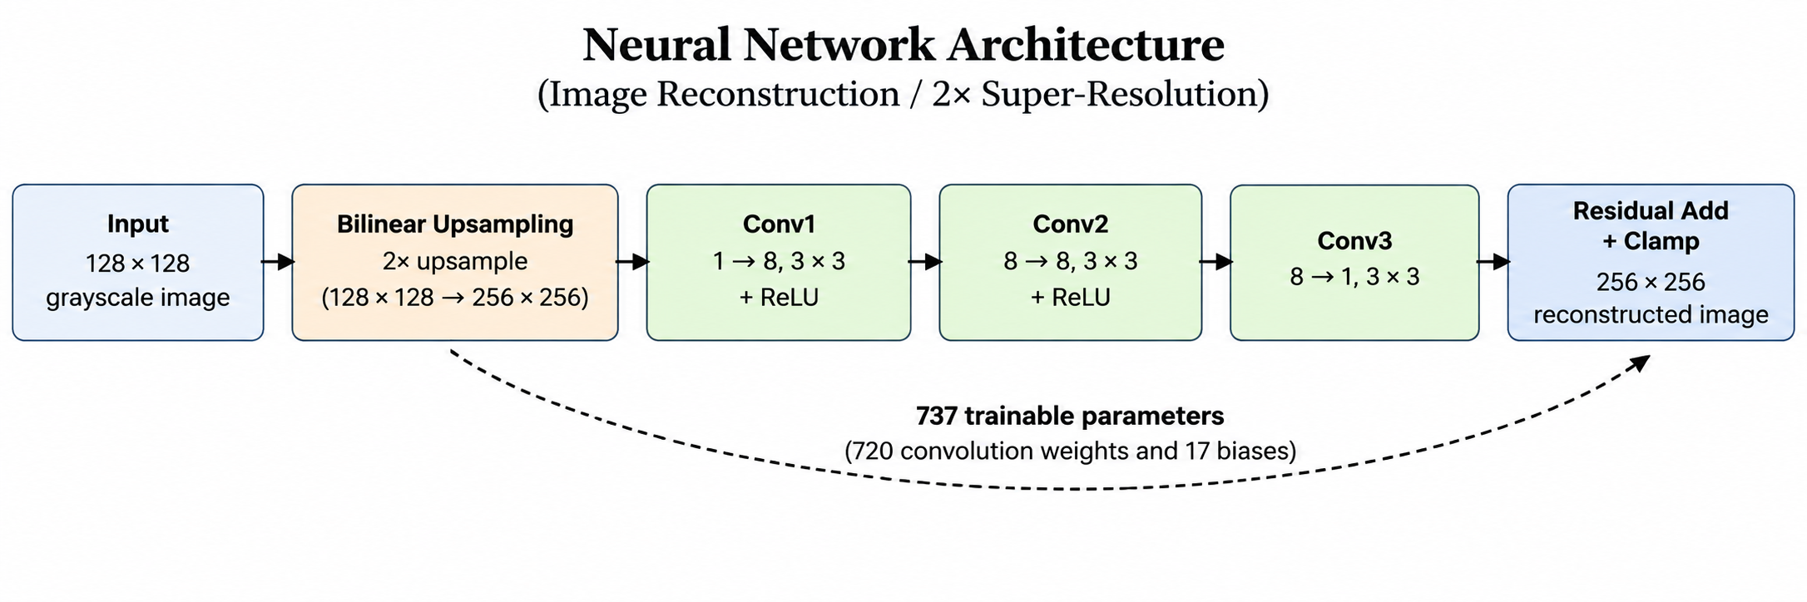
Figure 2 Compact residual convolutional network used for reconstruction and subsequent quantisation.

Quantisation and integer inference
Integer quantisation reduces parameter storage and replaces much of the floating-point arithmetic with explicitly bounded integer operations. Jacob et al. demonstrated that eight-bit integer inference can preserve much of the accuracy of floating-point networks while enabling efficient integer-only execution [3]. FPGA-oriented frameworks such as FINN further illustrate how reduced-precision neural arithmetic can be mapped to highly parallel programmable logic [4].
 | q = clip(round(x / s) + z) | (6)
Equation (6) is the generic affine quantisation form, where s is a scale factor and z is a zero point. The implemented accelerator uses fixed exported integer parameters rather than runtime floating-point conversion. Eight-bit weights are multiplied by integer activations, accumulated at wider precision and requantised using a fixed shift. Wider accumulation is essential because the sum of many signed products can exceed the range of an individual eight-bit or sixteen-bit product.

FPGA acceleration and high-level synthesis
Convolution is dominated by multiply-accumulate operations with substantial spatial and channel-level parallelism. A processor reuses a limited number of arithmetic execution units over time, whereas a field-programmable gate array can instantiate dedicated multipliers, adders, memories and pipelines. The design problem is therefore a trade-off among latency, initiation interval, throughput, resource use, routing and memory bandwidth.
Vitis High-Level Synthesis translates C/C++ descriptions into synthesizable register-transfer-level hardware and supports C simulation, synthesis and C-to-register-transfer-level co-simulation [5]. Pragmas and coding structure influence the generated microarchitecture: loop pipelining allows successive iterations to overlap, while unrolling can create several arithmetic operations in parallel. These transformations improve throughput at the cost of additional hardware resources and routing pressure.

KV260 platform and AXI integration
The AMD Kria K26 system-on-module is based on a Zynq UltraScale+ multiprocessor system-on-chip and combines an Arm-based processing system with programmable logic. The KV260 starter kit provides external DDR memory and programmable-logic resources including digital-signal-processing slices, block RAM and UltraRAM [6], [7]. The target architecture therefore separates software responsibilities from the accelerator datapath: the processing system configures the hardware, allocates buffers and initiates transfers while the programmable logic performs reconstruction.
The accelerator exposes AXI-Lite control and two AXI memory-master interfaces. In the implemented block design, control is mapped at 0xA0000000 with a 64 KiB range. The memory masters use 32-bit data paths and connect through SmartConnect to wider processing-system high-performance ports. SmartConnect can perform protocol and width adaptation between differently sized AXI interfaces [8]. Real board testing remains necessary because behavioral simulation does not prove physical DDR traffic, clock/reset behaviour or software-controlled execution.
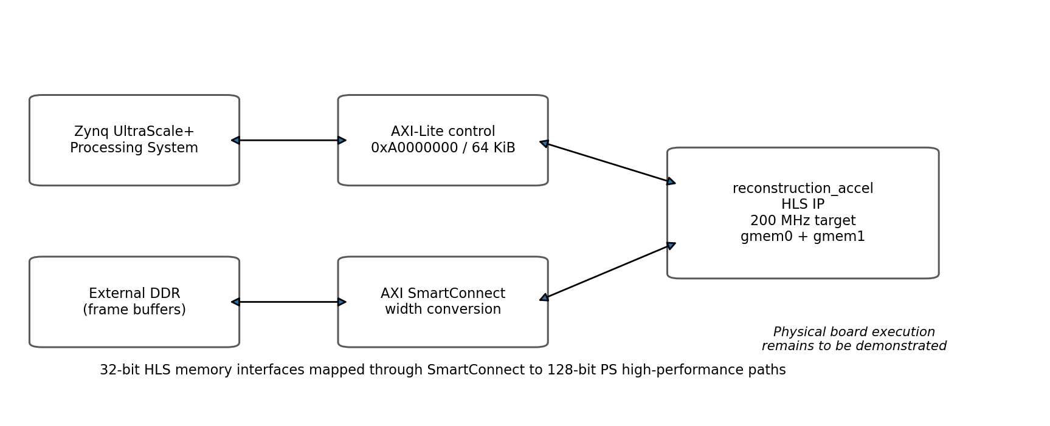
Figure 3 Planned KV260 processing-system, memory and programmable-logic integration.

Verification methodology
Verification is treated as a ladder of progressively stronger evidence rather than a single simulation. Software metrics establish reconstruction quality. Integer golden vectors define the exact arithmetic contract. C simulation checks the high-level-synthesis implementation, C-to-register-transfer-level co-simulation checks synthesized hardware against the same testbench, and an independent register-transfer-level harness exercises the generated AXI interface directly. Vivado implementation establishes structural integration, timing and deployable artifacts. Physical hardware validation is the final and still-pending evidence layer.
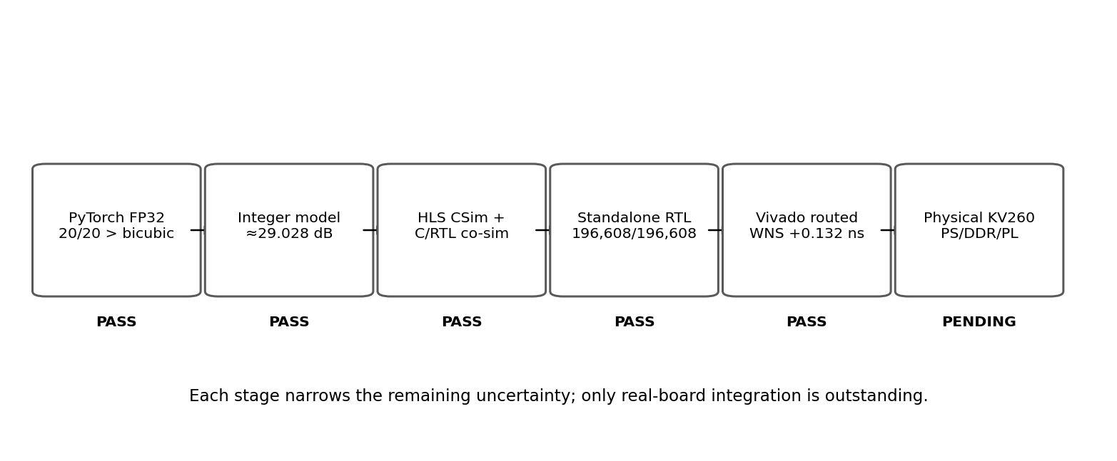
Figure 4 Verification ladder separating software, register-transfer-level, implementation and physical-hardware claims.

Software Reconstruction Methodology and Results

Data preparation and evaluation split
The software pipeline converts source images to grayscale, forms 256 × 256 high-resolution reference patches, generates corresponding 128 × 128 low-resolution inputs with a fixed documented downsampling method and normalises pixel intensities to the interval [0,1]. Training and validation source images are separated before patch extraction to avoid leakage between model optimisation and held-out evaluation. The final Round 3 experiment used 500 training patches and 20 held-out validation images identified as 0805-0824.
The original source-image dataset is not contained in the recovered Round 3 archive. The checkpoint, training history, per-image outputs and comparison tables have been recovered and hash-verified, but the exact source-image corpus and split manifest should be archived before the project archive is considered complete, if still available. This distinction is important: the trained model and reported evaluation are reproducible from preserved outputs, but end-to-end re-training from the original source corpus is not yet fully archived.

Network architecture and training procedure
The software model first performs deterministic bilinear two-times upsampling and then predicts a residual correction using the three-layer convolutional architecture described in Section 2.3. The small hidden width of eight feature channels was chosen to keep the model transparent and tractable for integer export and field-programmable-gate-array implementation.
Round 3 training used a fixed random seed of 42, batch size 8, learning rate 0.001 and 30 epochs, reaching global step 1,890. Mean squared error was used as the optimisation objective. The recovered best_model.pt checkpoint contains the six expected convolution weight/bias tensors and exactly 737 trainable parameters. Its SHA-256 digest matches the previously recorded project hash.
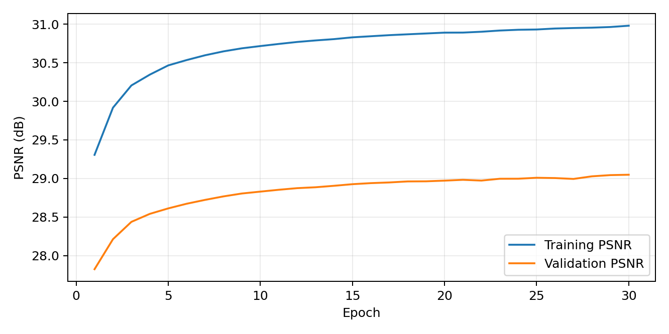
Figure 5 Round 3 training and validation peak signal-to-noise ratio over 30 epochs from the recovered training history.

Baselines and held-out results
Bilinear and bicubic interpolation provide fixed non-neural baselines. The residual network is evaluated on the same 20 held-out images. The floating-point model achieves higher mean peak signal-to-noise ratio than all interpolation baselines and exceeds bicubic on every held-out image.
Method | Mean MSE | Mean PSNR (dB) | Wins vs bicubic
Residual CNN (floating point) | 0.0012433 | 29.054 | 20 / 20
Bicubic | 0.0014894 | 28.270 | -
Torch bilinear | 0.0018490 | 27.331 | -
PIL bilinear | 0.0018518 | 27.324 | -

Table 2 Round 3 reconstruction results on the 20 held-out images.
The floating-point residual network improves mean peak signal-to-noise ratio by approximately 0.784 dB over bicubic interpolation. Because the held-out set is relatively small, this result should be interpreted as evidence for the chosen development dataset rather than a claim of general superiority across all image domains.
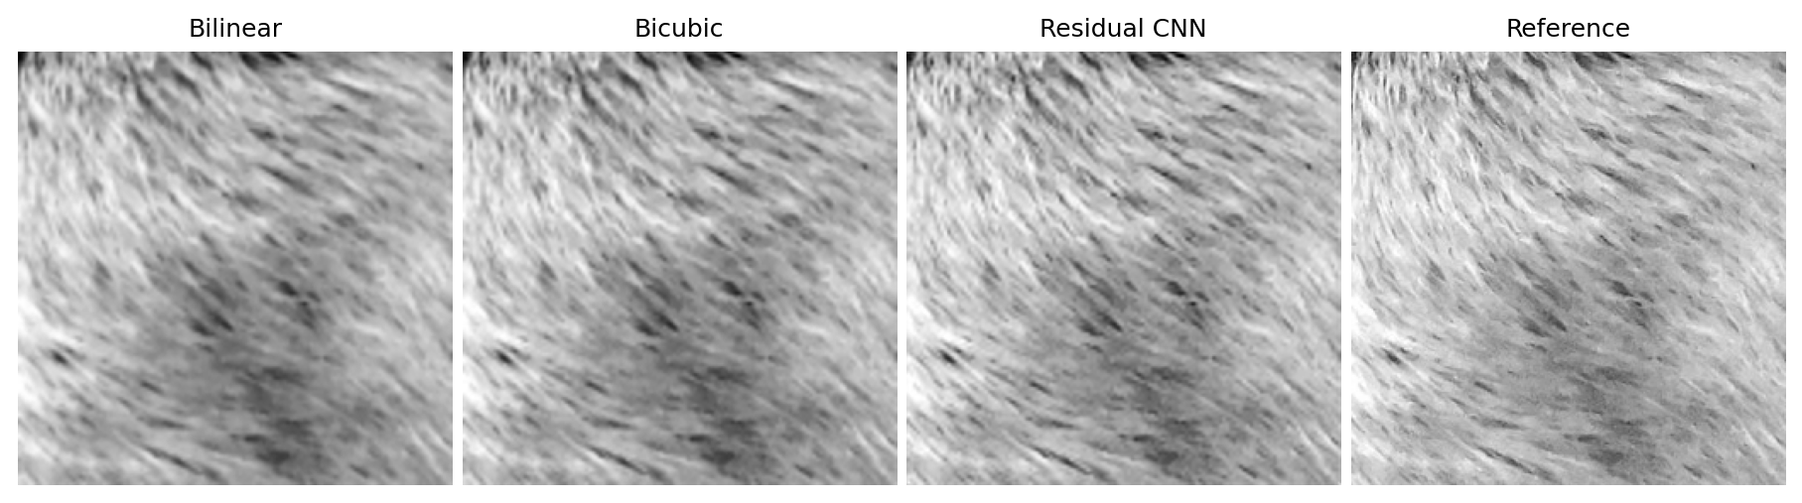
Figure 6 Representative Round 3 reconstruction comparison for validation image 0805.

Summary of Software Design Decisions
The software design deliberately prioritises traceability over model scale. Bilinear two-times upsampling supplies the low-frequency image geometry, allowing the three-layer network to learn a residual correction rather than the complete reconstruction. Eight hidden channels and 3 × 3 kernels provide a small receptive-field hierarchy while keeping the model to 737 trainable parameters. Grayscale input and a fixed two-times scale factor reduce confounding variables and make exact software-to-hardware comparison practical. Mean squared error is used for optimisation because it is directly related to peak signal-to-noise ratio, while the held-out comparison against bicubic interpolation provides the principal software-quality baseline.

Quantisation and Integer Reference Model

Integer parameter export
The trained network is converted to an explicit integer representation for hardware. The exported model contains 720 signed eight-bit convolution weights and 17 signed wider biases. Intermediate products and accumulations use wider arithmetic, and a fixed requantisation shift of 20 bits maps the accumulated result back toward the activation/output scale. The exported parameter set is treated as the authoritative mathematical contract for the accelerator.
The quantised model retains approximately 29.028 dB mean peak signal-to-noise ratio, only about 0.026 dB below the floating-point model, while retaining the 20/20 held-out win rate over bicubic interpolation. This small degradation supports the use of integer arithmetic for the hardware implementation.

Golden-vector strategy
Three validation images, 0805, 0809 and 0824, are selected as fixed golden vectors representing high-quality, very-low-error and more difficult reconstruction cases. Their purpose is not statistical model evaluation; they are deterministic regression cases that require exact output matching across the software and hardware verification chain.
Vector | Integer-reference PSNR (dB) | Verification role
0805 | ≈34.067 | High-quality case
0809 | ≈39.624 | Very high-quality / low-error case
0824 | ≈24.011 | More difficult reconstruction case

Table 3 Golden-vector integer reference quality.
Each 256 × 256 result contains 65,536 output pixels. A three-vector regression therefore checks 196,608 output values. The hardware-level pass criterion is exact equality at every output pixel; no tolerance band is used for the integer comparison.

FPGA Accelerator Design and HLS Implementation

Top-level architecture and interfaces
The accelerator top function is reconstruction_accel and targets the Kria K26 device xck26-sfvc784-2LV-c at a 5 ns clock period. The generated intellectual-property block exposes two AXI memory masters for image buffers and an AXI-Lite control interface. The C++ implementation is written as synthesizable high-level-synthesis code rather than general-purpose processor software; loops, arrays and arithmetic become counters, state machines, memories, multipliers and pipelines in the generated register-transfer-level design.

Convolution datapath and parallelism
The internal architecture uses packed eight-channel feature maps. The second and third convolution stages exploit input-channel parallelism so that multiple products can be evaluated concurrently. The first convolution has only one input channel and therefore provides less channel-level parallelism; it required targeted operation binding to achieve timing closure without increasing model size. This illustrates the central implementation trade-off: additional parallel hardware can reduce cycle count but increases digital-signal-processing, logic and routing demand.

High-level-synthesis verification and latency
C simulation passes all three golden vectors. C synthesis completes successfully, and C-to-register-transfer-level co-simulation under Vitis/XSim 2026.1.1 reports Verilog PASS with 0805, 0809 and 0824 all bit-exact and zero mismatches. The current-source co-simulation reports transaction latency of approximately 5.801 million cycles. This is simulator-reported register-transfer-level latency rather than measured end-to-end board performance; software-control overhead, real DDR traffic and physical interface timing remain to be measured.

Summary of Accelerator Design Decisions
The accelerator design retains the software model exactly but reorganises the computation around hardware constraints. Eight-bit weights reduce storage and multiplier cost, while wider accumulators and biases protect against overflow. Intermediate eight-channel feature maps are packed to support parallel channel access; Conv2 and Conv3 exploit channel-level parallelism, while Conv1 uses targeted operation binding to recover timing margin without changing the trained network. Memory-mapped AXI masters are used for input and output buffers and AXI-Lite provides control, separating datapath behaviour from processor-side orchestration. A 200 MHz clock target was retained throughout implementation so that architectural changes could be compared against a fixed timing objective.

Verification Methodology and RTL Validation

Independent standalone harness
Because the original high-level-synthesis co-simulation attempt failed inside generated AXI verification infrastructure before any accelerator output was compared, an independent register-transfer-level harness was developed around the packaged Verilog and ROM initialisation data. The harness includes an AXI memory model and exact comparison against the integer golden outputs. All 101 copied Verilog and data files were checked against the packaged accelerator source used for the run.

Baseline and deterministic-backpressure regressions
Mode | 0805 | 0809 | 0824 | Total result
STALL=0 baseline | 65,536 / 65,536 | 65,536 / 65,536 | 65,536 / 65,536 | 196,608 / 196,608; 0 mismatches
STALL=1 deterministic AXI backpressure | 65,536 / 65,536 | 65,536 / 65,536 | 65,536 / 65,536 | 196,608 / 196,608; 0 mismatches

Table 4 Standalone register-transfer-level golden-vector verification.
The stress configuration introduces deterministic stalls on AXI address, data and response channels together with AXI-Lite delays. Passing demonstrates that the packaged behavioral register-transfer-level design preserves its numeric result under the exercised interface backpressure. It does not prove physical DDR behaviour, SmartConnect width conversion, post-route functional behaviour or board-level execution.

Co-simulation recovery and historical-source control
The historical Vitis High-Level Synthesis 2025.1.1 co-simulation failed before transaction 1 with a simulator kernel exception in generated AXI verification code. No accelerator output was compared, so the event could not be interpreted as an arithmetic mismatch. The gap was later reopened under Vitis/XSim 2026.1.1 on a 32 GB workstation.
The current source state completed C simulation, synthesis and three-vector co-simulation with zero mismatches. To separate a source-code fix from an environment/toolchain effect, the exact historical source state at Git commit 8c847cd was materialised outside the working repository and run under the same 2026.1.1 toolchain. The historical source also passed all three vectors bit-exact. The source revision is therefore ruled out as the necessary cause of the original failure.
The original root cause remains unisolated because both the tool version and host environment changed. The two passing 2026.1.1 runs used approximately 8.42-8.89 GB peak simulator memory while the original laptop had 8 GB total RAM. Memory pressure is therefore a plausible contributing factor, but the historical record contains a simulator kernel exception rather than an explicit allocation failure. The correct conclusion is that the verification gap is resolved, not that a unique historical cause has been demonstrated.

Vivado System Integration and Implementation

Block design, reset topology and address map
The accelerator was integrated with the Kria processing system through a Vivado block design. Control is mapped through AXI-Lite and data traffic through two memory-master paths. A reset-topology audit established that the shipped design already used the correct polarity: pl_resetn0 is inverted before driving rst_200m/ext_reset_in, while the external-reset-high property remains propagated as one. A historical attempted set-to-zero command was therefore identified as misleading script residue rather than a required design change.

Reproducible block-design replay
The original integrated design depended on the saved block-design file. To improve reproducibility, the design was exported using write_bd_tcl and wrapped in a portable replay script with an explicit reset-topology assertion. A controlled forward-toolchain replay under Vivado 2026.1.1 compared 422 explicit properties from the earlier block design with the reconstructed design. There were no substantive property differences; two apparent mismatches were whitespace/parser artifacts. Part, board, clocking, addresses, reset topology, nets and interfaces were checked before synthesis.

Synthesis, implementation and timing closure
Vivado 2026.1.1 synthesis completed successfully. The default implementation routed fully but missed setup timing with worst negative slack of -0.104 ns. Three implementation-only strategies were then evaluated from the same synthesized design without source or constraint changes. Performance_Explore and Performance_ExplorePostRoutePhysOpt both achieved +0.132 ns setup slack; Performance_NetDelay_high achieved +0.044 ns. Performance_Explore was selected because it produced the best timing with the simpler and faster implementation path.
Metric | Preferred routed result
Target clock | 200 MHz (5 ns)
Setup WNS / TNS | +0.132 ns / 0
Hold WHS / THS | +0.011 ns / 0
Routing | 14,401 / 14,401 routable nets; 0 routing errors
LUT / FF | 7,125 / 6,090
DSP | 69
BRAM / URAM | 45.5 / 32
Vivado estimated power | ≈3.00 W (estimate only; not measured board power)

Table 5 Preferred routed implementation summary using Performance_Explore.

Deployable artifacts and provenance
A bitstream and fixed hardware-platform archive including the bitstream were generated from the passing routed design. Both are hash-verified and preserved. Unpacking the hardware-platform archive confirmed that its embedded bitstream is byte-identical to the preserved standalone bitstream. Build artifacts were produced from source state a5e1e07; the later repository head 449606ff contains documentation-only updates recording the resolved co-simulation status, and the deployment artifacts were not regenerated after that documentation change.

Results and Analysis

Software quality and quantisation trade-off
The floating-point model improves mean peak signal-to-noise ratio by approximately 0.784 dB over bicubic interpolation across the 20 held-out images. Integer quantisation reduces the average result by only about 0.026 dB. For this model and dataset, the measured numerical cost of moving from floating-point parameters to the exported integer representation is therefore small relative to the improvement over bicubic interpolation.

Functional-verification evidence
Two independent register-transfer-level verification paths now agree with the integer reference. Standalone simulation verifies 196,608 output pixels exactly under both baseline and deterministic-backpressure conditions. Vitis/XSim co-simulation independently verifies the same three golden vectors with zero mismatches for both the current source and the historical source used in the failed 2025.1.1 experiment. This substantially reduces the probability that the observed correctness is an artifact of a single verification wrapper.

Timing, resources and implementation margin
The preferred routed implementation meets the 200 MHz target with +0.132 ns setup margin and +0.011 ns hold margin while using 69 digital-signal-processing slices, 45.5 block-RAM equivalents and 32 UltraRAM blocks. Timing closure was recovered using implementation strategy only; the logical design and constraints were not changed between the default failing implementation and the passing Performance_Explore run. The experiment therefore shows that the 2026.1.1 timing deficit was recoverable through placement/routing optimisation rather than a required functional redesign.

Current limitations of the evidence
The existing evidence does not prove physical DDR access, SmartConnect width conversion on silicon, processing-system software control, board clock/reset behaviour, sustained execution, measured power or end-to-end latency. The project therefore deliberately avoids claiming physical deployment before the KV260 is programmed and exercised. Similarly, Vivado power is an estimate rather than a measured board value, and the recovered training archive does not yet establish complete provenance for the original source-image dataset.

Summary of Established Results
The evidence available before physical-board testing supports four bounded conclusions. First, the floating-point residual network improves mean reconstruction quality over bicubic interpolation on all 20 held-out images. Second, integer quantisation preserves nearly all of that quality, with only about 0.026 dB mean peak-signal-to-noise-ratio loss. Third, the generated hardware is bit-exact with the integer reference for the exercised golden vectors in both high-level-synthesis co-simulation and independent register-transfer-level testing, including deterministic interface stalls. Fourth, the integrated Vivado design routes successfully and meets the 200 MHz timing target. These results do not yet establish real-board memory traffic, processor control, physical latency, throughput, thermal behaviour or measured power.

Physical KV260 Validation and Experimental Results

Hardware setup and board bring-up

Processing-system control and DDR/AXI validation

Golden-vector correctness on physical hardware

Latency, throughput, repeatability and power

Measured versus predicted behaviour

Discussion
This chapter separates conclusions that are already supported by software, simulation and routed implementation from those that depend on physical KV260 measurements. Hardware-dependent comparisons remain intentionally incomplete in this working draft.

Reconstruction-quality versus hardware-cost trade-off
The current results show that a small model can retain a measurable reconstruction advantage after integer conversion. The floating-point model reaches 29.054 dB mean peak signal-to-noise ratio compared with 28.270 dB for bicubic interpolation, while the integer model remains at approximately 29.028 dB. This quality is obtained with 737 parameters and a routed implementation using 69 DSP slices, 45.5 BRAMs and 32 URAMs. The principal unresolved part of the trade-off is energy and end-to-end latency: Vivado power is an estimate, not a board measurement, and the simulator-reported accelerator latency does not include processor orchestration or real DDR behaviour.

Software, simulation and physical-hardware agreement

Bottlenecks and generalisability
The architecture is intentionally specialised to 128 × 128 single-channel inputs, a two-times reconstruction factor and a fixed three-layer residual network. This narrow scope improves traceability and verification but limits generalisation to colour images, arbitrary resolutions and larger neural architectures. The convolutional datapath remains compute intensive despite the small parameter count because weights are reused at every output location, so throughput depends on the balance between multiplier parallelism, on-chip feature storage and external-memory traffic. The final board measurements are required to determine whether computation, DDR bandwidth or processor-side overhead dominates the realised system.

Reproducibility, limitations and validity
Reproducibility is strengthened by preserved Git source states, hash-verified checkpoints and deployable artifacts, deterministic golden vectors, portable block-design replay and independent RTL regressions. The main archival limitation is that the recovered Round 3 package does not contain the original source-image dataset, so the exact training corpus cannot yet be reconstructed solely from the preserved archive. Validity is also bounded by the evaluation population: the 20-image held-out set supports the reported software comparison, while the three golden vectors are verification cases rather than a statistical sample of model quality. Physical validity remains pending until the real processing-system, DDR, SmartConnect and programmable-logic path is exercised on the KV260.

Conclusions and Future Work

Conclusions
Based on the completed pre-hardware evidence, the project has demonstrated a reproducible path from a compact learned reconstruction model to a timing-closed FPGA implementation. The residual network improves held-out reconstruction quality over bicubic interpolation, quantisation introduces only a small measured quality penalty, and the resulting integer arithmetic is reproduced exactly by the generated hardware for the exercised golden vectors. The routed design meets the 200 MHz target and deployable artifacts have been preserved. The final technical conclusion must nevertheless remain conditional until the same arithmetic and system behaviour are demonstrated on the physical KV260.

Limitations
The current work is limited to grayscale two-times reconstruction with a deliberately small network and a 20-image held-out validation set. Only three frames are used for exact hardware golden-vector regression, which is sufficient for deterministic arithmetic verification but not for broad statistical claims. The original source-image dataset is not yet preserved with the recovered Round 3 archive. Most importantly, no current evidence proves real PS-to-DDR-to-programmable-logic execution, measured board power, thermal behaviour, or sustained end-to-end throughput. The historical 2025.1.1 co-simulation failure is resolved as a verification gap but its precise root cause remains confounded between toolchain and host-environment changes.

Future Work
The immediate next step is physical KV260 validation: program the preserved design, verify AXI-Lite control and DDR buffers, execute golden vectors 0805, 0809 and 0824, and require 196,608 of 196,608 output pixels to match the integer reference. Accelerator-only and end-to-end latency, throughput, repeatability, temperature and board power should then be measured and compared with HLS/Vivado estimates. After the core claim is closed, useful extensions include evaluation on a larger and fully archived dataset, colour-image reconstruction, alternative quantisation widths, streaming or tiled memory architectures, and comparison against CPU/GPU implementations using common quality, latency and energy metrics.

Glossary of terms
Term | Meaning
AXI | AMBA Advanced eXtensible Interface used for control and memory transactions.
BD | Vivado block design.
BRAM | Block RAM implemented in FPGA fabric.
CNN | Convolutional neural network.
CSim | C/C++ behavioural simulation in Vitis High-Level Synthesis.
DSP | Dedicated FPGA arithmetic slice.
HLS | High-level synthesis from C/C++ to register-transfer-level hardware.
PS / PL | Processing System / Programmable Logic in the Zynq multiprocessor system-on-chip.
PSNR | Peak signal-to-noise ratio.
RTL | Register-transfer level hardware description.
URAM | UltraRAM memory resource.
WNS / WHS | Worst setup slack / worst hold slack; positive values indicate timing margin.

Nomenclature
Symbol | Definition
N | Number of pixels in the evaluated image.
xᵢ | Reconstructed pixel i.
yᵢ | Reference pixel i.
s | Quantisation scale.
z | Quantisation zero point.
q | Quantised integer value.
rθ | Learned residual function parameterised by θ.
D | Downsampling operator.
H | Image-degradation or blur operator.

References
[1] C. Dong, C. C. Loy, K. He and X. Tang, “Image Super-Resolution Using Deep Convolutional Networks,” IEEE Transactions on Pattern Analysis and Machine Intelligence, vol. 38, no. 2, pp. 295-307, 2016, doi: 10.1109/TPAMI.2015.2439281.
[2] W. Shi et al., “Real-Time Single Image and Video Super-Resolution Using an Efficient Sub-Pixel Convolutional Neural Network,” Proceedings of the IEEE Conference on Computer Vision and Pattern Recognition, pp. 1874-1883, 2016, doi: 10.1109/CVPR.2016.207.
[3] B. Jacob et al., “Quantization and Training of Neural Networks for Efficient Integer-Arithmetic-Only Inference,” Proceedings of the IEEE Conference on Computer Vision and Pattern Recognition, pp. 2704-2713, 2018.
[4] Y. Umuroglu et al., “FINN: A Framework for Fast, Scalable Binarized Neural Network Inference,” Proceedings of the ACM/SIGDA International Symposium on Field-Programmable Gate Arrays, 2017, arXiv:1612.07119.
[5] AMD, Vitis High-Level Synthesis User Guide, UG1399, version 2026.1, 2026.
[6] AMD, Kria K26 SOM Data Sheet, DS987, rev. 1.6, 2026.
[7] AMD, Kria KV260 Vision AI Starter Kit Product Brief, 2026.
[8] AMD, SmartConnect LogiCORE IP Product Guide, PG247, 2026.
[9] United Nations, “Goal 9: Industry, Innovation and Infrastructure,” Sustainable Development Goals, accessed September 2026. [Online]. Available: https://sdgs.un.org/goals/goal9
[10] United Nations, “Goal 12: Responsible Consumption and Production,” Sustainable Development Goals, accessed September 2026. [Online]. Available: https://sdgs.un.org/goals/goal12

Risk Assessment
This appendix contains the unsigned electronic copy of the project risk assessment. Its content should match the most recently signed-off risk assessment used for project work; signatures and personal identifying information are omitted from the shared report copy for GDPR/privacy and future sharing.
Hazard | Likelihood | Severity | Controls / residual risk
Electrostatic discharge to KV260 | Possible | Moderate | Use ESD-safe handling; discharge before contact; store board in antistatic packaging. Residual risk: low.
Short circuit / incorrect connection | Unlikely | Moderate | Power down before wiring; inspect connectors; use manufacturer-specified supply only. Residual risk: low.
Thermal stress during long FPGA runs | Possible | Moderate | Use supplied fan/heatsink; monitor temperature; stop on abnormal thermal behaviour. Residual risk: low.
Data/evidence loss | Possible | Moderate | Git remote, SHA-256 manifests, frozen build/evidence directories and separate artifacts. Residual risk: low.
Excessive tool runtime / workstation load | Possible | Low | Limit parallel jobs where needed; monitor RAM/disk; preserve checkpoints to avoid unnecessary rebuilds. Residual risk: low.

Appendix A - Reproducibility and Artifact Provenance
Artifact | Identifier / SHA-256 | Status
Round 3 best_model.pt | af6c79ce172c70a97a565edd76ea183af25c8fcc4cb2002de2a575a15c335ac5 | Recovered and hash-verified
Git repository | kv260-integration @ 449606ffac962080301e001e1723a42b39bf861c | Clean and synchronized with origin
Preferred routed DCP | a0d6d36cacf0e2d74bb63e1a345329eb949d1479269a095410a562a5b873b727 | Preserved
BIT | 9296fc80638ec7fcb4750c7fc598f185bb150c45ee3b49e6bae41ffc226dbd03 | Preserved; not yet programmed on board
XSA | c4222e0d05ea2c8d35ae63d6617d37df770a82fd4eb8304bb5cebf6eb760dd70 | Preserved; embedded bitstream verified
Standalone RTL regression | 196,608 / 196,608 pixels; 0 mismatches in STALL=0 and STALL=1 | PASS
HLS C/RTL co-simulation | 3 / 3 golden vectors; 0 mismatches under 2026.1.1 | PASS

Build artifacts were produced from source state a5e1e07. The later repository head 449606ff contains documentation updates recording the resolved co-simulation status. The bitstream and hardware-platform artifacts were not regenerated after the documentation-only commit.

Appendix B - Generative AI Usage Declaration
To be completed by the author before public release if required by the chosen publication or sharing context. This working draft intentionally does not pre-populate tool names, prompts or claims of use. Any final declaration should describe only actual, permitted document-editing assistance and must remain consistent with the signed authorship declaration and the applicable disclosure requirements.

Appendix C - Source-Code Implementation Walkthrough
This appendix connects the report-level architecture and verification claims to the source code that implements them. The selected excerpts are taken from the project repository source state a5e1e07, the source state recorded for the preserved build artifacts. Listings are intentionally selective: they show the control and arithmetic mechanisms needed to understand the design while leaving complete files in the repository.
C.1 Software residual model and training loop
The software model implements residual super-resolution directly. The input is first enlarged by deterministic bilinear interpolation. The three convolution layers then predict only the correction to that baseline, and the residual is added back to form the reconstruction. This source structure is the executable counterpart of the network diagram used earlier in the report.
Listing C.1 Residual forward path from src/model_residual.py.
def forward(self, x):
baseline = F.interpolate(
x, scale_factor=2,
mode="bilinear", align_corners=False
)
residual = F.relu(self.conv1(baseline))
residual = F.relu(self.conv2(residual))
residual = self.conv3(residual)
output = baseline + residual
return output
The final convolution was initialised to zero in the same source file, so the untrained network initially reproduces the bilinear baseline exactly. Round 3 training then updates the convolution parameters by minimising mean-squared error using Adam. The essential optimisation step is shown below; validation MSE is converted to PSNR and the best checkpoint is preserved whenever validation error improves.
Listing C.2 Core optimisation step from src/train_round3.py.
optimizer.zero_grad()
output = model(lr)
loss = criterion(output, hr)
loss.backward()
optimizer.step()
C.2 Integer reference, requantisation and golden-vector generation
The hardware reference avoids runtime floating-point conversion. Accumulators are multiplied by fixed integer requantisation multipliers, rounded with a signed right shift and clipped into the next activation range. The same arithmetic is used when producing the golden vectors, which is why an exact integer comparison can be required later in HLS and RTL verification.
Listing C.3 Fixed signed requantisation from src/generate_golden_vectors.py.
def rounded_shift_signed(value, shift):
offset = 1 << (shift - 1)
positive = (value + offset) >> shift
negative = -(((-value) + offset) >> shift)
return np.where(value >= 0, positive, negative).astype(np.int64)
def requant_uint8(accumulator, multiplier):
product = accumulator * multiplier[:, None, None]
q = rounded_shift_signed(product, REQUANT_SHIFT)
return np.clip(q, 0, 255).astype(np.uint8)
The golden-vector generator applies the integer convolutions in the same order as the network, then converts the signed residual into the common output-tick domain before adding it to the exact bilinear baseline. The saved intermediate arrays (bilinear ticks, branch input, Conv1, Conv2, residual and final output) make arithmetic mismatches localisable rather than treating the accelerator as a black box.
Listing C.4 Condensed integer inference path used to produce golden outputs.
acc1 = conv2d_integer(q0[np.newaxis, :, :], w1, b1)
q1 = requant_uint8(acc1, m1)
acc2 = conv2d_integer(q1, w2, b2)
q2 = requant_uint8(acc2, m2)
acc3 = conv2d_integer(q2, w3, b3)
q_residual = requant_int8(acc3, m3)
output_ticks = baseline_ticks + residual_ticks[0]
output_ticks = np.clip(output_ticks, 0, OUTPUT_DEN).astype(np.uint16)
C.3 HLS interfaces, packed feature storage and synthesis directives
The HLS top function exposes two AXI4 memory masters for the input and output image buffers and an AXI-Lite control bundle. Eight UINT8 feature channels are packed into a 64-bit word so one memory access supplies all channel values for a spatial location. The optimized source binds the two large intermediate feature maps to UltraRAM and partitions weight arrays to support parallel access.
Listing C.5 Selected interface and storage directives from hls/src/reconstruction_accel.cpp.
typedef ap_uint<64> feature_word_t;
void reconstruction_accel(
const uint8_t input[INPUT_PIXELS],
uint16_t output[OUTPUT_PIXELS]
) {
#pragma HLS INTERFACE m_axi port=input offset=slave bundle=gmem0 depth=16384
#pragma HLS INTERFACE m_axi port=output offset=slave bundle=gmem1 depth=65536
#pragma HLS INTERFACE s_axilite port=input bundle=control
#pragma HLS INTERFACE s_axilite port=output bundle=control
#pragma HLS INTERFACE s_axilite port=return bundle=control
#pragma HLS bind_storage variable=conv1_out type=ram_1p impl=uram
#pragma HLS bind_storage variable=conv2_out type=ram_1p impl=uram
#pragma HLS ARRAY_PARTITION variable=CONV2_WEIGHTS cyclic factor=8 dim=1
The accelerator also uses explicit pipelining, loop unrolling and DSP binding in the convolution path. These directives are not annotations for documentation; they change the generated microarchitecture. For example, an initiation interval of one allows successive window positions to enter the pipeline on consecutive cycles, while unrolling exposes parallel arithmetic and the bind_op directive places the requantisation multiply in a DSP slice.
Listing C.6 Abridged Conv1 scheduling and DSP-binding directives.
CONV1_X_PAD:
for (int px = 0; px < OUTPUT_W + 2; ++px) {
#pragma HLS PIPELINE II=1
// line-buffer/window update omitted here
CONV1_OC:
for (int oc = 0; oc < CHANNELS; ++oc) {
#pragma HLS PIPELINE II=1
#pragma HLS UNROLL factor=8
// nine 3x3 multiply-accumulates form acc
const int64_t product = ((int64_t)acc) * ((int64_t)CONV1_MULT[oc]);
#pragma HLS bind_op variable=product op=mul impl=dsp latency=2
}
}
C.4 Bit-exact RTL checking and deterministic AXI backpressure
The standalone RTL environment deliberately varies interface timing instead of assuming an always-ready memory system. When STALL=1, the AXI RAM model periodically withholds AWREADY, ARREADY and WREADY; it also inserts read-data and write-response delays. This tests whether the generated master interfaces obey the AXI handshake rules while preserving the numerical result.
Listing C.7 Selected backpressure logic from hls/reports/standalone_rtl_sim/axi_ram.sv.
assign awready = aresetn && !wr_active && !bpending && !bvalid &&
(!stall_enable || tick%7 != 0);
assign arready = aresetn && !rd_active && !rvalid &&
(!stall_enable || tick%5 != 0);
assign wready = aresetn && wr_active &&
(!stall_enable || tick%4 != 0);
if ((arvalid && !arready) || (awvalid && !awready) ||
(wvalid && !wready))
stalled_cycles <= stalled_cycles + 1;
The testbench reads each 16-bit output pixel from the simulated output RAM and compares it with the committed golden value. It also checks that both output bytes were actually written. Any mismatch is fatal, so the acceptance criterion remains exactly zero differing pixels rather than a tolerance-based image metric.
Listing C.8 Zero-tolerance output checker from hls/reports/standalone_rtl_sim/tb_body.sv.
if ($value$plusargs("STALL=%d", stress))
stall_enable = (stress != 0);
for (i = 0; i < 65536; i = i + 1) begin
actual = {output_ram.mem[offset_out+2*i+1],
output_ram.mem[offset_out+2*i]};
if (actual !== expected[i] ||
output_ram.written[offset_out+2*i] !== 1'b1 ||
output_ram.written[offset_out+2*i+1] !== 1'b1)
mismatches = mismatches + 1;
end
if (mismatches)
$fatal(1, "RTL_GOLDEN_FAIL id=%s mismatches=%0d", case_id, mismatches);
C.5 Reproducible Vivado replay and reset-topology checking
The Vivado design is reproduced through Tcl rather than depending only on a saved GUI project. The replay wrapper derives repository-relative paths, creates a fresh KV260 project, registers the committed HLS IP repository and then sources the exported block-design Tcl. This makes the block design reconstructable on a clean path and turns missing IP into an explicit build failure.
Listing C.9 Core block-design replay steps from vivado/replay_bd.tcl.
set _script_dir [file dirname [file normalize [info script]]]
set _repo_root [file dirname $_script_dir]
set _ip_repo [file join $_repo_root vivado ip_repo]
set _bd_tcl [file join $_script_dir neural_reconstruction_bd.tcl]
create_project replay_bd $_out -part xck26-sfvc784-2LV-c -force
set_property board_part xilinx.com:kv260_som:part0:1.4 [current_project]
set_property ip_repo_paths $_ip_repo [current_project]
update_ip_catalog
source $_bd_tcl
A separate read-only assertion script then checks the reset topology rather than silently modifying it. In particular, it observes the propagated C_EXT_RESET_HIGH property and fails the build if the value is inconsistent with the verified inverted pl_resetn0 path. This converts a previously manual integration assumption into an executable regression guard.
Listing C.10 Reset-polarity assertion from vivado/assert_reset_topology.tcl.
set _erh [get_property CONFIG.C_EXT_RESET_HIGH [get_bd_cells rst_200m]]
if {$_erh ne "1"} {
_fail "rst_200m C_EXT_RESET_HIGH = '$_erh', expected '1'"
} else {
_ok "rst_200m C_EXT_RESET_HIGH = 1"
}
puts "ASSERT_RESET_TOPOLOGY_PASS"
Together, these source components implement the complete pre-hardware chain described in the report: PyTorch reconstruction and training, integer reference generation, synthesizable HLS, exact RTL regression under interface stress, and reproducible Vivado integration. Physical KV260 control software remains the next source component to document once the board-validation stage is completed.

