Design and Verification of a Quantised FPGA Accelerator
for Real-Time Neural Image Reconstruction
  - Software-to-hardware co-design, bit-exact verification and KV260 deployment
Fortune Olose
Independent Research and Development Project
FPGA and Digital Hardware Research

  - INTERIM REPORT
Independent interim technical report documenting research, implementation and verification progress to date.
September 2026

Abstract
This project investigates the design and verification of a compact quantised convolutional neural network (CNN) accelerator for real-time 2× grayscale image reconstruction on an AMD Kria KV260 platform. The work combines neural reconstruction, integer quantisation, high-level synthesis (HLS), RTL verification and Vivado system integration. A 737-parameter residual CNN was trained on 500 grayscale patches and evaluated on 20 held-out images. The recovered Round 3 checkpoint is SHA-256 verified, and the FP32 network achieves a mean PSNR of 29.054 dB compared with 28.270 dB for bicubic interpolation, outperforming bicubic on all 20 validation images. The integer model retains approximately 29.028 dB mean PSNR. The accelerator uses INT8 weights, INT32 biases and a fixed requantisation step, and targets 200 MHz on the Kria K26 device. Standalone RTL testing is bit-exact for 196,608 output pixels under both baseline and deterministic AXI backpressure conditions. Vitis HLS C/RTL co-simulation also passes for all three golden vectors with zero mismatches. Vivado implementation closes timing with +0.132 ns setup slack and produces preserved BIT/XSA artifacts. Physical KV260 validation remains the principal outstanding milestone.
Declaration
I declare that this interim report and the project it describes are exclusively my own work, except where specifically noted. I confirm that I have appropriately cited information derived from the published and unpublished work of others. Tool-assisted development and verification activities are documented as engineering workflow support; all project claims in this report are based on preserved experimental evidence and are bounded by the stated limitations.
Signed: ______________________________ Date: __________________

Table of Contents
Abstract ii
Declaration ii
1 Introduction 1
1.1 Motivation and problem statement 1
1.2 Aim, research question and objectives 1
1.3 Scope and success criteria 2
2 Technical Background 2
2.1 Neural image reconstruction and super-resolution 2
2.2 Image-quality metrics 2
2.3 Compact residual CNN architecture 3
2.4 Quantisation and integer inference 3
2.5 FPGA acceleration and high-level synthesis 3
2.6 KV260 platform and AXI integration 4
2.7 Verification methodology 4
2.8 Safety, ethics and sustainability 5
3 Progress and Work Plan 5
3.1 Training pipeline and Round 3 results 5
3.2 Quantisation and golden vectors 6
3.3 HLS implementation and optimisation 7
3.4 Standalone RTL verification 7
3.5 Vivado integration and reproducibility 7
3.6 Timing closure and deployable artifacts 8
3.7 HLS co-simulation recovery and control experiment 8
3.8 Current objective status 9
3.9 Remaining hardware work 9
3.10 Schedule risks and mitigation 9
3.11 Gantt chart 10
4 Interim Conclusions 10
Glossary of Terms 11
Nomenclature 11
References 12
Appendix A - Interim Risk Assessment 12
Appendix B - Artifact Provenance Snapshot 13

1 Introduction
Image reconstruction and super-resolution attempt to recover a higher-resolution representation from lower-resolution measurements. The problem is intrinsically ill-posed because downsampling removes spatial detail; therefore reconstruction depends on learned or assumed image priors. CNN-based methods demonstrated that an end-to-end nonlinear mapping can improve reconstruction quality over conventional interpolation [1], while later work showed that architectural choices strongly affect computational cost and real-time feasibility [2].
The engineering focus of this project is not to maximise neural-network scale. Instead, it asks whether a deliberately compact reconstruction network can retain a measurable quality advantage after integer quantisation and then be mapped through HLS to FPGA hardware with bit-exact verification, timing closure and a clear path to physical deployment. This creates a tractable co-design problem spanning machine learning, fixed-point arithmetic, computer architecture, RTL verification and embedded-system integration.
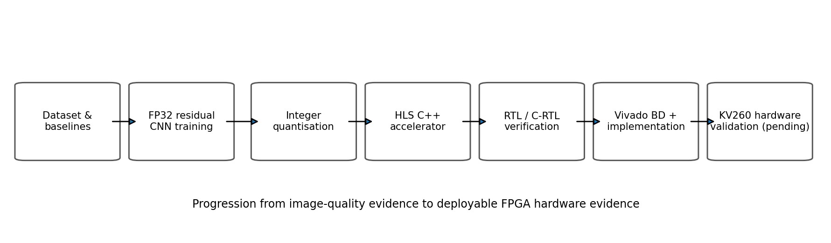
Figure 1 Overall software-to-hardware project flow and current physical-validation boundary.

1.1 Motivation and problem statement
Neural image reconstruction is usually developed and benchmarked in floating-point software. Edge deployment changes the constraints: arithmetic precision, memory traffic, deterministic latency, resource use and interface behaviour become first-class design concerns. FPGAs are attractive because they permit application-specific parallelism and deterministic datapaths, but that flexibility creates a verification burden. A visually plausible software model is not sufficient evidence that the hardware produces the intended numeric result.
The project problem is therefore defined as follows: design a transparent, compact 2× grayscale neural reconstruction model; quantise it to an integer representation suitable for programmable logic; implement the datapath as an HLS accelerator; and establish a verification chain from software metrics through bit-exact RTL and routed implementation before evaluating the design on a physical KV260 board.

1.2 Aim, research question and objectives
The project aim is to demonstrate a reproducible software-to-FPGA workflow for neural image reconstruction in which image-quality improvement and hardware correctness are both supported by measurable evidence.
The working research question is: can a compact quantised CNN for 2× grayscale reconstruction be mapped to the AMD Kria KV260 with negligible quality loss relative to FP32, bit-exact agreement between integer reference and RTL, and timing closure at a 200 MHz target clock?
1. Establish bilinear and bicubic reconstruction baselines and a fixed evaluation methodology.
2. Train a compact CNN that improves mean reconstruction quality on held-out data without relying on a large opaque model.
3. Quantise the trained model to integer parameters and establish golden vectors for exact verification.
4. Implement and optimise the integer datapath in Vitis HLS for the Kria K26 device.
5. Verify the generated RTL independently of HLS C simulation, including deterministic AXI backpressure stress.
6. Integrate the accelerator into a reproducible Vivado block design, close timing and preserve deployable hardware artifacts.
7. Validate the full PS-DDR-PL data path on the physical KV260 and benchmark end-to-end latency, correctness and resource/power behaviour.

1.3 Scope and success criteria
The current scope is intentionally narrow: single-channel 128×128 low-resolution inputs are reconstructed to 256×256 grayscale outputs using a compact residual CNN. The project does not attempt to reproduce a proprietary commercial upscaler or a large generative model. The emphasis is on transparent arithmetic, reproducibility and hardware verification.
Table 1 Project success criteria and present status.
Criterion | Measure | Interim status
Software quality | CNN mean PSNR greater than bicubic on held-out images | Achieved: 29.054 dB vs 28.270 dB; 20/20 wins
Quantisation fidelity | Small average loss relative to FP32 | Achieved: ≈29.028 dB, ≈0.026 dB below FP32
RTL numeric correctness | Exact golden-vector output | Achieved: 196,608/196,608 pixels in standalone RTL; 3/3 HLS co-sim vectors
Timing closure | Routed design meets 200 MHz target | Achieved: WNS +0.132 ns, WHS +0.011 ns
Deployable artifacts | BIT/XSA generated and preserved | Achieved under Vivado 2026.1.1 forward-toolchain rebuild
Physical validation | Real KV260 PS/DDR/PL execution | Pending board availability

2 Technical Background

2.1 Neural image reconstruction and super-resolution
Single-image super-resolution estimates a high-resolution image from a lower-resolution observation. Dong et al. showed that a compact CNN can directly learn the low-to-high-resolution mapping [1]. Shi et al. later demonstrated that real-time constraints motivate careful placement of upsampling and feature extraction operations [2]. These results motivate the present project's compact-network approach: reconstruction quality must be balanced against the arithmetic and memory cost that will ultimately be mapped to hardware.
For this project the input is a 128×128 grayscale image and the target is 256×256. A deterministic interpolation stage first produces a 2× image. A learned residual CNN then predicts a correction term. Residual learning keeps the network small because it focuses model capacity on the reconstruction error rather than learning the complete upscaling transform from scratch.

2.2 Image-quality metrics
Mean squared error (MSE) measures the average squared pixel error between a reconstructed image x and a reference image y over N pixels:
 | MSE = (1 / N) Σᵢ (xᵢ − yᵢ)² | (1)
Peak signal-to-noise ratio (PSNR) expresses the reconstruction error on a logarithmic scale. For images normalised to [0,1], the peak value is 1:
 | PSNR = 10 log₁₀(1 / MSE) dB | (2)
Higher PSNR indicates lower mean squared error. In this interim work PSNR and MSE are the primary quantitative metrics because the hardware verification flow ultimately requires exact numeric comparisons, not only perceptual inspection.

2.3 Compact residual CNN architecture
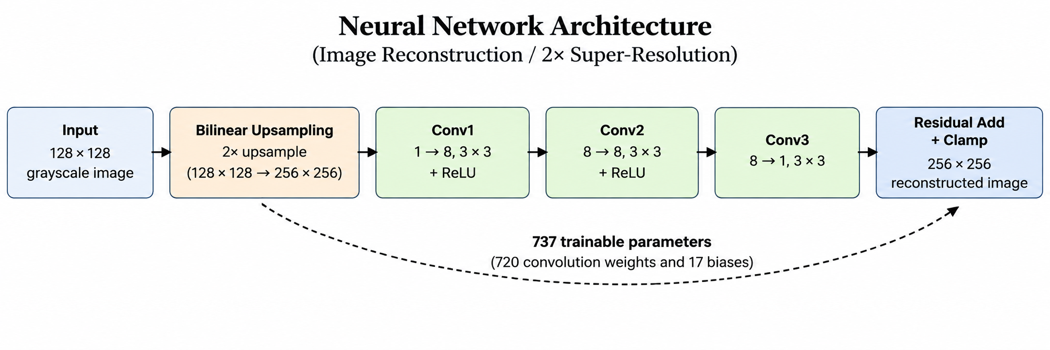
Figure 2 Compact residual CNN used for the reconstruction baseline and subsequent quantisation.
The network contains three 3×3 convolution layers. After bilinear 2× upsampling, Conv1 maps one input channel to eight features, Conv2 processes eight hidden features, and Conv3 maps the hidden representation back to one channel. ReLU is applied after the first two convolutions and the final network output is added to the interpolated image. The trained model contains only 737 parameters, making it small enough for detailed arithmetic tracing and hardware mapping.

2.4 Quantisation and integer inference
Integer quantisation reduces storage and replaces floating-point operations with integer arithmetic. Jacob et al. demonstrated that 8-bit quantised inference can preserve much of the accuracy of floating-point networks while enabling efficient integer-only execution [3]. FPGA-oriented work such as FINN further illustrates how reduced-precision neural arithmetic can be mapped to highly parallel programmable logic [4].
The implemented accelerator stores 720 convolution weights as INT8 and 17 biases as INT32. Intermediate accumulation is performed at wider precision, followed by a fixed requantisation shift of 20 bits. This explicit arithmetic contract is central to the verification strategy: the same integer reference is used to generate golden vectors and to judge RTL output exactly.
 | q = clip(round(x / s) + z) | (3)
Equation (3) shows the generic affine quantisation form, where s is a scale and z is a zero point. The project implementation uses a fixed integer export and requantisation scheme chosen to be directly realizable in HLS/RTL rather than a runtime floating-point conversion.

2.5 FPGA acceleration and high-level synthesis
Vitis HLS translates C/C++ descriptions into synthesizable RTL and supports C simulation, C synthesis and C/RTL co-simulation [5]. C/RTL co-simulation reuses the C testbench: input vectors are generated from the software testbench, the synthesized RTL is simulated, and the RTL output vectors are returned to the C testbench for comparison [5]. This provides an important bridge between algorithmic code and generated RTL, but independent RTL testing remains valuable because it can stress interface behaviour separately from the HLS wrapper environment.
The accelerator target is 5 ns (200 MHz). The internal architecture uses packed eight-channel feature maps and parallelised Conv2/Conv3 processing. Conv1 required targeted operation binding to achieve timing closure without increasing the model size. The HLS design exposes AXI memory masters for image buffers and AXI-Lite for control.

2.6 KV260 platform and AXI integration
The AMD Kria K26 system-on-module is based on a Zynq UltraScale+ MPSoC and combines a processing system with programmable logic. The KV260 starter kit provides 4 GB DDR memory and the programmable-logic resources required by this accelerator, including DSP, BRAM and UltraRAM resources [6], [7]. This heterogeneous architecture allows the processing system to manage buffers and control while the FPGA fabric executes the reconstruction datapath.
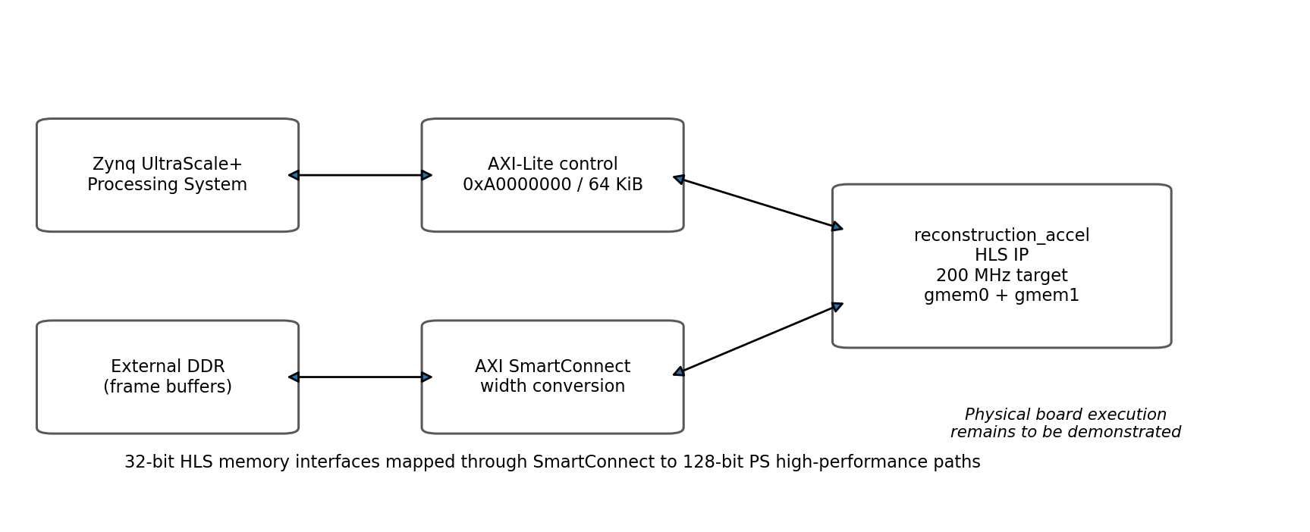
Figure 3 Planned KV260 system integration for control and image-buffer traffic.
The implemented block design maps AXI-Lite control at 0xA0000000 with a 64 KiB range. Two HLS memory masters use 32-bit data interfaces and are connected through AXI SmartConnect to wider processing-system high-performance paths. SmartConnect supports automatic AXI data-width conversion between differently sized interfaces [8]. Physical board testing is still required to validate real DDR transactions, software control, clock/reset behaviour and end-to-end PS-to-PL execution.

2.7 Verification methodology
Verification is treated as a ladder of progressively stronger evidence rather than a single pass/fail simulation. Software metrics establish reconstruction quality; integer golden vectors define the exact arithmetic result; HLS C simulation checks the C/C++ implementation; C/RTL co-simulation checks synthesized RTL against the same testbench; standalone RTL simulation independently exercises the generated interface; and Vivado implementation establishes structural integration and timing. The final step is physical board execution.
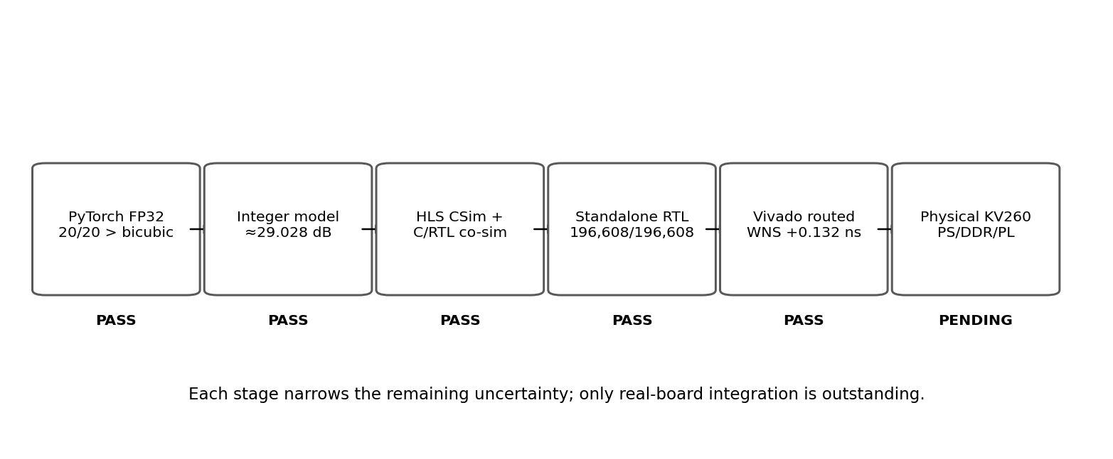
Figure 4 Verification ladder used to separate functional, implementation and physical-hardware claims.

2.8 Safety, ethics and sustainability
The project processes generic image data and does not require collection of personal biometric or medical information. Where third-party images are used for training or evaluation, provenance and usage rights should be documented in the final data appendix. The recovered Round 3 archive contains model checkpoints, training history and generated comparison images, but it does not contain the original source-image dataset; therefore full data provenance remains an archival action rather than a completed claim.
The principal physical risks are low-voltage electronics, electrostatic discharge, accidental short circuits and thermal loading of the FPGA board. These are mitigated by standard ESD handling, powered-down wiring changes, inspection before energisation and use of the supplied cooling solution. From a sustainability perspective, the project deliberately explores a 737-parameter quantised model rather than scaling model size unnecessarily; final hardware measurements will be used to discuss quality-per-resource and quality-per-power trade-offs rather than relying only on software accuracy.

3 Progress and Work Plan
The software and FPGA implementation stages are substantially complete. The project is intentionally shelved at the point where further claims require a physical KV260. The following subsections summarise the evidence produced to date and the remaining plan.

3.1 Training pipeline and Round 3 results
The final software experiment used 500 training patches and 20 held-out validation images with IDs 0805-0824. Training used seed 42, batch size 8 and learning rate 0.001 for 30 epochs, reaching global step 1,890. The recovered best_model.pt checkpoint contains the six expected convolution weight/bias tensors and reports 737 model parameters. Its SHA-256 digest matches the previously recorded project hash; the full digest is recorded in Appendix B.
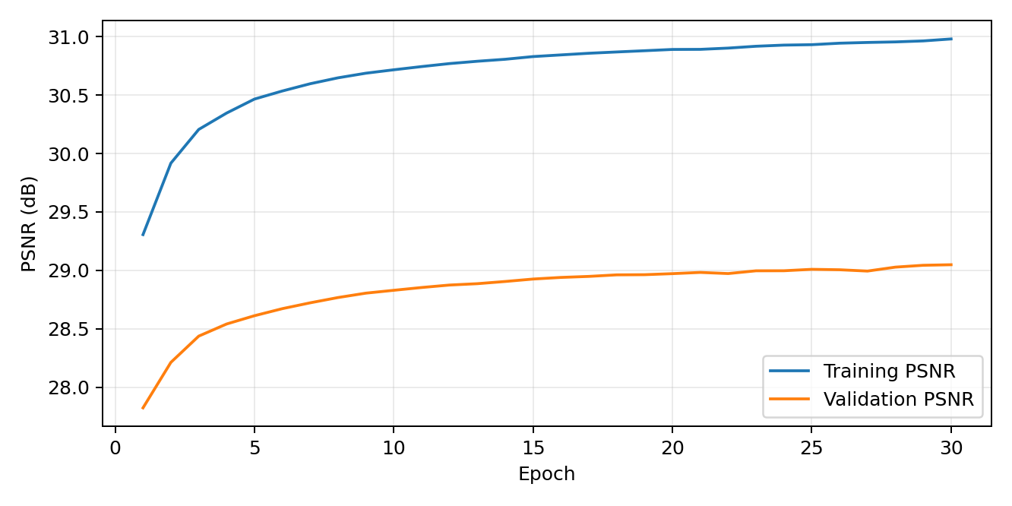
Figure 5 Round 3 training and validation PSNR over 30 epochs from the recovered training history.
Table 2 Round 3 reconstruction results on the 20 held-out images.
Method | Mean MSE | Mean PSNR (dB) | Wins vs bicubic
Residual CNN (FP32) | 0.0012433 | 29.054 | 20 / 20
Bicubic | 0.0014894 | 28.270 | —
Torch bilinear | 0.0018490 | 27.331 | —
PIL bilinear | 0.0018518 | 27.324 | —

The FP32 residual CNN improves mean PSNR by approximately 0.784 dB over bicubic interpolation and wins on every held-out image. The archived Round 3 package also contains per-image bilinear, bicubic, CNN and target outputs plus the full comparison CSV and training history.
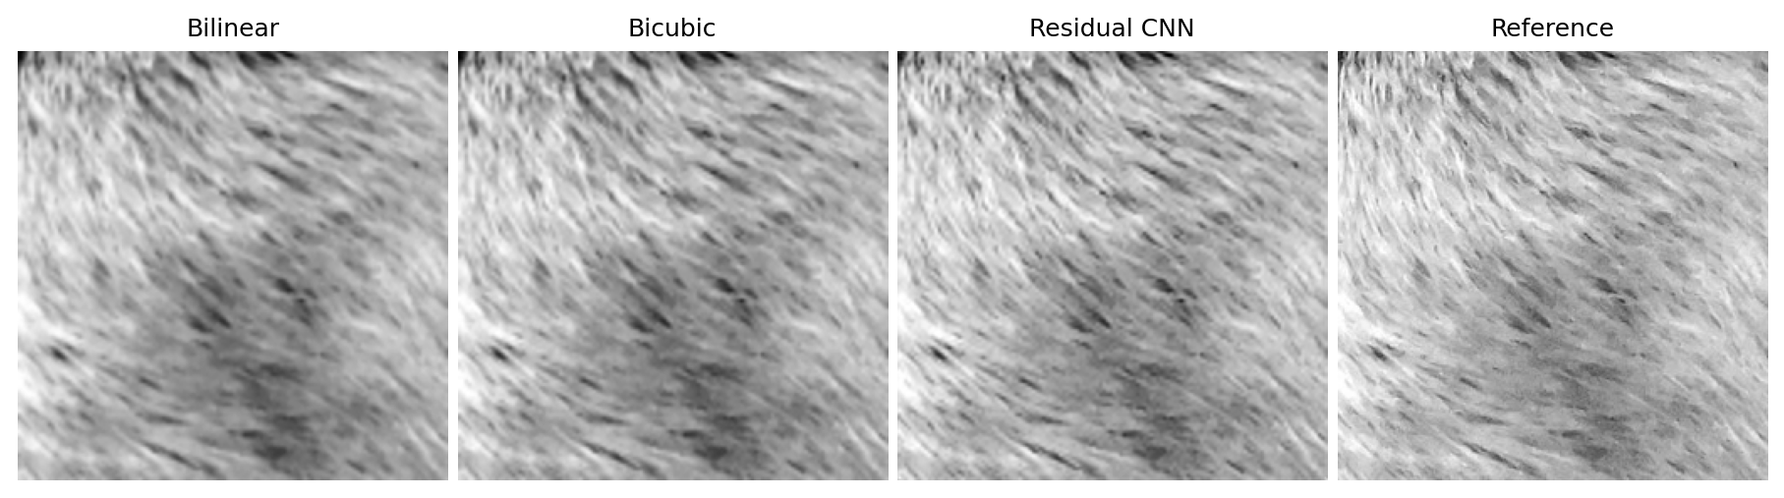
Figure 6 Representative Round 3 reconstruction comparison for validation image 0805.

3.2 Quantisation and golden vectors
The trained model was converted to an integer representation for hardware. The quantised model preserves a mean PSNR of approximately 29.028 dB, only about 0.026 dB below FP32, and retains the 20/20 win rate over bicubic interpolation. Three validation images (0805, 0809 and 0824) were selected as golden vectors to span easy, medium and more difficult reconstruction cases.
Table 3 Golden-vector integer reference quality.
Vector | Integer-reference PSNR (dB) | Role in verification
0805 | ≈34.067 | High-quality case
0809 | ≈39.624 | Very high-quality / low-error case
0824 | ≈24.011 | More difficult reconstruction case

These vectors are not used as statistical evidence for overall model quality; their purpose is exact end-to-end arithmetic verification. Every hardware-level comparison requires all 65,536 output pixels per frame to match the integer reference exactly.

3.3 HLS implementation and optimisation
The accelerator top function is reconstruction_accel. The HLS architecture uses packed eight-channel feature maps, parallel Conv2/Conv3 processing and a targeted binding change in Conv1. The implementation targets xck26-sfvc784-2LV-c at 5 ns. The generated IP exposes two AXI memory masters and an AXI-Lite control interface.
HLS C simulation passes the three golden vectors. C synthesis completes successfully, and C/RTL co-simulation under Vitis/XSim 2026.1.1 reports Verilog PASS with all three vectors bit-exact and zero mismatches. The current-source co-simulation reports a transaction latency of approximately 5.801 million cycles. This is simulator-reported RTL latency; final real-board throughput and software overhead remain to be measured.

3.4 Standalone RTL verification
Because an earlier HLS co-simulation attempt had failed inside generated AXI VIP infrastructure, an independent RTL harness was developed around the packaged Verilog and ROM data. The harness includes an AXI RAM model and exact comparison against the integer golden outputs. This provides functional evidence that is independent of the HLS co-simulation wrapper.
Table 4 Standalone RTL golden-vector verification.
Mode | 0805 | 0809 | 0824 | Total result
STALL=0 baseline | 65,536 / 65,536 | 65,536 / 65,536 | 65,536 / 65,536 | 196,608 / 196,608; 0 mismatches
STALL=1 deterministic AXI backpressure | 65,536 / 65,536 | 65,536 / 65,536 | 65,536 / 65,536 | 196,608 / 196,608; 0 mismatches

STALL=1 introduces deterministic AW/AR/W/R/B backpressure and AXI-Lite delays. Passing this test demonstrates that the packaged behavioral RTL tolerates the exercised interface stalls without numeric corruption. It does not, by itself, prove real DDR, SmartConnect width conversion, routed netlist behaviour or board-level execution.

3.5 Vivado integration and reproducibility
The original integrated design was preserved as a block design and then converted into a portable replay flow using write_bd_tcl output plus a wrapper replay script. A reset-topology assertion was added after an audit showed that the shipped reset polarity was already correct: pl_resetn0 is inverted before driving rst_200m/ext_reset_in, while C_EXT_RESET_HIGH remains 1 as propagated by the block design. A historical attempted set-to-zero command was therefore identified as dead/misleading rather than an actual design requirement.
A controlled forward-toolchain replay under Vivado 2026.1.1 compared 422 explicit properties from the 2025.1 block design with the reconstructed design. There were no substantive property differences; two apparent mismatches were whitespace/parser artifacts. The part, board, clocks, address map, reset topology, nets and interfaces were all rechecked before synthesis.

3.6 Timing closure and deployable artifacts
Vivado 2026.1.1 synthesis completed successfully. The default implementation routed fully but missed setup timing with WNS -0.104 ns. Three implementation-only strategies were then evaluated from the same synthesized design without source or constraint changes. Performance_Explore and Performance_ExplorePostRoutePhysOpt both achieved +0.132 ns WNS; Performance_NetDelay_high achieved +0.044 ns. Performance_Explore was selected because it produced the best timing with the simpler/faster flow.
Table 5 Preferred routed implementation summary (Performance_Explore).
Metric | Result
Target clock | 200 MHz (5 ns)
Setup WNS / TNS | +0.132 ns / 0
Hold WHS / THS | +0.011 ns / 0
Routing | 14,401 / 14,401 routable nets; 0 routing errors
LUT / FF | 7,125 / 6,090
DSP | 69
BRAM / URAM | 45.5 / 32
Vivado estimated power | ≈3.00 W (estimate, not measured hardware power)

A BIT file and fixed XSA including the bitstream were generated from the passing routed design. Both the standalone BIT and fixed XSA were hash-verified and preserved; their full SHA-256 digests are listed in Appendix B. Unpacking the XSA confirmed that its embedded bitstream is byte-identical to the preserved standalone BIT.

3.7 HLS co-simulation recovery and control experiment
The historical Vitis HLS 2025.1.1 C/RTL co-simulation failed before transaction 1 with a simulator kernel exception inside generated AXI VIP sequence code. No accelerator output had been compared, so the failure could not be treated as evidence of an arithmetic mismatch. This gap was later reopened under Vitis/XSim 2026.1.1.
The current source state completed C simulation, synthesis and three-vector C/RTL co-simulation with zero mismatches. To separate a source-code fix from an environment/toolchain effect, the exact historical source state at Git commit 8c847cd was materialised outside the repository and rerun under the current 2026.1.1 toolchain on the 32 GB PC. That historical source also passed all three vectors bit-exact. The source revision is therefore ruled out as the necessary cause of the original failure.
The exact historical root cause remains unisolated because both tool version and host environment changed. The two passing 2026.1.1 runs used approximately 8.42-8.89 GB peak XSim memory, while the original laptop had 8 GB total RAM. This makes memory pressure a plausible contributor, but the historical record shows a simulator kernel exception rather than an explicit allocation failure. The evidence therefore supports a resolved verification gap, not a unique causal attribution.

3.8 Current objective status
Table 6 Objective completion at the interim reporting point.
Objective | Status | Evidence
Baselines and evaluation pipeline | Complete | Round 3 metrics and comparison archive
Compact FP32 CNN | Complete | 737-parameter checkpoint; 29.054 dB mean PSNR
Integer quantisation | Complete | ≈29.028 dB; INT8 weights / INT32 biases
HLS accelerator | Complete | CSim, synthesis and co-simulation PASS
Independent RTL verification | Complete | 196,608/196,608 exact pixels in two stall modes
Vivado integration and timing | Complete | Portable BD replay; routed WNS +0.132 ns
Deployable BIT/XSA | Complete | Hashed and preserved artifacts
Physical KV260 execution | Pending | Board not yet programmed / PS-DDR-PL path not exercised
Final performance benchmark and technical analysis | Pending | Requires physical hardware measurements

3.9 Remaining hardware work
The next meaningful verification step is physical hardware, not further software simulation. The planned board-validation sequence is intentionally incremental:
1. Program the preserved design on the KV260 and confirm successful configuration.
2. Verify AXI-Lite register access and accelerator start/done control from the processing system.
3. Allocate DDR input/output buffers and verify addressing through the real SmartConnect and PS high-performance ports.
4. Run golden vector 0805 and require 65,536/65,536 exact output pixels.
5. Run 0809 and 0824 and require a combined 196,608/196,608 exact pixels.
6. Measure end-to-end and accelerator-only latency, repeatability, software overhead and board power where practical.
7. Compare measured hardware behaviour with HLS/Vivado estimates and document any discrepancy.

3.10 Schedule risks and mitigation
Table 7 Main technical and schedule risks.
Risk | Impact | Mitigation
KV260 delivery/availability delay | Blocks the only remaining verification boundary | Keep software state frozen; begin board bring-up immediately on arrival; preserve exact BIT/XSA and test vectors.
Toolchain/licensing changes | Could make rebuilds difficult or alter implementation | Preserve tool versions, Tcl replay scripts, DCPs, reports, hashes and deployable artifacts.
PS-DDR-PL integration issue | Could reveal an interface/addressing problem not visible in behavioral RTL | Bring up AXI-Lite first, then single-vector DDR transfer, then three-vector regression; capture all console evidence.
Training-data provenance gap | Limits full ML training reproducibility | Recovered checkpoint and metrics are hash-verified; archive the original source-image set and split manifest before the project archive is considered complete if available.
Hardware power/thermal behaviour | Could constrain sustained operation | Use supplied active cooling, monitor temperature, and treat Vivado power as an estimate until measured.
Evidence drift / accidental overwrite | Could weaken project traceability | Maintain read-only evidence manifests, Git commits and SHA-256 checks; never overwrite frozen Phase B-D artifacts.

3.11 Gantt chart
Figure 7 gives the provisional project schedule. Completed tasks are shown with solid bars; planned tasks are hatched. Exact future dates depend on physical board availability and the planned project completion timeline.
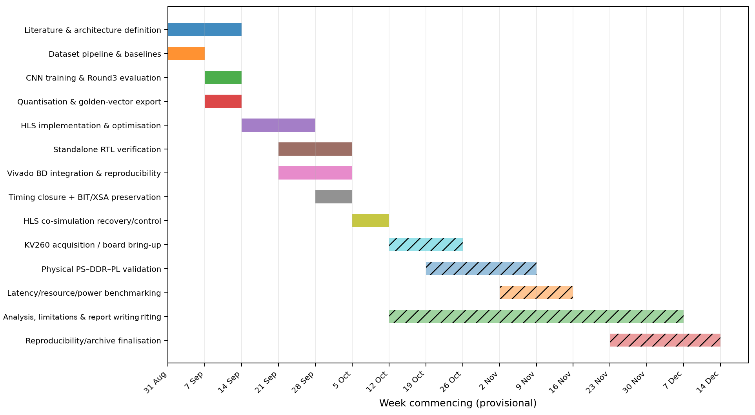
Figure 7 Interim Gantt chart. Solid bars indicate completed work; hatched bars indicate planned work.

4 Interim Conclusions
The project has progressed from an initial software reconstruction experiment to a fully routed and preserved FPGA implementation with two independent RTL-level functional verification paths. The compact FP32 network achieves 29.054 dB mean PSNR and outperforms bicubic interpolation on all 20 held-out images. Quantisation reduces average PSNR by only about 0.026 dB. The integer accelerator passes HLS C simulation, Vitis C/RTL co-simulation and standalone RTL regression with exact golden-vector agreement. The preferred Vivado 2026.1.1 implementation closes timing at 200 MHz with +0.132 ns setup slack and has preserved BIT/XSA deployment artifacts.
The earlier HLS AXI-VIP co-simulation failure has been resolved as a verification gap: both the current source and the historical source that previously failed now pass under 2026.1.1 on the current host. The experiment does not isolate whether the historical failure was caused by the older simulator/toolchain, host-memory pressure or an interaction between them, and the report does not claim otherwise.
The principal remaining uncertainty is physical integration. No current evidence proves real DDR access, SmartConnect width conversion, processing-system control, board clock/reset behaviour or sustained execution on silicon. Consequently, the project is intentionally shelved until the KV260 is available. The next milestone is a three-vector physical regression requiring 196,608/196,608 exact pixels, followed by latency and power/resource interpretation for the final technical report.

Glossary of Terms
Term | Meaning
AXI | AMBA Advanced eXtensible Interface used for control and memory transactions.
BD | Vivado block design.
BRAM | Block RAM implemented in FPGA fabric.
CNN | Convolutional neural network.
CSim | C/C++ behavioral simulation in Vitis HLS.
DSP | Dedicated FPGA arithmetic slice.
HLS | High-level synthesis from C/C++ to RTL.
PS / PL | Processing System / Programmable Logic in the Zynq MPSoC.
PSNR | Peak signal-to-noise ratio.
RTL | Register-transfer level hardware description.
URAM | UltraRAM memory resource.
WNS / WHS | Worst negative setup slack / worst hold slack; positive values indicate timing margin.

Nomenclature
Symbol | Definition
N | Number of pixels in the evaluated image.
xᵢ | Reconstructed pixel i.
yᵢ | Reference pixel i.
s | Quantisation scale.
z | Quantisation zero point.
q | Quantised integer value.

References
[1] C. Dong, C. C. Loy, K. He and X. Tang, “Image Super-Resolution Using Deep Convolutional Networks,” IEEE Transactions on Pattern Analysis and Machine Intelligence, vol. 38, no. 2, pp. 295-307, 2016, doi: 10.1109/TPAMI.2015.2439281.
[2] W. Shi et al., “Real-Time Single Image and Video Super-Resolution Using an Efficient Sub-Pixel Convolutional Neural Network,” Proc. IEEE CVPR, pp. 1874-1883, 2016, doi: 10.1109/CVPR.2016.207.
[3] B. Jacob et al., “Quantization and Training of Neural Networks for Efficient Integer-Arithmetic-Only Inference,” Proc. IEEE CVPR, pp. 2704-2713, 2018.
[4] Y. Umuroglu et al., “FINN: A Framework for Fast, Scalable Binarized Neural Network Inference,” Proc. ACM/SIGDA FPGA, 2017, arXiv:1612.07119.
[5] AMD, Vitis High-Level Synthesis User Guide, UG1399, version 2026.1, 2026. Sections used include C synthesis and C/RTL co-simulation methodology.
[6] AMD, Kria K26 SOM Data Sheet, DS987, rev. 1.6, 2026.
[7] AMD, Kria KV260 Vision AI Starter Kit Product Brief, accessed September 2026.
[8] AMD, SmartConnect LogiCORE IP Product Guide, PG247, 2026. Width-conversion and AXI interconnect behaviour.

Appendix A - Interim Risk Assessment
This interim risk assessment covers the foreseeable activities remaining in the project. It should be reviewed and signed in accordance with the appropriate laboratory risk-assessment procedure before physical laboratory work.
Hazard | Likelihood | Severity | Controls / residual risk
Electrostatic discharge to KV260 | Possible | Moderate | Use ESD-safe handling; discharge before contact; store board in antistatic packaging. Residual risk: low.
Short circuit / incorrect connection | Unlikely | Moderate | Power down before wiring; inspect connectors; use manufacturer-specified supply only. Residual risk: low.
Thermal stress during long FPGA runs | Possible | Moderate | Use supplied fan/heatsink; monitor temperature; stop on abnormal thermal behaviour. Residual risk: low.
Data/evidence loss | Possible | Moderate | Git remote, SHA-256 manifests, frozen build/evidence directories and separate artifacts. Residual risk: low.
Excessive tool runtime / workstation load | Possible | Low | Limit parallel jobs where needed; monitor RAM/disk; preserve checkpoints to avoid unnecessary rebuilds. Residual risk: low.

Author signature: __________________________ Date: ________________
Independent review: __________________________ Date: ________________

Appendix B - Artifact Provenance Snapshot
Table 8 Selected preserved artifacts at the interim reporting point.
Artifact | Identifier / SHA-256 | Status
Round 3 best_model.pt | af6c79ce172c70a97a565edd76ea183af25c8fcc4cb2002de2a575a15c335ac5 | Recovered and hash-verified
Git repository | kv260-integration @ 449606ffac962080301e001e1723a42b39bf861c | Clean and synchronized with origin
Preferred routed DCP | a0d6d36cacf0e2d74bb63e1a345329eb949d1479269a095410a562a5b873b727 | Preserved
BIT | 9296fc80638ec7fcb4750c7fc598f185bb150c45ee3b49e6bae41ffc226dbd03 | Preserved; not yet programmed on board
XSA | c4222e0d05ea2c8d35ae63d6617d37df770a82fd4eb8304bb5cebf6eb760dd70 | Preserved; embedded bitstream verified
Standalone RTL regression | 196,608 / 196,608 pixels, 0 mismatches in STALL=0 and STALL=1 | PASS
HLS C/RTL co-sim | 3 / 3 golden vectors, 0 mismatches under 2026.1.1 | PASS

Build artifacts were produced from source state a5e1e07; the later repository HEAD 449606ff contains documentation updates recording the resolved HLS co-simulation status. BIT/XSA artifacts were not regenerated after the documentation-only commit.

