ENGINEERING TEST REPORT

PCB-001 KiCad Simulation Results
  - Adjustable NE555 astable LED flasher | transient characterization
Project: PCB-001 adjustable NE555 astable LED flasher
Record date: 2026-08-21
Tool: KiCad Simulator; application version not recorded
Evidence state: Simulation characterization complete; physical validation pending

Scope and status
This report records transient-simulation characterization of the PCB-001 timing range and loaded LED branch. The KiCad simulation schematic is separate from the production schematic.
STATUS Evidence is recorded, but no requirement is marked PASS. Formal acceptance criteria were not documented before the run, and simulation does not close fabrication, assembly, or physical-validation gates.

Simulation configuration
Parameter | Configuration
Analysis | Transient; PSpice/LTspice compatibility enabled
Supply | 5 V DC
Timer model | External uA555.sub, subcircuit UA555; symbol pins 1-8 mapped to model pins 1-8
Timing network | R1 = 10 kOhm, R2 = 10 kOhm, C1 = 10 uF
Adjustment | R4 substitutes for RV1; evaluated at 1 Ohm, 50 kOhm, and 100 kOhm
Timing runs | D1/R3 excluded; 100 us step and maximum step; 2 s or 10 s duration
Loaded run | R4 = 50 kOhm; D1 and R3 = 330 Ohm included; 2 s duration
LED model | Generic built-in diode: is = 1e-18 A, rs = 5 Ohm, n = 2; not manufacturer-specific

Timing-range characterization
R4 was swept across the simulated adjustment range. The 1 Ohm case approximates the minimum setting while avoiding a zero-ohm SPICE element.
R4 | Period | Frequency | High / low | Duty | VCAP range
1 Ohm | 0.197 s | 5.08 Hz | 0.127 / 0.070 s | 64.5% | approx. 1.85-3.38 V
50 kOhm | 0.845 s | 1.18 Hz | 0.443 / 0.402 s | 52.4% | approx. 1.85-3.38 V
100 kOhm | 1.45 s | 0.690 Hz | 0.767 / 0.683 s | 52.9% | approx. 1.85-3.38 V
Observation: saved CSV data shows VCAP repeatedly traversing approximately one-third to two-thirds of the 5 V supply while VOUT toggles.
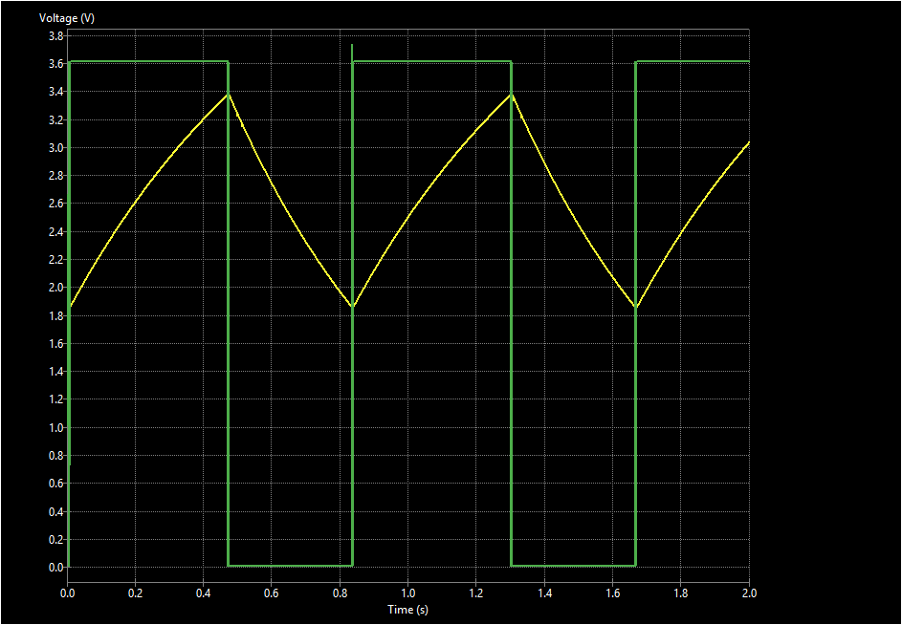
Figure 1. Midrange timing response at R4 = 50 kOhm: VOUT toggles as VCAP ramps between the timer thresholds.
Brief switching spikes seen in some VOUT exports are treated as external UA555-model or numerical switching artifacts, not as expected steady hardware output levels.

Loaded LED-branch characterization
The LED branch was restored at the 50 kOhm timing setting. D1 used the documented generic red-LED diode parameters and R3 remained 330 Ohm.
Quantity | Recorded result
Steady VOUT high level | approximately 3.62 V
D1 cathode / R3 input node | approximately 1.72 V while on
LED forward voltage | approximately 1.90 V
LED on-current | approximately 5.20 mA
R3 steady on-state power | approximately 8.92 mW
R3 maximum saved transient power | 10.19 mW
Consistency check. 1.72 V / 330 Ohm = 5.21 mA, agreeing with the simulated 5.20 mA LED current.
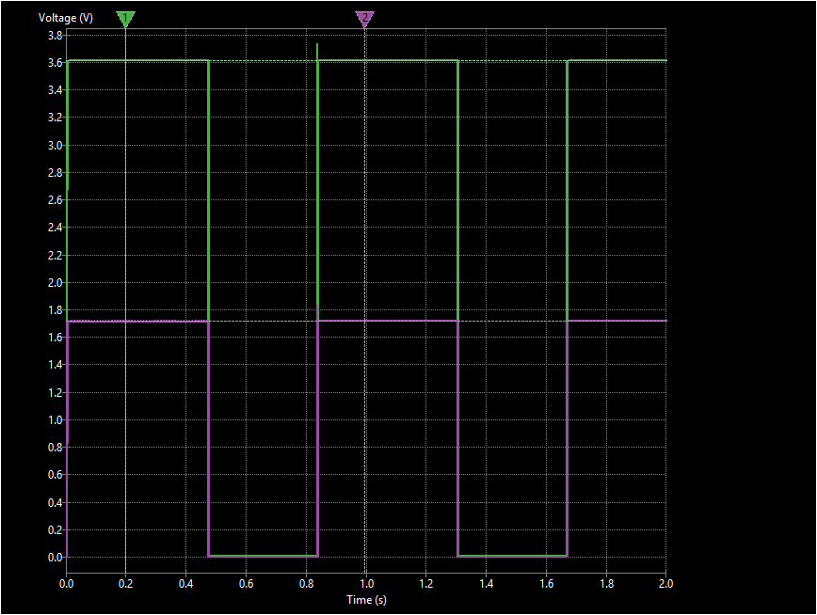
Figure 2. Loaded LED voltages at R4 = 50 kOhm: VOUT and the D1 cathode / R3 input node.

LED current and resistor dissipation
The LED current settles near 5.20 mA during each on interval. The narrow transition excursion is retained in the evidence but is not used as the steady operating current.
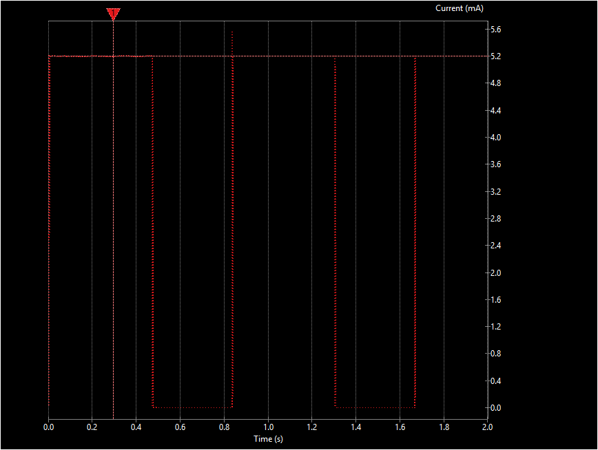
Figure 3. LED current at R4 = 50 kOhm; steady on-state current is approximately 5.20 mA.
R3 dissipates approximately 8.92 mW in steady operation, with a maximum saved transient value of 10.19 mW.
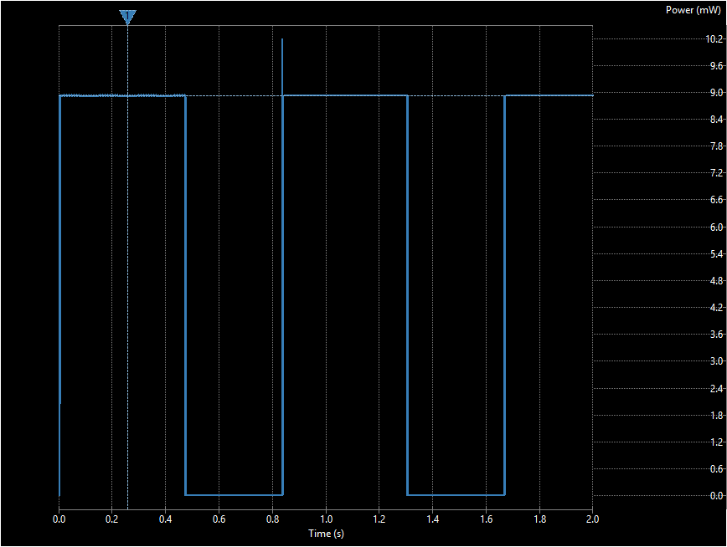
Figure 4. R3 power at R4 = 50 kOhm; steady on-state dissipation is approximately 8.92 mW.

Evidence index
The complete evidence set contains paired PNG and semicolon-delimited CSV exports. Paths below are relative to the repository root.
ID | Evidence | Files | Repository path (extension omitted)
01 | Mid timing, 50 kOhm | PNG + CSV | simulation/kicad/schematic_simulation_response_plots/  Timing_range_exports/01_timing_mid_50k
02 | Minimum timing, 1 Ohm | PNG + CSV | simulation/kicad/schematic_simulation_response_plots/  Timing_range_exports/02_timing_min_1ohm
03 | Maximum timing, 100 kOhm | PNG + CSV | simulation/kicad/schematic_simulation_response_plots/  Timing_range_exports/03_timing_max_100k
04 | LED current, 50 kOhm | PNG + CSV | simulation/kicad/schematic_simulation_response_plots/  led_current/04_led_current_mid_50k
05 | Loaded LED voltages | PNG + CSV | simulation/kicad/schematic_simulation_response_plots/  loaded_voltage_exports/05_led_loaded_voltages_mid_50k
06 | R3 power | PNG + CSV | simulation/kicad/schematic_simulation_response_plots/  r3_power_recording/06_r3_power_mid_50k
07 | Loaded branch composite | PNG + CSV | simulation/kicad/schematic_simulation_response_plots/  loaded_led_exports/07_led_branch_composite

Source artifacts
Simulation schematic: simulation/kicad/simulation_schematic/pcb-001-ne555.kicad_sch
Simulator workbook: simulation/kicad/workbook/pcb-001-ne555.wbk
Archived plot package: simulation/kicad/schematic_simulation_response_plots.zip
Timer model: kicad/models/uA555.sub

Limitations and remaining verification
Reproducibility. Record the exact KiCad application version used.
Acceptance. Define requirement-level criteria before assigning PASS or FAIL status.
Components. Confirm tolerances, temperature sensitivity, LED datasheet limits, and the selected R3 power rating.
Physical gate. Complete fabrication review, assembly inspection, and powered bench measurements before physical-validation closure.
Conclusion: the saved KiCad evidence characterizes stable astable operation across the tested adjustment range and a plausible loaded LED branch. It does not replace requirement-based or physical verification.

