ENGINEERING WORKLOG

PCB-001 NE555 Astable LED Flasher
  - Detailed progress report - 21 August 2026
Field | Record
Project | PCB-001 adjustable NE555 astable LED flasher
Session outcome | KiCad schematic and PCB review complete; DRC and parity clean
Authoritative PCB | kicad/pcb-001-ne555/pcb-001-ne555-placement-modified.kicad_pcb
Fabrication decision | Gerber/drill generation intentionally deferred; no fabrication purchase planned
Repository status | Local working tree contains unstaged/untracked engineering artifacts; no commit or push performed

End-of-day position: The electrical design, KiCad simulation evidence, routing, 3D mechanical representation, interface labels, and PCB consistency checks were brought to a coherent reviewed state. The final PCB DRC reported zero violations, zero unconnected items, zero schematic-parity findings, and zero ignored tests. This is a design-review milestone, not a fabrication or physical-validation release.

1. Executive summary
Today’s work consolidated the project from a routed KiCad design and exploratory simulator setup into a documented, mechanically reviewed, internally consistent prototype baseline. No manufacturing files were generated because fabrication spending was explicitly ruled out for this stage.
- Completed and reviewed the two-layer PCB routing, including the sensitive VCAP timing network, the U1-C3 supply-decoupling loop, the discharge path, output/LED path, +5 V distribution, and GND connectivity.
- Established a reproducible KiCad transient-simulation setup using an external UA555 subcircuit model and recorded timing, LED-current, loaded-voltage, and resistor-power evidence as PNG and CSV exports.
- Created a concise KiCad simulation-results Word document and retained the KiCad simulator workbook plus an archived plot package in the repository.
- Defined an exact prototype component baseline and bare-board construction profile, including controlled manufacturer part numbers for the timer, potentiometer, resistors, capacitors, LED, and terminal block.
- Added manufacturer 3D models for RV1 and J1, corrected their offsets/orientations, and visually confirmed that pins, bodies, wire access, and adjustment access align with the board.
- Added functional front-silkscreen labels for the power connector and test points, then resynchronized resistor and potentiometer values between the schematic and PCB.
- Closed the session with clean KiCad checks: 0 PCB violations, 0 unconnected items, 0 schematic-parity findings, and 0 ignored tests.
Verification boundary: Simulation and DRC results demonstrate model behaviour and design consistency only. They do not prove manufactured-board quality, assembly correctness, or physical performance. Fabrication, assembly, inspection, and powered bench validation remain unperformed.

2. Project baseline at close of session
Item | Controlled baseline
Circuit | Adjustable NE555 astable oscillator driving a red LED
Supply | +5 V DC through J1; pin 1 = +5 V, pin 2 = GND
Timing network | R1 = 10 kOhm, R2 = 10 kOhm, RV1 = 100 kOhm, C1 = 10 uF
Support components | C2 = 10 nF control-pin bypass; C3 = 100 nF supply decoupling
Output branch | U1 OUT / VOUT -> red LED D1 -> R3 330 Ohm -> GND
Board | 38.50 mm x 40.75 mm, two copper layers, FR-4 target, through-hole assembly
Copper | F.Cu and B.Cu routing with GND zones on both layers; no vias
Test access | TP1 +5 V, TP2 GND, TP3 VOUT, TP4 VCAP
Current design status | Schematic/PCB consistency and DRC clean; fabrication release deliberately not pursued

3. Schematic and KiCad simulation work

3.1 Timer-model integration
The absence of a bundled 555 macromodel was resolved by assigning the repository model kicad/models/uA555.sub to U1. The selected subcircuit is UA555, and symbol pins 1 through 8 were mapped directly to model pins 1 through 8:
Symbol pin | Function | Model pin
1 | GND | 1
2 | TRIG | 2
3 | OUT | 3
4 | RESET | 4
5 | CONT | 5
6 | THRES | 6
7 | DISCH | 7
8 | VCC | 8

3.2 Potentiometer simulation substitute
A simulation-only resistor R4 was placed across the potentiometer terminals while the production RV1 symbol was excluded from simulation. R4 was evaluated at 1 Ohm, 50 kOhm, and 100 kOhm. The 1 Ohm value approximates the minimum setting without using a zero-ohm SPICE element. R4 is not part of the production schematic, PCB, or BOM.

3.3 Transient-analysis settings
- Analysis type: transient (TRAN), with PSpice/LTspice compatibility enabled.
- Supply: 5 V DC.
- Timing runs: 100 us time step and maximum step; 2 s duration for 1 Ohm and 50 kOhm, and 10 s for 100 kOhm.
- Loaded LED run: R4 = 50 kOhm, D1 and R3 included, 2 s duration, voltage/current/power data saved.
- LED model: adjusted generic built-in diode (is = 1e-18 A, rs = 5 Ohm, n = 2), not a manufacturer-specific Kingbright model.

3.4 Timing-range results
R4 | Period | Frequency | High | Low | Duty | VCAP
1 Ohm | 0.197 s | 5.08 Hz | 0.127 s | 0.070 s | 64.5% | ~1.85-3.38 V
50 kOhm | 0.845 s | 1.18 Hz | 0.443 s | 0.402 s | 52.4% | ~1.85-3.38 V
100 kOhm | 1.45 s | 0.690 Hz | 0.767 s | 0.683 s | 52.9% | ~1.85-3.38 V

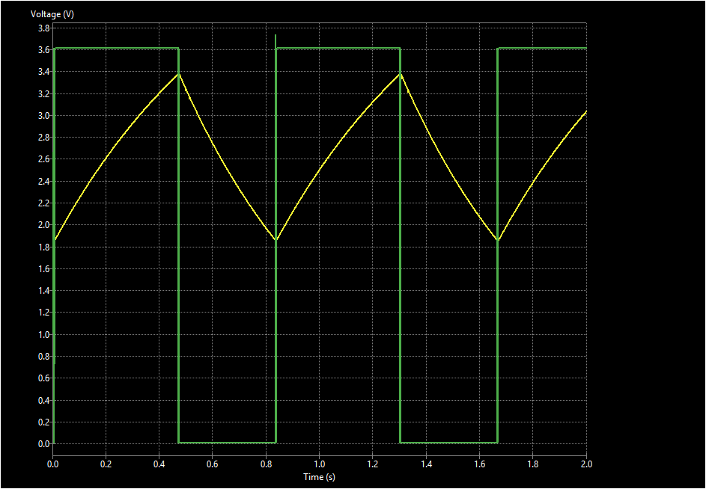
Figure 1. Mid-range timing response at R4 = 50 kOhm (VOUT and VCAP).

3.5 Loaded LED-branch results
Quantity | Recorded simulation result
Steady VOUT high | approximately 3.62 V
D1 cathode / R3 input node while on | approximately 1.72 V
LED forward voltage | approximately 1.90 V
LED on-current | approximately 5.20 mA
R3 steady on-state power | approximately 8.92 mW
R3 maximum saved transient power | 10.19 mW

The branch values are internally consistent: 1.72 V / 330 Ohm = 5.21 mA, matching the recorded 5.20 mA LED current. The R3 result provides substantial margin relative to the selected 0.25 W resistor rating, subject to component tolerance and physical validation.
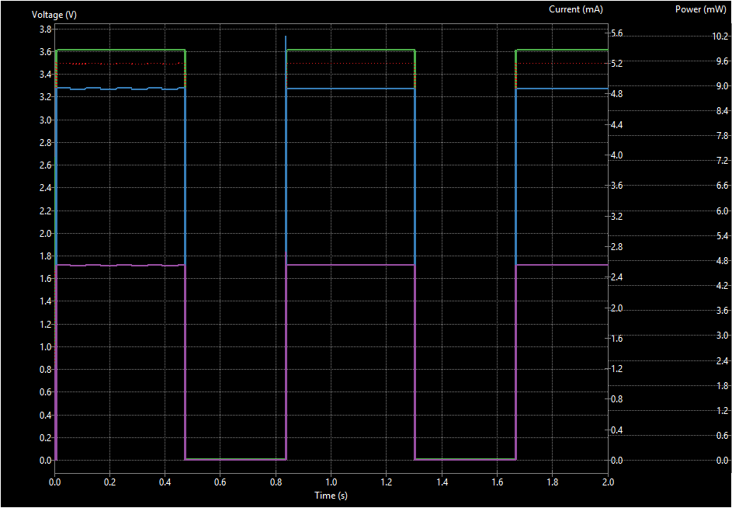
Figure 2. Loaded LED branch composite at R4 = 50 kOhm.

3.6 Simulation evidence retained
- simulation/kicad/simulation_schematic/pcb-001-ne555.kicad_sch
- simulation/kicad/workbook/pcb-001-ne555.wbk
- simulation/kicad/schematic_simulation_response_plots/ (PNG and CSV exports)
- simulation/kicad/schematic_simulation_response_plots.zip
- docs/PCB-001_KiCad_Simulation_Results_2026-08-21.docx
- docs/test-report.md

4. PCB routing and copper completion
Routing was completed using a deliberate two-width scheme: 0.50 mm for +5 V and explicit GND connections, and 0.30 mm for ordinary and timing signals. Through-hole pads allowed layer changes without vias; the final board contains no vias.

4.1 Critical routing decisions
- C3 decoupling loop: U1 pin 8 (+5 V) was routed to C3 pad 1, and U1 pin 1 (GND) to C3 pad 2. The loop was redrawn into a compact, legible path close to the DIP package.
- VCAP timing node: U1 pins 2 and 6, C1 positive, TP4, and RV1 timing terminals were kept as a compact timing network. Layer use was reviewed to avoid false assumptions that blue and red traces electrically interfere when they cross on different copper layers.
- Discharge path: U1 pin 7 DISCH was connected to the R2 discharge-side pad; R2 pad 2 was then routed to RV1 pad 1.
- Power distribution: +5 V was routed between the timer, R1/R2 timing chain, TP1, and J1 pin 1 using 0.50 mm copper.
- Output and LED branch: U1 pin 3 VOUT was routed to TP3 and the LED/resistor branch, after checking the LED schematic/netlist orientation and current path.
- Ground strategy: F.Cu and B.Cu GND zones were added with thermal reliefs, 0.25 mm zone clearance, 0.25 mm minimum zone width, and island removal.

4.2 Copper inventory
Copper category | Segments | Width
F.Cu +5 V | 11 | 0.50 mm
F.Cu GND | 2 | 0.50 mm
Remaining F.Cu signals | 18 | 0.30 mm
B.Cu signals | 7 | 0.30 mm
Total routed track segments | 38 | -
Vias | 0 | Not used

5. Exact component and fabrication definition
A controlled prototype component baseline and fabrication profile were added to the repository. These records define what would be purchased and manufactured if the project later resumes fabrication, but they do not authorize fabrication now.
Refs | Manufacturer | Part number | Controlled description
U1 | Texas Instruments | NE555P | PDIP-8 bipolar 555
RV1 | Bourns | 3386P-1-104LF | 100 kOhm top-adjust trimmer
R1, R2 | YAGEO | MFR-25FBF52-10K | 10 kOhm, 1%, 0.25 W axial
R3 | YAGEO | MFR-25FBF52-330R | 330 Ohm, 1%, 0.25 W axial
C1 | Panasonic Industry | ECEA1VKA100 | 10 uF, 35 V radial electrolytic
C2 | Vishay BCcomponents | K103K10X7RF53H5 | 10 nF X7R radial MLCC
C3 | Vishay BCcomponents | K104K10X7RF53H5 | 100 nF X7R radial MLCC
D1 | Kingbright | L-53LID | Low-current red 5 mm LED
J1 | Same Sky | TB007-508-02BE | 2-position 5.08 mm terminal block

5.1 Bare-board profile recorded
- 38.50 mm x 40.75 mm rectangular two-layer board; no slots, cut-outs, castellations, or edge plating.
- 1.60 mm FR-4 target, 1 oz copper, lead-free HASL, green solder mask, white front legend.
- Actual minimum routed track 0.30 mm; actual minimum copper clearance 0.25 mm; 0.50 mm copper-to-edge rule.
- Plated through-holes only; minimum component hole 0.80 mm, terminal-block hole 1.60 mm; no vias.
- All-through-hole manual assembly target using lead-free solder; polarity and pin-1 checks defined.
Production BOM: fabrication/PCB-001-production-bom.csv
Fabrication profile: fabrication/PCB-001-fabrication-profile.md
Datasheet traceability: Manufacturer datasheet URLs and controlled requirements are recorded in the BOM and fabrication profile. Individual KiCad symbol Datasheet fields were not universally populated during this session; completing those fields remains optional metadata cleanup rather than an electrical or DRC blocker.

6. 3D model integration and mechanical review

6.1 Manufacturer model assignment
- Bourns RV1 model: kicad/pcb-001-ne555/models/Bourns_3386P001XXX.stp
- Same Sky J1 model: kicad/pcb-001-ne555/models/Same_Sky_TB007-508-02BE.step
- Models were assigned through footprint 3D-model properties rather than replaced with visually similar generic library bodies.

6.2 Alignment correction
The first model assignments exposed two visible mechanical errors: the potentiometer pins did not coincide with the PCB holes, and the terminal-block body/wire-entry orientation was incorrect. Model offsets and rotations were corrected in the PCB footprint properties. The revised view confirmed that RV1’s three pins enter their plated holes and that J1’s pins, screw positions, body, and horizontal wire entry align with the board.
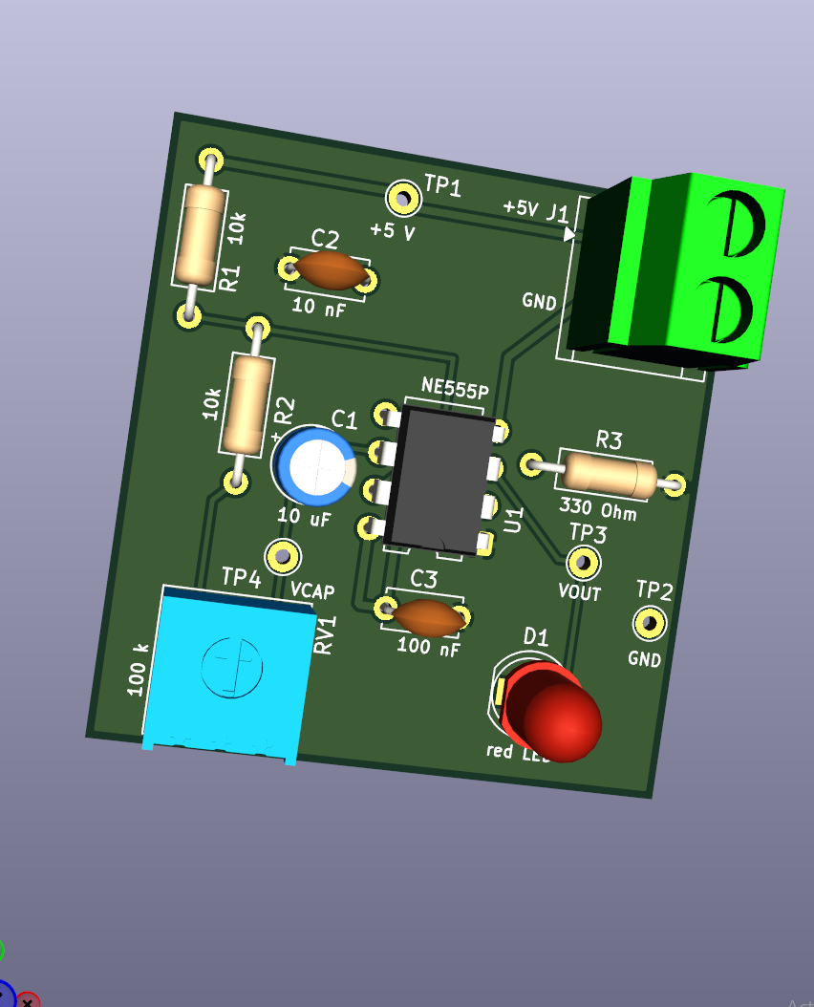
Figure 3. Final 3D assembly view after model alignment and silkscreen labeling.

6.3 Mechanical observations
Review area | Observation
Board envelope | 38.50 mm x 40.75 mm rectangular outline confirmed.
J1 access | Connector sits at the top/right edge with screw and horizontal wire access available. Courtyard-to-edge margin remains close (approximately 0.35 mm).
RV1 access | Top adjustment slot is accessible from the component side; model pins align with holes.
Test points | TP1-TP4 remain physically accessible; TP2 is close to the right board edge (approximately 0.50 mm courtyard margin).
Polarized parts | U1 orientation, C1 positive marking, D1 polarity, and J1 pin-1 power identification are visible for assembly review.
Mounting | No mounting holes are present. This is acceptable only if the eventual enclosure/mounting method does not require them.

7. Silkscreen and interface identification
Functional labels were added on F.Silkscreen using approximately 0.8 mm text with 0.15 mm stroke thickness. Existing reference designators were retained so assembly documentation and electrical bring-up remain traceable.
Location | Label | Purpose
J1 pin 1 | +5V | Placed beside the upper power terminal
J1 pin 2 | GND | Placed beside the lower ground terminal
TP1 | +5V | Power-rail probe point
TP2 | GND | Ground-reference probe point
TP3 | VOUT | Timer/LED output probe point
TP4 | VCAP | Timing-capacitor probe point

The 3D review showed all functional labels visible with components fitted. The J1 reference and +5V label were kept distinct enough to avoid reading them as one combined identifier.

8. Schematic/PCB parity cleanup and final verification

8.1 Value-string mismatch
After the silkscreen work, DRC reported three schematic-parity warnings. They were not electrical discrepancies: KiCad was comparing equivalent but textually different value strings. The PCB held 10 kOhm / 100 kOhm while the current schematic symbols used 10k / 100 k. The schematic was saved and the PCB was updated from the schematic without replacing footprints, thereby preserving the custom 3D-model assignments.

8.2 Final KiCad result
Check | Count | Disposition
PCB violations | 0 | Clean
Unconnected items | 0 | All nets routed
Schematic parity | 0 | Values and symbol/footprint relationship synchronized
Ignored tests | 0 | No current ignored-test exceptions

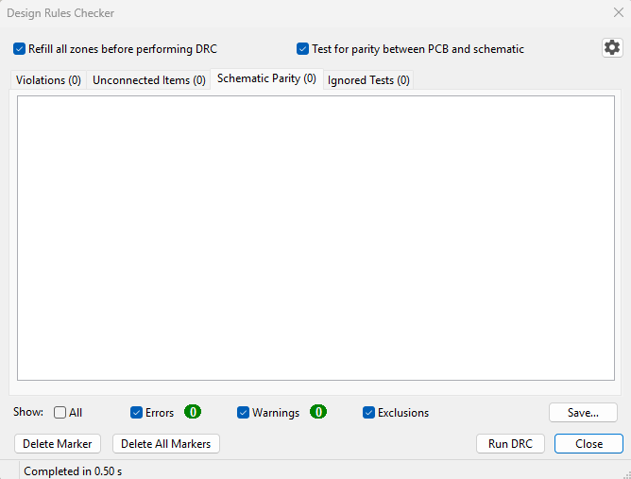
Figure 4. Final PCB Design Rules Checker result: all categories clear.
Gate interpretation: The PCB layout/design-rule review gate is evidenced as clean for the saved design state. The result does not automatically pass the later fabrication, assembly, or physical-validation gates defined by the repository workflow.

9. Repository artifacts and traceability
Artifact class | Repository location
Authoritative design | kicad/pcb-001-ne555/pcb-001-ne555-placement-modified.kicad_sch and .kicad_pcb
KiCad project settings | kicad/pcb-001-ne555/pcb-001-ne555-placement-modified.kicad_pro
Simulation model | kicad/models/uA555.sub
Simulation source | simulation/kicad/simulation_schematic/pcb-001-ne555.kicad_sch
Simulator workbook | simulation/kicad/workbook/pcb-001-ne555.wbk
Plot/data evidence | simulation/kicad/schematic_simulation_response_plots/ and ZIP archive
Simulation report | docs/PCB-001_KiCad_Simulation_Results_2026-08-21.docx
Production definition | fabrication/PCB-001-fabrication-profile.md and PCB-001-production-bom.csv
3D models | kicad/pcb-001-ne555/models/Bourns_3386P001XXX.stp and Same_Sky_TB007-508-02BE.step

9.1 Version-control condition
The repository working tree remains intentionally uncommitted. Modified and untracked design, evidence, documentation, model, and autosave artifacts are present. Historical simulation-folder and temporary lock-file deletions also appear in Git status and should be reviewed before any future staging operation. No staging, commit, push, or upload-changes.ps1 execution was performed as part of this report.

10. Fabrication decision and deferred gates
Decision recorded: The project owner does not intend to spend money on fabrication at this time. Gerber, drill, job, checksum-manifest, manufacturing-order, assembly, and bench-validation activities are therefore intentionally deferred rather than failed.
Gate/output | State | Reason
Gerber X2 plots | Not generated | Deferred by project decision
Excellon drill files / drill map | Not generated | Deferred by project decision
Independent Gerber/drill viewer inspection | Not performed | Requires fabrication outputs
Fabricator electrical test | Not performed | No manufacturing order
Assembly and visual inspection | Not performed | No physical PCB
Powered bench validation | Not performed | No physical PCB
Physical requirement closure | Pending | Simulation and DRC are not substitutes

11. Recommended no-cost next activities
- Record the exact KiCad application version used for the final simulator and DRC runs.
- Open the final schematic and PCB once more after a clean application restart to confirm the saved files reproduce the zero ERC/DRC/parity state.
- Optionally populate missing KiCad Datasheet symbol fields using the manufacturer URLs already controlled in the BOM and fabrication profile.
- Review Git status carefully, decide which autosave/lock/deleted temporary artifacts should be retained or removed, and stage only intentional files if a future commit is authorized.
- Preserve a read-only archive of the final KiCad source, simulator workbook, UA555 model, PNG/CSV evidence, and the two Word reports.
- If fabrication is reconsidered later, restart at the fabrication-release gate rather than assuming today’s clean DRC is a complete manufacturing release.

Appendix A. Session chronology
Step | Activity | Recorded outcome
1 | Routing review and completion | Power, timing, discharge, output, LED, and GND paths completed and cleaned; dual-layer GND zones established.
2 | ERC/parity cleanup | Footprint/symbol mismatch warnings investigated and resolved; clean electrical-rule state recorded.
3 | UA555 simulation integration | External subcircuit located, assigned, and pin-mapped; transient setup established.
4 | Timing characterization | Minimum, midpoint, and maximum timing substitutes simulated and exported.
5 | LED branch characterization | Loaded voltage, LED current, R3 power, and composite evidence exported as PNG/CSV.
6 | Simulation documentation | Workbook retained, evidence archive created, and simulation-results Word document produced.
7 | Production audit | Exact parts, BOM, fabrication profile, and component-source traceability recorded.
8 | 3D model correction | Manufacturer RV1 and J1 bodies assigned; pin/body offsets and orientation corrected.
9 | Mechanical and silkscreen review | Component access reviewed; connector/test-point functional labels added.
10 | Final consistency check | Value-string parity corrected; final DRC returned 0/0/0/0.
11 | Scope decision | Fabrication outputs and spending explicitly deferred; project retained as a verified design/simulation milestone.

Appendix B. Evidence interpretation
Recorded evidence supports the following bounded conclusions:
- The KiCad schematic and PCB are mutually consistent in the final recorded state.
- All intended PCB nets are routed and the configured PCB design rules report no violations.
- The selected UA555 simulation model oscillates with the recorded timing range and drives the modeled LED branch at the recorded current and power levels.
- The manufacturer 3D models for J1 and RV1 align visually with the PCB footprints after correction.
- The component and fabrication records are suitable as a future planning baseline, but no manufacturing release package exists.
End of report

